American
Printing House
For The Blind

Department of Research

Annual Report
of Research &
Development Activities

Fiscal Year 2018

Table of Contents

MISSION STATEMENT 6
Letter From Director of Educational Product Research 7
Advisory Committees 8
DEPARTMENT OF RESEARCH STAFF 9
Agencies Participating in Research (98) 11
Consultants (86) 14
Field Evaluators / Expert Reviewers (153) 19
ACCESSIBLE TESTS 27
EDUCATIONAL PRODUCT RESEARCH 32
ADULT LIFE 33
Adult Life Needs 34
AFB Foundations of Rehabilitation Teaching Kit 34
Color Star® 35
CORE CURRICULUM 37
BUSINESS AND VOCATIONAL EDUCATION 38
FINE AND PERFORMING ARTS 38
Color-by-Texture CIRCUS Coloring Pages 38
Feel 'n Peel Sheets: Carousel of Textures II 40
Feel the Beat: Braille Music Curriculum 46
Paint-By-Number Safari™ (Series) 49
Strike-A-Pose: Body Awareness Cards for Students with Visual Impairments and Blindness 52
MATHEMATICS 56
AnimalWatch VI Suite 56
AnyMath Kit 59
Common Core Math Kits 62
Flip-Over Concept Books: FRACTIONS 64
Flip-Over Concept Books: TELLING TIME 68
Graph Benders 73
Hundreds Board and Manipulatives 76
inTouch with Math supports enVisionmath®2.0 77
Math Drill Cards in Braille and Large Print [Modernization] 79
MathBuilders 80
Nemeth Code Reference Sheet for Basic Mathematics [Modernization] 83
Place Value Setter 84
Practice2Master Fractions 87
Tactile Algebra Tiles 90
Tactile Five and Ten Frames 93
PHYSICAL EDUCATION / HEALTH 102
Count Me In: Motor Development in a Box 102
Health Education for Students With Visual Impairments: A Guidebook for Teachers 105
Hop-A-Dot Mat 108
Physical Education, Recreation, and Health Web Site 126
Physical Education and Health Special Projects and Needs 127
SPORTS COURTS 128
READING AND LANGUAGE ARTS 156
Early Braille Trade Books 156
Expanded Dolch Word Cards [Modernization] 159
Wilson Reading System 160
SCIENCE 163
Adapted Biology Lab Manual (ABLM) 163
Adapted Science Materials Kit (ASMK) 164
Azer’s Interactive Periodic Table Study Set [Modernization] 167
Build-A-Cell 170
Earth Science Tactile Graphics (ESTG) 173
Periodic Table of the Elements Reference Chart and Booklet [Modernization] 174
Snap Circuits Jr.® Access Kit 178
Submersible Audio Light Sensor (SALS) 183
Tactile Caliper Set 187
Talking Scientific Balance 188
SOCIAL STUDIES 191
Tactile World Globe 191
TECHNOLOGY AND MEDIA 204
CodeQuest 204
EARLY CHILDHOOD 206
Animal Recipes 207
Art Digitizing/Modernizing of On the Way to Literacy Storybooks 209
Astro Adventure Balls: Swirl, Twirl, & Whirl 218
Early Childhood Needs 220
Emergent Numeracy Kit For Preschool 221
Fingers That Dream 224
FirstTouch Books 231
Going to the Playground 240
Laptime and Lullabies 244
Moving Ahead: Tactile Graphic Storybooks 250
Reach & Match® Learning Kit 254
Tactile Book Builder 292
Tactile Book Texture and Item Accessory Pack 302
Visio Tactual Profile 308
What Is It? [Modernization] 309
EXPANDED CORE CURRICULUM 312
Multiple Disabilities Projects and Needs 313
Quick & Easy ECC Mobile App 314
Visual and Multiple Impairments Website 316
ASSISTIVE TECHNOLOGY AND ELECTRONICS 316
APH SMART Brailler by Perkins 317
DC Supplement Adapter 329
Joy Player Digital Cartridge 329
CAREER EDUCATION AND TRANSITION 342
Transition Program Components 342
COMPENSATORY AND ACCESS SKILLS 345
Braille 345
Braille Buzz 345
Braille Contraction Cards [Modernization] 349
Braille Formats: Principles of Print-to-Braille Transcription 350
Braille Literacy Web Site 352
Building on Patterns, Second Edition: Kindergarten Level 353
Building on Patterns, Second Edition: Prekindergarten Level 364
Fun with Braille [Modernization] 382
I-M-ABLE (Individualized Meaning-Centered Approach to Braille Literacy Education) Kit 382
Low Cost Brailler/Embosser 386
Quick Pick Braille Contractions [Modernization] 387
Handwriting 388
Study Skills / Organizational Skills 388
Tactile Graphics 388
Feel 'n Peel Stickers: Additional Packages 388
Feel 'n Peel Stickers: Braille/Print Capital Letters A-Z 395
Feel 'n Peel Stickers: UEB Braille/Print Numbers 0-100 397
Finger Walks 399
Flip-Over Concept Books: MAKE A FACE 401
PermaBrailleTM [Modernization] 404
Room with a View: Map-Reading Concepts and Skills 411
Tactile Graphics Research 432
Tactile Skills Online Matrix 434
TactileDoodle 439
Textured Graphic Art Tape 455
TG TV 459
INDEPENDENT LIVING SKILLS 460
ORIENTATION AND MOBILITY 460
Crossings With No Traffic Control: Teaching Concepts and Skills to Deal With Them 460
O&M Trivia 464
RECREATION AND LEISURE 468
Flip-Over FACES App 468
SELF-DETERMINATION 482
V-file 482
SENSORY EFFICIENCY SKILLS 483
DeafBlind Pocket Communicator 483
Let’s Join In [Modernization] 487
Light Box Ledges 489
SLK: Sensory Learning Kit (Revision) 500
Cortical Visual Impairment 501
Color Raceway 501
Cortical Visual Impairment (CVI) Projects and Needs 504
CVI Book Builder [Modernization] 505
CVI Companion Guide to Developmental Guidelines for Infants with Visual Impairments [Modernization] 508
CVI Web site 509
Increasing Complexity Pegset 510
Mini-Lite Box Overlays 514
Visual Organization Toolbox 517
Low Vision 519
Barraga Visual Efficiency Program 519
Decision Making Guide 548
Explorer Bright Ray: LEDs for Persons with Low Vision 552
Light Box and Reading Stand Mounting System 554
MATT Connect 556
See Like Me: Low Vision Simulators 559
TADPOLE Overlay Electronic Version [Modernization] 568
Topaz Filters [Modernization] 570
SOCIAL INTERACTION SKILLS 571
TESTS AND ASSESSMENTS 572
BRIGANCE CIBS II 573
Functional Skills Assessment 574
KeyMath™-3 Large Print and Braille Adaptation 578
NewT: New Tools for Use with FV/LMA 580
Test and Assessment Needs 584
Wide Range Achievement Test (WRAT5) 586
Woodcock-Johnson® IV – Tactile and Large Print Adaptation 588
TECHNOLOGY PRODUCT RESEARCH 593
3-D Printed 8-Dot Slate Files 594
40-Cell Braille Display with a QWERTY Keyboard 595
BrailleBlaster 596
Canute 598
Graphiti™ 599
Math Flash [Modernization] 601
Math Flash Online [Modernization] 603
Monitoring Technological Developments and Educational Applications 604
Nearby Explorer 607
Orbit Reader 20™ 611
Talking Typer Web Application 627
Talking Word Puzzles [Modernization] 628
UEB Math Tutorial 630
TECHNICAL & MANUFACTURING RESEARCH 633
Technical & Manufacturing Research Activities 634
Other Technical and Manufacturing Research Projects 668
PRESENTATIONS & WORKSHOPS 672
PRODUCT MATERIALS 678
PUBLICATIONS 681
FISCAL YEAR 2018 PRODUCT STATUS CHARTS 683
Proper Trademark Notice and Attribution 694

MISSION STATEMENT

The American Printing House for the Blind promotes independence of people who are blind and visually impaired by providing specialized materials, products, and services needed for education and life.

Letter From Director of Educational Product Research

October 1, 2018

Dear Reader,

In our 160th year, the American Printing House for the Blind (APH) is pleased to present to you the 2018 Annual Research Report. More than 200 projects are highlighted in this year’s report.

Fiscal year (FY) 2018 was a very productive year. APH completed 38 projects, resulting in 51 new product catalog items. This fiscal year witnessed APH’s historic release of a refreshable braille display utilizing new pin technology and the exploration of a full-page tactile graphics display. Equally exciting was the release of BrailleBlaster, a free braille translation software that is dramatically improving the ability of transcribers to get books into the hands of students who read braille. At the same time, APH focused on creating many other products to meet the needs of people at all ages and stages of life.

In the midst of our work in product development, the Research team began to implement a new, more structured product development process, which provides better communication throughout the company and swifter movement on individual projects.

In April 2018, the U.S. Department of Education undertook its annual review of product development at APH. The group found that APH excels at creating products that are relevant, in high need, well researched, built around input from end-users, and of great utility—meaning we achieve what we set out to do.

This report details the product development work that has occurred this year. I hope that you discover within it the dedication, passion, and love that the project teams have for the mission of APH, the products they create, and the people they serve.

Sincerely,

Kate Herndon

Director of Educational Product Research

Advisory Committees

APH especially wishes to acknowledge the superb leadership and guidance from the Ex Officio Trustees serving as members of the Educational Products Advisory Committee (EPAC) and the Educational Services Advisory Committee (ESAC).
Educational Products Advisory Committee – FY 2018
Chair – Kristin L. Oien (MN)

Doug Anzlovar (IL)
Emily Coleman (WA)
Nancy Moulton (ME)
Paul H. Olson (ND)
Christine Short (IA)
Mary Jo Wagner (WV)

Alternate – Angyln Young (AR)

Educational Services Advisory Committee – FY 2018

Chair – Marty McKenzie (SC)

Donna B. Earley (SC)
Robert Hair (MD)
Marjorie A. Kaiser (SD)
Mary T. Lane (NH)
Serena Preston (IL)
Daniel Wenzel (MN)

Alternate – Robin King (LA)

DEPARTMENT OF RESEARCH STAFF

Accessible Tests
Knapp, Louise B.A. ………………………………………………………………….Accessible Test Editor Knight, Priscilla, M.A. …………..………………………………………………… Accessible Test Editor
Moschowsky, Daria, B.A. ……………………………………………..………… Accessible Test Editor
Padgett, Katherine, M.L.S. ……………………………………………………… Accessible Test Editor
Scott, Kristopher, M.A. …………………………………………………………… Accessible Test Editor
Thompson, Jane, M.A. …….………… Director, Accessible Tests and Textbook Department

Educational Product Research
Bishop, Rachel, M.F.A………………………………………………………………………...Project Leader
Grimany, Emily, B.A..…………………………………………………..………………Research Assistant
Herndon, Kate, M.S.L.I.S…….………………………..Director of Educational Product Research
Hoffmann, Rosanne, Ph.D……………………………………………………….Project Leader (STEM)
Kirwan, Lara, M.F.A……………………………………………………………………..Research Assistant
Lee, Sara, B.A……………………………………………………………………………..Research Assistant
Mimms, Kelly Kennedy, M.F.A..……………………………………..………………Research Assistant
Otto, Fred, B.A……………………………………..….Project Leader (Tactile Literacy) (part-time)
Pierce, Tristan, M.I.A……………..……….Project Leader (Multiple Disabilities/Health & P.E.)
Poppe, Karen, B.A…………………….……………………………..Project Leader (Tactile Literacy)
Renfrow, Mark, M.B.A………………………………………………………………….Program Manager
Senft-Graves, Cathy, M.Eng…………………..Project Leader (Braille Literacy & Technology)
Sullivan, Susan, M.Ed...................................................................Project Leader (CVI)
Taylor, Justine, M.A………………………………………………………..Project Leader (Low Vision)
Twyman, Leasha, M.A.……………………………………………….……………….Research Assistant
Wicker, Jeanette, M.S.Ed………………………………………………………….………..Project Leader
Wilkinson, Dawn, M.Ed………….................................... Project Leader (Early Childhood)
Willingham, Adrienne, B.A…………………………………………………….. Business Administrator
Wright, Suzette, B.A……………………………………….……Project Leader (Emergent Literacy)
Zhou, Li, Ed.D…………………………………………………………Project Leader (Core Curriculum)
Zierer, Carolyn, M.Ed..........................................Project Leader (Tests & Assessments)
Zierer, Laura, M.A...…………………………………………………………………………..Project Leader

Technology Product Research
Blakey, Leon…………………………………………………………………………………………Programmer
Conaghan, Robert, B.A...................................................Technology Product Specialist
Creasy, Keith, M.S…………………………………………………………………………………Programmer
Freeman, William, B.A.…………………………………………..............Quality Assurance Analyst
Hedges, John, B.S.………………………………………….…………………………………...Programmer
Hodges, Joseph, B.S…………………………………………………………Quality Assurance Analyst
Karr, John, B.S........................................................................................Programmer
Kennedy-MacKenzie, Heather, M.A…..……………………………Technology Program Manager
Klarer, Mark, M.A……..……………..……………………………………………………………Programmer
Knapp, Corey, B.A..………………………………………………………………………………Programmer
Lovelace, Lawrence, M.S..…………………..……………………………………………iOS® Developer
Luttmer, Rebecca, B.S….………………………………………………………………………Programmer
Mason, Lemuel………………………............................. Nearby Explorer Technical Assistant
McDonald, Michael, B.S ………………………………………………………………………..Programmer
Meredith, Rob……………………………….…………………………….……………………….Programmer
Milallos, Rezylle, B.S. .……………………………………………….…………………………Programmer
Perry, Ken, B.S…………………………………………………………………………….…….. Programmer
Pike, Haden, B.S…………………………………………………………………………………..Programmer
Rohret, Mark, B.A.……………………………………………. Nearby Explorer Technical Assistant
Rose, Jeremiah, M.A……………………………………………………………Digital Maps Coordinator
Skutchan, Larry, B.A.…………………………………. Director of Technology Product Research
Snow Wilson, Denise, M.S.……………..…………………Technical Communications Specialist
Tribbey, William, Ph.D…………………………………………………………………………..Programmer
Valdes, Leyvis, B.S………………………………………………………………………………..Programmer
Wegner, Joseph…………………………………………………………………………..……….Programmer

Technical & Manufacturing Research
Clark, Adam, B.A...................................................................Manufacturing Specialist
Corcoran, Katherine, B.S., B.F.A…………………………………………………Model/Pattern Maker
Dakin, Andrew, B.F.A.…………………………………………………….…………Model/Pattern Maker
Dixon, Rod, M.F.A……………………………………………………………....Manufacturing Specialist
Etter, Nancy……………………………………………………………….….…..Administrative Assistant
Hayden, Frank, A.A.S., C.E.T.………………Director of Technical & Manufacturing Research
Moulton, Andrew, B.S., M.E.………………Manager of Technical & Manufacturing Research
Robinson, James, M.S, E.E.…………………………………….…………...Manufacturing Specialist
Rogers, Bryan, A.A.S. …………………………………………………….…..Manufacturing Specialist
White, Patrick, M.A.....................................................................Model/Pattern Maker

Agencies Participating in Research (98)

4PLUS, Council Bluffs, IA
Alabama Institute for the Deaf and Blind, Talladega, AL
Allied Instructional Services, Broadway, VA
Anchor Center, Denver, CO
Arizona State Schools for the Deaf and the Blind, North Central Regional Cooperative, Flagstaff, AZ; Tucson, AZ
Ashland Independent School District, Ashland, KY
Association for the Blind & Visually Impaired/Goodwill of the Finger Lakes, Rochester, NY
Association for Vision Rehab, Binghamton, NY
Brockton Public Schools, Brockton, MA
California Deafblind Services, San Francisco State University, San Francisco, CA
California State University, Los Angeles, Division of Special Education and Counseling, Los Angeles, CA
Catholic Charities Maine, Biddeford, ME
Catholic Charities Maine, Portland, ME
Cen-Clear Child Services, Inc., Kersey, PA
Center for Assistive Technology, Buffalo, NY
Chicago Lighthouse for the Blind, Chicago, IL
Children's Center for the Visually Impaired, Kansas City, MO
Cincinnati Public Schools, Cincinnati, OH
Clara Barton Elementary School, Anaheim, CA
Cleveland County Schools, Shelby, NC
Colorado Division of Vocational Rehabilitation, Denver, CO
Columbus City School District, Columbus, OH
Conroe Independent School District, Conroe, TX
Coppell Independent School District, Coppell, TX
Corpus Christi Independent School District, Corpus Christi, TX
Department of Education NSW Australia, Earlwood, NSW
Department of Services for the Blind, Vancouver, WA
DORS/BESB, Windsor, CT
Douglas County School District, Castle Rock, CO
Eastern Upper Peninsula Intermediate School District, Sault Sainte Marie, MI
Edinburg CISD, Edinburg, TX
Educational Service Center of Northeast Ohio, Berea, OH
Educational Service Unit #3, La Vista, NE
Emporia State University, Emporia, KS
Farmington Municipal Schools, Exceptional Programs Office, Farmington, NM
Florida School for the Deaf and Blind, St. Augustine, FL
Francis Howell School District, St. Louis, MO
Friedman Place, Chicago, IL
Governor Morehead School, Raleigh, NC
Hillsborough County Public Schools, Tampa, FL
Independence Science, LLC, West Lafayette, IN
Indiana School for the Blind & Visually Impaired, Indianapolis, IN
Institute of Movement Studies for Individuals with Visual Impairments, Brockport, NY
Invision Services, Roaring River, NC
Iowa Educational Services for the Blind and Visually Impaired, Vinton, IA
Jessamine County Schools, Nicholasville, KY
Kansas State School for the Blind, Kansas City, KS
Kennewick School District, Kennewick, WA
Kentucky School for the Blind, Louisville, KY
LightHouse for the Blind and Visually Impaired, San Francisco, CA
Lillie Jackson Early Childhood Center, Lewisville, TX
Maine Division for the Blind and Visually Impaired, Bangor, ME
Massachusetts Commission for the Blind, Boston, MA
Mesa Public Schools, Mesa, AZ
Minnesota State Academy for the Blind, Faribault, MN
Montana School for the Deaf and Blind, Great Falls, MT
Naperville School District 203/Scott Elementary School, Naperville, IL
Nevada County Superintendent of Schools, Nevada, CA
New Mexico School for the Blind and Visually Impaired, Alamogordo, NM
New Rochelle School District, New Rochelle, NY
North Dakota Vision Services/School for the Blind, Grand Forks, ND
Northern Illinois University, DeKalb, IL
Northwest Suburban Special Educational Organization, Mount Prospect, IL
Oklahoma School for the Blind, Muskogee, OK
Ozark R-VI School District, Ozark, MO
Pasco School District, Pasco, WA
Paulding County School District, Dallas, GA
Peoria Public School District 150, Peoria, IL
Perkins School for the Blind, Watertown, MA
PlayAbility Toys™, LLC, Tucson, AZ
Precision Circuit, Columbus, IN
Roanoke City Public Schools Vision Program, Roanoke, VA
San Bernardino County Superintendent of Schools, San Bernardino, CA
San Juan Unified School District, Carmichael, CA
Seattle Public Schools, Seattle, WA
South Central Service Cooperative, North Mankato, MN
Spring Independent School District, Humble, TX
Squirrel Devices, Cambridge, MA
St. Lawrence-Lewis BOCES, Canton, NY
St. Vrain Valley School District, Longmont, CO
State of Delaware Division for the Visually Impaired, Milford, DE
Texas School for the Blind and Visually Impaired, Austin, TX
The Ohio State School for the Blind, Columbus, OH
The Ohio State University, Columbus, OH
The School Association for Special Education (SASED), Lombard, IL
The Watson Institute, Bridgeville, PA
Traverse Bay Area Intermediate School District, Traverse City, MI
Tustin Unified School District, Huntington, Tustin, CA
University of Alabama, Huntsville, AL
University of Arizona, Tucson, AZ
Ute Pass BOCES, Manitou Springs, CO
VISTAS Education Partners, Highland Park, NJ
Visually Impaired Preschool Services (VIPS), Louisville, KY
Washington State School for the Blind, Vancouver, WA
Washoe County School District, Reno, NV
Wisconsin School for the Blind and Visually Impaired, Janesville, WI
Zanesville City Schools, Zanesville, OH
Zionsville Community Schools, Zionsvillle, IN

Consultants (86)

Allen, Tim, B.S., APH Technology Consultant, Louisville, KY
Bailey, Ian, O.D., Optometrist, University of California, Berkeley, CA, [Decision Making Guide]
Baker, Sandi, M.S.Ed., Core Curriculum Consultant, Louisville, KY [Flip-Over Concept Books: FRACTIONS]
Barker, James, Multimedia Producer, Northern Illinois University, DeKalb, IL [Health Education for Students With Visual Impairments: A Guidebook for Teachers]
Belote, Maurice, Project Coordinator, California Deafblind Services, San Francisco, CA [Health Education for Students With Visual Impairments: A Guidebook for Teachers]
Bender, Dianne, M.A., Retired Teacher of Students with Visual Impairments, Plattsmouth, NE [Functional Skills Assessment]
Black, Amanda, M.Ed., Teacher of the Visually Impaired, Metro Nashville Public Schools, Nashville, TN [Feel the Beat: Braille Music Curriculum]
Blaylock, Luanne, Educational Vision Specialist, Pulaski County Special School District, Retired, Little Rock, AR [Building on Patterns Second Edition, Prekindergarten and Kindergarten]
Brauner, Diane, Certified Orientation and Mobility Specialist, Independent Consultant, Pittsboro, NC, [BrailleBuzz]
Brewer, Alison, Health and Physical Education Teacher, The Ohio State School for the Blind, Columbus, OH [Health Education for Students With Visual Impairments: A Guidebook for Teachers]
Buhler, Kristen, M.S.Ed, M.M. Choral Conducting, Teacher of Students with Visual Impairments, Columbia Regional Program, Portland, OR [Building on Patterns Second Edition, Prekindergarten and Kindergarten]
Chambers, Stacey, M.Ed., Teacher of the Visually Impaired, Coppell Independent School District, Coppell, TX [Sensory Learning Kit Revision Kit and SLK Videos]
Chen, Deborah, Professor Emerita of Early Childhood Special Education, Department of Special Education, California State University, Northridge, CA [CVI Companion Guide]
Clarke, Kay, Ph.D., Teacher of the Visually Impaired, Certified Orientation and Mobility Specialist, Visual Impairment Consultant, Worthington, OH [Laptime and Lullabies]
Croft, Jo Ellen, M.Ed., Certified Orientation and Mobility Specialist, Educational Vision Consultant, Educational Services for the Visually Impaired, Little Rock, AR [Building on Patterns Second Edition, Prekindergarten and Kindergarten]
Dalton, Susan, M.S.Ed., Director/Transition Specialist, TransVision, Sycamore, IL [Transition Program Components]
Daugherty, William, Superintendent, Texas School for the Blind and Visually Impaired, Austin, TX [Barraga Visual Efficiency Program]
Davidson, Whitney Blair, M.S., Educational Aide, Lillie Jackson Early Childhood Center, Lewisville, TX [Adapted Biology Lab Manual]
De Lucchi, Linda, FOSS Co-Director, Lawrence Hall of Science, University of California, Berkeley, CA [Adapted Science Materials Kit]
Dibble, Frances, M.A., Teacher of Students with Visual Impairments, Administrator of High School and Special Education Services, and Coordinator of the Assessment Program at the California School for the Blind (retired); Supervisor of Student Teachers at San Francisco State University; Oakland, CA [Building on Patterns Second Edition, Prekindergarten]
Dilworth, Kate, M.S. Special Education, Teacher of Students with Visual Impairments, Certified Orientation and Mobility Specialist, Columbia Regional Program, Portland, OR [Building on Patterns Second Edition, Prekindergarten and Kindergarten]
Dotseth, Kimberly, Masters Candidate, Department of Special and Early Education, College of Education, Northern Illinois University, DeKalb, IL [Health Education for Students With Visual Impairments: A Guidebook for Teachers]
Erin, Jane, Ph.D., Professor, College of Education, University of Arizona, Retired, Tucson, AZ [AnimalWatch VI Suite], [Barraga Visual Efficiency Program], [Woodcock-Johnson® IV – Braille Adaptation]
Ethridge, Edith, M.A.Ed., Certified Low Vision Therapist, Low Vision Specialist, Kentucky School for the Blind, Retired, Louisville, KY [V-file]
Ferrell, Kay Alicyn, Ph.D., Professor Emerita of Special Education, University of Northern Colorado, Greeley, CO [Barraga Visual Efficiency Program], [Building on Patterns Second Edition, Prekindergarten]
Filicetti, Mary, M.Ed. Early Childhood Special Education, Teacher of Students with Visual Impairments, Certified Orientation and Mobility Specialist, Fairfax County Public Schools, Fairfax, VA [Building on Patterns Second Edition, Prekindergarten and Kindergarten]
Gray, Michael, APH Technology Consultant, Louisville, KY
Hadfield, Nick, Teacher of the Blind and Visually Impaired, Certified Orientation and Mobility Specialist, Clearwater, MN [Light Box and Reading Stand Mounting System]
Haegele, Justin A., Ph.D., CAPE, Assistant Professor, Department of Human Movement Sciences, Old Dominion University, Norfolk, VA [SPORTS COURTS]
Haibach-Beach, Pamela, Ph.D., Associate Professor, The College at Brockport: State University of New York, Brockport, NY [Count Me In: Motor Development In a Box]
Hapeman, Julie, Certified Orientation and Mobility Specialist, Certified Vision Rehabilitation Therapist, Teacher of the Visually Impaired, Clinician, Milwaukee, WI [O&M Trivia]
Hartmann, Elizabeth, Associate Professor of Education, Lasell College, Auburndale, MA [CVI Companion Guide]
Hicks, Tom, Programmer, University of Arizona, Tucson, AZ [AnimalWatch VI Suite]
Holbrook, Cay, Ph.D., Professor, Educational and Counseling Psychology and Special Education, University of British Columbia, Vancouver, British Columbia, Canada [Building on Patterns Second Edition, Prekindergarten and Kindergarten]
Ilic, Sanja, Ph.D., Assistant Professor, Human Sciences, College of Education and Human Ecology, The Ohio State University, Columbus, OH [Health Education for Students With Visual Impairments: A Guidebook for Teachers]
Jaffe, Lynne E., Ph.D., Learning Disabilities and Reading Specialist, Tucson, AZ [Woodcock-Johnson® IV – Tactile Adaptation]
Jain, Pranay, Company Representative, Squirrel Devices, Cambridge, MA [Tactile Caliper Set]
Kaiser, Justin, Ph.D., Certified Orientation and Mobility Specialist, University of South Carolina Upstate, Spartanburg, SC [Going to the Playground]
Kapperman, Gaylan, Ph.D., Professor, Department of Special and Early Education, College of Education, Northern Illinois University, DeKalb, IL [Health Education for Students With Visual Impairments: A Guidebook for Teachers]
Kelly, Stacy, Ed.D., Assistant Professor, Department of Special and Early Education, College of Education, Northern Illinois University, DeKalb, IL [Health Education for Students with Visual Impairments: A Guidebook for Teachers]
Larkin, Sara, M.A., Statewide Mathematics and Science Consultant for the Blind and Visually Impaired, Iowa Educational Services for the Blind and Visually Impaired, Vinton, IA [AnimalWatch VI Suite], [inTouch with Math supports enVisionmath®2.0)]
Lau, Shuk-Man Mandy, BENG (Hons), M.Des, Social Designer, Melbourne, Australia [Reach & Match® Learning Kit]
Lepore, Monica, Ed.D., Certified Adapted Physical Educator, Professor, Department of Kinesiology, Coordinator of Adapted Physical Activity Programs, West Chester University, West Chester, PA [SPORTS COURTS]
Lepore-Stevens, Maria, M.A., Certified Adapted Physical Educator, Certified Orientation and Mobility Specialist, West Chester University, West Chester, PA [SPORTS COURTS]
Lieberman, Lauren, Ph.D., Distinguished Service Professor, The College at Brockport: State University of New York, Brockport, NY [Count Me In: Motor Development In a Box], [SPORTS COURTS]
Lopez, Joyce, Product Developer, Phantom Concepts (for PlayAbility Toys™), San Leandro, CA [Paint-By-Number Safari™]
Lueck, Amanda H., Professor Emerita, Department of Special Education, San Francisco State University, CA [Decision Making Guide], [Barraga Visual Efficiency Program] [CVI Companion Guide]
Maffei, Patricia, M.A., Program Director, The Hatlen Center for the Blind, San Pablo, CA [Quick & Easy ECC Mobile App]
Martin, Erika, Ph.D., Biology Lab Coordinator, Emporia State University, Emporia, KS [Adapted Biology Lab Manual]
McCarthy, Tessa, Ph.D., Assistant Professor, Department of Instruction and Learning, University of Pittsburgh, Pittsburgh, PA [Sensory Learning Kit Videos]
Meza, Rene, APH Technology Consultant, Louisville, KY
Millar, Laura, Sexual Health Service Program Coordinator, LightHouse for the Blind and Visually Impaired, San Francisco, CA [Health Education for Students With Visual Impairments: A Guidebook for Teachers]
Miyake, Yoshi, B.S., Freelance Graphic Artist [NewT], [Explorer Bright Ray]
Montgomery, Marshall, Manufacturer, Napa, CA [Adapted Science Materials Kit]
Neybert, Ashley, Overland Park, KS [Submersible Audible Light Sensor]
Orel-Bixler, Deborah, Ph.D., O.D., Professor of Clinical Optometry, University of California, Berkeley, School of Optometry [Barraga Visual Efficiency Program]
Osterhaus, Susan, M.Ed., Statewide Mathematics Consultant, Outreach Program, Texas School for the Blind and Visually Impaired, Austin, TX [Nemeth Code Reference Sheet for Basic Mathematics]
Peek, Rebecca, M.Ed. Special Education, M.Ed. Early Childhood Special Education, M.Ed. Curriculum and Instruction (Reading), Teacher of Students with Visual Impairments, Fairfax County Public Schools, Fairfax, VA [Building on Patterns Second Edition, Kindergarten]
Ramella, Beth, B.S., M.Ed., Outreach Director and CVI Project Leader, Teacher of the Visually Impaired, Certified Orientation and Mobility Specialist, Certified in Special Education Supervision, Western Pennsylvania School for Blind Children, Pittsburgh, PA [Color Raceway]
Read, Izetta, B.A., Teacher of Students with Visual Impairments, Santa Barbara County Education Office, Santa Maria, CA [Building on Patterns Second Edition, Prekindergarten and Kindergarten]
Rines, Justine Carlone, M.S., CCC-SLP, Perkins School for the Blind, Watertown, MA [Wilson Reading System]
Roman-Lantzy, Christine, Ph.D., Consultant, Allison Park, PA [Barraga Visual Efficiency Program]
Rowley, Rosalind, M.Ed., Teacher of the Visually Impaired, Perkins School for the Blind, Watertown, MA [Wilson Reading System]
Rosenblum, L. Penny, Ph.D., Adjunct Associate Professor, Department of Special Education, Rehabilitation, and School Psychology, University of Arizona, Tucson, AZ [AnimalWatch VI Suite], [Barraga Visual Efficiency Program]
Ross, Karen S., Ph.D., Former Director of Education and Community Outreach at Carrol Center for the Blind, Sudbury, MA [V-file]
Sauerburger, Dona, M.A., COMS, Consultant, Gambrills, MD [Crossings with No Traffic Control]
Schimmelpfennig, Sue, M.A., Teacher of Students with Visual Impairments, Northwest Regional Education Service District, Hillsboro, OR [Building on Patterns Second Edition, Prekindergarten and Kindergarten]
Scoggins, Deanna, M.A.T., M.S.S.W., Teacher of Students with Visual Impairments, Retired, APH Braille Projects Consultant, Louisville, KY [Building on Patterns Second Edition, Prekindergarten]
Short, Christine, M.Ed., Teacher of the Visually Impaired, Braille and Low Vision Literacy Consultant, Iowa Educational Services for the Blind and Visually Impaired, Vinton, IA [Feel the Beat: Braille Music Curriculum]
Skuller, Josh, Ph.D., OTR/L, BCP, ATP, Assistant Professor, Auerbach School of Occupational Therapy, Spalding University, Louisville, KY (Sensory Learning Kit Revision]
Smith, Daniel, M.Eng., APH Technology Consultant, Louisville, KY
Smith, Derrick W., Ed.D., University of Alabama in Huntsville, Huntsville, AL [MathBuilders], [Nemeth Code Reference Sheet for Basic Mathematics]
Smith, Millie, M.Ed., Teacher of Student With Visual Impairments (retired), Consultant, Farmersville, TX [Barraga Visual Efficiency Program], [Multiple and Visual Impairments Web site], [Sensory Learning Kit Revision and SLK Videos]
Sticken, Jenna, M.S.Ed., Teacher of the Visually Impaired, COMS, Indian Prairie School District #204, Naperville, IL [SPORTS COURTS]
Supalo, Cary, Ph.D., President, Independence Science, LLC, Purdue Research Park, West Lafayette, IN [Submersible Audible Light Sensor]
Supalo, Ron, Project Manager, Independence Science, LLC, Purdue Research Park, West Lafayette, IN [Submersible Audible Light Sensor]
Swain, Mark, Owner, Precision Circuit, LLC, Columbus, IN [Submersible Audible Light Sensor]
Swenson, Anna, M.Ed., Teacher of the Visually Impaired, Fairfax Co. Public Schools, Retired, Dunn Loring, VA [Building on Patterns Second Edition, Prekindergarten and Kindergarten], [Early Braille Trade Books]
Topor, Irene, Ph.D., Adjunct Associate Professor/Specialization in Vision Program, Department of Disability and Psychoeducational Studies, University of Arizona, Tucson, AZ [Barraga Visual Efficiency Program]
Vaught-Compton, Monica, M.S.S.W., APH Project Consultant, Louisville, KY
Wejrowski, Mary, Certified Orientation and Mobility Specialist, Milwaukee, WI [O&M Trivia]
Whapples, Michael, APH Technology Consultant, Louisville, KY
Wild, Tiffany, Ph.D., Assistant Professor, Department of Teaching and Learning, College of Education and Human Ecology, Visually Impaired Program, The Ohio State University, Columbus, OH [Health Education for Students With Visual Impairments: A Guidebook for Teachers]
Williams, Greg, Ph.D., Director of Products and Training, Independence Science, LLC, Purdue Research Park, West Lafayette, IN [Submersible Audible Light Sensor]
Wingell, Robin, B.S.Ed., Teacher of Students with Visual Impairments, Santa Barbara County Education Office, Santa Maria, CA [Building on Patterns Second Edition, Prekindergarten and Kindergarten] [Fun with Braille]
Wormsley, Diane P., Ph.D., Brenda Brodie Endowed Chair, North Carolina Central University – Retired, Pittsburgh, PA [I-M-ABLE]

Field Evaluators / Expert Reviewers (153)

Animal Recipes
Anonymous, Teacher for the Visually Impaired, New Jersey Commission for the Blind, Newark, NJ
Anonymous, Teacher, The New York Institute for Special Education, Bronx, NY
Bartram, Lori, Teacher of the Visually Impaired, The North Carolina Early Learning Sensory Support Program, Fletcher, NC
Hank, Jessica, Teacher for the Visually Impaired, Anchor Center for the Blind, Denver, CO
Harris, Shel, Teacher for the Visually Impaired, Seattle Public Schools, Seattle, WA
Maynard, Staci, Teacher for the Visually Impaired, VIPS, Louisville, KY
McLaughlin, Mary Kate, Teacher of the Visually Impaired, The Chicago Light House, Chicago, IL
Sheline, Diane, Teacher for the Visually Impaired, Sugar Land, TX
Smith, Sarah, Teacher, Children’s Center for the Visually Impaired, Kansas City, KS

Color Star®
Dockter, Ken, Daily Living Skills Instructor, North Dakota Vision Services/School for the Blind, Grand Forks, ND
Gonzalez, Ivan, Assistive Technology Instructor, Center for Assistive Technology, Buffalo, NY
Laurent, Joanne, Program Specialist, Certified Orientation and Mobility Specialist, Department of Services for the Blind, Vancouver, WA
Matheson, Whitney, Teacher of the Visually Impaired, COMS, Roanoke City Public Schools Vision Program, Roanoke, VA
White, Carol, Eastham, MA

Finger Walks
Bailiff, Leslie, O&M Specialist, San Juan Unified School District, Carmichael, CA
Ektermanis, Tina, Braille/Adaptive Communication Skills Instructor, Colorado Division of Vocational Rehabilitation, Denver, CO
Hollinger, Kevin, Francis Howell School District, St. Louis, MO
Horter, Faith, Teacher of the Visually Impaired, DORS/BESB, Windsor, CT
Greer, Kenda, Teacher of the Visually Impaired, Spring Independent School District, Humble, TX
Llewellyn, Nikki, Children & Families Program Manager, Association for the Blind & Visually Impaired/Goodwill of the Finger Lakes, Rochester, NY
McEnderfer, Julie, Teacher of the Visually Impaired, Pasco School District, Pasco, WA
Miller, Rosemary, Speech Language Pathologist, South Easton, MA
Portugue, Kristi, Teacher of the Visually Impaired, South Central Service Cooperative, North Mankato, MN
Querciagrossa Danaher, Judith, Vision Rehabilitation Therapist, Friedman Place, Chicago, IL
Vollmer, Darcy, Developmental Therapist, Cen-Clear Child Services, Inc., Kersey, PA
Viola, Rebecca, Teacher of the Visually Impaired/O&M Specialist, Nevada County Superintendent of Schools, Nevada, CA

Five Little Speckled Frogs
Alan, Tammie, Teacher of the Visually Impaired, Aiken County Public School District, Aiken, SC
Barber, Susan, Teacher of the Visually Impaired, South Central Kansas Special Education Cooperative, Pratt, KS
Chumbley, Kara, Teacher of the Visually Impaired, Region 10 Education Service Center, Richardson, TX
Greenman, Sandra, Teacher of the Visually Impaired, Region Education Service Center, Richardson, TX
Grim, Debbie, Teacher of the Visually Impaired, Ohio School for the Deaf, Columbus, OH
Kraft, Linda, Teacher of the Visually Impaired, ND Vision Services/School for the Blind, Fargo, ND
Lewellen, Tammy, Early Childhood SPED Teacher, John Wayland Elementary, Bridgewater, VA
Marie, Sharon, Teacher for the Visually Impaired, Department of Rehabilitation Services Bureau of Education and Services for the Blind, Windsor, CT
Matthijs, Marigaiil, Teacher of the Visually Impaired, The North Carolina Early Learning Sensory Support Program, Raleigh, NC
Parker, Pam, Teacher for the Visually Impaired, Washington State School for the Blind Outreach, Walla Walla, WA
Patterson, Linda, Teacher of the Visually Impaired, McDonald County R-1 Student Services, Anderson, MO
Pruner, Lisa, Preschool Education Consultant, DORS-Bureau of Education and Services for the Blind, Windsor, CT
Stewart, Donna, Teacher of Blind Low Vision, Covered Bridge Special Education District, Terre Haute, IN
Summers, Sandy, Team Lead Early Intervention, CNIB, Alberta, CA
Thomas, Sallyan, Teacher of the Visually Impaired, Capital Area Intermediate Unit, Enola, PA
Vaughan, Betty, Early Childhood Itinerant Teacher of the Visually Impaired, Rockwood Early Childhood Education, Chesterfield, MO
Voll, Samantha, Teacher of the Visually Impaired, Houston Independent School District, Houston, TX

Flip-Over FACES App
Anonymous, Teacher of the Visually Impaired, Jessamine County Schools, Nicholasville, KY
Bigham, Rachel, Teacher of the Visually Impaired/Certified Orientation and Mobility Specialist, Zanesville City Schools, Zanesville, OH
Bonacci, Carrie, Teacher of the Visually Impaired/Certified Orientation and Mobility Specialist, The Watson Institute, Bridgeville, PA
Bourgeous, Gina, Teacher of the Blind and Visually Impaired, Washington State School for the Blind, Vancouver, WA
Carey, Jude, Teacher of the Visually Impaired, Catholic Charities Maine, Biddeford, ME
Coleman, Monique, Teacher of the Visually Impaired, VISTAS Education Partners, Highland Park, NJ
DeLeon, Judy Harris, Certified Teacher of the Visually Impaired/Certified Orientation and Mobility Specialist, Conroe Independent School District, Conroe, TX
Felty Stephens, Lora, Teacher of the Visually Impaired, Ashland Independent School District, Ashland, KY
Garn, Gary, Teacher Consultant for Visually Impaired/Teacher Consultant for Hearing Impaired/Certified Orientation and Mobility Specialist, Eastern Upper Peninsula Intermediate School District, Sault Sainte Marie, MI
Hayes, Janiel R., Teacher of the Visually Impaired, Corpus Christi Independent School District, Corpus Christi, TX
Mauldin-Casanova, Juliet, Teacher of the Visually Impaired, Invision Services, Roaring River, NC
Mekeel, Tina, Teacher, Wisconsin School for the Blind and Visually Impaired, Janesville, WI
Michell, Gina, Teacher of the Visually Impaired, Tustin Unified School District, Huntington, Tustin, CA
Mooney, Leanne, Teacher of the Visually Impaired, Educational Service Center of Northeast Ohio, Berea, OH
Morse, Mary, Certified Teacher of the Visually Impaired/Special Education Consultant, Private Practice, Nashua, NH
Mowry, Karen, Teacher of the Visually Impaired/Orientation and Mobility Specialist, Washington State School for the Blind, Vancouver, WA
Muthukumaran, Anitha, Teacher of Students with Visual Impairment and/or Blindness, Douglas County School District, Castle Rock, CO
O’Neil, Susan, Itinerant Support Teacher Vision, Department of Education NSW Australia, Earlwood, NSW
Oulton, Jennie, Teacher of the Visually Impaired, Catholic Charities, Portland, ME
Rubino, Jessica, Teacher Consultant for the Visually Impaired, Traverse Bay Area Intermediate School District, Traverse City, MI
Singletary, Sara, Teacher of the Visually Impaired, Cleveland County Schools, Shelby, NC
Vander Haar, Caroline, Teacher of the Visually Impaired, Seattle Public Schools, Seattle, WA
Wieder, Elizabeth, Teacher of the Visually Impaired, St. Vrain Valley School District, Longmont, CO
Wilks, Tracy, Teacher of the Visually Impaired, Naperville School District 203/Scott Elementary School, Naperville, IL
Woolley, Chloann, Teacher of the Visually Impaired/Assistive Technology Coordinator, Ute Pass BOCES, Manitou Springs, CO
Young, Tonya, Teacher of the Visually Impaired, St. Lawrence-Lewis BOCES, Canton, NY

Going to the Playground
Anonymous, Teacher for the Visually Impaired, New Jersey Commission for the Blind, Newark, NJ
Anonymous, Teacher, The New York Institute for Special Education, Bronx, NY
Bartram, Lori, Teacher of the Visually Impaired, The North Carolina Early Learning Sensory Support Program, Fletcher, NC
Hank, Jessica, Teacher for the Visually Impaired, Anchor Center for the Blind, Denver, CO
Harris, Shel, Teacher for the Visually Impaired, Seattle Public Schools, Seattle, WA
Maynard, Staci, Teacher for the Visually Impaired, VIPS, Louisville, KY
McLaughlin, Mary Kate, Teacher of the Visually Impaired, The Chicago Light House, Chicago, IL
Sheline, Diane, Teacher for the Visually Impaired, Sugar Land, TX
Smith, Sarah, Teacher, Children’s Center for the Visually Impaired, Kansas City, KS

Graph Benders
Campbell, Anita, Teacher of the Visually Impaired/High School Math Teacher, Minnesota State Academy for the Blind, Faribault, MN
Coleman, Monique, Itinerant Teacher of the Visually Impaired/Consultant, VISTAS Education Partners, Highland Park, NJ
Fulton, William, Digital Learning Director, Governor Morehead School, Raleigh, NC
Humphreys, Erin, Teacher of the Visually Impaired, Arizona State Schools for the Deaf and the Blind, North Central Regional Cooperative, Flagstaff, AZ
Jacobs, Aimee, Teacher of the Visually Impaired, Washoe County School District, Reno, NV
Joyner, Michele, Teacher of the Visually Impaired, Farmington Municipal Schools, Exceptional Programs Office, Farmington, NM
Michaelson, Kathy, Teacher of the Visually Impaired/Braille Specialist, Florida School for the Deaf and Blind, St. Augustine, FL
Ramirez, Amanda, Teacher of the Visually Impaired, Edinburg CISD, Edinburg, TX
Starrfield, Lisa, Math Teacher, Indiana School for Blind & Visually Impaired , Indianapolis, IN
Webb, Tera, Teacher, Oklahoma School for the Blind, Muskogee, OK

Key Math3 Large Print and Braille
Botsford, Kathyrn, Ph.D., Research Assistant Professor, Visually Impaired Learner Program, Portland State University, Portland, OR
Larkin, Sara, M.A., Statewide Mathematics and Science Consultant for the Blind and Visually Impaired, Iowa Educational Services for the Blind and Visually Impaired, Vinton, IA
Smith, Derrick W., Ed.D., Certified Orientation and Mobility Specialist, Department of Curriculum and Instruction Associate Professor, University of Alabama in Huntsville, Huntsville, AL

Light Box Ledges
Hehner, Jennifer, Teacher of Students with Visual Impairments, Peoria Public Schools, Peoria, IL
Kerr, Erin, Teacher of Students with Visual Impairments, Aurora Public Schools, Aurora, CO
McDaniel, Lisa, Teacher of Students with Visual Impairments, Eastern Illinois Area of SpEd, Charleston, IL
McMahon-Estephan, Mary, Teacher of Students with Visual Impairments, Monroe 1 BOCES, Penfield, NY
Poisson, Nichole, Teacher of Students with Visual Impairments, Catholic Charities
Maine, Eliot, ME
Scepaniak, Amy, Outreach Vision Consultant, South Dakota School for the Blind and Visually Impaired, Aberdeen, SD
Summers, Sandy, Team Lead Early Intervention, CNIB , Calgary, Alberta, Canada
Turba, Mary, Certified Orientation and Mobility Specialist/Teacher of Students with Visual Impairments, CESA #12, Ashland, WI
Unwin Watson, Wendy, Teacher of Students with Visual Impairments, Aurora Public Schools, Aurora, CO
Williams, Rosemary, Certified Orientation and Mobility Specialist/Teacher of Students with Visual Impairments, Mt. Pleasant Blythedale School, Valhalia, NY
Woolley, Chloann, Assistive Tech Coordinator/Teacher of Students with Visual Impairments, Ute Pass BOCES, Manitou Springs, CO

MATT Connect
Robinson, Cecilia, Technology Consultant, Texas School for the Blind and Visually Impaired Outreach Programs, Austin, TX
Taylor, Robert, Educational Technologist—Field Services, Kansas State School for the Blind, Kansas City, KS

O&M Trivia
Ackerman, Dede, Orientation and Mobility Specialist, Cincinnati Public Schools, Cincinnati, OH
Bieder, Joy, Teacher of the Visually Impaired, Certified Orientation and Mobility Specialist, Certified Vision Rehabilitation Therapist, New Rochelle School District, New Rochelle, NY
Casias, Nicholas, Certified Orientation and Mobility Specialist, San Bernardino County Superintendent of Schools, San Bernardino, CA
Clark, Kristen, Certified Orientation and Mobility Specialist, Perkins School for the Blind, Watertown, MA
Cooper, Kim, Certified Orientation and Mobility Specialist, TVI, Mesa Public Schools, Mesa, AZ
Cremmen, Laurie, Certified Orientation and Mobility Specialist, Brockton Public Schools, Brockton, MA
Darko, Geri, Teacher of the Visually Impaired, Certified Orientation and Mobility Specialist, Montana School for the Deaf and Blind, Great Falls, MT
Delage, Diane, Certified Orientation and Mobility Specialist, Florida School for the Deaf and Blind, St. Augustine, FL
Moody, Debbie, Teacher of Students with Visual Impairments, Certified Orientation and Mobility Specialist, Kansas State School for the Blind, Kansas City, KS
Naimy, Brenda, Lecturer, California State University, Los Angeles, Division of Special Education and Counseling, Los Angeles, CA
Opalka, Margaret, Certified Orientation and Mobility Specialist, CVRT, Association for Vision Rehab, Binghamton, NY
Penrod, William, Associate Professor of Special Education, Northern Illinois University, DeKalb, IL
Rippee, Reeda, Certified Teacher of the Visually Impaired, Certified Orientation and Mobility Specialist, Ozark R-VI School District, Ozark, MO
Roberts, Sharisse, Orientation and Mobility Instructor, Maine Division for the Blind and Visually Impaired, Bangor, ME
Robertson, Meg, Certified Orientation and Mobility Specialist, Massachusetts Commission for the Blind, Boston, MA
Sapp, Cristina, Orientation and Mobility Instructor, Florida School for the Deaf and Blind, St. Augustine, FL
Sauerburger, Dona, Certified Orientation and Mobility Specialist, Consultant, Gambrills, MD
Sexton, Jennifer, Certified Orientation and Mobility Specialist, Florida School for the Deaf and Blind, St. Augustine, FL
Tabb, Christopher, Statewide Orientation and Mobility Consultant, Texas School for the Blind and Visually Impaired, Austin, TX
Telgren, Stacey, Teacher of the Visually Impaired, 4PLUS, Council Bluffs, IA
Thompson, Amanda, Teacher of the Visually Impaired, O&M Specialist, Allied Instructional Services, Broadway, VA
Underwood, Elizabeth, Certified Orientation and Mobility Specialist, TVI, Hillsborough County Public Schools, Tampa, FL

Practice2Master Fractions
Christian, Keith, Teacher of Students with Visual Impairments, Clara Barton Elementary School, Anaheim, CA
Dunne, Molly, Teacher of the Visually Impaired, Northwest Suburban Special Educational Organization, Mount Prospect, IL
Fulton, William, Middle/High School Mathematics Teacher, Governor Morehead School for the Blind, Raleigh, NC
Greenleaf, Juli, Teacher of Students with Visual Impairments, Paulding County School District, Dallas, GA
Winslow, Jen, Teacher of the Visually Impaired, Educational Service Unit #3, La Vista, NE

Tactile Book Texture and Item Accessory Pack
Anderson, Jackie, Teacher of Blind Students, Early Intervention Specialist, Cobb County School, Marietta, GA
Daniels, Amanda, Teacher of Students with Visual Impairments, Preschool Program Director, Children’s Center for the Visually Impaired, Kansas City, MO
Feldman, Pauletta, Special Projects Coordinator, Visually Impaired Preschool Services, Louisville, KY
Hehner, Jenn, Teacher of the Visually Impaired, Peoria Public School District 150, Peoria, IL
Jester, Jacqueline, M.Ed., Teacher of the Visually Impaired, State of Delaware DVI, Milford, DE
Maynard, Paige, Teacher of the Visually Impaired & Developmental Interventionist; certified in Elementary Education, IECE, TVI, Visually Impaired Preschool Services, Louisville, KY
Moseley, Jan, Specialist, Ed.S., Visual Impairment, Teacher of Students with Visual Impairments, Elementary Ed., EMH, TMH, S/PH, Teacher, Consultant, Director of Special Education, Visually Impaired Preschool Services, Louisville, KY
Roesch, Tommie, Blind and Low Vision Teacher and Orientation & Mobility Instructor, Zionsville Community Schools, Zionsvillle, IN
Schles, Rachel, Doctoral Student, Teacher of Students with Visual Impairments, University of Pittsburgh, Pittsburgh, PA

Tactile Caliper Set
Killebrew, Jeff, Science Teacher and Teacher of the Visually Impaired, New Mexico School for the Blind and Visually Impaired, Alamogordo, NM
Larkin, Sara, Math Consultant, Iowa Educational Services for the Blind and Visually Impaired, Vinton, IA
McFall, Linda, Teacher of the Visually Impaired, Kennewick School District, Kennewick, WA
Osterhaus, Susan, Statewide Mathematics Consultant, Texas School for the Blind and Visually Impaired, Austin, TX
Smith, Derrick, Associate Dean & Associate Professor, University of Alabama in Huntsville, Huntsville, AL

Woodcock-Johnson® IV Large Print
Gaines, Sarah, School Psychologist, Arizona State Schools for the Deaf and the Blind, Tucson, AZ
Ho, Selina, School Psychologist, Indiana School for the Blind & Visually Impaired, Indianapolis, IN
Ihorn, Shasta, Ph.D., Licensed Specialist in School Psychology, Texas School for the Blind and Visually Impaired, Austin, TX
Lackey, Anna, School Psychologist, Alabama Institute for the Deaf and Blind, Talladega, AL
Liskowiak, Lindsay, School Psychologist, Columbus City School District, Columbus, OH
Loyer, Karen, School Psychologist, The School Association for Special Education in DuPage County, Lombard, IL
McGrath, Jennifer, Educational Diagnostician/TVI, Texas School for the Blind and Visually Impaired, Austin, TX
Wilson, Courtney, Licensed Specialist in School Psychology, Texas School for the Blind and Visually Impaired, Austin, TX

ACCESSIBLE TESTS

Jane Thompson, Director of Accessible Tests and Textbooks

Accessible Tests Department

Purpose
The Accessible Tests Department provides high stakes tests and test-related materials in high-quality accessible media. Accessible Tests addresses, conveys, and facilitates best practices and appropriate accommodations when testing or assessing individuals who are blind and visually impaired. The department promotes the inclusion of visual impairment professionals and individuals with visual impairments during test development, and it seeks to enhance the test performance of blind and visually impaired individuals through research, education, and communication.

Background
In FY 2000, the initiative called Test Central, which had been prepared by Debbie Willis while Director of APH’s Educational Research Department, received federal funding. In FY 2002, Test Central became APH’s new Accessible Tests Department. The primary focus of the department was, and continues to be, the review and editing of high stakes test materials to be produced in accessible media, delivered in a timely manner, and administered to individuals who are blind and visually impaired. The initial goal of the new department’s charge was expanded in FY 2003 to provide practice tests and test-prep materials in accessible media. The department encounters primarily high stakes, standardized tests for grades 3 through 12, including math, science, social studies, and English Language Arts tests. Additionally, Accessible Tests staff has reviewed for bias and accessibility thousands of items for possible inclusion on future assessments.

Past and present customers have included the following: American College Testing (ACT®) Central Services; American Institutes for Research® (AIR®); Association of American Medical Colleges; Cheeney Media Concepts; College Board®; Comprehensive Adult Student Assessment Systems (CASAS®); CTB McGraw-Hill; Data Recognition Corporation (DRC); Discovery Communications™; Dynamic Learning Maps™ (DLM®); Alternate Assessment ​System Consortium; Measured Progress™; Measurement Incorporated®; NCS Pearson, Inc.; New England Common Assessment Program​ (NECAP); Partnership for Assessment of Readiness for College and Careers (PARCC); Questar Assessment, Inc.TM; Smarter Balanced Assessment Consortium (SBAC); ThinkLink; Touchstone Applied Science Association; multiple states’ departments of education; National Center and State Collaborative (NCSC); and WiDA™.

The number of unique tests that Accessible Tests has provided each year in accessible media continues to indicate a strong demand for such materials, as the following table reflects. In 2001, the number of unique tests produced was 232. In 2018, the number of different tests reviewed and edited was 1,858. Further, by 2015, Accessible Tests had produced tests for nearly every state in the United States via our routine test contracts and our working relationship Smarter Balanced, PARCC, and the minor consortia.

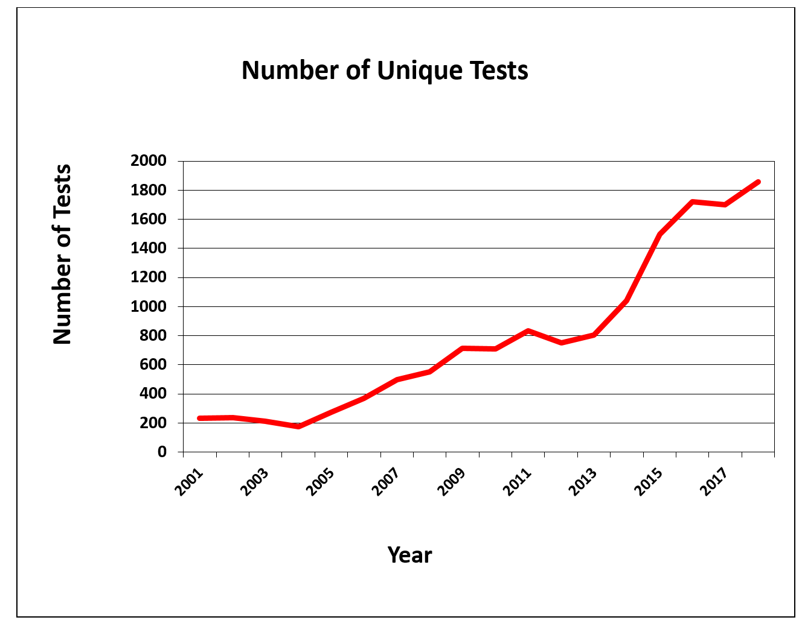

Year | Number of Unique Tests | Quantity Invoiced
2001 | 232 | 21,774
2002 | 236 | 12,444
2003 | 214 | 9,116
2004 | 173 | 9,604
2005 | 273 | 16,135
2006 | 371 | 24,929
2007 | 497 | 31,750
2008 | 551 | 34,179
2009 | 712 | 36,343
2010 | 711 | 17,733
2011 | 834 | 44,328
2012 | 751 | 19,359
2013 | 803 | 25,793
2014 | 1,041 | 39,761
2015 | 1,497 | 35,094
2016 | 1,875 | 48,795
2017 | 1,631 | 53,860
2018 | 1,858 | 76,342

Work during FY 2018
Our ability and need to provide assistance to test takers who are blind and visually impaired, test publishers, and assessments teams has continued to grow at a brisk rate, with The Accessible Tests Department successfully processing over 1,800 unique tests in FY 2018. These figures represent an estimated 14.9% increase over FY 2017 in unique tests produced and an estimated 41.7% increase over FY 2017 in tests invoiced. Such growth is expected to continue for FY 2019.

Moreover, work and tasks have grown to include online assessments with access via assistive technology such as speech output and refreshable braille displays. Accessible Tests staff continue to write text-based descriptions of graphical information to be used with speech output and tactile graphics during high stakes testing.

Additionally, work continues on the Accessible Tests Resource Center Web site, as the evolving field of blindness/visual impairment requires that staff diligently update site content.

Work planned for FY 2019
The continued editing of high stakes assessments for students who are blind and visually impaired will remain the primary focus of the Accessible Tests Department in FY 2019. Additionally, the department seeks to expand collaboration with, and education of, test publishers, test developers, school psychologists, state assessment personnel, test administrators, and test takers.

Accessible Tests Department goals for FY 2019 include the following:
- To continue partnering with test developers, publishers, and state assessment personnel, thereby better ensuring the availability of accessible tests and practice tests and test-related tools and materials
- To continue refining existing guidelines as research results and additional information become available
- To continue working with PARCC and SBAC so that assessments developed via these consortia will be accessible for students who are blind and visually impaired
- To work with ILSSA and other organizations so that alternate assessments developed will be accessible to severely cognitively impaired students who are blind and visually impaired
- To continue emphasizing the need for test preparation materials and practice tests in the same media/format as the actual tests
- To continue collaborating with the Braille Authority of North America (BANA) on developing and implementing guidelines for transcription and formatting of standardized tests and readable tactile graphics with or without accompanying text-based descriptions
- To promote the inclusion of individuals who are blind and visually impaired and/or professionals in the area of visual impairment during the initial stages of test development
- To collaborate on research, product development, literature reviews, resources, guidelines, position papers, and informational papers
- To explore the delivery of test items via various electronic devices with or without the use of assistive technology
- To prepare alt-tags and text-based descriptions of graphics-based information for use with assistive technology, such as speech output and refreshable braille displays
- To explore the appropriate delivery of mathematical and scientific equations, formulas, and symbols via use of MathML, MathPlayer, and MathType
- To identify topic-specific websites and other relevant resources that may serve students, parents, and medical and educational professionals
- To explore possible uses of 3-D printers for creation of tactile objects
- To support and fully participate with APH’s internal departments on the REAL [Resources with Enhanced Accessibility for Learning] Plan to ensure that students who are blind or visually impaired have timely access to educational materials

EDUCATIONAL PRODUCT RESEARCH

Kate Herndon, Director

ADULT LIFE

Adult Life Needs
(Ongoing)
Purpose
To develop adult life products and services that are affordable, user-friendly, and consumer driven and that address the diverse needs of the blind and visually impaired population

Project Staff
Laura Zierer, Project Leader
Kelly Kennedy Mimms, Research Assistant

Background
Product development in the area of Adult Life was initiated at APH in the summer of 1998. The first products derived specifically from this effort were made available during FY 1999. Product research, along with consumer and professional networking, has continued to characterize the development of products for adults.

Work planned for FY 2019
Investigation and development of new products for adults will continue. The project leader will continue to seek input from the field by networking with APH Ex Officio Trustees and consumer and professional groups. Focus groups will be conducted as needed.

AFB Foundations of Rehabilitation Teaching Kit
(Continued)

Purpose
A group of products that APH either currently produces or will produce to help teach the concepts and skills discussed in the new edition of the Foundations of Rehabilitation Teaching textbook

Project Staff
Martin Monson, Project Leader

Background
The idea for this project followed the normal trajectory for an APH product; it was reviewed and approved by both the Product Evaluation Team and the Product Advisory and Review Committee. While called a “product,” this will actually be a number of products that will be kitted together. Some products in the kit will be current products, and others will be purchased or newly developed products. The kit will also contain a copy of a new textbook currently being written by the American Foundation for the Blind® (AFB). The products in the kit supplied by APH will function to support the concepts and exercises discussed in the textbook. The concept behind the product is the same as that of the kit being developed for the I-M-ABLE textbook.

Product Description
This product is a kit of items currently produced by APH, items that will be produced by APH, or items purchased by APH to support the teaching and implementation of skills and concepts discussed in the next edition of the Foundations of Rehabilitation Teaching book published by AFB.

Work during FY 2018
A copy of the current edition was purchased and reviewed for possible products to include in the kit. A wide range of products was identified, from very simple and inexpensive (bold-line writing paper) to high-end assistive technology devices.

Work planned for FY 2019
APH Press will identify authors for each chapter of the textbook. As chapter titles and rough drafts of chapters are developed, they will be provided to APH. In conjunction with the list developed for the previous edition, new products will be added or identified to match the new text.

Color Star®
(Completed)

Purpose
To provide a new color identifier device for individuals with visual impairments

Project Staff
Laura Zierer, Project Leader
Leasha Twyman, Research Assistant
Kelly Kennedy Mimms, Research Assistant

Background
Identification of colors is a useful skill for many reasons. A device that assists individuals with visual impairments to perform this function will allow them to gain independence by not requiring assistance for this task. The need for a portable color identifier is evident by the variety of units being sold and portable apps available on mobile devices. Unfortunately, the apps are not always accurate, and must be calibrated before each use.

In May 2017, CareTec approached Craig Meador at the SightCity exhibition in Frankfurt, Germany, with their newest color identifier—Color Star®. Currently, APH offers two similar products: ColorTest II (available with Quota funds) and Colorino (not available with Quota funds). Lately, there has been concern regarding the ColorTest II, as CareTec will no longer support repairs for this device.

The Color Star® unit was reviewed by Zierer and three employees who are visually impaired. Durability, accuracy, and features were tested. All in-house reviewers agree to sell this product, preferably on Quota. Color Star® detects light, compares colors, and performs pattern recognition in addition to basic features. The Color Star® unit is smaller and sleeker than the ColorTest II, and contains many useful functions for individuals who are visually impaired.

Zierer submitted a Product Modernization Form on May 31, 2017, recommending APH replace ColorTest II with Color Star®. More information about this existing product can be found on the CareTec Web site.

Work during FY 2018
Four units were purchased from CareTec for evaluative purposes. Zierer sought out professionals who would be willing to review the product through a post to four social media groups, of which she is a member, in August 2017. With limited units available for testing, only five sites were chosen based on their type. These sites are geographically distributed as follows (one site in each state listed): North Dakota (vision services/school for the blind), Massachusetts (adult consumer/performer), New York (center for assistive technology), Virginia (public school system – vision program), and Washington (government agency).

The review was launched in September 2017, and concluded in October 2017. Following this review, it was decided to move forward with making Color Star® available in APH’s catalog. CareTec and APH have an established relationship; therefore, processes were already in place to order and receive units. CareTec agreed to print and affix labels with the APH catalog number, as well as the unit serial numbers, onto the product box prior to shipping. Quality control procedures were developed with the help of the Technical Manufacturing Research Department. The User’s Manual provided from CareTec was converted into a Microsoft® Word® document and made available for digital download on the APH Web site.

Color Star® was released to the U.S. market in April 2018, available for purchase with Quota funds.

CORE CURRICULUM

BUSINESS AND VOCATIONAL EDUCATION

For FY 2018, there are no active Business and Vocational Education products to report.

FINE AND PERFORMING ARTS

Color-by-Texture CIRCUS Coloring Pages
(Completed)

Purpose
To provide additional raised-line coloring page packets to complement the newly introduced Color-by-Texture Marking Mats

Project Staff
Karen J. Poppe, Tactile Literacy Project Leader
Matthew Poppe, Graphic Designer
Rod Dixon, Manufacturing Specialist

Background
Color-by-Texture Marking Mats (Catalog No. 1-03332-00) was introduced for sale on August 26, 2016, and is available with Federal Quota funds. In addition to tactile marking mats and a coloring tray, the kit includes a package of 25 raised-line coloring pages depicting a variety of objects including a kite, an apple, a teddy bear, a beach ball, a mitten, and much more. This package of coloring pages in the CIRCUS kit is available for separate purchase. Between September and December 2016, Color-by-Texture Marking Mats experienced brisk sales of 285 units. The sales of the full kit were complemented by 122 purchases of the related Raised-Line Coloring Pages (Part No. 62-114-012).

Approximately one month after the introduction of Color-by-Texture Marking Mats, the project leader constructed and posted an online Product Feedback Survey (www.surveymonkey.com/r/G2G5PSS) to garner additional feedback about the end product. This survey was announced via several venues, including APH’s pages on Facebook® and Twitter® (https://twitter.com/APHfortheBlind/status/796722261843709952), the December 2016 issue of APH News, and direct e-mails to Educational Products Advisory Committee members for dissemination to teachers in their respective states. Many survey respondents requested additional coloring-page options and/or additional textured mat follows:
- “Our students love seasonal and holiday-themed activities as well as their sighted peers. Please provide these mats with seasonal textures (i.e., Fall leaves, acorns, bats, spiders, snowflakes, etc.).”—TVI in Nebraska
- “Holiday packets (one for each holiday); birthday packets; different themes—farm, circus, school, dolls, animals, etc.”—TVI/O&M Instructor in Nebraska
- “Holiday/season coloring pages; animals divided by farm/zoo/jungle, etc.; baby animals; insects; vehicles (cars, trucks, ambulance/fire truck, etc.); geometric shapes (like adult coloring for older students); and fairy tales (e.g., castles, fairies, princesses, knights, dragons).”—TVI in Minnesota
- “Variety of coloring/raised line designs.”—TVI in Michigan

In response to the common request for thematic coloring-page packets, the project leader prepared a product modernization form on January 3, 2017. Later that month, the Product Evaluation Team and Product Advisory and Review Committee gave approval for the product’s development, beginning with the circus-theme coloring page packet.

On March 24, 2017, the project leader conducted a meeting with the Product Development Committee to review the intended design of the product. Because the production processes and materials needed to produce the circus-theme coloring pages mirrored those of the original Raised-Line Coloring Pages, a quick development timeline was anticipated. Initial efforts began with the project leader and graphic designer creating unique coloring-page images related to the circus theme, such as those shown below. A total of 25 images were rendered to ensure ideal translation to thermographic output via the in-house Green Machine method. Each image has a print and braille label.

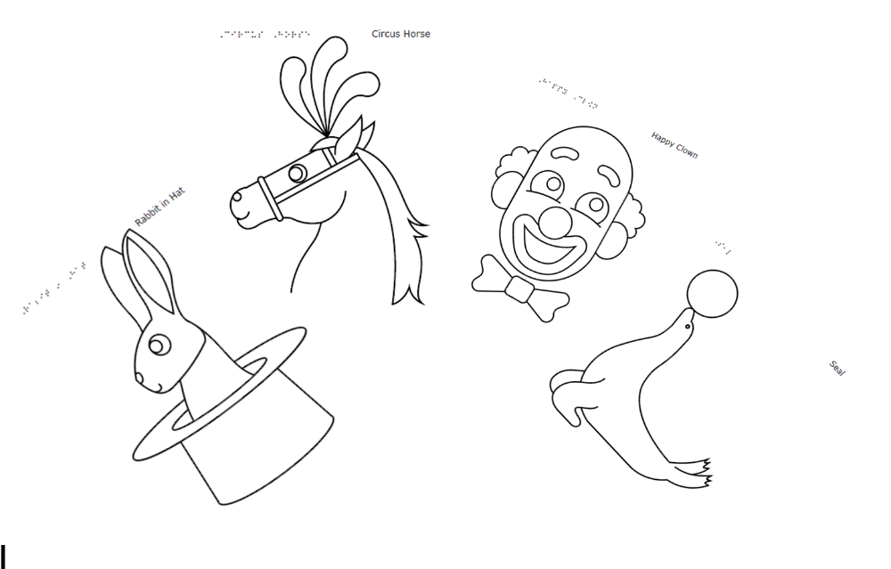

A brief insert with cover art and the assigned catalog number were prepared; braille translation of the insert was completed in April. The manufacturing specialist prepared the product specifications document and presented this to Production staff in mid-June. Production quantities for the pilot and production runs were forecasted.

Work during FY 2018
The Color-by-Texture CIRCUS Coloring Pages (Catalog No. 1-03333-00) was announced as a new APH product on November 13, 2017, with a selling price of $27.00. Images of the 25 coloring pages were uploaded to the Tactile Graphic Image Library for free download.

Work planned for FY 2019
The project leader will possibly develop additional coloring-page packets that address themes suggested by the field (e.g., transportation, animals, seasons) pending project priorities assigned via the New Product Development cycle.

Feel 'n Peel Sheets: Carousel of Textures II
Formerly Carousel of Textures II
(Continued)

Purpose
To provide an extended assortment of textured and brightly colored sheets that can be used by teachers, transcribers, students, parents, and adults with blindness and visual impairments for a variety of purposes, including adapting/creating storybooks, classroom worksheets, or commercial game boards; preparing collage tactile displays; labeling; coloring; arts and crafts; and so forth

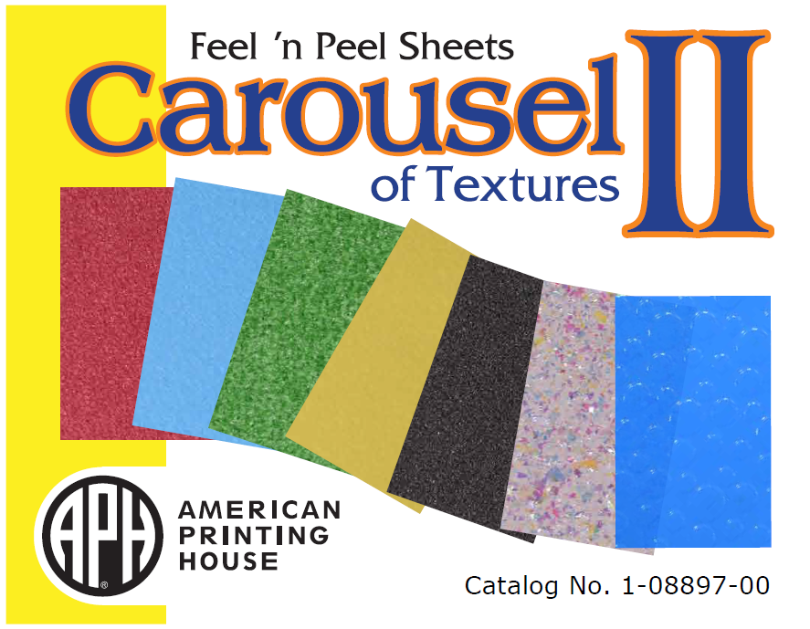

Project Staff
Karen J. Poppe, Tactile Literacy Project Leader
Rod Dixon, Manufacturing Specialist
Katherine Corcoran, Model/Pattern Maker
Matthew Poppe, Graphic Designer
Anthony Jones, Director of Creative Services

Background
The original Feel ꞌn Peel Sheets: Carousel of Textures (Catalog No. 1-08863-00), designed by the project leader, was released on November 11, 2011. After many years of availability, the kit remains among APH’s top-selling products and consistently sells nearly 2,000 units annually; in FY 2017, it was among APH’s top 15 selling products. Although the original kit offers a plethora of textured sheets in a variety of colors, the project leader recognized the need for a larger toolbox of options. The second collection, titled Feel nꞌ Peel Sheets: Carousel of Textures II, will expand the current texture palette that teachers, parents, and students can select from for project-specific needs. This unique collection of textures will provide a convenient, one-stop source for those who do not have the time or purchasing volume to quickly and cost-effectively acquire a variety of unique textured sheets. The field evaluators for the original Feel ꞌn Peel Sheets: Carousel of Textures II indicated many applications, such as the following:

- Adapting tactile displays
- Enhancing commercial and self-made tactile books
- Providing open-ended art activities
- Math assignment adaptations
- Light box matching (color and texture) activities
- Art class activities
- Coloring and writing activities
- Bar graph and pie chart construction
- “Same/different” cards
- Construction of experience books related to orientation and mobility
- Creation of maps of classrooms and business areas
- “Touchy” shapes and numbers

In February 2017, the project leader prepared a formal Product Modernization Form that detailed the expected contents of Feel ꞌn Peel Sheets: Carousel of Textures II. In April 2017, the modernization proposal was presented to the Product Evaluation Team; and in May 2017, it was presented to the Product Advisory and Review Committee. Both committees supported the product endeavor. The project was assigned Grant #684. Formal field testing was deemed unnecessary due to the similar structure of the original Carousel of Textures kit.

Before launching into the identification and selection of textures for Feel ꞌn Peel Sheets: Carousel of Textures II, the project leader developed and posted an online survey to garner advice and feedback from current customers and users of the original kit; the survey link (www.surveymonkey.com/r/CarouselofTextures) was posted in the July 2017 issue of APH News. In August 2017, the project leader reviewed the responses to the survey submitted by 32 teachers of the visually impaired, certified orientation and mobility specialists, braille transcribers, and regional VI assistants from across the United States. All of the survey respondents, except one who was uncertain, indicated that they had purchased multiple kits of Carousel of Textures in the past; 38% had purchased 2-5 kits, 25% had purchased 6-10 kits, and 34% had purchased more than 10 kits. Supportive comments included the following:
- “This is one of our most used and favorite items!”
- “Love them.”
- “A must-have product.”
- “We use Carousel of Textures for many of the projects we have for students of all grades.”

The survey respondents indicated an eclectic use of Feel ꞌn Peel Sheets: Carousel of Textures and echoed many of the uses reported by the original field evaluators. The following list details some of their common, varied, and specific applications of the kit:
- “Art projects, books, games, tactile discrimination between color-coordinated items in the classroom.”
- “I use the textures to support functional braille reading for my student with intellectual disabilities. I use the textures to create simple pictures as word cues. I also use the C-of-T with students with multiple disabilities to make simple books. The translucent sheets are great to make cutouts for the light box.”
- “Graphs, labeling areas, art projects.”
- “Use the textures for our projects, adapting games, and books. I use every sheet in the Carousel of Textures. It just depends on the needs that I have and the needs of my students.”
- “We use the sheets when we add textures to books for young children.”
- “Art class; students use to illustrate their writing, mark items in the classroom, creating tactile books.”
- “Adaptation of story books, maps, graphs, tactile symbols.”
- “Shapes, letters, numbers. Stories, concept development, designating centers or labeling rooms, maps, graphs, tracking sheets, prebraille, rubbings for coloring or writing.”
- “Tactile maps, graphs, diagrams for science, tactile pictures, adapting games for blind children use.”
- “I use them to create tactile symbols and other tactile materials for students (e.g., schedules, numbers, etc.). I also use them to add textures to other instructional materials, including books and adaptive switches.”
- “Adapted art; use to adapt classroom projects and worksheets.”
- “Maps, art, math, story, and science tactiles.”
- “We create different activities for our students such as identifying and matching textures, games, and use in creating stories.”
- “Making different sections for eye diagrams for low vision students studying anatomy.”
- “Tactile graphic organizers, tangible symbols, adding textures to books, making maps, making tactile graphics (math), art projects, and matching games.”
- “Used for maps—show land, water. Math—points on graph.”
- “We cut out the corrugated paper and use pins to attach it to the graphing or cork boards.”

Survey respondents indicated their preferences for the additional textures proposed by the project leader for inclusion in Feel ꞌn Peel Sheets: Carousel of Textures II. Table 1 shows the results of their feedback:

Table 1
Textures Preferred by Survey Respondents
Suggested Texture | Percentage of Survey Respondents Preferring Inclusion of Suggested Texture
Wavy |  | 81%
Zigzag |  | 78%
Coarse sandpaper |  | 69%
Scalloped |  | 66%
Brick pattern |  | 72%
Soft/plush |  | 78%
Fabric-like |  | 69%

Other textures (and colors) suggested by the respondents included the following:
- translucent textures
- shiny/metallic (foil-like)
- polka dot, more black sheets
- “longer shaggy texture”
- “feather and grass textures”
- glitter-free options

Additional work undertaken by the project leader during the latter part of FY 2017 included the following:
- Ordered and reviewed commercially available materials and textures (e.g., embossed pebbled texture, alligator texture, brick pattern).
- Ordered commercially available adhesive materials/sheets
- Met with another project leader to avoid duplication of items planned for a theme-based textured sheet package (e.g., an outdoor package) for tactile book construction
- Conducted a Product Development Committee (PDC) meeting to review the purpose and expected design of the product with in-house staff

Work during FY 2018
The project leader continued to locate and identify ideal/potential textures and related materials for inclusion in Feel ꞌn Peel Sheets: Carousel of Textures II. In January 2018, the project leader conducted a PDC meeting and reviewed anticipated materials for the final product with the project team. Careful attention was given to maintaining a balance of established materials/processes and the development/introduction of uniquely designed items by APH. Verification of NET 30-term allowance by outside vendors was ensured for commercially acquired textures.

The project leader and graphic designer co-created four unique texture designs for eventual vacuum-forming on rigid .005-in. transparent sheets of various colors. These textures were defined as brick, bubble, grid, and wavy. The digital-file designs of these four textures, shown below, were output as tactile masters on the Roland® UV printer. The model maker then used the masters to construct the production-ready 4-up vacuum-form pattern. This specific production tooling was completed in March 2018.
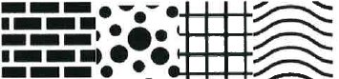

The project leader also made final selection of commercially acquired items for inclusion in the Feel ꞌn Peel Sheets: Carousel of Textures II (1-08897-00) kit, including the following:
- Vivelle® adhesive-backed A4-size sheets in a variety of colors
- Vivelle® Papier Plus green turf-like sheets
- Craft foam adhesive-backed sheets in a variety of colors
- Stiff felt adhesive-backed sheets in a variety of colors
- Non-skid, adhesive-backed sponge rubber sheets (in black only)
- Grass paper, 8.5 x 11-in. non-adhesive sheet
- Iridescent card stock, 8.5 x 11-in. non-adhesive-backed sheet
- Package of Sticky Dots® adhesive sheet package (APH Catalog No. 1-08452-00)
- Double-tac adhesive sheets in two sizes—8.5 x 11-in. and 9 x 12-in.

The project leader prepared content for the accompanying product insert. Tactile displays and samples were readied to complement the suggested uses, such as storybook adaptation, graphs/charts, labeled diagrams, and greeting cards. The constructed samples, shown here, were used as props for needed photos.
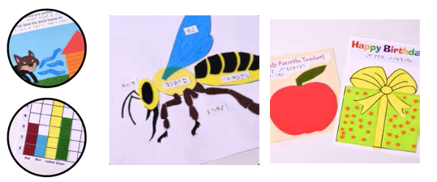

After the graphic layout of the product insert was approved in May, the braille translation was undertaken and completed in June. The project leader ushered the product through the newly established New Product Development cycle by conducting a Gate 4: Modifications meeting. The gate form identified an estimated selling price, as well as the forecasted yearly volume of sales. All required signatures were collected on the gate form, indicating approval to proceed with planned production methods and processes for the final kit design.

By July 2018, the physical tooling for in-house produced items was available and the specifications document was under construction. The manufacturing specialist determined the ideal packaging style within the selected box to ensure convenient collation on the production floor. The graphic designer readied an accompanying box label.

According to a new matrix-scoring process used by an in-house review committee to evaluate all APH product ideas and endeavors, Feel ꞌn Peel Sheets: Carousel of Textures II garnered a weighted score of 61 out of a possible 93. The project was selected to remain as active status under direction of the current project leader.

Work planned for FY 2019
The specifications document will be formally presented to Production staff; dates and quantities for initial pilot and production runs will be re-evaluated and planned. The project leader will assist in monitoring the quality of the produced units. Actual availability of Feel ꞌn Peel Sheets: Carousel of Textures II is expected within FY 2019.

Feel the Beat: Braille Music Curriculum
(Continued)

Purpose
This product is intended to be used with students who read braille in grades 2 through 8 so he or she can learn both music and the braille music code using the same instrument and at the same time as sighted peers. Full implementation of the curriculum will allow students to learn to read and to write music braille.

Teachers of the visually impaired (TVIs) who do not know music or the braille music code can use this curriculum, and general music teachers who don’t know braille can also use this curriculum. The curriculum uses the Soprano Recorder, which is used throughout the United States, to teach beginning music concepts.

Project Staff
Laura Zierer, Project Leader
Christine Short, Author
Martin Monson, Project Leader
Emily Grimany, Research Assistant
Leasha Twyman, Research Assistant
Joon Lee, Copyright & Cataloging Librarian

Background
Christine Short, an Ex Officio Trustee from Iowa, submitted the idea for this product. Christine developed the product over a period of years and has submitted it to APH for completion and production. The curriculum uses the Soprano Recorder to teach the basics of the music braille code to students already proficient in literary braille and is intended for early elementary to middle school age use.

Relevance
The prevalence of recorder use in the United States was briefly surveyed with a poll to two groups of TVIs with members from all areas of the nation. TVIs were simply asked to reply if they had students in districts that still utilized the recorder as a tool to teach music. TVIs in Wyoming, Maryland, Philadelphia, Texas, Virginia, Iowa, and several others, including a residential school, all replied that recorders are still used in music classes.

APH does not produce a similar product. A search of the Internet did not produce a similar product. The product idea and introductory pages from music lessons were shared with two staff members at APH who have a music background as well as the music teacher at the Kentucky School for the Blind (KSB). The music teacher at KSB notes, “This is a great resource and very well written and easy to understand. Recorders are usually a great instrument to teach classes in general music about the basics of music and notes/rhythms, and I know a lot of public school teachers who use them quite a bit.”

Comments from staff at APH:
- Dawn Wilkinson: I don’t think it’s a necessary part of life, vital to daily functioning, or essential to our existence. But, people will snap this up like there is no tomorrow. What it does do is present a very easy and fun introduction to braille music; very different than the hideous experience I had with it. It also addresses that students will read a measure and then memorize it; never being able to play and read at the same time.
- Terrie Terlau: I think this is well done. I learned to read braille music outside of school, and I never knew why the braille D indicates the note C, etc. Now I do! And the explanation of why braille note states whole, half, quarter, and eighth notes the way it does would have been very helpful for me to have known as a child. And it would be something fun for the child and TVI to do that would put the child on an equal footing with her sighted peers in music class. It also would be a good precursor for the instructional music materials that a music teacher at the California School has developed.

This product was approved by the Product Advisory and Review Committee in August 2016 and was approved by the voting members. The project leader identified several consultants to provide input, ideas, and feedback into the project. Consultants included Short, the Ex Officio Trustee who developed the draft of the product and submitted the idea; Amanda Black, an itinerant teacher of the visually impaired with a Master of Arts in Music; and Peggy Spiess, a certified braille music transcriber. Spiess removed herself from the project as other work demands started to increase. She did provide a name of another certified transcriptionist. That person is currently under contract with APH to work on this project but did no work in FY 2017.

A review of the product was undertaken by the two TVI consultants, and several changes and additions to the music instruction were proposed. These changes were reviewed, and it was decided that any additions to the music component of the product would not be incorporated. This decision was based on the premise that the product is intended to teach primarily the braille music code. At that same time, it was decided that since the draft form of the product had been reviewed informally by TVIs over the past few years and changes had been made to the product based on that input, APH would have the product go through the expert review process rather than field testing. Expert reviewers were identified through a volunteer request placed on several social media pages. Expert reviewers were identified and selected from the responses received. Copies of the Teachers Edition and Student Song Book were edited for basic formatting and typographical errors, and then printed, bound, and mailed to the expert reviewers.

Work during FY 2018
Expert reviewers completed their evaluation of the material and submitted feedback through SurveyMonkey®. Nine expert reviewers filled out the online survey to completion. These sites were geographically distributed as follows: Colorado, 1 (11%); Georgia, 1 (11%); Maryland, 1 (11%); Massachusetts, 1 (11%); Minnesota, 1 (11%); Ontario, 1 (11%); Tennessee, 1 (11%); Texas, 1 (11%); and Washington, 1 (11%). Regional distribution of sites is displayed on the following map.

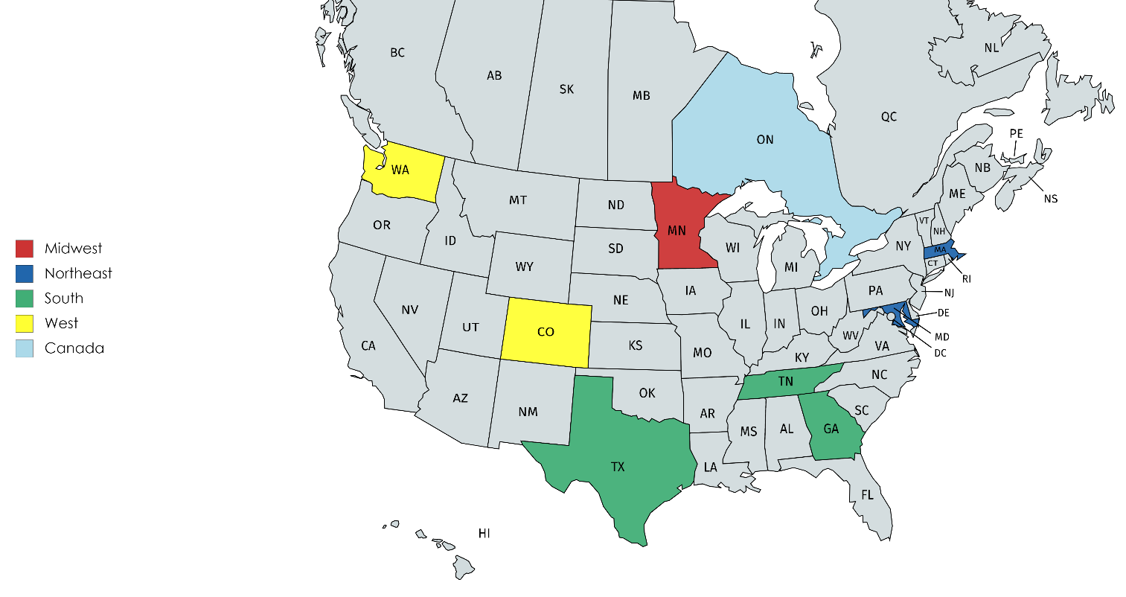

Expert reviewers suggested the removal of a few lessons, reordering of the lessons in a more logical sequence, as well as style and grammar edits. Reviewers also returned booklets with comments and suggested edits. Zierer compiled and reviewed all feedback before sharing the results with Short. Short considered all feedback and made appropriate changes to the lesson plans. A recorder fingering chart will be included, likely on the inside cover of the book based on reviewer comments. Evaluators also requested more information for teachers who may not have much music knowledge. This concern was not addressed, as this was not the original scope of the product. Short also developed a template to present lessons in a more consistent manner throughout the curriculum.

Lee was tasked with verifying all songs and fonts were available for reprint, noting that Short will simply have to credit the sources. A few songs in the original curriculum were replaced with songs in the public domain to prevent copyright issues. The recorder fingering font is available online: http://hindson.com.au/info/free/free-fonts-available-for-download/.

Short submitted final content to Zierer in June 2018. Also in June 2018, this project was placed on hold due to the new product development process at APH. Work is slated to resume in FY 2019.

Work planned for FY 2019
Zierer will review and edit the final content submitted by Short. A music braille transcriber will be contracted to complete the translation of included songs. Dot 6 will begin working on design and layout.

Paint-By-Number Safari™ (Series)
(Ongoing)
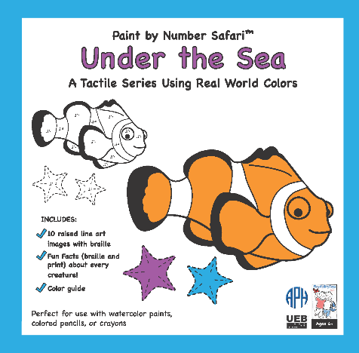
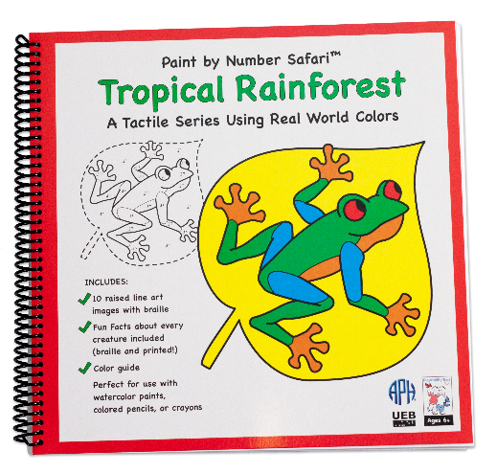
Purpose
To provide an art product that gives a fun and educational glimpse into how subjects in the world look, live, eat, and function

Project Staff
Tristan Pierce, Project Leader
Fred Otto, Tactile Literacy Project Leader/Advisor
Kelly Kennedy Mimms, Research Assistant
Emily Grimany, Research Assistant
Joyce Lopez, PlayAbility Toys™ Consultant
Debi Harrison, Artist
Melissa Escobar, Artist

Product Description
Paint-by-Number Safari™ is a series of paint-by-number books that represent five (possibly six) animal locations: tropical rainforest, jungle, under the sea, desert, and backyard animals. Each print tactile drawing has information relating to core subjects, (e.g., size–math, habitat–social studies, etc.). The product includes color-mixing instructions to create "real-world colors." The target market is K-12 students who have visual impairment and blindness.
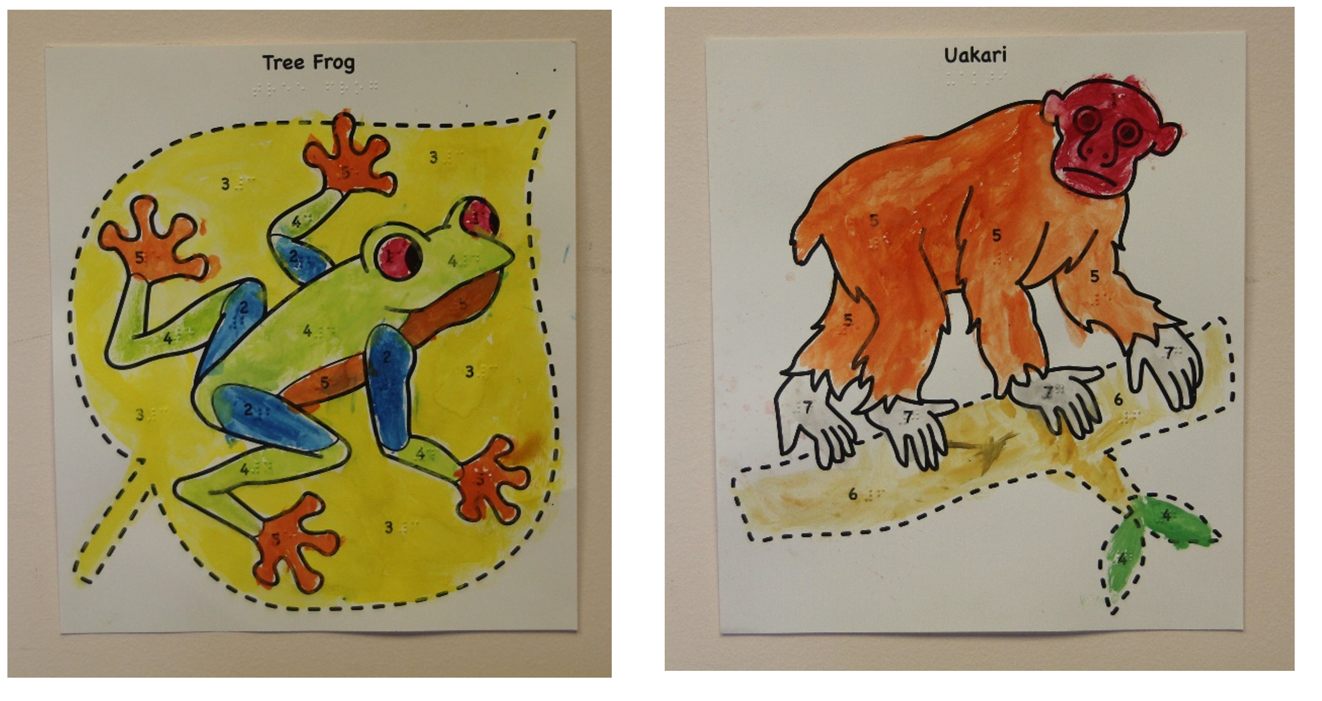

Background
Paint-by-Number Safari™ is a series of interesting and fun subject matters presented in print-raised line art format. The “Paint-by-Number” concept is similar to traditional Paint-by-Number products with the addition of the following:
- Braille translation for all of the words (name of subject matter, colors, and numbers that coincide with the colors)
- Carefully executed, easy to follow lines for each subject matter
- Fun and interesting facts about each subject matter

Relevance
The American Printing House for the Blind (APH) made the decision to produce Paint-by-Number Safari™ based on APH’s standardized process of product development. Joyce Lopez submitted the New Product Idea Submission Form on September 5, 2014. Lopez is a product developer for PlayAbility Toys™, a company that designs toys, games, and educational materials for special needs populations. APH has a history of successful collaboration with PlayAbility Toys™ (e.g., Rib-it-Balls, Paint Pot Palette). The Multiple Disabilities Project Leader presented the idea to the Product Evaluation Team (PET) on November 18, 2014. The committee approved it and forwarded the product submission to the Product Advisory and Review Committee (PARC). PARC members approved Paint-by-Number Safari™ on November 20, 2014. Upon submission, the name of the product was Tactile, Braille, and Fun Facts–Paint by Number! Kit. During development, APH and PlayAbility Toys™ agreed on the new name.

Paint-by-Number Safari™ is fully accessible to the population using it. It features large print and braille for the Fun Facts and the words (name of subject matter, colors, and numbers) that coincide with the colors. The raised-line drawings are easy to follow. With the exception of the hummingbird and toucan, the drawings present the subjects in a frontal view, which presents both eyes and all appendages. APH made an exception with the birds because their long, pointed bills are the main discriminatory feature of each animal, therefore it presents best in profile.

This product follows APH Research Guidelines for determining relevance for a product. The Smithsonian National Museum of American History exhibited (April 6, 2001 through January 7, 2002) the paint-by-number phenomenon as a window on the history of creativity, leisure, and domesticity in postwar America. The project leader conducted a review of commercially available paint-by-number kits that proved the activity has a long history of popularity and that people still love it today. Large retailers offer a plethora of paint-by-number kits to keep children and adults occupied happily for many years. Young children practice color and number recognition and patterning, while developing fine motor skills. This tactile version of a paint-by-number kit will allow students with visual impairment to enjoy this educational and popular activity with their families and peers.

APH examined the need for a product like the Paint-by-Number Safari™. The Lopez new product submission was not the first submission requesting that APH produce a paint-by-number product. A teacher from DeKalb, Illinois, submitted a product named Tactile Paint by Number Kit on January 21, 2014. APH selected the Lopez submission because the execution of the uniform-sized art, thematic units tied to literacy and social engagement, and that PlayAbility Toys™ is in the position to provide tooling and manufacturing, thus freeing up APH’s resources and schedule for additional products in development. On April 2, 2015, the Multiple Disabilities Project Leader conducted an online needs survey. Teachers and parents (39 respondents) completed the survey over 25 days. The respondents (97%) stated that children with visual impairment or blindness want to know the “real colors” for things in nature. They (97%) believed that using a paint-by-number product provides an opportunity for children to practice following instructions (e.g., painting a section of the drawing with the correct color, mixing colors).

The following is a sample of comments regarding the need for this kind of product:
- I think this is a simple yet genius idea to help visually impaired students enjoy arts and crafts more.
- I like the idea of thematic units. I work with adults and it is often difficult to find “age appropriate” stuff, without having to make it myself. Themes seem like it may be something that can be used with adults as well as children.
- Many more inventive products are needed for blind children of all ages. This is a good first step.

APH sought the opinion of knowledgeable individuals to determine the need for Paint-by-Number Safari™. People who are blind, parents of children who are blind, teachers of students with visual impairments, and art teachers of individuals with visual impairments completed the APH needs survey. Prior to the product submission, Lopez worked closely with the art teacher at the California School for the Blind, who supports the need for such a product.

The Paint-by-Number Safari™ addresses an identified need for a person who meets the definition of “visually [and multiply] impaired.” This product makes it possible for children and adults who are blind to learn to create art using “real world colors” by following directions. Although most children—sighted or blind—use any color(s) they want to create art, individuals with blindness often want to know “the real colors for things.” Paint-by-Number Safari™ uses real world colors for each image presented along with “Fun Facts” that describe the images and explain why and how creatures live, function, and are the way they are. This blending of creativity, fun, and learning (understanding of vocabulary and concepts) is an ideal combination for learners of any age.

Research
This is an ongoing series, therefore, to review the original field-testing of the product, please see the 2017 Annual Research Report.

Work during FY 2018
APH submitted the first book in the series, Tropical Rainforest, to the Department of Education Expert Panel Review. The project leader was available to answer questions. APH and PlayAbility Toys™ completed the 10 drawings and Fun Facts on the second book in the series, Under the Sea. The underwater kingdom consists of a seal, clownfish, sea turtle, great white shark, dolphin, jellyfish, seahorse, crab, octopus, and stingray. The launch of the new book is set for September 2018.

Work planned for FY 2019
APH and PlayAbility Toys™ will begin work on the third book in the series.

Strike-A-Pose: Body Awareness Cards for Students with Visual Impairments and Blindness
(Continued)

Purpose
To provide a set of tactile/print cards that feature various body positions/movements that a student can mimic with her own body or with a 3D model/human figurine (e.g., reaching upward, stretching arms out to one’s side, bending an elbow/knee, leaning forward, touching toes, etc.)

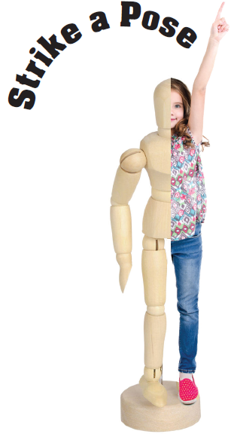

Project Staff
Karen J. Poppe, Tactile Literacy Project Leader
Rachel Bishop, Research Assistant
Laura Greenwell, Graphic Designer

Background
In January 2017, the project leader submitted a formal product submission form that described the instructional value and expected tangible design of Strike-A-Pose: Body Awareness Cards for Students with Visual Impairments and Blindness. The intention was to provide a set of tactile/print cards that feature various body positions and movements (e.g., reaching upward, stretching arms out to one’s side, bending an elbow/knee, leaning forward, raising one arm, touching toes, etc.). Similar cards are sold commercially to provide yoga, dance, and gymnastics instruction, as shown below:

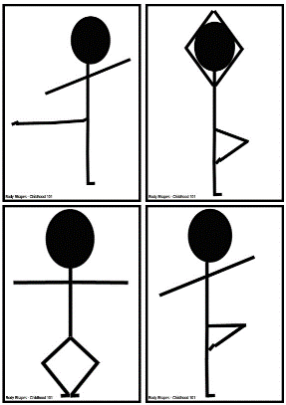

The project leader detailed many skills and concepts that would likely be addressed by Strike-A-Pose, including the following:
- Develop spatial awareness through movement
- Improve physical coordination, gross motor skills, and balance
- Increase understanding of spatial terminology and directional concepts
- Encourage movement and increase mobility skills
- Build muscular strength
- Promote creative self-expression

From a tactile literacy focus, Strike-A-Pose could effectively facilitate a young child’s interpretation of tactile illustrations by showing body positions from different perspectives (front view and side view). It will also help the child navigate from his own body to a realistic model and then to a representative 2D tactile graphic. This tactile continuum is emphasized within several APH products, especially Setting the Stage for Tactile Understanding and Room with a View (see separate annual report).

Several online articles and research studies stress the importance of body awareness concepts for students with visual impairments and blindness:
- Carmen Willings, Teacher of Students with Visual Impairments, states that “Physical experiences will help lay the foundation for development. Once a student has learned the concepts using their bodies, they can then develop concepts related to models and representation.” Retrieved from
https://www.teachingvisuallyimpaired.com/concepts-to-teach.html

- “Children who grow up without useful visual information often have difficulties with motor planning, are at risk for delayed motor development, and may have sensory integration deficits. Body awareness leads to concept development, which is a foundation for more complex concepts and abstract reasoning. Motor responses significantly increase when modeled. Concepts must be taught more deliberately to students who are blind and visually impaired.” Retrieved from: http://scholarworks.sfasu.edu/cgi/viewcontent.cgi?article=1028&context=brightideas

- “Poor motor skills may lead to poor performance in physical activities, which may reduce a child’s sense of competence. This may lead to withdrawal from movement activities that would, in turn, lead to limited opportunities to practice motor skills and participate socially (Skinner and Peck).” Houwen, S., Visscher, C., Lemmink, K. A., & Hartman, E. (2009, May 1). Motor skill performance of children and adolescents with visual impairments: A review. Exceptional Children, 75(4), 464-492.

The product concept was formally reviewed by fellow project leaders who could objectively evaluate it based on several criteria. Amy T. Parker, Product Development Project Leader, indicated the following:
“The need for activities, games, and supports that help teach blind and deafblind students in the areas of body movement, body awareness, body positioning, posing is well documented. Teaching students to purposefully use body poses and positions are related to areas within the Expanded Core Curriculum, including orientation and mobility; social skills; recreation/leisure; and employment skills. People who are blind and deafblind are at risk for passivity and learned helplessness. Body awareness, strength and confidence are associated with increased quality of life, positive transition outcomes, and favorable employment outcomes. Some practitioners and researchers have incorporated activities such as yoga, which include body positioning and awareness, into interventions with students who are blind and deafblind and have seen positive behavioral and emotional outcomes.”

The project leader envisioned the Strike-A-Pose kit consisting of the following components:
- Print/tactile body position cards
- Small wood manikin from outside vendor
- Instruction Booklet in separate large print and braille versions
- Carrying/sorting box for materials

In April 2017, the development and production of Strike-A-Pose was presented to the Product Evaluation Team, and in May 2017, to the Product Advisory and Review Committee. The project was assigned the grant #690. Minimal work on this newly approved product occurred during FY 2017. However, the project leader and project staff partook in the following tasks:
- Locating a 3D model that does not rest on a metal rod (potentially misinterpreted as a third leg)
- Reviewing relevant literature and products that addressed body awareness concepts, such as the Hill Performance Test of Selected Positional Concepts, published in 1981 and developed by Everett W. Hill, Ed.D.
- Dabbling in possible graphical presentations that merge images of real children with the 3D model, as well as related body-position cards

Work during FY 2018
Significant progress on Strike-A-Pose was interrupted by focus on higher priority projects by both the project leader and other project team members. However, a few notable strides included the following:
- The project leader located and acquired a sample of commercially available 3D 8-in. model/manikin that stands on a magnetic base, thus avoiding the “third-leg” confusion posed by other similar models that used a metal rod stand.
- The project leader reviewed a product called Fleximan, designed by Boguslaw Marek and produced by Hungry Fingers™, that has a similar instructional objective and uses a magnetic 2D stick figure with movable joints (http://www.hungryfingers.com/Fleximan.pdf). This product was observed at a recent international tactile graphics conference by a co-project leader, who brought it to the current project leader’s attention. The product does not appear to be currently available in the United States; but, perhaps, it can be ordered by APH from the distributor and included with the eventual APH product. Reference to the product would be made in APH’s accompanying activity guide for Strike-A-Pose.
- The project leader honed and broadened the product design to include hook-backed pieces in various shapes/textures that could be used to create poses on a felt board (see below), similar in style to APH’s existing Picture Maker kit and accessories. The interactive pieces for student assembly, paired with the included 3D model, will give the product a unique structural design that is different from anything currently on the market and one that utilizes existing APH materials and manufacturing processes.
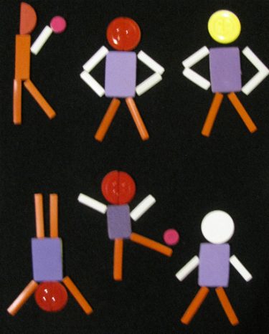

In January 2018, the project leader conducted the first Product Development Committee meeting to review the expected structure of the prototype. The color, size, and quantity of planned items were listed in detail and reviewed with the project team.

Work planned for FY 2019
According to a new matrix-scoring process used by an in-house review committee to evaluate all APH product ideas and endeavors, Strike-A-Pose garnered a weighted score of 56 out of a possible 93. In an effort to minimize the number of active projects on a given project leader’s work plate, as well as the time demands on other staff resources, Strike-A-Pose reverted to on-hold status as of July 2018. Reintroduction of this project to active status hinges on the completion of projects closer to availability and the reassessment of the project leader’s priorities. If the project re-enters the active project pipeline in FY 2019, the project leader will continue prototype development for eventual field-test purposes.

MATHEMATICS

AnimalWatch VI Suite
(Continued)

Purpose
To provide a fun and interesting iPad® mobile device application for students with visual impairments in grades 5-9 to build math problem solving skills using scientific information and data about endangered animal species

Project Staff
Rosanne Hoffmann, STEM Project Leader
Li Zhou, Core Curriculum Project Leader
Frank Hayden, Director of Technical & Manufacturing Research
Lawrence Lovelace, iOS® Programmer
Tom Hicks, Programmer
L. Penny Rosenblum, Consultant
Carole Beal, Consultant
Jane Erin, Consultant
Sara Larkin, Consultant

Background
AnimalWatch VI Suite (AWVIS) uses data and information about 12 endangered species in a series of 24 lessons designed to develop pre-algebra math skills of grade 5-9 students. The original conception of this product included an iPad® mobile device app, User’s Guide, 68 full color tactile graphics and braille text for braille reading students, 65 full color tactile graphics for students with low vision, miniature models of the 12 endangered animals, a user guide, print screenshot book, and a storage container. All items, including the iPad® app, were developed by three of the consultants (Rosenblum, Beale, & Erin); the braille and tactile graphics for preliminary field testing were produced by an outside vendor. After a local study at the University of Arizona was completed in December 2013, the consultants approached APH for production of the braille and tactile graphics and ultimately the distribution of the entire kit as an APH product. While the product idea was under consideration by APH, the consultants conducted a feasibility study throughout the state of Arizona, which took place from January 13 through April 25, 2014.

Two project leaders (Zhou & Hoffmann) reviewed the product submission in December 2013, and AWVIS became an official product under development in July 2014. The results of the statewide Arizona study confirmed the outcome of the local study and supported APH’s endorsement for product development. Feedback from the statewide Arizona study included the following recommendations with regard to the iPad® app: improve the scratch pad capability (for math calculations) and include a setting for gridlines; replace the help videos with a solution video for each math problem; rework the hints for all problems to provide scaffolding information; include measurement units in the answer pad, audio feedback during keystrokes, audio read back of entered answers, and Nemeth code display for use with refreshable braille; devise introductory screens to familiarize users with the app; and add a login screen with icons indicating a student’s progress within each unit. The product was also streamlined by the elimination of a print screenshot book and the miniature models of 12 endangered animals included in the original product design.

The consultants conducted a nationwide intervention study (field test) of the revised AWVIS app with accompanying braille text and braille and print full color tactile graphics during the 2014-2015 school year. In all, 44 teachers and 66 students in 22 states participated in the study.

As part of the product development process, Tactile Vision Graphics (Windsor Ontario, Canada) was originally selected to produce the high-quality full color tactile graphics that correspond to the images in the AWVIS app. The tactile graphics were designed with large print titles and labels for low vision students and literary braille and Nemeth code for students who read braille; these versions were used in all field test studies. In light of new UEB regulations, the tactile graphics and braille app text were transcribed to UEB at APH, to be offered in addition to the large print and literary braille/Nemeth code versions. To that end, transcription of the tactile graphics and app text to UEB by the APH Braille Department took place between April and August 2015.

The technical data transfer necessary for programming and maintenance of the AWVIS iOS® app took place in June 2015 from Tom Hicks at the University of Arizona to Lawrence Lovelace at APH. Since then, the iOS® AnimalWatch VI Suite app has been kept up to date by Lovelace.

During this time, single samples of all large print and literary braille/Nemeth tactile graphics were ordered and received from Tactile Vision Graphics for review by APH. Four of the sample graphics were not acceptable and required redesign. The project leader submitted new files for the four full color tactile graphics to Tactile Vision Graphics for new samples in August 2015. The project leader did not receive the new samples in a timely fashion and therefore sought a new vendor in 2016. A company in Lafayette, IN (gH) was approached, but ultimately rejected because of their high prices. Throughout the spring, summer and early fall of 2016, the project leader investigated the possibility of producing the tactile graphics at APH with either the Green Machine or the Roland® Large Format Printer.

Also during this time, field test evaluations from the nationwide pool of teachers and students obtained by telephone interview were analyzed by the consultants. In general, the response to the app and tactile graphics was very good; however in July 2016, the project leader decided to eliminate the solution videos embedded in the AWVIS app for two reasons. Less than 10% of the students involved in the national field test actually used them, and after extensive analysis by math expert Sara Larkin it was revealed that many errors in terminology and presentation were identified in all but 12 of the 147 solution videos. A total redo of the solution videos was cost-prohibitive with regard to the continued development of this product. Lawrence stripped the solution videos from the app in October 2016.

By December 2016, the project leader was informed that in-house production of the full color braille and print tactile graphics at APH was not possible with the Green Machine and too costly and time consuming to be accomplished with the Roland®. A major revamp of the product was discussed with the consultants. Since the product had already been simplified to include an iOS® app, user guide, and accompanying braille text and print/braille tactile graphics, a decision was made to house digital text and graphics files on the APH server and make them available for free download with purchase of the iOS® Animal Watch VI Suite app.

The consultants redesigned the tactile images as fuser ready graphics files that can be downloaded, printed, and processed through a swell form machine to create the tactile graphics on demand. The consultants updated the user guide to reflect changes in product design.

Work during FY 2018
All files for this product (User Guide, braille text files, and print and braille tactile graphics files available in literary braille/Nemeth and UEB) were uploaded to the APH server by November 2017 at the same time the AWVIS iOS® app was made available on the App Store® at no cost to the buyer.

Work planned for FY 2019
No further work is planned for this product.

AnyMath Kit
(Continued)

Purpose
To develop an adaptable, accessible kit that allows blind or visually impaired users to graph and label a wider variety of math problems and functions than currently available kits do

Project Staff
Li Zhou, Core Curriculum Project Leader
Fred Otto, Tactile Literacy Project Leader
Frank Hayden, Director of Technical & Manufacturing Research
Andrew Moulton, Manufacturing Specialist
Tom Poppe, Model/Pattern Maker
Katherine Corcoran, Model/Pattern Maker

Background
The idea for the kit took shape when the Core Curriculum Project Leader proposed reworking APH's Graphic Aid for Mathematics (GAM) to allow for easier graphing of curves and easier labeling. Discussions led to the idea of using low-profile hook material as the base of the board with grid lines represented by narrow gaps in the material. This allows users to apply certain kinds of string or cord to make curves and shapes. Also envisioned were a variety of pre-made geometric outline shapes, raised point symbols, and print/braille labels with letters and numerals, all backed with loop material to hold them to the board. The project came to be called AnyMath Kit.

After trying out low-profile hook fabric with many kinds of cords, string, laces, and rope, project leaders selected a combination of a black background board, a white hook material, and two types of nylon cord in contrasting colors. These proved to offer good adhesion, reusability, and tactual readability.

The model makers produced a few sample boards, labeling tiles, and geometric shapes to aid in the in-house evaluation, and later 18 sets for the field evaluation.

The evaluation period was March through May 2014. Fifteen educational sites were selected for the field evaluation, some with multiple teacher reviewers for a total of 18 evaluations. Sites were located in the following states: Arizona, Iowa, Kansas, Missouri, Montana, New Mexico, New York, North Carolina, Ohio (two sites), Oklahoma, Pennsylvania (two sites), Texas, and Virginia. Nine of the sites were residential schools, and six were public school settings.

In all, 80 students participated in the field test. Here is a breakdown of their demographics:

- Students were divided evenly by gender.
- Over half (44) reported ethnicity as White/Caucasian, 14 reported Black/African-American, 8 reported Hispanic, and the rest reported in other categories.
- Academic levels ranged from grades 3 through 12, with the mode (most frequently reported grade) being 8.
- For primary reading medium, 43 listed braille, 17 large print, and 4 audio; and the rest listed a combination or transition from one medium to another.

Responding to a question on the overall utility of the kit, 17 evaluators (one of the 18 evaluators did not answer this question) said that MGK would be highly useful in their classroom exactly as envisioned in the evaluation kit (n=5) or MGK would be highly useful if their suggested revisions were incorporated (n=13) (one evaluator chose both).

As part of the evaluation, teachers were asked to devise three graphing or calculation tasks for each student to try on the MGK and to report whether students performed each task with more or less ease than when using other tools. A Likert-type scale was used for reporting these outcomes. The data indicate that of 196 tasks performed by 80 students, 125 (64%) were done with more ease on the MGK than on other graphing materials. Some evaluators, however, voiced strong support for both the GAM and Math Window® in specific situations, and the overall opinion was that all three products have their place in the math classroom.

Only one evaluation site expressed reservations about the grid board format (i.e., raised squares with gaps between them to form the grid), and even with those reservations had largely positive experiences with the kit components. Most of the changes recommended by evaluators involved preferences (such as more or different geometric shapes) rather than problems with the concept or basic design of the kit.

Another opportunity to receive feedback arose at a professional in-service in Michigan in summer 2014. Project leaders sent a prototype kit along with a simple questionnaire to gather impressions about the kit's potential usefulness. The responses to the questions were added to those gathered from the earlier field evaluation.

The project leaders decided on final design changes and additions to the kit and worked with the Model Shop and Technical Research to get the production tooling made. The most significant changes were the following:
- revise the size of circular dots and include “V” shaped point symbols;
- change the shape of letter labels to make them different from number labels;
- add mid-point marks on the grid and blank boards;
- add uncapitalized letters and more Nemeth symbols;
- provide duplicates of some geometric shapes to allow for comparison;
- add more geometric shapes (e.g., rhombus, hexagon, more triangles); and
- add straight line shapes for various uses.

Project leaders made the Teacher’s Guide content final, and the graphic designer created the art for the booklet and storage box.
The manufacturing specialists worked with a local carton vendor to design a carrying box that will be durable and appealing.

An emphasis was given to designing tooling and procedures in the most efficient way to reduce time and waste of materials. It came to light that laser cutting, which was assumed to be the best way to make the labeling tiles and shapes, would not work for the type of vinyl specified for these parts. Technical Research staff obtained new samples from a local vendor using a water-jet cutting process; and while these appeared to be acceptable at first, they were later deemed too ragged for use.

Technical Research staff communicated several times with vendors, sometimes getting replies that indicated the vendors’ uncertainty about their ability to do the work. Late in 2017, a vendor supplied samples of the outline shapes that corrected the quality problems that were evident in previous samples.

Work during FY 2018
The vendor who appeared to be capable of producing well-made parts proved to be unreliable, and project staff once again looked for alternative ways to obtain the geometric shapes and symbols needed for the kit. Attention shifted to design changes that could allow the pieces to be produced in-house by a familiar process such as die-cutting.

A sample die was designed and purchased to test different widths of the outline shapes and different thicknesses of plastic material. Staff evaluated the samples and decided on a wider outline than originally specified; this change is expected to reduce the stress on the cutting die and produce more uniformly clean cutting. A change in material and production method for the point symbols was decided at the same time.

The design and layout for tooling of the Nemeth braille set of tiles was completed and work on the UEB set begun.

Work planned for FY 2019
Changes to the Teacher’s Guide necessitated by material and tooling changes will be incorporated in the final content. Final production specifications will be written this year by TMR staff. A pilot run should be completed during the year, and any lingering difficulties with coordinating manufacturing processes will be addressed.

Common Core Math Kits
(Continued)

Purpose
To provide teachers with manipulatives to teach and reinforce the concepts identified in the Common Core State Standards in Mathematics

Project Staff
Jeanette Wicker, Core Curriculum Project Leader
Frank Hayden, Director of Technical & Manufacturing Research
Ricky Irvine, Website and Video Designer
Andrew Moulton, Manager of Technical & Manufacturing Research
Malcolm Turner, Database and Website Coordinator

Background
Forty-five states and three territories have adopted the Common Core State Standards (CCSS). Students in these states will be tested on the reading and math standards in the 2014-2015 school year. Traditionally, students who are blind and visually impaired do not perform well in math or math assessments due to the visual nature of math. APH has developed the MathBuilders series for grades K-3 but has no formal collection of manipulatives and tools for other grades.

A math survey was sent to all Ex Officio Trustees for input as to the need for math products. Respondents were asked to rank a list of eight items as to their greatest need. These eight items were recommended by attendees at a “Meeting of the Minds” held in Louisville, KY; product submissions; and/or informal request received during product displays. Two of the three highest rated needs were Student Math Kits for Common Core Grades 4-5 (3rd place) and Student Math Kits for Common Core Grades 6-8 (2nd place).

Preliminary Research
- An Internet search found that there are no math kits with manipulatives aligned to teach the CCSS available for students with visual impairments. However, there are several kits available for the regular education classroom.
- A survey sent to Ex Officio Trustees identified a need for such a product.
- A review of the Maryland Common Core State Curriculum Framework for Braille found identification and recommendations for manipulatives and tactile graphics that could be used for instruction.
- A survey was sent to Ex Officio Trustees to identify other states that have developed Curriculum Frameworks for Braille students—none were identified.

In FY 2012, a product submission form was developed by the project leader and approved by the Product Evaluation Team and Product Advisory and Review Committee. A Product Development Committee meeting was held to get input from other project leaders. A group of eight TVIs met for 4 days in July 2012 to begin work on the project. It was determined that there was a need for two different tools for TVIs:
- A website that would identify existing products and manipulatives available to teach the standards for grades K-8 and high school
- Kits with tools and manipulatives for grades 4-5 and grades 6-8
The committee identified materials for grades 4-5 and for geometry for all grades 4-8.

In FY 2013, a website was developed to provide TVIs with a reference tool to determine currently available math products for grades K-8 that may be used to teach the standards identified in the CCSS or to share with classroom teachers who have a braille student in their classes. Additionally, the site links to other resources for TVIs including the Maryland Common Core State Curriculum Framework for Braille. Components for the kits have been outlined. Manipulatives were identified for kits for grades 4-5, and development was started by Technical Research. Tactile graphics needed to teach the standards for grades 4-5 have been identified.

In FY 2014, the website was completed for math products for the high school level CCSS. APH products are now linked to all CCSS for Mathematics grades K-12. In FY 2015, FY 2016, and FY 2017, the website was monitored and updated as new math products became available from APH.

Work during FY 2018
The website was monitored and updated as new math products became available from APH.

Work planned for FY 2019
The website will be monitored and updated as new math products become available from APH.

Flip-Over Concept Books: FRACTIONS
Formerly Flying Through Fractions
(Continued)

Purpose
To provide teachers with a tool, in the form of a flip-chart type booklet, that will assist primary and intermediate students in learning fractions

Project Staff
Li Zhou, Co-Project Leader, Core Curriculum Project Leader
Karen J. Poppe, Co-Project Leader, Tactile Literacy Project Leader
Katherine Corcoran, Model/Pattern Maker
Patrick White, Model/Pattern Maker
Andrew Moulton, Manager of Technical & Manufacturing Research
Rachel Bishop, Research Assistant
Laura Greenwell, Graphic Designer
Frank Hayden, Director of Technical & Manufacturing Research
Anthony D. Jones, Art Design/Production Manager
Anthony Slowinski, Graphic Designer
Sandi Baker, Core Curriculum Consultant
Jeanette Wicker, Core Curriculum Consultant
Cathy Senft-Graves, Research Assistant
Terri Gilmore, Graphic Designer

Background
The product submission for this product came from a teacher of the visually impaired. The original product idea was to develop a pin screen that could be explored tactually. The pins would be stable enough to remain in position during tactile exploration, yet loose enough to depress with a template. Templates would be created for fractional sections of common shapes. The templates would be pushed onto the pin board, and the sections of the fraction would appear. A full-sized plate would be used to “clear” the pin screen. This tool would provide students who are blind and visually impaired with an instant tactile representation of the fractions that their sighted peers are seeing.

In January 2010, this product underwent product review. It was determined that the cost to develop and produce it as originally presented would be prohibitive. APH staff came up with two different potential options. The project leader at the time contacted the teacher who had submitted the product idea to discuss these options. After consulting with Technical Research and the teacher, a low tech option was chosen. For each fraction, there would be a small booklet. The booklet would be hole-punched in the upper corner with a ring binding. On the first page would be a circle divided into the appropriate fractional part with the fractional name; the pages that followed would include a tactile representation of the fraction as well as the fraction written in braille and large print. The teacher or student could then quickly flip to the correct fraction for identification or comparison. The book could be taken apart at the ring binding to easily compare fractions.

The project was turned over to project leader Sandi Baker in October 2011. It went to the Product Evaluation Team and the Product Advisory and Review Committee in November 2011. A Product Development Committee meeting was held in January 2012. After much discussion, it was decided that this product will become part of the Flip-Over Concept Books series and utilize the format of the previous Flip-Over books, the exception being that this book will have two possible display options: flat or easel style. It will be an interactive print and tactile booklet that will provide support for students who are beginning to learn about and understand fractions, decimals, and percents, and will focus on halves, thirds, fourths, fifths, sixths, eighths, and tenths. This product will consist of a series of print/tactile panels and two booklet covers on which to display the panels. The print/tactile panels will be divided into five categories: Piece of the Pie, Pie Chart, Fractions, Decimals, and Percents. Fractions will utilize the same special binding as the previous Flip-Over books, and will include one 4-panel-wide booklet cover and one 2-panel-wide booklet cover.

In June 2011, the project leader met with Technical Research to present the layout design for the panels. In July, the project leader met with Technical Research to review the vacuum-form and line art. Also in July, the project leader completed the first draft of the teacher's guide and submitted it to the research assistant for review and editing.

In FY 2012, the content of the teacher's guide was finalized and turned over to Terri Gilmore for design.

The project was turned over to current project leaders in January 2014. After project staff met and reviewed previous product design, some changes were made. For example, easel style as a display option was dropped. Instead of providing two booklet covers, only one 3-panel-wide booklet cover would be provided. The teacher's guide was revised to reflect the changes.

In 2015, provision of print/tactile panels was revised after checking related math standards. Changes included dropping the Piece of the Pie category, reducing the number of panels in the Decimal and Percent categories, and adding a Comparison Sign category. Print and tactile graphics of the Pie Chart panels were revised to increase readability.

To increase the pace of the prototype stage, as well as to enhance the quality of the tactile presentations of the pie charts, the Tactile Graphics Project Leader encouraged a shift away from CNC-router generated parts. Instead, tactile masters of the pie charts were generated via the Roland® UV printer and were later used by Katherine Corcoran to make vacuum-form masters. By mid-summer of 2015, vacuum-form patterns of all needed panels were constructed. Print and tactile covers of the booklet were designed as well.

Field test of the Flip-Over Concept Books: FRACTIONS was conducted during October and November 2015. Eight teachers completed the field test. They were from eight states: California, Illinois, Iowa, Montana, Nevada, New York, Tennessee, and West Virginia. Participants were selected based on the number of available students, diversity of setting, and geography.

Seven of the eight participating teachers were teachers of students with visual impairments, and one was an instructional assistant. Regarding their years of experience teaching students with visual impairments, four teachers were between 0 and 5 years, one was between 11 and 15 years, one was between 16 and 20 years, and two were more than 20 years. Six teachers worked in itinerant positions, one taught in a resource classroom, and one worked as a state math and science consultant for the blind and visually impaired.

In all, the participating teachers worked with 20 students in this field test. Below is a breakdown of students' demographics:
- Nine students (45%) were female, and 11 (55%) were male.
- Fourteen (70%) reported their ethnicity as White, three (1.5%) reported Black/African-American, two (1%) reported Hispanic, and one (0.5%) reported two or more races.
- Students' ages ranged from 7 to 16 years, with the average being 9.9 and the mode (most frequently reported age) being 9.
- Academic levels ranged from 1 through 7, with the mode (most frequently reported grades) being 3 (six students).
- Eleven students (55%) had blindness, and nine students (45%) had low vision.
- For primary reading medium, nine (45%) listed braille, 10 (50%) large print, and one student did not answer this question.
- Five students (25%) had disabilities in addition to their visual impairments. Their conditions included hearing impairment, ADHD, learning disabilities, and emotional disturbance.

After testing the product with each of their students, teachers were asked to what extent they agreed or disagreed that this product was helpful to that particular student for achieving his/her learning objectives. The scale ranged from 1 (strongly disagree) to 6 (strongly agree). Out of 20 students, teachers answered 1 (strongly disagree) for three students (1.5%), 2 (disagree) for one student (0.5%), 4 (somewhat agree) for one student (0.5%), 5 (agree) for eight students (40%), and 6 (strongly agree) for six students (30%, one student did not answer this question). The average was 4.5.

Based on teachers' observations, most students (13 of 18 students, two students did not answer this question) were very interested in using this product. The other five students were somewhat interested in using it.

After working with all students, teachers were also asked about their overall opinion of this product. Three teachers (37.5%) strongly agreed and five teachers (62.5%) agreed that this product could assist students with visual impairments in learning about the concept of fractions. All teachers (100%) said that APH should produce this product and make it available. Below are quotes from some of the teachers:
- "It is a tactile tool that is useful in explaining and demonstrating the fraction and decimal connection. Demonstrated fractions on multiple levels of understanding. Is accessible to both blind and vision impaired students to support learning about fractions."
- "The quality of the graphics and braille were outstanding. Also, because of the nature of the binding it would stay put for the student, but also allowed for use in a variety of ways. It is also extremely portable and doesn’t take up a lot of desk space."
- "The comparison practice was very helpful. The actual use of the book w/ the easy to flip spirals was very handy. The spirals also made changing cards much less of a hassle."
- "This student really benefited from both the tactile and braille on the cards. This tool brought the concepts conveniently together to help her make the connections."
- "To see sighted peers get excited & engage with a blind student to learn collaboratively was great!"
- "I Loved that it attracted multiple students (with no vision impairment) to ask if they could see it (check it out). They wanted to join in with the student who was blind and share in the learning lesson. Once there were 5-7 students at the table, I gave them stacks of cards to share and play a matching game. They worked together collaboratively to learn the meaning of the fractions."

Teachers and students suggested several changes. The development team discussed all suggestions and decided to incorporate the followings into the final design of this product:
- This product would be made available in two separate versions, one in UEB code and the other in Nemeth code. Both the guidebooks and panels were made distinguishable between two versions.
- Eight new percent panels and one new comparison sign panel were added.
- Shape of decimal indicators used on the panels was changed from square to round.
- Size of print comparison signs was increased.
- A thicker material was used for the back cover.

Work during FY 2018
Product tooling was completed. Writing of product specifications was completed.

Work planned for FY 2019
A product specification meeting will be held. The project staff will monitor the quality of samples during the pilot and initial production runs. Production will be completed, and the product will become available for purchase.

Flip-Over Concept Books: TELLING TIME
(Continued)

Purpose
To provide young children with an interactive tactile book series that encourages the development and understanding of basic concepts and tactile skills related to shape, texture, spatial concepts, and so forth. Flip-Over Concept Books: TELLING TIME will provide an interactive way to practice telling time on analog and digital clocks via the flip-over panel format.

Project Staff
Karen J. Poppe, Tactile Literacy Project Leader
Rachel Bishop, Research Assistant/Editor
Matthew Poppe, Graphic Designer
Anthony Jones, Director of Creative Services
Adam Clark, Manufacturing Specialist
Andrew Moulton, Manufacturing Specialist
Andrew Dakin, Model/Pattern Maker
Patrick White, Model/Pattern Maker
Tom Poppe, Model/Pattern Maker
James Williams, Braille Transcriber

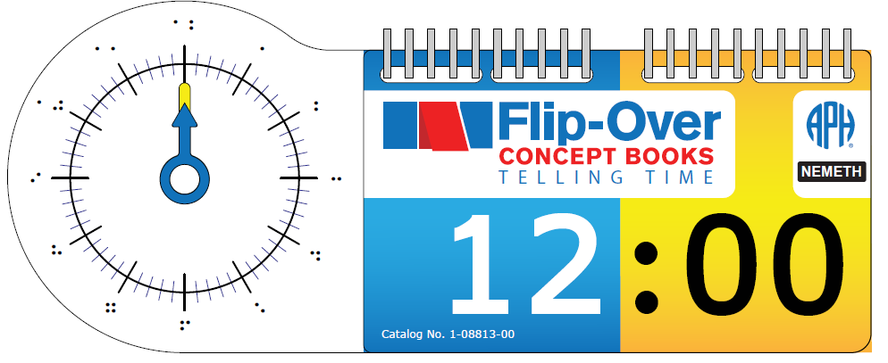

Background
In April 2006, the project leader submitted a formal proposal to develop a series of interactive tactile/print books to encourage young children's development and understanding of basic concepts related to shape, texture, spatial concepts, counting, and so forth. Flip-Over Concept Books incorporates an interactive feature whereby the child independently flips pages or adjacent print/tactile panels that can be matched or sequenced. The panels turn so that, for instance, the child can find all of the panels that have a rough texture, continue a line path, complete a sequence, build an image, and so forth. Over a decade later, APH has introduced three unique books as part of the Flip-Over Concept Books series, including LINE PATHS, PARTS OF A WHOLE, and TEXTURES; two additional books—FRACTIONS and MAKE A FACE—are currently under development (see separate annual reports). Even after years of availability, the first three books continue to sell in large numbers: LINE PATHS—430 (FY14); 317 (FY15); 311 (FY16); PARTS OF A WHOLE—407 (FY14); 387 (FY15); 263 (FY16); TEXTURES—810 (FY14); 787 (FY15); 567 (FY16).

In January 2011, the project leader reviewed a product submission idea received from two teachers of the visually impaired who requested tactile Analog Clock Flash Cards. The requested product was described as a set of tactile analog clock flash cards including all times on the hour and half hour, and at least one example of each time on the 5-minute interval (e.g., 1:10, 2:35). A cardboard clock with moveable hands was suggested as well. The identified target audience included tactile readers and low-vision readers in elementary grades through middle school. The project leader listed the following advantages of the proposed product:
- The product would complement APH’s existing analog clock model.
- The product would provide good practice of tactile graphic interpretation skills needed for success on standardized tests and in the classroom.
- The product would have appeal for a wide audience.
- The product would offer an ideal way to illustrate proper tactile illustration of clock faces according to Braille Authority of North America (BANA) guidelines for transcribers and teachers.

Although recognized as a viable product idea, the Analog Clock Flash Cards lingered on APH’s “PARC-ing Lot” for a lengthy period due to higher company-identified product priorities. The project leader later determined that the product concept could be addressed as a Flip-Over Concept Book. In June 2016, the product transitioned to the active product timeline with official approval from the Product Advisory and Review Committee (PARC).

Flip-Over Concept Books: TELLING TIME will function similarly to previous Flip-Over Concept Books. Specifically, it will feature freely rotating panels that are threaded onto a ProClick® binding, allowing the removal and repositioning of panels, if desired. However, rather than three panels wide, the book will feature HOUR and MINUTE stacks that are positioned next to an analog clock model with movable HOUR and MINUTE hands, as shown in image below. The HOUR and MINUTE panels will be printed and vacuum-formed on .010-in. white vinyl.

Given the successful design of previous Flip-Over Concept Books, formal field testing of TELLING TIME was deemed unnecessary; however, guidance and feedback was garnered from in-house staff, especially from tactile/braille readers, as the optimal visual and braille design was fleshed out. Additionally, project leaders with expertise in Core Curriculum instruction were consulted; guidance from APH tactile graphic designers versed in BANA’s braille and tactile guidelines was invited as well. The design of the tactile analog clock for TELLING TIME mirrors expected design elements (e.g., discriminable textures and lengths of clock hands, placement and lengths of MINUTE and SECOND tic marks, position of braille labels). Correct NEMETH and Unified English Braille (UEB) braille notations were utilized for the two complementary TELLING TIME flip-over books.

The project leader conducted repeated Product Development Committee (PDC) meetings throughout the fiscal year to review the expected product design, invite input from others, and monitor and test experimental tooling samples for eventual production of the book. Details discussed by PDC members encompassed a wide variety of product-building topics, including the following:
- Die-cutting of clock hands
- Ideal color and texture of clock hands
- Layout for the HOUR and MINUTE panels for printing and vacuum-forming
- Assembly of central hub of analog clock to ensure ideal tension for the rotation of clock hands
- Thickness and overall shape of back polyethylene panel
- Radius corners of book to ensure smooth edges
- Provision/packaging of separate UEB and NEMETH versions of the same flip-over book

The project leader prepared a suggested multi-up panel arrangement for the NEMETH and UEB panels for both books with SimBraille for reference. The UEB flip-over HOUR and MINUTE panels are shown below:
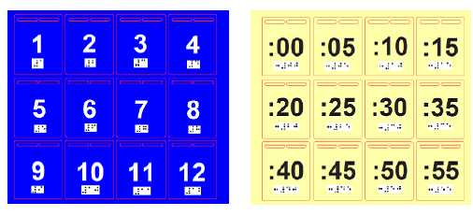

The NEMETH flip-over HOUR and MINUTE panels are shown below:
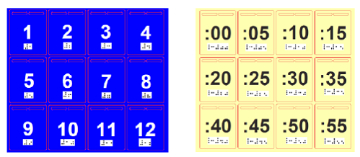

In January 2017, catalog numbers were assigned to the UEB and NEMETH versions of the accompanying Reader’s Guide—1-08814-00 and 1-08813-00, respectively. The project leader authored content for the accompanying Reader’s Guide, shown below. Except for needed references to unique braille notation represented on the panels of the flip-over book, the content for the UEB and NEMETH versions of the Reader’s Guide is nearly identical. After careful editing by Rachel Bishop, the final content was provided to Matt Poppe for final layout and design. In early February, the project leader forwarded the clean files and the final graphical layout of each version of the Reader’s Guide to the manufacturing specialist for delivery to the Braille Department. Braille translation was prepared and approved for production in May after multiple reviews by the Braille Department and Research staff. Final page counts for print and braille versions of the Reader’s Guide were incorporated into the product specifications.

Work during FY 2018
Throughout FY 2018, staff in various APH departments—Model Shop, Technical Research, Graphic Design—were pivotal during the planning and construction of necessary production tools for the eventual manufacturing of Flip-Over Concept Books: TELLING TIME, including the following items:

VACUUM-FORM PATTERNS
1 | Pattern for UEB panels (HOURS)
2 | Pattern for UEB panels (MINUTES)
3 | Pattern for NEMETH panels (HOURS)
4 | Pattern for NEMETH panels (MINUTES)
5 | Pattern for UEB flip-over book clear cover
6 | Pattern for NEMETH flip-over book clear cover
7 | Pattern for clock (generic design for both UEB and NEMETH books)
CUTTING DIES
1 | Multi-up cutting die for HOUR and MINUTE panels (will serve for both UEB and NEMETH books)
2 | Multi-up cutting die for CLOCK—likely 4-up (will serve for both UEB and NEMETH versions)
3 | Multi-up cutting die for front, clear flip-over cover (will serve for both UEB and NEMETH books)
4 | Cutting die (possibly multi-up) for white polyethylene back cover
5 | Multi-up cutting die for HOUR hand (blue/textured)
6 | Multi-up cutting die for MINUTE hand (yellow/smooth)
PRINT FILES
1 | UEB Reader’s Guidebook—completed
2 | NEMETH Reader’s Guide—completed
3 | Cover art for NEMETH flip-over book (w/assigned cat. #)
4 | Cover art for UEB flip-over book (w/assigned cat. #)
5 | Clock face with print numbers using multi-up die template—will be used for both NEMETH and UEB books)
6 | UEB panels using multi-up die template (HOURS)
7 | UEB panels using multi-up die template (MINUTES)
8 | NEMETH panels using multi-up die template (HOURS)
9 | NEMETH panels using multi-up die template (MINUTES)
10 | SMALL PARTS Warning Label (existing APH part)
11 | Print Parts List
BRAILLE FILES
1 | Braille translation of Reader’s Guide (NEMETH)—completed 5/22/17
2 | Braille translation of Reader’s Guide (UEB)—completed 5/22/17
3 | SMALL Parts Warning Label (existing APH part)
4 | Braille Parts List

The project leader periodically convened the project team to monitor progress, provide information for the specifications document, and approve sample parts. By December 2017, the graphic designer had all of the print files completed for the book covers, HOUR and MINUTE panels, and the clock face for the Nemeth and UEB versions of the book. Steady accomplishments on tooling preparation by Technical Research and Model Shop staff were impacted by concurrent work on other higher priority products. No active work on this product was reportable for the remainder of FY 2018.

Work planned for FY 2019
It is anticipated that all related tooling for the production of TELLING TIME will continue into FY 2019. The specifications document will be formally presented to Production staff; quantities for initial pilot and production runs will be determined. Actual availability of TELLING TIME is expected in late FY 2019, following the introduction of Flip-Over Concept Books: FRACTIONS.

Graph Benders
Formerly Math Homework Kit
(Continued)

Purpose
To develop an inexpensive, consumable set of items that allow blind or visually impaired students to make math graphs that can be turned in for homework, read by the teacher, and kept by the student for later review. Ease of use, readability, and marking on the top side of the graph sheet (rather than embossing from the reverse) are among the aims for the product.

Project Staff
Fred Otto, Tactile Literacy Project Leader
Li Zhou, Core Curriculum Project Leader
Frank Hayden, Director of Technical and Manufacturing Research
Andrew Moulton, Manufacturing Specialist
Rod Dixon, Manufacturing Specialist
Rachel Bishop, Research Assistant
Laura Greenwell, Graphic Designer
Tom Poppe, Model Maker

Background
Blind students in math classes face considerable challenges in producing graphs, particularly when those graphs are to be turned in for grading. While a tool such as APH’s Graphic Aid for Mathematics works admirably for classroom demonstration, it is too bulky to carry home, and each graph must be taken apart before another one is made. Some students have solved this problem by turning in photos of graphs they make on the board, but this method may be beyond the ability of many students. It offers no tangible way to review the graphs after they have been taken apart.

Many students use raised-line graph paper and embossing tools as an alternative to the large graphing boards. The major drawback here is that the embossing must be done from the back of the sheet in order to be felt on the top surface, meaning that a mental reversal must be done on the image as it is being constructed. This puts an extra burden on the student and makes the graphing task much more exacting. Waxed string products are another widely used option, but these may fall off or cause sheets to stick together, and they provide no tactual contrast.

This project aims to give students and teachers an easy way to make raised-line graphs directly on top of a graph sheet. These graphs will allow for revision, be durable enough to carry around and review, and provide strong tactile and visual contrast for good readability. The materials will also be inexpensive and appealing to use.

The project leaders researched and experimented with numerous commercially available adhesive tapes and fabrics capable of producing tactual lines. Model Shop staff also produced some embossing tools and plates with raised points to try out. Although some of the ideas tried out may be worth pursuing later, they all gave way once the idea of using adhesive foam strips was tried.

The project leaders obtained peel-and-stick foam sheets with varying degrees of visual and tactile contrast. The model maker used these to produce a sample set of foam strips and point symbols with various dimensions.

Project leaders continued to investigate and obtain samples of numerous kinds of textured foam to serve as tactual contrast to the smooth foam already selected for the kit. Staff also discussed printing a texture onto foam sheets as another option. Technical Research staff then suggested using an adhesive-backed non-skid rubber, already used in other APH products, as an alternative. Because this material has a distinctive texture and can be die-cut easily, project leaders agreed that it is the best choice.

Project staff had discussions with a local vendor to see if the foam sheets could be “kiss-cut” into strips and point symbols as desired (i.e., die-cut but with the backing sheet left intact, so items can be peeled off the sheet). The vendor expressed confidence that it could be done.

Work during FY 2018
The manufacturing specialist worked with the vendor to make cutting dies and obtain prototype sets for evaluation.

Field evaluation was conducted in the fall of 2017 after a call for testers ran in APH News. Evaluators received a quantity of the foam and textured rubber sheets, cut into strips and point symbols, and some APH low-relief graph paper. The evaluation survey form was designed and posted on SurveyMonkey®.

Field evaluation summary
The evaluators were asked to introduce the materials to students by having them do these basic steps:
- Practice removing one foam strip at a time from the backing sheet
- Practice locating and removing point symbols from the sheet
- Lay out a foam strip on paper as a straight line
- Place three dot symbols on paper to make a triangle, then connect them using a foam strip
- Construct a triangle using a foam strip without placing the dots first
- Practice cutting or breaking off any unneeded length of foam strip
- Practice repositioning items for better accuracy by lifting them off the paper and reapplying them

Teachers were asked to rate students’ performance on these steps, and then to use the materials in whatever ways were appropriate to their studies.

Completed evaluations were received from sites in 10 states: Arizona, Florida, Indiana, Minnesota, North Carolina, New Jersey, New Mexico, Nevada, Oklahoma, and Texas. Seven teachers were at residential schools, and three were in public school or itinerant settings. Evaluators were all either TVIs, math teachers, or both.

The materials were tested with 54 students ranging from 2nd grade through 12th, with a majority in the upper grades. Two-thirds of the students were braille users, with the rest using large print, regular print, audio, or a combination of these.

The field test results were compiled and reviewed. The results were favorable and indicated that the product design meets the goals that inspired it. Among the survey results were the following findings:

- Regarding the introductory tasks, 80% of students either “had no difficulty with this” or “had difficulty at first but came up with a method for doing this.” The percentages were similar for all the construction tasks.
- A few comments suggested that isolating and removing a single foam strip was hard for students with motor or dexterity problems, and that making the strips wider could help.
- No students had difficulty trimming the strips to the needed length. Some students had problems with repositioning the strips or symbols and others didn’t; this was expected because of the variability of pressure different users may apply when first sticking the pieces to the paper.
- Uses reported for the materials included making shapes and angles; Venn diagrams; bar graphs; graphs of inequalities; scatter plots; lines and rays; and various graphs on the X-Y coordinate plane.
- About half of the teachers reported some students having trouble placing items accurately in making graphs. When asked to explain the difficulty, some stated that the raised grid lines on the graph paper were not clear enough, while others said their students lack experience, concepts, or dexterity needed for the tasks. It is unknown how many of the 54 students had these problems because teachers were asked to comment on their students as a group.
- When asked to rate how well the product fulfills its stated goals (ease of use, durability, tactual/visual contrast, etc.) on a 1 to 5 scale, with 5 representing high success, the kit received one 3, seven 4s, and two 5s.

The project leaders gave serious consideration to the problems reported and the suggested improvements. A primary concern was to keep the kit straightforward to produce and affordable, and some of the suggestions ran counter to this goal. Because of this concern, project leaders elected not to follow two suggestions that were repeated in the evaluations, namely, to include raised grid paper with the kit and to space the foam strips apart for easier removal. Both ideas were seen as adding unnecessary cost to the kit. Suggested changes which were adopted, however, included the addition of square point symbols and the addition of several teaching tips in the pamphlet that will accompany the materials.

Project leaders worked with the graphic designer to develop the pamphlet and logo for the kit. Project staff began work on final product specifications.

Work planned for FY 2019
Approval for Federal Quota sale will be requested. The kit will be produced and made available for sale, and staff will work with Marketing to bring attention to the new product.

Hundreds Board and Manipulatives
(Completed)

Purpose
To modernize the current Hundreds Board and Manipulatives to include both a Nemeth and Unified English Braille (UEB) version

Project Staff
Jeanette Wicker, Core Curriculum Project Leader
Laura Zierer, Product Development Project Leader
Frank Hayden, Director of Technical & Manufacturing Research
Adam Clark, Manufacturing Specialist
Andrew Moulton, Manager of Technical & Manufacturing Research
Patrick White, Model/Pattern Maker

Background
The Hundreds Board is a math tool used in many elementary classrooms to teach number concepts. The use of the Hundreds Board is supported by the Common Core State Standards and the National Council of Teachers of Math (NCTM) Standards. As APH is currently offering many math products in both UEB and Nemeth, it is appropriate to produce the Hundreds Board and Manipulatives in both formats.

The product submission from a teacher in the field was reviewed and received approval from the Product Evaluation Team in January 2017 and the Product Advisory and Review Committee in February 2017.

Project leaders met with staff from Technical Research and Production to determine parts that could be shared between the two versions of the Hundreds Board. Part numbers and catalog numbers were requested and received. The model maker began the process of developing the Number Board in UEB.

Work during for FY 2018
The Model Shop continued to develop the new parts needed for the kits. The guidebook was revised. Technical & Manufacturing Research completed writing the specifications for the two products. A specifications meeting was held on March 27, 2018. Production is scheduled for FY 2018.

inTouch with Math supports enVisionmath®2.0
Formerly Publisher Collaboration – Pearson (enVisionmath®2.0)
(Continued)

Purpose
To collaborate with a publisher of a mainstream math program in producing accessible materials for students who are blind and visually impaired that will allow them to participate fully in the regular education classroom

Project Staff
Jeanette Wicker, Core Curriculum Project Leader
Sara Larkin, Project Consultant
Rachel Bishop, Research Assistant
Rod Dixon, Manufacturing Specialist
Laura Greenwell, Graphic Designer
Frank Hayden, Director of Technical & Manufacturing Research
Anthony D. Jones, Art Production/Design Manager
Andrew Moulton, Manager of Technical & Manufacturing Research
Patrick White, Model/Pattern Maker

Background
The enVisionmath®2.0 by Pearson Publishing for grades K-6 became available for sale in December 2105. The program is aligned to the Common Core State Standards and supports print, blended, and a digital learning experience. The program includes an online component that students use in conjunction with the print math book and a set of manipulatives.

APH was approached to work in collaboration with Pearson Publishing to develop materials including a set of manipulatives for students who are blind and visually impaired that aligns with the enVisionmath®2.0 program.

The product submission was reviewed and received approval from the Product Evaluation Team and the Product Advisory and Review Committee in August 2015.

Sara Larkin, the Statewide Mathematics and Science Consultant for the Blind and Visually Impaired from the Iowa Educational Services for the Blind and Visually Impaired, signed a contract with APH to act as a consultant for this project. Larkin and the project leader met at APH in October 2015 to begin work on the project. They reviewed the manipulatives, the student books, and the teacher’s manuals for each grade level.

A contract was finalized with Pearson Publishing in February 2016.

Many existing math manipulatives from APH are accessible version of the manipulatives used in the enVisionmath®2.0 program and will be included in the kits. Project staff began the process of designing and developing new manipulatives needed to accompany the kits. As many of the same manipulatives are used in several grades, it was decided to have one kit of manipulatives for grades K-2 and three separate manuals for each of the three grades. Larkin and the project leader met via telephone/video conferences throughout the winter and spring to develop the manual for Kindergarten.

Larkin and the project leader worked again at APH in June 2016 to complete a draft of the Kindergarten Manual. The draft of the first Kindergarten topic was sent to Pearson for review. Revisions to the manual were made based on this feedback. Pearson agreed to review the first topic of each grade level.

In FY 2017, Larkin and the project leader reviewed and revised the Kindergarten Teacher’s Manual. Graphic design completed the layout of the Kindergarten Teacher’s Manual. Work began on the Teacher’s Manual for Grade 1.

Work during FY 2018
The kits of manipulatives and the Kindergarten Teacher’s Manual were sent for expert review at four sites with teachers of the visually impaired who use the enVisionmath®2.0 program with their students. Work continued on the development of the manual for Grade 1.

Work planned for FY 2019
The kit of manipulatives and the Kindergarten Teacher’s manual will be revised based on the expert reviews. Work will be completed on the Teacher’s Manuals for Grade 1 and Grade 2.

Math Drill Cards in Braille and Large Print [Modernization]
(New)

Purpose
To modernize an existing product by adding an additional version in Unified English Braille (UEB)

Project Staff
Li Zhou, Core Curriculum Project Leader
Rod Dixon, Manufacturing Specialist
Emily Grimany, Research Assistant
Deborah Adams, Braille Transcriber
Frank Hayden, Director of Technical & Manufacturing Research
Andrew Moulton, Manager of Technical & Manufacturing Research

Background
Math Drill Cards in Braille and Large Print is to be used with children ages 5 to 10 years for practicing basic math signs and facts. The existing product consists of five separate sets of handy math skill reinforcing cards, including Number & Math Signs, Addition, Subtraction, Multiplication, and Division. The cards in the Number and Math Sign set have a math sign or number sign in braille and large print and braille on opposite sides. Large print and braille math operations cards have a math fact and the fact with the answer on opposite sides.

The braille in the existing product is Nemeth Braille Code for Mathematics. This modernization project is to add an additional version of this product by changing the braille to UEB.

Work during FY 2018
Braille transcription of the new cards started. Work on product tooling and specifications started.

Work planned for FY 2019
Product tooling and specifications will be completed. The project staff will monitor the quality of samples during the pilot and initial production runs. Production will be completed, and the product will become available for purchase.

MathBuilders
(Continued)

Purpose
To develop instructional math materials for use with students in the primary grades who are blind and visually impaired either as a supplement to the classroom math program or as a core curriculum

Project Staff
Jeanette Wicker, Core Curriculum Project Leader
Li Zhou, Core Curriculum Project Leader
Derrick Smith, Project Consultant
Rachel Bishop, Research Assistant
Frank Hayden, Director of Technical & Manufacturing Research
Anthony D. Jones, Art Production/Design Manager
Andrew Moulton, Manager of Technical & Manufacturing Research
Patrick White, Model/Pattern Maker

Background
Math achievement of blind students has been consistently behind that of their sighted peers. In recent years, very little research and product development has been done to improve this situation. Teachers of students who are blind, however, have continuously requested special braille curricular materials for math similar to those in the Patterns program developed at APH to teach braille reading. Because of the dramatic increases in the number of blind students mainstreamed, the use of the itinerant special education teacher model, the math priority stated in GOALS 2000, and new teaching standards adopted by the National Council of Teachers of Mathematics, it became critical to focus once again on math materials for visually impaired students. This project received special funding as part of a 3-year research initiative to develop new products in math, science, and geography.

During the Mathematics Focus Group Meeting in September 1994, this program was discussed and specifications were determined. During FY 1995, work on the project included a review of the research and literature on math instruction for visually impaired students; analyses of math curriculum guides; thorough analyses of current textbooks to determine mathematical symbols, terms, and concepts being taught; a search of the catalogs for commercially-available math related products; and a review of programs on abacus instruction. By 1996, prototypes of eight Primary Math Units and a general guidebook began to take shape with guidance from William E. Leibfritz, math consultant. In July 1996, a group of teachers of the visually impaired met at APH to share ideas they found to be particularly effective for developing math concepts and practice materials for their visually impaired students in the primary grades.

In July 1997, project consultants, Leibfritz and Susan Millaway, met at APH and reviewed in detail the teaching strategies for the kindergarten and first grade Primary Math Units. A draft of an introductory book that presents the philosophy and overview of the program was developed by the project leader later in FY 1997. In FY 1998 and 1999, worksheets were developed to supplement the Lessons for Unit 1: Matching, Sorting, and Patterning for kindergarten through third grade.

In FY 2000, the decision was made to field test by units rather than waiting for the program to be finished in its entirety. Tooling of Unit 1 prototype worksheets for field testing began. In FY 2001, evaluation forms for the introduction and Unit 1 were drafted. Tooling of the prototype worksheets continued with coordination of the print and braille requiring much more time than originally planned.

In FY 2002-2003, Jenny Dortch completed the final draft of the introductory book and Unit 1. The evaluation forms for the book, lessons, and worksheets were developed. During FY 2004, the evaluation forms, Guidelines (introductory material), and Unit 1 Lessons for kindergarten through third grade were finalized and prepared for field testing. Materials were placed with teachers having braille reading students in kindergarten through third grade for approximately six to eight weeks and then returned to APH for compilation and analyses of data. Results were extremely positive with only a little revision required. Dortch continued work on Units 2, 3, and 4 during FY 2004 and 2005. These units cover Number Concepts, Place Value, and Number Operation. Eleanor Pester served as project leader during this phase of development.

In FY 2006, the project was assigned to Jeanette Wicker, Core Curriculum Project Leader (a newly created position). Revisions were made to Unit 1, Matching, Patterning, and Sorting and to the General Guidelines based on the feedback from the field testing. MathBuilders was selected as the name for the series. Manipulatives were added to Unit 1 based on feedback from field testing. Graphic design and braille translation were completed. Tooling for worksheets began. A consultant, Derrick Smith, was hired for Unit 6, Geometry and Unit 8, Data Collection, Graphing, and Probability/Statistics. Objectives were reviewed for alignment with Principles and Standards for School Mathematics from the National Council of Teachers of Math for Units 6 and 8.

In FY 2007, Unit 1 and the General Guidelines became available for sale. A prototype of the Geometry Unit was completed and field tested at 10 sites for 3 months in the spring of 2007. The text for Unit 8 was written, and the development of a prototype was initiated.

In FY 2008, revisions based on field reviewers’ comments were completed for Unit 6, Geometry. Production was completed, and the Unit became available for sale in May 2008. Field testing of Unit 8, Data Collection, Graphing, and Probability/Statistics was completed, and revisions were made based on field reviewer’s comments. A prototype of Unit 7, Fractions, Mixed Numbers, and Decimals was completed.

Unit 8, Data Collection, Graphing, and Probability/Statistics became available in September 2009. Unit 7, Fractions, Mixed Numbers, and Decimals was field tested in FY 2009. The development of Unit 5, Measurement began in FY 2009.

In FY 2010, revisions to Unit 7, Fractions, Mixed Numbers, and Decimals were completed. A specification meeting was held on May 3, 2010. Production was scheduled for February 2011. Unit 7, Fractions, Mixed Numbers, and Decimals became available for sale in April 2011.

Unit 5, Measurement was field tested from February to May 2010 at 13 different sites. An analysis of the evaluations provided feedback as to the needed changes to the prototype. Revisions to Unit 5, Measurement were completed, and manipulatives were finalized. Specifications were written.

In February 2012, Unit 5, Measurement became available for sale. Five of the eight units are now available for use in the classroom. The objectives for the last three units of the series were developed and organized in a series of meetings with the consultant for this project, Derrick Smith. Work on the last three units, Number Concepts, Place Value, and Number Operations was started. Some lessons were written and some worksheets designed. Technical Research began work on some of the manipulatives.

In FY 2013, project staff continued working on the last three units. Li Zhou was hired as the Core Curriculum Project Leader and will assist with this project. Lessons were drafted for Unit 3, Place Value, and work continued on Unit 2 and Unit 4. Technical Research created prototypes of several manipulatives and continued work to complete the remaining pieces.

A working session was held in June 2014 to complete revisions to Unit 3. Work began on writing and revising Units 2 and 4 during this work session. Prototypes of all three of the last units will be field tested together as the concepts of Place Value, Number Concepts, and Number Operation overlap. One set of manipulatives will be used for all three units.

In FY 2015, FY 2016, and FY 2017 the project leaders and Smith continued to write the lessons for Units 2, Number Concept and Unit 4, Number Operations.

Work during FY 2018
There was no major work on this project in the last year. Lessons were edited and revised for Unit 3. The project was put on hold in accordance with the New Product Design (NPD) Process.

Work planned for FY 2019
The project will be moved from the Hold status and placed in the Active status of the NPD Process. Project staff will complete the remaining lessons for Units 2 and 4. Staff will develop prototypes for field testing of all three remaining units including manipulatives and worksheet.

Nemeth Code Reference Sheet for Basic Mathematics [Modernization]
(Continued)

Purpose
To revise and expand the Nemeth Code Reference Sheet for Basic Mathematics, a quick reference sheet of basic Nemeth Code

Project Staff
Jeanette Wicker, Core Curriculum Project Leader
Susan Osterhaus, Project Consultant
Derrick Smith, Project Consultant
Laura Greenwell, Graphic Designer
Frank Hayden, Director of Technical & Manufacturing Research
Anthony D. Jones, Art Production/Design Manager
Sara Lee, Research Assistant
Cathy Senft-Graves, Braille Literacy and Technology Project Leader

Background
Ex Officio Trustees have requested additional supports for teachers and students using Nemeth Code. Additionally, with the advent of Common Core State Standards, the emphasis on high stakes testing, and the increased emphasis on STEM classes and careers, staff at APH reviewed existing products that needed updating. The current Nemeth Code Reference Sheet for Basic Mathematics is very general in the Nemeth Code listed. Some of the code would be taught in an elementary class while some would be taught in an advanced mathematics class.

In FY 2014, a Product Modernization form was submitted. The revised Nemeth Code Sheet will be three individual bi-fold sheets: Beginning Level, Intermediate Level, and Advanced Level. The Maryland Common Core State Curriculum Framework for Braille, Mathematics outlines the Nemeth Code needed by grade level to participate successfully in math classes. This document, the work of Gaylan Kapperman, and the work of Susan Osterhaus were used to identify the symbols to be included at each level. Osterhaus and Derrick Smith agreed to be reviewers, and to make recommendations as to the final content.

In FY 2105, the project leader developed a draft listing of the three levels of Nemeth Code using the Maryland Common Core State Curriculum Framework, the APH Nemeth Tutorial developed by Kapperman, TSBVI Nemeth Code Reference Sheets, and the APH Nemeth Code Reference Sheet for Basic Mathematics. These were sent to Osterhaus and Smith for review. Their suggestions for additions and revisions were incorporated. Additionally, Cathy Senft-Graves, Braille Literacy and Technology Project Leader, reviewed the listings for appropriate groupings of the Nemeth Code Symbols. The project leader finalized the content for the Beginning Level and the Intermediate Level.

In FY 2016, the project leader finalized the content for Advanced Level of the Braille Reference Sheets with input from Osterhaus and Smith. The project leader began the development of the chart of the Nemeth Code for each of the three levels. In FY 2017, the braille translation of the content and layout of the beginning level was completed, proofed, and revised. Work began on the content and layout of the intermediate level.

Work during FY 2018
The project leader and the consultant, Smith, completed the Intermediate and Advanced level sheets. The three sets were proofed and turned over to graphic design for layout completion.

Work planned for FY 2019
The three sets of Nemeth Code Reference sheets will be reviewed by experts in the field of Nemeth Code. The sets will be revised, and specifications will be completed.

Place Value Setter
(Continued)

Purpose
To give early elementary school students with blindness or low vision a quick, fun, and hands-on way to learn about and develop a firm understanding of the basic math concept place value

Project Staff
Li Zhou, Core Curriculum Project Leader
Andrew Dakin, Model/Pattern Maker
Adam Clark, Manufacturing Specialist
Rachel Bishop, Research Assistant
Matthew Poppe, Art Designer
Frank Hayden, Director of Technical & Manufacturing Research
Andrew Moulton, Manager of Technical & Manufacturing Research

Background
Place value is a positional notation system in which the position of a digit determines its value. For example, in the base 10 number system that we use every day, each place has a value 10 times that of the place to its right. As the basis for students' understanding of numbers, place value is a fundamental concept that must be acquired prior to moving onto more complex math skills and concepts.

To fully understand place value, students must gain knowledge of conceptual models of place value and then connect that knowledge with written representations. To facilitate number setting with written digits for students with blindness and low vision, a teacher of students with visual impairments in Manahawkin, NJ, submitted the idea of a new product Place Value Setter: In Braille and Large Print to APH in July 2014. After a thorough evaluation, APH accepted that idea and assigned it to the current project leader.

The Place Value Setter is designed to have number strips installed on a base board. Strips have written digits in both large print and braille, which allows braille students to work together with non-braille readers. Sliding the strips allows students to show place value digits. With that refreshable and concrete display, the Place Value Setter will give students with blindness and low vision as well as their teachers a prompt way to represent numbers using written digits. Designed for elementary school students, especially 1st to 3rd graders, this tool will be particularly useful for the following groups:
- students with blindness and low vision who need to practice quick and simple place value setting;
- teachers or teaching assistants of students with visual impairments who want to set up place value problems quickly so that, in inclusive settings, their students can follow classroom math teachers' instructions and participate in real time classroom activities;
- for non-braille readers such as parents and sighted students to work together with students with visual impairments; and
- for students who benefit from hands-on learning to get a concrete learning experience.

In 2015, prototypes for use in field test were designed and made. Field test documents were completed. Field test sites were identified. Field test began in September 2015.

Field test of the Place Value Setter was conducted from September to November 2015. Eight teachers completed the field test. They were from seven states including Illinois, Iowa, Kansas, New York (2), Pennsylvania, Texas, and Washington. Participants were selected based on the number of available students, diversity of setting, and geography.

All participating teachers were teachers of students with visual impairments. Their years of experience teaching students with visual impairments ranged from 2 to 41 years, with the average being 14 years. Most teachers (6, 75%) worked in itinerant positions, one teacher (12.5%) worked at a residential school for students with visual impairments, and one (12.5%) worked in an inclusive classroom at a regular school.

In all, the participating teachers worked with 30 students in this field test. Below is a breakdown of students' demographics:
- Fourteen students (46.67%) were female, and 16 students (53.33%) were male.
- Eleven students (36.67%) reported their ethnicity as White, six (20%) reported Hispanic, three (10%) reported Black/African-American, two (6.67%) reported Asian, and one (3.33%) reported Russian. Seven students did not provide this information.
- Students' ages ranged from 6 to 12, with the average being 8 and the mode (most frequently reported ages) being 9 (10 students).
- Academic levels ranged from 1 through 5, with the mode (most frequently reported grades) being 2 (eight students).
- Twenty students (66.67%) had low vision, and nine students (30%) had blindness. One student did not provide this information.
- For primary reading medium, 11 students (36.67%) used braille, 18 students (60%) used large print material, and one (3.33%) reported regular print.
- Thirteen students (43.33%) had disabilities in addition to their visual impairments. Their conditions included hearing impairment, ADHD, cognitive impairment, speech disorder, learning disabilities, and cerebral palsy.

After testing the product with each of their student, teachers were asked to what extent they agreed or disagreed that this product was helpful to that particular student for achieving his/her learning objectives. The scale ranged from 1 (strongly disagree) to 6 (strongly agree). Of 30 students, teachers answered 2 (disagree) for one student (3.33%), 4 (somewhat agree) for seven students (23.33%), 5 (agree) for 14 students (46.67%), and 6 (strongly agree) for eight students (26.67%). The average was 4.9.

After working with all students, teachers were also asked about their overall opinion of this product. Five teachers (62.5%) strongly agreed and two teachers (25%) agreed that this product could help students with visual impairments study the concept of place value. One teacher (12.5%) somewhat agreed with that. Seven teachers (87.5%) thought that this product would be highly useful in their classrooms if the changes they suggested were made. One teacher (12.5%) thought that this product would probably not be very useful in her classroom. Following is a quote from a teacher: "To gain a full understanding place value requires the student to understand the connection between base ten units, how they can be bundled and unbundled, and positional notation. In my opinion, the place value setter goes beyond where other manipulative tools leave off in that it reinforces positional notation and helps students' conceptual understanding in a way that cubes or rods alone cannot. The place value tool is helpful for students with blindness or low vision because it brings all three conceptual requirements together and gives them a means of writing numbers with an understanding of how the digits have value based on their position within a number."

Teachers and students suggested several changes. The development team discussed all of them and decided to make the following revisions:
- Increase the dimension of the base board
- Increase font sizes of print letters, numbers, and symbols
- Increase the height of the number window area
- Change abbreviations of place value digits
- Add tactile symbols to help with orientation for students with blindness
- Provide better color contrast to help with orientation for students with low vision

Work during FY 2018
Product tooling and writing of specifications were completed. Product was submitted for production.

Work planned for FY 2019
The project staff will monitor the quality of samples during the pilot and initial production runs. Production will be completed, and the product will become available for purchase.

Practice2Master Fractions
(Completed)

Purpose
To give students who are visually impaired an accessible app for fraction calculation study

Project Staff
Li Zhou, Co-Project Leader, Core Curriculum Project Leader
Fred Otto, Co-Project Leader, Tactile Literacy Project Leader
Rachel Bishop, Research Assistant
Lawrence Lovelace, iOS® Developer
Laura Greenwell, Graphic Designer
Anthony D. Jones, Art Design/Production Manager

Background
Basic fraction calculation, including addition, subtraction, multiplication, and division, is an important but sometimes difficult part of elementary and middle school math study. For students to achieve fluency in fraction calculation, adequate practice is a must. Many smart phone and tablet apps have been developed to help students with this. However, because the design of these apps does not give adequate if any consideration to the special needs of students with disabilities, it is very hard for students who are blind or have low vision to use them effectively and benefit from them as their sighted peers do. Lack of access to such tools might put these students at a disadvantage in fraction study.

To give students who are visually impaired an accessible fractions app, the project leaders submitted this new product idea in September 2016. Although Practice2Master Fractions is specifically designed for students with vision loss, it can be used by all students. Among its many features, this app allows students and teachers to do the following:
- Do free practice in fraction addition, subtraction, multiplication, and division and get assistance from the app when needed.
- Take drills on fraction calculation and save drill reports for future reference.
- Create users' own fraction calculation problems for future practice and drills.
- Customize the app by setting problem types, difficulties, and so forth.
- Learn how to use the app through written instructions and video demonstrations.

In February 2017, this new product idea was approved by the Product Evaluation Team and the Product Advisory and Review Committee and became an active project.

Work during FY 2018
The field test of Practice2Master Fractions was conducted during September and November 2017. Five teachers completed the field test. They were from five states: California, Georgia, Illinois, Nebraska, and North Carolina.

Four of the participating teachers were teachers of students with visual impairments. Their years of experience teaching students with visual impairments ranged from 7 to 22 years, with the average being 14 years. One teacher was a middle and high school math teacher. Three of the teachers worked in itinerant positions, one worked at a residential school, and one worked in a resource room.

In all, the participating teachers worked with 14 students in this field test. Below is a breakdown of the students' demographics:
- Eight students (57%) were female, and six students (43%) were male.
- Eleven students (79%) reported their ethnicity as White, and the other three (21%) reported Black/African-American.
- Students' ages ranged from 8 to 16 years, with the average being 12 and the modes (most frequently reported ages) being 12 and 14 (three students each).
- Academic levels ranged from third grade through 10 grade, with the modes (most frequently reported grades) being seventh grade (five students).
- Six students (43%) had low vision, and six students (43%) had blindness. Two students did not report.
- For primary reading medium, seven students (50%) used braille, five students (36%) used large print material, and six (43%) also reported electronic. One student did not report.
- Five students (36%) had disabilities in addition to their visual impairments. Their conditions included hearing impairment, ADHD, and intellectual disability.

After testing the app with each of their students, teachers were asked to what extent they thought that the app was useful to that particular student for learning fraction calculations. The scale ranged from 1 (not useful at all) to 5 (very useful). Data for nine of the 14 students were reported by the teachers. Among them, teachers answered 3 (neutral) for one student (11%), 4 (useful) for one students (11%), and 5 (very useful) for seven students (78%). The average was 4.7.

Among those nine students whose data was reported, six of them (67%) were "very interested" in using the app based on teachers' observations. The other three students (33%) were "somewhat interested."

After working with all students, teachers were asked about their overall opinion of the app. Two teachers (40%) strongly agreed and three teachers (60%) agreed that the app could help students who are visually impaired with their fraction study. All teachers thought that the app would be highly useful in their classrooms if the changes they suggested were made. One teacher commented, "I feel that this app will allow students with VI to have access to a highly accessible "math game" so they can have fun practice similar to their peers when others get to use iPads for practice of math skills. We have found many of the commonly used games are not fully accessible with voice over so our kids get left out of ‘tech time’."

Teachers and students suggested a few changes. The development team discussed field test findings, and the following changes were made to the app:
- A feature was added to the app so that problem lists and drill reports could be shared through e-mail.
- Fun comments were added to the free practice mode to make the app more interesting for children.
- During drills, timer could be toggled on and off.
- User interfaces were improved (e.g., font sizes, spacing, colors, etc.) to make the app more accessible for students with low vision.
- The answer submission process was improved to increase speed.

The Practice2Master Fractions app was released in May 2018.

Work planned for FY 2019
The Practice2Master Fractions app is now complete. Except for maintenance of the app, no other work on this project is planned for FY 2019.

Tactile Algebra Tiles
(Completed)

Purpose
To provide math students who are visually impaired with an accessible version of algebra tiles, a math manipulative used in elementary, middle, and high school algebra study

Project Staff
Li Zhou, Core Curriculum Project Leader
Katherine Corcoran, Model/Pattern Maker
Rod Dixon, Manufacturing Specialist
Rachel Bishop, Research Assistant
Matthew Poppe, Graphic Designer
Frank Hayden, Director of Technical & Manufacturing Research
Andrew Moulton, Manager of Technical & Manufacturing Research
Anthony D. Jones, Art Production/Design Manager

Background
Algebra tiles are mathematical manipulatives that provide students with concrete models for understanding abstract algebraic concepts and procedures. With tiles representing variables and constants, algebra tiles can be used by students from elementary to high school for adding, subtracting, and multiplying integers; simplifying expressions; solving linear and quadratic equations; and multiplying and factoring polynomials. By providing students with a graphical way to solve algebraic problems in addition to abstract manipulation, algebra tiles are seen as helpful tools that meet students' diverse needs in algebra study.

Preliminary research has found that algebra tiles are commercially available through many vendors of educational manipulatives. However, these tiles are not readily accessible for students who are visually impaired. For example, the tiles come in different colors, but students who are blind cannot distinguish colors; the tiles are often small, which makes it difficult for students with visual impairments to manipulate them; and physically touching tiles, which might be helpful for visually impaired students, interferes with laying the them out into graphical patterns because they are not fixed on a desktop. The National Council of Teachers of Mathematics (NCTM) has developed a free online illumination of algebra tiles, but it is not accessible for students with severe vision loss.

In the summer of 2011, APH Core Curriculum Project Consultant, Jeanette Wicker, and Core Curriculum Project Leader, Sandi Baker, surveyed about 70 math teachers and teachers of students with visual impairments about potential math products. Algebra tiles were found to be one of the top three products that these teachers wanted the most for their students.

Therefore, the project leader submitted the product idea of adapting algebra tiles for students with visual impairments.

In 2014, the project leader presented the new product to the Product Evaluation Team and Product Advisory and Review Committee. Approval was received, and project staff began designing the product.

In 2015, design of the prototype for use in field testing was completed, and the Model Shop and Technical Research made prototypes for the field test. The project leader prepared field test documentations including a user's guide and evaluation forms.

Field testing of Tactile Algebra Tiles was conducted during January and April 2016. Eight teachers completed the field test. They were from seven states including Indiana, Kentucky, Missouri (2), New Jersey, Tennessee, Texas, and Wisconsin. Participants were selected based on number of available students, diversity of setting, and geography.

All participating teachers are teachers of students with visual impairments. Their years of experience teaching students with visual impairments ranged from 3 to 25 years, with the average being 7.6 years. Half of the teachers (4, 50%) worked in itinerant positions, and the other half (4, 50%) worked at residential schools for students with visual impairments.

In all, the participating teachers worked with 28 students in this field test. Below is a breakdown of the students' demographics:
- Thirteen students (46.43%) were female, and 15 students (53.57%) were male.
- Thirteen students (46.43%) reported their ethnicity as White, eight (28.57%) reported Black/African-American, six (21.43%) reported Hispanic, and one (3.57%) reported Asian.
- Students' ages ranged from 6 to 18 years, with the average being 14.36 and the modes (most frequently reported ages) being 14 and 16 (six students each).
- Academic levels ranged from K through 12, with the modes (most frequently reported grades) being 8 (seven students).
- Fifteen students (53.57%) had low vision, and 13 students (46.43%) had blindness.
- For primary reading medium, 17 students (60.71%) used braille, four students (14.29%) used large print material, six (21.43%) reported electronic, and one (3.57%) reported regular print.
- Seven students (25%) had disabilities in addition to their visual impairments. Their conditions included hearing impairment, ADHD, learning disabilities, and cerebral palsy.

After testing the product with each of their students, teachers were asked to what extent they agreed or disagreed that the product was helpful to that particular student for achieving his/her learning objectives. The scale ranged from 1 (strongly disagree) to 6 (strongly agree). Of the 28 students, teachers answered 2 (disagree) for one student (3.57%), 4 (somewhat agree) for three students (10.71%), 5 (agree) for seven students (25%), and 6 (strongly agree) for 17 students (60.71%). The average was 5.4.

Based on teachers' observations, most students (21 of 28 students, 75%) were very interested in using the product. Five students (17.86%) were somewhat interested, and two (7.14%) were uninterested.

After working with all students, teachers were asked about their overall opinion of the product. Four teachers (50%) strongly agreed and two teachers (25%) agreed that the product could help students with visual impairments in algebraic study. One teacher (12.5%) somewhat agreed with this statement, and one teacher (12.5%) disagreed. One quote from each teacher is listed below that represents his or her opinion of the product:
- "This is an excellent tool for teaching a number of algebraic skills."
- "The Tactile Algebra Tiles provided a fully accessible model of several algebraic concepts for students with visual impairments. The use of the tiles increased the acquisition and mastery of the concepts. The color contrast and tactile qualities were of the highest qualities, which enabled all of my students who practiced with the tiles the ability to model the polynomial problems independently!"
- "Very good tactile representation. Could use more tiles."
- "In each instance I used the tiles they were helpful and easy for the students and facilitators to understand. Each student was asked to use the tiles in their classroom math class for a week and then tell me how they worked or didn’t work. In each case the student and facilitator reported positive responses."
- "THE STUDENT FELT THE TILES COULD HAVE MANY USES AND BE VERY HELPFUL FOR THE VISUALLY IMPAIRED AND EVEN HELP THOSE WHO ARE NOT VISUALLY IMPAIRED DUE TO THEIR USES AND ABLE TO EXPLAIN THE ‘BALANCING OF EQUATIONS.’"
- "These tiles are so helpful that I hate to send them back (but will!). I'll make some temporary tactile tiles to hold us over until APH makes them available (soon I hope!?)."
- "I feel that this tool can be useful to teach the initial concept such as solving a two-step algebra problem. Ultimately, the student’s answer must be recorded (I.E.) pencil/paper, electronic device, braillewriter. Once the student learns the concept then they should try solving the problem without the tactile tiles."
- "I like the idea, but it is just too confusing for tactile users; at least, it was for mine."

Teachers and students suggested few changes. The development team discussed field test findings and decided to add one more steel board to the kit to provide more room for tile storage.

Work during FY 2018
Production of Tactile Algebra Tiles was completed. The product became available for purchase in February 2018.

Work planned for FY 2019
This project is complete. No work is planned for FY 2019.

Tactile Five and Ten Frames
(Continued)

Purpose
To provide students who are blind and visually impaired a math manipulative comparable to that used in the elementary classroom by sighted peers

Project Staff
Jeanette Wicker, Core Curriculum Project Leader
Rachel Bishop, Research Assistant
Laura Greenwell, Graphic Designer
Frank Hayden, Director of Technical & Manufacturing Research
Anthony D. Jones, Art Production/Design Manager
Andrew Moulton, Manager of Technical & Manufacturing Research
Patrick White, Model/Pattern Maker

Background
Five and ten frames are graphic organizers designed to help young children visualize sets of five and ten. These frames can help students develop subitizing skills, the ability to instantly see “how many.” When a student instantly “sees 5” on a domino or die, she is using her subitizing skills.

The understanding that numbers are composed of tens and ones is an important foundational concept. A strong sense of 10 is a prerequisite for number sense, composing and decomposing numbers, place value understanding, and mental calculations.

Many mainstream math textbooks incorporate the use of five and ten frames into math activities. In order for students with visual impairments to be included in the mainstream math class, it is important that they have similar tools.

Tactile Five and Ten Frames were planned for inclusion in MathBuilders Units 2 and 4. The design and development of the molds had previously been completed for these units. A product submission was received from a teacher of the visually impaired in Kentucky requesting the frames as a separate project.

The product submission was reviewed and received approval from the Product Evaluation Team in June 2015 and the Product Advisory and Review Committee in August 2015.

The Model Shop and Technical Research prepared additional frames for field evaluation, a manual to accompany the frames was completed, and graphic design prepared labels for the carrying case.

In FY 2017, the announcement for the field testing of the Tactile Five and Ten Frames was included in the September APH News. Thirty-one teachers responded to the announcement. Eighteen sites were selected to field test the prototypes from October 2016 through February 2017.

Field Evaluator Test Sites: The Tactile Five and Ten Frames were sent to 18 field evaluators in 12 states.
- States represented in the evaluation were California, Colorado, Indiana (2), Kentucky, Louisiana, Michigan (2), Missouri (3), New Mexico, New York (2), Ohio, Vermont, and Wisconsin (2).

Field Evaluators: The Tactile Five and Ten Frames were sent to 18 sites for review by teachers with students who are blind and visually impaired.
- Four evaluators reported 0-5 years of experience (22%), six reported 6-10 years of experience (33%), three reported 11-15 years of experience (17%), and five reported 16-20 years of experience (28%).
- One evaluator is Hispanic (6%), and 17 evaluators are White (94%).
- Sixteen of the evaluators listed their preferred reading medium as print (89%); two listed Large Print as the preferred reading medium (11%).
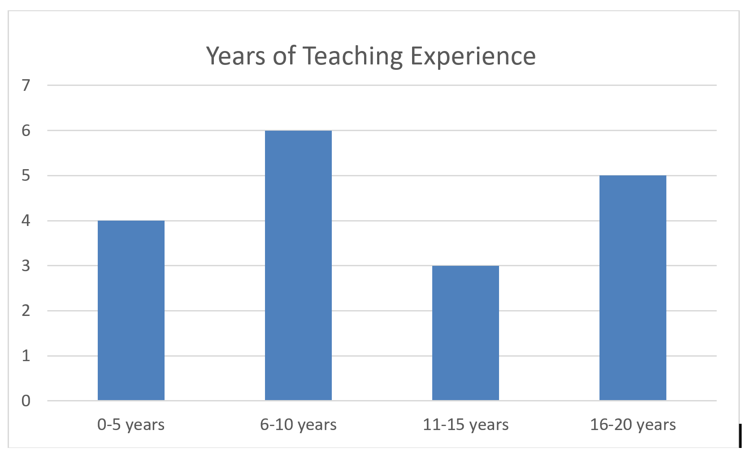

Students: Thirty-seven students used the Tactile Five and Ten Frames in the field test.
- Twenty-one of the participants are female (57%), and 16 are male (43%).
- Of the 37 students, 21 are White (56%), six are Black/African American (16%), five were reported as two or more races (14%), four are Hispanic (11%), and one is Middle Eastern (3%).
- Seventeen of the students received services in an itinerant setting (46%), 13 received services in a residential setting (35%), five received services in a resource room (13%), one student was in a self-contained setting (3%), and one student was home schooled with services provided by a TVI (3%).
- Twenty of the students were braille readers (54%), nine students were print reader (24%), five used a combination of print and braille (14%), and teachers reported for three students that they are “not certain at this time” as to the reading medium (8%).
- Teachers reported that 21 students (57%) had other disabilities/conditions that might impact math skills while 16 (43%) students had no additional disability that might impact their math skills.
- Students ranged in ages from 5 to 13 at the time of the evaluation. Seven students were 5 years old (19%), six were 6 years old (16%), 12 were 7 years old (32%), six were 8 years old (16%), three were 9 years old (8%), two were 10 years old (6%), and one student was 13 years old (3%).
- Three of the students were enrolled in a Pre-K class (8%), nine were enrolled in a Kindergarten class (24%), 12 were enrolled in first grade (32%), eight were enrolled in second grade (22%), four were enrolled in third grade (11%), and one student was enrolled in an ungraded classroom (3%).
- Teachers were also asked to report the level of math skills of the students. Six students were functioning at a Pre-K level (16%), 12 were functioning at a Kindergarten level (32%), 13 were functioning at a first grade level (35%), five were functioning at a second grade level (14%), and one student was functioning at a third grade level (3%).
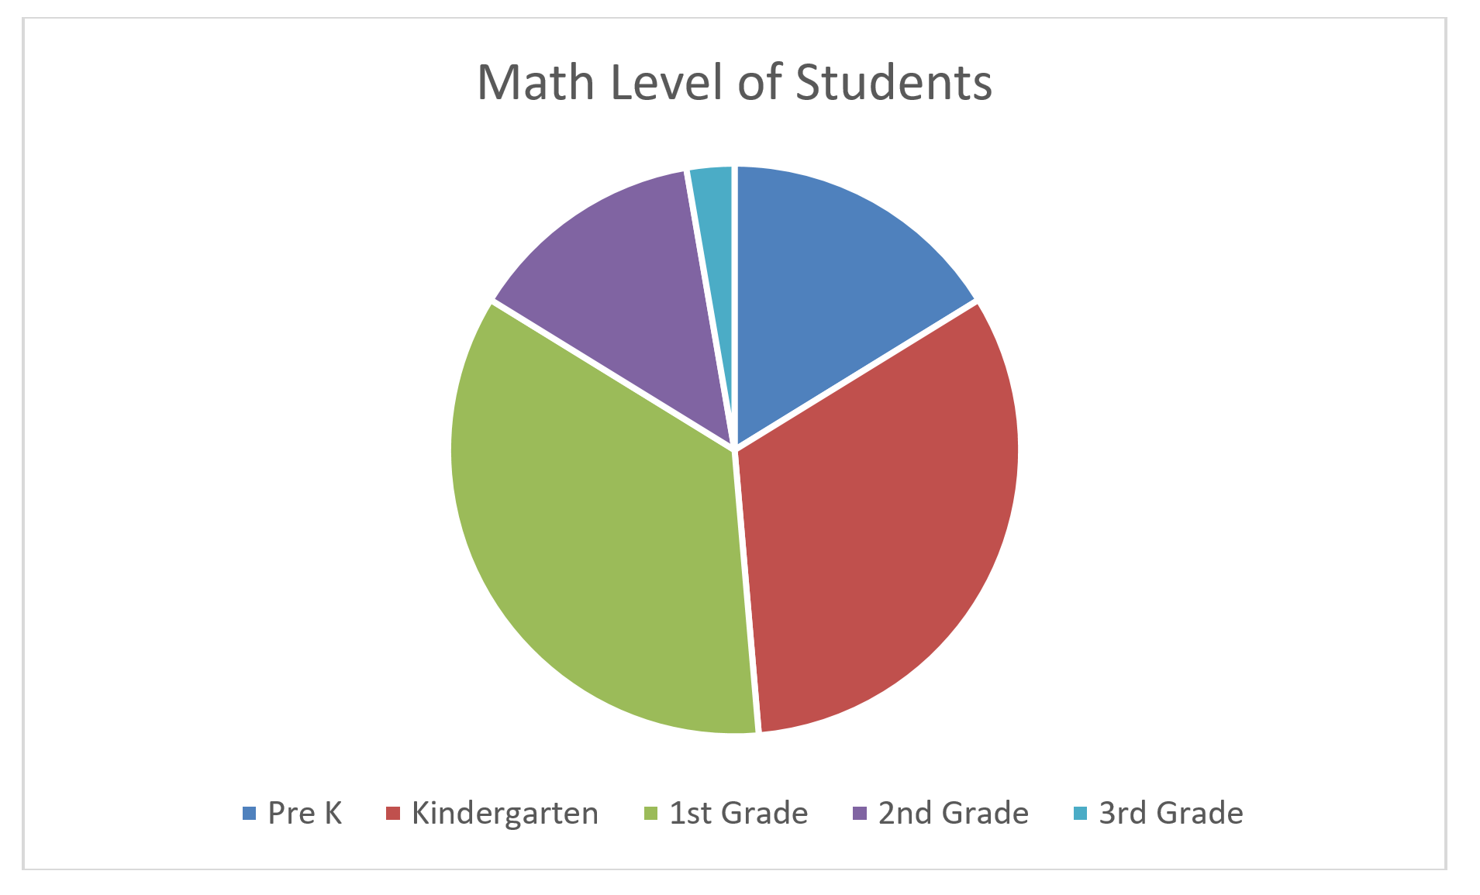
Evaluation: All students were asked to complete four types of tasks using the Tactile Five and Ten Frames. The field evaluator determined the student’s success in completing the task and reported the results.

Task | Yes | No | Sometimes
Is the student able to recognize a grade/age appropriate number of tiles in the frame(s)? | 30  (81% | 3  (8%) | 4  (11%)
Is the student able to recognize the benchmark numbers of 5 and/or 10 using the frames and tokens? | 27  (73%) | 6  (16%) | 4  (11%)
Is the student able to perform grade/age appropriate addition problems using the frames and tokens? | 21  (57%) | 10  (27%) | 6  (16%)
Is the student able to use the frame with sighted peers? | 20  (54%) | 1  (3%) | Sometimes – 1  (3%)  N/A – 15  (40%)

There were 20 “No” responses recorded by teachers. Of the 20 student “No” responses, 19 of those responses were from students who had other disabilities/conditions that might impact math skills.

There were 15 “Sometimes” responses recorded by teachers. Of the 15 student “Sometimes” responses, nine of those responses were from students who had other disabilities/conditions that might impact math skills.

Teacher Guidebook: Evaluators were asked to provide feedback on the guidebook included in the kit.

Guidebook | Strongly Agree | Agree | Somewhat Agree | Disagree | Strongly Disagree
The guidebook was clear and concise. | 8  (45%) | 10  (55%) | 0 | 0 | 0
The activities in the guidebook were helpful in using/learning to use the frames. | 9  (50%) | 6  (33%) | 3  (17%) | 0 | 0
The pictures of the frames were helpful in understanding how to use the frames. | 11  (61%) | 6  (33%) | 1  (6%) | 0 | 0

Teacher Comments:
- “I felt the Guidebook did a nice job explaining activities and how to use the frames.”
- “Would like to see more materials for students with multiple disabilities.”

Tactile Five and Ten Frames: Evaluators were asked to provide feedback on the Tactile Five and Ten Frames.

Tactile Five and Ten Frames | Strongly Agree | Agree | Somewhat Agree | Disagree | Strongly Disagree
The frames were sturdy and of good quality. | 12  (66%) | 3  (17%) | 3  (17%) | 0 | 0
The frames were an appropriate size and depth to accommodate the tokens. | 11  (61%) | 4  (21%) | 1  (6%) | 1  (6%) | 1  (6%)
There were an appropriate number of frames in the kit for classroom activities. | 6  (33%) | 8  (44%) | 3  (17%) | 1  (6%) | 0
The frames were appropriate to share with sighted peers in a classroom setting. | 10  (56%) | 7  (39%) | 0 | 0 | 0  N/A – 1  (6%)

Teacher Comments:
- “Maybe just a hair more height on the dividing of the columns/rows (grid).”
- “Yes, the tokens fit perfectly into each frame. Tactually it was easy to place tokens into different frame boxes.”
- “The frame is not very deep, so both of my student had difficulty when they would place a piece in the frame as they moved to the next box the piece would slide out. I believe the depth is what kept my students from being able to use the frames more accurately. It would have been nice to have four frames so my student could have participated in more of a small group setting with their peers.”
- “Somewhat Agree – Stored inside student’s desk with other books so it took a beating.”
- “Somewhat Agree – There were only three available.”
- “The frames accommodated the tokens and any other token utilized by the student and her peers within the classroom setting very easily – very adaptable. Her peers loved using the frames when working with my student and she loved being fully included without the needing as much adult assistance.”
- “The tokens did not stay in the spaces well enough. This made them unusable. A magnetic set works much better.”

Tactile Tokens: Evaluators were asked to provide feedback on the Tactile Tokens.

Tactile Tokens | Strongly Agree | Agree | Somewhat Agree | Disagree | Strongly Disagree
The Tactile Tokens were sturdy and of good quality. | 12  (66%) | 4  (22%) | 2  (11%) | 0 | 0
The Tactile Tokens were an appropriate size for elementary students. | 12  (67%) | 6  (33%) | 0 | 0 | 0
The opposite sides of the Tactile Tokens were tactually discernable. | 12  (67%) | 4  (22%) | 1  (6%) | 1  (6%) | 0
There were an appropriate number of tokens in the kit for classroom activities. | 8  (44%) | 7  (39%) | 2  (11%) | 1  (6%) | 0
The Tactile Tokens were appropriate to share with sighted peers in the classroom. | 10  (56%) | 6  (32%) | 1  (6%) | 0 | 0  N/A – 1  (6%)

Teacher Comments:
- “Students had no difficulty discriminating. It was helpful with counting one-to-one correspondence. There were more than enough tokens provided.”
- “The tokens were very light. Easily got misplaced. The tokens are not very heavy. They easily get knocked out of the tray.”
- “Both of my students have CP. It would have been nice if the pieces were thicker or more weighted so they stayed in the frame a little easier as well.”
- “They need Velcro.”
- “Enough to fill three frames.”
- “I wish there were a way to adhere the tokens in their spot. There were times she would check her tokens and they’d move on her. I was trying to think of Velcro or something similar but without it interfering with the textured sides.”
- “Very helpful and versatile.”
- “Excellent quality! These were also the perfect size for preschoolers!”
- “The students I work with were able to handle/manage the Tactile Tokens easily and were able to tactually distinguish the different textures, even some of the students who have some limited fine motor/tactile discrimination skills at this time. For a classroom of many students who all have visual impairments, I would need to order multiple sets, but I think an itinerant teacher working with only 1-2 students with visual impairments in a particular classroom there would be enough. I think they would be appropriate to share. I work in a residential setting where all the students have a visual impairments and I know they all had a good time with the frames and tokens. I would imagine they would be appropriate in a public school setting.”

Teachers were asked to respond to several general questions about the Tactile Five and Ten Frames.

Tactile Five and Ten Frame Kit | Yes | No
Did your student experience and particular difficulties with the Tactile Five and Ten Frames? | 5  (28%) | 13  (72%)
Did your students have any notable comments about the Tactile Five and Ten Frames? | 5  (28%) | 13  (72%)
Do you feel your students benefited from using the Tactile Five and Ten Frames? | 17  (94%) | 1  (6%)
Were the Tactile Five and Ten Frames a good solution for incorporating your students in math class activities whey the class was using Five and Ten Frames? | 16  (88%) | 1  (6%)  NA -1  (6%)
Do you recommend that APH produce the Tactile Five and Ten Frame Kits? | 17  (94%) | 1  (6%)

Teacher Comments:
- “Easy to use for solving math problems and bar graphs – tokens stay in place so no slipping around or losing pieces. Easy to explore hands on. This was very helpful when discussing the presidential election. Print math books uses five and ten frames as part of the common core standards. It is wonderful to have a tactile version for students who are blind and visually impaired to use hands-on so they can solve problems such as recognizing more or less. This is a wonderful kit to help a child who is blind learn hands-on tactilely the concepts in math books. The child does not get frustrated about pieces moving around since each token has its own square. Very well done.”
- “She likes ‘playing with’ or moving her ‘math’ and setting up problems for me to solve.”
- “Yes, it is something I will continue to use. It has been great for concept development, one to one correspondence, introducing new skills and practicing old. This was a great supplemental material to use alongside the curriculum. It can be incorporated in many different ways in the classroom (independent work, group work, direct instruction, etc.) Overall, it was a good kit to help reinforce those important basic math skills.”
- “I enjoyed using the materials with my student.”
- “Making the tokens heavier and magnetic would help them stay put. Change the token issue.”
- “My students had difficulties with the frames. The pieces would come out as they were counting and moving to the next space in the frame. Even though they had difficulties, I felt it was beneficial for my students. Their sighted peers enjoyed the frames and it helped them feel more like a part of the class setting. I hope it can be revised to add more depth to the frame.”
- “The Tactile Frames seemed to make this visual activity much more beneficial for my students to be independent during classroom activities.”
- “This is a wonderful tool in many ways for our students.”
- “The product is very helpful and keeps items organized for the students to be able count and move things without double counting or losing the items on the desk.”
- “The five and ten frames were nicely designed to suit the needs of students with visual impairments. The frame gives the students an opportunity to be physically engaged and active during math. The frames allow students to associate the number with a visual/tactile image.”
- “This is a huge part of the common core math, so having a ready-made, durable accommodation in place is extremely helpful.”
- “Tokens do not stay in place will enough.”
- “Occupational Therapist also used them.”
- “The students I worked with really enjoyed these materials and had more success using/understanding them than from the pictures/tactile graphics from their textbooks. They really helped the students with their subtraction skill.”

Changes to Kit based on Teacher Feedback
- Addition of a second 5 frame
- Addition of a second bag of tokens
- Changed the depth of the frames to 1/4 inch to resolve issue of slipping tokens
- Changes to the teacher’s guide to reflect the changes as mentioned

Work during FY 2018
The Tactile Five and Ten Frames received Quota Approval in October 2107. The project leader finalized all components of the kit, and a specification meeting was held on May 22, 2018. Production is scheduled for FY 2019.

Work planned for FY 2019
Production of Tactile Five and Ten Frames is scheduled. The product will be released for sale.

PHYSICAL EDUCATION / HEALTH

Count Me In: Motor Development in a Box
(Continued)

Purpose
To provide a product to help early childhood professionals and parents teach and encourage locomotor skills and object control skills prior to young learners entering school

Project Staff
Tristan Pierce, Physical Education Project Leader
Lauren Lieberman, Consultant
Pamela Haibach, Consultant
Monica Vaught-Compton, Project Assistant
Frank Hayden, Director of Technical & Manufacturing Research
James Robinson, Electronics Specialist
Andrew Dakin, Model Maker

Product Description
Count Me In is a box of adapted sports equipment with quickstep instructions.

Background
APH considered creating Count Me In: Motor Development in a Box after Lauren Lieberman, The Brockport College at SUNY, presented to a standing-room-only crowd at the 2011 APH Annual Meeting of the Ex Officio Trustees in Louisville, KY. Attendees and APH’s Early Childhood Project Leader requested that the Gross Motor Development Curriculum include preschoolers. Because children who are 3 years old require physical and motivational supports that older children may not, the Physical Education Project Leader and the consultants decided to create Count Me In to meet the specific needs of very young children who are just learning to move independently in their environment. The product “box” will include adapted equipment for children 3-years-old and up to learn locomotor and object control skills.

Relevance
APH made the decision to produce this product based on a standardized process of product selection. Lieberman and Pamela Haibach (also a professor at The Brockport College at SUNY) submitted the project idea on October 17, 2011. The project leader presented the product submission to the Product Evaluation Team (PET) on November 3, 2011. PET voted to move the project forward. On November 9, 2011, the Product Advisory and Review Committee approved the project, and assigned it grant #507.

This product will be fully accessible to the population who will use it. The Count Me In instruction cards will be available in print, BRF, text file, and HTML to meet APH requirements for accessibility. APH has the online link to access the Motor Development videos. (See report on Gross Motor Development Curriculum.)

This product follows APH guidelines for determining relevance of a product. The consultants conducted research with over 90 children with visual impairments throughout the United States. (See report on Gross Motor Development Curriculum.) Motor skill activities help to improve agility, balance, motor coordination, manipulation skills, and eye-hand and eye-foot coordination (Lieberman & Pecorella, 2006). These skills promote independence, self-esteem, and a feeling of competence.

There is evidence of an examination of the need for this product. The most prevalent barriers for children with visual impairment to participate in general physical education are professional preparation, equipment, programming, and time (Lieberman, Houston-Wilson, & Kozub, 2002). Count Me In will help address professional preparation and equipment so very young children will have an opportunity to develop gross motor skills prior to entering school.

APH did not seek opinions of knowledgeable individuals to determine the need for this product because attendees at the 2011 APH Annual Meeting of the Ex Officio Trustees voiced the need for the product. (See Background section of this project.)

This product addresses an identified need for a person who meets the definition of “visually impaired.” The adapted equipment in the “box” will include items that are not available on the commercial market. The custom-made items will help young children with visual impairment and blindness feel more comfortable and be motivated to move in their environment. APH is exploring several items for possible inclusion in the kit, including a beep-t-stand, a tactile guidebar, and motivational switches.

Research
Initial piloting of the guidebar at Visually Impaired Preschool Services in Louisville, KY, resulted in a new prototype with a tactile surface. An APH model maker and an electrical engineer created prototypes of a beep-t-ball, motivational switch, and tactile guidebar. The beep-t-ball was run through a battery of tests (hits with an aluminum bat), and multiple prototypes with housing and foam variations were tried. At the National Family Conference in Boston, MA, and at the Center for Courageous Kids in Scottsville, KY, young children used the beep-t-ball and running guidebar; the project leader took photographs at both venues. Students from the Kentucky School for the Blind and several adults with blindness played with the prototype beep-t-balls at Louisville Slugger Field in Louisville, KY. Manufacturing specialist Andrew Dakin researched a better fastener (than glue) for the tactile covering on the running guidebar.

The project leader, manufacturing specialist, and model maker were not happy with the weight and performance of the prototype beep-t-ball. They redirected to explore the possibility of a beep-t-stand. The project leader used the tactile running guidebar and the motivator switches in a simulation activity at the 2014 AER International Convention in San Antonio, TX.

The project leader held a session during the 2016 APH Annual Meeting to discuss several problematic design obstacles related to cost, weight, easy transportation, and an accurate figure model. The project leader and model maker researched and tested new options for the running guidebar stand and placed an advanced order for a posable figure model called Stickybones, which is still in development. The project leader showed the Stickybones website to a member from the Educational Products Advisory Committee (EPAC) who had attended the product session at Annual Meeting and received positive feedback on the posable model from her as well as another EPAC member.

References
Lieberman, L. J., & Pecorella, M. (n.d.) Activity at home for children and youth who are deafblind. Retrieved from http://mtdeafblind.ruralinstitute.umt.edu/MainMenu/InformationalResources/ArticlesMonographs/Lieberman_Activity.pdf
Lieberman, L. J., Houston-Wilson, C., & Kozub, F. M. (2002). Perceived barriers to including students with visual impairments in general physical education. Kinesiology, Sport Studies and Physical Education Faculty Publications. Paper 21. Available from http://digitalcommons.brockport.edu/pes_facpub/21

Work during FY 2018
The project leader and the model maker focused on the running guidebar to overcome design obstacles. The team decided to change the location and number of bumps on the guidebar. The new location acts as an indicator to the runner that he is approaching the end of the guidebar. The team decided to change the two stands from heavy and expensive safety cones to 7-gallon red buckets. After trying several kinds of non-skid tactics, the team decided on four non-skid discs on the bottom of the buckets (for field test purposes). They changed the Tangle® Toy loop to a swimming pool diving ring. The model maker designed a topper to snap onto the top of the buckets. The topper holds the running guidebar in place. The team conducted tests to determine exactly how much weight the bucket needed inside to stabilize it. The documentation will give teachers a list of items that are easily obtainable to place inside the buckets for stabilization.

Work planned for FY 2019
This product is on hold until resources become available. When the time comes, APH will reevaluate the need and if still relevant, the team will complete the revised prototype of the running guidebar with ring, stands, and motivator switches for testing.

Health Education for Students With Visual Impairments: A Guidebook for Teachers
Formerly Health Education for Students With Visual Impairments Teacher’s Manual
(Continued)

Purpose
To provide teachers of the visually impaired (TVIs) and classroom teachers with a guidebook that assists in teaching health education curricula to students with visual impairments

Project Staff
Rosanne Hoffmann, STEM Project Leader
Fred Otto, Tactile Learning Project Leader
Monica Vaught-Compton, Consultant
Adam Clark, Manufacturing Specialist
Katherine Corcoran, Model Maker
Frank Hayden, Director of Technical & Manufacturing Research
Tiffany Wild, Consultant
Gaylen Kapperman, Consultant
Stacy Kelly, Consultant
Alison Brewer, Consultant
Sanja Ilic, Consultant
Kimberly Dotseth, Consultant
James Barker, Multimedia Producer
Anthony D. Jones, Art Production/Design Manager
Victoria A. M. Klotz, Illustrator
Laura Greenwell, Graphic Design
InGrid Design, Graphic Design

Background
Gatherings of professionals in the field of vision impairment field during the last 8 years (e.g., Meeting of the Minds, 2011 & 2014) revealed a need for adaptive and educational support for individuals teaching the various aspects of health education to students with visual impairments. Recent published research and input from educators at residential schools for the blind and public schools confirmed this need. Health Education for Students With Visual Impairments: A Guidebook for Teachers is designed to assist K-12 classroom teachers, TVIs, and health education teachers to adapt existing health education curricula for students with visual impairments. Because of the sensitive nature of the curriculum content (e.g., human anatomy, reproduction, etc.) and the teaching challenges presented by visual impairment, health education curricula require special adaptations in order to make this content accessible and appropriate for the population of visually impaired students. While not a curriculum itself, the guidebook is organized to include background information, pre-teaching guidance, links to videos that cover important concepts such as hand-washing and accessible science experiments, a resource guide for appropriate anatomical models and reliable information sources, and a flash drive containing short videos on specific aspects of sex education, in addition to accessible versions of the guidebook (HTML and BRF). The curriculum areas for adaptation, which also correspond to the five chapters, include diet and nutrition, personal health, sex education, communicable and noncommunicable diseases and disease prevention, and injury prevention and safety.

Work began on this project in February 2015. Wild, Kapperman, Kelly, Ilic, and Brewer completed the first draft of the five chapters described above in August 2015. A resource guide including sources for products and models as well as informational links was compiled and placed at the end of each chapter. Video scripts highlighting hand washing and food safety, preparation and shopping were composed but not pursued because appropriate videos with the same content exist and are readily available on YouTube™.

During the fall of 2015, Hoffmann and Vaught-Compton edited all chapters of the guidebook and prepared prototypes of print copies in three-ring binders for field testing.
Kelly and Kapperman investigated the possibility of 3-D printing models needed for the chapter on sex education, but this was abandoned due to the high cost of the design process. Instead, Kelly and Kapperman worked with Dotseth to prepare teacher-made models of male and female genitalia and internal anatomy using simple and easily obtainable materials from hardware and discount stores. Detailed instructions with labeled photographs for building the models were included in the sex education chapter. Twenty-two videos demonstrating the construction and appropriate uses of the teacher-made and commercial models were prepared by Barker, Kelly, Kapperman, and Dotseth. All 22 videos were loaded onto flash drives along with an electronic version of the guidebook and BRF files of four age-appropriate sex education books.

Field testers and expert reviewers were solicited via the November 2015 APH News and materials sent to 11 field testers and four expert reviewers in January 2016. In addition to the print guidebook and flash drive, field testers received all materials needed to construct the teacher-made models using the instructions provided by the guidebook and videos. Expert reviewers received the same materials except the teacher-made models were premade for them. Both the field testers and expert reviewers also received a total of nine different commercially available models/kits that are recommended resources in the sex education chapter of the guidebook for their review. The models covered topics including male and female reproductive anatomy, self-exam health (e.g., breast and testicle), birth control, and general sex education appropriate for a wide range of student ages. Evaluations of the guidebook, videos, models, and braille books were received from nine field testers and all four expert reviewers by June 2016. Hoffmann and Vaught-Compton reviewed the comments provided by the field testers and expert reviewers and incorporated suggested revisions into a second draft of the guidebook by the fall of 2016.

Field and expert review revealed that information including accessible demonstrations and modeling of human anatomy and physiology (in addition to what was already presented for the reproductive system) was needed in Chapter 2: Personal Health. In late fall 2016, Wild and Brewer were tasked with writing an additional section that addressed the digestive, cardiovascular, muscular, nervous, respiratory, skeletal, lymphatic, endocrine, and excretory systems; this section was received in January 2017 and incorporated into the personal health chapter. Readers are referred to Chapter 3: Sex Education for details on the anatomy and physiology of the reproductive system.

Field and expert review also revealed that students with visual impairments would benefit from a set of tactile graphics to augment the anatomy and physiology sections of Chapter 2: Personal Health and Chapter 3: Sex Education. The project leader found several sources of tactile graphics that addressed some of these systems, but it was ultimately decided that APH would design and produce a complete set of high-quality tactile graphics for a product separate from, but related to, the health education guidebook. Image design for 20 tactile graphics corresponding to the 10 human physiological systems began in June 2017 with assistance from Fred Otto.

In the spring of 2017, the project leader received feedback on the Sex Education chapter from two external reviewers: Laura Millar (Sexual Health Services Program Coordinator - LightHouse for the Blind and Visually Impaired) and Maurice Belote (Project Coordinator - California Deafblind Services), both located in San Francisco, CA. Their comments were reviewed by Kelly and Kapperman, and some new information was added to Chapter 3: Sex Education. For example, an effective demonstration on the proper (and improper) use of lubricants with condoms is now included.

After editing and acquiring publisher permissions, Hoffmann and Vaught-Compton added the “Systems of the Body” section to Chapter 2: Personal Health in the spring of 2017. Kelly and Kapperman added a two-page introduction to the guidebook, specifying the purpose and goals of the publication. Each author provided a short biography to include in the front matter of the guidebook.

The completed second draft of the guidebook was given to the APH President, the APH Vice President of Advisory Services and Product Development, and the Director of Educational Product Research for review in June 2017. All three provided their approval of the guidebook content by the fall of 2017.

Work during FY 2018
The guidebook text was turned over to InGrid Design for layout in September 2017. The cover design for a cloth-bound, three-ring binder to hold the print text was finalized in November 2017. Layout of the introduction and all five chapters of the guidebook, including the index and accessibility modifications, was completed in September 2018.

Health Education for Students With Visual Impairments: A Guidebook for Teachers was presented for and received Quota approval at APH’s 149th Annual Meeting for Ex Officio Trustees in October 2017.

In the spring of 2018, Barker, Kapperman, and Kelly completed editing the videos for the sex education chapter per suggestions made by the field/expert reviewers. James Barker added closed captioning to the edited videos, and provided still photographs of the teacher-made models for the same chapter. Victoria Klotz provided illustrations for the several chapters in the guidebook.

Hoffmann and Otto completed the design of 20 tactile graphics for the separate but related product, Health Education Tactile Graphics, by December 2017. The tactile graphics illustrate aspects of the human male and female human reproductive systems, as well as the skeletal, muscular, digestive, circulatory, respiratory, excretory, endocrine, nervous, and lymphatic systems. Clark and Corcoran completed the tooling to make the full-color, thermoformed tactile graphics with print and braille labels in March 2018.

Work planned for FY 2019
Preparation of accessible HTML and BRF versions of the print guidebook will be completed by December 2018. It is expected that the print guidebook and accompanying flash drive with videos will be available for sale in the spring of 2019. Hoffmann and Otto will write a Teacher’s Guide to accompany the set of health education tactile graphics for which tooling is complete.

Hop-A-Dot Mat
(Continued)

Purpose
To provide a durable foam floor mat in the shape of a braille cell that encourages young students to learn the braille cell and dot configurations for each alphabet letter (or single-cell contractions) through movement and activity, especially in recreational contexts with peers

Project Staff
Karen J. Poppe, Tactile Literacy Project Leader
Rachel Bishop, Research Assistant
Tom Poppe, Model/Pattern Maker (Retired)
Andrew Moulton, Manufacturing Specialist
Adam Clark, Manufacturing Specialist
Anthony Jones, Director of Creative Services
Matthew Poppe, Graphic Designer

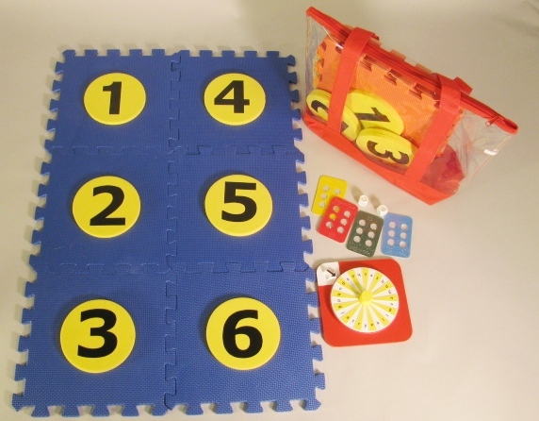

Background
The idea for Hop-A Dot Mat occurred to the project leader while attending a presentation by Dr. Penny Rosenblum at the 2014 Ohio AER Conference; the presentation outlined ways to provide a braille-rich environment for tactile readers. The project leader shared the idea of the Hop-A-Dot Mat with a teacher of the visually impaired who was attending the conference and who regularly works with young students. The teacher encouraged the project leader to submit and pursue the idea after citing the many benefits of the braille mat for her young braille students, adding that her “little ones love taking their shoes off and touching textures with their feet.” This casual conversation sparked a variety of ideas for possible games and activities to enhance the use of the mat, including braille-learning sing-alongs.

The primary objective of the Hop-A-Dot Mat is to encourage young children to learn the braille cell and dot configurations for each alphabet letter (or single-cell contractions) through movement and physical activity with peers. As described in the product submission form, the product will consist of six interlocking EVA (ethylene vinyl acetate) foam floor mats that can be displayed in the configuration of a large braille cell. Each interlocking square will have six removable foam circles. The circles, when removed, will provide large openings in the mat into which the child can place a foot/hand when locating dot numbers/positions. The removable circular pieces will be printed with the dot numbers and constructed so they are elevated slightly above the rest of the mat, forming short “steps.” The students can then tactually locate these steps with their feet or hands when identifying dot positions. Fun, “Twister® game-like” contortions would be accommodated (e.g., letter “c” can be formed by placing left foot on Dot 1 and right foot on Dot 4 simultaneously). As a variation, the student can hop or step on the elevated circles to build a braille letter/single-letter contraction. As another option, the student can insert the foam circles into openings of the mat to build a chosen letter. Note: EVA foam is a nontoxic material that is safe (does not contain plasticizers), waterproof, and washable, thus suitable for use with young children.

The Hop-A-Dot Mat will allow young children to become enthused about learning braille in an active way. Many braille learning tools currently offered by APH present braille learning through sedentary activities, and routine tools and materials. Learning through movement and kinesthetic reinforcement appeals to young children who learn experientially through play, experimentation, exploration, and discovery. Young students with visual impairments and blindness especially need opportunities to be physically active to reinforce important skills related to body awareness and spatial concepts (e.g., top, bottom, left, right, next to, between). The following image from an online slide presentation posted by the New Mexico School for the Blind in 2010 illustrates the importance of movement specific to learning braille and is accompanied by the following quote: “The Arts are not meant to replace the traditional methods of teaching braille. Instead, they should be used along with teaching the contractions to increase motivation and learning. You will find the Arts make teaching and learning more enjoyable and meaningful.” Movement stimulates the brain and strengthens memory.

The product submission form was shared with outside expert reviewers. Their ratings, according to specific criteria (e.g., overall need, appropriate target populations, originality), were collected prior to presentation of the product idea to in-house product review committees. Many of the reviewers’ comments alluded to anticipated benefits of the Hop-A-Dot Mat including the following:
- “This is a great product! It embeds so many necessary core areas in one activity.” – Lauren Lieberman, Ph.D., Professor, The College at Brockport, Brockport, NY
- “I think this will be a fun product for children to use and one that sighted children can also use as a way for them to learn braille with classmates and positional concepts. I love the tie in to movement as well as literacy. I can see a lot of games that can be created to use with this mat.” – Penny Rosenblum, Ph.D., Adjunct Associate Professor, Department of Special Education, Rehabilitation, and School Psychology, University of Arizona, Tucson, AZ
- “Benefits: active learning; encourage physical movement (so important for our kids especially); good way to break up a lesson and get little ones up so they are not sitting forever; reinforces braille dot positions; has the potential for many games that can be played with the mat.” – Frances Mary D’Andrea, Ph.D., Independent Educational Consultant in Visual Impairments, Pittsburgh, PA

On March 24, 2015, the product idea of the Hop-A-Dot Mat was considered and approved by the Product Evaluation Team who assessed its product development difficulty as “medium” and production difficulty as “high.” The estimated yearly volume for the first 3 years is 800 units. On April 3, 2015, the Product Advisory and Review Committee reviewed and approved the development of the product. The product transitioned immediately to the active timeline and was assigned the grant number 583.

Throughout May and June 2015, rapid progress was made by the project staff with regard to prototype development. Specifically, the project leader located and acquired EVA foam in a variety of colors and worked with the model/pattern maker to create the first prototype options of the Hop-A-Dot Mat. Attention was given to making the removable braille dots sit higher than the mat itself to make locating the foam braille dots within the entire mat easier by hand or foot. The best foam colors and sizes for the interlocking frames and circles were chosen.

The remainder of FY 2015 was focused on the creation of suggested activities for the Hop-A-Dot Mat, as well as the development of accessory items (e.g., print/braille alphabet spinner) as suggested by the expert reviewers. Structural options for linking multiple Hop-A-Dot Mats were explored and tested as well.

Prototype design and construction characterized the first and second quarters of FY 2016. A decision was made to include two Hop-A-Dot Mats in each kit—one with a blue frame with yellow numbered circles and one with a red frame with yellow numbered circles. As anticipated, the numbered circles where constructed by laminating two layers of EVA foam disks together; this extra thickness ensured a height difference between the circles and surrounding frame. Large adhesive-backed print numbers (output on the Roland® UV printer) were applied to the foam circles.

As the multiple Hop-A-Dot Mats were constructed, the project leader and model/pattern maker focused on the original design of the accompanying Print/Braille Alphabet Spinner. They made decisions regarding color, tactile arrow style, and braille/print letter placement. The spinner was designed with a flexible plastic “tongue” that clicks along a grooved vacuum-formed disk, providing auditory reinforcement. Additionally, the grooves of the disks assist in aligning the pointer with each alphabet letter.

The project leader located and gathered accessory materials (commercial and existing APH items) to accommodate a variety of braille activities that could be used with the Hop-A-Dot Mat. These materials included four Pop-A-Cells, a pair of tactile dice, and six bean bags in assorted colors. The project leader authored and graphically prepared an Activity Booklet for field test purposes. Activities included the following:

- Build-A-Cell
- Roll-A-Dot
- Letter Twist
- Roll-A-Letter
- Spin-A-Letter
- Pop-A-Cell to Hop-A-Dot
- Bean Bag Braille
- Two-Cell Rock
- All Feet on Deck
- Spell Your Name
- Braille Cha Cha
- Braille Punch
- Puddle Dots
- Build-A-Number
- Color-A-Cell
The Activity Booklet also offered “Body Building Braille Tips,” which suggests ways to form braille letters with your body on the Hop-A-Dot Mat, as well as care and safety instructions when using the mat. The addition of a durable color-coded carrying/storage bag for each Hop-A-Dot Mat was the finishing touch to the prototype.

A field test announcement was posted in the March 2016 issue of the APH News. Approximately 25 teachers expressed interest in participating in the evaluation of the Hop-A-Dot Mat. From this sample, 11 field evaluation sites were selected based upon geographic location, number of available students, and type of instructional setting; preference was given to those who had not recently field tested an APH product. Some selected sites allowed multiple teachers to share and evaluate the prototype.

Potential evaluators gave reasons for wishing to field test with their students with visual impairments and blindness; reasons hinted at the product’s usefulness even before formal field test. Their shared explanations included the following:
- “This looks like a great opportunity for my kindergartners and fourth grader who are learning Braille to get out of their desks and become more aware of their bodies while learning and practicing the Braille cell.”
- “My students are new Braille learners who may benefit from the large motor movements involved in playing this game.”
- “It looks like great fun for Braille introduction, as well as a way to engage our sighted peers in the process.”
- “My second grade student has some vision (ONH, roughly 20/200) and really is struggling to learn braille. He is at a kinder/first grade level in braille; just started the first grade Patterns series with him. Having a physical way to learn and understand the braille cell and how the dots are arranged would be hugely beneficial to him. He is very overweight but loves dance, games, and moving, and this type of learning activity would really engage all of his senses to learn in a visceral way. This might be the breakthrough we’ve been waiting for!”
- “I am always looking for ways to insert fun into Braille lessons. Having physical movement is always a plus when learning a new skill.”
- “I currently work with three students who are beginning to learn how to read. Two of these students need to be moving in order to stay engaged in learning; the third student has emerging gross motor and fine motor skills and so I am continually looking for ways to integrate meaningful movement into Braille lessons.”

Prototypes of the Hop-A-Dot Mat and related materials were mailed on March 17, 2016.
Evaluators were asked to return their completed evaluation forms and student outcome forms by May 15, 2016.

While the field test stage was underway, the project leader conducted a Product Development Committee (PDC) to acquaint members with the anticipated contents of the kit and to start investigating and acquiring material samples (e.g., EVA foam) from multiple vendors. Early experimentation of Roland® printed numbers on the thick EVA substrate was tested with successful outcomes. The tactile residue of the Roland® printed numbers proved a welcomed feature for the product and helpful to the end user.

In June 2016, the project leader compiled a final field test report. Field test evaluation forms were completed by 12 teachers of the visually impaired and blind. (One selected evaluator from Louisiana did not complete and return her evaluation form.) The field evaluators represented the states of Alabama, California, Florida, Georgia, Kentucky (2), Missouri (2), Ohio, South Dakota, and Virginia (2). The largest percentage (66%) of sites represented itinerant or itinerant/resource settings. Table 1 and Figure 1 show the distribution of field test sites according to type of educational setting and geographical location.

Table 1
Type of Educational Setting
Type of Educational Setting | State Location of Field Test Sites | Percentage
Residential | MO, SD | 17%
Itinerant | VA (2), FL, CA, GA, OH, MO | 58%
Itinerant/Resource | AL | 8%
Center-based/onsite Preschool/reverse inclusion | KY (2) | 17%
N = 12 |  | 100%
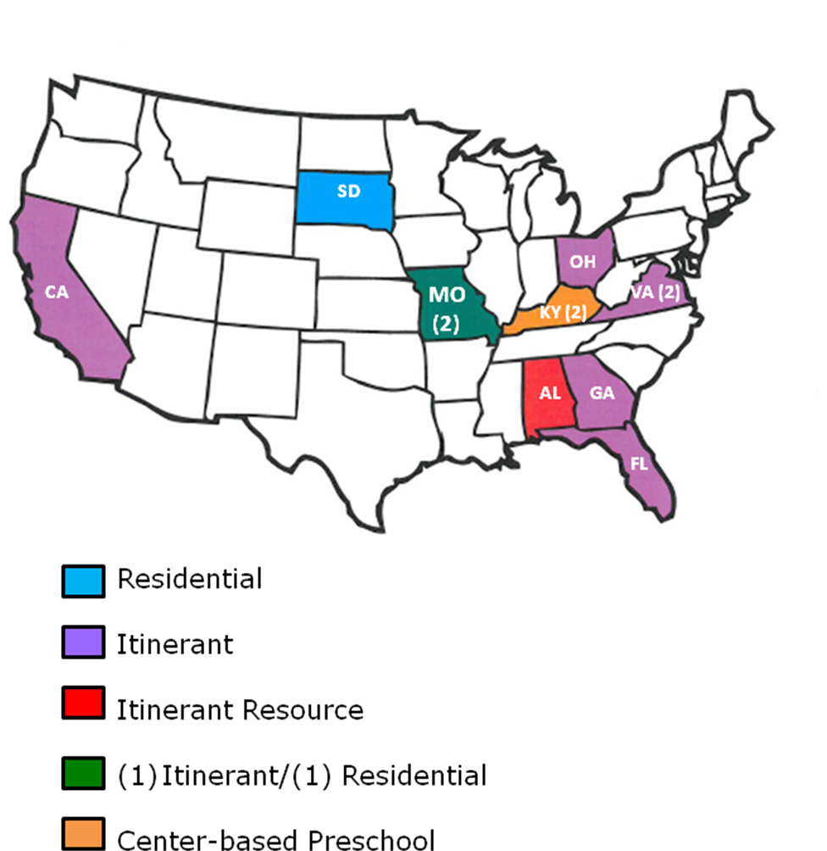
Figure 1. Geographical Distribution and Educational Setting of Field Test Sites.
Participating field evaluators represented a young generation of teachers of the visually impaired; 75% had 5 or less years of teaching experience and the remaining 25% had 6-10 years of teaching experience. A large percentage (83%) of the evaluators reported teaching braille reading “frequently” to their students with visual impairments and blindness. Prior to field testing, two of the teachers reported having created a floor-size representation of the braille cell; one did so using hula hoops, each labeled with a braille dot.

The field evaluators used the Hop-A-Dot Mat and related accessories with a total of 32 students who represented slightly more males (59%) than females (41%). The sample population represented cultural diversity: 72% White, 13% Black, 6% Asian, 3% Hispanic, 3% American Indian, and 3% two or more races. Half of the students had other disabilities such as autism, cognitive disabilities, developmental disabilities, and orthopedic impairments.

Students ranged in age from 3 to 16 years of age. Equal percentages were either 3 to 5 years old (25%) or 6 to 8 years old (25%). Another noticeable percentage (38%) were 9 to 11 years old. Only 12% were teenagers. (See Figure 2.)
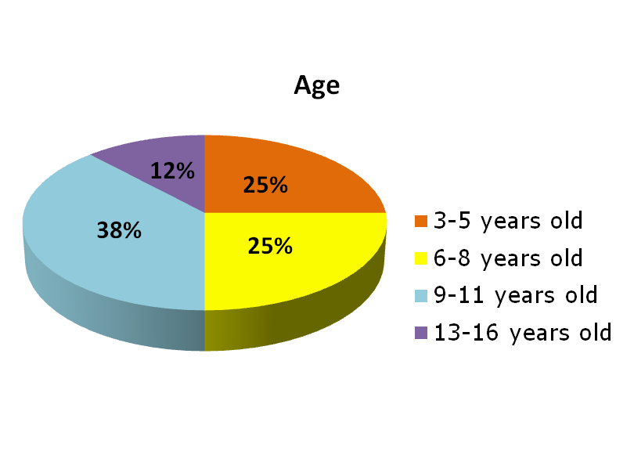
Figure 2. Students’ Age Range

With regard to grade level representations, equal percentages of students were classified as either preschoolers (19%) or kindergarteners (19%); 28% were in Grades 1 to 3, 25% were in Grades 4 to 6, and 9% were in Grades 7 to 9. (See Figure 3.)

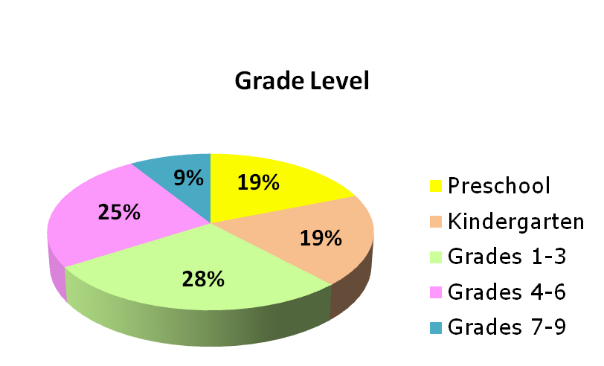
Figure 3. Students’ Grade Level
Nearly equal percentages of the student sample were reported as primarily braille readers (31%) or large print readers (28%); 22% were dual readers (e.g., auditory/braille or braille/large type), 9% read print with magnification, 6% were prereaders, and 3% were primarily auditory readers. (See Figure 4.)

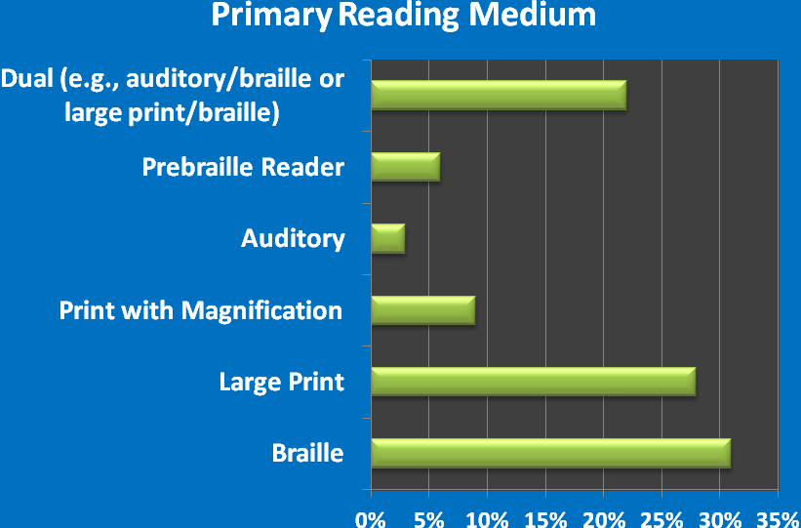
Figure 4. Students' Primary Reading Medium
The students’ level of braille knowledge varied with 25% unfamiliar with braille; 38% were familiar with the braille configuration and dot numbers, 28% knew the braille alphabet letters, 19% read uncontracted (letter-for-letter) braille, and 25% read contracted braille.

The field evaluation form allowed teachers to rate each feature of the Hop-A-Dot Mat. [Note: Two Hop-A-Dot Mats were provided to each evaluator in two different color schemes—blue frame with yellow braille dots and red frame with yellow braille dots.] Table 2 provides the average rating for each feature of the mat.

Table 2
Overall Design of Hop-A-Dot Mat
Rating Scale: 5 = Excellent to 1 = Poor (or Unneeded)
Product Feature | Number of Evaluators | Average Rating | 5 | 4.5 | 4 | 3 | 2 | 1
Overall size of Hop-A-Dot Mat | N = 12 | 4.5 | 67% | 8% | 25%
Quantity of provided Hop-A-Dot Mats (2 total) | N = 12 | 5.0 | 100%
Visual contrast of blue Hop-A-Dot Mat with yellow foam dots | N = 12 | 5.0 | 100%
Visual contrast of red Hop-A-Dot Mat with yellow foam dots | N = 12 | 4.92 | 92% |  | 8%
Size of numbers on foam dots | N = 12 | 4.92 | 92% |  | 8%
Ease of assembly/setup (i.e., linking squares and inserting foam dots). | N = 12 | 4.92 | 92% |  | 8%
Storage style (i.e., each Hop-A-Dot Mat stored in its own individual carrying bag) | N = 12 | 5.0 | 100%
Durability of Hop-A-Dot Mat | N = 12 | 4.75 | 75% |  | 25%
Portability of Hop-A-Dot Mat | N = 12 | 5.0 | 100%

Specific evaluators’ comments related to the features of the Hop-A-Dot Mat supported its overall strong ratings; comments included the following:
- “I liked how big it was [when] put together, but I especially like the fact that it could be taken apart, which made it so much more portable.”
- “Held up well under some active, occasionally rough play.”
- “Students could do this [assemble the mat] themselves with just a little verbal guidance.”
- “I thought the storage was very convenient.”

Planned improvements to the final product were decided based on ratings and comments. One such improvement will be the provision of braille number stickers to label the foam circles. This adaptation was used by one of the field evaluators using APH’s number stickers.

The field evaluation form allowed teachers to rate each and every feature of the Braille/Print Alphabet Spinner. Table 3 provides the average rating for each feature of the spinner.

Table 3
Overall Design of Braille/Print Alphabet Spinner
Rating Scale: 5 = Excellent to 1 = Poor (or Unneeded)
Product Feature | Number of Evaluators | Average Rating | 5 | 4 | 3 | 2 | 1
Overall visual presentation/color contrast | N = 11 | 4.91 | 91% | 9%
Overall size | N = 11 | 4.72 | 91% |  |  | 9%
Arrow position and style | N = 11 | 4.18 | 45% | 36% | 9% | 9%
Alternating color bands | N = 11 | 4.91 | 91% | 9%
Readability of print letters | N = 11 | 4.36 | 64% | 18% | 9% | 9%
Readability of braille letters | N = 11 | 4.91 | 91% | 9%
Random order of alphabet letters on spinner | N = 11 | 4.55 | 73% | 9% | 18%
Auditory sound made my spinner | N = 11 | 5.00 | 100%
Stability of spinner on flat surface | N = 11 | 5.00 | 100%
Knob in center of spinner for grasping/turning | N = 11 | 5.00 | 100%
Note: One of the 12 evaluators who shared the prototype with another colleague did not receive the spinner for review; therefore, only 11 evaluators reported ratings for this component.

Specific evaluators’ comments related to the features of the Braille/Print Alphabet Spinner supported its overall strong ratings, including the following:
- “Good size for students’ hands.”
- “My blind student was able to read the braille letters very well.”
- “Students were really attracted to this feature [auditory sound].”
- “All students could grasp [the knob].”

Planned improvements to the spinner were decided based on these ratings and comments (e.g., to enlarge print letters some). The majority of the evaluators (83%) recommended that APH offer the Braille/Print Alphabet Spinner as a separate product as well, apart from the Hop-A-Dot Mat. They also encouraged the development and production of a similar number spinner. Teachers suggested that the Braille/Print Alphabet Spinner could be used for a variety of word games and activities. One teacher stated, “This spinner is simply fantastic! I will be using it for many different things.”

One hundred percent of the field evaluators thought the accompanying Activity Guide sufficiently described the purpose and the use of the Hop-A-Dot Mat; they unanimously liked the layout and design of the booklet as well. Related comments included the following:
- “The activity guide gave more ideas than I have thought of on how to use the product.”
- “Brief and to the point. Just enough detail.”
- “The description of the game rules and body movements were very well understood.”
- “Attention grabbing, easy to read and understand.”
- “Visually appealing and handy to refer to all activities possible.”
- “Helped the classroom teacher to understand; full knowledge of braille not needed.”
- “It has enough variety for most TVIs and leaves room for them to design their own activities.”

The Activity Booklet presented an assortment of activities and games that could be played using the Hop-A-Dot Mat and related accessories. With the exception of one, all of the games and activities were performed with students during the field test period. The games “Build-A-Cell,” “Spin-A-Letter,” and “Bean Bag Braille” were among the most frequently used. These three activities/games were also reported as the students’ favorites. Table 4 indicates the frequency of use for each game/activity.

Table 4
Frequency of Game/Activity Use
Activity/Game | Number of Evaluators | Frequently | Occasionally | Never
Build-A-Cell | N = 12 | 67% | 33%
Roll-A-Dot | N = 12 | 50% | 17% | 33%
Letter Twist | N = 12 | 25% | 50% | 25%
Roll-A-Letter | N = 12 | 25% | 42% | 33%
Spin-A-Letter | N = 12 | 75% | 17% | 8%
Pop-A-Cell to Hop-A-Dot | N = 12 | 25% | 33% | 42%
Bean Bag Braille | N = 12 | 58% | 33% | 8%
Two-Cell Rock | N = 12 | 8% | 8% | 83%
All Feet on Deck | N = 12 | 8% | 17% | 75%
Spell Your Name | N = 12 | 17% | 42% | 42%
Braille Cha Cha Cha | N = 12 | 17% | 25% | 58%
Braille Punch | N = 12 | 8% | 17% | 75%
Puddle Dots | N = 11 | 0% | 36% | 64%
Build-A-Number | N = 12 | 8% | 33% | 58%
Color-A-Cell | N = 12 | 0% | 0% | 100%

As expected and encouraged, the teachers and students created games of their own using the Hop-A-Dot Mat such as “Alphabet Relay” and “Which One is Missing?” The project leader intends to incorporate these additional activity ideas into the final Activity Booklet. One of the evaluators suggested creating a blog with additional ideas.

Along with the Braille/Print Alphabet Spinner, additional game accessories were included with the prototype of the Hop-A-Dot Mat including a pair of tactile dice, four APH Pop-A-Cells, and six bean bags. The evaluators were asked if each accessory should remain a part of the kit, and if so, to indicate the ideal quantity. Table 5 shows the results of their feedback.

Table 5
Need for Accessories
Accessory | Number of Evaluators | YES, include with Hop-A-Dot Mat | NO, omit from Hop-A-Dot Mat
Pair of tactile dice | N = 12 | 83% | 17%
Pop-A-Cells | N = 12 | 67% | 33%
Print/Braille Alphabet Spinner | N = 11 | 100%
Bean Bags | N = 12 | 83% | 17%

Evaluation of the tactile dice (purchased from an outside vendor, but used in many of APH’s game kits) illuminated the need for less “prickly” dots. The project leader will pursue the product idea of a more tactually pleasant pair of dice for immediate or eventual inclusion with the Hop-A-Dot Mat.

The Hop-A-Dot Mat was favorably received by the students themselves. Evaluators indicated that 100% of the students enjoyed using the mat. Comments ranged from a short, enthusiastic “Loved it!” to lengthier explanations for its positive reception: “Greatly improved overall class interest in braille in general,” “This was a great reward for completing work!” and “My students asked to play Hop-A-Dot at the beginning of each class period.” According to 92% of the evaluators, the mat enhanced students’ interest in braille. Some of the comments captured on the Student Outcome Forms included the following:
- “He loved it—extremely motivating and engaging.”
- “Student is naturally very active. He seemed to enjoy using it. It was likely more fun than tactually reading braille.”
- “This student enjoys playing games. She is very tactile and enjoyed a different approach to braille.”
- “Since braille is usually 1-on-1 with a teacher or working with one other student, it increased his excitement to have everyone in the class exploring braille. He also liked the active aspect of the product.”
- “She liked that it was a game she could play better than others because she knows braille and they don’t.”

In some cases, the transition between the large presentation of the braille cell and standard braille size posed difficulties for students, yet 58% reported no observed hindrance. Usually this type of challenge was experienced by students with intellectual disabilities.

Half of the field evaluators indicated that sighted peers participated in the use of the Hop-A-Dot Mat with their students. Specific comments highlighted how the mat provided social interaction opportunities:
- “It started lots of conversations about braille, about sharing with peers, how to explain braille, and how to explain visual impairment, etc.”
- “They used the mats as much as their visually impaired friends, playing right alongside them. They were very interested in this active way to learn braille.”
- “We put the Hop-A-Dot in the kindergarten classroom as a center. The sighted kids spun the spinner, the braille student read the letter tactually, then made it with the bean bags. The sighted children were able to use the braille configuration on the spinner to tell if she had done it correctly or not.”

The majority (75%) of the evaluators indicated that the Hop-A-Dot Mat offered specific advantages over other braille awareness/instruction products including “ease of use,” “getting kids up and moving enhances learning,” “the physical aspect of it,” “very engaging,” and “a way for regular ed staff to better understand the braille cell.” Ninety-two percent of the evaluators indicated being more impressed and pleased by the Hop-A-Dot’s usefulness for students with visual impairments and blindness compared to their original expectations prior to field testing. Using a rating scale of 7 = Strongly Agree to 1 = Strongly Disagree, the evaluators gave a combined score of 6.67 when asked to indicate how well the Hop-A-Dot met its original goal and objective of increasing braille awareness and knowledge within a recreational context. As shown in Table 6, data collected on each of the 32 returned Students Outcome Forms reiterated this positive impact.

Table 6
Impact on Student’s Braille Awareness and Knowledge
Did the Hop-A-Dot Increase Student’s Braille Awareness and Knowledge?
N = 32
Strongly Agree | Agree | Somewhat Agree | Somewhat  Disagree | Disagree | Strongly  Disagree
38% | 34% | 22% |  | 6%

Teachers described the impact of Hop-A-Dot Mat on their students’ braille knowledge and awareness:
- “She loved it and I saw faster progress with spatial awareness and recognition of dot numbers than I have ever seen with her before.”
- “This was helping her form more concrete knowledge of Braille.”
- “This activity feeds into this particular child’s intellect. He really enjoys Braille and telling others about it.”

Table 7 indicates the evaluator ratings for the product usefulness for promoting other skills and concepts beyond braille knowledge and awareness.

Table 7
Other Skills/Concepts Promoted with Use of the Hop-A-Dot Mat
Skill/Concept | Number of Evaluators | Average Rating | 7 | 6 | 5 | 4 | 3 | 2 | 1
Social Interaction | N = 11 | 5.65 | 55% |  | 18% | 8% | 18%
Self-Expression | N = 12 | 5.08 | 17% | 25% | 33% |  | 25%
Physical Activity/Exercise | N = 12 | 6.50 | 67% | 17% | 17%
Body Awareness and Coordination | N = 12 | 6.08 | 50% | 25% | 8% | 17%
Tactile Discrimination | N = 12 | 4.80 | 17% | 17% | 33% | 17% |  | 17%
Understanding Spatial Concepts | N = 12 | 5.50 | 25% | 33% | 17% | 17% | 8%

Data collected via 32 Student Outcome Forms also illuminated strides made by individual students (see Table 8). Many of the students improved in multiple skill areas: 31% in two skill areas, 16% in three skill areas, 9% in four skill areas, and 9% in five skill areas.

Table 8
Individual Student Improvements in Skill Area(s)
Did you observe the student improve in any of the following areas after using the Hop-A-Dot Mat [check all that apply]? N = 32
Social Inter-action | Self-  Ex-pression and Creativity | Physical  Activity/Exercise | Body Awareness and Coor-dination | Tactile  Discrim-ination | Under-  standing of Spatial  Concepts | Other skill/con-cept (indicate)
47% | 22% | 44% | 38% | 5% | 14% | 9% (Team Work)

One hundred percent of the field evaluators recommended that APH produce Hop-A-Dot Mat. Supportive comments regarding its strengths included the following:
- “Makes braille fun and a social activity.”
- “It helps the child develop associative thought between the large circles and the Braille cell.”
- The mat “adds another dimension to braille instruction that we haven’t had before.”
- “It makes learning the braille cell fun. Student doesn’t have to stay seated at a desk.”
- “Great reward/motivator.”
- “Supported learning of new braille letters and contractions.”
- “Works on cognitive and motor skills simultaneously.”
- “Good proprioceptive practice” and “good spatial awareness practice.”
- “It is fun and the kids thought of it as a game.”
- “It included many pieces that can be used for a variety of activities.”
- “It encourages turn-taking skills when others must shake dice, jump on the mat, etc.”
- “Class discussion of Braille was the strength of Hop-A-Dot.”
- “Portable, something different, moving the entire body, games that can involve sighted peers.”

As Table 9 reveals, the most appropriate target populations for the Hop-A-Dot as assessed by the 12 field evaluators were tactile and low vision preschoolers, kindergarteners, and students in early elementary grades. However, use with older students was possible as well.

Table 9
Appropriate Target Populations
Target Population | Percentage of evaluators  (N =12) indicating appropriateness of product for target population
Preschoolers who are blind | 83%
Preschoolers who are low vision | 83%
Low vision students in Grades K-2 | 83%
Tactile readers in Grades K-2 | 100%
Low vision students in Grades 3-5 | 50%
Tactile readers in Grades 3-5 | 75%
Low vision students in Grades 6-8 | 17%
Tactile readers in Grades 6-8 | 25%
High school students with low vision/blindness | 8%
Students with additional physical disabilities | 33%
Students with deafblindness | 33%
Sighted peers | 50%
Adults who are beginning braille readers | 17%
Low vision adults | 8%
Sighted adults | 25%
Other (indicate): | - Sighted adults when playing with a visually impaired child  - Any NEW braille reader

Formal field test feedback was complemented by supportive and enthusiastic comments from the writers of Building on Patterns who got a sneak preview of the Hop-A-Dot Mat and the Braille/Print Alphabet Spinner during their onsite work meeting at APH in June 2016. They wanted to see the product available as soon as possible.

In late July 2016, the graphic designer initiated work on the layout of the Activity Booklet using final content authored by the project leader and edited by the research assistant. The guidebook incorporated new games and activities proposed by the field evaluators, such as “Braille Relay” and “Braille Bingo.” The graphic designer enhanced the “Body Building Braille Tips” section by including pictorial icons of hands, feet, and knees to illustrate suggested ways to form the braille alphabet letters.

In mid-August 2016, the following catalog numbers were assigned to the final product and associated spinners.
- Hop-A-Dot Mat (1-08819-00)
- Braille/Print Alphabet Spinner (1-08817-00)
- Braille/Print Number Spinner (1-08818-00)

In late August 2016, the project leader prepared the Braille Order Detail Form to request in-house braille translation of the Activity Booklet. Braille translation was completed in early September. Page counts of both the print and braille booklets were furnished to the manufacturing specialist to incorporate into the final product specifications.

In mid-September, the project leader regrouped the PDC members to transition the product to the “tooling stage” and review needed updates based upon feedback and suggestions from field evaluators. The following notable improvements and provisions were anticipated:
- Slightly larger print letters on the Braille/Print Alphabet Spinner
- Addition of a Braille/Print Number Spinner
- Addition of braille number stickers to label the foam dots
- Creation and assignment of separate replacement part numbers for blue and red Hop-A-Dot Mats to allow separate purchase apart from the full kit, if desired

In October 2016, Quota approval for the Hop-A-Dot Mat and related spinners was requested and received from the Educational Products Advisory Committee (EPAC) during Annual Meeting.

Prior to his retirement, Tom Poppe finalized the majority of the production tooling needed to produce the two spinners, which included the vacuum-form master for the upper disc with braille numbers (or letters), a multi-up vacuum-form master for the spinner’s arrow/pointer, the cutting die design for the spinner’s sound-generating “tongue,” and a cutting die for the spinner’s rigid foam base. A vendor was identified for the rubber cap to apply to the spinner hub.

In late October 2016, PDC members reviewed remaining tooling tasks and material selections. Although progress was sporadic in the coming months because of other higher product priorities, notable strides included the following:
- Purchasing staff secured cost for the clear vinyl carrying/tote bags. The graphic designer prepared related art for the bag insert.
- Samples of numbers printed onto EVA foam via the Roland® UV printer were generated so the project leader could select the ideal number of print layers to achieve a discernible tactile “footprint.”
- The project leader acquired interlocked EVA foam frames from the expected supplier for safety testing purposes and for cutting die layout.
- The graphic designer prepared the print design of the new Braille/Print Number Spinner and provided this to the manufacturing specialist to drop into a template for eventual printing and die cutting operations.
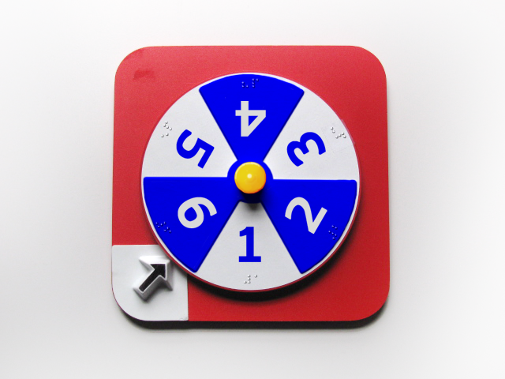

- Final packaging styles, including needed braille/print labels for the spinners and mats, were determined for warehousing and shipping purposes.

In April 2017, the project leader conducted another PDC meeting; however, progress continued to stall due to higher product priorities assigned to Technical Research staff. Frank Hayden received safety-testing results that confirmed the safety of the EVA foam according to Consumer Product Safety Improvement Act (CPSIA) guidelines.

Work during FY 2018
Progress on the production and progress of the Hop-A-Dot Mat continued to stall for most of FY 2018 in the Technical Research area due to higher product priorities and workload constraints. Newer opportunities to provide ready-made, purchasable commercial products/toys (e.g., Reach & Match® Learning Kit) leaped ahead in the production schedule. During the third quarter of FY 2018, the project regained some momentum with final approvals of some vendor parts (e.g., hub color for the spinners) and artwork preparation for the numbers to be printed on the EVA foam circles via the Roland® UV printer. The manufacturing specialist completed the product specifications document and conducted a Gate 5: Specifications meeting in July 2018. The final artwork for the print guidebook and carrying bag insert were uploaded to the production server. Expected production quantities were forecasted, and a production schedule was determined.

Work planned for FY 2019
Actual production of the Hop-A-Dot Mat and related spinners will likely occur during the second half of FY 2019. The project leader and manufacturing specialist will closely monitor the quality of the initial pilot and production runs. The project leader will prepare content for the product brochure and be active in marketing the product via presentations and workshops at national conferences. The project leader will also explore the development of an activity guide that offers additional fun, recreational games and braille learning opportunities using the alphabet and number spinners apart from the Hop-A-Dot Mat.

Physical Education, Recreation, and Health Web Site
(Ongoing)

Purpose
To provide individuals with visual impairments and blindness, parents, and teachers with a resource list that promotes health, physical education, and recreation

Project Staff
Tristan Pierce, Physical Education Project Leader
Kelly Kennedy Mimms, Research Assistant
Monica Vaught-Compton, Project Assistant
Malcolm Turner, Database and Website Coordinator
Ricky Irvine, Website and Video Designer

Background
APH funded a 3-year study on parent-child physical activity intervention among families of children with visual impairments. The investigators who conducted the study were Moira Stuart, Ph.D., Northern Illinois University; Lauren Lieberman, The College at Brockport; and Nicole Riscica, The College at Brockport. During year three of the study, APH produced a resource manual for the participating families. Upon completion of the study, APH decided to make the information available on its website. Staff updated the original resource manual and launched it on the APH Web site. Viewers can navigate between PE programs, nutrition, organizations, articles, books, equipment, events, magazines, mailing lists, national services, regional and state services, sport camps, stories, toys and games, videos, and websites. This is a live document; viewers can submit items for review and possible placement on the APH PE Web site.

Work during FY 2018
Staff posted the 2018 winter and summer sports camps. Once posted, as camp directors submitted updates, APH edited the camp listing as needed. Staff updated the Events page to include 2018 events, such as the Sports Extravaganza 2018 – 20th Anniversary, the 2018 Goalball Nationals, and the 2018 Beep Baseball World Series. Staff created five new features that included three coaching videos (in collaboration with the Institute of Movement Studies for Individuals with Visual Impairments-IMSVI) on cross-country running, track & field, and swimming; a review of a book on beep baseball; and an introduction with resources on using bike trainers. Staff added new online videos to the video library and updated the publications listing. Staff continues to work on new videos on basketball, soccer, and wrestling with the IMSVI.

Work planned for FY 2019
Staff will continue to launch new material and to update website.

Physical Education and Health Special Projects and Needs
(Ongoing)

Purpose
To research, identify, and develop products that promote physical activities, good health practices, social interactions, and self-advocacy

Project Staff
Tristan Pierce, Physical Education Project Leader
Kelly Kennedy Mimms, Research Assistant
Monica Vaught-Compton, Project Assistant

Background
APH recognized the need and began to develop products and fund university research in the area of physical activity in relation to students and adults who have visual impairment, blindness, and deafblindness. The positive feedback from the field prompted a new designation in the budget for Health and Physical Education.

Staff created the APH Physical Education, Recreation, and Health website. APH has since produced two books for teachers, one book for middle school students through adulthood, one storybook at 4th grade reading level, and one electronic book featuring stories by adults with deafblindness. APH produces three kits with which to teach and promote walking/running, jumping rope, and playing tennis. APH manufactures a variety of sound emitting balls and a portable sound source. APH has created or worked in collaboration with professionals in the vision field to provide health and sport related videos.

Work during FY 2018
The project leader continued to maintain the Physical Education, Recreation, and Health Web site. APH continued work on Count Me In: Motor Development in a Box. Staff continued collaboration with adapted physical education university professionals from The College at Brockport-SUNY and West Chester University to created three coaching videos: cross-country running, track & field, and swimming. The completed videos are on the APH Physical Education, Recreation, and Health website. Staff edited scripts for additional videos on basketball and soccer.

Work planned for FY 2019
Work will continue on the PE Web site. Staff will continue to review new product submissions from the field.

SPORTS COURTS
Formerly SPORTS COURTS: Touch and Play
(Continued)

Purpose
To provide a variety of interactive sports courts and fields (e.g., basketball, tennis, football, bowling) with interactive pieces to demonstrate player positions and game rules. The tactile displays will be accompanied by reference booklets coauthored by a team of experts who regularly provide instruction in this content area to students with visual impairments and blindness.


Project Staff
Karen J. Poppe, Tactile Literacy Project Leader/Coauthor/Product Designer
Rachel Bishop, Research Assistant/Primary Editor
Lauren Lieberman, Contributing Author
Justin A. Haegele, Contributing Author
Monica Lepore, Contributing Author
Maria Lepore-Stevens, Contributing Author
Jenna Sticken, Contributing Author
Tom Poppe, Pattern/Model Maker (Retired)
Andrew Dakin, Pattern/Model Maker
Patrick White, Pattern/Model Maker
Andrew Moulton, Manufacturing Specialist
Anthony D. Jones, Director of Creative Services
Matthew Poppe, Graphic Designer
Joon Lee, Copyright and Cataloging Librarian

Background
The prospect of developing an interactive set of tactile sports courts and fields was originally explored by the Tactile Graphics Brainstorming Committee in August 2002. Over the years, the project leader consistently incorporated the development of such a product into her annual budget reports. However, the project was repeatedly sidelined due to higher priority research projects. The product idea gained some careful consideration after repeated product submissions were received from teachers in the field, especially from those who routinely teach physical education to students with visual impairments and blindness.

SPORTS COURTS is expected to address the following needs and requests from the field:
- To provide interactive tactile materials to assist students’ understanding and participation in a variety of sports and physical activities
- To alleviate the burden of teachers having to create and build their own tactile displays for introducing sports-related concepts to their students
Example: “I make tactile boards for my students. If there were commercially-available diagrams, I would buy them! It would be a time saver for me!” – Megan O’Connell, Teacher–Adapted Physical Education, Perkins School for the Blind (survey respondent)
- To address expanded core curriculum skills such as social skills and self-determination
- To broaden APH’s inventory of physical education products and tactile learning materials

Feedback regarding the need for SPORTS COURTS was most directly indicated by 32 respondents to a product-specific survey conducted by the project leader in February 2012. The following are the results of that study.

Survey respondents represented the following states, as well as one Canadian province: Washington (2), California, North Dakota, Colorado, New Mexico (2), Minnesota (2), Iowa (2), Missouri (4), Illinois, Indiana, Alabama (2), Florida (4), Pennsylvania (2), New York (2), Massachusetts (2), Alaska (2), and Calgary, Alberta (1). (Refer to Figure 1.)

Figure 1. Distribution of Survey Respondents by Geographical Location

As Figure 2 illustrates, the respondents reflected a dynamic group with a variety of titles including Teacher of the Visually Impaired, Certified Orientation and Mobility Specialist, Rehabilitation Teacher, Braille Specialist, Vision Specialist, and Physical Education/Recreation Specialist.

Figure 2. Survey Respondents’ Professional Titles

Survey respondents indicated a multitude of barriers to a student’s involvement and understanding of sports if he or she is visually impaired or blind. The top three barriers related to 1) adequate instruction time, 2) others’ attitudes regarding the student’s ability/interest, and 3) available time for instruction. Instructor’s knowledge/background and availability of sports equipment were additional obstacles. The student’s own attitude toward sports and scheduling conflicts seemed to have the least negative impact. (Refer to Figure 3.)

Figure 3. Barriers to Student’s Involvement and Understanding of Sports

The frequency of teaching concepts related to sports courts and fields to students with visual impairments and blindness was nearly equally distributed across the continuum of “frequently (two times a week or more)” to “occasionally (once a month)” to “seldom (two or three times a year)”—31%, 28%, and 34%, respectively. The remaining percentage of respondents reported “never,” “depends on grade level,” “one time a week,” or no response was given. (Refer to Figure 4.)
Figure 4. Frequency of Teaching Concepts Related to Sports

The following graph reflects the top-10 most needed sports courts/fields based upon the respondents’ rankings. The top-10 sports courts/fields included (from most to least) soccer, basketball, baseball/softball, bowling, beep baseball, goalball, track and field, football, volleyball, and tennis. Diminishing in demand were swimming, bocce, hockey, golf, badminton, speedball, lacrosse, and rugby. (Refer to Figure 5.)

Figure 5. Top 10 Requested Sports Courts and Field Layouts

Respondents were asked to indicate the overall need for SPORTS COURTS on a scale from 5 = extremely needed to 0 = not needed. Nearly half (47%) of respondents thought the product was extremely needed, and 31% gave it a “4” rating. (Refer to Figure 6.)

Figure 6. Overall Need for SPORTS COURTS

The results of the SPORTS COURTS survey were presented at APH’s 144th Annual Meeting during a product input session. Although the session was attended by a small audience, a lively discussion addressed possible structural formats from magnetic to VELCRO® brand compatible platforms and from mostly ready-made (static tactile presentations) to very interactive 3D models. To spark conversation, the project leader presented an interactive tennis court she fabricated with moveable players, tactile court lines/boundaries, braille labels, and a 3D net.

On May 8, 2013, the project leader submitted a formal product submission form describing and recommending the development and production of SPORT COURTS. The product idea was approved by the Product Evaluation Team on May 29, 2013, and by the Product Advisory and Review Committee (PARC) on June 13, 2013. The product development difficulty was rated as “high,” as well as the production difficulty. An estimated development time (PARCing Lot to stock) of 2.5 years was forecasted.

Appropriate target populations for SPORTS COURTS will encompass the following:
- Students/adults with visual impairments and blindness who need and want to participate in sports activities
- Adapted physical education teachers
- General physical education teachers
- Orientation and mobility instructors
- Teachers of the visually impaired

Components proposed by the project leader for inclusion in the kit include the following:
- Various multi-color screen printed/vacuum-form sports courts that can be mounted to a metal surface
- Moveable players (e.g., perhaps using Tactile Town’s pedestrian pieces with two colors and two textures) to differentiate between teams or individual players and to demonstrate player positions and movement on the field/court
- Accompanying guidebook highlighting the background/history, adaptations/modifications, and basic rules of various sports. This guidebook will be written and prepared by experts in the field, some of whom submitted similar product submissions to APH in recent years.
- A housing binder with built-in compartments for players and other game pieces

Toward the end of FY 2013, the project leader and Tom Poppe fabricated some possible 3D pieces (e.g., bowling pins, two sizes of goal posts, basketball goals) for consideration, as well as a thermoform pattern of a tactile tennis court.

Significant updates on SPORTS COURTS occurred throughout FY 2014, characterized by the continued development, design, and generation of the first court layout—Tennis. Multiple copies were produced using a prepared vacuum-form pattern and silkscreen art. The project leader devised a way to produce the 3D net with a commonplace needlepoint canvas material. Strong magnetic tabs were located and tested for secure placement of the 3D parts on a metal surface (i.e., APH’s ALL-IN-ONE Board). The colors of the pedestrian pieces from Tactile Town were updated to include a red player.

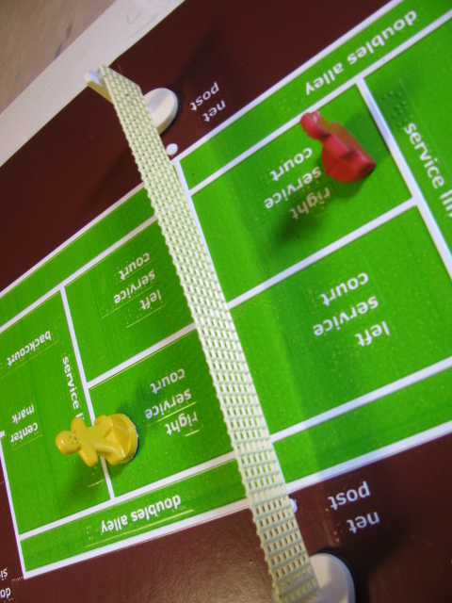

In early January 2014, a team of consultants, some who had previously submitted similar product submissions for tactile court and field layouts, joined the project. The lead consultant, Dr. Lauren Lieberman, worked directly with the project leader to decide on planned courts and fields and related components, based upon earlier survey results. A magnetic platform, based on the initial tennis court layout, was deemed the right direction for the courts versus a VELCRO® brand style surface. The foldable feature was also advantageous for convenient storage in a binder.

The project leader and consultant outlined the purpose, target populations, and expected product components of the kit for the Product Development Committee (PDC). It was decided that the following 11 x 17-in. tactile/print layouts would be readied for field test purposes:
- Badminton
- Baseball
- Basketball
- Beep Baseball
- Bowling
- Floor Hockey
- Football
- Goalball
- Golf
- Lacrosse
- Soccer
- Swimming
- Tennis
- Track and Field
- Volleyball

Additional sports chapters, minus tactile/print layouts, would be provided for Softball (reviewed in combination with the Baseball layout), Ultimate (played on a flat grass field), and Speedball (usually played on a soccer field or basketball court).

Ideal field test times were discussed and tentatively planned, as well as probable field test sites—five summer camps and 15 academic settings. The co-authors/consultants were contacted, contract agreements were signed, and delineation of authoring tasks was determined via a teleconference call. Per the consultants’ request, the project leader developed an initial design of the Tennis chapter that could serve as a starting point for later refinements; a complementary tennis logo was designed to match the basketball motif. Eventually, final content headings were determined by the authoring team and shared in a Google Docs™ template; regular updates were made to each sport chapter throughout April and May 2014.

Concurrent with the aforementioned project-related activities, the project leader assisted APH Development Staff in pulling together product information and budget estimates for grant submission purposes. Several positive outcomes resulted from this mutual effort. Initially, after reviewing a grant application and taking a tour at APH’s research and manufacturing plant, the United States Tennis Association (USTA) Southern granted $1,000 to APH for the development of the SPORTS COURTS kit consisting of 15 different interactive, tactile sports models and guidebook www.aph.org/development/thanks/. Secondly, APH was notified that the development of SPORTS COURTS will be featured in the September 2014 issue of TENNIS magazine, a national magazine that goes to every USTA member in the United States; complementary photo(s) of students with visual impairments and blindness exploring the tactile court layout will be included. The project leader assisted with the photo shoot taken at the Kentucky School for the Blind.

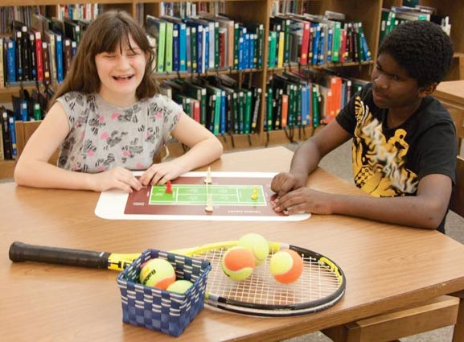

Throughout June and July 2014, the project leader and Tom Poppe concentrated on design of the actual court and field layouts. Because of higher project priorities in Technical Research, the project leader personally assumed the complex task of creating a matrix to accommodate and ensure minimal silkscreen setups using a limited number of ink colors; she also outlined the vacuum-form master setups with a total of eight 2-up patterns needed. This matrix served as a roadmap for all subsequent work on the prototype versions of the courts/fields. Each court/field design was planned taking into account proper dimensions, typical court/field features, visual contrast, texture application, and print and braille label placement. A unified look and feel for the overall presentation of all of the courts and fields was maintained throughout the design process.

Prototype development also encompassed the original molding and fabrication of related 3D manipulatives such as goal posts, bowling pins, basketball nets, and players. Separate thermoform patterns were built to produce magnetic X and O pieces to demonstrate defensive and offensive player positions of team sports (e.g., football, volleyball, soccer). Andrew Dakin and Andrew Moulton generated the basketball backboards via a 3D printer; Tom Poppe fabricated the remaining 3D parts and embellishments.

In August 2014, the project leader took the opportunity to gather additional names and contact information from those attending the 2014 International AER Conference in San Antonio, TX, who might be interested to serve as field evaluators. The field test opportunity was announced at a general session presented by Dr. Lieberman. A total of 20 teachers completed and submitted forms that also captured their ideas for product components. Many of the requested design features echoed the planned blueprint for the product with emphasis on appropriateness for both students with low vision and blindness, portability, simple-but-functional presentation, durability for indoor/outdoor use and by multiple users, easy to share, proper dimensions/ratios of courts, foldable, and different shapes for offensive and defensive players.

Although originally optimistic that the field test stage might begin during FY 2014, it became apparent that the complexity and scope of prototype development, as well as the project staff’s involvement in other project endeavors, would dictate a lengthier timeline.

A steady pace of activities and tasks by the project staff characterized the first two quarters of the FY 2015. Significant strides were made in the preparation and design of the dual tactile/visual layout of each sport court or field layout. First, the dimensions and important features of each field/court were researched; the most tactually meaningful way to show each layout was then determined. Effort was made to incorporate interesting textures and varying elevations of graphic elements into all of the sports layouts (e.g., water texture in Swimming layout, rough sandy bunkers in the Golf layout).

After the tactile layouts were established, complementary silkscreen art was created to generate the print counterparts. Attention was given to utilizing and juxtaposing high-contrast colors within a given field or court layout, always with the low vision reader in mind; large print text was incorporated as well.

To generate multiple copies of each layout for field testing purposes, 2-up images of the sports layouts were screen printed in-house. The printed sheets were then vacuum-formed to create the final combined tactile/color layouts and were trimmed to finished size. Each layout was captured on a single 11 x 17-in. sheet and hinged slightly off center and three-hole punched for inclusion in a binder.
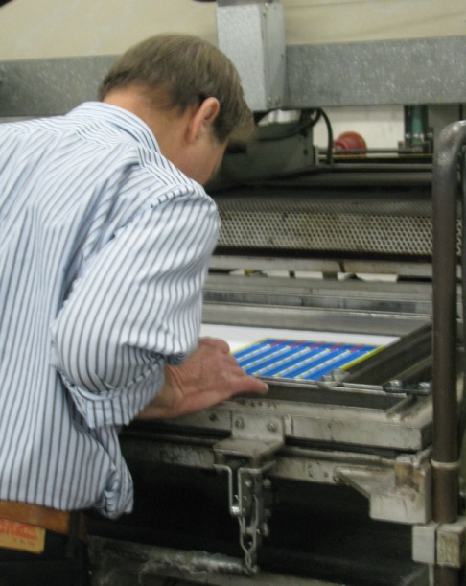
The design of the accompanying 3D features (e.g., players, nets of various lengths, goal posts, bowling pins, basketball nets) was concurrent with the development of the tactile/print sports layouts. The 3D parts were created using a variety of mold-making techniques (e.g., liquid resin process or 3D printer). Hook material and/or magnetic attachments were added to each manipulative for eventual positioning on the corresponding sport field or court. Careful attention was given to the incorporation of high-contrast colors, textures, and recognizable features. For example, the 3D players contrast in both color (red versus yellow) and texture (smooth versus rough). Additionally, the 3D pieces accommodate multiple uses across all of the court and field layouts. For example, the two sizes of goal posts can be used as supports for nets (as in Tennis and Volleyball), goal posts (as in Football), hoops (as in Basketball), or flags (as in Soccer and Golf).

Under the corners of each sports layout are four corner magnetic tabs that secure the layout to a metal surface such as APH’s ALL-IN-ONE Board (as shown in the photo) or to a cookie sheet. The 3D pieces have magnetic bases that can be used in combination with the sports layouts. The layouts can also be used as stand-alone displays on a flat desk or table surface.
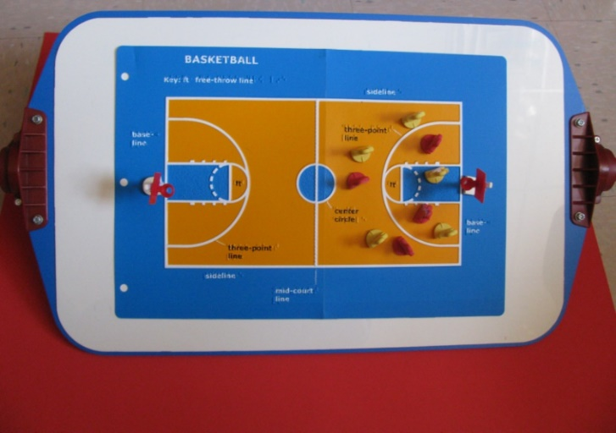

Following the construction of the tangible parts (court/field layouts and 3D items), the project staff’s attention shifted to the editing and layout design of the accompanying sport chapter booklets. Using the chapter content previously submitted by the consultants/contributing authors, the project leader performed the following tasks:
- edited and expanded chapter content
- incorporated new chapter sections (e.g., resources such as videos, adaptive materials/products, and online research/articles)
- guided the general layout and design of the sports chapter, each visually identified by a unique banner/logo created by Anthony Jones
- established a look for the binder cover art
- incorporated final grammatical and typographical corrections throughout all chapter booklets based on needed edits identified by Rachel Bishop
- finalized the layout of each sport chapter booklet and inserted photos of the corresponding field/court layout
- prepared an “Overview” chapter that describes the product’s purpose and target population, the type and quantity of each 3D component, and possible application and recommended setups of the sports fields and courts.

Each sports chapter was printed separately as a saddle-stitch booklet and 3-hole punched for inclusion in the binder with its corresponding tactile/print sports layout.
Chapter subheadings include the following:
- History
- Objective of Game
- Court Dimensions and Layout
- Equipment
- Attire/Uniforms
- Player Positions and Roles
- Game Rules
- Scoring Methods
- Basic Strategies
- Adaptations for Blind and Visually Impaired Students
- Assessment Strategies
- Deafblind Strategies
- Terminology
- Major Sports Events
- Famous Players
- Trivia
- Additional Resources:
- Adaptive Materials/Products
- Online Information, Articles, and Research
- Videos

A field test announcement was posted in the April 2015 APH News; it included a link to a short Google DocsTM survey (goo.gl/forms/1gu7j9MUpZ) that each interested field test evaluator was required to complete to be considered for selection. Besides basic contact information, the survey gathered feedback regarding each respondent’s student population (number and grade level), preferred testing session (summer or fall), types of fields and courts most likely needed, and reason(s) for desiring to field test. Responses to the latter question illuminated the obvious need for the product as demonstrated by the following statements:
- “I am always trying to enhance my teaching strategies when working with my visually impaired students! I find it most difficult to find the resources I need to introduce, implement, and evaluate my work with my VI students. I would love to have the tools to give them knowledge and opportunity to successfully participate in as many sports/activities as possible. I want my students to experience every possible enjoyment that can come from our curriculum.”—Adapted PE Teacher
- “I have made up some of my own sports tactile graphics in the past; they were very helpful, but limited. I like for my students to know about sports as it is such a huge past time in our society. This gives the VI students the ability to talk intelligently about subjects that sighted individuals consistently talk about. It will be a big help for the APE teachers in our district.”—Teacher of the Visually Impaired/O&M Instructor
- “I have students who have expressed a desire during their IEPs to be more physically active during the new school year. I have spoken to them about the importance of playing team sports and have also encouraged them to apply with local agencies, clubs, and centers to get more involved with social activities to foster friendships within their community. As an O&M Specialist, I like to use tactile graphics as often as possible to foster greater problem solving skills and to reinforce map skills and object-to-object spatial relationships.”—O&M Specialist
- “I work with a group of students who have expressed interest in learning more about the sports their siblings are playing. I believe that SPORTS COURTS would complement the research and reading my students have done and would provide them with a better understanding of sports they have chosen to study.”—Teacher of the Visually Impaired
- “I would like a quality standard tactile graphic that I am able to manipulate for instruction. Many home-made graphics I have made in the past are not easily manipulative or not durable to withstand use over multiple years.”—Goalball Specialist
- “I want to encourage greater participation and understanding of sports for students with visual impairments and blindness. While describing the sport and using Draftsman or Picture Maker is my normal go to, it is not the best practice and I want a product to help get the main concepts to my students.”—Teacher of the Visually Impaired/O&M Specialist
- “Some of my students have siblings who participate in sports and are drug along to the games and have no idea about how the game is played.”—Teacher of the Visually Impaired

Survey respondents’ indication of which sport court and field layouts they would likely use during field testing reinforced the need for particular layouts. As illustrated in Figure 7, basketball, track and field, and soccer were among the most needed; conversely, badminton, lacrosse, and golf were among the least in demand.

Figure 7. Need for Sports Layouts by Type

A total of 40 teachers and parents expressed interest in participating in the evaluation of SPORTS COURTS: Touch and Play by completing the initial survey. A spreadsheet of possible field test sites was generated. The titles of survey respondents included teachers of the visually impaired, orientation and mobility instructors, adapted physical education teachers, a goalball specialist, a braille specialist, and program directors, a vision rehabilitation therapist, and one parent. From this sample, five summer camp sites and 12 fall session field test sites were selected. Participants were selected based upon geographic location, number of available students, and type of instructional setting; preference was given to those who had not recently field tested an APH product.

A total of 20 complete prototypes were built and available for field testing by mid-June 2015. On June 17, five prototypes were mailed to five summer camp evaluators who represented the states of Louisiana, New York, Florida, Ohio, and Alaska. On September 1, 12 prototypes were mailed to the fall-session evaluators who represented the states of Arizona, Florida, Indiana, Nebraska, Pennsylvania, Washington, Maine, Minnesota, North Dakota, Texas, and Missouri, as well as Canada. Two prototypes remained at APH for tooling and in-house reference, Quota approval, and product display purposes. The remaining prototype circulated among the co-authors for their review.

Each prototype of SPORTS COURTS: Touch and Play included the following components:
- 1 three-ring binder with all sports courts tactile/print layout and related chapters
- 3D manipulatives including the following:
- 10 bowling pins
- 2 basketball nets
- 2 football U-shaped goals
- 4 tall white goal posts
- 2 short white goal posts
- 6 red players
- 6 yellow players
- 12 “X” players
- 12 “O” players
- 4 red flags
- 1 long yellow net
- 2 long white nets
- 2 medium-sized white nets
- 2 short white nets
- CD-ROM with chapter content for each sport
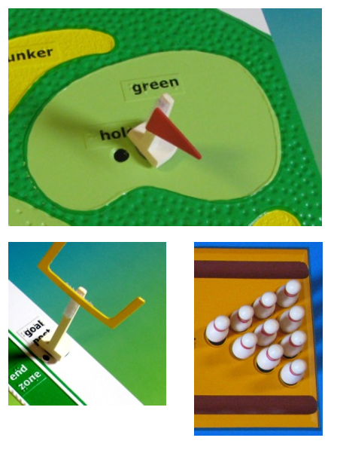

Each prototype was accompanied by an extensive Product Design Evaluation Form, as well as a Student Outcome Form (to be completed for each student involved in the field test activity). Summer camps were asked to return their completed forms by September 1, 2015, and fall-session evaluators were asked to return completed forms by November 20, 2015.

Field test evaluation forms were returned by 18 reviewers representing a variety of professional titles including teacher of the visually impaired, certified orientation and mobility specialist, adaptive physical education teacher, goalball specialist, learning media specialist, youth and family service director, and research assistant/graduate student. Some of the field evaluators requested more time to field test the prototype; extra review time was granted. Multiple evaluation forms were returned from coaches and other specialists using the prototype at Camp Abilities Brockport in New York, but some of their forms were incomplete. As a result, this site was not included in the final evaluator sample (N = 18) for determining average ratings; however, the reviewers’ collective suggestions/comments were recorded throughout the final field test report and taken into consideration. One selected evaluator from Indiana submitted a 2-page summary of her review of the prototype in lieu of a formal evaluation form. Three of the originally selected field test sites from Canada, Minnesota, and Ohio did not return evaluation forms. A final field test report was prepared in April 2016.

The field evaluators (N=18) represented the states of Alaska, Arizona (2), California, Florida, Georgia, Louisiana, Maine, Massachusetts, Missouri, Nebraska, North Dakota, New York (2), Pennsylvania (2), Texas, and Washington. Table 1 shows the distribution of field test sites according to type of educational setting and geographical location.

Table 1
Type of Educational Setting
Type of Educational Setting | State Location of Field Test Sites | Percentage
Summer/Sports Camp | AK, AZ, NY (2) | 22%
Residential | CA, MA, TX | 17%
Itinerant | FL, GA, ME, MO, ND, NE,  PA (2), WA | 50%
School Based Day School | AZ | 5%
Summer Camp (summer session)/Itinerant (fall session) | LA | 5%

Participating field evaluators varied in their teaching experience with students with visual impairments and blindness. The largest percentage (33%) reported 6-10 years teaching experience, 17% reported 16-20 years teaching experience, and 6% reported 11-15 years teaching experience. The percentage of teachers with fewer than 5 years of teaching experience mirrored the percentage of teachers with more than 21 years of teaching experience—22% within each category.

The majority (72%) of field evaluators indicated that the lack of available instruction time was the most common barrier to students’ involvement and understanding of sports. Other barriers included lack of instructional materials and others’ attitudes regarding the students’ ability and interest.

The evaluators varied in their frequency of teaching sports-related concepts to students with visual impairments and blindness prior to field testing: 39% addressed these concepts “occasionally (once a month),” 33% reported “seldom (2 or 3 times a year),” 11% reported “frequently (2 times a week or more),” 11% reported “never,” and 6% reported “once a week.” They utilized a variety of materials to encourage the students’ participation in sports including beep balls and sound sources, APH products (e.g., 30-Love Tennis, Everybody Plays! How Kids with Visual Impairments Play Sports), and teacher-made tactile boards and models. The majority (72%) of field evaluators indicated having to create teaching tools on their own such as tactile diagrams of baseball fields, tennis courts, and bowling alleys using craft materials (e.g., yarn, glue, tape, puff paint, Wikki Stix®, etc.).

The field evaluators used SPORTS COURTS with a total of 89 students who represented slightly more males (53%) than females (45%); the gender of two students was unreported. The distribution of the student sample across the various types of instructional settings is shown in Figure 8.

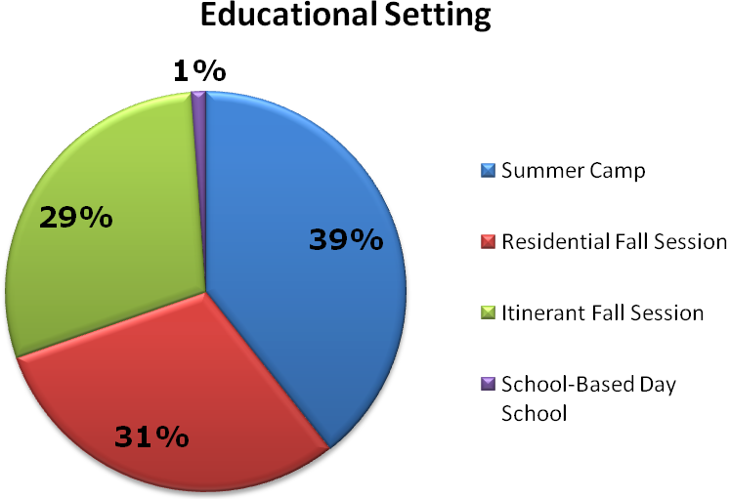
Figure 8. Distribution of Student Sample by Educational Setting

As evident in Figure 9, the student population represented cultural diversity: 39% White, 17% Hispanic, 15% Black, 4% Asian, 3% American Indian, and 4% Two or more races; the ethnicity of 18% of the students was unreported. One-fourth of the students had other disabilities such cerebral palsy, severe or moderate cognitive disabilities, ADHD, autism, and hearing impairment.

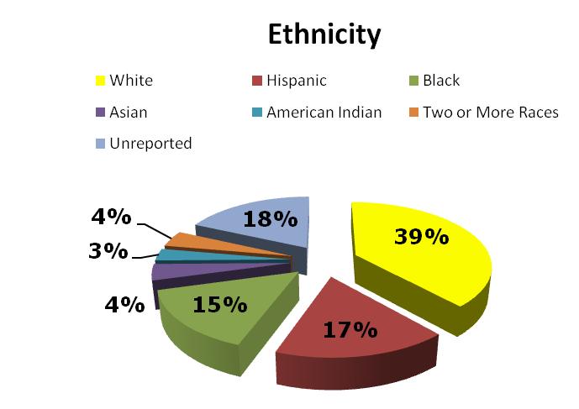
Figure 9. Students’ Ethnicity

Students ranged in age from 6-48 years old. Nearly half (49%) were 14-18 years old, and 34% were 10-13 years old. Identical percentages were either 6-9 years old (8%) or 19-48 years old (8%). The largest percentage (40%) of students were in Grades 9-12, 33% were in Grades 6-8, 8% were in Grades 4-5, 6% were in Grades K-3, and 7% were high school graduates. Grade level was unreported for 6% of students; one adult did not graduate from high school.

As shown in Figure 10, the majority (72%, n = 64) of the students were braille readers. Each remaining classification of primary reading medium was represented by 13% or less of the student sample that included large print readers, auditory readers, dual readers, and regular print readers.

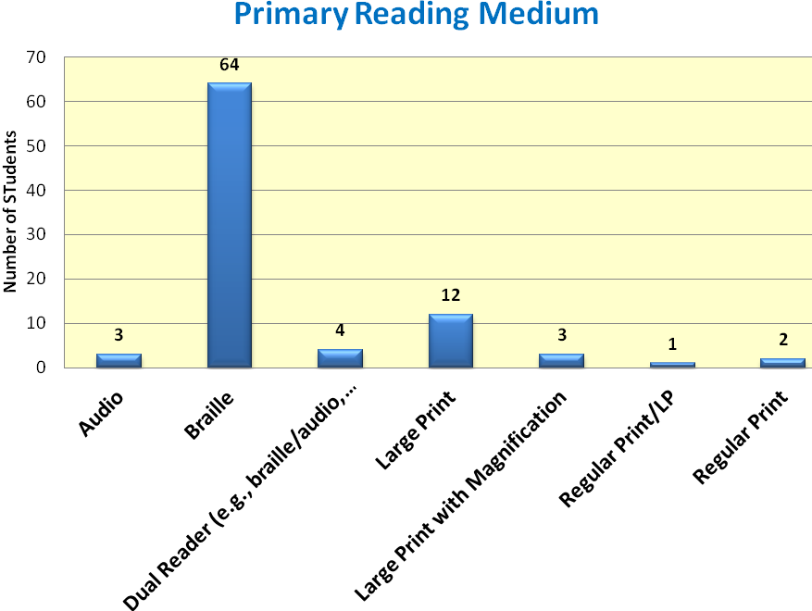
Figure 10. Students’ Primary Reading Medium

The field evaluation form allowed teachers to rate each feature of SPORTS COURTS. Table 2 provides the average rating for each product feature.

Table 2
Overall Design of SPORTS COURTS
Rating Scale: 5 = Excellent to 1 = Poor (or Unneeded)
Product Feature | Number of Evaluators | Average Rating | 5 | 4 | 3 | 2 | 1
Overall design/presentation | N = 18 | 4.39 | 50% | 39% | 11%
Overall visual presentation of individual court/field layouts | N = 18 | 4.83 | 89% | 6% | 6%
Overall tactile presentation of individual court/field layouts | N = 18 | 4.78 | 83% | 11% | 6%
Variety/assortment of provided court/field layouts | N =16 | 4.75 | 81% | 13% | 6%
Size of foldable 11 x 17-in. court/field layouts | N = 18 | 4.72 | 78% | 17% | 6%
Use of court/field layout in combination with 3D manipulatives | N = 17 | 4.12 | 47% | 35% | 6% | 6% | 6%
Durability of court/field layouts | N = 18 | 4.44 | 50% | 44% | 6%
Portability/storage style of court/field layouts (i.e., hole-punched and included in binder | N = 18 | 4.67 | 67% | 33%
Separate booklet style of each sport chapter | N = 15 | 4.90 | 87% | 6% (4)  6%  (4.5)
Content sections for each sports chapter | N = 18 | 4.61 | 78% | 11% | 6% | 6%
Binder cover design and sports logos | N = 18 | 4.83 | 89% | 6% | 6%

The field evaluation form also invited the instructors to assess each 3D manipulative. Table 3 provides the average rating for each of these pieces. Evaluators who did not have access to a magnetic board chose not to rate the 3D pieces due to nonuse or gave the 3D part the lowest possible rating.

Table 3
Overall Design of 3D Manipulatives
Rating Scale: 5 = Excellent to 1 = Poor (or Unneeded)
3D Manipulative | Number of Evaluators | Average Rating | 5 | 4 | 3 | 2 | 1
Bowling pins | N = 15 | 4.33 | 60% | 27% | 6% |  | 6%
Red basketball nets | N = 14 | 4.14 | 50% | 29% | 14% |  | 7%
Football U-shaped goals | N = 14 | 4.43 | 71% | 15% | 7% |  | 7%
Tall white goal posts | N = 15 | 4.40 | 67% | 20% | 7% |  | 7%
Short white goal posts | N = 15 | 4.47 | 73% | 13% | 7% |  | 7%
Red 3D players | N = 15 | 4.27 | 67% | 13% | 7% | 7% | 7%
Yellow 3D players | N = 15 | 4.33 | 73% | 7% | 7% | 7% | 7%
X players | N = 14 | 4.57 | 79% | 14% |  |  | 7%
O players | N = 14 | 4.57 | 79% | 14% |  |  | 7%
Red flags | N = 14 | 4.64 | 93% |  |  |  | 7%
Nets in various lengths | N = 15 | 4.60 | 80% | 13% |  |  | 7%

The majority (83%) of evaluators indicated that SPORTS COURTS offered specific advantages over other similar products, homemade or commercially available including the following: “the quality was great,” “much more colorful (for LV students),” “better, more durable Braille than most graphics,” “it was made of a very nice, durable material,” “saved so much time from trying to create diagrams for students,” “consistent and clear lines,” “creative color combinations,” “made the whole court/field accessible,” and “durable—ready to use!” As indicated in Table 4, SPORTS COURTS was assessed by field evaluators as appropriate for a broad range of students and instructors.

Table 4
Appropriate Target Populations
Target Population | Percentage of evaluators (N = 17) indicating appropriateness of product for target population
Tactile readers in Grades 4-6 | 88%
Low vision students in Grades 4-6 | 88%
Tactile readers in Grades 7-8 | 94%
Low vision students in Grades 7-8 | 88%
Tactile readers in high school | 88%
Low vision students in high school | 88%
Adult tactile readers | 76%
Adults with low vision | 76%
Students with additional physical disabilities | 59%
Students with cognitive disabilities | 64%
Students with deafblindness | 76%
Sighted peers | 82%
Teachers of the Visually Impaired | 88%
Orientation and Mobility Specialists | 94%
Adaptive Physical Education Teachers | 94%
Parents of students with visual impairments | 82%

On April 26, 2016, the project leader conducted a meeting with the PDC team. Anticipated revisions to product were reviewed, as well as expected production processes. Notable structural improvements to the product based on field test results were the following:
- Inclusion of a ready-to-use magnetic board
- Provision of extra 3D parts (e.g., bowling pins) in case pieces are lost
- Design of more realistic sports figurines (instead of the gingerbread man version)
- Updates to the tactile courts and fields as related to label placement, additional labels, color assignments, and tactile enhancements. The number of changes varied from layout to layout and were, for the most part, minimal.
- Elimination of folding of sports layouts to address concern about long-term durability of hinge material
- Strengthening of 3D parts (e.g., basketball goals) prone to breaking
- Revision of product name—omission of subtitle “Touch and Play”
- Added court layout: Ultimate (as strongly encouraged by the coauthors)
- Tabs for sports chapters housed in binder

On May 31, 2016, the project leader conducted a follow-up meeting to address continuing concerns about amount of product assembly expected of the customer. A compromise was reached to have in-house production staff apply all magnetic backing to needed parts and the customer apply VELCRO® brand strips or tabs to the remaining parts.

In July 2016, the project leader and Tom Poppe reviewed needed revisions to each sport layout. Tooling of the 2-up vacuum-form pattern for Basketball and Track and Field was undertaken first. The transition from silkscreen art (as used for the prototype) to the Roland® printing process (as expected for final production) required testing and reselection of colors based on the UV printer’s ink palette. Registration of the print and tactile artwork is critical.

Field evaluators noted some inconsistencies and errors within the sports chapters regarding some game rules, strategies, and so forth. Therefore, project leader requested additional reviews by APH staff who coached, played, or were avid fans of a sport(s). Approximately 20 APH staff representing various in-house departments “stepped up to the plate” to offer their expertise on many of the chapters. Their feedback proved invaluable to the accuracy of the content. By the end of summer, the graphic designer initiated work on the layout design of the sports chapters.

Although work on SPORTS COURTS continued at a steady pace throughout the FY 2017, the loss of critical staff and the reassignment of priority to other research projects significantly impacted momentum. Conversion of scanned silkscreen art to digitized files also contributed to a lengthened project timeline. Project milestones and notable tasks accomplished throughout the fiscal year encompassed the following:

October 2016
- SPORTS COURTS was presented to the Educational Products and Advisory Committee at the Annual Meeting; Quota approval was received.
- Prior to his retirement from APH in mid-October, Tom Poppe acquainted Technical Research and Model Shop staff with the existing production tooling for generating the print/tactile sports layouts and related parts (e.g., bowling pins, goal posts). Andrew Dakin was assigned as the primary model/pattern maker.

November 2016
- Andrew Moulton scanned images of the 2-up silkscreen art of the Basketball and Track and Field layouts used for field testing. Matthew Poppe then prepared a digital file, which will be used to print the full-color layouts on vinyl via the Roland® UV printer. He also prepared the digital file layout for the Bowling Pin Setup and the braille transparency for reference during the fabrication of the vacuum-form pattern.

December 2016
- The project leader scheduled biweekly working meetings with staff from all departments—Research, Model Shop, Technical Research, Graphic Design, and Production—in an attempt to keep steady progress on the product and allow team members to share updates and plan next steps.

January 2017
- Working meetings were conducted on January 5 and 19.
- Rachel Bishop and the project leader incorporated final edits into the Basketball chapter based on field-test feedback and in-house staff reviews.

February 2017
- Joon Lee verified copyright clearance for the use of the final product title, SPORTS COURTS. The subtitle, Touch and Play, was omitted.
- Working meetings were conducted on February 2 and 23.
- Patrick White joined the project team and initiated work on the fiberglass vacuum-form pattern for the Bowling Pin Setup using a Roland® UV printer master.
- A catalog number was assigned to the Large Magnetic Dry-Erase Board (1-03557-00) that will be included with SPORTS COURTS, as well as sold as a separate product.
- The final content was reviewed and approved by the project consultants.
- The graphic designer prepared the final layout and design of the print version of the Basketball chapter and incorporated silhouette images of players.
- Joon Lee furnished proper trademark attributions for this chapter, as well as for all sports chapters addressed throughout the year.
- The project leader prepared the clean file of the Basketball chapter for eventual braille translation and HTML conversion.

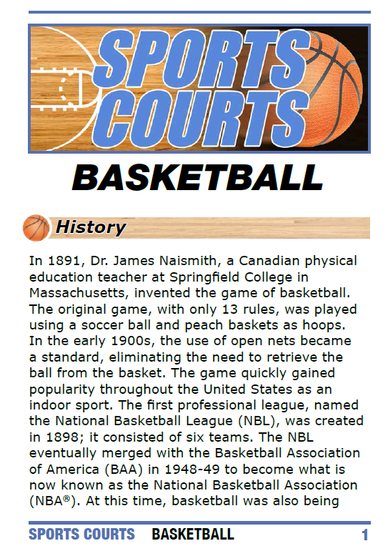

March 2017
- Working meetings were conducted on March 9 and March 27.
- Rachel Bishop and the project leader incorporated final edits to the Track and Field chapter. Consultants reviewed and approved the final chapter content.
- The graphic designer prepared the print layout and design of Track and Field.
- Andrew Moulton provided scanned images of the 2-up silkscreen art of the Football and Lacrosse layouts for digital file conversion.

April 2017
- Working meetings were conducted on April 5 and April 24.
- Rachel Bishop and the project leader made final edits to the FOOTBALL chapter; final content was approved by the consultants prior to layout and design.
- Patrick White enhanced the design of 3D figurines to be tactually discriminated by base shape, arm position, shirt texture, and/or color. The same figurine styles will be used in Room with a View (see separate annual report).
- Andrew Moulton worked on the product specifications for the Large Magnetic Dry-Erase Board.
- Matthew Poppe prepared the digital file for the Football and Lacrosse layouts, as well as the transparency layer for the braille/tactile counterpart.
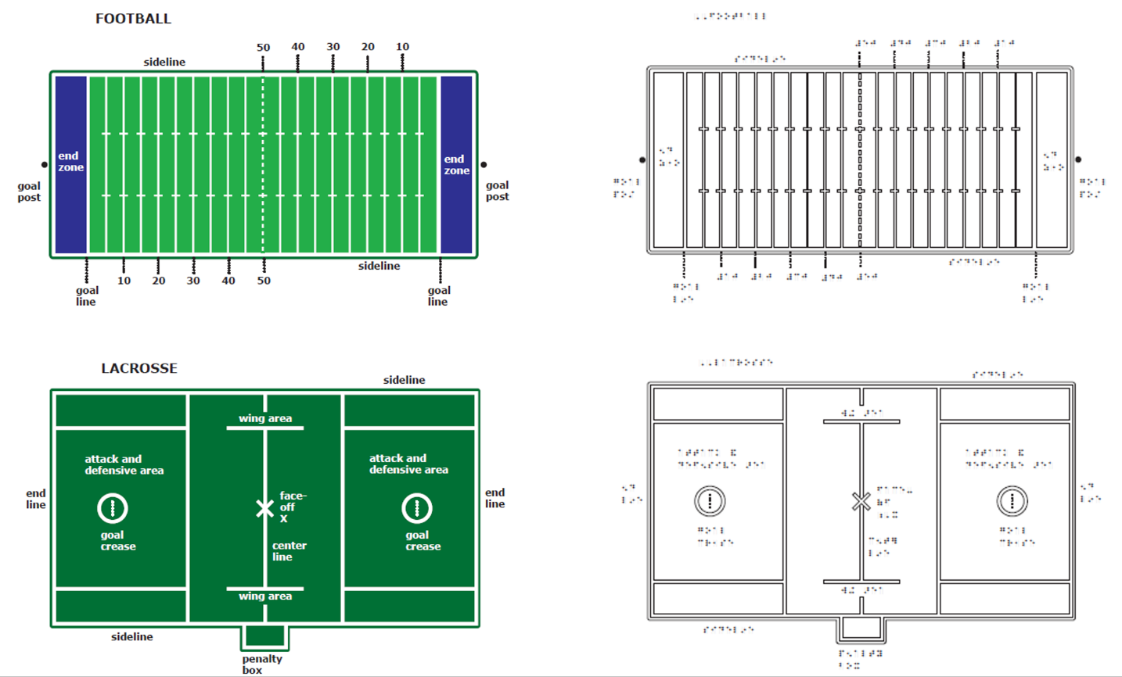

May 2017
- A working meeting was conducted on May 19.
- The layout and design of the Football chapter was initiated.
- The project leader created the clean file for the Track and Field chapter.
- Rachel Bishop initiated edits to the Lacrosse chapter.
June 2017
- Layout and design of the Football chapter was finalized.
- Edits were made to the Bowling chapter.
- The layout/design of the Bowling chapter was initiated.
- The ideal binder size was chosen for the final product.
- The product specifications meeting was conducted for the Large Magnetic Dry-Erase Board.

July 2017
- The layout/design of the Bowling chapter was completed.
- Edits were made to the Swimming chapter and shared with consultants for approval.
- The layout/design of the Swimming chapter was initiated.
- Rachel Bishop edited the Tennis chapter.
- Andrew Dakin initiated final construction of the Football and Lacrosse vacuum-form master.

August 2017
- Working meetings were conducted August 4 and 18.
- The layout/design of the Swimming chapter was completed.
- The Tennis chapter was approved by the consultants.
- The layout/design of the Tennis chapter was initiated.
- Andrew Dakin completed final tooling of the Football and Lacrosse layouts.
- Rachel Bishop and the project leader made edits to the Badminton chapter.
- The final layout/design of the Badminton chapter was completed.

September 2017
- Working meetings were conducted September 1, 15, and 29.
- Andrew Dakin completed final tooling preparation of the Football and Lacrosse layouts and tested registration of the printed and vacuum-formed parts.
- Digital-scans of the original sports layouts continued to be readied by the manufacturing specialist.
- Edits were made to the Volleyball chapter.
- The pilot run of the Large Magnetic Dry-Erase Board was underway.

Work during FY 2018
Progress on SPORTS COURTS continued at a steady, monthly pace throughout the fiscal year. Conversion of scanned silkscreen art to digitized-files, the construction of vacuum-form masters, and the editing of the related sports chapters through various rounds of proofs accounted for most the project staff’s efforts. Project milestones and notable tasks accomplished throughout the fiscal year encompassed the following:

October 2017
- On October 12, the “Airplane” announcement for the Large Magnetic Dry-Erase Board was launched. The selling price is $41.00 (available with Quota funds). This board will be available for separate purchase and will be included with the SPORTS COURTS kit.
- Updated content of each edited chapter was sent to consultants for their final review.
- The initial graphic layout and related editing for the Tennis, Goalball, Bowling, Baseball, Speedball, and Ultimate chapters was accomplished.
- Joon Lee continued to provide trademark attributions for each prepared sports chapter.
- On October 19, a working meeting was conducted with the entire in-house project team to report project status and maintain momentum on the project. Production staff were included in these meetings to keep them abreast of forthcoming printing, collation, and assembly tasks for the end product.

November 2017
- A working meeting was conducted on November 16.
- The manufacturing specialist requested a quote from an outside vendor for the cutting die to generate the X and O magnetic pieces. It was anticipated that a side-out punch would be used during the die-cut process to avoid damage to parts.
- The project leader reviewed representative 3D-printed parts (e.g., bowling pins, basketball goals) for planned injection molding. The goal posts (large and small) were resized and printed with base sizes similar to the prototype version.
- The printed transparency of the Badminton/Tennis layouts were Roland® UV-print and furnished to the Model Shop for vacuum-form setup.
- The sports chapters were in various stages of editing, layout/design, and consultant review. By the end of the month, all of the sports chapters had transitioned to the layout/design stage.

December 2017
- Andrew Dakin initiated work on the related 2-up vacuum-form master for the Badminton/Tennis layouts.
- The design layout of each sports chapter continued to be carefully proofed by the research assistant and project leader.

January 2018
- Working meetings were conducted on January 17 and January 25. The ideal size of magnetic coins for the various 3D pieces was addressed.
- A quote was received from the vendor for the X and O cutting dies.
- The graphic designer and project leader developed the tactile/print design for the Ultimate field layout, a new field layout added after the field test stage.

February 2018
- Working meetings were conducted on February 8 and February 22.
- Andrew Dakin continued to work on the related vacuum-form pattern for the Badminton/Tennis layouts. Braille pin position was checked on the vacuum-form master.
- The sports chapters continued to be in various stages of layout and design; proofs were approved or refined by the project leader and research assistant.

March 2018
- Andrew Dakin prepared the vacuum-form master for the Swimming/Ultimate layouts.
- Plans for die-cutting a needlepoint canvas for the long and short nets were addressed.

April 2018
- Working meetings were conducted on April 5 and April 25.
- The project leader provided a chart to Technical Research staff that documented the lengths and quantities of all hook and loop strips to affix to the 3D pieces.
- The project leader provided a sketch of the desired shape and size of the football goal to accommodate the hook-strip attachment; a polyblend sample part was cut to needed size.
- The 2-up Swimming/Ultimate layout was printed on .010-in. vinyl and vacuum-formed to verify ideal registration between tactile and print elements, as well as the readability of the braille dots. The part was approved.

May 2018
- The research assistant and project leader reviewed all pre-final layouts for the 18 sports chapters. Both content and layout were checked for consistency across all chapters.
- The manufacturing specialist furnished scans of the six remaining sports layouts. The project leader and graphic designer implemented both tactile and print refinements to the following layouts: Baseball, Beep Baseball, Golf, Soccer, Volleyball, and Floor Hockey.
- The project leader prepared clean files for each sports chapter for eventual braille translation and accessible electronic files.

June 2018
- Edits to the pre-final sports chapters were provided to the graphic designer. Remaining updates per chapter were few and did not impact pagination or basic layout. In turn, the graphic designer supplied pre-final two versions of the sports chapters for a new round of editing/approval.
- Final print artwork and braille transparencies for the remaining three 2-up sport field/court layouts were furnished to the manufacturing specialist and model shop.

July 2018
- A working meeting was conducted on July 26.
- A larger binder size was selected to accommodate all of the materials/booklets more comfortably. The graphic designer updated the binder art based on the new dimensions. The new APH branding style was used, and a small parts warning label was incorporated into the final artwork.

August 2018
- The project leader conducted a Gate 4: Modifications meeting on August 23.
- The project leader prepared final content for the Overview chapter.
- The model maker continued to work on the three 2-up vacuum-form patterns for the remaining sports courts/field layouts.

September 2018
- All vacuum-form patterns needed for the production of the sports layouts were completed and approved.
- The layout of the Overview chapter was finalized.
Even with steady monthly progress, significant tooling was still needed for actual production of SPORTS COURTS at the conclusion of the fiscal year.

Work planned for FY 2019
Project staff will usher the project through the remaining goals of tooling construction and specifications for eventual production. Due to the complexity of the product’s design and number of related components, as well as priority on other research projects/products, final product availability of SPORTS COURTS is unlikely to occur until FY 2020.

READING AND LANGUAGE ARTS

Early Braille Trade Books
(Continued)

Purpose
To provide emergent and beginning braille readers with a wide selection of small books that provide practice and reinforcement of early reading skills and aid in the development of reading fluency

Project Staff
Jeanette Wicker, Core Curriculum Project Leader
Anna Swenson, Project Consultant
Rachel Bishop, Research Assistant
Frank Hayden, Director of Technical & Manufacturing Research
Anthony D. Jones, Art Production/Design Manager
Michael McDonald, Programmer
Andrew Moulton, Manager of Technical & Manufacturing Research

Background
The need for Early Braille Trade Books (EBT) was identified by the Early Literacy Focus Group conducted by Suzette Wright in the summer of 2005. These small books for emergent readers are used in classrooms to support the reading curriculum and are available from several publishers. In the winter of 2006, APH conducted a reading survey to determine the types and series of leveled reading materials used by teachers of the blind and visually impaired.

Using information gained from the 2005 Early Literacy Focus Group and the customer surveys, the Wright Group Books were chosen for the first project. Cay Holbrook, Associate Professor at the University of British Columbia, agreed to serve as the consultant for this project. In July 2007, Holbrook along with five of the original members from the Early Literacy Focus Group of 2005 met in Louisville, KY, to review and select books to be included in the kits.

Members of the work group included the following:
- Anthony, Tanni, State Consultant on Visual Impairment, Colorado Department of Education, Denver, CO
- Brasher, Jeanie, Teacher, Kentucky School for the Blind, Louisville, KY
- D’Andrea, Frances Mary, Doctoral Student at the University of Pittsburgh, Pittsburgh, PA
- Hassman, Dotta, Retired, Instructional Materials Center, Iowa Braille School, Vinton, IA
- Swenson, Anna, Teacher of Students with Visual Impairments, Fairfax Co. Public Schools, Dunn Loring, VA

The group developed a rubric based on the work of Holbrook for selection of the books. They also reviewed 90 books from the Wright Group Sunshine Kits and determined the type of information about the book to include for the teacher. Hassman agreed to serve as a consultant to complete a text analysis of each book. One set of 13 books was selected for the development of an initial prototype to be used in field testing and review.

In FY 2008, the prototype of a kit of commercially available leveled books adapted for braille readers was completed. The initial design of the prototype included a commercially available book with braille overlays and a guide for the teacher. The teacher’s guide would include the number and frequency of the braille contractions in the book, punctuation marks, and composition signs, as well as the theme of the book with connections to the core curriculum and expanded core curriculum.

In the development of the prototype for field evaluation, the format for the teacher’s guide changed from a print document to a website hosted by APH. The EBT Web site allows the teacher to continually update the student record and access records of books. Anna Swenson became a consultant for the project and wrote the follow-up activities for each book.

The prototypes, including the website, were field tested from September 2008 to March 2009 at 15 sites with 22 different students. The evaluations were positive, and teachers unanimously recommended that APH produce the book with braille label sets and make the website available to customers. Changes and modifications were made to the materials and the website based on reviewers’ feedback.

A work session with the original six members was held in the spring of 2009. Additional books were reviewed, and three new sets were chosen to add to the series. The first set of Books, Sunshine Kit 2, became available for sale in 2009.

In FY 2010, the second set of books, Sunshine Kit 1, became available for sale in November. A total of 26 books were now available to teachers and emerging braille readers. Work began on two sets of nonfiction books at the first grade level. Books were analyzed for contraction type and count. Information on each book as well as activities to use with each of the books was added to the EBT Web site. A specification meeting for the two sets of nonfiction books, TWiG 1 and TWiG 2, was held in September 2010. The EBT Web site was updated to include a connection to the Patterns Reading Series from APH. As a teacher prepares for a lesson in Patterns, he/she may search the EBT Web site for commercially available books in braille to supplement the new lesson.

In FY 2011, the first set of nonfiction books from Wright Group, TWiG 1, became available for sale in January and TWiG 2 became available for sale in February 2011. With the addition of the two new sets, a total of 46 books became available to emerging braille readers.

The committee selected Rigby Publishing for the next two sets of books. The committee met in June 2011 and reviewed books; they selected 15 fiction books and 14 nonfiction books to add to the EBT collection. Books were analyzed for contraction type and count. Titles were added to the website and the books prepared for braille translation.

Two new sets of books from Rigby were made available for sale in May 2012 adding 29 new titles to the collection. The website was updated to include the two new sets of books including a link to Books to Use with Building on Patterns. Seventy-five books at the first grade level are now available for TVIs to use with emerging braille readers.

In FY 2013, three books from the various collections went out of print. Project staff reviewed other books from various publishers to replace these books. Books were selected, and modifications to the kits and the website were completed.

In FY 2014, project staff continued to monitor the existing kits for books going out of print. The website was updated to include the Developmental Reading Assessment® (DRA) level of each existing book. The Wright Group, the publisher of four sets of books, was purchased by another publisher; a decision was made by the new publisher to eliminate the Sunshine and TWiG series.

With the implementation of UEB and with the loss of the Wright Group Books, a new grouping system of the existing books was developed. Each set would now contain five or six books based on the leveling system used by Fountas & Pinnell and DRA. All existing Rigby books will be retranslated into UEB. The existing website will be retained to support books already in the field. A new link will be established for the books translated into UEB.

New sets of Rigby books were ordered for review. In May 2015, Swenson, Brasher, Susan Spicknall, and Dawn Wilkinson met with the project leader to review a selection of books. Thirty-three new books were selected to add to the existing 30 books for a total of 63 books. There will seven fiction sets and six nonfiction sets for braille readers in late kindergarten through first grade.

In FY 2016, revisions to the EBT Web site began. The website will still support the older books in EBAE but will also introduce the new books in UEB. A conversion software was developed for the website that will allow a teacher to move the contractions learned in EBAE to UEB without the laborious task of reentering all of the contractions by hand.

In FY 2017, the first three sets of books were transcribed and files placed on the production server. Graphic design developed new box labels for the first three sets of books. The website was updated to reflect the contractions in UEB as well as the data for the first three sets of books. A specification meeting was held, and production was scheduled for June 2017. The kits were released for sale in October 2017.

Work during FY 2018
Work on the first three sets of nonfiction books was started. The books were selected and transcribed into UEB, the information for the three sets of books was added to the website, graphic design completed the box labels, and a specification meeting was held on July 3, 2018.

Work planned for FY 2019
The project leader will monitor the production and release for sale of the first three sets of nonfiction books. Work will begin on the last four sets on fiction books to add to the collection.

Expanded Dolch Word Cards [Modernization]
(Completed)

Purpose
To modernize an existing product to reflect the change in the braille code from English Braille American Edition to Unified English Braille (UEB)

Project Staff
Martin Monson, Project Leader
Kate Herndon, Director of Educational Product Research
Frank Hayden, Director of Technical & Manufacturing Research
Andrew Moulton, Manager of Technical & Manufacturing Research
Anthony D. Jones, Art Production/Design Manager
Matthew Poppe, Tactile Graphics Designer
Jeremiah Rose, Research Assistant
Jonathan Carson, Braille Transcriptionist

Background
The original flashcards, consisting of 220 sight vocabulary words and 95 words with pictures, can be used for reading practice or an informal assessment of a student's ability to read words in contracted braille and to spell words in uncontracted braille.

Cards measure 3 1/2 x 2 inches with an orientation corner cut and an orientation braille line. Words are shown in contracted braille on one side and uncontracted braille on the other, with large print on both sides. Words on the contracted braille side will be converted to use contractions consistent with UEB. Also included will be blank cards for adding words, tabbed indexing cards, and a box for storage.

Work during FY 2018
In 2017 and 2018 input from the Building On Patterns consultant group was gathered in relation to the black-line pictures on 95 of the cards. The pictures were an attempt to represent the braille word on the card. The group consensus was to discontinue the use of the black-line pictures. Braille and print files were made of the cards. Braille plates were made, and a pilot sample was run. Because of how the cards are imprinted and cut, some of the dots in the orientation line were being crushed. The orientation line was reconfigured in the software files, and new plates were made.

This product was made available for sale in February 2018.

Work planned for FY 2019
No further work is planned on this project.

Wilson Reading System
(Continued)

Purpose
To provide a remedial reading program for students with visual impairments

Project Staff
Laura Zierer, Project Leader
Jeanette Wicker, Project Consultant
Emily Grimany, Research Assistant
Kelly Kennedy Mimms, Research Assistant
Cheryl Kamei Hannan, Project Consultant
Mary McCarthy, Project Consultant
Justine Carlone Rines, Project Consultant
Rosalind Rowley, Project Consultant
Rod Dixon, Manufacturing Specialist
Katherine Corcoran, Model Maker
Frank Hayden, Director of Technical & Manufacturing Research
Anthony D. Jones, Art Production/Design Manager
Andrew Moulton, Manager of Technical & Manufacturing Research

Background
The Wilson Reading Program, with its well-developed multi-sensory approach, is one of the most respected programs used to teach reading in the United States. This program has been used to teach reading to students with visual impairments who experience reading difficulties, but the program is not available for sale in large print or braille. Teachers working with students at Perkins School for the Blind, Arizona School for the Blind, and North Carolina Schools for the Blind have reported good results.

The project was approved by the Product Evaluation Team and the Product Advisory and Review Committee in July 2006. Three teachers from Perkins School for the Blind, Justine Rines, Mary McCarthy, and Roz Rowley, were contracted as consultants for the project. A contractual agreement was reached with the Wilson Reading Systems to produce the materials in braille and large print.

As there are many components to the system, it was decided to produce the Readers Levels 1, 2, and 3 in braille as quickly as possible since the readers required no modification.

The Student Readers 1, 2, and 3 became available for sale in braille in February 2008. The consultant from Perkins developed supplemental worksheets that reinforce braille skills and knowledge of braille contractions.

The first three readers and the first six workbooks were reformatted for large type editions. The Readers and Workbooks became available in October 2009.

In FY 2009, prototypes of the first six workbooks were translated and the supplemental worksheets were revised and translated for use in field testing. A set of six modified workbooks was developed and translated for field evaluation. Work started on the prototypes of the Print/Braille Word Cards, Syllable Cards, Sound Cards, and Magnetic Tiles to be used in field testing.

In FY 2010, prototypes of the remaining components of the Wilson Reading System were completed. A call for field evaluators was sent to Ex Officio Trustees in May 2010 and also appeared in the June and July APH News. A 3-day Web Training was held on August 30, 31, and September 1. The three consultants from Perkins (Rowley, McCarthy, and Rines) with the trainer from Wilson provided training to 30 participants on the use of the Wilson Reading System and the modified and adapted braille materials. Dr. Cheryl Hannan trained teachers in the use of data collection tools that would be used to evaluate the effectiveness of these braille materials.

In 2011, field evaluators were recruited from the 30 participants in the Web-based training. Participants were to use the materials daily with their students to determine the effectiveness of the modified/adapted Wilson Reading System. Students were given a pretest, a posttest, and completed weekly DIBLES assessments. The yearlong evaluation of the modified/adapted Wilson Reading materials was completed in May 2011.

In FY 2012, Hannan, Dr. Jane Erin, and two graduate assistants completed the disaggregation of the data from the field evaluation and presented the results at the Getting in Touch with Literacy Conference in Louisville and the National Council for Exceptional Children Conference in Colorado. The data showed positive results and reading gains for braille readers using the Wilson Reading System.

Information from the field evaluation and the expert review were used to begin the revisions and modifications to the many prototypes of the components of the Wilson Reading System. In December 2011, the project leader and the three consultants from Perkins traveled to meet with Ed Wilson and staff at the Massachusetts office. The prototypes as well as the planned changes and information from the field testing were shared with Wilson Staff. Representatives from Wilson reviewed the materials and in March made suggested changes and approved the work. The project leader, the Perkins staff, and APH staff began revisions of prototypes.

In FY 2013, project staff completed the revisions to the readers, workbooks, modified workbooks, supplemental worksheets, letter tiles, and word cards. Revisions were sent to Wilson Reading for approval in November 2012. A final request for revisions and approvals was received from Wilson Reading in March 2013. Project staff implemented these revisions to all print and braille files. Specifications for production were partially completed.

In FY 2014, project staff completed the written specifications and a product specification meeting was held in February. A production schedule was developed for the remaining pieces. The Wilson Card Sets and the Wilson Letter Tiles with Magnetic Journal became available in July 2014. The production schedule of the Wilson Student Braille Kits was staggered. Braille Student Kit Step 1 was scheduled for August 2014, Braille Student Kit Step 2 was scheduled for September 2014, and Braille Student Kit Step 3 was scheduled for October 2013. All items will be available on Quota.

In October 2015, both the Wilson Reading System Braille Student Kit 2 and Wilson Reading System Braille Student Kit 3 became available for sale. Project staff continued to update files of existing products as changes, and revisions were made by Wilson Reading System.

In FY 2016, the conversion to UEB for the braille readers, workbooks, cards, and the WADE began. The Wilson Card Sets were reviewed, and cards were identified for revision. The cards are produced on sheets, and thus several sheets were identified for revision. Production files were requested and received for revision of the Braille Kits 1, 2, & 3.

Plans for the conversion to UEB were placed on hold when the contract with Wilson Reading to produce the materials in large print and braille expired. A contract was signed with Wilson Reading System in July 2017.

Work during FY 2018
In March 2018, Zierer assumed responsibility for the UEB conversion of the Wilson Reading System. A conference call was conducted with Wilson Training Corporation staff and APH staff to go over details of the conversion. A Product Design Meeting was held in April 2018 to discuss product components, production quantities, and timelines. Clean text files were created for submission to the Braille Translation Department in May 2018. As of the writing of this report, 75% of braille files are complete. Also in May 2018, Grimany and Zierer met with Corcoran to identify modifications needed in the tooling of the magnetic tiles included in the product. These changes were completed and approved in June 2018.

Work planned for FY 2019
Braille translation will be completed, files will be delivered to an identified flash drive production vendor, and a specifications meeting will be held. The product is anticipated to be released in FY 2019.

SCIENCE

Adapted Biology Lab Manual (ABLM)
(Continued)
Purpose
To provide high school and college instructors with 12 biology laboratory protocols adapted for students with vision impairments including blindness

Project Staff
Rosanne Hoffmann, STEM Project Leader
Frank Hayden, Director of Technical & Manufacturing Research
Erica Martin, Consultant
Whitney Davidson, Consultant
Monica Vaught-Compton, Project Assistant

Background
Erika Martin teaches biology laboratory courses at Emporia State University in Kansas. After learning that several students with visual impairment were enrolled in her classes, she discovered that no published introductory biology laboratory manuals with adaptations for students with vision impairment existed to assist instructors in this situation. This product aims to change this fact. Martin submitted a New Product Idea form to APH in August 2016. The Adapted Biology Lab Manual (ABLM) consists of 12 modules typical of and appropriate for high school and college introductory biology courses. Martin works in collaboration with Whitney Davidson, a disabilities specialist at the Lillie Jackson Early Childhood Center (Lewisville, TX). The laboratory activities are designed for students with low vision, complete blindness, or typical vision and include an introduction, glossary of terms, hands-on activities (what is actually “done” in the lab), and a teacher’s protocol that includes a materials list and instructions on how to set up each activity for students who are sighted and non-sighted. Sections intended to be read by students with visual impairments will be made available in large print, embossed braille, and as a BRF file accessible via e-reader. Each module is expected to be approximately 25 print pages and 35 embossed pages, but the length will vary according to the topic and included activities.

ABLM was reviewed by the project leader in September 2016, presented to the Product Evaluation Team in January 2017, and to the Product Advisory and Review Committee in February 2017. A Product Development Committee meeting was held at the end of January 2017 in order to discuss future production elements. After the details of consultant contracts were worked out, ABLM entered the formal product development pipeline in March 2017.

The project leader received the first two modules of adapted biology laboratory exercises in April 2017 and provided the consultants with preliminary comments and suggestions in May to assist them in the preparation of the remaining 10 modules.

Work during FY 2018
The consultants completed all 12 modules by May 2018, and the project leader and project assistant began preparing the modules for field testing. Preparation included editing content, adding photographs to illustrate adaptation procedures, and formatting all 12 modules for consistency.

Work planned for FY 2019
When all 12 modules are ready in the fall of 2018, the project leader will select a geographically diverse set of expert reviewers and prepare evaluation instruments to collect demographic information and prototype evaluations. Expert review will be completed before the end of 2018. Suggested changes to the modules will be considered when editing the modules for final publication. Layout of the modules will begin in spring 2019 by graphic artists at APH. Appropriate sections of each module will be transcribed into braille and prepared as accessible BRF and e-reader files.

Adapted Science Materials Kit (ASMK)
(Completed)

Purpose
To provide a set of science tools adapted for use by K-12 students who are blind or visually impaired, allowing them to participate in science activities alongside their sighted peers

Project Staff
Rosanne Hoffmann, STEM Project Leader
Frank Hayden, Director of Technical & Manufacturing Research
Katherine Corcoran, Model Maker
Patrick White, Model Maker
Laura Greenwell, Graphic Design
Rod Dixon, Manufacturing Specialist
Marshall Montgomery, Consultant
Linda De Lucchi, Consultant

Background
The Adapted Science Materials Kit (ASMK) consists, in part, of science measurement tools originally devised by educators at the Lawrence Hall of Science (LHS in Berkeley, CA) and Delta Education® (Nashua, NH) in the mid-1970s. Funded by the U.S. Department of Education, these tools and a set of corresponding curriculum modules constitute the SAVI (Science Activities for the Visually Impaired) program that was field tested by LHS from 1976-1979. These educational materials have been available from LHS and used with the SAVI, SELPH (Science Enrichment for Learners with Physical Handicaps), and FOSS (Full Option Science System) programs until 2010. LHS stopped producing these measurement tools, which was brought to the attention of APH by TVIs. APH intends to kit many of these time-tested science measurement tools into one product along with other adaptive measurement aids, thus making them available again to the community of students with visual impairments and TVIs.

ASMK consists of the following items: 1) Balance; 2) set of 100 one-gram pieces; 3) set of 35 mass pieces (5, 10, and 20 grams); 4) 100-milliliter (ml) modified Tri-Pour® beaker; 5) 1000-ml modified Tri-Pour® beaker; 6) two 50-ml graduated cylinders with braille float scales; 7) two 100-ml graduated cylinders with braille float scales; 8) large print braille tactile meter tape; 9) 50-ml syringe with stop; 10) large print tactile histogram board with round stickers; 11) funnel stand; 12) two tray inserts of the APH Multi-Section Tray (with adhesive backed non-slip rubber pads); 13) talking Fahrenheit/Celsius thermometer; 14) laminated instruction card; and 15) a large bag to hold all items.

Most of the items in ASMK are available from Delta Education® and have been field tested and used successfully by students with visual impairments and TVIs for more than three decades. These include the balance, set of 100 one-gram pieces (a small parts caution statement in print and braille will be adhered to the bag holding this set), set of 35 mass pieces (including 5, 10, and 20-gram masses), 100-ml Tri-Pour® beaker, 1000-ml Tri-Pour® beaker, 50-ml graduated cylinder, 100-ml graduated cylinder, 50-ml syringe with stop, and the funnel stand. The original 35-piece mass set from Delta Education® was discontinued and replaced by a set imported by Delta Education®, LLC, from another vendor. The replacement item complies with CPSIA (Consumer Product Safety Improvement Act) standards for lead. All other items obtained from Delta Education® are made in the USA.

Other items included in the kit are established APH products: The talking Fahrenheit and Celsius thermometer from ThermoWorks, Inc., is available for separate purchase in the APH catalog. Two inserts of the APH Multi-Section Tray replace the sorting tray originally made for LHS by Montgomery.

The large print tactile histogram board will be custom made at APH. The 100-ml and 1000-ml Tri-Pour® beakers will be modified at APH by punching a hole at the 100-ml measurement line and the 1000-ml measurement line, respectively. These items will replicate the same items from the original SAVI program kits sold by LHS. Although Montgomery produced acceptable samples of 50-ml and 100-ml braille float scales, due to equipment, pattern, and materials problems he was unable to make an acceptable sample of the large print braille tactile meter tape. It was also brought to our attention that Montgomery was unable to fill orders for APH due to obligations to other institutions. Consequently, APH is responsible for producing the large print braille tactile meter tape and braille float scales for the 50- and 100-ml cylinders in addition to the other items already mentioned. Acceptable samples of the meter tape and braille scales for the floats were produced in-house on the Roland® Large Format Printer, finalizing the method for their full-scale production. These items will replicate the same items from the original SAVI program kits sold by LHS.

The Adapted Science Materials Kit received Quota Approval in May 2016 during the spring meeting of the Educational Products Advisory Committee.

Due to production limitations at APH, the large print braille tactile meter tape will be printed in-house on the Roland® Large Format Printer and subcontracted out-of-house for die cutting. Katherine Corcoran built a device to modify the plastic Tri-Pour® beakers in-house, and created the pattern and mold needed to vacuum-form the histogram board. Patrick White built a device to assemble the braille float scales for the graduated cylinders. The project leader worked with Laura Greenwell to create a four-page information card with text and photographs describing all elements of the product. The information card will be printed in-house and laminated out-of-house. The APH Innovations Tote bag was selected as a carry case to contain all items included with the product. Tooling for all elements of the product was completed in January 2017.

Work on compiling the specifications for this product began in February 2017. After working out details of the production of the large print braille meter tape, the specifications meeting was held on July 12, 2017. Pilot runs of several of the APH-produced items in the kit were scheduled for early 2018.

Work during FY 2018
A pilot run for production of the float parts of the 50-mL and 100-mL braille float scales took place in May 2018. Unfortunately, the tooling for this part of the product did not work as anticipated on the production floor. This problem was solved by sending the float material to Marshall Montgomery in Napa, CA, to prepare several thousand floats at his workshop. Floats received from Montgomery were assembled with the 50-mL and 100-mL braille scales on the APH production floor. Pilot runs of the other APH-made items were scheduled for the fall of 2018.

Work planned for FY 2019
Full production runs of all elements of this product will take place in the fall and early winter of 2018. Release of the Adapted Science Materials Kit is anticipated before the end of 2018. The project leader will prepare a short video to detail the use of all elements of the kit.

Azer’s Interactive Periodic Table Study Set [Modernization]
(Continued)

Purpose
To modernize Azer’s Interactive Periodic Table Study Set (APH Catalog No. 1-08856-00) with the incorporation of recently-discovered elements according to the International Union of Pure and Applied Chemistry (IUPAC), as well as offer both Nemeth and Unified English Braille (UEB) versions of the kit

Project Staff
Karen J. Poppe, Tactile Literacy Project Leader
Rachel Bishop, Research Assistant
Emily Grimany, Research Assistant
Sara Lee, Research Assistant
Rod Dixon, Manufacturing Specialist
Andrew Moulton, Manufacturing Specialist
Patrick White, Model/Pattern Maker
Laura Greenwell, Graphic Designer
Anthony Jones, Director of Creative Services

Background
In 2009, APH introduced the Azer’s Interactive Periodic Table Study Set that was co-designed by Samir Azer (originator of product idea) and Karen Poppe, APH’s Tactile Literacy Project Leader. The tangible materials included with this study set complement APH’s Periodic Table of Elements Reference Chart (see separate annual report) and allow students to enhance their understanding of concepts aligned with the Next Generation Science Standards (NGSS). This product assists in the instruction and demonstration of concepts related to the arrangement of the periodic table, atomic structure, ionic and covalent bonding, and balancing of chemical equations to students who benefit from hands-on interactive models. The product was carefully designed to ensure tactual discriminability and visual appeal/contrast for the intended target population; it also is useful for all students in inclusive educational settings. Based on original field test results, the ideal target populations for this product are tactile and low-vision readers in secondary grades; 75% of the field evaluators extended suitability to those in Grades 6-8, and 88% rated the product as appropriate for sighted peers as well.

The sales history of the Azer’s Interactive Periodic Table Study Set over recent fiscal years has revealed fluctuating demand; 114 kits were purchased in FY 2014, 58 kits in FY 2015, 89 kits in FY 2016, and 55 kits in FY 2017. As of July 2018, 40 kits have been sold.

The modernization of Azer’s Interactive Periodic Table Study Set is critical so that students with visual impairments and blindness have access to the same STEM-learning experiences and information as their sighted peers. The updates planned for this kit will ensure incorporation of formally named elements reported by the IUPAC (refer to https://iupac.org/iupac-announces-the-names-of-the-elements-113-115-117-and-118/).
Within APH’s current kit, elements 112-118 are named with previously assigned__and now outdated__atomic symbols Uub, Uut, Uuq, Uup, Uuh, Uus, and Uuo; these elements have officially been identified by IUPAC as copernicium (Cn), nihonium (Nh), flerovium (Fl), moscovium (Mc), livermorium (Lv), tennessine (Ts), and oganesson (Og). Refer to https://www.iupac.org/cms/wp-content/uploads/2015/07/IUPAC_Periodic_Table-28Nov16.jpg for the 2016 IUPAC version of the table.

In February 2017, the project leader prepared a formal Product Modernization Form that detailed the expected updates to the Azer’s Interactive Periodic Table Study Set, including the provision of both Nemeth and UEB versions to comply with recent shifts and adoptions of the UEB code by some states and/or state districts. In April 2017, the modernization proposal was presented to the Product Evaluation Team, and in May 2017, it was presented to the Product Advisory and Review Committee. Both committees supported the product endeavor. The project was assigned Grant #682.

Work tasks undertaken by the project leader during the latter part of FY 2017 included the following:
- Ordered and reviewed the current product to specify needed updates
- Determined, with in-house support, priority of redesigning the original kit and the new UEB version, based on consequential impact on other APH departments and existing production tooling.
- Conducted the first Product Development Committee meeting to review the purpose and expected redesign of the product
- Initiated edits to the accompanying instruction booklet

New catalog numbers were assigned for the two modernized versions of the kit and related print instruction booklets:
- Azer’s Interactive Periodic Table Study Set, Nemeth version: 1-08856-01
- Azer’s Interactive Periodic Table Study Set, UEB version: 1-08959-00
- Azer’s Interactive Periodic Table Study Set Print Instruction Booklet, Nemeth version: 7-08856-01
- Azer’s Interactive Periodic Table Study Set Print Instruction Booklet, UEB version: 7-08859-00

Work during FY 2018
The first and second quarters of the fiscal year witnessed continued attention to and completion of needed production tooling by various members of the project team. Notable accomplishments included the following:
- The project leader completed all content updates to the accompanying instruction booklet; it was thoroughly copyedited by the research assistants. Those with braille certification verified the SimBraille translation of the chemical equations featured in one of the appendices.
- The graphic designer updated the existing layout of the instruction booklet, including refinements to some of the illustrations and photos. Peripheral artwork related to the binder art and cover art was also updated with the newly assigned catalog numbers, and small parts warning label.
- In late October, the project leader prepared a clean file of the instruction booklet that was used for braille translation. The braille translation was readied by early November.
- Concurrent with strides related to the instruction booklet, the project team focused on updates to the print files needed to generate the hexagonal element pieces. Because the element pieces would no longer be screen printed as in years past, ideal ink colors were reselected for eventual printing on the Roland® UV printer.
- Corresponding vacuum-form patterns needed to generate the hexagonal element pieces were updated accordingly. Specifically, the braille pins were updated for the elements Cn, Nh, Fl, Mc, Lv, Ts, and Og; they appear on one of the three vacuum-form setups to accommodate elements packaged in Bag A, Bag B, and Bag C.
- Parts were printed, vacuum-formed, and die-cut using the newly prepared tooling to check for ideal registration between the print and tactile parts. New cutting dies were ordered to replace those with duller blades, and a full-bleed application of color around each block/cluster of elements was employed to prevent unwanted white edges if die-cut slightly off center. 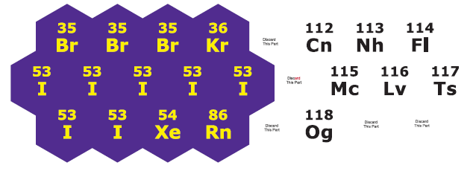

In April 2018, Rod Dixon had completed the specifications document and presented the overview section to the project leader for review and approval prior to the formal Specification meeting. At that time, it was anticipated that the Gate 5: Specifications meeting would be held by the end of the fiscal year.

Work planned for FY 2019
According to a new matrix-scoring process used by an in-house review committee to evaluate all APH product ideas and endeavors, the modernization of the Nemeth version of the Azer’s Interactive Periodic Table Study Set garnered a weighted score of 61 out of a possible 93; it retained active status under the current project leader’s direction. In an effort to minimize the number of active projects on a given project leader’s work plate and time demands on other staff resources, the UEB version of the Azer’s Interactive Periodic Table Study Set, which garnered a weighted score of 59 out of a possible 93, was reverted to on-hold status as of July 2018. Reintroduction of the latter version to active status is contingent on the completion of projects closer to availability and the reassessment of the project leader’s priorities.

Actual production of the modernized Azer’s Interactive Periodic Table Study Set (Nemeth version) is expected to occur in the third quarter of FY 2019. The project leader and manufacturing specialists will closely monitor the quality of the initial pilot and production runs. The project leader will prepare content for the product brochure and be active in the marketing of the product via presentations and workshop at national conferences.

Build-A-Cell
(Continued)

Purpose
To provide an interactive set of biology manipulatives, accessible to students who are blind and with low vision, that allows them to construct models of plant, animal, and bacterial cells

Project Staff
Rosanne Hoffmann, STEM Project Leader
Frank Hayden Director of Technical & Manufacturing Research
Andrew Dakin, Model Maker
Andrew Moulton, Manager of Technical & Manufacturing Research
Rachel Bishop, Research Assistant
Laura Greenwell, Graphic Designer

Background
Requests for a product similar in design to the DNA-RNA Kit for cell structure have been noted at gatherings of TVIs and other professionals, such as the Meeting of the Minds at APH in 2014 and the Unity Conference at the Tennessee School for the Blind (2013). This product will fulfill these requests and align with the Next Generation Science Standards. The product will consist of full color, tactile outlines or templates of three types of cells (plant, animal, and bacterial) printed and thermoformed on separate 8.5 by 11-inch plastic sheets. These sheets will be three-hole punched to fit in a binder. The center part of the cell outlines will be covered with loop material that sticks to hook material dots. The product will also include full-color tactile organelles and internal cellular structures including mitochondria, chloroplasts, nuclei, smooth endoplasmic reticulum, rough endoplasmic reticulum, lysosomes, peroxisomes, vacuoles, cytoskeletal fibers, centrosomes, polysomes, ribosomes, and Golgi bodies. The organelles will be identifiable by color and shape as well as a single braille letter that will coorespond to a key. The details of the structures will be printed in color and vacuum-formed on plastic, mounted on 1/8-inch thick foam, and then die-cut into appropriate shapes. Hook adhesive dots will be attached to the underside of each organelle. Students can demonstrate their knowledge of plant, animal, and bacterial cell structure by selecting the appropriate organelles for a particular cell template and adhering them to the headliner material background of each cell type. A guidebook with instructions for use will be included in the kit.

The project leader met with model maker Andrew Dakin in early spring 2015 to brainstorm the original design of the product and prepare preliminary drawings to present to the APH product review committees. A New Product Idea Submission Form was submitted by the project leader on June 18, 2015. The Product Evaluation Team accepted the product idea on October 30, 2015. The Product Advisory and Review Committee recommended that Build-A-Cell enter the product development cycle on January 6, 2016.

Preliminary drawings of all components of the product were completed in June 2016, and Dakin began the production of 10 sets of prototypes for field testing. A call-out for field testers was published in the August 2016 APH News, and a geographically diverse set of field testers across the U.S. was identified.

Andrew Dakin completed the 10 sets of Build-A-Cell prototypes in April 2017. The project leader prepared a prototype guidebook including descriptive text and photographs of all of the components of the product. The project leader also prepared the online evaluation instrument and demographic information forms using Google Drive™. Prototypes were mailed to 10 field testers in May 2017; nine evaluations were returned by the end of June.

Overall, field testers were satisfied with the prototype but some suggestions for simplification were given. For example, omitting some fimbriae from the bacterial model and the flagellum from the animal cell model. Field testers also suggested having a choice of dark or light background headliner material to which the organelles are adhered in order to increase the contrast for students with low vision. Some field testers suggested making a greater distinction between the cell membrane, cell wall (of the bacterial and plant cells), and capsule (of the bacterial cell) using layer thickness and texture, if possible.

Work during FY 2018
The project leader discussed suggested changes and modifications to the Build-A-Cell prototype in September 2017 with Andrew Dakin. The following changes were implemented for the final tooling process: covering the center of each cell template with black headliner material; increasing the space between the two outer membranes of the chloroplast; decreasing the size of the vacuole; redesign of the nuclear envelope to include a double membrane and pores; redesign of the cytoskeleton to improve the distinction between microtubules, intermediate filaments, and microfilaments; omitting the animal cell flagellum; redesign of the bacterial nucleoid to make the DNA loop more discernible; decreasing the number of bacterial fimbriae; shortening of the bacterial flagellum; and adding plasmids. The textures of the outer layers of the three cell templates were made more distinguishable from each other: sandy-textured capsule layer (bacterial cell), smooth cell wall (bacterial and plant cells), and raised-dot cell membrane (bacterial, plant, and animal cells). The three cell templates were also modified to accommodate three-hole punching by decreasing the dimensions of the cells where needed. Based on field test results, the project leader and Dakin designed a pattern for a vacuum-formed key to cell surface layers, organelles, and all other intracellular structures. Tooling for the manipulatives was completed in the fall of 2018. The project leader edited and finalized the guidebook text in the summer of 2018 and turned it over to the graphic designer for layout in the fall.

Work planned for FY 2019
When the guidebook layout is complete, the text will be translated into braille and rendered in HTML. Build-A-Cell will be presented for Quota Approval during the 150th Annual Meeting of Ex Officio Trustees in October 2019. Product release is expected in 2019; at that point in time, downloadable BRF and HTML versions of the guidebook will be available from the APH Web site.

Earth Science Tactile Graphics (ESTG)
(Completed)

Purpose
To provide a set of color tactile graphics of diagrams and illustrations found in current high school Earth Science textbooks. The intention is to assist the classroom teacher or TVI in providing ready-made tactile representations of typical Earth Science visuals for their students who are visually impaired.

Project Staff
Rosanne Hoffmann, STEM Project Leader
Fred Otto, Tactile Learning Project Leader
Frank Hayden, Director of Technical & Manufacturing Research
Andrew Moulton, Manager of Technical & Manufacturing Research
Rod Dixon, Manufacturing Specialist
Katherine Corcoran, Model Maker
Anthony D. Jones, Art Production/Design Manager
Laura Greenwell, Graphic Design
Denise Snow Wilson, Research Assistant
Rachel Bishop, Research Assistant

Background
Since the release of APH’s Life Science Tactile Graphics in 2010, the project leader received requests from TVIs in the field for an Earth Science product rendered in a similar way. Science textbooks are filled with visual images of all types (graphs, diagrams, illustrations, and photographs), many of which are not accessible to students with visual impairments, particularly those who are blind. Current technology now permits renderings of well-designed thermoformed images with varying tactile heights and high-contrast colors. This process inspired the concept behind Life Science Tactile Graphics and ensured its success; the project leader intends to replicate this for Earth Science Tactile Graphics.

A product input session during Annual Meeting 2012 provided a platform to gather ideas and interest levels for color and tactile presentation of Earth Science diagrams. Responses from attendees indicated a clear need for such a product and provided direction.

The project leaders selected 40 images for tactile rendering using Earth Science textbooks, the Next Generation Science Standards, and online educational resources. Fred Otto prepared each image in CorelDRAW®, modifying the original two-dimensional images as appropriate for tactile rendering yet still conveying the intended Earth Science concept.

The project leaders prepared for field testing in the fall of 2015. Four graphics of varying complexity were selected for tactile rendering for the field test process. Patterns for the four graphics were prepared initially with the Roland® Large Format Printer and completed by Katherine Corcoran in order to make the final vacuum-form patterns. Appropriate numbers of the four tactile graphics were printed and vacuum-formed, and the same number of the remaining 36 two-dimensional images were printed. All graphics were subsequently collated into binders. Otto wrote the Teacher’s Guide to accompany the set of 40 graphics. Hoffmann prepared the online field test demographic and evaluation instruments. Field testers were solicited via the November 2015 APH News, and prototypes were sent to 12 field test sites in 10 different states over a wide U.S. geographic distribution in December. Eleven field test evaluations were received by the end of April 2016. The project leaders made changes to the Teacher’s Guide and graphics according to the suggestions made by the field testers. For example, colors were modified to enhance image contrast, arrows showing processes were modified to enhance clarity, and the design of a few graphics was changed almost entirely to better ensure comprehension. The Teacher’s Guide was edited to reflect these changes. The revised images were turned over to Corcoran who began preparing the patterns for all 40 tactile graphics, and the Teacher’s Guide text was turned over to the Graphic Design Department in summer 2016 for layout.

Tooling for this product was completed by the summer of 2017: Laura Greenwell completed the layout and design of the Teacher’s Guide and binder front and spine inserts, a three-ring binder was selected by the project leaders to hold the tactile graphics and Teacher’s Guide, transcription of the Teacher’s Guide into braille and conversion of the text to HTML were completed in order to provide accessible free downloads of this part of the product when it is available for sale, and Corcoran completed all 40 of the patterns needed for vacuum-forming the tactile graphics. A specifications meeting was held in September 2017.

Work during FY 2018
Earth Science Tactile Graphics was presented for and given Quota Approval at APH’s 149th Annual Meeting for Ex Officio Trustees in October 2017. Production began in the spring of 2018, and it became available for sale on August 8, 2018.

Work planned for FY 2019
No further work is planned for this project.

Periodic Table of the Elements Reference Chart and Booklet [Modernization]
(Continued)

Purpose
To modernize the Periodic Table of the Elements Reference Chart with Print Booklet (7-08855-00) and Braille Booklet (5-08855-00) for incorporation of recently discovered elements according to the International Union of Pure and Applied Chemistry (IUPAC) as well as offer both Nemeth and Unified English Braille (UEB) versions of the product
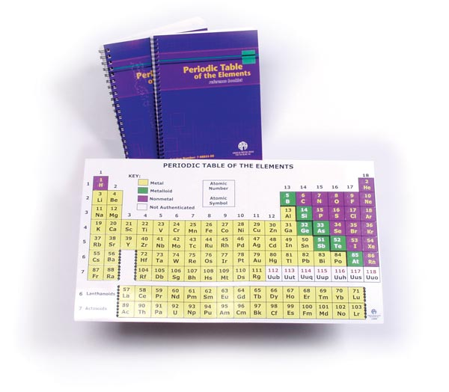

Project Staff
Karen J. Poppe, Tactile Literacy Project Leader
Rachel Bishop, Research Assistant
Emily Grimany, Research Assistant
Sara Lee, Research Assistant
Rod Dixon, Manufacturing Specialist
Andrew Moulton, Manufacturing Specialist
Patrick White, Model/Pattern Maker
Laura Greenwell, Graphic Designer
Anthony Jones, Director of Creative Services

Background
In 2007, APH introduced the Periodic Table of the Elements Reference Chart with Print Booklet (7-08855-00) and Braille Booklet (5-08855-00); this product was designed by Karen Poppe, Tactile Literacy Project Leader. The tactile/print chart is complemented by a reference booklet containing information about each element—atomic name, atomic weight, electron configuration, and so forth. The product allows students to enhance their understanding of concepts aligned with the Next Generation Science Standards (NGSS). The tactile/print chart was carefully designed to ensure tactual discriminability and visual appeal/contrast for the intended target population; it also is useful for all students in inclusive educational settings. The product is ideal for students in middle school, high school, and college.

The sales history of the product over recent years revealed fluctuating demand for each version. The braille version (5-08855-00) sold 116 in FY 2014, 95 in FY 2015, and 207 in FY 2016; likewise, the print version (7-08855-00) sold 130 in FY 2014, 116 in FY 2015, and 118 in FY 2016.

The modernization of the Periodic Table of the Elements Reference Chart and Booklet is critical for ensuring students with visual impairments and blindness have access to the same STEM learning experiences and information as their sighted peers. The updates planned for this product will ensure the incorporation of formally named elements reported by the IUPAC (refer to https://iupac.org/iupac-announces-the-names-of-the-elements-113-115-117-and-118/). Within APH’s current kit, elements 112-118 are named the previously assigned—and now outdated—atomic symbols Uub, Uut, Uuq, Uup, Uuh, Uus, and Uuo; these elements have officially been identified by IUPAC as copernicium (Cn), nihonium (Nh), flerovium (Fl), moscovium (Mc), livermorium (Lv), tennessine (Ts), and oganesson (Og). Refer to https://www.iupac.org/cms/wp-content/uploads/2015/07/IUPAC_Periodic_Table-28Nov16.jpg for the 2016 IUPAC version of the table.

In February 2017, the project leader prepared a formal Product Modernization Form that detailed the expected updates to the Periodic Table of the Elements Reference Chart and Booklet, including the provision of both Nemeth and UEB versions to comply with recent shifts and adoptions of the UEB code by some states and/or state districts. In April 2017, the modernization proposal was presented to the Product Evaluation Team; and in May 2017, it was presented to the Product Advisory and Review Committee. Both committees supported the product endeavor. The project was assigned grant #683.

Work tasks undertaken by the project leader during the latter part of the fiscal year included the following:
- Ordered and reviewed the current product to specify needed updates
- Determined, with in-house support, priority of redesigning the original kit and the new UEB version, based on consequential impact on other APH departments and existing production tooling. The decision was made to focus on the updates to the original kit (Nemeth version) after the modernization of the Nemeth version of the Azer’s Interactive Periodic Table Study Set (see separate annual report).

Work during FY 2018
The project team stayed on course to modernize the Nemeth version of the Periodic Table of the Elements Reference Chart (with separate print and braille booklets) following the production-tooling completion of the Nemeth version of the Azer’s Interactive Periodic Table Study Set. However, some work between the two products occurred concurrently so that an illustration of the print layout of the updated chart could be readied and incorporated into the instruction booklet for the Azer’s kit.

In late October 2017, the project leader conducted a Product Development Committee (PDC) meeting to review with internal staff the expected revisions to the existing Periodic Table of the Elements Reference Chart. (Note that the purpose of this PDC meeting is equivalent that of the newly-established Gate 4: Modifications meeting.) The project staff conducted the following tasks by the end of March 2018:
- Planned the graphical conversion from offset printing of the chart, by an outside vendor, to the in-house generation of the chart via the Roland® UV printer. The UV printer will generate the vacuum-form master to emboss the chart; this process will replace the existing zinc plate for die-press operation. Ultimately, the product’s tactile and print quality will be greatly enhanced because of this conversion.
- Determined the ideal enlargement of the original chart to accommodate added tactile point-symbol designations used for the element classifications. The point symbols mimic those used within the Azer’s Interactive Periodic Table of Elements Study Set to maintain a consistent tactile experience for students when using the two products in tandem.
- Verified the correct Nemeth translation of the chart’s content (as reviewed by research assistants with braille certification).

As of February 2018, the updated print layout of the chart was approved. The word “Nemeth” was applied to the outside die-cut region to safeguard against a possible mix-up with the eventual UEB version on the production floor. The adjusted size of the chart was confirmed feasible based on in-house vacuum-form capabilities. Artwork for the digital file to generate the Roland® UV-printed master was readied; it was then used by the model maker to construct the final fiberglass vacuum-form pattern. Some doctoring to the master was necessary to achieve the ideal sandpaper-like texture for the staircase divider visible on the chart. Likewise, the height of the demarcation-squares bordering the lanthanide and actinide series was elevated. As of March 2018, the vacuum-form pattern was constructed and approved.

According to a new matrix-scoring process used by an in-house review committee to evaluate all APH product ideas and endeavors, the modernization of both versions (Nemeth and UEB versions) of the Periodic Table of the Elements Reference Chart received a weighted score of 61 out of a possible 93. In an effort to minimize the number of active projects on a given project leader’s work plate (as well as time demands on other staff resources), the project reverted to an on-hold status as of July 2018.

Work planned for FY 2019
Reintroduction of this project to active status hinges on the completion of projects closer to availability and on the reassessment of the project leader’s priorities. After the project re-enters the product development cycle, the first step will be to test a Roland® UV-printed sample of the final print artwork in combination with the prepared vacuum-formed part (using .010-in. vinyl) to ensure proper registration between the chart’s print and tactile elements. The content and layout of the accompanying reference booklet for both print and braille editions will be updated as well.

Snap Circuits Jr.® Access Kit
(Completed)

Purpose
To give blind and visually impaired students access to the popular Snap Circuits Jr. ® kit, an entry-level electronics kit used for instruction and recreation

Project Staff
Fred Otto, Tactile Literacy Project Leader
Ken Perry, Programmer III
Heather Kennedy-MacKenzie, Technology Program Manager
Frank Hayden, Director of Technical and Manufacturing Research
Rod Dixon, Manufacturing Specialist
Matt Poppe, Graphic Design
Rachel White, Research Assistant
Leasha Twyman, Research Assistant

Background
Technology staff became interested in the Snap Circuits® line of products after realizing how easily they could be made accessible to blind or visually impaired users. The products, particularly the Snap Circuits Jr.® kit, are already in widespread use in schools, and so making accessible adaptations of them can further the goals of STEM learning and inclusion. 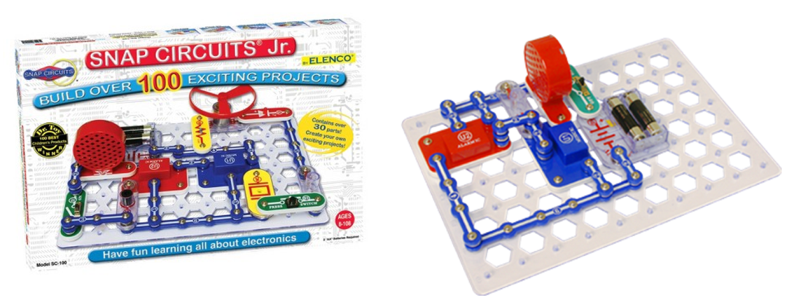

The kit has parts and plans for building over 100 basic electronics projects. Most of the projects produce an effect that can be experienced by a blind student, such as running a fan or making music or sound effects; thus, there is a “payoff” at the end of a completed project. In the kit, there is a grid board with fixed pegs, to which all of the various electronic components can be snapped. By snapping components and connectors to the proper coordinates, users can complete a circuit and then close a switch to experience the result.

The instructions are given in a booklet in pictorial form; that is, students are required to duplicate images of the completed circuits. This presents the only major barrier to access because the other needed accessibility modification (labeling the components with braille) is relatively easy to accomplish.

The development of this project began with in-house trials and conversations, with several different options for adaptation discussed. It was decided that written instructions in step-by-step lists were preferable to tactile graphics, both for ease of use and ease of production.

The great interest expressed for the project led to contacts with Elenco®, the manufacturer, arranged through APH’s Vice-President of Development. Representatives from Elenco® visited APH in August 2015 and agreed to assist in the adaptation of the Jr. kit.

The project idea was submitted and approved, and a project leader was assigned. Technology staff had previously made project notes and a timeline to guide the process. The timeline specified preparatory work, braille labels, and written instructions being done in the first half of 2016, along with presentations and discussions at conferences to gauge interest. All of these steps were completed, with Technical and Manufacturing staff overseeing the braille labels and the project leader writing instructions for 20 projects, sufficient for field evaluation.

APH was able to purchase 105 Snap Circuits Jr.® sets at cost from Elenco®. Research staff worked with Development to explore funding sources to support and promote the project further.

Field testing in schools and other locations was conducted in fall 2016. A call for evaluators was put out through APH News, trustees and other personal contacts, and e-mail discussion lists. Because all kinds of input and data were welcome, and because there was an abundance of purchased sets available, nearly everyone who responded to the call was given a kit to evaluate. Thirty-six kits were sent to 32 sites in early September 2016 for evaluation.

The following is a summary of the field evaluation demographics, settings, and representative comments:

Teacher Data:
- Title
  - 46% (15 of 32) Teachers of the Visually Impaired
  - 25% (8 of 32) Math and/or Science Teachers
  - 15% Media, Technology or Software specialists, teachers, coordinators or engineers
  - 6% Unspecified Teachers
  - 3% Orientation and Mobility Specialists
  - 3% “N/A”
- States Represented: 20

- Program Type
  - 50% Residential (16)
  - 12.5% Full Inclusion (4)
  - 9.38% Resource (3)
  - 28.13% Other (9)
- Years’ Experience
  - Out of the 32 evaluators, 20 reported more than 10 years of experience teaching Blind/VI students.
Student Data:
  - 131 Total Students
  - Average age: 13 yrs. old
  - Mode: 15 yrs. old
  - 59.5% Male, 40.4% Female
- Grade Level
  - Average grade: 7th
  - Mode: 10th
- Primary Reading Medium
  - 43.4% Braille readers
  - 38.7% Large print readers
  - 14.7% Print readers
  - 3.1% Auditory listeners
- 29.7% (39 of 131) identified having a disability other than VI

Classroom Data:
  - 34% science class/classroom
  - 17% resource room
  - 10% applied academics or technology classroom
  - 7% residential home/non-classroom
  - 7% “pull out” setting”
  - <4% for each—general classroom, braille class, fabrication class, TVI office, or N/A
- Is basic electronics regularly included in your students' curriculum?
  - 62.07% Yes
  - 37.93% No
  - 89% said the adapted Snap Circuits Jr.® would fit into a study of electronics in general.
  - The majority of responders (79.31%) said that this product could be used for both educational and recreational purposes.

- Please indicate how each student preferred to access the project instructions (i.e., through hard copy braille, speech access, large print, or hearing them read aloud).
  - Roughly 40% Braille
  - Roughly 30% Large Print
  - Roughly 15% Auditory
  - Roughly 10% Print

Teacher comments/observations:
  - Many students showed interest in building the projects they were assigned. Several responders said their students were interested in making their own circuits after doing the projects. A few responses are as follows:
    - 5th grader wanted to build the whole book!
    - Yes, many of them wanted to just start making their own circuits without following a plan.
    - They all agree that if they are allowed to "play" with the kits - they would all like trying to put things together randomly to "see what would happen..."
    - Students did interchange parts to see effects of sounds and lighting.
  - They wanted to know if they were available at stores so they could ask their parents for them. Many students have asked to use them at other times besides their science class when we explored them.
  - Students were thrilled to succeed in putting projects together and they work. They would trace parts with hands to understand why they worked.
  - They liked that the Braille and large print listed the parts needed and then the 1st, 2nd layer, etc. They liked that the pieces snapped together and didn't need to work with all the wires.
  - Students were pleased to learn that they could independently create working circuits. They were all proud of themselves. Student 1 (totally blind) would have spent hours making all the projects if we had the time.
  - They were very excited when they created circuits that played a noise. They liked having the grid labeled in braille.
  - Blind students or students who used braille were a bit slower than sighted students, but were still able to do a good job.
  - Overwhelmingly, most respondents said their students increased speed and accuracy as they continued to complete projects. One mentioned students needing some assistance for the first few projects, but after that they worked mostly independently.

Final decisions about the product were made based on the evaluators’ responses. There was great overall enthusiasm for the adapted kit; the only negative responses or suggested improvements centered on the placement of braille labels, transcription errors in the instructions, and other details that will be corrected in final production.

Of particular interest were questions about whether the kit should be sold with the braille labels already applied (at higher cost) or with labels for the user to apply. Support was given for both options, but the majority preferred to have the parts pre-labeled and ready to use out of the box. For the convenience of users who already own the commercial kit, a second product called the Snap Circuits Jr.® Access Pack was created; this will include the same labels and instruction booklets as the Access Kit but not the actual Snap Circuits Jr.® materials.

Production staff studied the labeling requirements and determined that they could apply the labels at a reasonable cost if some changes were made to their number and configuration. To this end, Technical Research and the project leader collaborated on revising the labels and producing a pictorial guide to assist workers to apply the labels correctly.

The project leader and assistants completed writing instructions for all 101 projects in the commercial kit. Layouts for the adapted instruction booklets in print and braille were completed, and graphic art for the print materials was created. Tooling for the braille labels was revised. Production specifications were written, and a meeting was held to prepare for production.

Work during FY 2018
Approval for Quota sale was obtained in October. Project staff obtained the adhesive braille labels from the vendor, and then worked with Production on the pilot run to see if any problems arose in assembly.

Both the pilot and full production runs went smoothly, and the completed Access Kit and the Access Pack are now offered for sale.

Work planned for FY 2019
Project staff and Marketing will support the product through demonstrations and innovative promotion. The possibility of creating a webpage or forum for visually impaired users of Snap Circuits® to share projects and ideas will be explored.

Submersible Audio Light Sensor (SALS)
(Continued)

Purpose
To provide a device that allows K-12 students who are visually impaired to participate more fully in scientific experiments and promote their interest in STEM (science, technology, engineering, and mathematics) related fields of study

Project Staff
Rosanne Hoffmann, STEM Project Leader
Frank Hayden, Director of Technical & Manufacturing Research
Lawrence Lovelace, iOS® Programmer
Ken Perry, Programmer
James Robinson, Manufacturing Specialist
Joseph Hodge, Software Quality Assurance Analyst
Larry Skutchan, Director of Technology Product Research
Cary Supalo, President; Independence Science, LLC
Mark Swain, Electrical Engineer; Precision Circuit, LLC
Ron Supalo, Project Manager; Independence Science, LLC
Greg Williams, Director of Products and Training; Independence Science, LLC
Ashley Neybert, Chemist

Background
The SALS device detects changes in light during various applications in air (e.g., placement over dark or light objects) or aqueous solution (e.g., chemical reactions that form precipitates) and converts this signal to comparable changes in sound tones. This instantaneous feedback allows students who are visually impaired to observe the same information as students with typical vision in real time. SALS is unique in that the probe detects light while immersed in liquids in addition to detecting light in air.

The first prototype of SALS was developed in 2005 by a team led by Cary Supalo, a scientist who is blind, as part of the Independent Laboratory Access for the Blind (ILAB) project at The Pennsylvania State University, which was funded by a 3-year grant from the National Science Foundation (NSF). Supalo was inspired to design the device after years of experience in the laboratory as an undergraduate and graduate student during which he was dependent upon others to conduct chemistry experiments. The SALS device was field tested with students who participated in the ILAB project over a 3-year period. During this time, suggested modifications from student field testers were incorporated into five subsequent generations of SALS, each one with design improvements. A second NSF grant beginning in 2007 provided funding for continued development and refinement of SALS.

All prototypes of the SALS device at this point in its history consisted of a light-detecting probe (photocell contained within a glass and plastic wand) connected to a standalone output or control box. Detected changes in light intensity due to chemical reactions taking place in a beaker or test tube, such as precipitate formation or pH indicator color change, were immediately converted to pitch changes of sound output over a range of several octaves. For example, as a solid precipitates within a solution, less and less light is detected by the probe. Within the tone output/control box, this response is converted to lower and lower frequencies of sound waves and the device emits sound of decreasing pitch. Data collection was in real time, allowing the student with visual impairment to make the same scientific observations as sighted peers. The control box of the prototype device allowed the user to listen to and store pitch data and compare a current pitch to a reference pitch. Voice output capability further enhanced data retrieval and manipulation.

SALS was never intended to provide precise quantitative data; rather, it indicates whether a reaction is taking place, or whether the light detecting probe is near a dark or light object. Preliminary field test results showed that when used by students who are visually impaired, SALS both increased independence and promoted interest in STEM related fields. In spite of many improvements over several years, the need for a more versatile and state-of-the-art device was clear, prompting a redesign effort.

Mark Swain submitted a SALS Redesign Proposal to APH and Independence Science (IS) in April 2011. APH and IS supported the following engineering changes in the SALS control box: improved audio, a simplified user interface, improved manufacturability to facilitate mass production, improved battery longevity, and interface capability for future applications using the same audio output technology (using sensors other than a light-detecting probe, such as pressure, temperature, acceleration, etc.). A July 2011 update to the proposal added modification of the SALS control box for Universal Serial Bus (USB) capability, thus permitting the use of an external flash/thumb drive. This feature would facilitate speech data programming, mass data storage during an experiment and exportability to Microsoft® Excel®, software upgrades (eliminating the need to return units to APH for reprogramming), and access to USB communication from SALS to a personal computer (a future capability not included in this project). Although this engineering change impacted both the development time and final prototype cost ($14.00 per unit), it was deemed appropriate given the benefits.

Contract negotiations between IS and APH were complete in November 2011, allowing Swain to begin work on a redesigned prototype. Mechanical, electrical, and software requirements were defined in December 2011. Most of the mechanical and electrical designs, including CADD (computer-assisted design and drafting) renderings of the control box housing, were completed between January and May 2012. Preliminary software development, including USB, speech, and tone generation, were completed by August 2012. Using code from hardware verification, the software for basic functionality of the light conversion to sound application was completed and speech capability perfected. A tool and die shop was identified for custom-machining of the prototype control box housing. After some of the circuit boards were reworked and the housing was delivered, a first new prototype of the SALS control box was constructed. The light-detecting probe was assembled and housed in a clear plastic test tube. The project leader received a video demonstrating basic functionality of the first prototype of the redesigned SALS device and light-detecting probe in June 2014. The internal parts needed to build five light sensors were ordered by Swain. Difficulties finding an appropriate light probe housing as well as software and hardware issues set back completion and delivery of the five prototypes needed for field testing.

It was not possible to find over-the-counter glass tubes of the correct size (rather than plastic, which floats and thus interferes with device functioning) to house the light probes. This problem was solved in January 2015 when custom-made glass tubes of the correct size were ordered and received. Five light-detecting probes were constructed at APH with the internal parts ordered by Swain and the custom-made glass housings. Five prototypes of the SALS control box built by Swain were delivered to APH in April 2015. The project leader collaborated with Supalo in writing an Instruction Manual and Activity Guide for field evaluation with the SALS units and light probes. Continued software development and update processing duties were transferred from Swain to Williams.

The project leader identified nine field testers over a wide geographic distribution via call-out in the April 2015 APH News. Evaluations were received from the nine field testers who worked with a total of 25 students in May, June, and July of 2015. Changes to the control box suggested by the field testers included improving connections from the device to the ear bud and AC charger jacks and applying non-slip bumpers on the bottom of the output box. Field testers also suggested changes in the Instruction Manual including better identification of control box buttons, tips on how to hold the light probe for the most consistent data acquisition, ways to prevent damage to the light sensor glass housing, and more suggested activities appropriate to the scientific use of SALS.

The initial field test results revealed that SALS benefitted students with blindness, but not students with low vision, mainly because the latter were able to use their vision for the suggested experiments. Consequently, the project leader extended the field test by soliciting evaluations from three more TVIs and 17 more students in the fall of 2015.

SALS received Quota approval in October 2015 during the 147th Annual Meeting of Ex Officio Trustees.

The evaluations and comments received by the second set of field reviewers in February 2016 reiterated those from the first round, thus confirming the value of SALS for students with blindness.

During FY 2016, the project leader learned that APH would be responsible for finding manufacturers for all components of the SALS device (probe and control box) rather than Supalo, contrary to the original agreement between APH and IS. Furthermore, in the 5-year period since APH’s involvement in the redesign of SALS, many changes with regard to electronic devices and educational institutions had taken place: cell phones and tablets are more accepted in schools; most students own or have access to cell phones and tablets; and scientific companies are developing applications, or apps, compatible with iPhone® and Android™ devices. Specific apps that exploit the use of these small and now commonplace devices connect with scientific probes directly or wirelessly via Bluetooth®. For example, temperature can be measured with a probe connected wirelessly via Bluetooth® and reported on a cell phone after downloading the appropriate app from Vernier Software & Technology, LLC.

Ken Perry, programmer at APH, tested the feasibility of using the SALS light detecting probe with off-the-shelf mobile devices (instead of a standalone single purpose control box). A sample software app was created on Android™ using a library appropriate for any of the three main OS platforms. The app, which connected to the IOIO-OTG development board from Sparkfun via USB or Bluetooth®, was able to read the same light values that the APH light probe normally sends to the standalone SALS control box and produce a corresponding tone. Work commenced to create a prototype Bluetooth® connected probe and iOS® and Android™ apps that will essentially replace the standalone SALS control box. This will result in lower production costs, decreased production time, and ultimately translate to a lower cost to the consumer. The app software is less expensive and can be easily upgraded to include more features than what would be possible with the standalone SALS control box.

Feedback solicited from five of the original SALS field testers was positive regarding the development of a cell phone or tablet app that receives signals from the APH light detecting probe and reports them as corresponding changes in emitted tone, instead of a standalone device.

In March 2016, Supalo hired Ashley Neybert, a chemist who is visually impaired, to design and test more SALS activities to incorporate into the Instruction Manual.

Hardware development of the Bluetooth® light detecting probe and firmware and software for the Android™ and iOS® apps began in the fall of 2016. By December 2016, sample Android™ and iOS® SALS apps created by Perry and Lovelace were working, and 10 SALS lab activities were received from Neybert to include in the revised Instruction Manual. By April 2017, the iOS® beta version of the SALS app could simulate tones and was uploaded for testing. In September 2017, a first model of the light probe with hardware connecting it to the iOS® app on a phone or iPad® via Bluetooth® showed functionality.

Work during FY 2018
Glass tubes and hardware parts for 10 more light detecting probes with Bluetooth® connection were ordered and received by December 2017. The search for an appropriately sized plastic box to house the hardware at the top of each probe extended the timeline for preparing probes for field testing into the spring of 2018. A first prototype probe connecting to the iOS® SALS app was completed in September 2018 in time for presentation at the 2018 IsLAND Conference on Disability in Princeton, NJ.

Work planned for FY 2019
The project leader will edit the SALS Instruction Manual to include the new activities from Neybert and reflect the SALS design changes. Joseph Hodge will add a section to the Instruction Manual about using the VoiceOver® feature of iOS® devices with the app. Seven probes and the revised Instruction Manual will be sent to field testers (including those with and without previous experience with earlier versions of SALS) in the fall of 2018 for evaluation. Field test results will be compiled in early 2019, and suggested changes to the SALS app and Bluetooth® light detecting probe will be considered and implemented. After finalization of hardware design, the best site for building the light detecting probes will be determined (in-house or out-of-house). The Instruction Manual will be edited to reflect changes suggested by the field testers including tips regarding the best use of the light detecting probe. When complete, the Instruction Manual will be translated into braille. The Instruction Manual will be made accessible as downloadable BRF, HTML, and EPUB® files available with the purchase of the SALS app and Bluetooth® light detecting probe.

Tactile Caliper Set
(New)

Purpose
To provide metric and imperial unit length measurement devices accurate to 1 millimeter and 1/16th inch, respectively, for students with visual impairments including blindness

Project Staff
Rosanne Hoffmann, STEM Project Leader
Pranay Jain, Consultant
Frank Hayden, Director of Technical & Manufacturing Research
Rod Dixon, Manufacturing Specialist

Background
Pranay Jain first approached APH in March 2014 to be a distributor of a tactile-braille 12-inch caliper accurate to 1/16th of an inch that his company, Squirrel Devices, had developed. The internal review process at APH supported the concept of a tactile-braille caliper, but noted that a metric device would be more applicable to STEM academic subjects. Distribution of the 12-inch tactile-braille caliper by APH was declined at this time. Subsequent to this, Jain distributed the 12-inch caliper to the visually impaired community through the National Braille Press (NBP).

In February 2017, Jain approached APH with a request to distribute a 30-centimeter metric version of the caliper accurate to 1 mm in addition to the 12-inch caliper. In August 2017, a supportive internal APH review (including anecdotes of enthusiastic responses from individuals who had purchased the 12-inch caliper from NBP) was submitted. This made it clear that the 12-inch caliper was accurate, appropriate for many applications, and easy to learn and use.

Each caliper from Squirrel Devices comes with a protective plastic pouch in which a large print instructional insert is folded. A caliper set includes one of each caliper (12-inch and 30-cm) packaged together in a box with a braille instructional insert.

Work during FY 2018
Expert review of the 12-inch and 30-cm calipers took place in April 2018. Five math experts with experience teaching students with visual impairments from a wide geographic distribution in the U.S. provided their evaluations. Enthusiastic feedback from the reviewers supported the development of a Tactile Caliper Set including the 12-inch and 30-inch calipers. In August 2018, the project leader prepared a short braille instructional insert (for both calipers) to include with the product.

Work planned for FY 2019
A specifications meeting for the Tactile Caliper Set and release of this product are anticipated this fiscal year.

Talking Scientific Balance
(Discontinued)

Purpose
To provide students with visual impairments with an economically priced balance suitable for use in science laboratory activities with a mass readability to the hundredth gram (0.01 gram)

Project Staff
Rosanne Hoffmann, STEM Project Leader
Ken Perry, Programmer
James Robinson, Manufacturing Specialist
Frank Hayden, Director of Technical & Manufacturing Research

Background
This product idea was submitted in August 2015 by a college student with vision impairment who identified a need, from his personal educational experience, for a talking scientific balance with a mass readability of a hundredth gram (0.01gram) for laboratory experiments in high school and college level science classes. This would place students with visual impairments on the same playing field as students with ordinary vision with regard to participating in massing (weighing out) very small quantities of chemicals or detecting very small changes in mass of an object or organism. Talking balances and scales are available but most are associated with cooking and baking and measure in units of the imperial system (pounds, ounces, etc.) rather than the Metric System of units (grams, milligrams, etc.), which is the scientific standard. Some available talking balances do report mass with metric units, but only to the tenth of a gram, and a finer level of readability is called for. Feedback solicited by the project leader via the online APH News in the fall of 2015 from science teachers and TVIs verified the need for this type of balance.

After progressing through the APH Product Evaluation Team and Product Advisory and Review Committee meetings, development of the Talking Scientific Balance commenced in June 2016. The project leader began research for scientific balances with 0.01 g readability and a measuring range from 0.01 to 600 g that can be interfaced with a speaking device.

The project leader identified and purchased a balance with the specified mass measuring range; the unit came equipped with an RS-232 serial port that can be used to connect the balance with other external devices. James Robinson built a cable to fit the port so this possibility could be further explored. Discussions with Ken Perry indicated that three development paths could be pursued: 1) Create an Android™ or/and iOS® app that connects wirelessly to a dongle connected to the balance so the VoiceOver® function of the phone/tablet devices can be used to speak the mass measurement; 2) Build a small external device that physically connects to the balance via the RS-232 port and speaks the measured mass; and 3) Modify the balance internally such that the measurement is spoken. The first path is the most economically and developmentally feasible, the only caveat being that the balance would need to be near the device to which it is connected. It would require developing, building, and selling a dongle for Bluetooth® connection. The second path could go in two directions: APH can build and sell a small wire-connected external device that speaks the measurement, or APH could supply instructions for teachers to build their own. The third path would require purchasing many balances and modifying them internally for resale by APH; this could not be done in-house at APH. Out-of-house work like this would likely be prohibitively expensive.

In early 2017, the project leader and Perry discovered that several companies that make scientific balances in the desired measurement range also make talking balances for cooking and baking for individuals with vision and/or print impairment. But, as discussed above, these particular devices do not have the desired 0.01 gram readability. In July 2017, the project leader and Perry contacted technical staff at Setra Systems (Boxborough, MA) to seek their collaboration in the development of a talking balance with the desired measurement range and readability from the ground up, rather than modifying an existing balance. In August 2017, two technicians (Bob Clark and Ross Johnson) from Setra built a prototype balance and sent a video demonstrating its function in September.

Work during FY 2018
A conference call with APH staff and Clark and Johnson took place in October 2017 in order to discuss cost and a possible RFP (Request for proposal). The discussion revealed a projected $1,000 cost to the APH customer for the proposed talking balance. This was deemed unacceptable, and this avenue was no longer pursued.

The project leader and Perry then pursued the first option described above in the background section: designing a dongle to connect wirelessly an appropriate balance with an app that uses device VoiceOver® to speak the mass measurement. By December 2017, the project leader ordered and received a balance with the appropriate measurement specifications and USB connection to a Bluetooth® dongle. Perry made many attempts to access speech using the scale and dongle, but the development of a digital protocol was problematic due to poor balance documentation. By February 2018, work on this project slowed due to the rearrangement of Perry’s priorities.

The availability of artificial intelligence (AI) cell phone apps might obviate the need for the proposed talking balance. In April 2018, Perry suggested that an AI app might be able to read and speak the display off an existing commercial balance of any kind. By June 2018, all work on this project was placed on hold; in September, it was taken off the New Product Development timeline.

Work planned for FY 2019
No further work is planned for this project.

SOCIAL STUDIES

Tactile World Globe
(Completed)

Purpose
To update APH’s Globe: Tactile and Visual by applying a topographical relief and braille labels for continents, oceans, and latitude/longitude lines

Project Staff
Karen J. Poppe, Tactile Literacy Project Leader
Andrew Dakin, Model/Pattern Maker
Tom Poppe, Model/Pattern Maker (Retired)
Patrick White, Model/Pattern Maker
Carie Ernst, Cartographer
Laura Zierer, Research Assistant
Andrew Moulton, Manufacturing Specialist
Matthew Poppe, Graphic Designer

Background
APH has a long history of designing and producing excellent tactile world globes for use by students and adults with blindness and visual impairments. Past models are showcased in the APH Museum. Among the most fondly remembered of these tactile globes is the 30” Floor Pedestal Globe that was first introduced in 1955. According to APH’s Museum collection database, the globe is described in the 1956 edition of the APH product catalog like so:
30-inch diameter, overall height of 51 inches; hollow-plastic construction; painted in contrasting blue and yellow to highlight land and sea areas; with brown stippling for mountainous areas; raised latitude and longitude lines; sturdy metal base
Cost: $225.00

The February 13, 1955, issue of The Courier-Journal Magazine, commemorating APH’s 100th anniversary, described this globe as “the first ‘accurately-exaggerated’ relief globe in the United States. The altitudes are exaggerated 30 times to the flat surface. With such a globe, the world will be at the fingertips of the blind student.”

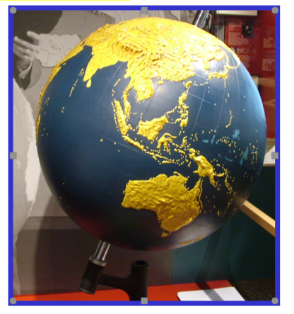

The 30-inch Floor Pedestal Globe, produced in conjunction with the Panoramic Studios of Philadelphia, was still available in the 1980 product catalog, although few were apparently sold. Production between 1975 and 1979 averaged 17 units per year. By 1984, the floor model had been removed from the APH catalog. Some of the original production copies of this globe are still displayed and used throughout the country in residential schools for the blind.

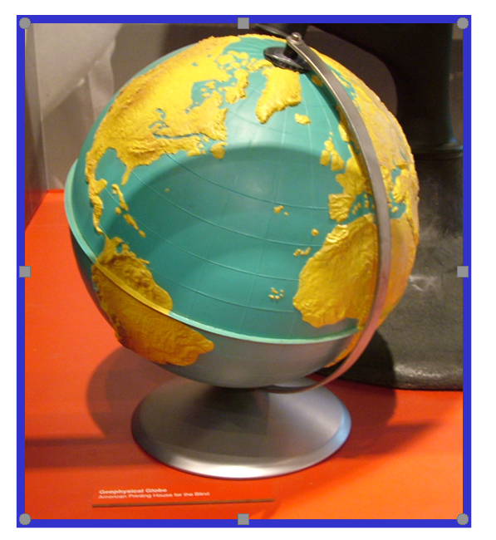

In 1959, APH introduced two 12-inch plastic relief globes—the Panoramic Model Globe and the Geo-Physical Model Globe. These globes were painstakingly hand-painted by APH production staff; they featured topographical detail, and their visual simplicity was ideal for low vision students. Only slight differences distinguished the two globes—type of base (cup-shaped versus tripod), equator design (indented versus a thin lip), and degree of elevation in comparison with horizontal distances (32 to 1 versus 50 to 1). In later years, only the Geophysical Globe was offered, and its base had been updated to a permanent metal stand (as shown in the photograph).

The painting effort required to produce the Geophysical Globe eventually proved too laborious and expensive in the midst of an ever-increasing number of new educational products manufactured in-house during the 1990s. At the sluggish production rate of two painted globes per day, and complicated by the extra step of epoxy reinforcement and limited floor space for drying, an alternative manufacturing approach was needed.

In 1993, the current project leader and T. Poppe addressed the challenge of creating a new tactile globe that imposed less production time and translated into a cost-savings for the customer. Using a production approach conceptualized by the project leader—specifically, the application of two clear vacuum-formed hemispheres onto a commercially-available globe—the model/pattern maker undertook the tooling of a new “world” mold. The new mold featured a pebbly, braille-like texture for continental land masses with higher elevations noted by a slightly different areal pattern; raised latitude and longitude lines were formed as well. The two-part mold was used for vacuum-forming the northern and southern hemispheres out of clear thin vinyl; the two halves were then registered onto a purchased 12-inch table-top political globe. This manufacturing process translated into a 67% cost reduction and the introduction of a new globe—Globe: Tactile and Visual—in 1994.

The urgency to find a solution to the globe’s production difficulties, followed by immediate implementation of the new process, prevented the project staff from conducting a formal field test study of its design. Although the current globe design has served its purpose for two decades, the project staff have always desired to revisit the mold and make improvements to its tactile quality. Prompted by many compliments about the former Geophysical Globe, paired with the arrival of talking globes on the market, globe design discussions surfaced periodically throughout the years. Although tactile adaptations of commercial talking globes were considered in 2003 and proposed in a formal product submission to the Product Evaluation Team and the Product Advisory and Review Committee (PARC), the discontinuation of such globes alerted APH that creating extensive production tooling for a potentially scrapped commercial product was a risky undertaking. In addition, talking globes have the disadvantage of presenting too many sight-dependent tasks, such as asking questions about very specific locations/landmarks; the detail required to perform the tasks cannot be adequately captured in a tactile counterpart.

In June 2012, the project leader visited PARC and proposed active development on the tactile globe. Her idea involved re-introducing the popular topographical relief style encountered in the Geophysical Globe and marrying it with the current print globe; inclusion of braille labels for continents, oceans, and latitude/longitude lines was planned. T. Poppe created a small sample of the anticipated globe design and shared it with the Product Development Committee on August 1, 2012. All attending supported the intended improvements. Production staff were copacetic with the suggested manufacturing procedures.

Significant progress was made on the design and development of the new Tactile World Globe throughout FY 2013. Guided by early feedback garnered during a Product Input Session at APH’s Annual Meeting in October, the project leader and T. Poppe made numerous decisions about various globe features including the type of tactile latitude and longitude lines, braille label positions for all continents and oceans, and topography enhancements to replace the less-desired “pebbled” texture of the existing globe. The staff also located a desirable non-glare vinyl to use for the prototype model.

By the end of March 2013, T. Poppe had completed sculpting the Northern Hemisphere. The decision was made to field test only the Northern Hemisphere to verify that the presentation was ideal for student use before significant tooling effort was undertaken for the production of the entire globe. A fiberglass master for eventual vacuum-forming of the Northern Hemisphere was built and tested. The first attempt to form a part proved successful; the registration of the tactile part to the print globe was ideal, and proper fit was verified. By the end of April, 20 complete prototypes were assembled, each with the transparent, tactile hemisphere applied permanently to the commercial globe.

Anticipating that sufficient time was still available to field test in the spring, the project leader posted a field test announcement in the April issue of APH News. The announcement was also e-mailed to those in Research’s field tester database who had expressed interest in evaluating social studies products. Although approximately a dozen teachers responded to the request, it was decided to postpone the field test activity until the beginning of the 2013-2014 school year to give teachers a lengthier and more convenient timeframe for evaluating the product. The same teachers who expressed interest in field testing agreed to the updated schedule.

Prior to field testing, the project leader constructed an extensive evaluation packet with multiple rating opportunities for each main design feature of the prototype. Beyond just a product evaluation form, a student outcome form was created to assess each student’s basic knowledge of a world globe prior to the use of the prototype. In addition, 25 assessment tasks were devised to test the readability of the new Northern Hemisphere. Carie Ernst reviewed the questions to check for clarity and accuracy from a cartographer’s expertise.

On September 17, 2014, prototypes were mailed to a total of 18 teachers of the visually impaired representing the states of Missouri, Michigan, New York (2), Texas (2), California (2), Louisiana, Tennessee, Nebraska, North Carolina, Maryland, Utah, Ohio, Kentucky, Pennsylvania, and Montana.

A total of 14 completed evaluations and 37 student outcome forms were returned from participating field test sites by January 2015. Some evaluators were unable to complete the evaluation process. Nevertheless, sufficient data was collected to determine the effectiveness of the new bas relief design of the prototype globe. The project leader intermittently recorded data from these student outcome forms as time allowed. The research assistant created a Microsoft® Excel® spreadsheet to report the students’ performances on the pre-quiz and 25 related assessment tasks.

The 14 field evaluators represented the states of California, Ohio, Louisiana, Maryland, Michigan (2), Montana, Nebraska, New York (2), North Carolina, Tennessee, Texas, and Utah.

Type of Educational Setting (N =14)
Itinerant | Residential | Resource
OH, MI (2), NC, NE, NY, TX, UT  57% | LA, MD, NY, TN  29% | CA, MT  14%

Participating evaluators varied in their teaching experience with the largest percentage (33%) reporting 21 or more years teaching experience; 27% had 0-5 years teaching experience, 20% reported 6-10 years teaching experience, and another 20% reported 11-25 years teaching experience. Various titles and professions were represented in this teacher sample (e.g., teacher of the visually impaired, social studies teacher, teacher consultant for the visually impaired, orientation and mobility instructor, vision specialist, and paraprofessional). All of the evaluators were Caucasian/White.

The majority (93%) of the participating evaluators were familiar with APH’s existing globe and had used it with their student(s); 71% had the existing APH globe available for comparison purposes during the field test activity. All evaluators briefly described their current teaching strategies for teaching geography and map skills. Reported strategies included starting with handmade tactile maps of a familiar area (e.g., school, classroom) and then progressing to unfamiliar areas (e.g., globe, US map, world atlas), teaching cardinal directions, introducing concepts of keys and legends, presenting globes and maps in a systematic manner, and so forth. Over one-third (35%) indicated they teach geography/map skills to their students less than once a week. Equal percentages taught these skills/concepts either once a week (14%) or two or three times a week (14%). A smaller percentage (7%) indicated “more than five times a week.” Among the most challenging concepts for the students to grasp were latitude and longitude/imaginary lines and points, location of continents and land features, where objects on a globe/map are in relation to other objects, understanding how the globe relates to a flat tactile map, and “seeing the whole picture and understanding where one part is in relation to another.”

Collectively, the field evaluators used the prototype of Tactile World Globe (the Northern Hemisphere only) with a total of 37 students.
[Note: The decision was made to field test only the Northern Hemisphere to verify that the presentation was ideal for student use before significant tooling effort was undertaken for the production of the entire globe.]

As observed in Table 1, the 37 students varied in age, grade level, ethnicity, and preferred reading medium. A small percentage (16%) were reported as having additional disabilities besides visual impairments and blindness.

Table 1
Student Sample (Gender, Age, Grade Level, Ethnicity, Preferred Reading Medium, and Other Disabilities)
GENDER
Female | 19 |  |  | 51%
Male | 18 |  |  | 49%
N = 37 |  |  |  | 100%
AGE
6 years | 2 | 5% |  |  | 12 | 32%
7 years | 2 | 5% |  |  | 12 | 32%
8 years | 2 | 5% |  |  | 12 | 32%
9 years | 2 | 5% |  |  | 12 | 32%
10 years | 4 | 11% |  |  | 12 | 32%
11 years | 2 | 5% |  |  | 6 | 16%
12 years | 3 | 8% |  |  | 6 | 16%
13 years | 1 | 3% |  |  | 6 | 16%
14 years | 6 | 16% |  |  | 14 | 38%
15 years | 5 | 14% |  |  | 14 | 38%
16 years | 3 | 8% |  |  | 14 | 38%
17 years | 2 | 5% |  |  | 5 | 14%
18 years | 2 | 5% |  |  | 5 | 14%
19 years | 1 | 3% |  |  | 5 | 14%
N = 37 |  |  |  |  |  | 100%
GRADE
Grade 1 | 3 |  | 8% |  | 6 | 16%
Grade 2 | 2 |  | 5% |  | 6 | 16%
Grade 3 | 1 |  | 3% |  | 6 | 16%
Grade 4 | 3 |  | 8% |  | 8 | 22%
Grade 5 | 5 |  | 14% |  | 8 | 22%
Grade 6 | 1 |  | 3% |  | 6 | 16%
Grade 7 | 4 |  | 11% |  | 6 | 16%
Grade 8 | 1 |  | 3% |  | 6 | 16%
Grade 9 | 8 |  | 21% |  | 17 | 46%
Grade 10 | 0 |  | 0% |  | 17 | 46%
Grade 11 | 7 |  | 19% |  | 17 | 46%
Grade 12 | 2 |  | 5% |  | 17 | 46%
N = 37 |  |  | 100% |  |  | 100%
ETHNICITY
White | 16 |  | 42%
Black | 7 |  | 19%
Hispanic | 7 |  | 19%
Asian | 4 |  | 11%
Two or More | 1 |  | 3%
Other: Moroccan | 1 |  | 3%
Unreported | 1 |  | 3%
N = 37 |  |  | 100%
PREFERRED READING MEDIUM
Braille | 27 |  | 73%
Large Print | 3 |  | 8%
LP/Braille | 2 |  | 5%
Print | 4 |  | 11%
Print/Braille | 1 |  | 3%
N = 37 |  |  | 100%
OTHER DISABILITIES
N=37 | 6 |  | 16%
Other Disabilities: ADHD, Cognitive Disabilities, Hearing Impairment, and brain tumor

As highlighted in Table 2, the 37 participating students also differed in their familiarity with world globes prior to field testing, their previous use of tactile maps prior to field testing, and their interest in tactile maps and globes prior to field testing.

Table 2
Students’ Familiarity with World Globes, Tactile Maps, and Interest in Both
Familiarity With
World Globes Prior to Field Testing
Unfamiliar | 7 | 19%
Somewhat familiar | 22 | 59%
Very familiar | 7 | 19%
Unknown | 1 | 3%
N = 37 |  | 100%
Previous Use of Tactile Maps
Prior to Field Testing
Frequently | 4 | 11%
Occasionally | 26 | 70%
None | 4 | 11%
Unknown | 3 | 8%
N = 37 |  | 100%
Interest in Tactile Maps and Globes
Prior to Field Testing
Very Interested | 12 | 32%
Somewhat Interested | 23 | 62%
Uninterested | 2 | 5%
N = 37 |  | 99%

The field evaluation form invited teachers to rate every feature of the prototype of the Tactile World Globe based on the mold of the Northern Hemisphere. Table 3 provides the average rating of each product feature. The ratings were complemented by specific comments and recommendations.

Table 3
Overall Design of Tactile World Globe
Design Features | Number of Eval-uators | Average Rating | % for each rating  5= Excellent to 1 = Poor or “unneeded”
Design Features | Number of Eval-uators | Average Rating | 5 | 4.5 | 4 | 3 | 3.5 | 2 | 1
Overall design/presen-tation | N = 13 | 4.27 | 46% |  | 38% |  | 8% | 8%
Readability of braille | N = 14 | 4.93 | 93% | 7%
Content labeled in braille (e.g., continents, oceans, latitude/longitude lines) | N = 14 | 4.43 | 57% | 36% |  |  |  | 7%
Quality of topography (e.g., elevated/contoured mountain ranges) | N = 13 | 4.35 | 54% | 7% | 15% | 23%
Tactile contrast between International Date Line and latitude/longitude lines | N = 14 | 4.71 | 79% |  | 14% | 7%
Tactile contrast between International Date Line and Prime Meridian | N = 14 | 4.93 | 93% |  | 7%
Tactile contrast of Tropic of Cancer and other latitude lines | N = 14 | 4.71 | 93% |  |  |  |  |  | 7%
Number and location of latitude lines labeled in braille | N = 14 | 4.00 | 29% |  | 57% |  |  | 14%
Number and location of longitude lines labeled in braille | N =13 | 4.15 | 31% |  | 61% |  |  | 8%
Height of Equator | N = 14 | 4.86 | 86% |  | 14%
Coastline elevation above water | N = 14 | 4.36 | 57% |  | 29% | 7% |  | 7%
Visibility of printed content through clear overlay | N = 14 | 4.00 | 64% |  |  | 14% |  | 14% | 7%
Durability and rigidity of plastic overlay | N = 14 | 4.43 | 64% |  | 21% | 7% |  | 7%

Nearly 80% of field evaluators indicated that the new tactile globe design had specific advantages over other globes used in the past, namely: “easier to locate areas,” topography (“gentle bumps to represent hills/land and more pronounced mountains”), addition of braille labels, latitude and longitude degrees, easily-discriminated tactile line types, and minimal glare for students with low vision. Several comments alluded specifically to the beneficial quality of the braille labels:
- “Many students felt comfortable with the globe immediately as the braille students loved finding the names of areas in braille. This was a huge accomplishment for novice globe users.”
- “The braille labels were great and having lines of latitude and longitude with coordinate labels was a great learning experience for the students.”
- The addition of braille labels “make the globe much more accessible to my completely blind students. I like how the landforms like mountains are distinguished better.”

One hundred percent of the students reported that they enjoyed using the prototype globe with supportive, informal comments such as “Yeah, Braille words!”
“Wow, it has braille on it,” and “The bumpy land feels better than the prickly continents [in reference to APH’s existing world globe].” The students’ performance on 25 outlined tasks using the prototype globe revealed specific successes with the globe, as well as highlighted more challenging concepts. (Refer to Figure 1.) Inability to perform a task was often attributed to a student’s unfamiliarity with the concept, or to the fact that the concept/task was too advanced for the student.

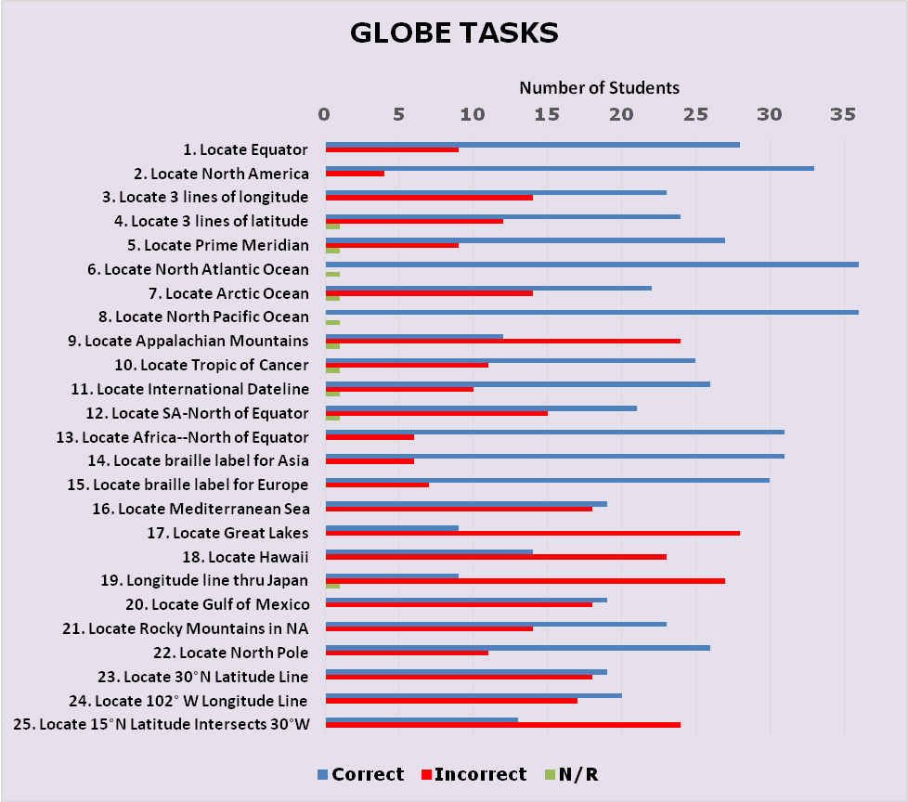
Figure 1. Student Performance on Globe Tasks
Ninety-three percent of field evaluators recommended that APH replace its existing tactile world globe with the prototype’s design, assuming that the Northern Hemisphere’s tactile presentation will be used as model for the construction of the Southern Hemisphere.
Based on field test feedback, anticipated improvements will include the following refinements:
- Non-skid material added to base of globe
- Incorporation of as many braille labels as possible for latitude/longitude lines
- Crisper/more defined edges between some coastlines and water areas
- Inclusion of an instruction booklet (as recommended by 57% of the evaluators) to explain line textures and labeled areas
By the end of FY 2014, the project leader prepared a comprehensive report of the field test results. Quota approval for the Tactile World Globe was requested and received from the Educational Products Advisory Committee at the 146th Annual Meeting in October. Due to the project leader’s and model/pattern maker’s involvement in the prototype development of SPORTS COURTS (see separate project report), active work on the project was curtailed until the second quarter of the fiscal year.

In early February 2015, the project leader regrouped with Technical Research and Model Shop staff to review expected tooling revisions and review intended production processes and assembly procedures of the new globe. Due to T. Poppe’s continued work on SPORTS COURTS, tooling of the globe shifted to A. Dakin. Several world globes were provided to the Model Shop for reference during topographical construction/molding. Tooling work on the Northern Hemisphere was intermittent between March and June. In July, the project leader reviewed the current mold of the Northern Hemisphere and made a short list of needed inclusions (e.g., additional islands), as well as refinements to mountain elevations and a dashed line representing the International Dateline. In September 2015, tooling tasks shifted to the construction of the Southern Hemisphere.

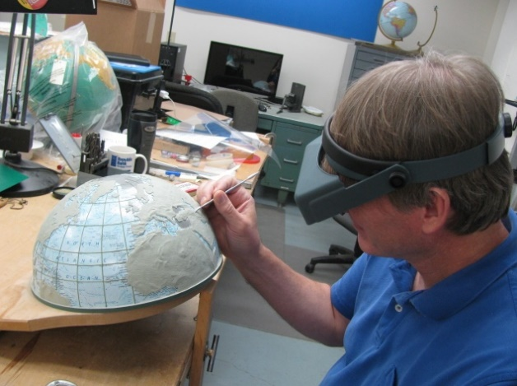

Tooling for the Southern Hemisphere overlay characterized most of the work performed in FY 2016. Work on the project was intermittent as the model/pattern maker tended to the production tooling for other ongoing research products. However, by the third quarter of the fiscal year, a fully constructed globe, using vacuum-formed hemisphere attachments, was assembled. The project leader reviewed the globe and recommended minor refinements and improvements.

In July 2016, momentum toward tooling completion for the Tactile World Globe was slowed by the following tasks:
- Identifying a way to make the base of the globe non-skid, a feature requested by field evaluators. Purchasing staff worked with the outside vendor to obtain non-skid bases to alleviate additional in-house modifications to the globe.
- Problem solving seemingly minor, but impactful deviations in the size of the print globes received from the outside vendor. A slight, unexpected enlargement of the newer globes necessitated identification and application of a clear plastic tape to create the tactile equator (similar to the equator style used for APH’s existing globe) in lieu of a permanently-formed version that was part of the original plan and tooling.

Concurrent tooling efforts included the design of an accompanying print and braille key, formatted at an 8.5 x 11 in. size, to capture the various tactile line types represented on the globe. This added component was also a suggestion from field evaluators. M. Poppe designed the print and braille layouts of the key.

Remaining tooling-related tasks for the new tactile globe continued into FY 2017. In October 2016, the permanent Equator, previously incorporated into the final mold, was removed to accommodate an unexpected, very slight diameter increase (3/16 inches) evident in the manufacturer’s newest globe model; although slight, the size increase prevented the two clear vacuum-formed hemispheres from locking together correctly. Instead, the Equator will be applied in production using a strip of flexible vinyl (as used in the existing APH globe) to form the tactile band that holds the two formed hemispheres together. In November, Patrick White initiated the construction of the 4-up vacuum-form pattern of the tactile key using a Roland®-printed master.

In early January 2017, a fully assembled globe, generated with the use of the new vacuum-form molds, was presented to the project leader for final review and approval. Only slight adjustments were necessary to straighten or nudge a few braille pins in one direction or another. A certified braille transcriber checked all of the braille labels for accuracy. After minor tweaks, the assembled globe was approved by the project leader. The approved globe will be used for reference during the initial pilot run.

Purchasing staff closely monitored the current stock of existing globes to assist in the transition to the new globe style. The vendor agreed to furnish nonskid tabs on the bottom of the globe’s flat, wood base. This feature was a welcome addition that saved the Production staff the laborious in-house steps of die-cutting and adding a foam insert to a concave metal base as originally planned.

In February 2017, White generated a single-up copy of the vacuum-formed part for the project leader’s review. Minor tweaks were needed. This part, too, was reviewed for braille accuracy by a certified braille transcriber. Part number assignment for the print/tactile key was the last step prior to finalizing the production specifications document.

In September 2017, the manufacturing specialist formally presented the product specifications to Production staff. Come the end of the fiscal year, feasible dates for the pilot run and production runs were yet to be determined.

Work during FY 2018
The majority of the fiscal year was spent gearing up for the eventual pilot and production runs anticipated for launch in spring. A representative globe reflecting the expected final attachment of the clear hemisphere overlays to the commercial globe was fabricated and supplied to the outside vendor for future reference and quality assurance. In January 2018, a shipment of 100 commercial globes was received. The project leader and manufacturing specialist verified the correct base style, dimensions, and application of non-skid pads.

The pilot run of the first 50 units of the updated globe was initiated in early April and dovetailed with stock depletion of the older globe. The project leader, manufacturing specialist, and model makers closely monitored the quality of the produced units, including the accompanying print/tactile key. On May 14, 2018, the Tactile World Globe (Catalog No. 1-01551-01) was announced as a new APH product with a selling price of $139.00.

On June 25, 2018, a Gate 6: Product Launch meeting was conducted by the project leader. The pilot and production runs were assessed as successful, with added precautions built in to prevent inadvertent misapplication of the vacuum-formed hemispheres. That is, a double quality check was adopted during the assembly process whereby the production workers who affixed the hemispheres to the commercial globe was different from the production workers boxing the final product.

As of August 2018, 125 units of the new Tactile World Globe had sold, and the product was on backorder status. The Field Services Representative created a Quick Tip: Tactile Globe video.
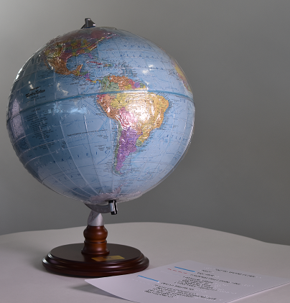

Work planned for FY 2019
Formal work on the development and provision of the Tactile World Globe is officially complete. The project leader and other APH staff will continue to demonstrate the new, enhanced globe at future workshops and conferences. The project leader will also gather and monitor product feedback from customers.

TECHNOLOGY AND MEDIA

CodeQuest
(New)

Purpose
To give young children with blindness or low vision a fun and accessible game app that introduces them to basic programming concepts

Project Staff
Li Zhou, Core Curriculum Project Leader
Rachel Bishop, Research Assistant

Background
Technology is shaping the world. In the digital age, the ability to program is of utmost importance. Educators around the world understand knowing how to program is essential for students' future success, and that learning should start at a young age.

Substantial effort has gone into creating tools to teach young students to program. However, most existing tools are highly visual in nature and therefore are not accessible for use by students who are blind or have low vision. Although these students are equally interested in and capable of learning about programming, lack of accessible tools puts them at a disadvantage.

To help address this barrier for students with visual impairments, a teacher of students with visual impairments, a university professor, and a group of university students in North Carolina designed and developed an iPad® game named CodeQuest.

CodeQuest is an accessible coding logic game created for preschool and early elementary students. It gives all students, with and without visual impairments, an opportunity to learn basic coding logic and concepts such as sequencing and looping through fun game play. In each CodeQuest game, the player first figures out a path in a grid and then navigates through the grid by designing a sequence of commands. The developers also created 3D manipulatives to accompany the digital CodeQuest game. These manipulatives include several laser-cut game boards and many other 3D-printed game pieces. Initial test on the app prototype conducted by the developers with students with visual impairments in various ages received positive feedback.

CodeQuest was submitted to APH as a new product idea by the teacher of students with visual impairments in September 2017. It was reviewed and then accepted in early 2018.

Work during FY 2018
Permissions were received from the original developers to allow APH to revise and distribute the app and its accompanying manipulatives. Starting with the app prototype received from the original developers, the APH development team worked on necessary changes.

Work planned for FY 2019
A field test will be conducted. Then necessary changes will be made to the app and the manipulatives. Product specifications will be completed. The product will be released.

EARLY CHILDHOOD

Animal Recipes
(Completed)

Purpose
To teach and reinforce a young child’s understanding of the salient features of animals. Animal Recipes will be followed to add key “ingredients” that make each animal unique.

Project Staff
Susan Sullivan, CVI Project Leader
Dawn Wilkinson, Early Childhood Project Leader
Kelly Kennedy Mimms, Research Assistant
Leasha Twyman, Research Assistant
Frank Hayden, Director of Technical & Manufacturing Research
Andrew Moulton, Manager of Technical & Manufacturing Research
Adam Clark, Manufacturing Specialist
Anthony D. Jones, Art Production/Design Manager
Matt Poppe, Graphic Designer
Katherine Corcoran, Model/Pattern Maker

Product Description
The Animal Recipe farm set will include seven animals: horse, cow, goat, pig, sheep, rooster, and goose. One of the main objectives of this kit is to allow young children to make the connection between the 3D components and the visual/tactile representations. In order to accomplish this concrete to abstract thinking, the foundational components of the kit begin with seven 3D jumbo farm animal figures. Each animal in the set will have a colored Mini-Lite Box underlay representing the animal’s side profile with a corresponding Mini-Lite Box clear tactile overlay side profile that can be associated with the toy figure. A set of clear puzzle pieces (eyes, ears, nose/snout) can then be used to create the image displayed on the colored Mini-Lite Box underlay and matching clear tactile overlay depicting the animal’s face.

Background
Animal Recipes was submitted by project leaders Susan Sullivan and Dawn Wilkinson in October 2016. It moved through the Product Evaluation Team in November 2016 and through the Product Advisory and Review Committee in December 2016. A brainstorming Product Development Committee meeting was held in April 2017 establishing the team and projected dates for development. Prototypes were created and mailed to field testers in April 2018. Reviewers worked with the prototypes through June 2018 and then completed a survey of related questions. Requested changes included the following: goose puzzle piece should match the shape of the face overlay/underlay, the pig should be a truer pink color, the tactile face overlays should be the same size as all other overlays, and make the top and bottom of puzzle pieces feel different for easier spatial identification.

The Gate #4 meeting was held in July 2018 where all members agreed to changes, as well as completing a new IDEA Scoring Matrix, assigning a number of 68 to the product.

Relevance
Early childhood learning standards in the area of science require that young children be able to observe, investigate, describe, and categorize living things, as well as identify, describe, and compare the physical properties of objects. Language arts benchmarks include describing familiar places, people, and things combined with the ability to provide additional detail. Young children with visual impairment, including cerebral/cortical visual impairment, may not be able to discriminate one animal from another without being specifically taught what makes them similar, and what makes them different.

Providing children with the ingredients for each animal, paired with the opportunity to create that animal, will foster a “hands on” understanding. Three-dimensional models will promote the transfer of knowledge to tactile representations of the animals.

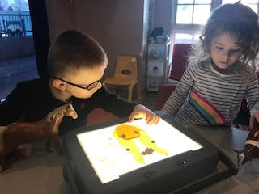
Research
The evaluation period took place from April to June 2018. Nine educational sites were selected for the field evaluation. Sites were located in the following states: Colorado, Illinois, Kentucky, Missouri, New Jersey (2), North Carolina, Texas, and Washington.
Nineteen students ranging from age two through seven participated in the field test. Twelve were male; seven were female. Visual acuity ranged from no light perception to 20/80. Sixty-eight percent of students had additional disabilities.

Seventy-eight percent of the field testers revealed that their students tend to have difficulty identifying animals as quickly or efficiently as sighted peers. Eighty-nine percent of students had little experience with farm animals. Fifty-six percent of students significantly improved their ability to identify and contrast the animals.

Teachers reported that the kit teaches salient features of the animals, helps students transfer understanding from concrete to abstract, develops comparative skills, supports multiple learning styles, progresses sequentially from general to specific details, integrates naturally with thematic units in the classroom, and promotes shared learning between students with and without vision.

Field tester comments included the following:
- “The kit was useful for discussing animal traits and comparing them to one another”
- “This product was especially helpful for my students with no light perception who have not been able to see what these animals look like”
- “helps introduce tactile graphics at a young age in a fun way.”

Fifty-six percent of reviewers agreed that there is a significant need in our field for this product, with 44% strongly agreeing.

Work during FY 2018
Prototypes of animal profiles and faces were created by Graphic Design. The puzzle pieces for the face were 3D printed. Prototypes were sent to field testers in April, and surveys were collected in June.

Work planned for FY 2019
Changes will be made to the prototype as recommended, and the product will move forward to production. Project leaders will complete the guidebook.

Art Digitizing/Modernizing of On the Way to Literacy Storybooks
(Continued)

Purpose
To replace deteriorating film art with digital art, reduce page sizes to enable in-house printing of the books, modify tactile and visual illustrations, convert and produce in Unified English Braille (UEB)

Project Staff
Suzette Wright, Emergent Literacy Project Leader
Anthony D. Jones, Art Production/Design Manager
Frank Hayden, Director of Technical & Manufacturing Research
Monica Vaught-Compton, Project Assistant

Background
The 18 storybooks in the On the Way to Literacy series were first produced in the early 1990s using film art, then standard in the printing industry. The original film art for the books had been deteriorating; some time ago, Production began asking that the print tooling for the books be recreated in digital file formats. In addition, because the cost of offset printing rises dramatically when fewer than 300 to 500 copies are printed, and books are not inventoried, Production staff recommended redesigning the books for IGEN® production. This would make it possible to produce smaller runs in-house. To make this change, however, required a reduction in page dimensions.

Meetings with production staff defined additional objectives for the modernization effort and the opportunity to update other aspects of the books. Consumers and focus group members have repeatedly noted the importance of providing read-aloud books that will also interest sighted peers. For this reason, it was proposed that print illustrations be modified to make the illustrations more visually attractive for sighted audiences without disadvantaging the tactual reader. The new print illustrations accomplish this by suggesting background images that duplicate information already in the tactile illustration or use decorative patterns (a colorful page border) intended only for the sighted reader. The project leader also requested that a more “book-like” binding be considered for some books, a request also voiced by teachers and parents, although this change was not approved at the time.

At the beginning of the effort, the project leader and Director of Technical Research analyzed the 18 books in the On the Way to Literacy series and grouped them according to type and nature of the modifications to be made. Colors were chosen based on IGEN® swatches, and the Low Vision Project Leader was consulted regarding visual art modifications. The project leader worked with the in-house graphic designer and outside graphic designers, under the in-house designer’s supervision, to begin the modernization of the first five books (Something Special, That’s Not My Bear, Giggly Wiggly, The Littlest Pumpkin, and Jennifer’s Messes). Two other titles began the process of modification. During FY 2011, the project leader, Technical Research, and Production staff reviewed test runs of the newly modernized art for Something Special, That’s Not My Bear, and Giggly Wiggly, produced on IGEN® equipment. Some files were modified to address concerns with color consistency and margins. These required repeated testing.

Digitized art for The Littlest Pumpkin was also completed. Updated print art for The Blue Balloon was designed by the project leader, and art files were completed. The graphic designer continued to work on digitizing and redesigning the art for The Longest Noodle. (Because The Littlest Pumpkin, The Longest Noodle, and The Blue Balloon contain multiple large foldout pages, these books were not able to be resized for in-house IGEN® production.)

Due to work on higher-priority projects and the discovery of a “work around” for the deteriorating film art, as well as time required to fit test runs into a busy Production schedule, a decision was made to suspend work on the art digitizing/modernization of the On the Way to Literacy series in FY 2013. Nevertheless, a spreadsheet was developed specifying each of the 15 steps in the redesign and testing process with space to record target dates and progress for each of the 18 titles.

In late 2014, work began again on the project. The progress spreadsheet was used to track progress as files were updated, given to Production for test runs and embossings, and returned for approvals and modifications. Two books (That’s Not My Bear and Giggly Wiggly) were tested again on the IGEN® and test embossed. Files for both books were ready to be posted to the Production server, requiring only that the graphic designer receive from Production information about the numbering and file setup for IGEN® production; this was delayed by negotiations related to the new IGEN® contract.

Following negotiation of the IGEN® contract, Production supplied the necessary information for file numbering so that work could proceed. The new graphic designer was acquainted with the project, status of each book, and located the previous graphic designer’s files. He was provided with templates to guide layout of print and braille interlined text. Specifications for That’s Not My Bear and Giggly Wiggly were provided to Production in January 2015.

In early 2015, the final decision was made to update all 18 titles to UEB. The project leader conducted an examination of all books to assess impact on each book’s layout of text and graphics. Steps for UEB translation and production of new UEB braille plates were added to the progress spreadsheet. It was decided that, beginning with the next book to be modernized, UEB changes would be incorporated into the modernization effort. Books already modernized will receive UEB updates later.

Modernized files (completed before the decision to move to UEB compliant) for Jennifer’s Messes and Something Special had been completed by the previous graphic designer. Braille alignment needed to be checked. The art also needed crop marks and correction of a card insert and punctuation sign. The current graphic designer made these changes. In 2016, modernized digital files with updated print art for Something Special and Jennifer’s Messes were posted to the Large Type server for Production’s use, and final specifications for both books were turned over to Production. The new digitized and redesigned print art files were used to produce Giggly Wiggly, That’s Not My Bear, and Something Special.

In 2016, work began on the next title to be modernized, Geraldine’s Blanket. In accordance with the decision to update to UEB, a new translation was made, checked, and approved. New braille plates were made and corresponding new print copy (with changed line breaks) was given to the graphic designer to produce new print art files. Final digitized and redesigned art files for Geraldine’s Blanket were completed, tested on the IGEN®, and approved. New plates bearing the UEB braille and specification were completed. The file was posted to the Large Type server and ready for Production to use.

As a significant extension of the modernization of this series of books, the project leader had long advocated a more book-like binding and update of tactile illustrations in some books to include collage style illustrations with a wider variety of textures. Research confirms the effectiveness of this type of illustration (Theurel et al., 2013). In 2016, Craig Meador, APH President, and other in-house staff supported an initiative to redesign The Caterpillar, an On the Way to Literacy book written by Josephine Stratton (1991), to create illustrations utilizing textures with multisensory and interactive elements and a more book-like binding and cover.

The project leader selected the book to pilot this more extensive redesign, mocked up two possible devices for creating a moving caterpillar and butterfly, and rewrote the text to be shorter with an altered ending. As a means of increasing the speed of development and providing additional ideas, upper management urged use of a workshop approach to development of The Caterpillar. The goal of the workshop was to gather design and construction ideas from a small group of graphic designers, artists, TVIs, and other in-house staff by providing them with materials to construct rough mockups of the book, utilizing, as much as possible, materials already used and tested in other APH products.

In preparation for the workshop, the project leader laid out UEB and print text and drew up actual size templates group members could use to sketch or mockup tactile/visual illustrations for the book. Production staff worked to provide six sample binders showing materials used in many other APH products. The project leader also reviewed existing APH products to add to the list of available materials for tactile book creation. In addition, the project leader purchased generic materials to be used in the workshop, carefully selecting items that might be useful given the elements of the story needing illustration. Before the workshop the project leader corresponded with participants regarding the purpose of the workshop. She provided them with excerpts from Tactile Book Builder: Guide to Designing Tactile Books to acquaint them with design guidelines for collage illustrations, layout for the story text, and links to view collage style tactile books produced by Les Doigts Qui Rêvent (LDQR).

The day-long workshop was held in late March 2016 and included InGrid designer (Emily Crawford), a local artist working with students at Kentucky School for the Blind (Michelle Amos), APH graphic designer (Anthony Jones), Director of Technical & Manufacturing Research (Frank Hayden), and the CVI Project Leader (Susan Sullivan). The sample binders of APH materials and a variety of collage style books produced by LDQR were laid out. Approved color combinations providing optimal contrast were posted. Making use of the tables of collage materials provided by the project leader, templates, scissors, and glue, group members created mockups of the book. They were encouraged to collaborate or work individually, as they chose. The Emergent Literacy Project Leader and Director of Technical & Manufacturing Research were available to answer questions and offer assistance.

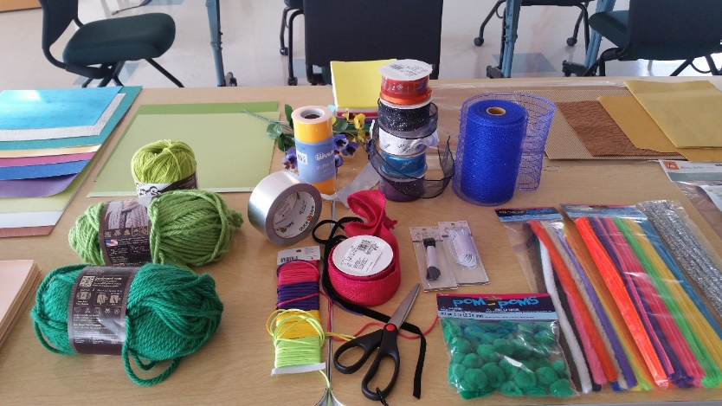

As a side note, the workshop approach was evaluated by sending participants a questionnaire inquiring about the amount of preparation they received before the workshop was held; introduction received at the workshop; structure and format of the workshop; and the time, space, and materials provided. All participants commented they appreciated the information about tactual learning and illustration sent beforehand, posted guidelines, and other tactile books provided at the workshop for inspiration. The sample binders of existing APH materials were considered very helpful. All commented they liked the basic workshop structure that allowed them to work alone, at their own speed, but to share ideas from time to time with other participants. One stated she would have preferred a more structured brainstorming period with the whole group at the beginning of the day. Although the graphic designer suggested more time was needed, another designer commented: "Timing seemed ‘spot on.’” Another stated: “The goals of the workshop and materials I was expected to use were clear. The organizer was very available and present. I felt free to interact with other participants.”

The day following the workshop, the Emergent Literacy Project Leader met with the Early Childhood Project Leader (Dawn Wilkinson) to review all versions created by the workshop members and to solicit her input. As both a TVI and a tactual learner, her feedback was highly important. The in-house staff who had attended the workshop then met with Wilkinson and discussed the mockups made. The Emergent Literacy Project Leader then synthesized all input into a single storyboard to guide InGrid in creating print art for a prototype of The Caterpillar. She provided a sample of print art from an LDQR book as a guide and print art for the entire book was received from InGrid within a few days.

The project leader prototyped all of the book’s tactile illustrations, and in combination with the print art, turned these over to Production staff for further input within 2 weeks. This was received and incorporated. The project leader continued experimentation with construction of tactile elements, particularly for the caterpillar, and timed hand labor involved. Hayden provided a detailed and extensive cost estimate. APH staff met, reviewed the project leader’s mockups of all pages and Hayden’s cost estimate, and elected to pursue development.
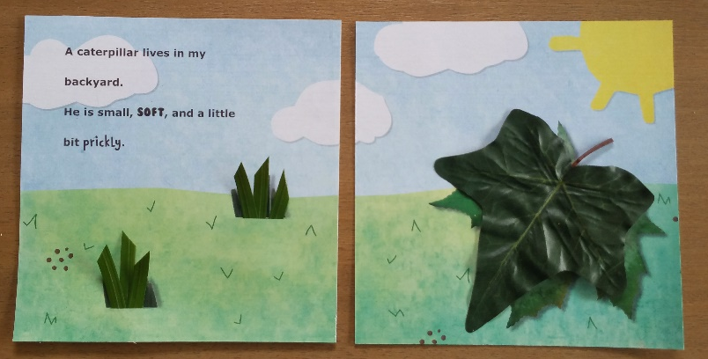

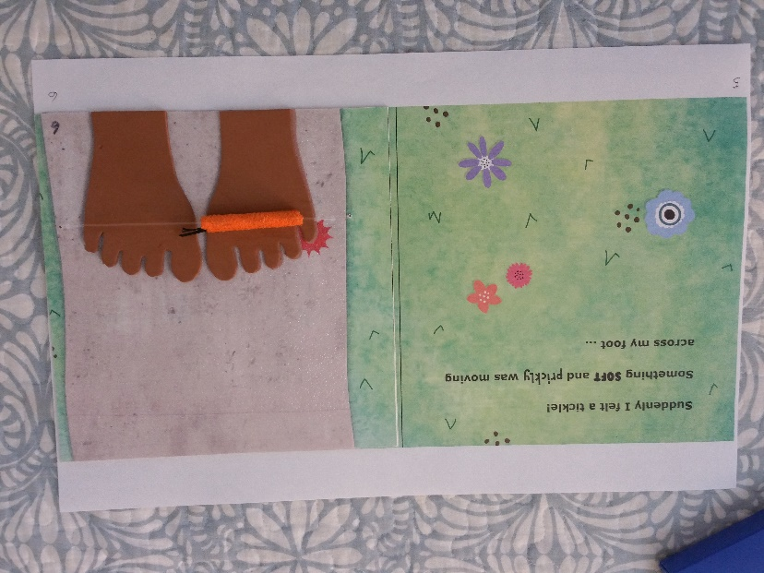

Several subsequent Product Development Committee (PDC) meetings were held with Production staff, Technical Research staff, and model maker Katherine Corcoran. Topics addressed included safety testing, available tools and in-house processes, binding methods, purchase and ordering of materials needed for prototype fabrication, and creation of needed thermoform patterns. In keeping with a request from Production a new paper stock, compatible with IGEN® was found, ordered, test printed and embossed, and approved. Print art was finalized according to instructions given to InGrid by the project leader. All thermoform patterns were completed. Dies were made for the applique pieces in the tactile illustrations. Previous inquiries by the project leader about braille for early books had resulted in a recommendation by APH staff to use UEB contracted braille for this and similar books. The braille files were prepared and proofed.

Numerous designs for creating the tactile caterpillar were explored but were not acceptable for production. After asking input from Production staff, project staff were requested to explore out of house options for making the caterpillar component. An organization was found; however, another design was accepted by Production and work began to locate the needed material and to investigate minimum order quantities and pricing for this less common material.

VELCRO® brand loop material in orange was found at acceptable minimum quantities, allowing in-house production of the caterpillars. Prototype pages and covers for The Caterpillar were printed on the IGEN®. Although the final book will have embossed pages, braille labels were completed and used for the prototypes. All other materials for the tactile components were purchased or fabricated, and prototypes were completed in early December 2016. A field evaluation questionnaire for teachers and for parents was written, as was a student data form. Prototypes and the questionnaire were delivered to two families of children who attend Visually Impaired Preschool Services (VIPS) for an extended period of home use. VIPS teachers then used the prototypes for the month of January. The project leader and project assistant observed the prototypes in use with students, obtaining video footage to be used in the review process.

Field test results indicated teachers and parents were very pleased with the book as redesigned. The highly positive comments centered around the developmentally appropriate nature of the book, its tactile appeal, and interactive qualities. Comments made included:
- In the past, I have used APH’s older version of a caterpillar story, and it helped students with concept development. However, frankly, the students have shown much more obvious excitement about reading and getting to explore this book.
- I am really excited about the potential for this new series of books. In my opinion, this book is of very high quality, and I cannot wait to be able to use it and any future titles with my students.
- I like how it is just enough – not too wordy, but rich and informative for her developmental level.
- There is a good variety in the tactile/visual illustrations that creates interest in looking and touching.
- Also, I like that the cover of the book is appealing. It looks like any other children’s book, which I think is so important!

All evaluators indicated:
- the book’s text was interesting and appropriate as a read-aloud story for most students in the intended target audience
- the tactile/visual illustrations used in the storybook were interesting and appropriate for most students in the intended target audience
- the construction of the book (durability, ease of use, attractiveness) was suitable for the target population

One evaluator noted the spiral binding worked well but might distract; however, the modified National Library Service style cover and binding chosen for the book was judged to be the best in-house process available, so the spiral binding will remain. One evaluator requested the addition of a cocoon and text about the life cycle of butterflies, but it was decided this would add too much to cost. A suggestion to incorporate the concept of “across” was given, and this limited revision to the text was made.

Small indicated revisions to the book were made, including use of a slightly larger ring size and spine width to facilitate page turning and a laminated cover allowing it to be wiped clean. A second cost estimation of the book was made and given to APH staff for approval to proceed. The project leader worked with InGrid to complete final art for interior pages (including placement marks for tactile elements), slightly enlarged cover and spine, flysheet and wood pattern for “fencepost” fabrication. The project leader opted for VELCOIN® brand tab attachment to replace the elastic attachment of the caterpillar on a single page, further reducing costs. Quotes for orange VELCRO® brand loop strips (.75” x 2.375”) were received. Quotes for 7/8” white low profile VELCRO® brand hook coins were also requested and received. Use of a single, longer strip of sushi grass (164mm) or 6.45 inches) was tested and decision confirmed to use this instead of a type of plastic floral grass. The Manufacturing Specialist is working with an outside printer regarding cover lamination, as this process no longer exists in-house, and has received quotes for outside printing of the cover and laminating of the cover. Other than receiving and approving the cover sample from the vendor development of the book was essentially complete in April of this year.

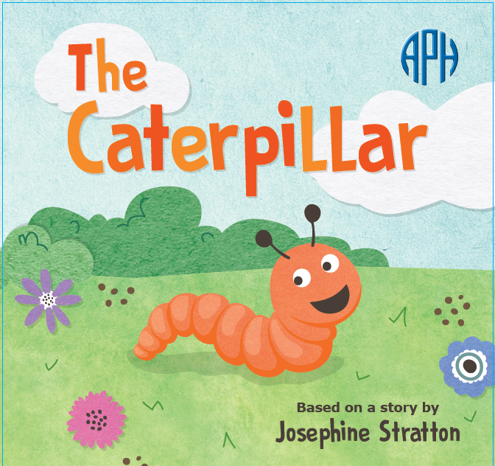

In keeping with the decision to continue modernization of the series, a second title, Jellybean Jungle, was chosen. The workshop to explore ideas for adapting the book was held in February. Participants included Production staff members (Tom Dunn, Denise Merideth), parents of children with visual impairments (Pauletta Feldman, Martha Hack), the InGrid graphic designer (Emily Crawford), and the Emergent Literacy and Early Childhood Project Leaders (Wright and Wilkinson). Preparation for and structure of the workshop were similar to the previous workshop, but more time was spent initially discussing the book as group before breaking to work separately. Some excellent rewrites of the original text were suggested. Following the workshop, the project leader led a group of in-house staff in a discussion of the mockups and alternative texts. Several rewrites of the text have been made, based on texts written by Dunn and Wilkinson. A mockup of Jellybean Jungle is being prepared by the project leader for presentation at the first PDC meeting.

Work during 2018
A sample of a printed, laminated cover and printed flysheet was received from the outside vendor. After some delay, a quote was also received from the vendor to print The Caterpillar, apply tactile components, adhere the pages (back to back), and ring punch before binding. The results of field testing, the prototype, samples and quotes, and a plan for shared production of the book with the outside vendor were presented at a Gate 4 meeting in the spring. At the meeting, it was requested that the print vendor also provide a finished, glued cover with flysheet to compare with an APH-made finished cover. The vendor has not yet provided the requested sample.

Further development of the next book being modernized, Jellybean Jungle, was placed on hold until project work is completed for The Caterpillar.

Work planned for FY 2019
Once the finished cover sample can be obtained from the vendor, attendees of the previous Gate 4 meeting will have the opportunity to select their preferred option: the APH-made cover or the vendor’s cover. Once that is done, final specifications can be written and final tooling given to Production for production of the book. A brochure will be written and the product priced and stocked. At that point, work on Jellybean Jungle can resume and a Gate 2 meeting will be held. Pending approval at this meeting, PDC meetings can begin with all members leading to completion of prototypes for field evaluation.

Astro Adventure Balls: Swirl, Twirl, & Whirl
(Ongoing)
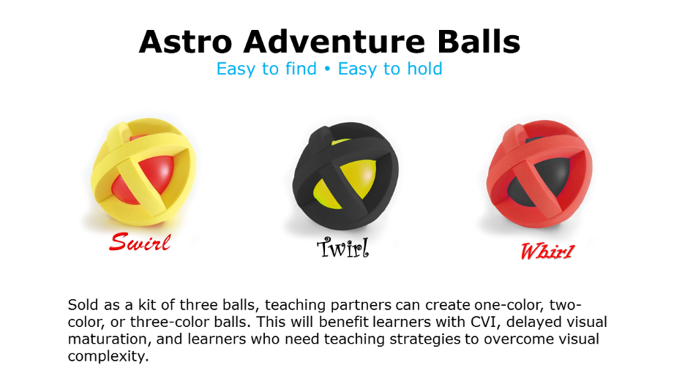
Purpose
Purpose 1: To bring back a discontinued ball that is in high demand by teachers, parents, and children. The commercial manufacturer discontinued it.

Purpose 2: To provide animated cartoons in an app that will help students develop visual complexity skills
Project Staff
Tristan Pierce, Multiple Disabilities Project Leader
Susan Sullivan, CVI Project Leader
Rod Dixon, Manufacturing Specialist
Corey Knapp, Android™ Developer
Lawrence Lovelace, iOS® Developer
Matt Poppe, Graphic Designer
Background
This lightweight plastic ball produces sound for 20 seconds after the ball stops rolling. The dense foam exoskeleton allows small hands to grasp and hold the ball; it is especially good for young learners who are learning hand movement and exploration. APH sold this ball in a variety of colors from 2004-2007. It was not available for purchase with Quota funds; it was a product sold for cash. When the manufacturer discontinued it, APH purchased all balls they had in stock and offered to purchase the tooling so APH could continue to provide the ball too young learners with visual impairments. Unfortunately, the manufacturer decided to sell that division of their business to another toy manufacturer, who then sold it to another. That manufacturer agreed to work with APH, but they could not find the ball among the purchased acquisitions. In addition, the patent on the design of the ball did not belong to the original manufacturer; it belonged to an independent toy inventor, with whom APH was unable to open a line of communication. APH waited 10 years for the patent to expire. Over the years, APH has had requests for this ball from swim coaches, teachers who work in early childhood programs, and from APH Ex Officio Trustees.

The Multiple Disabilities Project Leader conducted a short online survey titled, “Where did that ball go?” to confirm that persons familiar with the original ball still wanted APH to provide it again and to see if there was interest from individuals unfamiliar with the original ball. APH received 50 responses during the 30 days of posting. When asked if they would like APH to sell this ball again, 49 individuals answered the question and 100% of them said, “Yes.” Of the original ball colors, the weighted average of each color option shows that respondents preferred the red and yellow ball. APH plans to sell the new ball in a set of three using the colors red, yellow, and black. These high-contrast colors are advantageous for young learners with cerebral/cortical visual impairment; also, children with low vision and children who have no visual impairments enjoy these colors. The design of the ball allows the balls to be unassembled and reassembled to make a one-color ball, a two-color ball, and a three-color ball.

Additionally, APH hopes to incorporate another change from the original ball, which is to have a different sized/type BB ball inside each ball so each ball will have its own sound. Likewise, each ball will have its own name—Swirl, Twirl, and Whirl: The Astro Adventure Balls. The BB ball in the original ball measured 8mm. APH tried smaller and larger BB balls, but they did not work. APH met with engineers at First Build at the University of Louisville to confirm that ultrasonic welding with tongue and groove connects the two halves of the ball together. First Build provided names of possible vendors for tooling for ultrasonic welding.
Work during FY 2018
The Multiple Disabilities Project Leader and the CVI Project Leader wrote the script for the first cartoon (Whirl) for the development of the app. The graphic designer and the two developers met with the project leaders as needed to assess needs and progress. The Multiple Disabilities Project Leader and the manufacturing specialist continued to meet and work on drawings and specifications for the ball. To test the construction and the required length of sound the ball needs to make, APH approved manufacturing of tooling for production samples as opposed to prototypes. The bid package went out to vendors selected for tooling of the ultrasonic-welding tool and the injection-molding tool.

Work planned for FY 2019
This project is temporarily on hold until resources become available. When work commences, the sample balls will proceed to field testing or professional review.

Early Childhood Needs
(Ongoing)

To research and develop educational materials that meet the needs of early interventionists, teachers, and parents, which address the diverse needs of children birth to six years with visual impairments

Project Staff
Dawn Wilkinson, Early Childhood Project Leader
Monica Vaught-Compton, Consultant
Rachel White, Research Assistant
Kelly Kennedy Mimms, Research Assistant

Background
Product development in the area of early childhood has continually been a focus of the Research Department. Various project leaders have sought input from the field to develop products that meet the needs of early childhood across the curriculum. Dawn Wilkinson assumed the Early Childhood Project Leader position in March 2014.

Work during FY 2018
The project leader continued to manage the early childhood projects currently under development and review new product submissions, conduct needs and feedback surveys, and so forth. The project leader continued to represent APH at multiple events and network with Ex Officio Trustees, teachers, early interventionists, and parents.

Work planned for FY 2019
Investigation and development of new products for early childhood will continue, along with modernization of existing products. The project leader will collaborate with experts in the field, conduct literature reviews, attend conferences, and present information in order to determine appropriate educational products and materials to address best practices in the area of early childhood and visual impairment.

Emergent Numeracy Kit For Preschool
(Continued)

Purpose
To determine major needs areas in emergent numeracy for young children with visual impairments, and to develop a kit to be used by early interventionists and preschool teachers

Project Staff
Dawn Wilkinson, Early Childhood Project Leader
Jeanette Wicker, Core Curriculum Consultant
Kelly Kennedy Mimms, Research Assistant
Adam Clark, Manufacturing Specialist
Matt Poppe, Graphic Designer

Background
During the past few years, there has been a continual focus in many journal publications concerning teaching emergent numeracy concepts to very young children. There is evidence that combining math and literacy through the use of picture books in a meaningful situation can increase a young child’s understanding of numbers in the real world setting. Since a great deal of research has focused on storybooks that are picture based and use math manipulatives that are color dependent, it is in the best interest of young children with visual impairments that these materials be adapted accordingly. The development of an early childhood numeracy product was subsequently ranked as a very high priority by the early childhood focus group held at APH in 2012.

On May 30, 2013, APH received a product submission idea form from Christine Moe, a teacher of the visually impaired, suggesting a product that would include a storybook and manipulative to teach specific early numeracy skills to toddlers/preschoolers with visual impairments. This product idea was taken to the Product Advisory and Review Committed on January 9, 2014, by Kate Herndon and moved into active development.

The project leader gathered relevant journal articles addressing best practices in early numeracy. Research included a comparison of the development of numeracy skills by children with and without vision. Top selling commercially available math manipulatives were evaluated for their usefulness and adaptability for children with visual impairments. Popular storybooks addressing math concepts were considered for relevance in this kit. Suggestions were sought from the field concerning teaching beginning numeracy skills to preschoolers. Numerous possibilities of components to be included in the kit were discussed.

In 2015, project staff determined that the areas needing to be addressed encompassed such a wide range of skills that multiple kits would be required. At that time, the project leaders decided to develop three to five kits with books, based on the five domains of the Common Core State Standards for math that are addressed in kindergarten. These include counting and cardinality, operations and algebraic thinking, number operations, measurement and data, and geometry. Since there are not Common Core standards nationally for preschool, the project leaders compared these domains addressed in kindergarten to several sets of early childhood and pre-k standards from numerous states, determining this to be the most logical approach. Lists of the most popular books taught in general education classrooms were evaluated and the first book was chosen: Five Little Speckled Frogs. The first meeting was held with Technical Research in late January 2015 to discuss the multiple components of the kit for Five Little Speckled Frogs. This first kit would include a print/braille book with some tactile graphics, a storyboard with manipulatives and number tiles, frog and dragonfly manipulatives, and a short teacher guide. Materials were sought to make the manipulatives for the prototypes of Five Little Speckled Frogs, but work on this project was slowed by other priorities.

In 2016, meetings were held to review the prototypes of the 25 frogs and log needed for the Five Little Speckled Frogs book and storyboard. The jumping frogs were remade because they appeared too elongated. The manufacturing process for the log was determined, and the development of prototypes began.

The project leaders submitted permission requests to publishers for adaptations of two other books for the next kits in the Emergent Numeracy series. One book request was declined, but the second book proposed, My First Book of Shapes by Eric Carle, was granted permission by the publisher.

Graphic design completed the artwork to accompany the public domain text of the Five Little Speckled Frogs book, and the text was brailed. A survey for field testers was placed in the February 2017 APH News; a total of 63 participants responded to the survey. Field testing was expected to begin in late spring for the 15 participants who would be selected from those who responded to the early numeracy field test survey. There were problems while making the prototypes for field testing, however, when the printed pages were to be embossed from the braille plates. Both the print pages and the plates had to be redone, and a new texture was chosen during this process for the embossed log. As a result, field testing expected in the fall of 2017 was delayed until February of 2018.

Work during FY 2018
Field testing of Five Little Speckled Frogs lasted for 6 weeks, and 15 prototypes were sent to geographically diverse settings: Texas (2), Washington, North Carolina, South Carolina, Connecticut, Pennsylvania, Ohio, Virginia, Indiana, Missouri (2), Kansas, North Dakota, and Canada.

Surveys were returned by 16 teachers with a total of 39 students, 28 boys and 11 girls. Thirty-four students were ages 3-6, with 14 of them being 4 year olds. Fifty-one percent of students had disabilities in addition to blindness. Sixty-four percent of the students were receving some individualized instruction in a regular education preschool classroom; 15% were in an inclusive preschool setting, with only 6% at a center-based setting. All of the evaluators responded that when considering both sighted and blind children reading together, the book was appealing both visually and tactually.

Comments:
"The tactile images did trump the visual in students' interest, though. Everyone wanted to touch the illustrations!"
"My students loved it--the familiarity of the song, the tactile component, and the brightness of the page."
"Since this little guy is in an inclusion classroom, his classmates enjoyed reading the book as much as my student."
"Illustrations are lovely."
"Student really enjoyed the frog and the dragonfly. She would match them up to the ones on the pages."
"Children loved the manipulatives!"
"Both students enjoyed finding the dragonfly as we went through the book. This book is one of the best I have seen for early literacy. I used the song in addition to the book with my student. I thank you for including manipulatives, objects and numbers to extend the lesson into math and science. It also helped build vocabulary for second-language learners."
“Five Little Speckled Frogs is used in every pre-k class I have been in my three years with my current school district. Having this book allows students who are blind or visually impaired to fully participate in the Five Little Speckled Frog song with their class.”
The product received Quota Approval in April 2018. A Gate 4 product development process meeting was held on June 10 to discuss revisions needed to the prototypes based on field test evaluations. Storyboard tiles will be made thicker and low profile VELTEX® brand material will be used on all removable pieces. A dragonfly will be created for the storyboard, as this was a complete oversight not to include one.

Work planned for FY 2019
Project staff will work to complete the following tasks:
- Complete revisions requested by field evaluators
- Complete tooling of Five Little Speckled Frogs so that it is available for sale
- Identify field testers for the next early numeracy kit, My First Book of Shapes, using a request for field testers in the APH News and/or the early childhood electronic mailing lists, as well as a search in the APH Field Tester Database.
- Prepare evaluation and send out kits for field testing of My First Book of Shapes
- Analyze field test results and make revisions

Fingers That Dream
Formerly Tactile Books/International Collection
(Continued)

Purpose
To collaborate in order to provide high-quality tactile illustrated books with print/braille text to support the emergent literacy skills of young children with visual impairments and to join the efforts of Les Doigts Qui Rêvent (LDQR) and other organizations in sharing information leading to improved quality and production of tactile books

Project Staff
Suzette Wright, Emergent Literacy Project Leader

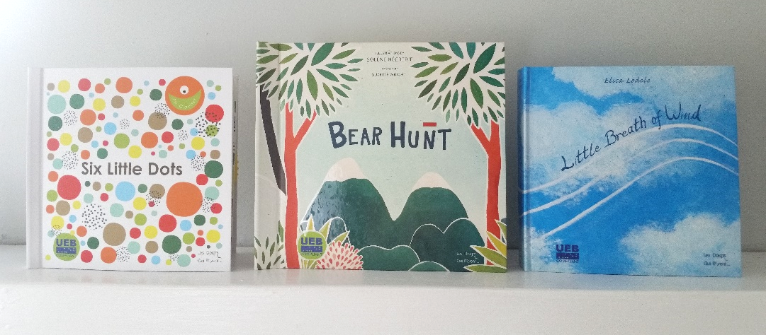

Background
The LDQR workshop, located in Dijon, France, has specialized in the production of collage style tactile illustrated books since its establishment in 1994, producing more than 40,000 books in in multiple languages. Philippe Claudet, a French TVI and director of LDQR, has been in communication with the project leader since 2005. He has presented at APH (2011), Getting in Touch with Literacy (2011), and with the Emergent Literacy Project Leader at the international conference of the Association for Education and Rehabilitation of the Blind and Visually Impaired (2014), and Western Regional Early Intervention Conference (2015). APH staff and conference participants commented on the high quality of the books’ construction, braille, and use of varied materials with rich textures and interactive materials that invite and encourage tactile exploration.

Richly textured books such as those produced by LDQR meet a need identified by the Early Books Focus Groups (2004, 2007) and Meeting of the Minds (2011) for a greater variety of books for young tactual learners—“something besides raised line drawings and thermoforms.” LDQR’s books include hand labor and often involve sewn parts and special methods of attachment, enabling moving parts, as well as fabric textures.

Available research supports the central role of texture in interpreting tactile illustrations (Theurel, et al., 2013; Gentaz & Hatwell, 2003). Research has shown that even for sighted children up to the age of 6, texture is more salient than shape and is given “massive priority” over shape and size as a classification criterion (Gentaz & Hatwell, 2003; Schwarzer et al., 1999).

After gathering input from in-house staff and others, Little Breath of Wind was chosen as the first book that APH would seek to purchase from LDQR, translate, and distribute. A product submission form for Little Breath of Wind was completed; it was approved by the Product Advisory and Review Committee (PARC) as a “pass through” product. In-house, decisions were made about preferred labeling and packaging methods, the need for safety testing, and issues related to shipping and passage through Customs. Claudet contacted Intertek, an international testing agency recommended by APH, to conduct all necessary safety tests. APH’s Purchasing staff negotiated purchase and terms of delivery with LDQR. The book’s text was translated into English and a braille file given to LDQR by the project leader. Permission to distribute the book as a Quota item was sought and received. All standard U.S. safety tests were passed. In March 2013, the first shipment of 250 copies arrived at APH’s docks, ready to ship. The second shipment of 250 arrived in May. By the end of September 2013, all 500 copies had sold.

Based on the successful purchase and quick sales of the first book, as well as positive feedback from teachers and APH Ex Officio Trustees, it was recommended that a second book be purchased from LDQR for distribution on Quota. The Emergent Literacy Project Leader reviewed copies of many LDQR books to identify those best meeting needs identified by previous focus groups and consultants. Most of the books available for selection were previous winners of the tactile book competition, Typhlo & Tactus. These entries are examined by professionals in the field as well as adults and students who were blind or visually impaired as a part of the selection process, helping to ensure their appropriateness. The project leader consulted with Claudet about the expense of producing each before selecting 14 books to submit to in-house staff and staff of the Building on Patterns PreK project to obtain their recommendations. Chameleon, a board book written by Antje Sellig, was chosen, featuring collage-style illustrations of a chameleon shape illustrating opposites. It was recommended the book be provided in contracted braille.

Following procedures used with Little Breath of Wind, a purchase of 500 copies of Chameleon was negotiated; APH provided an English translation of the text along with Unified English Braille (UEB) files. Intertek conducted all necessary safety tests, this time at significantly reduced cost since LDQR had identified a way to group materials. The project leader maintained contact with LDQR and communicated with APH’s Purchasing Department concerning progress. Production of Chameleon began in January 2015. In April, the first shipment of 250 books was delivered to APH. These sold quickly. The second shipment of 250 was requested, arrived in early August, and also sold quickly.

An informal written poll of Ex Officio Trustees at the 2015 Annual Meeting indicated many would like APH to repurchase copies of Little Breath of Wind and Chameleon. This was attempted; however, the author of Chameleon demanded a significantly higher payment from LDQR for the second run of this book (10% of APH’s previous selling price), in place of LDQR’s standard, flat fee agreed to in their initial contract. LDQR declined her terms and will not produce the book again.

In place of Chameleon, the project leader proposed another recent title published by LDQR, Little Paths, by Catherine Colin, ideal for promoting tracking skills and encouraging texture discrimination. PARC approved a request for a quote, a purchase was negotiated, appropriate translations made and given to LDQR, and 500 books were received by September 2016. All copies were sold within 6 months.

The purchase of three more titles from LDQR was successfully negotiated in 2017; all three titles were received and stocked: the requested repurchase of Little Breath of Wind in contracted UEB (November 2016)—and two new titles [Six Little Dots (June 2016); Bear Hunt (July, 2017)].

Six Little Dots, by Philippe Claudet, was translated into rhyming English text. “Meet Little Dot...he can hop from spot to spot!” begins this texture-rich book about braille fundamentals. Each ½-inch dot is a different and distinctive texture and color. Little Dot 1–sliding on elastic–“hops” and moves about, exploring different dot positions along the way. The print/braille text introduces and names dot positions 1 through 6. At its simplest level, it encourages fingertip texture discrimination and exposure to spatial concepts—top, middle, bottom, above, below, and under. For students ready to be introduced to dot positions and names, it offers a fun approach to this step in their learning.
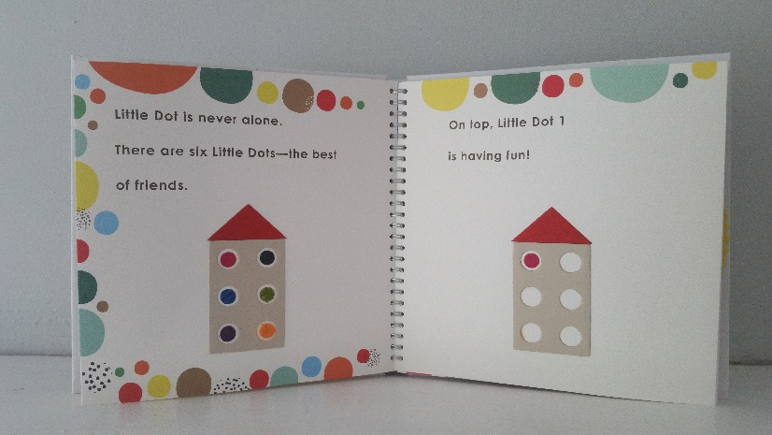
Bear Hunt, a collage style book with moving interactive pieces and diverse textures, is LDQR’s award-winning adaptation of the classic children’s chant. In 2016, the International Bologna Children’s Book Fair, the largest of its kind, established a new award category: books about a character with a disability or books accessible to children with a disability. Bear Hunt was one of five books awarded in this category and the only awarded book in an accessible format. Although LDQR’s text closely follows Michael Rosen’s version of the traditional public domain children’s chant (permitted by French copyright law), the text of the APH version was written to avoid similarities and the possibility copyright permission might be withheld by the holder of the U.S. rights to the Rosen text.
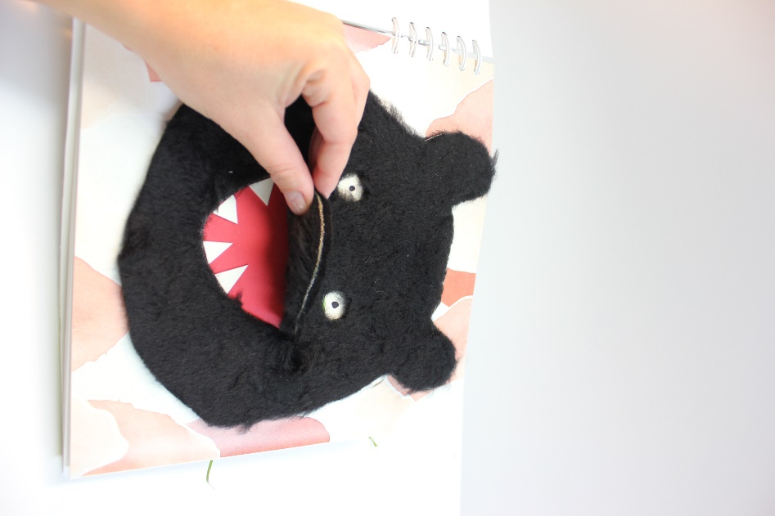

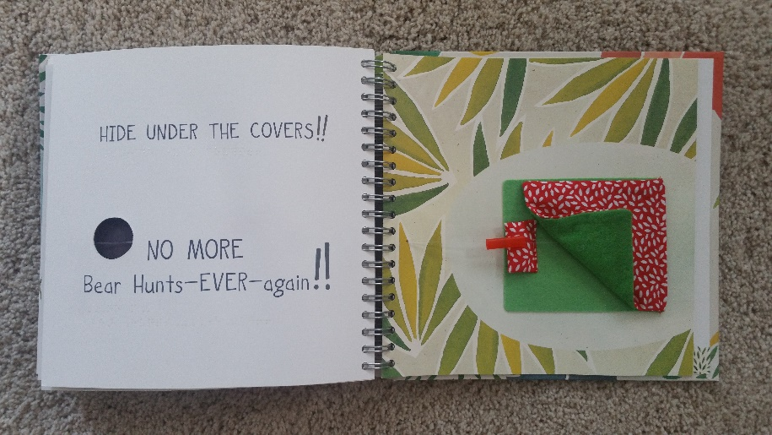

In addition to these titles, the project leader continued to communicate with LDQR about commercially available titles each discovered and discussed possible tactile adaptations. The project leader provided an English translation of a holiday Christmas story. Adaptation of The Gruffalo, by Julia Donaldson, and an initial prototype of another commercially available book, Quatre Petite Coins de Rien du Tout, by Jerome Ruillier, was made by LDQR based on collaboration between the project leader and LDQR staff.

In August 2017, a recommendation was made to PARC concerning additional titles to be translated and produced for APH in FY 2018. Two were recommended by the project leader: A Touch, a winning entry from France in the 2015 Typhlo & Tactus tactile book competition, written by Carlotta Vaccari; and an adaptation of Quatre Petite Coins de Rien du Tout.

APH also began negotiations with LDQR to translate and distribute the Six Dots Game of Cards as a companion to the book, Six Little Dots.

Work during FY 2018
In the late fall of 2017, the project leader was able to view the 70 plus tactile books entered in the 2017 international level of the Typhlo & Tactus book competition, assisting in plans for future book selections.

Appropriate permissions were received for adaptation of Four Little Corners (the English title for Quatre Petite Coins du Tout). Several prototypes for A Touch and Four Little Corners were made by LDQR, commented on, and eventually approved by the project leader.

A Touch is a colorful, texture-rich book suited for reading aloud with a very young child. The sturdy pages are small and easy to turn, and the text is extremely brief. Heart–shaped textured pieces can be manipulated and used to stroke the child’s hands and face. At the end of the book, as promised, the heart takes wing and lifts from the page.
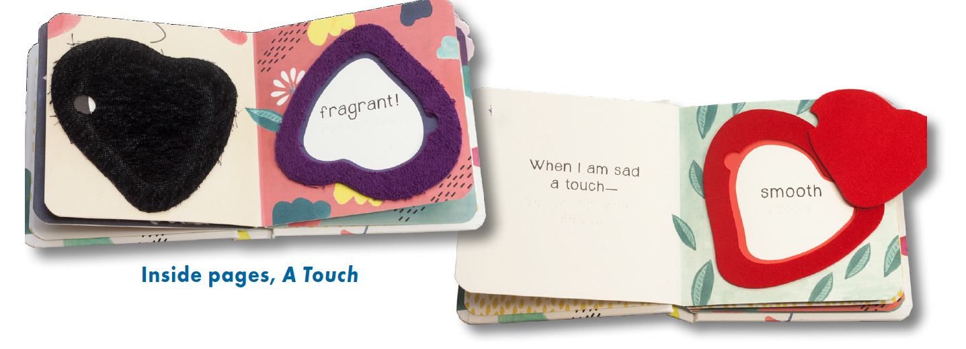

Four Little Corners is a story about what it means to belong and to have access. The Rounds, all friends of Little Square, are circles of varying textures and fit easily through the round school door, but Little Square cannot join them. Following the principle of “where there is a will there’s a way,” the Rounds suggest Little Square change himself (fold, turn, stretch, twist!) to fit through the door. At last, all realize it is the shape of the door to the school that must change so that all may enter. Children can lift the colorful, textured shapes to pass each piece through the school “door” and help Little Square join his friends.

The Six Dots Game of Cards consists of 42 colorful tactile cards, each belonging to one of seven different texture “Families” (names in print and braille on each card). Within every Family are six unique cards, each with a single textured Dot in numbered positions modeled after the arrangement of dots in a braille cell. Similar to “Go Fish,” the goal is to collect all six Dot cards needed to form a complete Family. For students practicing identification of numbered braille dot positions, Six Dots Game of Cards offers a fun approach to this step in their learning.
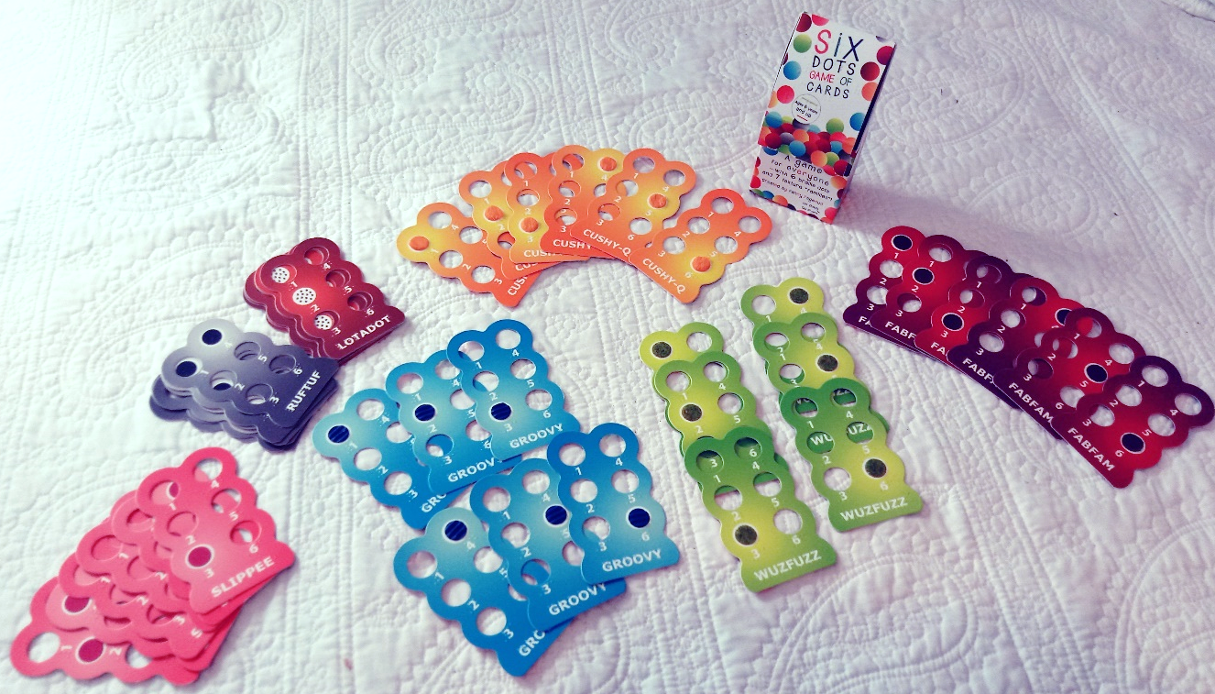

After the English print translations for the books and card game instructions were made by the project leader, UEB files were made, checked by the project leader, and all given to LDQR for final layout. As with all materials to date from LDQR, appropriate safety tests administered by Intertek were passed. Layouts of the print and braille were made and given to the project leader for proofing and approval; the books and materials entered production at LDQR.

Five hundred copies of A Touch arrived at APH in March 2018; 250 copies of the Six Dots Game of Cards and the first shipment of what will ultimately total 500 copies of Four Little Corners arrived in August 2018. The project leader has recommended APH place an order for additional copies of Six Little Dots since this book sold out quickly in 2017, and with the arrival of the companion card game, should be of continuing interest to customers.

Work planned for FY 2019
The project leader will continue to monitor sales of the LDQR books currently available from APH (at this writing, Bear Hunt, A Touch, and Four Little Corners). Together with LDQR staff, the project leader will continue to seek out and share information about promising commercially available books that might be adapted and to examine previous winners of the tactile book competition as well as current and past books produced by LQDR over their 20-year history. Information related to learning though touch, research articles and books, will continue to be shared, along with worldwide contacts interested in these topics.

FirstTouch Books
(Continued)

Purpose
To develop read-aloud, tactile illustrated books with interactive features that support the development of emergent literacy skills for students birth to 3 years

Project Staff
Suzette Wright, Emergent Literacy Project Leader
Monica Vaught-Compton, Project Assistant
Wendy Sapp, Consultant

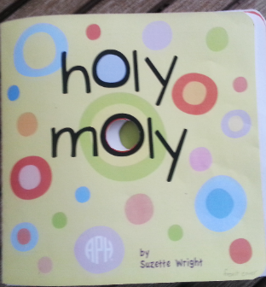

Background
Children take their first steps toward learning to read and write early in life. Reading aloud to a child, from infancy onward, has been cited as a key contributor to later success in learning to read. Early, positive experiences with books motivate children to become readers. Oral language skills, listening skills, and vocabulary are built as the adult reader and young child share a book and talk about its words and illustrations and relate these to the child’s own experiences. Early experiences with books provide opportunities to encounter written words and to learn book-handling skills. Young children who will read braille, however, face a limited selection of books in braille, particularly print/braille books that enable a typically sighted adult to read aloud to the child. Even fewer books contain tactile illustrations, capable of adding interest and meaning to the words of a story. APH and other braille publishers have worked to expand the availability of print/braille books. APH’s On the Way to Literacy books for children, ages 3 to 5 years, and the Moving Ahead Tactile Graphic Storybooks for ages 4 to 6 offer print/braille texts and tactile illustrations designed to introduce children to a range of types of tactile displays. Given the importance of books for young children who will read braille, APH continues to make strong efforts to poll the field to determine current needs and to seek help in prioritizing these needs. In an online survey, 140 of 156 respondents ranked very simple, early books for birth to 3 years as a high need. This need was also noted by focus groups.

The objectives for books for this target audience were defined in detail. The project leader examined current offerings of braille producers to determine what was already available in print/braille for children from birth to age 3. She searched commercially-available print books to identify titles that might be adapted, seeking books with high quality language that would lend themselves to the addition of simple tactile, interactive, or other multisensory components. Hundreds of books found through a wide variety of sources were considered. In addition, designs for a variety of kinds of tactile interactive components were considered and reviewed by in-house staff regarding their feasibility for mass production.

This information was submitted to two consultants with combined experience in teaching and in research regarding emergent literacy for children with visual impairments. The resulting recommendation was that APH develop both types of books for students ages birth to 3 years: adaptations of high-quality, commercially-available books with tactile components added by APH, and APH-created books with simple texts written to support meaningful tactile, interactive components.

The combined efforts of the project leader and consultants to locate a print book that would be excellent, once adapted, for children birth to 3 years were not initially successful. The project leader continues to monitor commercially-available print books for the birth-to-3 age group that could be adapted.

For books in the FirstTouch series, it was proposed that books be developed one at a time. The series will eventually include adaptations of commercially-available books, as suitable ones are discovered, as well as original books. The proposed project received the approval of the Product Evaluation Team and the Product Advisory and Review Committee and was removed from the parking lot in late spring of 2009. In June, the first Product Development Committee brainstorming meeting was held. A number of good ideas regarding book construction were received. Individuals, including both parents and teachers, were encouraged to submit ideas and original drafts. As a result, four promising drafts and sketches or descriptions of accompanying tactile, interactive components were obtained.

These were submitted to the project consultant for a detailed review, including a rating of each draft and ranking of their suitability for the target audience. Two drafts were rated “excellent” as candidates for further development. The draft ranked first, Holy Moly, was roughly laid out in electronic form by the project leader, including dimensions, materials, and tactile as well as visual illustrations. This file was sent to several current and past consultants for a preliminary, informal review and was examined by in-house staff regarding production methods that might be used.

The book includes a rhyming text and features textures, flaps to open, and die-cut holes on each page to be explored, counted, and compared. The braille text is embossed on clear labels applied over the print page. Brightly colored very simple background patterns form the print art. The large print text contrasts with the background colors and is in a san serif font.

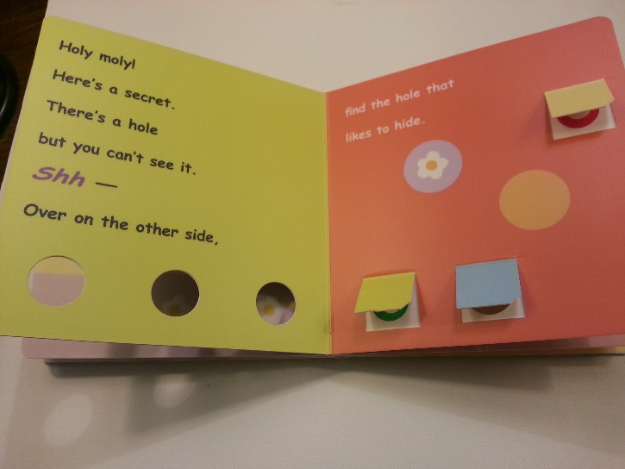

Various production methods for board books were examined and priced. Methods and materials for all of the book’s tactile interactive components were determined and priced; relevant safety standards were investigated to ensure compliance. The text and all tactile interactive components for the book were finalized. The braille tooling for the book has been completed. The project leader provided the graphic designer with the files and information needed to work on the book’s art.

The book was given out for bids, and a vendor was selected. The vendor agreed to provide the prototypes for the field evaluation. The graphic designer was given what was needed to produce print art files.

The braille files for the book were completed; the book is compliant with Unified English Braille (UEB). The graphic designer completed work on print art files. The textures, scented stickers, and cord for the book were selected. Field evaluation sites were sought and contacted. A questionnaire for the books was designed. Problems in obtaining all requested prototypes from the vendor and the winter holiday delayed the start of field evaluation by several months.

Field evaluation began in January, and completed forms were due by March 31; additional time was offered as needed, and all forms were received by end of April. Participating teachers were mailed the book, a general questionnaire and child information forms soliciting each student’s reactions to the book (level of interest, mode of exploration, level of prompts used as the book was read) and other student background information. In addition, a parent/caregiver form was provided to collect the parents’ observations regarding their child’s use of the book. Teachers were encouraged to leave the book in the home, when possible, for parents and caregivers to read to the child. Video footage was requested, if possible, of the first and second readings of the book.

Teacher evaluators were asked to read the book a minimum of 2 to 3 times with each student meeting the following criteria:
- child functions from 0 up to 4 years of age but has a chronological age less than 9 years
- has a severe visual impairment and is primarily a tactual learner or combination tactual and visual learner
- is not yet reading but were he/she to become a reader is likely to need braille
- does not have a motor impairment that significantly limits the child’s ability to use his/her hands and fingers for tactual exploration
- has moved beyond keeping hands in a tightly gripped/closed fist position and is just beginning or is already able to use fingers for exploration
- may or may not have additional disabilities, such as learning delays, mild to moderate cognitive impairment, and mild impairment of his/her ability to use fingers, hands, and arms for tactual exploration

The book was used by 13 TVIs and 16 parents with 27 students, aged 10 months to 5 years (chronological age). Video footage was requested; videos of 11 students were submitted. For three students, videos of the first and second reading were returned.

Data collected from the Child Information Sheet shows that 15 female students and 12 male students took part. Their ages were distributed as follows:
6 to 11 months—1 student (1 female)
12 to 17 months—1 student (1 female)
18 to 23 months—3 students (3 females)
24 to 29 months—7 students (2 females; 5 males)
30 to 35 months—6 students (3 females; 3 males)
36 to 41 months—4 students (3 females; 1 males)
42 to 47 months—1 student (1 female)
48 to 52 months—2 students (2 males)
52 to 60 months—1 student (1 female)
Unknown age—1 student (1 male)

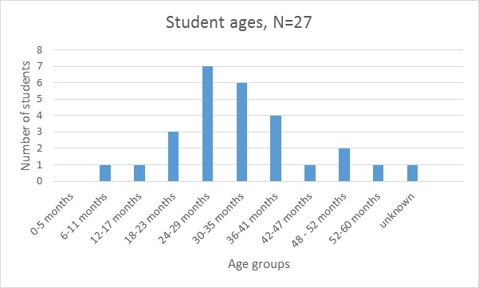

Teachers rated students’ interest from low (0=no interest) to high (3=very interested). Five students were rated “1” (19%). Seventeen students were rated “2” (63%); 5 students were rated “3” (19%).

In terms of interest as a function of gender, male students averaged a rating of 2.2 and females an average of 1.9. A possible mitigating factor in this difference is the fact that the 7 of the 12 youngest students in the evaluation were female, and all 5 of the youngest students were females.

Yet interest did not appear to be age-related in this small sample whose distribution was weighted in favor of children from 18 to 42 months. Of the students rated “3” or “very interested”—ages varied: 10 months, 24 months, and 36 months. (There was one student rated as very interested for whom a birthdate was not given). Similarly, for students rated a “1” (“not very interested”)—ages also ranged widely: 20 months, 24 months, 36 months, and 60 months.

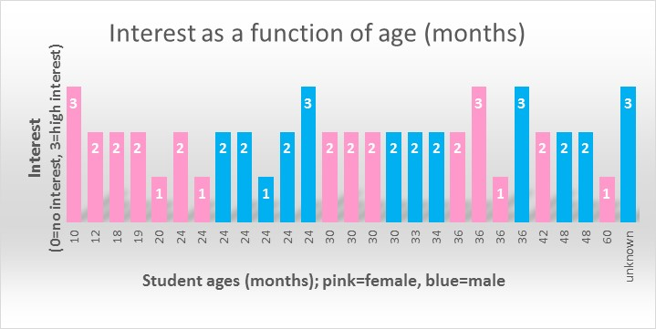

Teachers were asked to indicate how each child explored the book. Overall, 4 of the 27 students explored “only tactually,” 10 explored “primarily tactually,” 9 explored “equally tactually and visually,” and 4 explored “primarily visually.” Analyzing students’ interest in the book as a function of mode of exploration, of students rated “very interested,” 2 were primarily tactual learners, 2 explored equally tactually and visually, and 1 student was primarily visual in his exploration. Of students rated “not very interested,” 1 student was only tactual, 2 students were primarily tactual, 1 student was equally tactual and visual in his exploration, and 1 was primarily visual. These results and observation of student videos inclined the project leader to believe the book may have been slightly less engaging for strong tactual learners. In addition, some of the teachers expressed the opinion that more textures were needed.

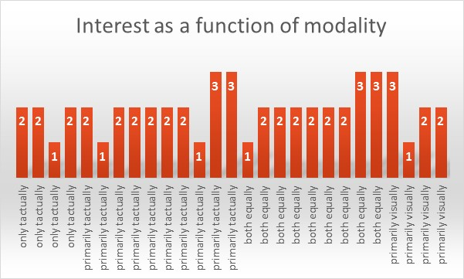

It was noted that only nine of the 27 students received more than one reading of the book, less than the requested minimum of two readings. And it appears that many students receiving two or more readings were rated as having higher interest in the book. For several students, teachers commented that the child became more interested by the book after the first or second readings. This was observed in the videos of one student, for whom the teacher supplied videos of an initial and a later reading. In previous evaluations of other tactile books, teacher evaluators have also made this observation: Interest appears to increase over several readings. However, it is also possible that some students received more readings because they requested/accepted additional readings, and that teachers did not repeat readings if a student was initially uninterested.

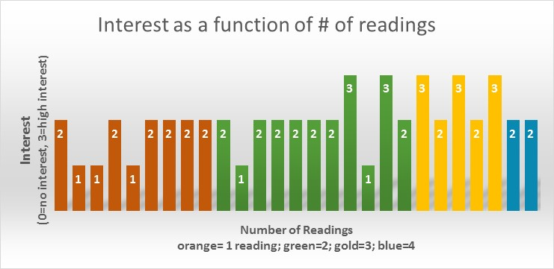
Parents answered similar questions about their child’s apparent interest in the book and mode of exploration. Their answers largely agreed with answers given by teachers on the teacher version of the Child Information Sheet. Separate analyses of parent answers are not provided here with the exception of two students, for whom only the parent version of the Child Information Sheet was returned.

Additional teacher input was collected via the Teacher Questionnaire, which asked the teacher to comment based not only on the current student(s) with whom he/she had used the book but on other students in the target audience with whom she/he had had experience.

Asked if the text was "interesting and appropriate" for children meeting the criteria set out for the field evaluation, 10 of 13 (77%) teachers responded "yes." Comments included the following:
- "I like the repetition of holes and the rhyming words. The book is simple."
- "Use of rhyme and silly language is attractive to these students."
- “I love how it rhymes and how it teaches many different concepts for 2 to 4 year olds.
- "Nice incorporation of concepts that can be incorporated into other prebraille activities."

Two evaluators indicated the text was "too long…babies want to move to the next page" and that "young toddlers" might not be ready for the book. A third evaluator indicated the text was not appropriate because children were directed to "see" but that otherwise, text was appropriate.

Ten of the teachers (77%) responded that the tactile/visual illustrations were "interesting and appropriate" for this population. Comments included the following:
- "Little fingers can easily find the holes and textures—they are just the right size."
- "I like that it looks like a typical book for young children and not something specific for a child who is blind or has disabilities."

Several evaluators indicated that depending on the child's visual diagnosis, colors could be "more stimulating." In addition, a longer cord was requested for the page that features lacing; however safety standards restrict the length to what was provided.

Construction of the book was approved of by all evaluators, who indicated the book's pages were easily turned and the book was durable. Two were concerned that flaps might be eventually torn.

Videos showed wide variation in how adults shared the book: length of time taken to read and explore the book, whether interactions surrounding the book were playful or “educational” in nature, and the extent to which the adult reader followed the child's lead or imposed a pace set by the adult. Videos showed the children covered a wide spectrum from being highly engaged and capably handling the book, to limited engagement and awareness of the activity. In some cases, environment may have contributed: Background noises were noticeably distracting in two videos, and the child was engaged in drinking while being read to, but appeared to need this to settle in the adult’s lap.

Based on the field evaluation, the following revisions were implemented: increasing contrast in indicated areas, adding texture to the spiral on page 1, and devising reinforcement for flaps. The target audience for the book will be defined as being for toddlers and preschoolers through age 3 years (developmental age).

Final specifications for Holy Moly were completed and turned over to Production in July. The project leader approved press proofs from the printer. Possible texts for the next FirstTouch book were sought from commercially available children’s’ books, original texts, and public domain children’s rhymes and songs suited to a toddler audience. A promising out-of-print text was located, and permission to adapt was made.

Work during FY 2018
Production of Holy Moly was completed as planned. The in-house portion of the work (braille labels and squares of textured materials) was given to the printer. The book was then printed, assembled, tactile components glued or attached, and braille labels applied by the printer. In-house staff monitored work at the printer as the book was produced, supplying a correctly assembled version to act as a guide. A brochure was written and produced. Holy Moly was priced and made available for purchase.

Selection of the second book in this series occurred and copyright permission was obtained. Further development, however, was placed on hold until project work is completed for The Caterpillar (see report provided for Art Digitizing/Modernizing of On the Way to Literacy Storybooks.)

Work planned for 2019
Staff will brainstorm ideas for the second book in the series, Tickly Prickly, by Bonny Becker, first published in 1999 and now out-of-print. Staff will plan tactile illustrations and layout and submit proposed design at a Gate 2 meeting. If approved to move forward with development, the project leader will hold Product Design Meetings as necessary to refine designs leading to prototype construction.

Going to the Playground
(Formerly O&M for iPad®)
(Continued)

Purpose
To teach beginning tactile map reading skills through a fun and interactive iPad® app

Project Staff
Dawn Wilkinson, Early Childhood Project Leader
Leasha Twyman, Research Assistant
Lawrence Lovelace, Programmer
Matt Poppe, Graphic Designer
Patrick White, Manufacturing Specialist
Andrew Dakin, Model/Pattern Maker

Background
This product idea was submitted to APH in 2015 by two renowned experts in the field of visual impairment: Justin Kaiser, Ph.D., Professor in the Vision Program at South Carolina Upstate and current Chair of the Mobility Division of AER and Tanni Anthony, Ph.D., Director of the Access, Learning, and Literacy team at the Colorado Department of Education. The objectives of this app with tactile overlays are:
- To teach children basic O&M concepts through multisensory play using an iPad® app
- To introduce tactile graphics and braille in fun and creative ways, while encouraging play between children with and without vision
- To provide the foundation for understanding positional and relational concepts for improved performance in O&M
- To develop beginning assistive technology awareness and promote kindergarten readiness

The product was submitted to the Product Evaluation Team in March 2016; a decision was made to gather further information about the need for such a product. A needs survey, Simple Tactile Overlays for the iPad®, was presented in the May 2016 APH News, sent to the AER Technology list serve, and distributed at the Preschool Seminar via SurveyMonkey®.

Excerpts from Product Needs Survey Results
Your students who are expected to become braille readers usually exhibit a strong desire to participate in iPad® activities with sounds, stories, etc.
- 26 of 35 (74%) of participants responded Very often
Even though very early apps that teach shape recognition, choice making, etc. usually do include sound, they are still picture based, and there is a need to make accessible screens for apps.
- 26 of 36 (72%) of participants responded Strongly agree
Having more accessible apps with clear tactile overlays could encourage social play and enhance technology equality between children with visual impairments and their sighted peers or siblings.
- 30 of 36 (83%) of participants responded Strongly agree
Consider the following scenario for an introduction to spatial relationships, orientation, and maps: The iPad® says: “You are on the playground. This picture shows the monkey bars, the merry-go-round, and the sandbox. You are playing in the sandbox, and it feels like a bumpy rectangle in this picture. Can you find it?” How likely would you be to use or recommend such an app?
- 19 of 36 (53%) of participants responded Very likely
Highlights from the Comments
- “I have brailled overlays since I bought my first iPad. It encourages exploration in infants.”
- “Teaching map reading skills is often overlooked. This would be a good start.”
- “I would love to see apps like the ones described in this survey. I think they would provide a fun way for visually impaired students to practice tactile discrimination skills.”

Based on the results of the needs survey, the Product Advisory and Review Committee approved the product in June 2016. Work began with Justin Kaiser, the consultant on this project, for the story content of the app. A product development committee meeting was held on August 9, 2016, where ideas for attaching the overlays to the iPad® were discussed, as well as material and embossing of the overlays. Technical Research and Graphic Design began to experiment with methods that resulted in the development of a simple plastic frame that adheres to the iPad® allowing each overlay to be placed inside for stability and easily removed. The overlays are embossed on clear vinyl that is five-thousandths thickness and are produced on the Roland®.

Since the basis of the story consisted of three simple tactile representations (a circle for the merry-go-round, bumpy square for the sandbox, and a ladder-like shape for the monkey bars), it was decided that the tactiles should be made first so that the screen could then be forced to match the tactile. In December 2016, the first three sets of overlays with frames were made. Graphic Design then completed the screen files. In February, the recording studio made voice files for the app. The idea was presented at CSUN in March with tactile overlays and the frame, but only showing slides of the screen shots as samples of the audio were played, presenting a scenario of how the story app might work. The feedback received from attendees of the CSUN presentation was very positive, and work began with the programmer to develop the actual app. Screen files were further separated in July by the graphic designer in order to create more visual effects such as the merry-go-round spinning and sand splattering in the sandbox. A couple of voice files were modified by the recording studio to reflect changes in the design of the app. Technical Research began working to produce the quantity of kits needed for field testing.

Work during FY 2018
After the tactile overlays were produced on the Roland®, extensive work continued on the iOS® app. The product name was officially changed to Going to the Playground at the January New Products Meeting. Ten sets of overlays were distributed to field testers in February of 2018 of which eight were completed. A summary of field test results follows.

Teachers were asked “How would you describe your level of expertise with assistive technology?”
Average – 66.67% (4)
Power user – 33.33% (2)

There were 14 students who used the app and overlays ranging in age from 3 to 14-years-old, but 71% of the students were age 4-7.

When asked which scenario of purchase would be most likely, 66% of respondents said they felt most customers would purchase the app and realize that the overlays were essential and then buy them. One person felt that customers would not buy the app without getting the overlays first, and one customer felt the app would be downloaded, but the overlays would not be purchased.

Eighty-three percent of field testers thought the app was visually appealing, and 100% of participants felt the app and overlays would promote play between children with and without vision. Eighty-three percent of evaluators said their students loved the sound effects, and 100% preferred the human voice narration over using the VoiceOver® screen reader.

Check the skills taught through this story by checking any that apply?
Shape recognition – 83.33% (5)
Texture discrimination – 100% (6)
Up/down, left/right – 83.33% (5)
In/out, inside/outside – 83.33% (5)
On/Off – 66.67% (4)
Symbolic association – 83.33% (5)
Positional relationships – 83.33% (5)
Listening skills – 83.33% (5)
Early map reading – 66.67% (4)
Beginning technology skills – 100% (6)
Beginning tactile graphics skills – 100% (6)
Other 16.67% (1)

Do you believe the skills in the above question relate to beginning orientation and mobility?
Yes – 100%

Revisions based on responses from field testing include removing the “help” button from the overlay because 66% of evaluators felt it was distracting and in the way. The information that was presented each time the “help” button was pressed is now spoken at the beginning of the game. Tactile raised print numbers will also be added to each overlay as field evaluators suggested this would be helpful for those who did not know braille. Other improvements to the app have been made such as making the merry-go-round spin visually, adding more questions to the map game, and fixing some tactile and visual alignment issues on the sandbox page.

The product was granted Quota approval in April of 2018.

Work planned for FY 2019
Project staff will work to complete the following tasks:
- Complete final tooling of the overlays based on revisions requested during field test
- Launch the app and accompanying overlays for sale

Laptime and Lullabies
(Continued)

Purpose
Based on current literature and research in emergent literacy, Laptime and Lullabies (formerly Focus on Fingers Kit) is designed to assist family members, caregivers, and early educators in their quest to prepare infants and young children—who are blind or visually impaired and may have additional special needs—to enjoy tactile learning and literacy.

Project Staff
Dawn Wilkinson, Early Childhood Project Leader
Kay Clarke, Author/Consultant
Kelly Kennedy Mimms, Research Assistant
Rachel White, Research Assistant
Anthony D. Jones, Art Production Design Manager
Anthony Slowinski, Graphic Design
Bryan Rogers, Manufacturing Specialist
Katherine Corcoran, Model Maker
Monica Vaught-Compton, Project Assistant
Charles “Burt” Boyer, Project Leader Retired

Background
A review of current literature and research on braille literacy reveals a growing body of information to guide our profession in meeting the braille literacy needs of young children and those with multiple disabilities. Present emergent braille literacy materials include lists of early critical skills areas (McComiskey, 1996) and “how-to” chapters and books for teachers of children who are visually impaired (Olsen, 1981; Wright & Stratton, 2007) with a primary focus on early braille reading and writing instruction for children ages 3-5. Strikingly absent are family-friendly materials that promote an overall parental understanding of the earliest skills necessary for tactile learning and literacy, while offering practical, engaging activities that parents may implement at home and with their infants and young children to support these skills. Laptime and Lullabies is an innovative, initial attempt to meet this need.

Author Kay Clarke states, “It is well known that literacy begins at birth. In contrast to prior products, Laptime and Lullabies (Focus on Fingers: Preparing Little Hands to Enjoy Tactile Learning and Literacy) addresses the earliest stages of tactile learning and literacy in a family-centered and developmentally-appropriate way, empowering families to play an active role in the beginning steps of their children’s tactile learning and literacy. Laptime and Lullabies additionally reflects a shift from traditional thinking about emergent braille literacy as ‘learning ABCs’ to a broader, research-based viewpoint that acknowledges the importance of a variety of early experiences that subsequently may contribute to competent, motivated braille readers and writers.” Laptime and Lullabies has the potential to make a significant difference for young blind or visually impaired children learning braille literacy.

The key is enjoyment! Young learners should have fun as they learn. Functional activities and literacy experiences that are developmentally appropriate and highly engaging best describe this product.

Clarke submitted this product idea to APH for consideration in FY 2010. The Product Evaluation Team recommended this product to the Product Advisory and Review Committee, which approved this product idea for development by APH. The author signed a contract allowing APH to be the sole distributor of Laptime and Lullabies, and an initial timeline to complete the product was developed. In September 2011, the project staff met to discuss the product. They established more definite timelines and a work plan for the completion of the product.

During FY 2012, the author renamed her product Laptime and Lullabies. The new title better reflects the interactive nature of preparing infants, toddlers, and preschoolers for tactile learning and literacy. The author and project leader worked to have the product meet early childhood standards, braille literacy standards, and APH standards. The author submitted six initial storybook prototypes to APH staff and sought feedback on tactile and literacy components. In August 2012, the author presented the product to the Early Childhood Focus Group at APH. Because of the many tactile components of the storybooks in this kit, a significant amount of time will be needed by APH to ready it for field testing as well as production.

In FY 2013, the author worked to complete the handbook content and preliminary prototypes of the storybooks. The author visited APH in mid-August. During the visit, project staff worked to identify product components that are feasible for production by APH. The author has developed Literacy Fun Activity Cards for inclusion in the kit; these may take the place of some of the storybooks. Each storybook is labor intensive and will add greatly to the cost of the final product.

Boyer retired from APH in March 2014, and Wilkinson commenced as project leader for this project. The author worked to complete the handbook content and mock-ups of storybooks and activity cards in the product; she submitted completed files in August 2014. Project staff began edits to submitted materials and provided extensive feedback to the author. The project leader and author worked with Technical Research to determine how the tactile components can be produced best in the field testing stage, with consideration for what materials are possible in final production. It is likely that the storybooks will be bound in three-ring binders similar to storybooks in the On the Way to Literacy Series; however, the binder size will be smaller and more appropriate for very young children to handle. Technical Research began work to design prototypes for two of the kit storybooks, Butterflies and Little Fuzzy.

A prototype of the Little Fuzzy book was completed in early January 2015 and sent to the consultant for review. The project leader and Technical Research met to discuss feedback and make revisions. New materials were sent to the consultant to evaluate for use in the revised prototype. New mock-ups of the gate and door (which are objects in the storybook), and replacement possibilities for a sticky material all had to be obtained and designed by the Model Shop. The Model Shop also began work on the first prototype of Butterflies after decisions were made regarding materials for the butterflies. Specifications for the butterflies were given to graphic design to assist in the creation of this book. The binder option had to be changed, as the On the Way to Literacy binders are approximately $25 per binder as compared to the new binder used in Tactile Book Builder, which is approximately $5 but still gives a small 3-ring binder option as agreed upon.

The handbook was divided into small booklets that will be inserted into a large binder. Graphic Design completed over half of these booklets during 2015. A new timeline was established for completion of this project in order to field test in the Spring of 2016.

In 2016, project staff completed a total of 18 booklets, which will compose the handbook set. The decision was made to include a booklet instead of bath time and bedtime cards to minimize labor and cost. The 18th booklet consists of reference citations. Five prototypes of the storybooks, Little Fuzzy and Butterflies were completed, along with five sets of the 18 saddle-stitched booklets. Field testers were selected using a request for field testers in the APH News and the early childhood electronic mailing lists, and via a search in the APH field tester database. Field testing took place from April-June 2016, with each of the five kits being shared with a second site during the second month of testing, for a total of 10 evaluators in five states. Prototypes were sent to Florida, New Mexico, Arkansas, Illinois, and Colorado.

Although the response/return rate was 70%, results were reported for a total of 39 children receiving early intervention services who used the kit. Responses were provided through SurveyMonkey® to an extensive questionnaire, with all questions requiring a response. Each storybook was analyzed separately, along with each booklet from the handbook, and the kit as a whole. A summation of field testing follows.

Demographics of Field Testers

None of the respondents had worked in the field of visual impairment for less than 5 years, and 57% of the respondents had worked 10 years or more. Two respondents were also parents of children with visual impairments.

Background of Students (39 Total)
Laptime and Lullabies was used with a total of 39 toddlers: 24 males (62%) male, 15 females (38%), between the ages of 8 to 36 months.
Of the 39 children, 26% of them were totally blind; 26% had CVI, and 59% had additional disabilities. Fifty-seven percent of the students were white, 28.5% were Hispanic, and another 28.5% were black.
Where’s Little Fuzzy Storybook
What was your overall impression of the text of Where’s Little Fuzzy?
86% said the kids liked it a lot and; 14% said the kids were somewhat interested.
100% said the book was appealing both visually and tactually.
Comments:
- I would put Little Squeaky at the end of the book because it was the children's favorite and they could squeak it through the other pages so it distracted them from learning the other concepts.
- The colors and simplicity were perfect for my low vision children. Those that had fine motor control really enjoyed lifting the blankets and opening the door, gate, etc. They especially liked hitting Little Squeaky. The book encouraged development of key concepts I work with my children on such as under, open, close, names of textures, colors, and finding hidden objects.

The Where’s Little Fuzzy? Book was appealing:
100% said both visually and tactually.
Butterflies! Storybook
The butterflies were:
43% said “easy to move around.”
57% said “not easy to move around.”

The kids found the text:
71% said “somewhat interesting.”
29% said “not at all interesting.”

The Butterflies! book was appealing:
43% said “both visually and tactually.”
57% said “visually but not tactually.”

The kids found the text:
71% said “somewhat interesting.”
29% said “not at all interesting.”

Did you find the net on the last page with the extra butterfly to be:
86% said “very useful.”
14% said “confusing.”

The butterfly finger puppet was:
86% said “a lot of fun.”
14% said “not very useful.”

Handbook Set:

Which of the following best describes your approach to using this collection of individually bound booklets?
71% said they “would pull out one section at a time randomly as needed.”
29% said they “would prefer to keep everything together at all times.”

Taking each of the sections into account separately, please rate each section on a scale from 1 to 5, where 1 equals strongly dislike and 5 equals strongly like:
(Weighted Averages)
First Chapters of Literacy: 4.71
Establishing Relationships: 4.71
Share Conversations: 4.71
Focus on Vision: 4.71
Grow Listening Skills: 4.86
Enhance Touch: 4.86
Partner in Play: 4.71
Explore the World: 4.71
Read Together: 4.86
Investigate Books: 4.71
Discover Symbols: 4.29
Experiment with Tools: 4.57
Team Up for Literacy: 4.57
Emergent Literacy and Developmental Milestones: 4.86
It Makes Sense to Me: 4.43
Literacy Fun at Bath Time and Bedtime: 4.71
Literacy Activities, Rhymes, and Songs: 4.86

The Laptime and Lullabies Kit as a Whole:

On a scale of 1 to 5, with 1 being not recommended and 5 being highly recommended, how would you rate these materials for use by parents at home, assuming an agency has a loan program or that parents can purchase the kit?
100% answered 5-(“Highly recommended”).

Which best describes the reaction of parents who saw part or all of the kit?
57% answered “very interested.”
43% answered “somewhat interested.”

Which scenario best describes how you feel the kit would most likely be used?
71% answered, “The interventionist loans parents one or two booklets from the handbook collection at a time so they can focus on specific areas of interest and need.”
29% answered, “The kit is viewed and used by parents primarily in the presence of the interventionist.”

Consider the population you feel this kit will serve. Please check all that apply.
100% answered parents; 86% answered early interventionists; 71% answered itinerant TVIs; 29% answered residential schools for the blind; 43% answered university preparation programs.

Comment:
Occupational Therapists

Please rate the need for this product on a scale from 1 to 5, where 1 equals very low and 5 equals very high.
29% rated it a 4; 71% rated it a 5.

Do you think this kit should be made available from APH using quota funds?
100% answered Yes.

Overall thoughts and comments about this kit:
- Kids, parents and professionals liked it and the directions that accompanied the book explaining the important concepts, pre-literacy, pre-Braille and motivation to explore pictures.
- Very well produced. Easy to use.
- Nice kit, felt that more interest was shown to texture books.
- If I had to pick, I would pick the Fuzzy book to start with my families.
- Very good product, especially offering the Handbook Collection. Every parent was requesting copies of each of the Handbook Collection sections, so I know this made a big impression on them. The children I work with are young, so one day they would be interested and the next visit they weren't. By having them interested at least half the time was a good sign in my opinion.
- I was very pleased with the entire kit. Very good information in the booklets. Probably wouldn't use butterfly kit for children under 24 months.
- I love it. It's needed!

In 2017, the 18 booklets that make up the Laptime and Lullabies handbook, along with the two tips cards that accompany the two storybooks, were recorded by the studio and translated into braille to be put onto a flash drive for inclusion in the kit. Several revisions were made to the two storybooks, Where’s Little Fuzzy? and Butterflies! based on the field evaluation results. Revisions included some changes to textures and colors of objects within the two books, as well as a couple of modifications to the text of the stories. Meetings discussing these revisions were held in January and again in April of 2017 to address changes in production that had transpired since the original field test revisions meeting in August 2016. More than 30 part numbers had to be requested, which further delayed any possibility of releasing the kit during FY 2017. Final tooling was completed, however, and a final specifications meeting was held in August 2017.

Work during FY 2018
There were numerous changes in techniques for production such as new machinery, some of the materials used in the prototypes were no longer available, and new sources were sought. Another specification meeting was held in February to discuss these changes and further delays to the tactile storybooks. It was decided in May 2018 that it would be best to go ahead and release the handbook separately. The handbook became available on July 27, 2018.

Work planned for FY 2019
Work will continue for production of the tactile storybooks, Where’s Little Fuzzy and Butterflies. The product will become available for sale.

Moving Ahead: Tactile Graphic Storybooks
(Continued)

Purpose
To provide print/braille storybooks for upper preschool, kindergarten, and first grade students featuring tactile graphics designed to encourage tactual exploration, refine tactual discrimination, and to introduce tactile symbols, simple keys, and maps in the context of a story

Project Staff
Suzette Wright, Emergent Literacy Project Leader/Author
Monica Vaught-Compton, Project Assistant
Lois Harrell, Consultant/Author
Mila Truan, Consultant
Josephine Stratton, Consultant

Background
Symbolic visual displays, such as maps and diagrams, play an increasingly important role in textbooks and computer displays for students with typical vision. They present a special challenge for students with significant vision loss, who are often expected to use a tactile equivalent in the course of their studies and in test-taking. Observers have suggested that difficulty interpreting tactile displays may be due, in part, to lack of early exposure. Storybooks developed in this project are designed to give young students opportunities to explore and interpret tactile illustrations that feature raised symbols, lines, and areal patterns. Of equal importance, the storybooks offer exposure to braille and foster key emergent literacy skills. The print/braille text of the books is intended to be read aloud by an adult reader. Embedded text (in large print and the user’s choice of either contracted or uncontracted braille) offers opportunities for the student to explore and read single words and short phrases, just as they might read labels included in a tactile diagram.

Initially, project leader efforts focused on identifying objectives and selecting or creating story texts and graphic media to support these. Lois Harrell served as project consultant, authoring a book and reviewing drafts of other books. Based on input from expert reviewers, four stories were chosen from a large pool of drafts. A variety of tactile media were considered. Paper embossed graphics were selected for the first book. A combination of embossed braille and Tactile Vision graphics was selected for three books.

Multiple prototypes of each of the four books were hand-produced. Accompanying storyboards (featuring symbols from the story mounted to attachable pieces) were created to enable students to create their own tactile displays. A Reader’s Guide including information about introducing the child to the book’s tactile graphics and briefly discussing emergent literacy skills and development of tactual learning skills was written to accompany each book.

Seven teacher-evaluators at seven sites participated in an expert review and conducted the field evaluation of the books/storyboards with 23 students ranging in age from 4.5 to 11 years of age, spanning an 8 to 10 week period. Without dissension, teachers indicated texts and tactile graphics for all four books were interesting and appropriate for kindergarten and first grade students; a majority also extended the books’ value upward to second grade students. Teachers reported 94-100% of the students, in their opinion, benefited from using the books during the evaluation period and would benefit from using the books for a longer period of time. Reasons given included the following: “increased motivation to read and exposure to braille and tactile exploration,” “allowed student to experience tactile graphics with a purpose,” “tactile graphics made the books more fun and motivated him to use his hands to explore and draw in information,” and “helped tracking skills.” The tactile graphics were also credited with enhancing understanding of the stories for 90% of the students. Accompanying storyboards were strongly endorsed by the teachers, who stated that their use improved comprehension, offered students an important opportunity to create their own graphics, and were highly motivating. A majority of teachers commented favorably on the Tactile Vision graphics. All evaluators rated the visual graphics in the books as a “very important” component of the books, promoting shared reading with typically sighted peers and adults and supplementing tactual information for the many braille readers with usable vision. The three project consultants also reviewed prototype books, provided favorable reviews, and suggested changes to specific tactile illustrations.

The four Moving Ahead storybooks and accompanying components received approval for sale on Quota. It was decided that each of the four books be produced separately to assist flow through the pre-production/tooling and production phases. Goin’ On a Bear Hunt was produced first and is available.

In order to produce the second storybook (Splish the Fish), sample tests were run to ensure compatibility of the paper stock, the outside vendor’s inks, and the Tactile Vision process; several problems with paper were encountered and resolved. It was necessary to design and add a special switch and tray to the Tactile Vision machine to accommodate the book’s page size. An initial pilot run of 100 books revealed some inconsistency in registration. A debriefing addressed possible sources. Subsequent runs of the book and runs of similarly produced books (The Boy and the Wolf, Turtle and Rabbit) have been problem-free.

The last of the books, Turtle and Rabbit became available for purchase in FY 2012. In FY 2013, the project leader, independently and through communication with the tactile books workshop Les Doigts Qui Rêvent (LDQR), began to look for commercially-available children’s books suited to development as the next Moving Ahead book. The project leader also reviewed a highly textured, interactive version of Goin’ On a Bear Hunt developed at LDQR and made suggestions regarding LDQR’s addition of textures and interactive elements to this book and Splish the Fish.

The project leader worked to select a commercially available children’s book to adapt as the next Moving Ahead storybook. Four commercially available children’s books were identified as promising for the type of tactile illustration used in this series. Four other books fit more appropriately in the On the Way to Literacy series of books for children from 3 to 5 years. A commercially available American children’s book, now out of print, is well suited to this series: Louella Mae, She’s Run Away! has an engaging rhyming text and involves the reader in a search for the title character in the cornfield, barn, and hay, and down by the stream.

The project leader also proposed a tactile adaptation of The Gruffalo to in-house staff and LDQR staff. The Gruffalo, by Julia Donaldson, is a very well-known, bestselling children’s book. First published in 1999, it continues to be read widely and carried in bookstores. The story is of a mouse, on a path through the forest, who must avoid being eaten by a Gruffalo. In rhyme, the Gruffalo is described with frightening features: “terrible tusks, and terrible claws, and terrible teeth in his terrible jaws.” As the story continues, other features are added until the real Gruffalo is met. Working through several ideas, a possible adaptation with tactile parts that can be assembled has been proposed and a map with multisensory elements, such as audio backdrop, was envisioned.

In addition to The Gruffalo, the project leader reviewed and suggested tactile illustrations for several commercially available titles from overseas. One of these is particularly suited to development as Moving Ahead book. In the print version of the book, Dans le Cour de l’Ecole (In the Schoolyard), pink circles (representing girls) and blue circles (boys) line up for lunch, play games, pair up for a dance, and perform other activities.

LDQR staff continued to work on possible tactile designs for The Gruffalo but were not satisfied with the results. The project leader worked with in-house copyright librarians to approach the publisher regarding the right to provide a tactile adaptation of the book to be sold within the U.S.

Uncertainty of obtaining copyright permission and work on higher priority projects prevented the project leader from pursuing further development of the next Moving Ahead book for a time. In the summer of 2017, the project leader contacted the author of the French commercially available book, Dans le Cour de l’ Ècole (In the Schoolyard) regarding copyright permission. Christophe Loupy, himself a teacher, responded very positively to the request and directed APH to inquire about permission with his publisher, Milan. The project leader obtained and gave contact information for Milan’s (now Milan Bayard) foreign distributions rights director to APH’s Joon Lee for further assistance in gaining permission. (The need for permission is due in part to the presence of print text and adapted illustrations replacing the existing illustrations. When a book is only a braille version of the print book, permission issues are not raised.)

Work during FY 2018
Permission to adapt Dans le Cour de l’ Ècole was not obtained. The Gruffalo and a third commercially available American children’s book, now out of print, is also well suited to this series. Louella Mae, She’s Run Away! has an engaging rhyming text and involves the reader in a search for the title character in the cornfield, barn, hay, and down by the stream.

Work planned for FY 2019
Further development is on hold until project work is completed for The Caterpillar (see report provided for Art Digitizing/Modernizing of On the Way to Literacy Storybooks.)

Reach & Match® Learning Kit
(Completed)
Purpose
Primary Purpose: To provide opportunities for target children to learn and engage with their peers in mainstream and self-contained environments. Secondary Purpose: To introduce all children to braille, which may encourage curiosity and future learning experiences that may lead to educational and career choices
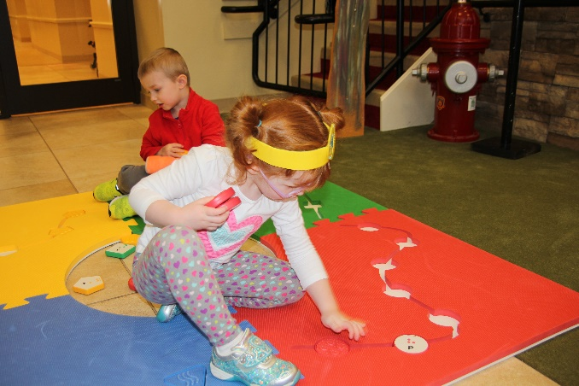

Project Staff
Tristan Pierce, Multiple Disabilities Project Leader
Mandy Lau, Inventor and Designer
Monica Vaught-Compton, Project Assistant
Kelly Kennedy Mimms, Research Assistant

Background
The American Printing House for the Blind (APH) proposes to be the exclusive distributor of the Reach & Match® Learning Kit in the United States. APH will edit and provide the product documentation in all accessible formats. APH conducted field testing in the United States to complement the testing done by the developer in Australia.
The introduction is from Mandy Lau, founder and designer of Reach & Match®, with editing by Tristan Pierce, APH Multiple Disabilities Project Leader.
Reach & Match® is an innovative system for students with sensory impairment and other special needs to learn and engage with their peers. It consists of four double-sided play mats, which can create different 2D and 3D configurations. It includes sensory components such as braille and print tiles, which help students with and without sight to develop literacy. Through well-designed exercises, activities, and games, students develop effective childhood skills such as space and direction; body concept; and motor, cognitive, communication, and social skills.
The double-sided sensory play provides distinctive modes of individual learning and group play. The front side provides toddler training for manual dexterity and identifying tactile patterns. The reverse side provides preschoolers with braille and print learning, motor development, direction, and spatial training.
The design concept and features are the result of a postgraduate research based on early childhood education in students with visual impairment and additional disabilities. It was developed and tested (in Australia) with early childhood educators, therapists, psychologists for early intervention programs, childcare centers, and schools. The design has won awards in the areas of assistive technology, education, and social inclusion.
Relevance
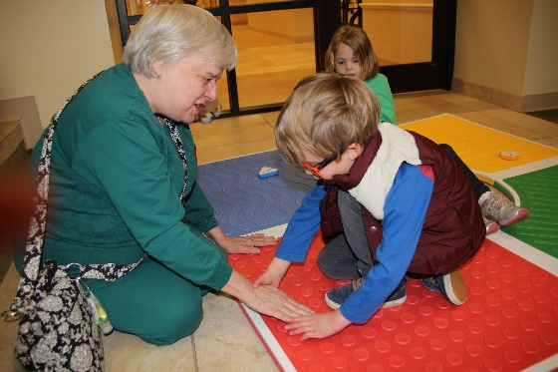
APH made the decision to field test, make the documentation accessible, and submit the product for Quota approval based on APH’s standardized process of product development. Mandy Lau submitted the New Idea Submission Form on October 5, 2016, just prior to attending the APH 148th Annual Meeting of Ex Officio Trustees. The project leader presented the idea to the Product Evaluation Team (PET) on December 13, 2017. The committee approved the PET Form and forwarded the product submission to the Product Advisory and Review Committee (PARC). PARC members approved Reach & Match® on December 15, 2016, and placed it on the parking lot. It quickly moved off the parking lot into the field test stage when APH purchased four production samples. After teachers and students field tested the production samples, APH compiled the data for this field test report.
This product is fully accessible to the population using it. The manual is electronic (HTML and BRF), so it is accessible to teachers and parents. The mat and tiles include large print, braille, tactile patterns, and textured shapes for the student who will use it. During field testing, a young student with low vision showed an adult volunteer, who is blind, the circle pattern on the red mat.
This product follows APH guidelines for determining relevance of a product. The Continuum of Visual Development (Ferrell, 2010) states that in the first month of life, babies show visual behaviors such as interest in pattern details in clothing and the environment. They attend to outside edges of a pattern or stimulus. By 2 months, babies perceive objects as three-dimensional; and by 3 months, they shift fixation from one object to another and watch the actions of others. By 4 months, they reach to visual stimulus. Jumping ahead to 9 months, eye-hand coordination improves and babies use vision to mediate reach and grasp. By 12 months, babies use vision to monitor motor activities and they discriminate same and different based on characteristics. By 18 months, toddlers stack objects vertically; and by 2 years, they stack objects horizontally. They begin to complete simple puzzles and foam boards by age 3 years. By 4 years, they identify red, green, blue, and yellow. By 5 years, children build bridges with blocks and matches by size and shape. Reach & Match® is for toddlers and young children.
According to the website How Kids Develop (2008), students develop skills in five main areas of development: cognitive development, social and emotional development, speech and language development, fine motor skill development, and gross motor skill development. There is a plethora of other student development outlines available to parents and educators today with the click of a quick Google™ search.
Whether one follows the Jean Piaget or Lev Vygotsky (both psychosocial) or the Erik Erikson (cognitive) theoretical approach to student development, or another student development theorist, of which there are many, what remains constant and relevant is that student development is a process that every student goes through. Many developmental skills, including visual behaviors, are attainable when playing with Reach & Match® and following the lessons in the manual. The premise of Reach & Match® is that the social interaction a student obtains while playing with peers encourages these developmental skills and behaviors (State of NSW, Department of Education and Training, 2010).
There is evidence of an examination of the need for this product. There are products that teach specific developmental skills; however, Reach & Match® not only comes with a complete outline of lessons for each skill, it is designed on the premise of playing with peers. Vygotsky encouraged the importance of relationships and interactions between students and more knowledgeable peers and adults. He believed that a student’s cognitive understandings were enriched and deepened when they were “scaffold” by a parent, teachers, or peers. Piaget and Vygotsky saw students as active partners in their own learning. The lessons in Reach & Match® allow and encourage this.
There is evidence that APH sought opinions of knowledgeable individuals to determine the need for this product. Knowledgeable individuals (teachers) sought out APH to communicate that they needed this product. APH heard from teachers in California and later in Vermont that APH should add Reach & Match® to its family of products. The teachers in California recommended that Mandy Lau present her product to APH. Teachers in both states obtained funding to purchase their kits directly from Lau (Australia). They then volunteered to participate in field testing for APH. APH recruited the other field test sites.
This product addresses an identified need for a person who meets the definition of “visually impaired.” The product documentation is electronic, making it accessible to regular print, large print, and electronic readers, including those using a refreshable braille display. The mat pieces provide distinct tactile learning while the tiles provide pre literacy learning and shape, color, and sound recognition.
Research
In FY 2017, APH conducted field-testing, edited the book for distribution in the United States and its outlying areas, and created the HTML and braille-ready file. The project leader presented the field test results at the 2017 CHARGE Foundation Conference in Orlando, FL.
APH gathered data using an appropriate method. The product development team collected data using SurveyMonkey®, an online survey program. The field test procedure included self-play observation and the playing of games (specific lessons) as outlined in the manual. The evaluation tool included multiple-choice, open-ended questions and comments, and questions that used 4 measure and 5 measure scales. APH collected data in a way to compare three groups of students. The students who participated in the field test were assigned to one of the three groups: students without a visual impairment, students with low vision, and students with little or no light perception.
APH used research data as part of decision-making in product completion. The main decision on this product was either to make it available in the United States or to turn the product down, which would require parents, teachers, and/or school districts to order from Australia. If APH had been involved in the initial development of the product, there are a few things we would have changed (e.g., make print letters raised and make the braille standard braille size on the tiles); but the cost to change tooling at this time is prohibitive. APH will make editorial revisions to the manual.
The product follows APH Research Guidelines (as a potential pass-through product) as outlined below.
- Input from the field—Prior to submission, teachers from California and prior to field testing, teachers from Vermont
- Safety Report/Technical Review—Provided by manufacturer
- Representative product prototype—Product production sample, Australian manual online
- Outside evaluators—APH selected field test sites by availability, location, educational setting, student/client size, and evaluator qualifications.
- Evaluation tool and collection—The project leader, a consultant, and the inventor/author developed the evaluation materials and survey. APH sent the books via Dropbox™ and sent forms electronically. APH hand delivered production samples to two field test locations, and shipped one production sample to New Mexico, where field evaluators shipped it sequentially to each field test location. The last two field test sites had their own Reach & Match® kit. Evaluators returned materials by the same means.
- Sufficient time—The field test sites in California and Kentucky had 2 months to complete the lessons in the book and submit the evaluation form. The evaluators at the three sites in New Mexico chose to divide the 2-month period between themselves. The Vermont site had their own kit and contacted APH shortly after field testing began.
- Reporting—The project leader presented the field test results to the Product Development Committee, and then the group met to determine future steps. Throughout the review of the product and the creation of the accessible documentation, the project leader reported updates at the monthly New Products Meeting.
- Modifications—APH made editorial changes to the manual to comply with APH standards (e.g., use of APA Style in writing, accessibility). APH to submit changes to the shipping box to meet UPS standards.
- Quota Approval—The project leader submitted the product for quota approval in April 2017.
- Specifications—pass through
- Availability—Summer 2017
- Marketing—APH markets the product via their website, print catalog, social media, and through conference presentations, training, and expositions. Mandy Lau continues to market the product worldwide.
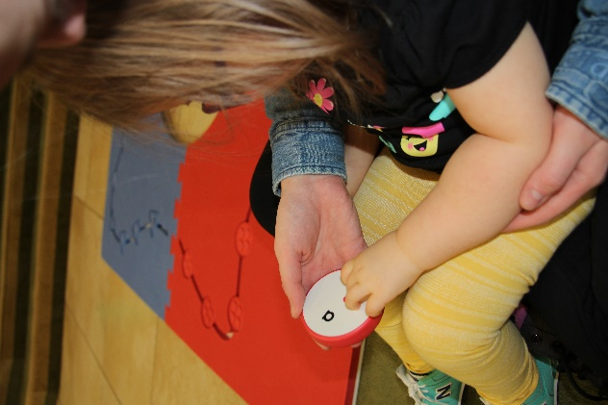
APH gathered data from a geographically diverse U.S. population. APH had seven field test sites in four states: California, Kentucky, New Mexico, and Vermont. The sites included Visually Impaired Preschool Services (students with visual impairment and their sighted siblings), Bluegrass Center for Autism, Vermont Association for the Blind & Visually Impaired, Stockton Unified School District, New Mexico School for the Blind and Visually Impaired (early childhood Program in Albuquerque, outreach in Carlsbad, and main campus in Alamogordo). Four (57.14%) classified their employment as service providers for people with vision impairment, two (28.57%) as schools for the blind and visually impaired, one (14.29%) as an early learning center, two (28.57%) as special schools, and one (14.29%) works directly with families.
The seven field test coordinators identified (per U.S. Census Bureau) as Asian, Black or African American, Hispanic of any origin, Native Hawaiian or other Pacific Islander, and White. As instructed, evaluators checked all with which they identify.
APH gathered data from appropriately qualified individuals. Many hold dual or multiple certifications/licenses. Four (57.14%) are early childhood educators, three (42.86%) are orientation and mobility instructors, two (28.57%) are braille teachers/teachers of students with visual impairments, two (28.57%) are speech pathologists, two (28.57%) are special education professionals, one (14.29%) is a behavior analyst, and one (14.29%) is a paraprofessional. Three (42.86%) field test coordinators had 1 to 5 years of experience teaching students who are visually impaired, three (42.86%) had 6 to 10 years of experience, and one (14.29%) has more than 20 years of experience.
APH gathered data from an adequate number of sources. When evaluators filled out the student information portion of the evaluation form, they documented six students without a visual impairment, 14 students with low vision, and seven students with little or no light perception; for a total of 27 students. However, within the 4 measure and 5 measure scales, a total 35 students are represented.
Group A: Students Without a Visual Impairment consisted of six students:
- Age 3 years, cognitive age 1 year, hearing impairment, intellectual disability, developmental delay, limited fine and gross motor skills
- Age 2 years, cognitive age 0 year, limited mobility, developmental disability
- Age 3 years, cognitive age 3 years, mild developmental delay
- Age 5 years, cognitive age 3 years, intellectual disability, developmental delay, limited mobility
- Age less than 1 year, cognitive age 0, developmental disability
- Age 2 years, cognitive age 1 year, autism, intellectual and developmental disability

Group B: Students with Low Vision consisted of 14 students:
- Age 3½ years, cognitive age 2 years, CVI, global delays
- Age 1½ years, cognitive age 0 years, cortical/cerebral visual impairment, intellectual and developmental disability
- Age ?*, cognitive age ?*, autism, limited mobility, limited fine motor skills, retinal atrophy, cerebral palsy *left blank
- Age 9 years, cognitive age 6 years, congenital glaucoma, intellectual and developmental disability, limited fine motor skills, learning difficulties
- Age 3 years, cognitive age 1 year, amblyopia and autism spectrum disorder
- Age 5 years, cognitive age 3 years, cortical/cerebral visual impairment, traumatic brain injury
- Age 2 years, cognitive age 1 year, microphthalmia, learning difficulties
- Age 6 years, cognitive age 5 years, optic nerve hypoplasia, traumatic brain injury, learning difficulties
- Age 3 years, cognitive age 3 years, left homonymous hemianopia and limited fine motor skills
- Age 5 years, cognitive age 3 years, cortical/cerebral visual impairment, tuberous sclerosis
- Age 2½ years, cognitive age 0 year, cortical/cerebral visual impairment, intellectual and developmental disability
- Age 8 years, cognitive age 5 years, optic nerve hypoplasia, traumatic brain injury, learning difficulties
- Age 4 years, cognitive age 3 years, optic nerve hypoplasia and developmental delay
- Age 1 year, cognitive age 0 year, cortical/cerebral visual impairment, intellectual and developmental disability

Group C: Students With Little or No Light Perception consisted of seven students:
- Age 2 years, cognitive age 2 years, no additional disabilities identified at this time
- Age 6 years, cognitive age 1½ years, anophthalmia, global delays
- Age 2 years, cognitive age 1 year, microphthalmia, learning difficulties
- Age 4 years, cognitive age 2 years, familial exudative vitreo retinopathy
- Age 5 years, cognitive age 2 years, limited fine and gross motor, intellectual disability, developmentally delayed
- Age 6 years, cognitive age 2½ years, optic nerve hypoplasia, global delays
- Age 4 years, cognitive age 4½ years, optic nerve hypoplasia

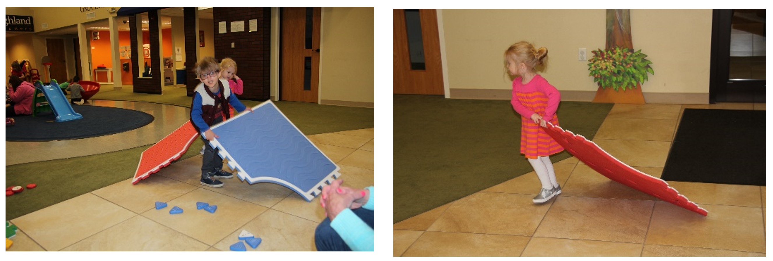
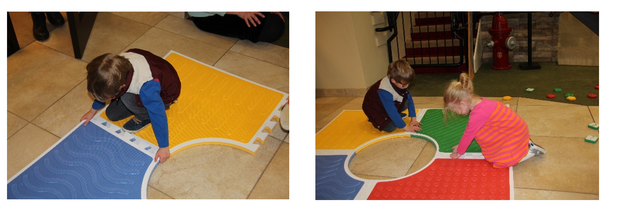
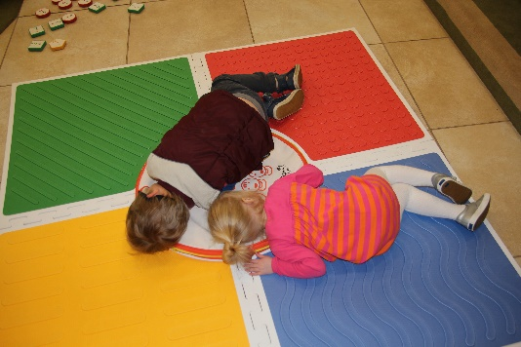
The research method used collected sufficient information. Teachers observed 35 students as they played with Reach & Match® for the first time, without adult prompting. Of the 34 students for whom teachers reported data for question 19, the majority of students in Group A (n=10) (40%) showed low to no interest/curiosity in the braille dots; the majority of students in Group B (n=18) (38.9%) showed somewhat low interest in the braille dots; and an equal percentage of students in Group C (n=6) (33.3%) showed low to no interest, medium interest, and high interest in the braille dots. Overall, totaling by level of interest, 26% showed low to no interest, 29% showed somewhat low interest, 15% showed medium interest, 15% showed somewhat high interest, and 15% showed high interest in the braille.
Q19. Rate each student's interest/curiosity in the embossed braille dots.
GROUP | Low to no interest | Somewhat low interest | Medium interest | Somewhat high interest | High interest | n =
Group A | 4  (40%) | 3  (30%) | 1  (10%) | 2  (20%) | 0 | 10
Group B | 3  (16.7%) | 7  (38.9%) | 2  (11.1%) | 3  (16.7%) | 3  (16.7%) | 18
Group C | 2  (33.3%) | 0 | 2  (33.3%) | 0 | 2  (33.3%) | 6
Student TOTALS | 9  (26%) | 10  (29%) | 5  (15%) | 5  (15%) | 5  (15%) | 34
APH asked teachers to rate each student’s interest in asking questions about braille, such as its relationship with print letters. Teachers submitted responses for all 35 students. The majority of students in all three groups showed low to no interest in the way of asking questions; however, a larger percentage of students in Group B, the low vision students, expressed more curiosity than their counterparts in Groups A and C did.
Q20. Rate each student's interest/curiosity in asking a lot of questions about braille, such as its relationship with print letters.
GROUP | Low to no interest | Somewhat low interest | Medium interest | Somewhat high interest | High interest | n =
Group A | 9  (90%) | 0 | 1  (10%) | 0 | 0 | 10
Group B | 12  (66.7%) | 3  (16.7%) | 3  (16.7%) | 0 | 0 | 18
Group C | 5  (71.4%) | 1  (14.3%) | 1  (14.3%) | 0 | 0 | 7
Student TOTALS | 26  (74%) | 4  (11%) | 5  (14%) |  |  | 35

When asked to rate each student’s initiative in trying to learn braille, teachers provided responses for 35 students. Group A showed initiative in three of the five measures: low to no initiative, somewhat low initiative, and medium initiative. Group B showed initiative in four measures: low to no initiative, somewhat low initiative, somewhat high initiative, and high initiative. All students in Group C showed low to no initiative except one who showed somewhat high initiative.
Q21. Rate each student's initiative in trying to learn braille.
GROUP | Low to no initiative | Somewhat low initiative | Medium initiative | Somewhat high initiative | High initiative | n =
Group A | 8  (80%) | 1  (10%) | 1  (10%) | 0 | 0 | 10
Group B | 14  (77.8%) | 1  (5.6%) | 0 | 2  (11.1%) | 1  (5.6%) | 18
Group C | 6  (85.7%) | 0 | 0 | 1  (14.3%) | 0 | 7
Student TOTALS | 28  (80%) | 2  (5.7%) | 1  (2.8%) | 3  (8.6%) | 1  (2.8%) | 35

Teachers rated each student’s level of attraction to the visual and textual attributes (e.g., bright colors, patterns, and textures). As expected, the students in Group B showed a higher level of attraction; no student showed low to no attraction. Students in Groups A and C had higher numbers showing low to no attraction but did show a spread across the remaining four measures. Overall, the 35 students did not display a wide variance in the levels of attraction to the visual and textual attributes; they ranged from 17% to 29%.
Q22. Rate each student's level of attraction to the bright colors, Q22. Rate each student's level of attraction to the bright colors, patterns, and textures.
GROUP | Low to no attraction | Somewhat low attraction | Medium attraction | Somewhat high attraction | High attraction | n =
Group A | 4  (40%) | 3  (30%) | 0 | 3  (30%) | 0 | 10
Group B | 0 | 2  (11.1%) | 5  (27.8%) | 5  (27.8%) | 6  (33.3%) | 18
Group C | 3  (42.9% | 1  (14.3%) | 1  (14.3%) | 2  (28.6%) | 0 | 7
Student TOTALS | 7  (20%) | 6  (17%) | 6  (17%) | 10  (29%) | 6  (17%) | 35

Teachers rated each student’s level of attraction to the four different sounds created when shaking tiles from each of the four shaped categories (i.e., circle, square, triangle, pentagon). This was the first attribute rating in which all three groups had some student whose level of attraction rated in the top two tiers of the five measures—somewhat high attraction and high attraction. The students with little or no light perception in Group C either showed little to no interest (57.1%) or somewhat high attraction to high attraction (42.9%).
Q23. Rate each student's level of attraction to the different sounds from the tiles.
GROUP | Low to no attraction | Somewhat low attraction | Medium attraction | Somewhat high attraction | High attraction | n =
Group A | 3  (30%) | 2  (20%) | 2  (20%) | 2  (20%) | 1  (10%) | 10
Group B | 5  (27.8%) | 2  (11.1%) | 6  (33.3%) | 2  (11.1%) | 3  (16.7%) | 18
Group C | 4  (57.1%) | 0 | 0 | 1  (14.3%) | 2  (28.6%) | 7
Student TOTALS | 12  (34%) | 4  (11%) | 8  (23%) | 5  (14%) | 6  (17%) | 35

The ratings on the product attributes showed that teachers seldom placed students in the medium initiative measure. When asked to rate each student’s initiative to explore all parts of the kit, this is where the majority of students shined. Half (50%) of the students in Group A and 33.3% of the students in Group B showed medium initiative. Although 57.1% of students in Group C showed low to no initiative to explore all parts of the kit, the combined percentages of Group C students who showed medium, somewhat high, and high initiative equaled 42.9%. It would be nice and optimistic to think that these students took this opportunity to self-implement the whole-part-whole strategy of teaching.
Q24. Rate each student's initiative to explore all the parts of the kit.
GROUP | Low to no initiative | Somewhat low initiative | Medium initiative | Somewhat high initiative | High initiative | n =
Group A | 4  (40%) | 0 | 5  (50%) | 0 | 1  (10%) | 10
Group B | 0 | 4  (22.2%) | 6  (33.3%) | 5  (27.8%) | 3  (16.7%) | 18
Group C | 4  (57.1%) | 0 | 1  (14.3%) | 1  (14.3%) | 1  (14.3%) | 7
Student TOTALS | 8  (23%) | 4  (11%) | 12  (34%) | 6  (17%) | 5  (14%) | 35

The students received high marks in their attempts to exhibit gross motor skills. Teachers rated half (50%) of the students in Group A as somewhat high in their attempts to make a lot of body movements. Once again the students in Group B excelled, with medium and somewhat high attempts rated at 23.5% each and high attempt rated at 47%. Four (57.1%) of the students in Group C were rated low to no attempt, and the remaining three students in Group C were split between medium attempt, somewhat high attempt, and high attempt for a combined percentage of 42.9. Overall, of the 34 students who teachers rated on this question, 20 students (58.8%) showed a somewhat high attempt or high attempt to make body movements compared to eight students (23.5%) who made low to no attempt or somewhat low attempt.

Q25. Rate each student's attempt to make a lot of body movements (gross motor skills).
GROUP | Low to no attempt | Somewhat low attempt | Medium attempt | Somewhat high attempt | High attempt | n =
Group A | 2  (20%) | 1  (10%) | 1  (10%) | 5  (50%) | 1  (10%) | 10
Group B | 1  (5.9%) | 0 | 4  (23.5%) | 4  (23.5%) | 8  (47%) | 17
Group C | 4  (57.1%) | 0 | 1  (14.3%) | 1  (14.3%) | 1  (14.3%) | 7
Student TOTALS | 7  (20.5%) | 1  (3%) | 6  (17.6%) | 10  (29.4%) | 10  (29.4%) | 34

According to Wolfberg, Bottema-Beutel, & DeWitt (2012), peer-play experiences are vital to a student’s socialization, development, and culture. Students with disabilities, especially autism, face challenges in social and imaginary play, which place them at high risk for exclusion by peers. Without well-designed opportunities, they are likely to remain isolated from peers, and thus experience few opportunities that encourage developmental growth. That said, teachers rated the students’ interest in interacting with others while they played with Reach & Match®. Half (50%) of the students in the Group A, 38.9% in Group B, and 42.9% in Group C demonstrated high interest in social interaction with peers. This was good to see because one of the main reasons Mandy Lau created Reach & Match® was to allow students with and without disabilities the opportunity to learn while playing together.

Q26. Rate each student's interest in interacting with others (i.e., teachers, peers) while playing with the kit.
GROUP | Low to no interest | Somewhat low interest | Medium interest | Somewhat high interest | High interest | n =
Group A | 2  (20%) | 1  (10%) | 2  (20%) | 0 | 5  (50%) | 10
Group B | 1  (5.6%) | 3  (16.7%) | 3  (16.7%) | 4  (22.2%) | 7  (38.9%) | 18
Group C | 2  (28.6%) | 1  (14.3%) | 1  (14.3%) | 0 | 3  (42.9%) | 7
Student TOTALS | 5  (14%) | 5  (14%) | 6  (17%) | 4  (11%) | 15  (43%) | 35

The teachers rated the majority of students in Group A (50%) and Group B (27.8%) as having a high use of creativity to figure out games independently. Again, the majority of students in Group C (71.4%) showed low to no use of creativity to figure out games. Teachers of students with visual impairments know that their students need distinct supports when learning a new skill. Many teachers, especially adapted physical education teachers, use the strategy of pre-teaching to a student with visual impairment prior to introducing an activity to the entire class. As mentioned earlier, this may reflect the need for whole-part-whole teaching.

Q27. Rate each student’s use of his/her creativity to figure out the games by himself/herself, for example, putting the tiles into the right pockets of the path, or putting tile with dot pattern on the mat with dot pattern.
GROUP | Low to no use of creativity | Somewhat low use of creativity | Medium use of creativity | Somewhat high use of creativity | High use of creativity | n =
Group A | 3  (30%) | 1  (10%) | 1  (10%) | 0 | 5  (50%) | 10
Group B | 4  (22.2%) | 4  (22.2%) | 2  (11.1%) | 3  (16.7%) | 5  (27.8%) | 18
Group C | 5  (71.4%) | 0 | 0 | 1  (14.3%) | 1  (14.3%) | 7
Student TOTALS | 12  (34%) | 5  (14%) | 3  (8.6%) | 4  (11%) | 11  (31%) | 35

Four of seven teachers (57.14%) observed that the students in Group B were the most surprised and excited about Reach & Match®. One teacher (14.29%) reported that students in Group A were most surprised and excited, and one teacher (14.29%) reported this for students in Group C. One teacher (14.29%) responded that there was no difference in surprise or excitement between the groups.

Three teachers (42.86%) observed that the students with low vision, Group B, ask the most questions about Reach & Match®. One teacher (14.29%) reported that students in Group A asked the most questions, and one teacher (14.29%) reported this for students in Group C. Two teachers (28.57%) responded that there was no difference between the groups on the amount of questions asked.

APH asked teachers which group of students required the most guidance when playing with Reach & Match®. One teacher (14.29%) responded Group A, two teachers (28.57%) responded Group B, two teachers (28.57%) responded Group C, and two teachers (28.57%) responded that there was no difference between the groups.

Three teachers (42.86%) reported that students in Group B required a longer time to explore Reach & Match®. Two teachers (28.57%) reported that Group C required a longer time to explore, and two teachers (28.57%) responded that there was no difference between the groups for time required to explore.

Four of the seven teachers (57.14%) noted that Group B showed the most confidence while playing with Reach & Match®. The remaining three teachers (42.86%) deemed there was no discernible difference in confidence between the groups.

Two teachers (28.57%) said students in Group B were the happiest to try to read the braille tiles; however, five teachers (71.43%) said there was no difference between the groups on this measure.

Data were gathered on student/consumer outcomes. APH asked teachers to indicate if a student could or could not perform a skill before and after playing with Reach & Match® (R&M). Teachers followed the lessons in the electronic manual and rated the students using four choices:
- No-No (Student could not perform skill before or after playing with the product.)
- No-Yes (Student could not do skill before but now performs skill minimally, moderately, or proficiently.)
- Yes-Same (Student could do skill minimally before and still performs skill minimally after playing with the product.)
- Yes-Yes (Student could do skill minimally but now performs skill moderately or proficiently.)

SESSION 1
There are seven sessions in the manual, each designed to teach a specific function. Session 1 teaches the function of braille and print learning. Question 34a asked teachers to evaluate learning to touch, feel, and explore tactile textures. Of the 34 students for whom teachers reported data on question 34a, 23.5% could not perform the skill before or after playing with the product (no-no response); 14.7% could not perform the skill before but now perform the skill minimally, moderately, or proficiently (no-yes response); 41.2% could do the skill minimally before and still perform skill minimally after playing with the product (yes-same response); and 20.6% of students could do the skill minimally but now perform the skill moderately or proficiently (yes-yes response).

Q34. Function: Braille and Print Learning
- Learned to touch, feel, and explore
GROUP | No-No | No-Yes | Yes-Same | Yes-Yes | n =
Group A | 5  50% | 4  40% | 0 | 1  10% | 10
Group B | 1  5.6% | 1  5.6% | 11  61.1% | 5  27.8% | 18
Group C | 2  33.3% | 0 | 3  50% | 1  16.7% | 6
Student TOTALS | 8  23.5% | 5  14.7% | 14  41.2% | 7  20.6% | 34

Question 34b addressed the braille alphabet. Teachers evaluated and reported on 30 students on their ability to learn five or more braille letters. Overall, only three students (9.9%) from Group B succeeded (no-yes + yes-yes). In Group B (n=18), 15 students (83.3%) could not perform skill before or after playing with the product, one student (5.6%) could not read five or more braille letters before playing with the product but could after playing with the product, one student (5.6%) could read five braille letters and maintained that level after playing with the product, and one student (5.6%) could read five braille letters prior to playing with Reach & Match® and improved this skill while playing with the product.

- Learned five or more braille letters
GROUP | No-No | No-Yes | Yes-Same | Yes-Yes | n =
Group A | 8  100% | 0 | 0 | 0 | 8
Group B | 15  83.3% | 1  5.6% | 1  5.6% | 1  5.6% | 18
Group C | 4  100% | 0 | 0 | 0 | 4
Student TOTALS | 27  90% | 1  3.3% | 1  3.3% | 1  3.3% | 30

Question 34c addressed the Roman alphabet. Teachers evaluated and reported on 30 students’ ability to learn five or more Roman letters. Six students (20%) accomplished the function while playing with Reach & Match®. Again, students in Group B (n=18) had more success, with one student (5.6%) in the no-yes category, one student (5.6%) in the yes-same category, and three students (16.7%) in the yes-yes category. One might expect better results with Group A—students without visual impairments—but all the students have additional disabilities. This question was not applicable to students in Group C.

- Learned five or more Roman letters
GROUP | No-No | No-Yes | Yes-Same | Yes-Yes | n =
Group A | 7  87.5% | 0 | 1  1.3% | 0 | 8
Group B | 13  72.2% | 1  5.6% | 1  5.6% | 3  16.7% | 18
Group C | 4  100% | 0 | 0 | 0 | 4
Student TOTALS | 24  80% | 1  3.3% | 2  6.7% | 3  10% | 30

Question 34d addressed the ability of the students to learn letters using the student’s name. Teachers evaluated and reported on 30 students. Overall, 83.3% demonstrated no improvement after using the product. Two students (11.1%) in Group B (n=18) demonstrated improvement on an existing function. The function of writing one’s name is considered a high skill for a typical child under 3 years old, which many of the students who played with Reach & Match® were (under 3 years old) at the time of field testing.

- Learned to write name
GROUP | No-No | No-Yes | Yes-Same | Yes-Yes | n =
Group A | 7  87.5% | 0 | 1  1.3% | 0 | 8
Group B | 14  77.8% | 0 | 2  11.1% | 2  11.1% | 18
Group C | 4  100% | 0 | 0 | 0 | 4
Student TOTALS | 25  83.3% | 0 | 3  10% | 2  6.7% | 30

SESSION 2
The function under Session 2 is cognitive skills. Teachers collected data on 35 students for questions 35a-35f. Question 35a asked teachers to rate their students’ ability to sort the tiles by color, shape, sounds, and patterns. Of the students in Group A (n=10), half showed improvement: Two students (20%) could not sort prior to playing with Reach & Match®, but through play they learned to sort at least minimally; and three students (30%) had a minimum skill of sorting prior to playing with the product and improved through play to a medium or master level. Likewise, 11 students (61.1%) from Group B (n=18) and two students (28.6%) from Group C (n=7) showed improvement from having no skill to at least minimal skill and from having minimal skill to a medium or master level.

Q35. Function: Cognitive Skills
- Sorting
GROUP | No-No | No-Yes | Yes-Same | Yes-Yes | n =
Group A | 5  50% | 2  20% | 0 | 3  30% | 10
Group B | 4  22.2% | 2  11.1% | 3  16.7% | 9  50% | 18
Group C | 4  57.1% | 1  14.3% | 1  14.3% | 1  14.3% | 7
Student TOTALS | 13  37.1% | 5  14.3% | 4  11.4% | 13  37.1% | 35

Question 35b asked teachers to rate their students’ ability to match (i.e., tile to mat with same color, tile to mat with same pattern). The students showed much improvement in their matching skills through playing with Reach & Match®. Of the 35 students, 11 (31.4%) showed no improvement, six students (17.1%) showed improvement from no skill to at least minimal skill, seven students (20%) remained at their previous skill level, and 11 students (31.4%) showed improvement of their prior skill level. In Group A (n=10) and Group B (n=18), the two combined categories of improvement (no-yes + yes-yes) outweighed the two combined categories of no improvement.

- Matching
GROUP | No-No | No-Yes | Yes-Same | Yes-Yes | n =
Group A | 4  40% | 3  30% | 0 | 3  30% | 10
Group B | 4  22.2% | 2  11.1% | 4  22.2% | 8  44.4% | 18
Group C | 3  42.9% | 1  14.3% | 3  42.9% | 0 | 7
Student TOTALS | 11  31.4% | 6  17.1% | 7  20% | 11  31.4% | 35

Question 35c asked teachers to rate their students’ ability to count. This included counting the number tiles for each color, shape, and pattern as well as to count the number of dots/stripes/curvy lines/diagonal lines on the tiles and mats. Four students (40%) in Group A showed improvement in counting through playing with Reach & Match®, while 10 students (55.6%) in Group B showed improvement, and two students (28.6%) in Group C showed improvement.

- Counting
GROUP | No-No | No-Yes | Yes-Same | Yes-Yes | n =
Group A | 5  50% | 0 | 1  10% | 4  40% | 10
Group B | 5  27.8% | 1  5.6% | 3  16.7% | 9  50% | 18
Group C | 5  71.4% | 0 | 0 | 2  28.6% | 7
Student TOTALS | 15  42.9% | 1  2.9% | 4  11.4% | 15  42.9% | 35

Question 35d asked teachers to rate their students’ ability to recognize patterns. Four students (40%) in Group A improved their ability to recognize patterns while playing with Reach & Match® as shown in the no-yes category and the yes-yes category. Nine students (50%) in Group B improved their ability, but no students in Group C showed improvement.

- Pattern recognition
GROUP | No-No | No-Yes | Yes-Same | Yes-Yes | n =
Group A | 6  60% | 1  10% | 0 | 3  30% | 10
Group B | 8  44.4% | 1  5.6% | 1  5.6% | 8  44.4% | 18
Group C | 6  85.7% | 0 | 1  14.3% | 0 | 7
Student TOTALS | 20  57.1% | 2  5.7% | 2  5.7% | 11  31.4% | 35

Question 35e asked teachers to rate their students’ ability to sequence tiles through play. This included sequencing in alphabetical order, color order, and shape order. This particular task proved to be too difficult for the majority of students (65.7%). Group B split down the middle with 50% unable to sequence before or after playing with Reach & Match®, and 50% able to sequence minimally before playing with the product and improved to a medium or master level through play.

- Sequencing
GROUP | No-No | No-Yes | Yes-Same | Yes-Yes | n =
Group A | 7  70% | 0 | 0 | 3  30% | 10
Group B | 9  50% | 0 | 0 | 9  50% | 18
Group C | 7  100% | 0 | 0 | 0 | 7
Student TOTALS | 23  65.7% | 0 | 0 | 12  34.3% | 35

Question 35f asked teachers to rate their students’ ability to use visual or tactile memory. This involved memorizing the order of different sounds, colors, shapes, or patterns as well as to memorize the correct tile by the same attributes. As is often seen in this field test, the two largest majorities of students fall on the outside of the four measures, (i.e., no-no and yes-yes). Fourteen students (40%) did not demonstrate visual or tactile memory prior to or after playing with Reach & Match®, and 13 students (37.1%) possessed a minimal ability to use visual or tactile memory prior to playing with Reach & Match® and improved to a medium or master level through play.

- Visual/Tactile memory
GROUP | No-No | No-Yes | Yes-Same | Yes-Yes | n =
Group A | 5  50% | 0 | 2  20% | 3  30% | 10
Group B | 5  27.8% | 1  5.6% | 2  11.1% | 10  55.6% | 18
Group C | 4  57.1% | 2  28.6% | 1  14.3% | 0 | 7
Student TOTALS | 14  40% | 3  8.6% | 5  14.3% | 13  37.1% | 35

SESSION 3
The function under Session 3 is sensory integration. Teachers collected data on 35 students (group values remain the same) for questions 36a-36c. Question 36a asked teachers to evaluate if students could distinguish between colors, patterns, and shapes of the tiles and mats. As expected, the students in Group A and Group B started and ended with better abilities. Only one student (14.3%) in Group C demonstrated improvement.

Q36. Function: Sensory Integration
- Sight and visual skills
GROUP | No-No | No-Yes | Yes-Same | Yes-Yes | n =
Group A | 3  30% | 0 | 2  20% | 5  50% | 10
Group B | 1  5.6% | 1  5.6% | 5  27.8% | 11  61.1% | 18
Group C | 6  85.7% | 0 | 0 | 1  14.3% | 7
Student TOTALS | 10  28.6% | 1  2.9% | 7  20% | 17  48.9% | 35
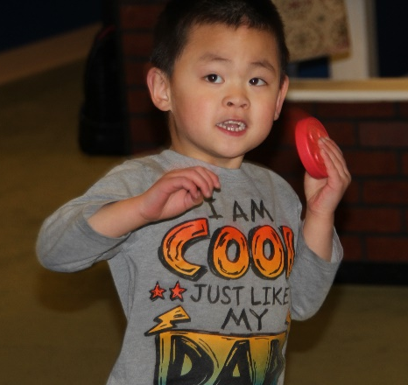
Question 36b asked teachers to determine if the students could distinguish different sounds given from the various tiles. Across the board, the majority of students in all three groups demonstrated improvement. Some students danced and twirled in circles to the sounds they made while shaking the tiles.

- Hearing
GROUP | No-No | No-Yes | Yes-Same | Yes-Yes | n =
Group A | 2  20% | 2  20% | 2  20% | 4  40% | 10
Group B | 0 | 1  5.6% | 6  33.3% | 11  61.1% | 18
Group C | 1  14.3% | 0 | 2  28.6% | 4  57.1% | 7
Student TOTALS | 3  8.6% | 3  8.6% | 10  28.6% | 19  54.3% | 35

Question 36c asked teachers to determine if the students could identify the different textures from the various components; distinguish the difference between patterns on tiles and mats; and use different parts of the body to touch the tactile parts, such as the feet, the hands, the arms, the legs, and the face. Half of the students in Group A demonstrated improvement, and the majority of students in Groups B and C demonstrated improvement through playing with Reach & Match®.

- Touch
GROUP | No-No | No-Yes | Yes-Same | Yes-Yes | n =
Group A | 3  30% | 0 | 2  20% | 5  50% | 10
Group B | 1  5.6% | 1  5.6% | 6  33.3% | 10  55.6% | 18
Group C | 1  14.3% | 0 | 2  28.6% | 4  57.1% | 7
Student TOTALS | 5  14.3% | 1  2.9% | 10  28.6% | 19  54.3% | 35

SESSION 4
The function under Session 4 is body concepts. Teachers collected data on 35 students (group values remain the same) for questions 37a–37c. Question 37a on exploration of body parts asked teachers to evaluate how the students explored the Reach & Match® (e.g., put right hand on mat and lift left hand). Overall, five students (14.3%) improved in the no-yes category and 10 students (28.6%) improved in the yes-yes category. Students in Group A (60%, no-yes + yes-yes) and Group B (44.5%, no-yes + yes-yes) showed improvement, but unfortunately only one student (14.3%, yes-yes) in Group C showed improvement.

Q37. Function 4: Body Concepts
- Exploration of body parts
GROUP | No-No | No-Yes | Yes-Same | Yes-Yes | n =
Group A | 2  20% | 2  20% | 2  20% | 4  40% | 10
Group B | 1  5.6% | 3  16.7% | 9  50% | 5  27.8% | 18
Group C | 3  42.9% | 0 | 3  42.9% | 1  14.3% | 7
Student TOTALS | 6  17.1% | 5  14.3% | 14  40% | 10  28.6% | 35

Question 37b on bodily awareness asked teachers to evaluate how well students learned to perform different body movements (e.g., crawl, jump, skip, lie down, and roll into a ball). Overall, 18 students (54.3%) improved (no-yes + yes-yes). In Group A, 60%; Group B, 66.6%; and in Group C, 14.3% demonstrated improvement.

- Bodily awareness
GROUP | No-No | No-Yes | Yes-Same | Yes-Yes | n =
Group A | 2  20% | 2  20% | 2  20% | 4  40% | 10
Group B | 1  5.6% | 6  33.3% | 5  27.8% | 6  33.3% | 18
Group C | 3  42.9% | 0 | 3  42.9% | 1  14.3% | 7
Student TOTALS | 6  17.1% | 8  22.9% | 10  28.6% | 11  31.4% | 35

Question 37c on spatial concept asked teachers to evaluate the students’ ability to experience the size of the mats (e.g., touching the edge of the mats; learn the distance from one mat to another by counting steps; and following directions, such as turn left and go to the red/circle patterned mat). Overall, 57.2% (no-yes + yes-yes) showed improvement through playing with Reach & Match®. Again, the students in Groups A (60%) and B (66.6%) showed the most improvement. Two students (28.6%) in Group C showed improvement in the yes-yes category.

- Spatial concept
GROUP | No-No | No-Yes | Yes-Same | Yes-Yes | n =
Group A | 2  20% | 2  20% | 2  20% | 4  40% | 10
Group B | 2  11.1% | 6  33.3% | 4  22.2% | 6  33.3% | 18
Group C | 3  42.9% | 0 | 2  28.6% | 2  28.6% | 7
Student TOTALS | 7  20% | 8  22.9% | 8  22.9% | 12  34.3% | 35

SESSION 5
Teachers provided data on 35 students (group values remain the same) for questions 38a–38d on orientation and mobility skills. Question 38a addressed the fine motor skill of finger manipulation. Teachers evaluated if students could pick up a specific tile, grasp a specific tile, and track the path of the mat using fingers. Overall, 51.4% (no-yes + yes-yes) of the students showed improvement through playing with Reach & Match®. Five students (50%) in Group A, 10 students (55.5%) in Group B, and three students (42.9%) in Group C improved.

Q38. Function 5: Orientation and Mobility Skills
- Finger manipulation
GROUP | No-No | No-Yes | Yes-Same | Yes-Yes | n =
Group A | 0 | 5  50% | 5  50% | 0 | 10
Group B | 2  11.1% | 2  11.1% | 6  33.3% | 8  44.4% | 18
Group C | 0 | 0 | 4  57.1% | 3  42.9% | 7
Student TOTALS | 2  5.7% | 7  20% | 15  42.9% | 11  31.4% | 35

Question 38b addressed the motor skill of wrist twisting. Teachers evaluated if students could fit different shapes of tiles into the corresponding pockets and shake the tiles to discover the different sounds. Overall, 19 students (54.3%, no-yes + yes-yes) improved their wrist twisting. Within each group, four students (40%) in Group A, 11 students (61.1%) in Group B, and 4 students (57.1%) in Group C improved.

- Wrist twisting
GROUP | No-No | No-Yes | Yes-Same | Yes-Yes | n =
Group A | 2  20% | 4  40% | 4  40% | 0 | 10
Group B | 3  16.7% | 0 | 4  22.2% | 11  61.1% | 18
Group C | 1  14.3% | 0 | 2  28.6% | 4  57.1% | 7
Student TOTALS | 6  17.1% | 4  11.4% | 10  28.6% | 15  42.9% | 35

Question 38c addresses hand and foot muscle training and development. Teachers evaluated the students’ experience in several locomotor skills (e.g., crawling, walking, jumping, running, hopping, skipping, and leaping; movement at different paces; move following a path; and travel and route planning skills). Overall, 24 students (84.7%) improved (no-yes + yes-yes); and more importantly, all three groups rated highly. Group A had six students (60%), Group B had 14 students (77.8%), and Group C had four students (57.1%) improve.

- Purposeful action movement (gross motor)
GROUP | No-No | No-Yes | Yes-Same | Yes-Yes | n =
Group A | 0 | 5  50% | 4  40% | 1  10% | 10
Group B | 1  5.6% | 1  5.6% | 3  16.7% | 13  72.2% | 18
Group C | 2  28.6% | 0 | 1  14.3% | 4  57.1% | 7
Student TOTALS | 3  8.6% | 6  33.3% | 8  22.9% | 18  51.4% | 35

Question 38d addresses auditory skills. Teachers evaluated the students’ use of sound to identify direction and distance. Overall, the 19 students (54.3%) improved (no-yes + yes-yes). Within the groups, Group A had six students (60%) and Group B had nine students (50%) improve. Again, it is encouraging to see that the majority of students (57.1%) in Group C improved.

- Auditory skills
GROUP | No-No | No-Yes | Yes-Same | Yes-Yes | n =
Group A | 2  20% | 5  50% | 2  20% | 1  10% | 10
Group B | 1  5.6% | 2  11.1% | 8  44.4% | 7  38.9% | 18
Group C | 2  28.6% | 0 | 1  14.3% | 4  57.1% | 7
Student TOTALS | 5  14.3% | 7  20% | 11  31.4% | 12  34.3% | 35

SESSSION 6
Teachers provided data on 32 of 35 students for questions 39a–39e on language enrichment. Many of the students who participated in the field testing were too young (chronologically and cognitively) for this session.

Question 39a asked teachers to evaluate the students’ positional and directional words by turning; walking forward, backward, and parallel to; walking next to; and around corners. They asked students to describe the location of an object using words such as above and below, near and far, front and back, and so forth. This proved to be one of the harder tasks for the students. Overall, 13 students (40.6%) fell in the no-no category. The remaining 18 students (41.4%) dispersed fairly evenly between the other three categories. In Group A (n=10), teachers evaluated five students (50%) as no improvement (no-no + yes-same). In Group B (n=18), teachers evaluated 13 students (72.2%) as no improvement, and in Group C (n=4), teachers evaluated two students (50%) as no improvement.

Q39. Function 6: Language Enrichment
- Positional and directional words
GROUP | No-No | No-Yes | Yes-Same | Yes-Yes | n =
Group A | 5  50% | 3  30% | 0 | 2  20% | 10
Group B | 6  33.3% | 1  5.6% | 7  38.9% | 4  22.2% | 18
Group C | 2  50% | 2  50% | 0 | 0 | 4
Student TOTALS | 13  40.6% | 6  18.8% | 7  21.9% | 5  15.6% | 32

Question 39b asked teachers to evaluate how well students learned to use sensory words (i.e., describe an object using words such as hard, soft, round, pointy, loud, and soft). Overall, 14 students (43.8%) fell in the no-no category and nine students (28.1%) in the yes-yes category. The students in Group A split 50-50 between improvement (no-yes + yes-yes) and no improvement (no-no + yes-same). The students in Group B just missed a 50-50 split with the majority (55.5%) showing no improvement. In Group C, three students (75%) showed no improvement.

- Object description
GROUP | No-No | No-Yes | Yes-Same | Yes-Yes | n =
Group A | 5  50% | 3  30% | 0 | 2  20% | 10
Group B | 6  33.3% | 1  5.6% | 4  22.2% | 7  38.9% | 18
Group C | 3  75% | 1  25% | 0 | 0 | 4
Student TOTALS | 14  43.8% | 5  15.6% | 4  12.5% | 9  28.1% | 32

Question 39c asked teachers to evaluate how well the students asked questions that start with “What,” “Why,” “How,” and “Where.” Again, the overall majority of 19 students (59.4%) fell in the no-no category with another five students (15.6%) in the yes-same category. On the positive side, three students (30%) in Group A and five students (27.8%) in Group B showed improvement (no-yes + yes-yes).

- Questions raising
GROUP | No-No | No-Yes | Yes-Same | Yes-Yes | n =
Group A | 6  60% | 2  20% | 1  10% | 1  10% | 10
Group B | 9  50% | 3  16.7% | 4  22.2% | 2  11.1% | 18
Group C | 4  100% | 0 | 0 | 0 | 4
Student TOTALS | 19  59.4% | 5  15.6% | 5  15.6% | 3  9.4% | 32

Question 39d asked teachers to evaluate how well the students learned descriptive words, such as round, curvy, straight, diagonal, and so forth. This task proved a little easier for Group A students with a 50-50 split between no improvement (no-no + yes-same) and improvement (no-yes + yes-yes). Unfortunately, 12 students (66.6%) in Group B and three students (75%) in Group C showed no improvement.

- Descriptive words
GROUP | No-No | No-Yes | Yes-Same | Yes-Yes | n =
Group A | 5  50% | 3  30% | 0 | 2  20% | 10
Group B | 4  22.2% | 3  16.7% | 8  44.4% | 3  16.7% | 18
Group C | 3  75% | 1  25% | 0 | 0 | 4
Student TOTALS | 12  37.5% | 7  21.9% | 8  25% | 5  15.6% | 32

Question 39e asked teachers to evaluate how well the students learned different body parts, such as hands, fingers, upper body, toes, and so forth. Overall, 19 students (59.3%) showed no improvement (no-no + yes-same) while 13 students (40.7%) showed improvement (no-yes + yes-yes). Within each group, the numbers look more positive for two of the groups. In Group A, 40% showed no improvement while 60% did improve. In Group B, 72.2% showed no improvement while the students in Group C had a 50-50 split between improvement and no improvement.

- Body concept
GROUP | No-No | No-Yes | Yes-Same | Yes-Yes | n =
Group A | 4  40% | 4  40% | 0 | 2  20% | 10
Group B | 4  22.2% | 2  11.1% | 9  50% | 3  16.7% | 18
Group C | 2  50% | 1  25% | 0 | 1  25% | 4
Student TOTALS | 10  31.3% | 7  21.9% | 9  28.1% | 6  18.8% | 32

SESSION 7
Q40. Function: Additional Learning Outcomes
Teachers provided data on 35 students for questions 40a–40d on additional learning outcomes. In this final session, the group values remain the same for the 35 students: Group A (n=10), Group B (n=18), and Group C (n=7). Question 40a asked teachers to evaluate each student’s active participation. Overall, 19 students (54.9%) showed improvement (no-yes + yes-yes). While each group showed some improvement, Group B continued to outpace the other two groups. Group A had three students (30%), Group B had 13 students (72.3%), and Group C had three students (42.9%) who showed improvement.

- Active participation
GROUP | No-No | No-Yes | Yes-Same | Yes-Yes | n =
Group A | 1  10% | 2  20% | 5  50% | 1  10% | 10
Group B | 0 | 3  16.7% | 5  27.8% | 10  55.6% | 18
Group C | 1  14.3% | 0 | 3  42.9% | 3  42.9% | 7
Student TOTALS | 2  5.7% | 5  14.9% | 13  37.1% | 14  40% | 35

Question 40b asked teachers to evaluate the social skill of turn taking. Overall, 24 students (yes-same + yes-yes) (68.5%) demonstrated that they possessed at least a minimal understanding and ability to take turns prior to field testing. Eleven of those students improved their turn taking to a medium or master level through playing with Reach & Match®. Overall, seven students (20%) did not know turn taking prior to field testing; but through playing with Reach & Match®, they learned at least a minimal ability to take turns.

- Turn taking
GROUP | No-No | No-Yes | Yes-Same | Yes-Yes | n =
Group A | 0 | 4  40% | 4  40% | 2  20% | 10
Group B | 2  11.1% | 3  16.7% | 5  27.8% | 8  44.4% | 18
Group C | 2  28.6% | 0 | 4  57.1% | 1  14.3% | 7
Student TOTALS | 4  11.4% | 7  20% | 13  37.1% | 11  31.4% | 35

Question 40c asked teachers to evaluate the students’ ability to communicate with their peers while playing with Reach & Match®. Overall, three categories (no-no, yes-same, and yes-yes) each had 11 students (31.4%) with only two students (5.7%) in the no-no category. Group A had seven students (70%) who showed no improvement (no-no + yes-same) and three students (30%) who showed improvement (no-yes + yes-yes). Group B split 50-50 the students who showed no improvement versus those who did. Group C had six students (85.7%) who showed no improvement while one student (14.3%) did improve.

- Communication with peers
GROUP | No-No | No-Yes | Yes-Same | Yes-Yes | n =
Group A | 5  50% | 1  10% | 2  20% | 2  20% | 10
Group B | 2  11.1% | 1  5.6% | 7  38.9% | 8  44.4% | 18
Group C | 4  57.1% | 0 | 2  28.6% | 1  14.3% | 7
Student TOTALS | 11  31.4% | 2  5.7% | 11  31.4% | 11  31.4% | 35

Question 40d asked teachers to evaluate how well the students cooperated with their peers. Overall, 21 students (60%) did not improve (no-no + yes-same) their ability to cooperate with peers while 13 students (37.14%) learned this skill or improved their ability (no-yes + yes-yes). By groups, six students (60%) in Group A showed no improvement while four students (40%) did improve. In Group B, 10 students (55.5%) showed no improvement while eight students (44.5%) did improve. Finally, in Group C, six students (85.7%) showed no improvement while one student (14.3%) did improve.

- Cooperate with peers
GROUP | No-No | No-Yes | Yes-Same | Yes-Yes | n =
Group A | 5  50% | 2  20% | 1  10% | 2  20% | 10
Group B | 2  11.1% | 1  5.6% | 8  44.4% | 7  38.9% | 18
Group C | 4  57.1% | 0 | 2  28.6% | 1  14.3% | 7
Student TOTALS | 10  28.6% | 3  8.6% | 11  31.4% | 10  28.6% | 35

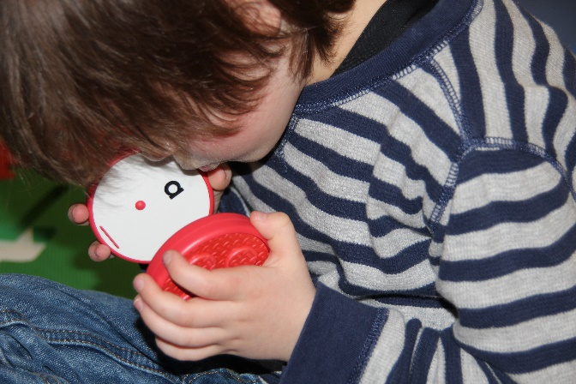
Teachers rated the students’ overall experience playing with Reach & Match® on five components: happiness, confidence, creativity, curiosity, and sharing. In general, teachers reported that students had a positive experience (i.e., rating averages of 3 or higher—3=medium, 4=somewhat high, and 5=high) on the components of happiness, confidence, curiosity, and sharing. On the remaining component of creativity, teachers reported that students had a less positive experience with an average rating of 2.71 (2=somewhat low).

APH asked teachers if both sides of the mats provide distinct learning and purposes. The majority (86%) said yes, and 14% said no. The comments below show that the patterns (often referred to as textures) on the sides of the mat and tiles generated the most pro and con remarks. What worked well with one set of students may not have been as purposeful for another set, such as praise for the patterned sides of the tiles for O&M concepts but not for tactile discrimination for young children who are just starting to learn and understand the same/different concept.
- Green and yellow sides were very similar texturally [had similar patterns].
- My students with low vision liked sorting by colors AND both groups liked putting the pieces into the corresponding holes. My blind students could not match the textures [patterns] because the textures [patterns] on the pieces were a "small" version and not actually the same as the textures [patterns] on the mat. Since they are just beginning to understand same/different, the textures [patterns] felt different. This is something I think needs to change in order to engage children who are tactile learners. My low vision students did not match/describe the textures [patterns] at all and only attended to the colors and shapes of the pieces. Additionally, when sorting by shape, they still only sorted by color since all the shapes were the same color, too. In order to really sort by shape, the shapes should be different colors. The students liked both sides of the mats, but side with holes for the pieces was the favorite and engaged both groups of students more.
- The texture [patterned] side was better for my O&M concepts.
- Both sides of the mat have the potential to provide multiple learning opportunities and sensory experiences.
- I used both sides of the mat when using this product. The side with the braille/print lettering on the puzzle pieces [tiles] provided many different experiences: braille identification, sequencing, matching, etc. The other side I was able to use for texture [pattern] matching and also for a student with low vision, who we have just realized that she has more vision than we originally thought, so it was great activity to learn color matching as well.

After reviewing the multiple levels of games provided in the manual, APH asked teachers if the games are versatile/flexible enough for children with visual impairments to play and learn with their peers. Six teachers (86%) said yes, and one (14%) said no. Reach & Match® is targeted for 18 months and older, but two teachers commented that the games were too advanced. One teacher suggested a tabletop version of the kit; offering multiple sizes of the same product is becoming more common in education toys, such as the product Imagination Playground™, available in big, medium, and small.
- I think the games in the manual are appropriate and easy to adapt for different levels of cognition and visual impairment. The materials are different and motivating for the students and the games/activities give so many different ideas! They're great, but most definitely need to be adapted for children who are developmentally below 3-4 years old.
- Overall, yes, the games are versatile/flexible enough, but if a TVI is not in charge of the materials for the class, then they need to collaborate with the teacher to make sure the game is taught and appropriate for the child(ren) with VI. Most of the games as written are too advanced for my students or need to be broken down step-by-step and modeled several times before the students started following along.
- [Yes], but only if an adult is providing support.
- Games and connected materials were not versatile for our learners. Our learners had limited mobility skills and could not fully participate in the activities or explore the entire mat. A smaller version with different sets of matching tiles would be helpful. If the tiles could incorporate other stimuli such as animals, sequencing activities, or numbers.
- The versatility and flexibility of this product is what I enjoyed most about it. This product is a great to complete many activities with sighted peers even involving a sighted younger sibling and having the older sibling with a visual impairment or blindness help them with sequencing or matching activities. It is a great tool to have students with visual impairments play alongside their peers or even teach them or guide them in the activities. I have previously worked with students with significant disabilities and I think Reach & Match® could be used for instruction and to encourage purposeful movement with those types of kiddos!

APH asked the teachers if the students were able to learn by themselves when playing with Reach & Match®. The majority (57%) did not think so. This may reflect the population the teachers had in the classroom—most of the children had multiple disabilities.
- Adult supervision needed to keep child engaged in activity. Children with visual impairments don't learn to play independently at the same time as their peers, they are usually years behind their peers in this area.
- Somewhat. They jumped right in and started sorting by color (the low vision group) and putting the right shapes in the right holes. They are not identifying any lower case letters yet, or braille letters, so they did not pay attention to these features. They also liked labeling the shapes and shaking the pieces to hear the sounds (though none of the students matched the sounds without modeling from an adult). In order to do more than that, students needed adult modeling and directions. (We have no sighted peers in our class.).
- The groups were not offered time outside of instruction to explore the kits after having some practice. (Note: Field test instructions asked that teachers conduct observation prior to instruction.)
- All the children I worked with are under the age of 3 years old, so some guidance and modeling was required. Our learners were not able to explore the materials without direct guidance.
- The children were able to do a lot of exploring on their own and use teamwork to help sequence or match.

APH asked teachers to rate the overall educational value of Reach & Match®. No teacher rated the product as low or somewhat low. Three teachers (43%) rated it medium, one teacher (14%) chose somewhat high, and the last three teachers gave it a high rating. Four teachers provided comments. Only one teacher wrote specific changes.
- I think the overall value and potential of this product is very high. The Speech Language Pathologist LOVED the materials. There's nothing like it out there. My biggest issue is that the braille on the pieces is not real braille, so it is actually harder for children who are braille readers to read it than if real braille was on the pieces—braille reading is done by shape and size recognition, the braille on the pieces is too big and does not maintain the spatial characteristics of braille that they are just beginning to read. Additionally, young children learn capital letters before lower case and my students do not know lower case letters yet and did not even pay attention to the letters on the pieces because they were so small. While the product has a lot of great potential, it's not totally accessible to students who are visually impaired without further modifications. The braille/print learning outcome is not appropriate without real braille on the pieces and large print capital and lowercase letters.
- I think this kit is great! As a traveling O&M specialist, it would have yielded better results if the kits were available for the kids to use more often than O&M lesson time. But I needed to take the kits from site to site.
- Overall the Reach & Match® Sensory Kit was a huge hit with the families and children I introduced it to. We played matching games, stacking, rolling the circles, shaking the different shapes, and putting into/taking out of the bag. The kit provides a variety of teaching and developmental activities.
- The students that used it in my classroom all have low vision. Using and following the activity guide and building off those activities throughout my time with Reach & Match®, I was able to see how great this product is for such a wide variety of students, which makes this product have such a high educational value. Students can explore themselves in so many ways, play games with sighted peers, promotes movement, promotes confidence, and can be used as tool for the student to teach others about braille and tactual discrimination skills.

APH asked teachers to rate the aesthetic design of Reach & Match®. All teachers like the design with 28.5% rating it somewhat high and 71.5% saying high.
- It's beautiful and I loved having it as part of my classroom.
- Every teacher who saw these kits had ideas on how they could use this for many other students who are not visually impaired. It is a wonderful sensory learning kit.
- I really liked all of the colors and overall design of the kit, except for the WHITE bag it comes in. While transporting the bag from point A to point B, I would have to lean the bag against something and I always seemed to pick up dirt, markings, etc. Maybe the bag could be a different color and/or material, so it would be easy to clean off or wipe down.
- The minute that I opened the box and placed it in the classroom, my students were instantly curious and wanted to see what the fun colored and textured 'wall' was. It is such a fun design and encourages curiosity almost instantly!
- It’s very heavy.

APH asked teachers to rate the manufacturing quality of Reach & Match®. Teachers responded with 14% at medium, 29% with somewhat high, and 57% at high. Five teachers submitted comments.
- Foam piece were too heavy. I have seen lighter interlocking alphabet foam pieces. Foam pieces did not interlock when standing nor did they interlock when two tactile sides were intertwined with the two puzzle sides. (Note: The mats do interlock when standing.)
- It's great. Everything is very sturdy and seems well made.
- IT NEEDS WHEELS!!! It is it hard to carry two kits on a cart through doors. It would be awesome if the kit had luggage style wheels.
- Materials were easy to clean and durable. Everything was easily stored.
- The quality and durability of this product in my opinion is great. It is sturdy and made from material that will last over a long time period.

APH asked teachers to rate the educational content in the manual. The teachers responded with 14% medium, 43% somewhat high, and 43% high.
- It took me a while to realize my students were exploring the kit from activities 1.1 to 2.1 to 3.1 and not from 1.1 to 1.2 to 1.3.
- I liked the manual a lot and was impressed with the number of games and ideas that we could do with the Reach & Match! Most games had to be adapted to be developmentally appropriate for my students, but it gives a good idea of what can be done and then I can figure out the starting place and work up to the actual suggested game/learning outcome.
- A creative teacher is still needed even with the manual.

After field testing the Reach & Match®, APH asked teachers if they would like to have a Reach & Match® Kit in their classroom. All (100%) said yes.

Then APH asked if money was no object, how many Reach & Match® Kits would meet the needs of their students best. Most classroom responded with one or two.
- My classroom-1-2, for school 4-5
- I [would] order two kits for several of my sites. I provide services in the homes of my students, so I'd likely just need one. If each family wanted a kit for their homes, I'd need around 12.
- For my classroom, I would only need one Reach and Match kit.
- I do have students on my caseload that are not in my classroom that have multiple disabilities that would benefit from the use of this product, so in all I would need two kits.

APH asked teachers if they had students on the Federal Quota census. Six teachers (86%) responded yes, and one teacher (14%) said no. If teachers responded yes to the question, APH asked if they would recommend that their school/agency use a portion of their Quota funds to purchase Reach & Match®. All six teachers said yes.

At the end of the evaluation, APH offered an opportunity for teachers to submit general comments about Reach & Match®.

Marketing suggestions
- Have you considered selling the tiles separately?
- Have you considered adding a sound component to the puzzle track?
Modification suggestions
- It would take months to years for students with additional disabilities to move through the activities in the manual.
- The kit is very heavy for itinerant teachers to carry it from the office into the car into the home/school and back.
- Make the textures on the pieces the same as the textures on the mat, not smaller versions. They do not feel the same to a totally blind preschooler; they feel different.
- Put capital letters on the pieces, along with lowercase, with space between the two letters and a larger font to make it easy for young children who visually fatigue easily or who have CVI and are learning to use their vision to see the letters.
- An additional change that would make it more certain that children were matching [patterns] textures, have the [patterns] textures on the pieces be white or black so they had to actually match [patterns] textures and couldn't rely on color perception (especially important for dual-media or low vision students). Also, each color should have different shapes instead of all shapes being one color, because then they could also be sorting by color rather than shape. Same thing with the sounds¬¬—don't make all colors/shapes the same sound since they could be matching/sorting by shape rather than sound. So, if you REALLY want to use these materials to teach sorting by shape, texture, or sound, the shape/texture/sound cannot all correspond to the same color and needs to be mixed up. My low vision students all sorted by color, no matter how much they were encouraged to sort by shape, texture, or sound. My blind students couldn't sort by texture since they don't feel the same and really only matched shapes by picking up a piece and finding the right shaped-hole.
- Overall I love the product and think it's such a GREAT idea, but it's not fully accessible to young children who are visually impaired without some major modifications.
- Put real braille on the pieces, not the current braille dots. If needed, this could be done by putting braille letter stickers (like the ones APH already makes) on the pieces (or directing the teacher who orders the kit to do it) if it cannot be done to the plastic pieced directly.
- Consider putting regular sized braille on the tile pieces instead or in addition to the large braille?
Positive remarks
- This kits makes me wish I still worked in Early Childhood Development.
- This kit would benefit ECE aged students.
- Thank you for allowing the children and families I work with to assist in this field test. They are excited about when the R&M Kit becomes available for continued learning opportunities!
- Based on our experience with Reach & Match® this could be a great learning tool for our population of students. Our learners often have limited mobility, so a table top version would make it more assessable for those learners. This would be a great tool for teaching sensory concepts and colors for those not visually impaired.
- Reach & Match® was so much fun to field test, I wish I had more time with it to try it with a variety of students with different needs and especially sighted peers. This product's flexibility, design, learning outcomes, etc. are great for a variety of settings in a variety of conditions. Products like these are invaluable to teachers.

Next Steps
The teachers top three concerns about Reach & Match® are the lack of standard braille on the tiles, the fact that the patterns are different on the tiles and the mats, and that the sound of the tiles are color and shape specific.

APH agrees with the teachers’ comments that standard braille on the tiles would be beneficial to children with total blindness; however, just as sighted children are introduced to all forms of printed type to know that there is an enriched world of typography that portrays importance, emotions, and aesthetics, children who read braille should be afforded this same opportunity. Repeatedly, through the years, parents and teachers have introduced young children to braille using a muffin tin with six tennis balls. APH offers other products with oversized braille as a way to provide more universally designed materials to encourage peer and sibling interaction. APH’s Lots of Dots Series provides two versions of enlarged braille (both bigger than the braille on Reach & Match®) and standard braille side by side on the pages. Teachers will always have the option and choice to add braille stickers (APH #1-08849-00) to the tiles.

There are different levels of learning, and some students may not be ready for same/similar/different in regards to the patterns being larger or longer on the mats than on the tiles. If a student does not know the concept, APH recommends that teachers use Reach & Match® to help teach it. Teachers begin to teach concepts of small/big and short/long at a very early age using the Light Box (APH #1-08669-00). As an expansion activity to teach shorter and longer, teachers can use two blue segments of the Tangle® Toy (APH #1-08750-00) to create the pattern on the blue tiles and then add a third segment to match the top four rows on the blue mat and then add a fourth segment for the remaining rows on the blue mat. Teachers are very creative; they will find innovative ways to incorporate Reach & Match® into lessons.

If low vision students do all the activities by color and not by sound or shape, there is always the opportunity to play games where all students wear eye shades. It is like interactive exhibits at zoos and nature preserve centers—stick your hand in a covered box and identify the nature object. APH will add this suggestion to the American version of the manual.

One of the reasons APH was interested in Reach & Match® is that it provides an opportunity for group play during which teachers can observe and take notes on students as they explore, play games, problem solve, and develop their imaginary play skills. APH understands that the product will be cost prohibitive for some schools and agencies, but that should not be a deterrent to provide this excellent educational product to as many students as possible.

References
Ferrell, K. A. (2010). Visual development. In A. L. Corn & J. N. Erin (Eds.), Foundations of low vision: Clinical and functional perspectives (pp. 306-310). New York: AFB Press.
How Kids Develop. (2008). What is child development and what skills do children develop at different ages. Retrieved from http://www.howkidsdevelop.com/developSkills.html
State of NSW, Department of Education and Training. (2010). Child development theorists. Retrieved from https://sielearning.tafensw.edu.au/MCS/CHCFC301A/12048/chcfc301a/lo/12020/index.htm#d27e301
Wolfberg, P., Bottema-Beutel, K., & DeWitt, M. (2012). Including students with autism in social and imaginary play with typical peers: Integrated playgroups model. American Journal of Play, 5(1), 55-80.

Work during FY 2018
APH completed the manual and sent the files to Mandy Lau. The manual is printed and packaged with the product in Hong Kong. The product became available as a pass-through product. The project leader presented a poster on the field test results at OCALICON in Columbus, OH, and in a presentation on inclusion at the AER International Conference in Reno, NV.

Work planned for FY 2019
If selected, the project leader will present Reach & Match® to the Department of Education Expert Panel Review.

Tactile Book Builder
(Continued)

Purpose
To develop a kit of book-making materials and an accompanying manual to facilitate and guide the creation of individualized tactile books for children; materials support inclusion of text in an appropriate medium as well as a wide variety of types of tactile illustrations including objects from the child’s own environment, shapes, textures, collaged illustrations, and raised-line illustrations.

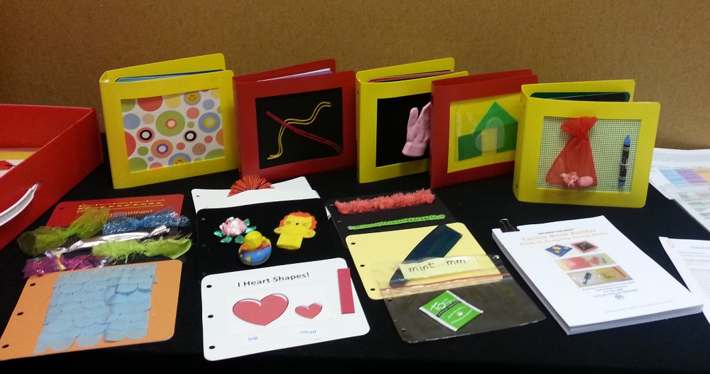

Project Staff
Suzette Wright, Emergent Literacy Project Leader
Monica Vaught-Compton, Project Assistant
Wendy Sapp, Consultant
Dana Fox, Consultant
Jane Barabash, Consultant
Christine Moe, Consultant

Background
The request that APH create a kit of materials enabling users to easily create a variety of individualized, custom-made tactile books has been expressed by focus groups and survey respondents. Because a young child’s concepts and language are limited, individualized books that address familiar topics and include things the child has experienced firsthand are more likely to be meaningful than visually complex, commercially available books designed for a typically sighted child. In addition, when the child helps dictate and produce the written text, the adult is able to use this opportunity to build important early literacy skills. When the child also participates in illustrating the book, it broadens his/her awareness of how tactile displays can be used to communicate meaning. Creating custom-made books, whether done by the adult or in collaboration with the child (participative design), can increase the number of appropriate books available to the child and motivate interest in books and in reading.

The idea for a tactile book-making kit with guidebook received approval from the Product Evaluation Team, and proceeded to the Product Advisory and Review Committee. The project was approved and released for work to begin. A brainstorming session marked the first Product Development Committee meeting and yielded useful suggestions for materials that might be part of the kit. The project leader examined a wide range of materials that could be used for book-making by searching online and in stores. The list of kit components and how they would be grouped was finalized and sketches made to show expert reviewers. Dimensions and quantities for kit materials were selected, and costs were estimated.

The project leader completed a rough draft of a kit guidebook containing guidelines for tactile design and instructions for using the kit materials to construct books with a variety of tactile illustrations.

The basis for the Tactile Book Builder kit is a relatively low cost, reusable, polyblend binder (9” x 8”) provided in two different spine widths: 2.5” to accommodate thicker textures and objects and a 1” binder for less bulky books. The binders feature plastic safety rings. The binders also include a “window” in the front cover for insertion of custom tactile cover art.

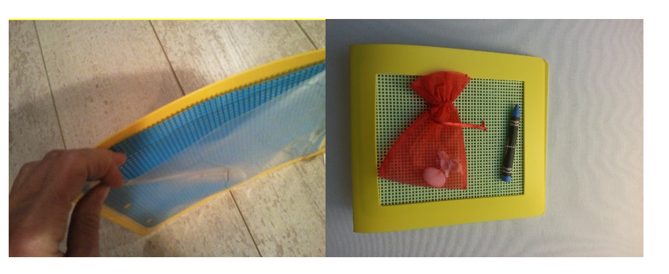

The remainder of the kit consists of blank pages, 3-hole punched, for insertion into the binders. A number of different page types are included for fitting into the binders: colorful board stock pages, polyblend pages, needlepoint canvas pages, polyblend “pocket pages,” Ziploc® pages, magnetic pages, loop material pages, doubled braille paper pages, and clear page protectors used to protect print pages and create twin vision books. Clear, adhesive-backed braille label material in three sizes is included in the basic kit, as well as adhesive-backed hook and loop material attachments, and
adhesive-backed magnetized strips. Also included is a version of the APH SoundPage with recording devices sized for the small binders in the kit.

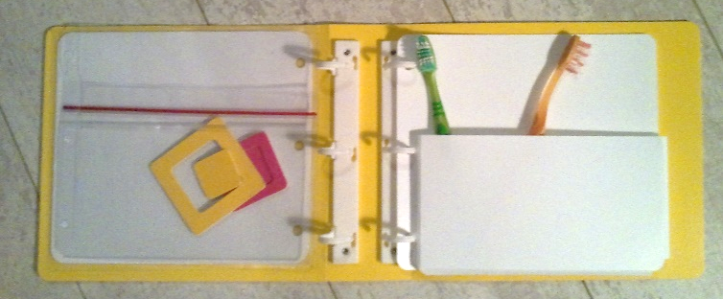
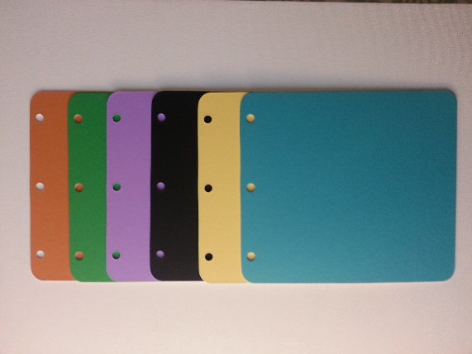

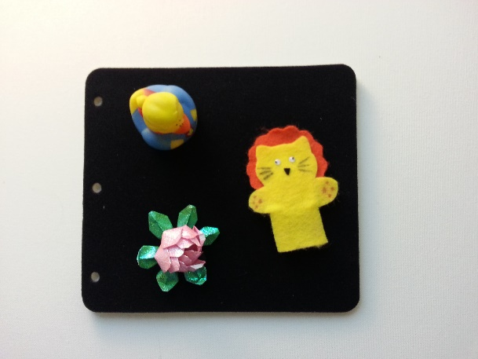

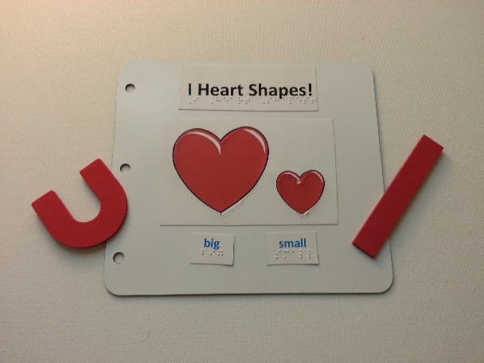

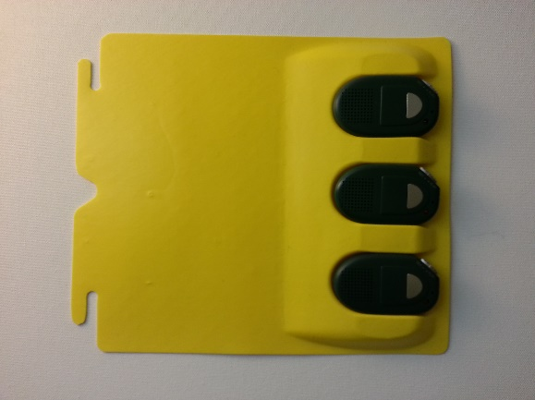

The list of suggested kit items and a draft of the manual were submitted to two consultants for evaluation. Overall, they were pleased with the kit items and contents of the manual. However, they recommended that the manual (Tactile Book Builder Kit Manual) and the Guide to Designing Tactile Illustrations for Children’s Books, a 35-page booklet available since 2008 as a free download from the APH website, be integrated into one document. Originally, the project leader had planned to include the second document as a separate piece.

Technical drawings were made of the kit’s custom binders, pocket pages, and Ziploc® pages. A vendor for these was identified. Several alternatives were explored with the vendor as a means to strengthen the binder cover and retain its open window. The dimensions of the Ziploc® page were also reworked after consultation with the vendor. Drawings were revised and given to vendors for price quotes. Sample prototypes were delivered by the vendors in the last quarter of 2013. A variety of alternatives regarding both the material and fabrication method to be used for the metal/magnetic pages for the kit were explored and sampled with Technical Research staff, the model maker, and outside vendors.

A final design for the binder covers was completed. Finalizing the binder dimensions allowed staff to have needed dies made for cutting the internal pages for the binders. Special high-strength, double-sided magnetic sheeting was located by the project leader, providing a way to produce magnetic pages in a low cost manner. Packaging for the kit was chosen. The project leader and Technical Research staff worked together to locate and order material for all other kit items. A cutting die was made to produce all prototype pages, and 10 prototype kits were fabricated and assembled for field evaluation. Braille templates for the binder pages and label material were designed to assist in planning and aligning braille text.

Extensive work was done on the manual to blend the two documents and update source material. A Quick Start Chart was prepared to show users in a glance how each page type could be used to make a variety of types of tactile illustrations.
Appendices list other products offered by APH that are useful in creating tactile books as well as an extensive illustrated list of suggestions for using available materials that are on hand in a classroom or home, or can be purchased at craft supply stores.

Tactile Book Builder Quick Start Chart
TBB Pages | Real Object Illustrations | Collaged Illustrations | Raised-Line Illustrations
Pocket Pages | Insert objects in pockets
Ziploc® Pages | Enclose objects
Needlepoint Canvas Pages | Attach objects with zip ties, “twisties” |  | Lace yarn, string, pipe cleaners through the canvas to form lines & raised shapes
Polyblend Pages | Attach objects: zip ties, hook/loop, magnetic attachments, glue | Glue or attach textured shapes using hook/loop or magnetic attachments | Glue string, yarn, or Wikki Stix®; apply puff paint to form lines & raised shapes
Board Stock Pages | Attach objects with zip ties, hook/loop, magnetic attachments, or glue | Glue or attach textured shapes using hook/loop or magnetic attachments | Glue string, yarn, or Wikki Stix®; apply puff paint to form lines & raised shapes
Fabric Pages | Attach objects with hook/loop attachments | Use hook attachments to back textured shapes to apply to page | Use hook attachments to back raised and outline shapes to apply to page
Magnetic Pages | Attach objects with magnetic attachments | Use magnetic strips or sheeting to back textured shapes to apply to page | Use magnetic attachments to back raised and outline shapes to apply to page
Card Stock Pages | Attach objects with hook/loop, magnetic attachments, or glue | Glue or attach textured shapes using hook/loop or magnetic attachments | Emboss; glue string, yarn, or Wikki Stix®; apply puff paint to form lines & raised shapes

The resulting 105-page manual was reviewed by Christine Moe, doctoral student at the University of Northern Colorado (UNC). At her recommendation, a brief section on emergent literacy was added; more updates to the manual’s references were provided by Moe; and the project leader drafted a detailed chart listing fine motor, tactual discrimination, cognitive, and language skills needed for effectively using different types of tactile illustration. The developmental chart suggests the illustration style and book genre appropriate for a child at each level. Data assembled from multiple sources by UNC provided the basis for the sequence of tactual discrimination, fine motor, cognitive, and language skills listed in the chart. The unformatted draft of the manual was then readied for field evaluation.

Field evaluation forms containing both closed and open-ended questions were written for the manual and kit items. Eight evaluation sites agreed to participate. In February through March of 2014, nine evaluators at six sites completed the evaluation. Two additional evaluators at one of the sites answered questions regarding kit items although they did not evaluate the manual. An evaluator at a seventh site delegated responsibility for the evaluation; although only parts of the questionnaire were answered, in its place a brief narrative impression of the kit and manual was provided. These results were recorded separately. The eighth site did not return an evaluation.

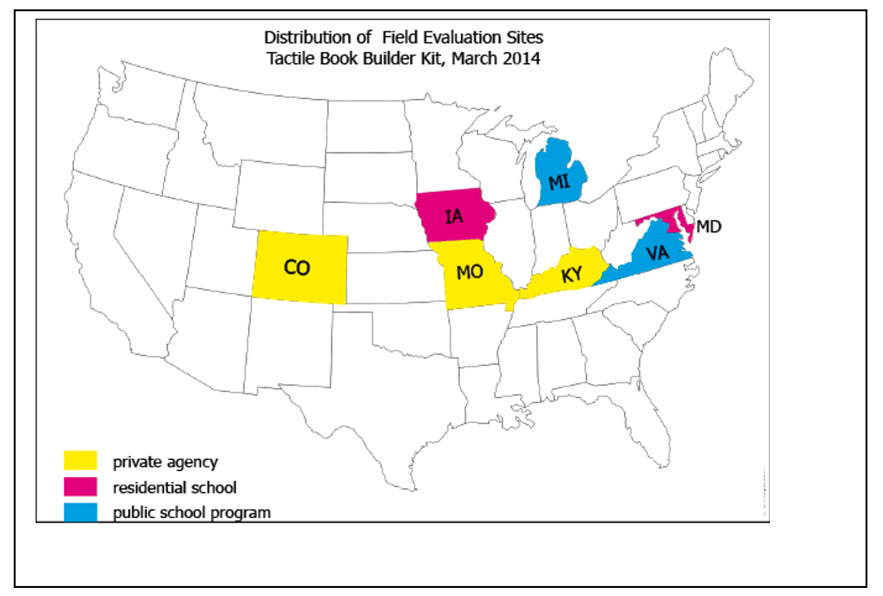

In all, nine TVIs, two TVI/COMS, a parent, and a teaching assistant took part. The TVIs ranged in years of experience from 2 to 24 years. The participating parent had also worked extensively in the field with 29 years of experience. The teaching assistant had been in the field for less than six months.

All nine evaluators completing the full evaluation indicated that each of the three sections of the manual would meet the needs of 80-100% of the TVI audience. Other data include the following:
- 89% of the evaluators rated all of the manual as appropriate for all or almost all early interventionists
- 78% of the evaluators rated all of the manual as appropriate for all or almost all regular education preschool teachers
- 67% of the evaluators rated the manual as appropriate for all or almost all paraprofessionals

Although parent use of the manual was not a primary objective of the project, 67% of the evaluators answered that all or almost all parents could use the manual; however, steps needed to improve the manual for parent use could, a majority indicated, limit its usefulness for the primary audience of TVIs.

Evaluators’ comments about the manual were highly positive:
- “I feel that this information will benefit all those that deal with students with different needs. Explanations are clear and easy to understand. I like the way items are broken down for more clarity.”
- “This is the most comprehensive description and discussion of tactile illustration I’ve seen. This is a fabulous resource for professionals and lay people, including parents and volunteers.”
- “I love it. It explains in a way that is understandable for everyone, yet not too wordy. Very applicable.”
- “I loved all the practical ideas.”
- “Again, I think motivated teachers w/VI child in their class are going to be thrilled to see this. Your info and high level of detail makes this so invaluable.”
- “The manual provides great examples of ideas for writing and making customized books.”
- “Again as with the other sections, information is written well and is easy to read and understand. The pictures are good and help with understanding the examples and suggestions. It is written to be easily understood.”
- “Good reminders for the variety of book topics/ uses. Valuable addition to include examples, suggestions and ideas for the use of TBB materials.”
- “I like the examples of different kinds of books and how they can be used. That way they don't have to come up with ideas from scratch. They can benefit from the books others have made. It also reinforced what I was thinking and spurred other ideas for my students.”

The Quick Start Chart, appendices, and developmental chart were considered useful by 89 to 100% of the field evaluators. Comments:
- “Love the developmental chart!”
- “I like how this [developmental chart] takes skills that blind kids need and puts activities (books) used to develop them. This could be a place where Core Standards for education can be applied and used so people can see how the standards fit in for our kids. This would be helpful for IFSPs and IEPs.”
- “[The developmental chart] is very useful the way that it is organized, divided and color coded as well. This chart can help with a wide variety of students with various needs. It is a good quick reference to use.”
- “[The Quick Start Chart] is great if you don’t have time to read the manual.”

At the seventh site, some parts of the evaluation were completed. The TVI and teaching assistant indicated that most TVIs would or should already know the information contained in the manual. They recommended the manual be divided into two separate documents—a shorter “how to” booklet and a second longer manual for those lacking training and experience. In many respects, this is similar to the two documents submitted to expert reviewers before integration of the two documents was recommended. To address this concern, the Quick Start Chart is being expanded slightly and the manual’s introduction suggests experienced tactile book designers skip the first section of the manual.

The majority of evaluators were pleased with the kit items:
- 89% indicated the basic design of the kit, featuring binders and a variety of page types for custom-making tactile books, “accomplishes its purpose well”
- 100% of evaluators said the binder and pages “were about the right size” for the target audience and purpose
- 89% stated the binders functioned well as a means of making tactile books quickly and easily for the target audience
- 100% favored the inclusion of both the thinner and thicker spine widths for the binder
- 90% indicated the binder was safe and durable (The single dissenting evaluator noted splitting due to pre-scoring of the prototype binder’s spine. This should not occur in production copies of the binder. In addition, a thicker plastic backing for the binder’s front cover, which had already been planned for production, was suggested.)
- 90% indicated all other kit items were safe and durable

Seventy percent stated the kit should be produced “as currently designed”; 30% indicated it should be produced with “a few but significant revisions” yet noted suggested changes were mostly a matter of adjusting colors and quantity of some page types.
- One evaluator suggested that the Ziploc® page be modified to open more easily.
- One suggested the magnetic page should be stronger.
- One requested a means of closing the open pocket page.

The suggested additions to the kit were longer plastic banding ties, page reinforcers for the paper braille pages, and rings to clip pages together for storage.

About the kit, in general, evaluators remarked:
- “I love literacy and making experience books for my students. I love the size of paper that you chose and variety of pages that are included.”
- “[I like] the variety of materials available so you do not have to search for what would be most appropriate.”
- “It supplies all the materials needed for making a tactile book.”
- “All of these materials provide a great variety for making the books. They are all necessary because I never know what I might need. I would like as many of each items as possible while keeping the price low.”
- “I like the variety of materials because I can individualize for each student based on his or her needs.”

The TBB kit and manual were approved for sale on Quota. Indicated revisions and additions to the Tactile Book Builder kit and manual were implemented. Final quantities and colors for all kit items were selected based on field evaluation results and consultation with other APH staff. A Product Structure Meeting was convened to discuss and approve these choices. The kit’s binders and each of the kit’s page types will be available for separate order as Refill Packets bearing part numbers; this allows customers to replenish the kit with the materials they use most often. The manual is also available as a separate purchase.

The manual received a final edit by the project assistant. Further illustrations were added to the manual. Cover art suggestions were given to the graphic designer. Final copy of the manual was given to the designer and the project leader consulted with the designer as work proceeded.

The Emergent Literacy Project Leader showed the kit and manual to the CVI Project Leader as a possible basis for a kit of book-making materials designed around the needs of students with CVI. The CVI Project Leader proceeded with plans to utilize the TBB materials and to develop a separate manual focused on how the kit materials can be used to custom-make books for a child with CVI. That project, as an offshoot of this project, was named CVI Book Builder.

The manual, Tactile Book Builder: Guide to Designing Tactile Books (117 pages), was formatted by the graphic designer. Descriptions were written for the 80 photos showing examples of types of tactile illustrations, a wide variety of tactile books from different sources, and materials used to construct them. Formatting was completed for the chart (Appendix C), which is designed to help teachers identify the type of tactile illustration and type of story suited to each student’s fine motor, cognitive, and tactile discrimination skills. A notice was added to the manual to explain the relationship between the Tactile Book Builder Kit and the CVI Book Builder Kit. The final file, clean file, and alt tags for the manual were turned over for creation of accessible files. The HTML and BRF for the manual were completed. Both accessible file types will be available as free downloads. Final specifications for the kit and manual were completed and provided to Production in July.

Work during FY 2018
The kit materials and manual were produced, priced, and made available for order. Refill Packets for each of the page types, additional binders, and the manual—available as separate purchases—were priced. A brochure was written and produced. The project leader provided information needed for a Product Launch and approved plans developed by Marketing staff. It was agreed that an opportunity for users to share ideas for books via Pinterest would be of interest.

Work planned for FY 2019
The project leader will support Marketing staff as needed in launching the product.

Tactile Book Texture and Item Accessory Pack
(Continued)

Purpose
To develop an accessory pack of textures and items to be used to construct collage-style tactile illustrations in books for a young child, such as custom-made books made using the Tactile Book Builder kit materials

Project Staff
Suzette Wright, Emergent Literacy Project Leader
Monica Vaught-Compton, Project Assistant
Emily Grimmany, Research Assistant
Bryan Rogers, Manufacturing Specialist

Background
In late spring 2014, evaluators of the Tactile Book Builder kit expressed the request that APH create a collection (accessory pack) of materials to make it easier for teachers and parents to create collage-style illustrations for custom-made tactile books. Seven of 11 evaluators rated a pack of textured materials as “highly needed,” three rated it “needed,” and only one labeled it “not needed.” Many educators and parents agree that custom-made tactile books can be highly effective in promoting an interest in books and reading for young children with visual impairments (Miller, 1985; Swenson, 1999, 2015; Lewis & Tolla, 2003). A book made for an individual child can be about the home environment or other firsthand experiences of the child. Illustrations can be designed with the child, involving him in choosing what has meaning for him and what he prefers to touch.

In particular, tactile illustrations that feature realistic textures offer a means to provide meaningful and engaging illustrations in books for children with visual impairment. A recent study found consistently higher rates of recognition for textured collage illustrations versus thermoform and raised-line drawings; the study was conducted with 23 students ages 6 to 16 years (Theurel, Witt, Claudet, Hatwell, & Gentaz, 2013).

Obstacles to custom-making collage illustrations include the fact that teachers and caregivers frequently lack time to locate and purchase the necessary materials. In addition, book creators must often buy a much larger quantity of material than they need, such as a suitable wallpaper texture, to produce a single book.

The proposed product saves teachers’ time and expense, making it more likely that they will create these more effective types of collage-style books. It is intended to be a limited collection of textured materials selected because they realistically represent the textures of common items that might be used to create a first-hand experience story or items that are often illustrated in a child’s book (e.g., grass/plastic “turf,” tree trunk/wood textured wallpaper, house/simulated brick texture, door/wood veneer, sidewalk/rough “sanded” wallpaper texture, animal/long fur, animal/short fur, fish/slippery shiny material, and snake/leather-like vinyl). The materials are representative of texture and also general color of the items to enable the illustration to function well visually as well as tactually. The materials can be used alone or with the Tactile Book Builder Kit to custom-make books featuring collage illustrations for a young child. They can also be used by the child to illustrate something of his own choosing.

The project leader developed a Product Submission Form for the product after reviewing the types of objects and settings that most commonly appear in children’s books as well as topics most likely to be the focus of a firsthand experience story. Of the many possibilities, textures and small items that depict familiar things likely to be found in a child’s backyard or park were chosen. This provided a theme/focus for the accessory pack, with the possibility that other themed packs (seasonal, common routines, etc.) could later be provided.

The project leader submitted the form after consulting with the Tactile Graphics Project Leader and examining Carousel of Textures and possible plans for an extension of this product. The two worked to define differences in what each would provide and were satisfied the products served different needs and would not result in duplication of effort. The product passed through the standard approval process and was approved by the Product Advisory and Review Committee with work to begin in February 2017. The project leader identified parts from existing APH products, including other tactile books that could be included in the accessory pack. In addition, other items were located and sources identified after exploration online, in craft stores, hardware shops, and do-it-yourself establishments. Every effort was made to shop all items from as few vendors as possible. To the extent possible, costs and quantities for each item were estimated by the project leader, samples were purchased and labeled, and minimum order quantities noted. An upper cost limit for the pack was set by the project leader based on perception of how the materials would be utilized in the field. At this point, higher priority work on other projects delayed the initial Product Development Meeting.

Work during FY 2018
The project leader held a Product Development Meeting and brainstorming in October 2017 to present proposed items and their sources. She requested help from Purchasing and the manufacturing specialist in obtaining product safety information about the materials to be included. An upper cost limit was given; price prediction, which is more difficult, was discussed.

Following the meeting, the project leader replaced items from vendors that did not offer Net 30 payment terms, in keeping with the request of Purchasing staff. It was particularly difficult to locate Net 30 fabric vendors, an important part of the pack, and this search continued for some time. In a few instances, a Net 30 vendor was not located. During this period, the manufacturing specialist and Purchasing staff provided help to obtain prices and confirm minimum order quantities for items that would be obtained from Darice. The project leader managed this effort for the remaining items. Ideal amounts for each item were weighed against cost by the project leader, and the pack’s contents were finalized for field evaluation.

The project leader wrote a short product insert listing ways teachers and children could use items in the pack:
- to make collage-style illustrations for a tactile book about the child’s own firsthand experiences
- create tactile concept books (small/large, rough/smooth, same/different)
- adapt a print children’s book by adding tactile illustrations
- include in a story box to accompany a print children’s book
- coach tactual exploratory and search strategies (scatter the plastic bugs or other items on the grass mat for the child to feel and find in the grass)
- create activities developing texture discrimination skills (short fur/long fur/long fur—find the one that is different)
- as a basis for a variety of sorting and matching activities (small leaves/large leaves, ants/earthworms, fur texture/bark texture)
- create counting activities (count the ants, pair the ants two by two)
- arrange a sequence of items for the child to duplicate (leaf/butterfly/ant)
- use in phonemic awareness activities (ask the child to find one or more items or textures that begin with a particular sound)
- use in letter naming activities (ask the child to find one or more items that begin with a particular letter)
- give to the child to create a piece of tactile artwork

The project assistant located field evaluation sites. The project leader bought all materials needed for creation of 10 sample Packs, cut sample pieces, and provided collation and shipping instructions to the project assistants. The project leader provided a written questionnaire placed by the project assistant on SurveyMonkey® for use by field evaluators. The questionnaire sought teachers’ opinions of the suitability of each item for the purposes listed above, but primarily for tactile book creation. The evaluators’ recommendations were sought concerning quantities for each item and the overall functioning and selling price of the product.

The sample packs were sent to reviewers in late April 2018. Evaluations were submitted in early June. Contents sent to reviewers were the following:
- Ants, black
- Assorted insects pack
- Bird feathers
- Butterflies, blue and “uncolored”
- Cloth “Vinylized” Green Buckram cloth
- Cloth, Lime Green Book binding cloth
- Cloth, Kelly Green Book binding cloth
- Earthworms, soft plastic
- Fabric paint, brown slick 3D paint
- Fabric paint, green slick 3D paint
- Faux brown “reptile” leather
- Faux fur, brown
- Faux fur, gray, short
- Flower Bush
- Garland, English ivy
- Garland, Evergreen
- Grass mat
- Jute twine, brown
- Leaves, large green
- Leaves, Maple orange mix
- Leaves, small green
- Raffia
- Sandpaper
- “Stone” gray vinyl tile, adhesive backed
- Wallpaper, brown bark textured
- Wallpaper, gray bark textured
- Wallpaper, green bumpy “lizard” texture
- Wallpaper, rough fleck stone texture
- Wood, Birch wood veneer
- Wooden Popsicle® sticks

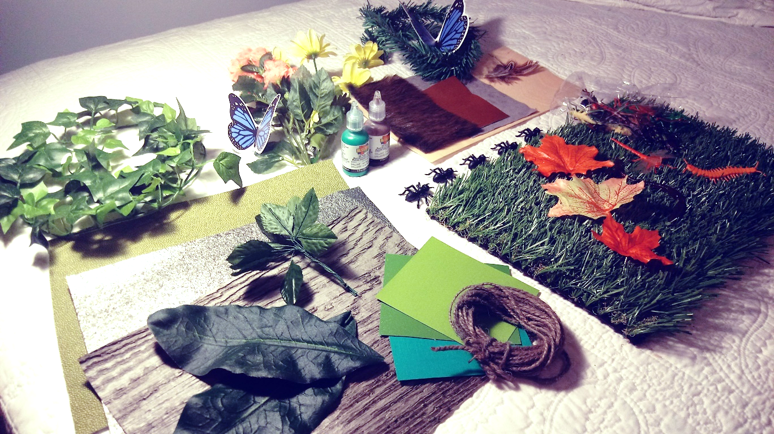
Results were obtained from nine evaluators at seven sites, including TVIs, TVIs with additional certifications (O&M, Early Intervention, special education) and a doctoral student in the field. Evaluators were asked to rate how well the pack would make it easier for users to create tactile books (firsthand experience stories, concept books, alphabet books) about common outdoor experiences for a tactual learner who is 3-7 years old. Given a rating system with 0 = “does not accomplish this purpose” and 4 = “accomplishes its purpose very well” the average score was 3.44. Comments included the following:
There is a wonderful diversity of textures which simulate realistic tactual outdoor experiences, so I think this would be very easy to use to make experience/concept books.
- It is a great combination of resources when creating tactile books/images about nature and outside. I wish it came in more of an organized pack and with some visual photographs as ideas.
- I liked the different textures of the items and how real they felt
- Majority of the materials were well chosen and had tactile appeal
- I think some of the leaves don't feel very realistic for a child who will exclusively use touch to identify. I think that the leathers and other textures are pretty realistic.

Using the same 0 to 4 point rating scale, when asked to rate how well the pack would perform in making it easier to design hands-on play and learning activities (sorting/matching, counting, beginning sounds identification, art projects) for these same learners, the average response was 3.67. Comments:
- There are a lot of options for how the materials in this kit can be used.
- It provides great materials for sorting/matching, counting, and beginning sounds. It also is great for art projects and tactile books! It allows for the learner to explore different pieces of materials and to understand that it is not "real" and that it is fake but representing something that is real.
- It was very helpful in making a book about our nature walk and making the items come to life. The small animals [plastic bugs, earthworms, butterflies] were good to use for counting and sorting.
- There is such a large array of items and so well organized I found it was very easy having the items readily available to create activities
- Materials being gathered and all in one spot make it easier for busy teachers, etc. to create appropriate learning materials
- Some materials could be improved
The evaluators were asked to indicate whether they would or would not include each item in the pack and if so, in what quantity. Based on their responses, some items that are readily available, such as jute string, will be dropped from the pack. In some cases, two colors of an item such as textured wallpaper resembling tree bark will be reduced to one color/type. Other items will be dropped or quantities reduced to keep price within the preferred range of $90 or less, provided the items can be easily found in appropriate quantities, such as sandpaper and Popsicle® sticks.
All recommended the pack be produced by APH and made available on Quota. All requested that additional packs based on other themes be provided by APH. Suggested themes were seasons, holidays, birthday, at school, beach, grocery store, gardening, and sports. Although most indicated that “In My Yard Theme Pack” was a good name for the set of materials, one evaluator suggested “In My Yard Creation Pack.”
Several evaluators expressed a strong desire for accompanying written materials with the Theme Pack. Beyond the inclusion of a 4-page product insert with a few general ideas, this will probably not be pursued. It is expected that the newly available Guide to Designing Tactile Books in the Tactile Book Builder materials will provide users with ideas and guidance for tactile book creation. The product insert will suggest interested users refer to this Guide.
Work planned for FY 2019
Final revisions will be decided based on field evaluation results. The sample pack prototype and field evaluation results will be presented at a Gate 4 meeting to required staff. If approved to move forward, a catalog number will be assigned and writing of final specifications will take place. Following this, the manufacturing specialist will schedule a Gate 5 meeting to place the specifications and related final tooling in the hands of Production and Purchasing staff.

Visio Tactual Profile
(Continued)

Purpose
Royal Dutch Visio Tactual Profile is an instrument for observing the tactual functioning of children ages 0-16 with severe visual impairments.

Project Staff
Dawn Wilkinson, Early Childhood Project Leader
Suzette Wright, Emergent Literacy Project Leader
Monica Vaught-Compton, Project Assistant
Kelly Kennedy Mimms, Research Assistant

Background
The Visio Tactual Profile has been validated by the University of Nijmegen in the Netherlands. Areas of sensory functioning, motor functioning, perceptual functioning, and practical skills are addressed. It was distributed by Optelec, U.S. in 2011, but no longer has a U.S. distributor. In an effort to make the product available in the United States, Anneke Blok of Visio, submitted the product to APH in September 2016.

The product was presented to the Product Evaluation Team in February 2017 where it was decided that before proceeding to the Product Advisory and Review Committee (PARC), the product should undergo an expert review. APH purchased two additional Visio Tactual Profiles for a total of three to be sent out for review. A poster presentation demonstrating how APH tactile products support the skill categories addressed in the Visio Tactual Profile was given at the first ever International Tactile Reading Conference in Stockholm in April 2017. Seven expert reviews were conducted in June 2017, and results were analyzed. A few of the questions and responses follow.

How would you rate the overall need in our field for the Visio Tactual Profile, where 1 equals not needed and 5 equals significantly needed?
3 | 14.29% (1)
4 | 42.86% (3)
5 | 42.86% (3)

Check any or all that apply:
Assesses a student's level of tactual development | 85.71% (6)
Identifies tactual strengths and weaknesses | 100.00% (7)
Presents learning to read tactile graphics in a sequential way | 85.71% (6)
Presents concrete to abstract representation | 100.00% (7)
Organizes materials into categories so that skills can be addressed accordingly | 85.71% (6)
Can be used to determine a baseline | 100.00% (7)
Can be used to reevaluate skills over time | 85.71% (6)
Presents tactile graphic use within the much larger context of tactual functioning across a wide variety of tasks | 85.71% (6)
Total Respondents | 7

To what extent do you agree with the following statement: The Visio Tactual Profile, when purchased by an agency, will serve numerous students over multiple years.
Strongly agree | 42.86% (3)
Agree | 57.14% (4)

Six reviewers (85.71%) believe that APH should distribute this product; one reviewer responded that APH should not distribute this product.

The results of the survey, in its entirety, were presented to PARC during the August 2017 meeting.

Work during FY 2018
Due to the interest sparked at the International Preschool Seminar in Illinois in September of 2017, APH loaned its Visio Tactual Profile to both early childhood centers at the New Mexico School for the Blind in Albuquerque and Alamogordo during the Spring semester of the school year. Because expert review was officially over, the shipping costs incurred were payed for by the receiver, but New Mexico was eager to try out the kit and offered to provide further feedback to APH.

Work planned for FY 2019
Contract negotiations will take place with Visio. If approved, the product will become available for purchase from APH.

What Is It? [Modernization]
(Completed)

Purpose
To promote comparative thinking and the ability to generalize

Project Staff
Dawn Wilkinson, Early Literacy Project Leader
Charles “Burt” Boyer, Project Leader Retired
Monica Vaught-Compton, Project Assistant
Lois Harrell, Author

Background
In 2008, the project leader collaborated with Harrell to develop the original APH product. Ten prototypes of the product were developed for field testing purposes. The product for field testing included: Instructional Guidebook, Words and Descriptors (102), and a recipe-type box to store the cards.

What Is It? was field tested in the spring of 2009. Six reviewers, representing the states of Kentucky and Indiana, evaluated the product. Fifteen students used the product. These students ranged in age from 6-14 years old; school grades ranged from Pre K to 8th, with the majority being Pre K. A wide range of visual acuities and eye conditions were represented.

Five of six evaluators recommended that this product be available from APH on Quota. Reviewers reported that 87.5% of students found the game to be both fun and challenging, and the large majority of students wanted to discuss and examine the actual object after identifying it based on the clues. Suggested revisions to the product were (1) use of a thicker card stock for the game cards, (2) revising several word cards so that the word is more specific to the provided clues, and (3) adding an orientation corner cut to the cards for the braille reader. The project leader made all of these requested revisions and the original product became for sale in 2010.

Due to the adoption of UEB, this product was approved for modernization. Only two braille cards need braille changes (“table” and “station”), but all cards will need a new catalog number printed. The revision will also include the braille version of the teacher guide. In 2017, braille job start forms were initiated, and cover art design for the print to reflect the new catalog number was completed.

Work during FY 2018
Due to changes in the production process with machinery, a significant amount of time
was needed to get the cards to match the necessary alignment in the new machines.
The Teachers Guide and cards were then rebrailled. Tooling was completed, and a
specifications meeting was held on August 17.

Work planned for FY 2019
The modernized product will become available; thus no further work is needed on this
project.

EXPANDED CORE CURRICULUM

Multiple Disabilities Projects and Needs
(Ongoing)

Purpose
To assess needs, plan research, and manage product development to serve individuals who are visually impaired and have additional disabilities

Project Staff
Tristan Pierce, Multiple Disabilities Project Leader

Background
A Multiple Disabilities Focus Group met at APH in March 2001. The group identified 48 product ideas and held detailed discussions on the revision of APH’s Sensory Stimulation Kit (SSK), the development of a tactile (communication) symbol system, and the value of adaptable calendar boxes. The project leader developed the 48 product ideas into a needs survey that APH distributed nationally; it received international participation. The project leader presented the survey results at the 2002 Annual Meeting. Ten years later, in 2011, APH hosted two Multiple Disabilities Focus Groups: Children Birth to Grade 12 Multiple Disabilities Focus Group (March) and Adult Multiple Disabilities Focus Group (June). Each group identified product needs for the specific age group and helped design a product needs survey to facilitate prioritization. Group members recruited colleagues to pilot the two surveys. APH made the final surveys available on the Internet that September. The project leader compiled the data and wrote the Report of the APH Birth to Grade 12 Multiple Disabilities Focus Group and Survey and the Report of the APH Adult Multiple Disabilities Focus Group and Survey. APH announced the reports in the APH News and posted them on the APH Web site.

Work during FY 2018
In addition to working on product development, the Multiple Disabilities Project Leader responded to customer service calls and e-mails to help customers with APH multiple disabilities products. She worked the APH exhibit booth at OCALICON, the Brain Injury Summit, CEC, CTEBVI, and AER; and presented at OCALICON, CTEBVI, and AER. She coordinated a full-day CEC preconference workshop for the Division of Visual Impairment and Deafblindness featuring Mille Smith and the APH Intervention Continuum. She presented APH multiple disabilities products to students visiting APH from the University of Kentucky, Vanderbilt University, and Illinois State University.
Work planned for FY 2019
The Multiple Disabilities Project Leader will continue to work on products recommended by the surveys and submissions from the field, and on existing APH products that may need updates to meet current APH and educational standards. She will again coordinate a CEC-DVIDB preconference workshop in Indianapolis.

Quick & Easy ECC Mobile App
(Continued)

Purpose
To provide teachers of students with visual impairments, certified orientation and mobility specialists, parents, and other members of the educational team with quick, creative lessons designed to teach skills related to the expanded core curriculum to secondary students in school, home, and community settings in a portable manner

Project Staff
Laura Zierer, Project Leader
Patti Maffei, Consultant/Author
Kelly Kennedy Mimms, Research Assistant
Michael McDonald, Programmer
Rezylle Milallos, Programmer

Background
Although instruction in the expanded core curriculum (ECC) has been identified as an important goal of the National Agenda for the Education of Children and Youth with Visual Impairments, Including Those with Multiple Disabilities, teachers of students with visual impairments report that it is difficult to find the time and resources required to consistently and systematically address the various skills contained in the following domains of the ECC: assistive technology/technology, career education, compensatory access skills, independent living, orientation and mobility, recreation and leisure, self-determination, sensory efficiency, and social interaction.

In order to effectively prepare transition students with visual impairments to live independently, Patricia Maffei, Program Director of The Hatlen Center for the Blind, and Patricia Williams, Executive Director of The Hatlen Center for the Blind, have been forced to address their students' lack of proficiency in the ECC. Knowing that this is a concern for almost anyone working with this population, Maffei approached APH in 2009 to develop a guide containing lesson plans and suggested adaptive aids and techniques to facilitate instruction in the ECC across a variety of environments by all members of the educational team, including parents. Quick & Easy ECC: The Hatlen Center Guide (1-08204-00) was released on October 7, 2014. For more information about this related product, please see previous Annual Reports of Research & Development Activities.

While Karen Poppe (Tactile Graphics Project Leader) and Zierer were working with the consultants on Quick & Easy ECC: The Hatlen Center Guide, Maffei expressed a desire to offer the content in the form of a mobile application to make the content more portable and readily available. However, constraints on resources did not make this a feasible plan at the time.

On October 10, 2016, Maffei sent in a New Product Idea Submission Form to revisit the idea of providing the existing content as a mobile application. APH approved this product for development on May 24, 2017. Maffei is listed as a consultant for this product; however, little effort will be required on her part as the content will be identical to the related product previously released.

A conference call was conducted in February 2017 with Maffei, Poppe, Larry Skutchan, and Heather Kennedy-MacKenzie to define the submission idea in terms of the desired end product. In April 2017, Poppe recommended the project be reassigned to Zierer, based on individual workloads. Poppe, Zierer, Skutchan, and Kennedy-MacKenzie met on April 19, 2017, to discuss the proposed product idea and lay out a general structure of the application.

Zierer indexed all lessons by varying characteristics: category (i.e., At School or Home, In the Community), primary ECC area addressed, alphabetically by topic, and items required for administration. Zierer began writing specifications, and in-house programmers were identified. Per Zierer’s request, an electronic mailing list was created for the purposes of field input. An announcement was published in the May 2017 APH News.

With very little response to the callout for participation, Zierer turned to social media to garner interest. A similar announcement was posted to four social media groups of which Zierer is a member, incentivizing potential subscribers with the chance to beta test the app. As of the writing of this report, 24 participants have subscribed to the electronic mailing list, with a geographically diverse distribution. Different topics are discussed weekly within this list with active participation from members.

This application will be designed to operate on all devices, regardless of the operating system. This will be APH’s first “universal” application, requiring additional development time in order to acclimate to a new cross-platform development software.

Work during FY 2018
Zierer, McDonald, and Milallos finalized specifications for the application. Due to a lack of resources, development was put on hold until Milallos is available to work on this project. Work is expected to continue in FY 2019.

Work planned for FY 2019
Milallos and McDonald will begin development of this application. Zierer will review content and functionality.

Visual and Multiple Impairments Website
(Ongoing)

Purpose
To provide parents, teachers, and support professionals with product support, information, and resources to help them serve individuals who have multiple disabilities in addition to visual impairment, blindness, or deafblindness

Project Staff
Tristan Pierce, Multiple Disabilities Project Leader
Millie Smith, Consultant
Kelly Kennedy Mimms, Research Assistant
Monica Vaught-Compton, Project Assistant
Malcolm Turner, APH Website Coordinator
Ricky Irvine, Website and Video Designer

Background
APH Customer Service receives calls and e-mail messages from parents and teachers who ask questions about APH multiple disabilities products and services. Attendees of APH National Instructional Partnership workshops requested a location where they could look for information about multiple disabilities and APH products. Over the years, products that are stored at resource centers and shipped to various schools year after year may experience loss of documentation that would assist teachers in using the product. APH decided that a website to support these products that includes videos, questions and answers, sample assessments, downloadable forms, and more would greatly benefit teachers and parents. Staff collected research, documentation, and photos for the future site. The project leader received “maintenance” training on WordPress®.

Work during FY 2018
The project leader turned over all website design and development to a new outside vendor. The project leader provided edits to materials submitted by the vendor. The project leader completed two Sensory Learning Kit videos and they are on YouTube™.

Work planned for FY 2019
The project leader will continue to research, write documentation, and work on additional videos.

ASSISTIVE TECHNOLOGY AND ELECTRONICS

For additional products related to Assistive Technology and Electronics, see the Technology Product Research section.

APH SMART Brailler by Perkins
(Continued)

Purpose
To provide a brailler that provides visual and voice feedback of what is being brailled in order to give immediate feedback to a student who is learning braille and to facilitate communication between a braille-using student and a sighted teacher or parent who does not know braille

Project Staff
Cathy Senft-Graves, Project Leader
Larry Skutchan, Director of Technology Product Research
Eleanor Pester, Braille Project Leader (Retired from APH, December 2012)
Frank Hayden, Director of Technical & Manufacturing Research
Sara Lee, Research Assistant

Background
In 2011, APH and Perkins Products agreed to produce a brailler that provides visual and voice feedback of what is being brailled. Perkins Products chose the name SMART Brailler for this product. Product Development Technologies (PDT) was contracted by Perkins Products to develop the firmware for the brailler. Voices used in the brailler are provided by Acapela Group, and contracted braille translation is provided by Duxbury Systems.

The base unit of the APH SMART Brailler by Perkins is the Perkins-APH Brailler Version 2. The SMART Brailler has a removable, rechargeable battery; a power switch; a power adapter port; and a module attached to the front of the brailler that includes a 4-inch color video screen, a speaker, and the other items shown in the following diagram.
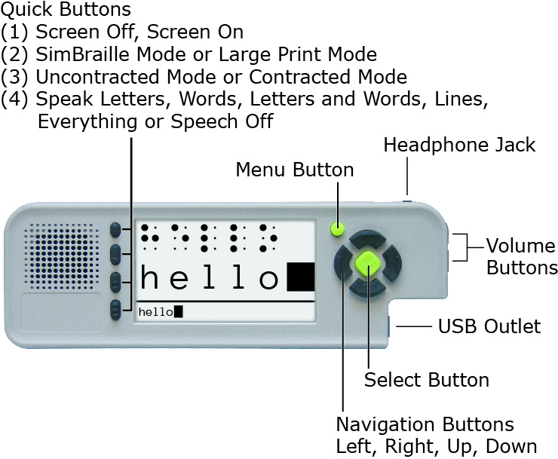
The video screen displays menus and visual feedback when someone is brailling. During braille entry, the screen can display SimBraille and large print, just large print, or be turned off.
- SimBraille mode shows six simulated braille cells above their corresponding print characters in 42-point type.
- In Large Print mode, the SimBraille is replaced by four large print characters in 70-point type.

Both modes display a full line of 28 print characters at the bottom of the screen in 12-point type. When the brailler is set for contracted braille, words containing contractions are underlined in this line.

The four Quick Buttons perform the following functions:
- Turn the screen on or off
- Toggle the screen display between SimBraille mode and Large Print mode
- Toggle the braille translation between contracted braille and uncontracted braille
- Change the speech feedback during braille entry to one of the following options: Speak Letters, Speak Words, Speak Letters and Words, Speak Lines, or Speak Everything

There are other settings that can be changed within the menus on the brailler. There are three text-to-speech voices available on the brailler and six color combination options for the display. The brightness of the display can be adjusted, and there are several options for the screen timer that turns the screen off if the brailler is not in use.

In addition to showing what is being brailled in print on the screen, the brailler stores the print in a text file. The text file can be saved in the brailler’s internal memory or to a USB drive. The text file can be transferred to a personal computer via the USB drive and saved, printed, edited, or e-mailed as needed (e.g., to a teacher or parent). A file can also be printed directly from the brailler to a printer with a USB port via a USB cable compatible with the brailler (USB A type) and the printer.

Up to 30 user accounts can be created on the brailler through the User’s Menu. The default user name and account is “Guest.” Each user account can have its own settings as described above. A file saved in the brailler’s internal memory can only be retrieved when the brailler is set to the same user as it was when the file was saved.

An audio tour, available in the Welcome menu on the brailler, provides an introduction to the brailler and most of the features and functions described above.

Relevance
The SMART Brailler provides immediate feedback to a child or adult who is learning braille via text to speech and a screen that displays SimBraille and large print of what is brailled in uncontracted or contracted braille. This audio and visual feedback also provides information about what a student is brailling for someone who does not know braille, including parents and general education teachers.

Research
During 2011, Research Department staff met to test the functions of prototypes of the brailler and recommend improvements to Perkins and PDT personnel. Members of the Research Department also took different prototype versions to the Kentucky School for the Blind (KSB) 3 times during the year to test with young students who are visually impaired. Perkins and PDT also began development of a software application (app) to provide additional exercises for students being instructed using the Building on Patterns (BOP) Kindergarten curriculum.

In January 2012, the BOP writers were asked to participate in testing and give input on the SMART Brailler. Three of the writers who had young students learning braille were shipped braillers that contained changes and improvements from the earlier prototypes. The writers gave feedback on the braillers’ functions to Perkins. In June 2012, during the Building on Patterns and Braille Literacy Meeting, Perkins brought several SMART Braillers to APH. The BOP writers, consultants, and Research personnel worked with the braillers; a list of issues and comments was created for Perkins and PDT to address.

Two separate field tests were conducted with the SMART Brailler. The first field test was a Perkins and APH joint field test of the braillers begun the third week of August 2012, and continued through the end of October 2012. APH sent braillers to five teachers of students who are blind or visually impaired (TVIs), and Perkins sent braillers to three TVIs who are writers for BOP Second Edition. The TVIs are located in California (2), Colorado, Florida, Indiana, Maryland, Missouri, and Oregon. All the field evaluators except one used the braillers with at least one student learning braille at the kindergarten, first, or second grade level. The evaluators were asked to complete a workbook of exercises themselves, work with a student to complete another set of exercises, work with a student and the BOP Kindergarten App, and provide comments about their experiences with the brailler. They were also asked to ship the electronic files and embossed pages from their work back with the brailler at the end of the field test. One update to the brailler’s core firmware was provided to the field testers during their evaluation period.

Comments from the field evaluators were reviewed and compared to the electronic files and embossed pages where relevant. Issues with the braillers’ performance based on these comparisons and the feedback from the field evaluators were compiled to be addressed in future updates to the brailler. Perkins and PDT made updates to the firmware based on the field test and discussions with APH personnel.

APH conducted a second field test late December 2012 through early February 2013 with braillers loaded with another updated version of the firmware. The TVIs for this field test were referred to APH by Ex Officio Trustees who are members or former members of the Educational Products Advisory Committee and are located in Kansas, Michigan, New Mexico, New York, Ohio, and Vermont. These evaluators also worked with at least one student learning braille at the kindergarten, first, or second grade level. An updated brailler was also sent back to one of the BOP writers in California who participated in the first field test. This test process was similar to that of the first field test (described in the Research section of this project report), but also included instructions for the teacher to use the brailler with a student in day-to-day activities with a student. In-house testing was also done at APH. The field testers documented specific examples of instances where the speech or visual feedback did not match what was brailled.

Summarized Ratings from Field Testers on Feedback Features

Embossed Braille
Good | 6/6
Satisfactory
Needs Improvement

Speech Feedback
Good | 2/6
Satisfactory | 1/6
Needs Improvement | 3/6

Visual Feedback
Good | 4/6
Satisfactory | 2/6
Needs Improvement

The field evaluators also provided these observations about the benefits of the SMART Brailler features:
- My student loves it. He's low vision, but has enough useable vision that he is able to see the letters on the screen.
- I think with all the demand to display students' work and levels the smart brailler is a useful tool.
- My student is LOVING the SMART Brailler. It is helping him figure out the correct fingering positions on the Brailler, as well as giving him the immediate feedback when he presses the wrong keys. (This TVI’s student has Septo-Optic Dysplasia.)
- My student was thrilled to hear his new letters, contractions and sentences. It was really reinforcing for him and motivating. When we turned the speech off and used the Brailler for math he missed it. He quickly learned how to turn the switch on/off and to change between speech on/off. He was so pleased to hear his name when he wrote it in sentences for me. He learned from his mistakes as well and this provided a terrific teachable moment. The classroom teacher does not know Braille and she enjoyed seeing what the student was writing so she could give him direct feedback. The peers in his room thought he was cool that he had a “talking pencil” to write with.

One of the in-house evaluators had this comment: I was able to help evaluate this unit back in the Summer [of] 2012 on earlier prototypes. I will say first and foremost that there have been vast improvements with the accuracy of keys pressed verses text printed out/spoken on the screen. This is not to say that the translation is without flaws… It’s not. There are still cases when the text does not match the Braille.

Comments from the field and APH in-house evaluators were reviewed and compared to the electronic files and embossed pages where relevant. Issues with the braillers’ performances based on these comparisons and the feedback from the evaluators were compiled to be addressed in future updates to the brailler. Hardware problems were also noted, and units with these problems were sent back to Perkins for evaluation.

A field test of the SMART Brailler organized by Perkins was completed in October 2012. APH conducted a second field test in late December 2012 through early February 2013. More information on the field tests are provided in the Research section of this project report. Throughout this process, Perkins, PDT and APH shared information and discussed issues via e-mail and phone. Staff from Perkins came to APH on March 20, 2012, for a more thorough discussion. Perkins and PDT provided several more firmware updates after the March meeting that were tested in-house at APH; the last of these resolved most of the main issues with the brailler’s core firmware functions.

APH tested updates to the BOP Kindergarten App in-house and discussed its performance with the BOP Second Edition writers and consultants. Thorough testing was done to document instances where the text to speech in the app was not clear enough for a student to understand, and this was shared with Perkins and PDT. Improvements were made to the app.

Work began on a quality control process to assess the braillers when they are delivered to APH. The brailler’s recorded audio tour was re-recorded at APH to correct errors, update information, and improve the quality of the recording. Work continued on a user’s manual begun in FY 2012.

In FY 2014, APH project staff and management prioritized the remaining issues in the core firmware and BOP Kindergarten App. Two issues caused by limitations in the electronic components were determined to be acceptable for the brailler’s release. The remaining issues were resolved through multiple updates from PDT and thorough testing by the project leader with assistance from other APH personnel who know braille. Additional issues were found in some of the updates, and those were resolved as well. The versions of the core firmware and BOP Kindergarten App that were tested and found to be acceptable were received January 24, 2014.

The project leader worked with Frank Hayden, Larry Skutchan, and APH Production personnel to develop and finalize the quality control procedures for the brailler. This included setting up a procedure to ensure the pressure required to press down the keys on the brailler was within an acceptable range. This range was based on data from Perkins Products and APH on the pressure required to press down the keys on the Perkins-APH Brailler Version 2, which was designed to require less pressure than the standard Perkins Brailler®.

The first shipment of 10 braillers was received on February 11, 2014. Representatives from Perkins and PDT traveled to APH to observe the quality control check and to be on hand in case of any issues that might arise. During this check, the test team discovered that the braille mode setting was not correct on any of the braillers due to one of the steps in Perkins’s quality control procedure. This problem was manually corrected on the 10 braillers, and Perkins’s personnel said they would change their procedure to prevent this problem in the future. Two of the 10 braillers were rejected for other problems: Both braillers failed to perform the erase function in the electronic file when the erase button was pressed, and key 3 stuck on one of these braillers. A few other minor problems were recorded and corrected.

After a second shipment of 50 braillers was received, it was determined that the electronic erase function did not work consistently unless the end of the erase button closest to the front of the brailler was pressed. Perkins determined that the solution to this problem was to “effectively increase the operating window between the magnet and the sensor” that activates the erase in the electronic file. Perkins’s timeline to implement this solution fully lists December 1, 2014 as the Full Production date. In the meantime, Perkins agreed that in the braillers shipped to APH the erase function would work consistently when the erase button is pressed in the middle. The project leader performed 100% testing for this issue on the second, third, and fourth shipments. While performing these tests, the project leader found other problems that were created due to Perkins’s quality control procedure. Perkins agreed to change their procedure to correct these. The APH quality control procedure was amended to check for these problems. Braillers that did not pass the APH quality control procedure or the 100% erase function test were shipped back to Perkins for repair or replacement.

The text of the user’s manual was finalized and converted into HTML and EPUB® formats. Files in both formats were posted on the APH Downloadable Product Manuals Web page. An electronic mailing list dedicated to questions about product was also established.

The APH SMART Brailler by Perkins was released on June 30, 2014. An AC adapter and lithium-ion battery were released as replacements parts on July 24, 2014.

During FY 2015, the project leader and Ex Officio Trustee Stephanie Bissonette (Vermont) presented training sessions on the APH SMART Brailler by Perkins in October at the 2014 APH Annual Meeting.

An online survey on the APH SMART Brailler was conducted from October 2014 through January 2015. Forty-seven survey responses were collected as of January 20, 2015, via mail and the Web. Most respondents (85.7%) purchased their unit in August, September, or October 2014. The survey was completed by 25.9% of customers who had purchased an APH SMART Brailler by Perkins.

The braillers were mainly used in elementary schools, by an average of 1.89 students each. The average student age was approximately 9 years with the most commonly reported ages being 6 and 8 years. Most of the students are blind, but approximately 30% have low vision. Seventeen respondents listed students using the brailler as having physical or cognitive disabilities.

Of 46 responses, 45.7% indicated their students used the BOP Kindergarten app. The feedback on the BOP Kindergarten app was generally favorable. There were several requests for more activities, including some for more advanced activities, and one comment that it was too slow.

On a scale of 1 (Low) to 5 (High), the average rating of the educational value of the brailler was 4.24. Of respondents, 57.8% gave the device a 5 rating, and 80% gave a rating of 3 or above. Positive comments on the educational value praised the motivational aspect of the brailler’s immediate feedback and an increase in students’ independence. Several respondents reported that their student was learning braille faster using the SMART brailler and that it helped with communication with classroom teachers and sighted peers. Negative comments noted that there were “glitches” that frustrate some students, that “it confuses the voice” when the same letter was typed, and that the voice feedback could be a “crutch” students rely on “instead of their knowledge of braille.”

The average rating of design of the brailler on a scale of 1 (Low) to 5 (High) was 3.38. Of respondents, 15.6% gave a 5 rating, and 84.5% gave a rating of 3 or above. Positive comments on the design of the brailler included that the mechanical part of the brailler was a familiar design, and that the screen and buttons were good. Thirty respondents provided comments that included issues with the design. A majority of the negative comments contained concerns about mechanical issues with the brailler, including loading paper and the sturdiness of the brailler’s body. Two comments reported problems with the battery.

Auditory feedback, visual display/output, and immediate feedback were cited as the most helpful features of the brailler. Comments praised the motivational aspect of the brailler’s immediate feedback and noted an increase in some students’ independence. The visual display was also noted as helpful for the regular classroom teacher.

Of 44 responses, 70.5% indicated they had downloaded the instruction manual. There were 24 respondents who said they found the manual to be helpful. Four respondents wanted more information.

Additional comments regarding the brailler thanked APH for making this product available, provided suggestion for improvement, and described problems with the device. Several people commented on problems with charging the battery. Two comments asked for the ability to use Nemeth code.

In conclusion, respondents indicated the electronic features of the SMART Brailler were significantly helpful for students learning braille, but continuing hardware and battery issues were a problem.

In December 2014, after multiple customer reports of problems with charging the battery, Perkins determined that their vendor had made an unapproved change to the battery safety circuit, which resulted in a configuration that was not compatible with the circuitry of the SMART Brailler. Personnel from several APH departments worked to get information about the problem out to customers and then with Perkins to provide replacement batteries to all customers with affected braillers. Due to the need to find another vendor to build hundreds of batteries, all affected batteries were not replaced until April 2015.

At a meeting in April, Perkins reported a hardware change to increase the hardness of the left and right drum end plates. This change “increased the material hardness on the drum endplates to eliminate the propensity of the drum pin to bend when excessive force is applied to the line spacer.” The “Effectivity Date” of this change was December 23, 2014.

In May, the project leader received a firmware update for the brailler that fixed a few problems and provided a Unified English Braille (UEB) “Language” option. The project leader tested the new firmware with assistance from Research Assistant Jeremiah Rose and the APH Braille Improvement department. Several translation issues were found and reported to Perkins and PDT. As of August 6, 2015, the project leader had not received another version of the firmware to evaluate.

The project leader received another firmware update, 1.1.0.46, in early October 2015. Due to other projects, review of this update was not completed until the end of December. Some issues from the previous release were fixed, but some were not and one regression was discovered.

In April 2016, the project leader received a question about one of the issues found in 1.1.0.46. This was in regard to how the brailler displayed characters in braille that do not have print equivalents, including the transcriber’s notes symbols and typeform indicators. After consulting with APH personnel and BOP consultants, it was decided that the brailler should not show anything on the screen for these symbols.

In mid-May, the Vice President of Educational Services and Product Development, Dorinda Rife, contacted Perkins Solutions (formerly Perkins Products) to strategize the next steps regarding the hardware issues with the brailler. A conference call was set up for June 2. An update to the firmware, 1.1.0.49, was received on June 1. For the meeting, Perkins provided information on their Quality Improvement (QI) initiative to reduce the hardware issues with the brailler. It identified the major defects as the back housing, main housing, paper feed, and carriage jam. The first three of these have been addressed by improvements to the housing and drum assembly. The last of these improvements was implemented October 1, 2015, with brailler serial number SB002793. New braillers were built with these improvements as they became available, and Perkins is replacing the QI parts when braillers are returned for repair. Additional improvements to reduce carriage jam issues and improve the reading rest, paper guide, and main housing support are in process. Perkins stated that the warranty return rate for SMART Braillers sold to APH after implementation of design improvements in FY 2016 (starting July 1, 2015) is 5.4%, the warranty return rate for braillers without the design improvements is 7.9%, and non-warranty return rates are 9.2%. In a summary of the work Perkins is doing, they stated that they are committed to the quality initiative to further reduce the warranty return rate to less than 3% and want to be more informed by the users to feed continuous improvement.

Follow-ups to the June 2 meeting included internal discussions, another teleconference with Perkins on June 17, and several e-mail exchanges to develop the language for a letter about the quality improvements for APH Ex Officio Trustees (EOTs) and other customers. This letter was distributed on the APH website and at the Association for Education and Rehabilitation of the Blind and Visually Impaired conference in Jacksonville, FL, in July. It was agreed that approved firmware updates for the brailler would be provided free of charge on the Perkins website, and the BOP App would also be available there. Offering an extended warranty for the brailler was discussed, and Perkins agreed to work on a cost for that. There are a few braillers that have been returned multiple times. Perkins agreed to consider possibly replacing these braillers, but requested more information about how they are being used; APH Customer Service will lead any discussions involving APH customers and Perkins. Perkins requested information about one of these customers; Marsha Overstreet, Manager of Customer Relations, contacted the customer and provided the information. When asked about past issues with the erase function, Perkins said that they have made changes to address that issue.

With input from the project leader, Perkins also began work to improve their documentation of brailler repairs to include information about the QI work on each brailler returned.

The project leader worked with Research Assistant Sara Lee to test the latest release of the firmware, 1.1.0.49, and Perkins’s download link for firmware updates.

Testing of firmware version 1.1.0.49 was completed in October 2016. Two major issues were found:
- All the braille symbols that start with dots 4-5-6 did not translate correctly. This included the contractions for these words: cannot, had, many, spirit, their, world. The contractions translated as a space and the alphabet contraction for the letter.
- The screen timer was not working correctly. The screen did not turn off automatically at all. The brailler seemed to think it was off (says “screen on” when you press Quick Button #1 [screen off/screen on] after it should have turned off), but it did not go off. This would be an issue for customers because it would cause the battery to run down faster.

Perkins corrected these problems as well as some other minor issues. The project leader received a new release of the firmware, 1.1.0.52, on February 1. Testing completed in early March by Lee and the project leader found that the major issues with the previous release were fixed, but also discovered one regression, a settings issue, and a translation issue.

A shipment of SMART Braillers was rejected in late February due to cracks in the housings of the braillers in the testing sample. The braillers were returned to Perkins to have the issue addressed, and a replacement shipment was received in March. Perkins’s
“Root Cause - Corrective Action Report” stated the following:
As part of the quality initiative, Perkins designed an additional 6 fastening points to more securely attach the plastic housings to the mainframe of the Smart brailler. The failure occurred on the 2 new fastening points located on the back housing. The result of the failure caused a fracture of the plastic around the fastening points.

The failure was caused by compressive force applied to the plastic during the assembly process. The defect was not observed during assembly and was found to be latent by nature, meaning that over time the stress on the plastic finally gives way to failure. This was validated by reproducing the assembly method and leaving them on a shelve for up to 5 days, after 3 days, 1 out of 4 units exhibited the same failure mode.

The next firmware release, 1.1.0.54, was received in late April 2017. The significant issues in the previous release were fixed; however, an issue with the font used when the language is set to UEB was discovered as well as a problem with the “Repeat Item” function in the BOP App. These results were reported to Perkins in mid-May.

At the end of July 2017, Perkins provided firmware release 1.1.0.55 to fix the issues in the previous release. This release was approved by Lee and the project leader. Perkins will load it into the braillers in shipments for APH starting immediately, and it will be distributed to customers who previously purchased braillers from APH.

The project leader had discussions with Perkin about how to distribute the updated firmware to APH customers. With approval from Dorinda Rife, APH Vice President of Educational Services and Product Development, plans were made to provide the firmware updates on the Perkins Web site and directions to that location on the APH Web site. APH customers were notified about the new firmware.

Work during FY 2018
A notice about the new firmware was included in the October APH News as an additional notification to customers. Only a few customers requested assistance with installing the new firmware. Perkins confirmed that they were updating the firmware in braillers that were sent in for repair and that the update did not alter any user files the customer has created.

In late December, a lot of 34 braillers was rejected due to incorrect information shown on the brailler screen during the quality control check. The lot was returned to Perkins for 100% inspection. When returned, the lot was accepted.

In April, Elizabeth Howell, APH Customer Service Specialist, reported that Perkins had “really improved” the turnaround time for brailler repairs to be about 6 weeks from the time APH ships a brailler to Perkins to the time APH ships it back to the customer.

In early May, Perkins notified the project leader that they were making some more design improvements to the SMART Brailler top housing and requested a vector file of the APH logo in order to include it on the bezel that goes on the housing. Perkins reported that the new housing was scheduled to be delivered in late August or early September. Anthony Jones, APH Director of Creative Services, provided files with the new APH logo.

In June, Perkins provided artwork for the new bezel and Jones approved it. Another shipment of braillers was rejected due to issues with the electronic feedback of what was being brailled in two units and because the Language was set to EBAE (English Braille American Edition) instead of UEB in some units. A 100% inspection was performed at APH: One additional unit with electronic issues was found, and four total units with the Language set incorrectly were found. The Language setting was corrected on those units, and the other defective units were sent to Perkins for repair.

The project leader answered a few customer questions concerning the brailler.

Work planned for FY 2019
When braillers with the new housing are received, APH will determine if customers need to be notified. Any additional updates to the firmware will be tested. Repairs for the brailler will continue to be monitored, and customer questions will be addressed.

DC Supplement Adapter
(Continued)

Purpose
To provide a way to operate battery-powered, switched-adapted devices using a battery-powered environmental control unit, such as the APH Select Switch. This allows the user to operate in four modes: direct, latch, timed seconds, and times minutes.

Project Staff
Tristan Pierce, Project Leader
James Robinson, Manufacturing Specialist
Frank Hayden, Director of Technical & Manufacturing Research

Product Description
This battery-powered (DC) adapter provides electrical current between the DC-powered Select Switch and the DC-powered SLK Caframo fan (purchase item) and the SLK vibrating pad (make item). Frank Hayden and James Robinson recommend “C” cell type alkaline batteries because they have lots of run time but are physically smaller than “D” cells. The initial idea is to supply the pack and cables but not the batteries. The batteries will be off the shelf and readily available at many regular stores. A discussion to use rechargeable batteries is an option.
Work during FY 2018
This project was on hold because the majority of the design is complete and the team is waiting for the revision of the Sensory Learning Kit to advance.

Work planned for FY 2019
The team will finalize design and create drawings for manufacturing.

Joy Player Digital Cartridge
(Continued)

Purpose
Purpose 1: To provide recordable, blank digital cartridges for The Joy Player to fill the void left when the National Library Service (NLS) put a hold on manufacturing Digital Talking Book (DTB) Cartridges
Purpose 2: To design a cartridge that is easier for individuals to push into and pull out of The Joy Player than the low profile NLS DTB cartridge

Project Staff
Tristan Pierce, Multiple Disabilities Project Leader
James Robinson, Manufacturing Specialist
Frank Hayden, Director of Technical & Manufacturing Research
Andrew Moulton, Manager of Technical & Manufacturing Research

Background
APH designed The Joy Player to work with DTB cartridges, which NLS manufactures. Shortly after The Joy Player became available for sale, NLS announced that they had enough DTB cartridges to meet their needs for the next year or two so they put a hold on future manufacturing. NLS is considering switching all audio books to download format, which would eliminate their need to manufacture DTB cartridges in the future. There is a growing population of individuals—young and old—who need access to music/audio book players in which they make choices and manipulate objects to make the music play. This physical action helps to build the cognitive synapses that help establish meaning of objects and symbols; it teaches ownership of thought and movement. Since The Joy Player’s debut, the project leader has made three videos representing a toddler, an elementary-aged student, and four adults. During filming of the videos, it was apparent that individuals with extended or fisted fingers had difficulty handling the low profile NLS cartridges, so APH believes that a new design would benefit our target population better.

Using Adobe® Illustrator®, the project leader designed a new shape for The Joy Player Digital Cartridge. The Product Development Team approved the design and decided to locate it in the Assistive Technology & Electronics section of the APH shopping site and catalog, along with a secondary location in Early Childhood next to The Joy Player. The manufacturing specialist designed the inside to house the USB. Technical & Manufacturing Research drew everything in CAD to produce a 3-D prototype.

Work during FY 2018
APH conducted field-testing on the new design of the Joy Player Cartridge. There is evidence that APH made the decision to produce the Joy Player Cartridge based on a standardized process of product selection. APH’s Joy Player uses digital talking book (DTB) cartridges manufactured by the National Library Service (NLS). In 2017, APH experienced a shortage of DTB cartridges because NLS decided to stop production temporarily of the cartridges. This resulted in APH backpedaling on their initial launch of the Joy Player with five DTB cartridges lowering the number of DTB cartridges included in the Joy Player to two. At that time, talk circulated of NLS switching to an all download format (NLS, June 21, 2017, https://www.loc.gov/nls/about/news/press-releases/nls-rolls-new-digital-initiatives/). Download formats are not always appropriate for individuals with visual and multiple impairments, be it cognitive or physical. On April 4, 2017, Tristan Pierce, project leader of the Joy Player, sketched a new cartridge design and submitted a New Product Idea Submission form to create an APH Joy Player Cartridge to meet the needs of individuals with visual and multiple impairments. The new design is more inclusive/universal then the NLS cartridge. The Pre-Product Evaluation Team (Pre-PET) decided to process the new submission as a product modernization form on May 1, 2017, and to move it forward to PET. At the July 13 PET meeting, the team discussed the modernization and agreed this was a good strategy for APH to pursue. There was no vote because modernizations of existing products do not require a vote.

This product is fully accessible to individuals who are visually impaired, blind, and experience fine motor skill challenges. The original NLS cartridge has a very low vertical profile of 3/16-inch, which is difficult to push the cartridge into the Joy Player. It sported a single hole that required someone to insert a finger into the hole to pull the cartridge out. This is difficult for an individual with rigid or spastic finger and hand movements. The new Joy Player Cartridge has a vertical profile of 1-7/16 inches. The height of the ledge allows someone to push the cartridge into the player using a fist and to grasp the ledge more easily to pull it out.

The development of the Joy Player Cartridge followed the APH guidelines to determine its relevance. The most relevant aspect of creating a new cartridge is that NLS stopped making them and announced a wireless download plan. In addition, the Joy Player serves a broad market from young children with visual and multiple impairments to adults with intellectual and physical disabilities—with or without visual impairments—and seniors with age-related disabilities. People of any age enjoy music, and music is extremely important to the individuals with disabilities—congenital and age-related. Music helps everyone learn, retain knowledge, provide socialization, and to make choices for themselves. The relationship between music and language development is socially acceptable and advantageous to children; it strengthens verbal competency (Brown, http://www.pbs.org/parents/education/music-arts/the-benefits-of-music-education/).

APH examined the need for this product. Again, the need presented itself when NLS stopped making cartridges. APH’s discussions about the cartridge shortage coincided with the project leader witnessing a problem of the NLS cartridge while filming adults with disabilities while they used a Joy Player at their day program. As stated in the accessibility paragraph, the NLS cartridge has a very low vertical profile and a single hole with which to pull the cartridge out of the player. There are children and adults who cannot insert or remove the NLS cartridge independently.

APH sought opinions of knowledgeable individuals to determine the need for this product. APH conducted an “interest to field test” survey and asked respondents what difficulties their students have when inserting the NLS cartridge in the Joy Player. Overwhelmingly, the respondents (n=18) stated the inability to grasp the cartridge due to finger and hand rigidity, spasms, and lack of strength when inserting the cartridge and similarly the same responses for removing the cartridge with the addition of unable to position one finger in the hole to remove the cartridge.

The Joy Player Cartridge addresses an identified need for persons who meet the definition of visually and multiply impaired. Individuals with visual and multiple impairments lost the ability to choose and play their chosen music or book when the electronics industry discontinued manufacturing cassette recorders and music players. The Joy Player returned that ability to said population. However, the Joy Player requires a digital cartridge, so with the NLS decision to switch to wireless download, individuals with visual and multiple impairments lose again. Not only does the newly designed cartridge allow them to play their chosen music or book, it empowers them independence and potentially self-determination.

APH used an appropriate method to gather field test information. Evaluators submitted the Joy Player Cartridge for Easy Push/Pull Evaluation via SurveyMonkey®, an online survey development cloud-based software.
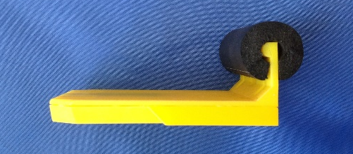
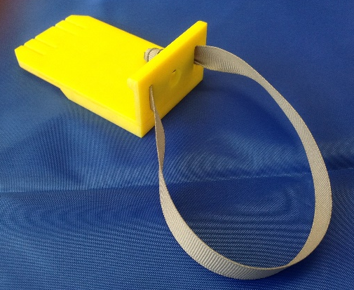
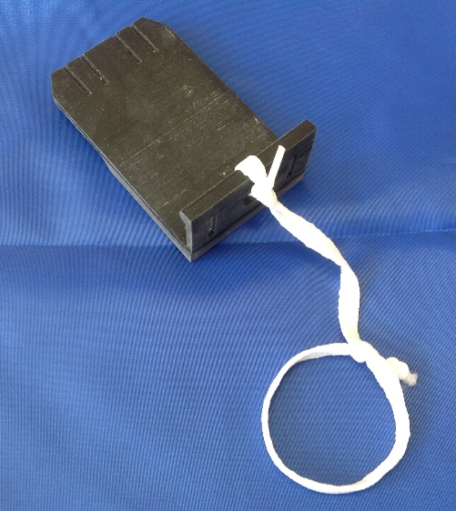
APH used the field test data as part of decision-making in product completion. Evaluators received an assortment of items to increase the accommodation ability of the cartridge. The items included a foam tube, a piece of grosgrain ribbon, and an adjustable-loop cord. Evaluators preferred the foam tube to the other two options. They placed the tube over the vertical ledge to make the gripping area softer and wider. They tied the ribbon through two slits in the vertical ledge to provide a soft and flexible pull handle. The cord was the least favorite. Evaluators tied one end of the cord through the central hole in the vertical ledge and the other end with the adjustable loop around the wrist. When asked if they would pay extra to have any of the accommodations included with the cartridge, only half (n=7) responded. Of those who answered, two (29%) said yes, one (14%) was neutral to the idea, and four (57%) said no. Based on the lack of responses and the answers of those who did respond, APH decided not to include items for accommodation.

The development of the Joy Player Cartridge followed APH Research Guidelines.
- Input from the field—The product interest survey provided APH with a valuable baseline demonstrating interest and need for the product. The prototype evaluation validated the need and provided guidance on potential accommodations for inclusion with the Joy Player.
- Safety Report/Technical Review—not applicable to this product
- Representative product prototype—APH manufactured 3-D prototype cartridges that are representative of the final product.
- Outside evaluators—APH selected field test sites by location, educational setting, student/client size, and evaluator qualifications.
- Evaluation tool and collection—The project leader and research assistant created the field test packets and sent them to the field test sites. Data collection was through SurveyMonkey®.
- Sufficient time—Field testing began in early December to coincide with the holidays. APH pre-downloaded the prototype cartridges with holiday music. Evaluators returned the evaluation form in January.
- Reporting—Throughout the development of the product, the project leader reported updates at the monthly New Products Meeting and in the Annual APH Research Report. The product development team met as needed.
- Modifications—APH determined modifications based on teacher and student evaluations, market availability, and cost.
- Quota Approval—Quota approval is not required because this is a modernization of an existing replacement part for the Joy Player.
- Specifications—TBD
- Marketing—TBD
- APH Communications—TBD

The research method used collected sufficient information. APH gathered data on 14 students completing eight trials (detailed in Outcomes paragraph) using the prototype cartridge and then again with three accommodations. In addition, APH gathered qualitative comments from the teachers about the easy push/pull Joy Player Cartridge.

APH gathered data from a geographically diverse U.S. population. Evaluators used prototype cartridges in nine states: California, Illinois, Kentucky, Michigan, Missouri, North Dakota, Ohio, South Carolina, and Texas.

The evaluators who provided data are qualified individuals. They are nine teachers of students with visual impairments—three of whom hold dual certification in orientation and mobility. The 10th evaluator is a direct support professional who works with adults with intellectual disabilities.

APH gathered data from an adequate number of sources. Evaluators submitted data on 14 students using the prototype cartridge. The students’ chronological ages ranged from 4 years to 53 years (4 adults and 10 youth). Students’ cognitive ages ranged from 1 year to 5 years with two listed as unknown/uncertain. The students’ visual diagnoses included nine with cerebral/cortical visual impairment (CVI), one of whom has a dual diagnosis of CVI and retinopathy of prematurity (ROP), one student each having one of the following: Wolf-Hirschhorn Syndrome, Retinal Scarring, Optic nerve atrophy, and ROP with cataracts. The 14th student’s visual diagnosis was unknown to the evaluator.

All students have multiple disabilities. In addition to visual impairment, nine have cerebral palsy, five have intellectual disability, four listed as having multiple disabilities, four have speech language impairment, two have orthopedic impairment, and one each with agenesis of the corpus callosum, autism, brain scarring, deafblindness, encephalopathy, hydrocephalus, Mowat-Wilson syndrome, other health impairments, physical impairment, seizures, and sensorineural hearing loss.

APH gathered data on student/consumer outcomes. APH asked teachers what the major hindrance is for their students when they insert the NLS cartridge. The most common hindrance (for seven students) is the inability to use or maintain fine motor skills (i.e., grasping, dexterity). Lack of strength (to push/insert) is the second most common hindrance, affecting five students. Two students have trouble locating the chute in which to place the cartridge; and two students do not cognitively understand the positioning, alignment, and sliding of the cartridge on the chute. Several teachers listed multiple hindrances for one student.

Teachers reported the ability of their students to remove the green NLS cartridge. Half of teachers (n=7) indicated that the student could not remove the cartridge and the staff must do it for the student. Two teachers (14.29%) said that the student removes the cartridge with major assistance from staff, one teacher (7.14%) said the student removes the cartridge with medium staff assistance, two teachers (14.29%) said the student removes cartridge with minor staff assistance, and two teachers (14.29%) reported that the student removes cartridge independently without staff assistance.

To measure outcomes, APH asked teachers to have their student(s) use the new Joy Player Cartridge in eight trials and then to repeat the process using the aforementioned items for accommodation. Data are reported on 13 of 14 students who participated in the trials; student #14 successfully completed all tasks independently (without staff assistance) for trials 1-4. The teacher chose not to have this student participate in trials 5-8; therefore, for this student, data are not reported as a part of the group in the following narrative.

First, students attempted to load/insert the prototype cartridge into the Joy Player. On the first trial of 8 trials (n=13), 69.23% of students were unable to insert cartridge (staff must do it), 23.08% of students inserted cartridge with major staff assistance, 0% of students inserted cartridge with medium staff assistance, 7.69% of students inserted cartridge with minor assistance, and 0% of students inserted cartridge independently (without staff assistance). On the final trial of 8 trials (n=13), 53.85% of students were unable to insert cartridge (staff must do it), 23.08% of students inserted cartridge with major staff assistance, 7.69% of students inserted cartridge with medium staff assistance, 7.69% of students inserted cartridge with minor assistance, and 7.69% of students inserted cartridge independently (without staff assistance). This shows fewer students needed staff to load the cartridge for them and thus more students improved their skills inserting the cartridge. For a visual of the narrative described above, see bar graph Figure 1: JP Cartridge-Insert.

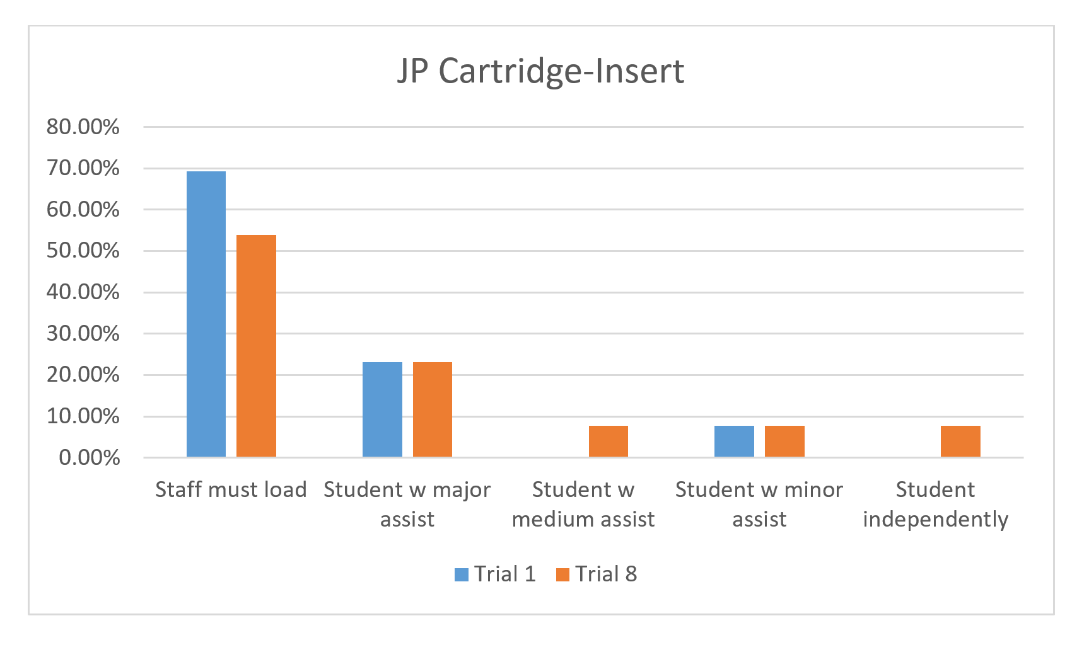
Figure 1. JP Cartridge-Insert

Next, students attempted to load/insert the prototype cartridge with the foam tube into the Joy Player. On the first trial of 8 trials (n=13), 46.15% of students were unable to insert cartridge (staff must do it), 23.08% of students inserted cartridge with major staff assistance, 7.69% of students inserted cartridge with medium staff assistance, 15.38% of students inserted cartridge with minor assistance, and 7.69% of students inserted cartridge independently (without staff assistance). On the final trial of 8 trials (n=13), 38.46% of students were unable to insert cartridge (staff must do it), 30.77% of students inserted cartridge with major staff assistance, 7.69% of students inserted cartridge with medium staff assistance, 15.38% of students inserted cartridge with minor assistance, and 7.69% of students inserted cartridge independently (without staff assistance). This shows that one student (7.69%) improved her skill inserting the cartridge with foam tube with less reliance on staff. For a visual of the narrative described above, see bar graph Figure 2: JP Cartridge-Insert With Foam Tube.

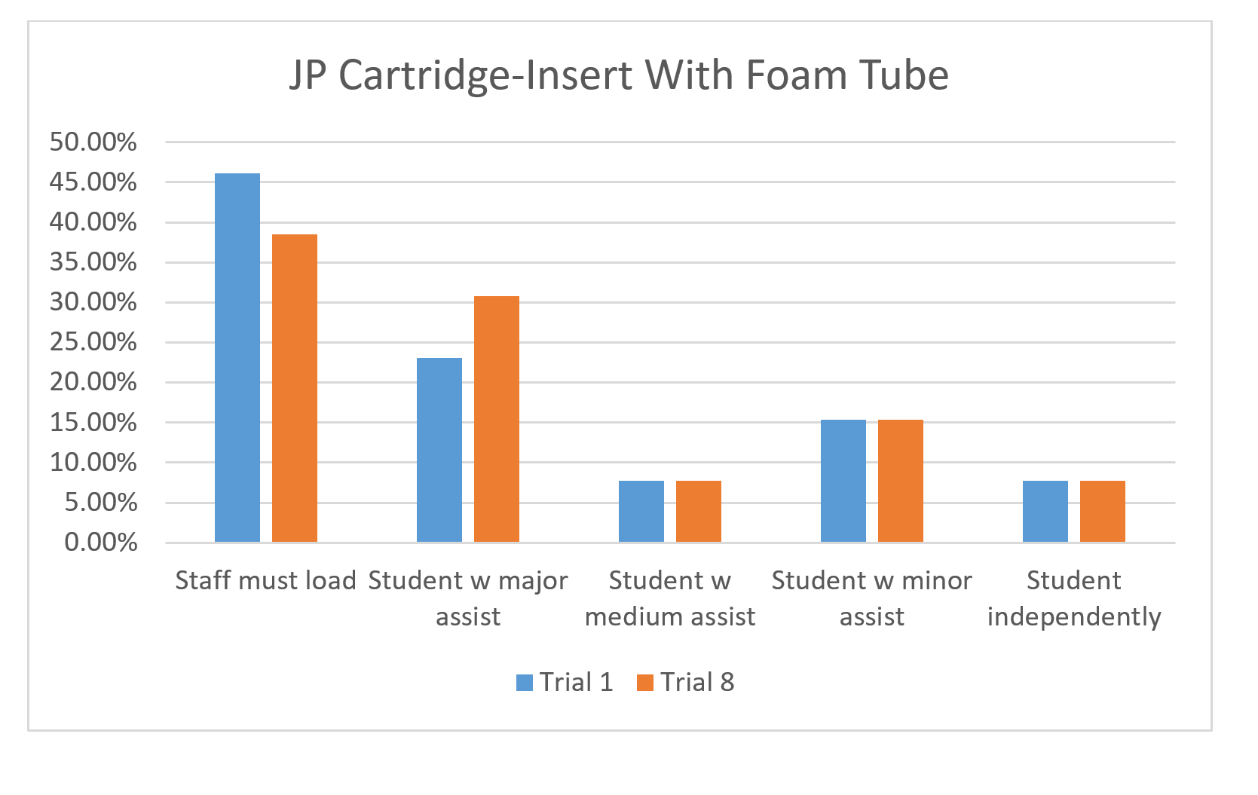
Figure 2: JP Cartridge-Insert With Foam Tube

In the next task, students attempted to remove the prototype cartridge from the Joy Player. On the first trial of 8 trials (n=13), 61.54% of students were unable to remove the cartridge (staff must do it), 23.08% of students removed cartridge with major staff assistance, 7.69% of students removed cartridge with medium staff assistance, 0% of students removed cartridge with minor assistance, and 7.69% of students removed cartridge independently (without staff assistance). On the final trial of 8 trials (n=13), 46.15% of students were unable to remove the cartridge (staff must do it), 30.77% of students removed cartridge with major staff assistance, 7.69% of students removed cartridge with medium staff assistance, 0% of students removed cartridge with minor assistance, and 15.38% of students removed cartridge independently (without staff assistance). This shows that two students (15.38%) improved their skills removing the cartridge with less reliance on staff. For a visual of the narrative described above, see bar graph Figure 3: JP Cartridge-Remove.
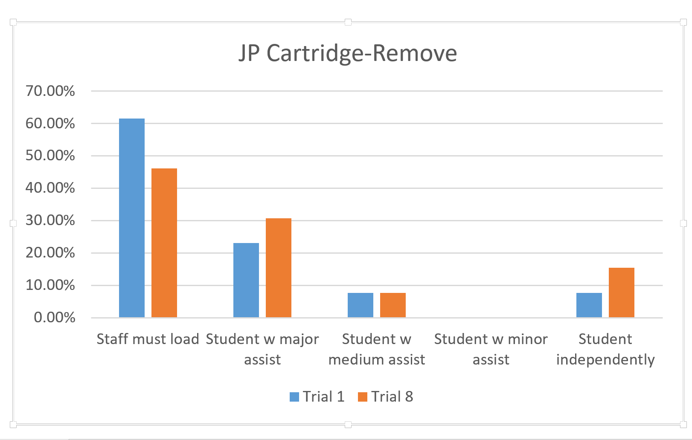
Figure 3: JP Cartridge-Remove

On the next task, students attempted to remove the prototype cartridge with foam tube from the Joy Player. On the first trial of 8 trials (n=13), 38.46% of students were unable to remove the cartridge (staff must do it), 30.77% of students removed cartridge with major staff assistance, 15.38% of students removed cartridge with medium staff assistance, 0% of students removed cartridge with minor assistance, and 23.08% of students removed cartridge independently (without staff assistance). On the final trial of 8 trials (n=13), 23.08% of students were unable to remove the cartridge (staff must do it), 30.77% of students removed cartridge with major staff assistance, 15.38% of students removed cartridge with medium staff assistance, 7.69% of students removed cartridge with minor assistance, and 23.08% of students removed cartridge independently (without staff assistance). This shows that two students (15.38%) improved their skills removing the cartridge with foam tube with less reliance on staff. For a visual of the narrative described above, see bar graph Figure 4: JP Cartridge-Remove With Foam Tube.
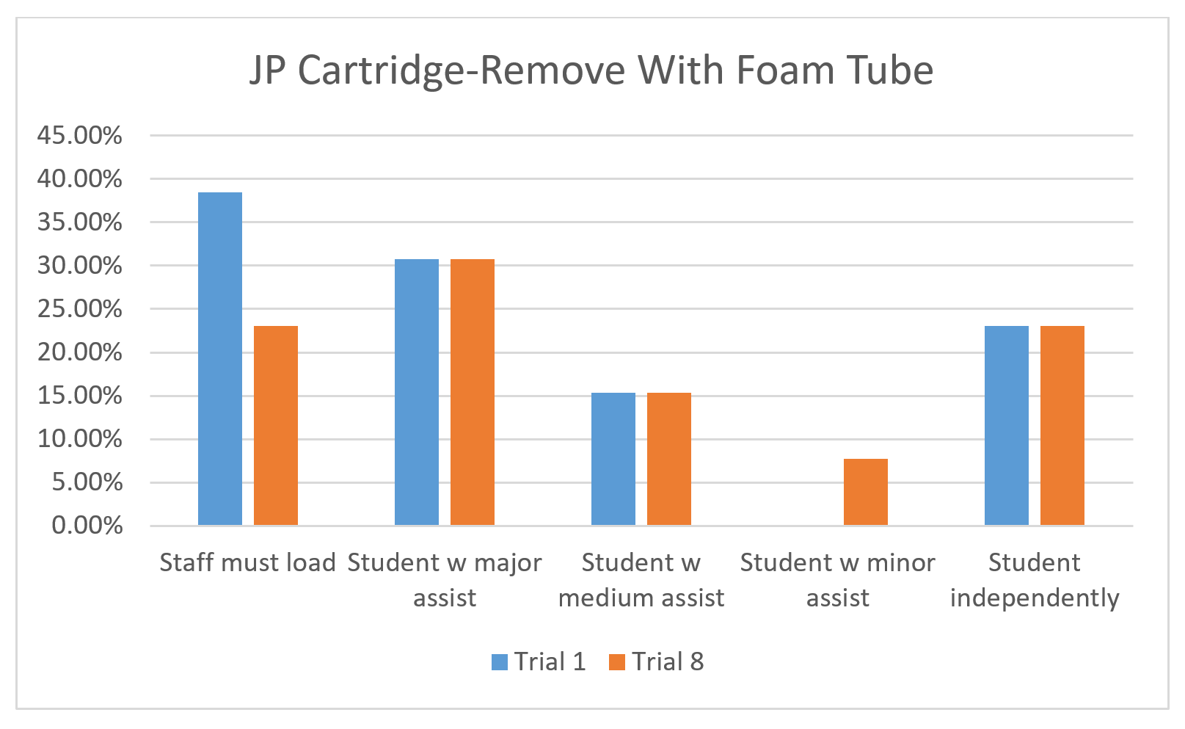
Figure 4: JP Cartridge-Remove With Foam Tube

On the next task, students attempted to remove the prototype cartridge from the Joy Player by pulling on a band of ribbon attached to the vertical ledge. On the first trial of 8 trials (n=13), 23.08% of students were unable to remove the cartridge (staff must do it), 30.77% of students removed cartridge with major staff assistance, 23.08% of students removed cartridge with medium staff assistance, 0% of students removed cartridge with minor assistance, and 23.08% of students removed cartridge independently (without staff assistance). On the final trial of 8 trials (n=13), 15.38% of students were unable to remove the cartridge (staff must do it), 30.77% of students removed cartridge with major staff assistance, 15.38% of students removed cartridge with medium staff assistance, 23.08% of students removed cartridge with minor assistance, and 15.38% of students removed cartridge independently (without staff assistance). This data show an improvement by two students (15.38%) to remove the cartridge with ribbon with less reliance on staff as well as skill regression by one student (7.69%) who had performed the skill independently in trial 1. For a visual of the narrative described above, see bar graph Figure 5: JP Cartridge-Remove With Ribbon.
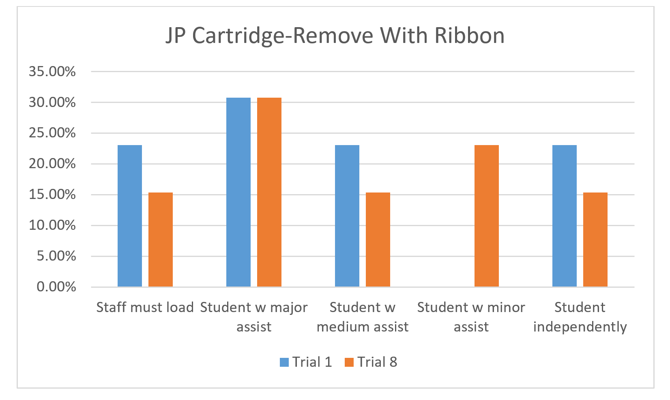
Figure 5: JP Cartridge-Remove With Ribbon

On the following task, students attempted to remove the prototype cartridge with cord around wrist from the Joy Player. On the first trial of 8 trials (n=13), 61.54% of students were unable to remove the cartridge (staff must do it), 7.69% of students removed cartridge with major staff assistance, 15.38% of students removed cartridge with medium staff assistance, 7.69% of students removed cartridge with minor assistance, and 7.69% of students removed cartridge independently (without staff assistance). On the final trial of 8 trials (n=13), 38.46% of students were unable to remove the cartridge (staff must do it), 30.77% of students removed cartridge with major staff assistance, 15.38% of students removed cartridge with medium staff assistance, 7.69% of students removed cartridge with minor assistance, and 7.69% of students removed cartridge independently (without staff assistance). This shows that three students (23.08%) improved their skills removing the cartridge with cord around wrist with less reliance on staff. Overall, students were less successful using the adjustable wrist cord than the other options. For a visual of the narrative described above, see bar graph Figure 6: JP Cartridge-Remove With Cord Around Wrist.
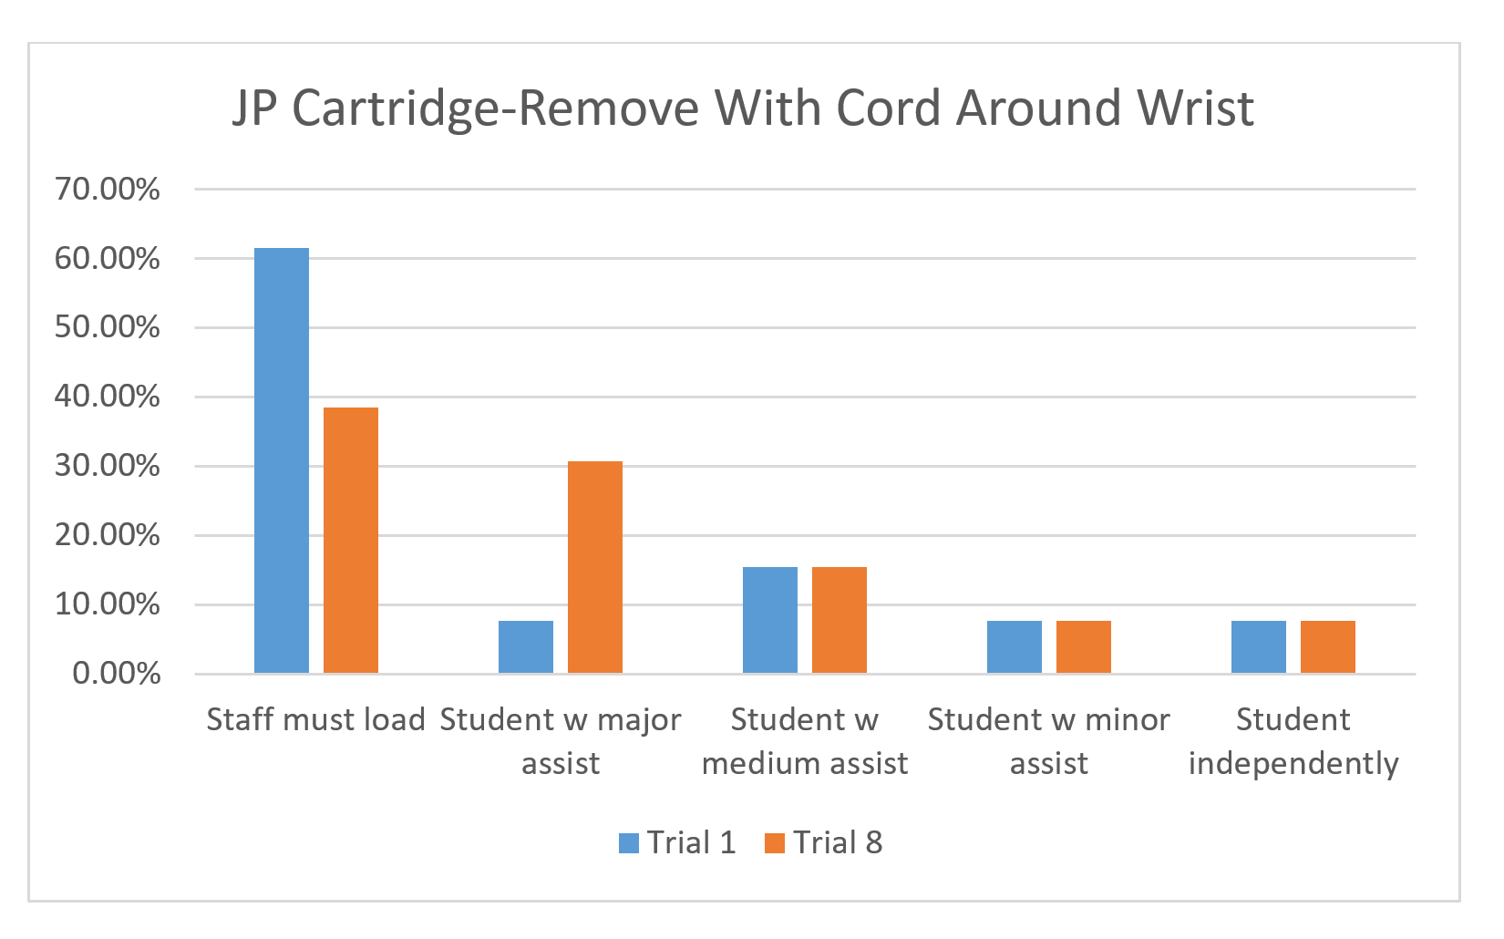
Figure 6: JP Cartridge-Remove With Cord Around Wrist

Teachers shared the following general comments about the Joy Player Cartridge:
- Like this much better. Less frustration and it can be used with six students who have other impairments.
- This is much easier to use for our MIVI kids. It is nice to have a variety of aids to try.
- The easy push/pull cartridge is better than the regular cartridge.
- The adaptations are great, however not useful for this particular student
- I am very hopeful that the Easy Push/Pull Cartridge will be produced for use with the Joy player because it will allow my students to achieve increased independence with using the Joy player (which they absolutely LOVE!).
- Even without the foam, the Easy Push/Pull cartridge design was much more accessible for my student and enabled him to position independently the cartridge in the player (something he is unable to do with the current design). The design of the raised handle enables the student to use visual and/or tactile skills to position it correctly in the player. The design of the Easy Push/Pull cartridge is far superior to the current design.
- It provided this student with a sense of independence and he loved the Christmas music.
- The L-shape was good, but I am not sure the foam tubing or ribbon made enough of a difference to utilize them.
- I liked the L-shape design. Again, I felt the foam tube was the most successful of the three options, but it fell off. I am wondering if there is any way to secure it to the cartridge.
- This individual did not need any of the adaptations that came with the prototype, but I appreciate the cartridge is designed in a way to allow for additional "add-ons" if needed.
- The ledge is a significant improvement. My student quickly caught onto pulling the ledge to remove the cartridge. He still struggles with the pushing motion. He may be more motivated to push the cartridge if there were some sort of sound / click or something that would "reward" his efforts.
- I like the change. I think with repeated instruction that the student I tried it with would be able to remove it independently.
In the event that the National Library Service switches to a download format and reduces production of or no longer manufactures digital cartridges, eight of the nine evaluators (89%) said APH should manufacture the Joy Player cartridge using this new design.
Work planned for FY 2019
APH will select the USB device to use inside the cartridge, adjust the CAD drawing to accommodate it, and send out bid packages for manufacturing.

CAREER EDUCATION AND TRANSITION

Transition Program Components
(Discontinued)

Purpose
To develop a transition product highlighting successful young adults. The young adults will identify the skills, services, products, and overall approach they took in middle and high school when learning the transition skills that helped them become the successful adults they are today.

Project Staff
Martin Monson, Project Leader
Amy Parker, Project Leader
Laura Zierer, Project Leader
Susan Dalton, Consultant

Background
This product is a combination of two product ideas submitted by Susan Dalton. The first product idea submitted included an overview of an effective transition program (what such a program might look like), lists of possible activities/instructional programming that could be included in such a program, and program content and detailed descriptions of how such activities/instructional programs could be conducted. The second product idea submitted was to develop a video in which former transition students talk about what they did in transition programming, what was helpful to them, and how they have experienced the benefits of the transition programming in young adulthood. The video would be used to educate current transition students about the value that transition programming will have for them in later life. Having this information come from their peers will motivate the students to participate fully in transition activities. The combination of the two product ideas into one was reviewed and approved by both the Product Evaluation Team in November and the Product Advisory and Review Committee in December.

Product Description
This product will be 100% available online. It will be a series of modules and supporting accessible documents to support the learning of the module content. The modules will be divided into broad areas that support the larger topic of transition.

In FY 2017, possible module ideas were developed by Dalton, and group discussions concerning them took place over several phone calls between January and June of 2017. Discussions focused on the content in the modules and how best to deliver the content. An online delivery method was decided upon. The idea of modules was decided upon as items within a module could be updated easily, and new module areas could be added. Five module content areas were identified to start the product development. Those modules and some supporting content ideas are as follows.

Module #1
“I Think I Can”
4Self-Determination
1: ADA 101: To Tell or Not to Tell
2: Resume, Cover Letter & Application Workshop
3: Self-Advocacy
4: Conflict Resolution
5: Practice, Application and Wrap-up

Knowing your rights and being familiar with ways to comfortably discuss your disability and the accommodations you might need at work and at school are essential to being successful; unfortunately, these skills are almost never taught in school and are rarely realistically discussed. These five modules will provide students with information on the laws that protect persons with disabilities, disclosure issues, writing a resume, cover letter and application, being a self-advocate, how to resolve conflicting situations, and being prepared for the workplace.

Module #2
Getting Around the Community
- How good are my personal mobility skills? What can I do to improve them?
- What are transportation options in my community? How can I navigate the system?
- What are some other ways of getting around that I may have overlooked?
- Scheduling: Working on transportation schedules, my schedule, and allowing sufficient time to travel.
- Accessibility options for navigation and travel. Would a guide dog be helpful for my independence?

Module #3
Choosing a Career
- What are some things that I like to do? How can these translate into future employment? What are the skills I need to have to achieve these jobs?
- Have you checked out the current job market? Do you know the trends for the next 10 years? What are employers looking for, and what skills are employers finding missing in many applicants or new employees.
- How can I get my foot in the door to get a job? Who could be in my personal network?
- How can I best use the services of Vocational Rehabilitation to assist me in finding a job? What can they do for me? What will I need to do for them to show that I’m capable of tackling this particular job?
- Hearing from currently employed (or formerly employed) adults to learn of challenges faced, how the challenges are addressed, suggestions for new job seekers.

Module #4
The College Experience: Am I Prepared for the Challenge?
- Choosing the post-secondary program most fitting for you. Are you ready to jump into a four-year university program? Would you benefit from college-prep programs available in your area? Does your job goal really need a bachelor’s degree or specialized technical training?
- Who’s paying the bill? Find out about assistance programs available. VR services. How to find scholarships. Weighing the options: costs, benefits of program, eventual job.
- Working with Disability Services at college. What will they do for me – and more importantly, what do I need to do to obtain the services? What are my responsibilities?
- Time management: Issues faced by college students relating to the change in daily schedules and routines, allowing for travel to and from class, additional reading requirements, troubleshooting if assistive technology fails.
- Self-Advocacy: Knowing your rights and how to present yourself as a capable, knowledgeable individual when dealing with professors, other college staff, and students. Speaking up and feeling confident about your needs and how classroom or assignment challenges can be addressed.

Module #5
Being a Part of the Community
- Basic Social Skills – Nonverbal communication.
- Fashion, grooming, shopping.
- Conflict resolution – how to deal with hurtful/insensitive remarks, explaining your visual disability, clever comebacks.
- Playing the dating game, dance, music, entertainment.
- Becoming a giving member of the community. Ways to volunteer, participate in community groups, taking advantage of community activities.

Work during FY 2018
Zierer conducted three phone calls with Dalton in early FY 2018. Product structure was discussed, and an action plan was set forth. A template was designed to ensure modules were consistently presented in the product. No further content was submitted to Zierer, and the project was abandoned.

COMPENSATORY AND ACCESS SKILLS

Braille

Braille Buzz
(Completed)

Purpose
To provide young braille readers and writers with an engaging device for learning early braille literacy, and phonics skills, with auditory and tactile support

Project Staff
Dawn Wilkinson, Early Childhood Project Leader
Susan Spicknall, Retired Project Leader
Kelly Kennedy Mimms, Research Assistant
Jeremiah Rose, Research Assistant
Anthony D. Jones, Director of Creative Services
Leslie Knox, Director of Marketing
Ricky Irving, Videographer
Laura Greenwell, Graphic Design
Michael McDonald, Programmer
Daniel Smith, Programmer
Andrew Dakin, Model Maker
Frank Hayden, Director of Technical & Manufacturing Research
Larry Skutchan, Director of Technology Product Research

Background
BrailleBuzz was adopted as a new product for development in August 2010. It was developed by engineering students, through the collaboration of Diane Brauner, a certified orientation and mobility specialist; Dr. Gary Bishop, a professor in the Department of Computer Science at the University of North Carolina (UNC); and Dr. Richard Goldberg, a professor in the biomedical engineering department at UNC. Dr. Bishop teaches a course called Enabling Technology, in which students are required to create accessible games for individuals with disabilities. Each Spring Dr. Bishop hosts Maze Day, and students with visual impairments, their parents, and their teachers come to UNC-Chapel Hill to try out the games created by Dr. Bishop’s and Dr. Goldberg’s students. BrailleBuzz is one of many prototypes developed through this collaborative effort.

The original device, submitted by Diane Brauner in December 2009, consisted of a plastic overlay that transformed a standard computer keyboard into a six-key entry device that emulated a Perkins Braillewriter. Each of the six keys that corresponded to a dot in the braille cell vibrated; the intensity of the vibration could be adjusted. The adapted keyboard was connected to any given computer through a USB port, thereby making it plug ‘n play. The accompanying software consisted of a series of activities to teach the student to form and to recognize specific braille symbols and to associate letters with their phonetic sounds.

The original prototype of the BrailleBuzz required special software drivers to operate a modified computer keyboard. There were a number of problems with the software that delayed the project. In addition, changes in APH staff inhibited progress. However, providing a device to support early literacy concept and skill development was a high priority of the Research Department. In August 2013, the BrailleBuzz project was assigned to Braille Literacy Project Leader, Susan Spicknall. A number of brainstorming/planning meetings were held to determine the scope and functionality of the machine. The decision was made to target the learning needs of young children with a low-cost, standalone device. A description of the emerging unit is as follows. BrailleBuzz will be a toy-computer for young children. The case size will be that of a standard notetaker with textured stripes planned to resemble a cartoon bumblebee—thus retaining the name. BrailleBuzz will have a Perkins-style keyboard, and two rows of alphabet buttons. When a braille letter is pressed, the letter will be spoken. Likewise, when the correct combination of keys are pressed, the letter name will be heard. Additional functions will make the device fun and enticing to use. Tamper-proof features will protect both the child and machine.

Specific pre-braille writing skills addressed by BrailleBuzz include isolated and coordinated finger movements, tactual discrimination of different braille shapes, and coordinated use of both hands. BrailleBuzz will not require the degree of strength and dexterity needed for successful operation of a mechanical brailler. BrailleBuzz will introduce and reinforce phonemic awareness by isolating a beginning sound and then pairing a sound with its corresponding letter.

In 2015, a working prototype was developed and made available for in-house testing. Necessary modifications to hardware and firmware were made. Models of the case (resembling a cartoon bumblebee) were fashioned on a 3-D printer. BrailleBuzz was presented by Susan Spicknall at the 2015 APH Annual Meeting as an input session. Suggestions were made with regard to functionality and appearance, and persons interested in field testing filled out a contact sheet.

A field test of the BrailleBuzz prototype was conducted from December 2015 to March 2016. Diane Brauner also conducted an expert review as part of the field testing process. Prototype devices and surveys were sent to 11 participants in eight states, some of whom shared the device, so responses were obtained from a total of 14 teachers. Participants from Kentucky, Iowa, Alabama, West Virginia, Arkansas, Washington, Michigan, and Massachusetts were included.

Setting
Out of 14 responses, 11 (78.6%) identified the setting as preschool. The other 3 (21.4%) of responses identified it as home, kindergarten, or public school (class level unspecified).

Age
Specific ages were provided for 15 children ranging from age 3 to 6. The average age of children was 4.3.

As field tests were returned, results were compiled by the research assistant in April of 2016. The BrailleBuzz Project was then assigned to Dawn Wilkinson, Early Childhood Project Leader.

A meeting was held on May 16, 2016, to discuss field test results and plan for changes accordingly. An account was created from which to purchase realistic sounds and the APH recording studio was given a script from which they made voice recordings. BrailleBuzz was granted Quota Approval, and a new projected for sale date of early FY 2018 was set.

In 2017, the manufacturing specialist and programmers continued to work on modifications to the product. Revisions were made to address the following requests from field evaluators.

Several comments from field evaluators noted that the child liked the rough/smooth combination texture of the device, while others requested color to make the device more appealing to students with vision. Given varying options of stripes with smooth/rough texture and black/yellow surface and key combinations, the prototype was redesigned to have a black top with textured stripes and yellow keys and buttons, with the bottom surface being yellow.

Volume control
Five of the 14 evaluators wanted adjustable volume. This was implemented using a simple key command and BrailleBuzz now has high, medium, and low volume.

On/Off Switch
Six field testers wanted an on/off switch, but this change could not be implemented because of the motherboard. To accommodate this request, the time-out length was increased to approximately two and a half minutes, and the spacebar is no longer used to turn the unit on.

Functionality
Ten of the 14 participants discussed, at some point during the survey, the need for additional functions. Numerous comments from field testers suggested the inclusion of dot numbers and that the spacebar announce its function. BrailleBuzz subsequently now has three activity modes:
- Keyboard mode: In this mode, BrailleBuzz announces single dot numbers and the spacebar, along with announcing the braille letter buttons.
- Letters mode: In this mode, BrailleBuzz only speaks a keyboard combination that is an actual letter. When the braille letter buttons are pressed, dot numbers are given after the letter is spoken. This feature helps children to make the association between reading the braille letter and writing the letter using the corresponding dot numbers.
- Phonics mode: Each letter written or pressed using the braille buttons speaks an associated phonics sound paired with a fun word and sound (e.g., D makes the sound “d” as in dog, and a barking sound plays). This fun feature ensures that BrailleBuzz is comparable with commercially available toys that teach phonics, but only have print letters.

BrailleBuzz, in its newly revised state, was exhibited by APH and presented by Dawn Wilkinson at the 2017 CSUN International Assistive Technology Conference where it was well received. The revised BrailleBuzz also delighted preschoolers and their families during a VIPS Day hosted by APH.

Technical Research began working on a request for proposal to be sent out to potential vendors. The BrailleBuzz Quick Start guide was written by the project leader and photos and enhancements were added by Graphic Design. A vendor was selected in August 2017 from the request for proposals for the injection molding of BrailleBuzz.

Work during FY 2018
Diane Brauner and the project leader, Dawn Wilkinson, presented on the BrailleBuzz at the Getting in Touch with Literacy conference in New Orleans. Project staff worked to complete the following tasks:
- Finalized the content of the Quick Start Guide
- A specifications meeting was held on April 11, 2018.
- Technical & Manufacturing Research worked with the vendor and approved the final injection mold and software of the unit for production.
- Sales and marketing created a video and a special thanks is extended to VIPS for their participation.
- Print and braille hardcopies were produced so that they would be ready when the BrailleBuzz units arrived.
- Expected sale date is September 2018.
Work planned for FY 2019
No further work is needed on this project; however, accompanying applications for voice assistant devices may be developed around the BrailleBuzz concept in the future.

Braille Contraction Cards [Modernization]
(Completed)

Purpose
To modernize an existing product to reflect the change in the braille code from English Braille American Edition to Unified English Braille (UEB)

Project Staff
Martin Monson, Project Leader
Kate Herndon, Director of Educational Product Research
Frank Hayden, Director of Technical & Manufacturing Research
Andrew Moulton, Manager of Technical & Manufacturing Research
Anthony D. Jones, Art Production/Design Manager
Matthew Poppe, Tactile Graphics Designer
Jeremiah Rose, Research Assistant
Jonathan Carson, Braille Transcriptionist

Background
This set of flashcards is to be used for practicing and learning the contractions and braille symbols in the UEB code. Included in both large print and braille are alphabet and numbers, punctuation, composition (typeform, capital, etc.) signs, one-cell whole-word and part-word signs, two-cell contractions, short-form words, and other print symbols.

The first 26 cards contain the braille alphabet on one side and large print on the other side. Remaining cards contain contracted braille on one side and both uncontracted braille and large print on the other side. The cards measure 3 1/2 x 2 inches. Blank cards, indexing cards with tabs, and a storage box are included. All cards have an orientation corner cut and an orientation braille line.

Work during FY 2018
The Building On Patterns consultant group provided input on determining which additional cards should be included (e.g., +, -, @). Braille files and print files were produced, and plates were made.

The product was made available for sale in February 2018.

Work planned for FY 2019
No further work is planned for this project.

Braille Formats: Principles of Print-to-Braille Transcription
(Completed)

Purpose
To provide the current version of the Braille Authority of North America’s Braille Formats: Principles of Print-to-Braille Transcription, 2016, in large print and braille for people who are blind and visually impaired and are not able to access the electronic versions of the document or who prefer a physical copy

Project Staff
Cathy Senft-Graves, Project Leader
Frank Hayden, Director of Technical & Manufacturing Research
Andrew Moulton, Manager of Technical & Manufacturing Research
Adam Clark, Manufacturing Specialist
Anthony D. Jones, Director of Creative Services
Matthew Poppe, Graphic Designer
Sara Lee, Research Assistant

Background
In March 2017, the Braille Authority of North American (BANA) released an updated, “pre-production” version of the Braille Formats guidelines, titled Braille Formats: Principles of Print-to-Braille Transcription, 2016. Braille Formats provides a foundation for braille transcribers and teachers to transcribe content in an accurate and consistent manner for braille readers.

This edition aligns the guidelines with Unified English Braille (UEB). The last version of the guidelines, Braille Formats 2011, made extensive changes to the guidelines, but was not produced in hard copy due to the adoption of UEB. That version had major changes, including to braille page numbering, headings, nested lists, and footnotes. This version is an update to that document, which was an update to the 1997 guidelines, the last version produced in hard copy.

APH is the official printing house for BANA, and they requested that this updated codebook be made available in hard copy as was the 1997 version of the codebook. Braille Formats is used extensively by braille transcribers, proofreaders, and teachers of students with visually impairments.

Based on input from the field between March and July 2017, the BANA Publications Committee and BANA Braille Formats Technical Committee made corrections and edits to the pre-production version of the guidelines.

In April 2017, the project leader submitted a Modernization Form for the 2016 version of Braille Formats. In May, Frank Hayden obtained catalog numbers for the hard copy print and braille versions of this product. The project leader discussed preliminary specifications with Technical & Manufacturing Research personnel and the Publications Committee. It was determined that the Braille Formats hard copies would be produced with specifications similar to the Music Braille Code, 2015, but that the print pages would not be placed in a binder. BANA also requested that this new edition have a color background for the title page and binder inserts to distinguish it from previous editions.

After receiving input from the Publications Committee, the project leader worked with Adam Clark to develop the production specifications for the print and braille books. Large print and braille files of the final guidelines were received from the Publications Committee in August. The project leader worked with Matthew Poppe to finalize the title pages of the documents and binder inserts for printing on the IGEN®; these were approved by the Publications Committees. The content of the spine labels for the braille volumes were also discussed with the Publications Committee.

In addition to work previously reported in FY 2017, members of the Accessible Tests and Braille Transcription departments (Louise Knapp, Katherine Padgett, and Jason Wilson) assisted in a review of the print document. The project leader submitted her and their findings to the Publications Committee. BANA personnel reviewed these and made the appropriate changes to the print and braille document files.

Work during FY 2018
The BANA Publications Committee provided final print and braille content files. BANA published online versions of the documents in November. A background color was chosen for the binder inserts for the hard copy print document. All other tooling was finalized. The specifications meeting was held in December. Proof copies were approved in May. The documents were released for sale in April. This project is complete.

Braille Literacy Web Site
(Continued)

Purpose
To provide teacher resources on braille literacy, including APH product information and links to other resources

Project Staff
Cathy Senft-Graves, Project Leader
Paul Ferrera, Social Media Coordinator
John Hedges, Programmer
Ricky Irvine, Website and Video Designer
Anthony D. Jones, Director of Creative Services
Malcolm Turner, Database & Web Site Coordinator
Sara Lee, Research Assistant
InGrid Design, Graphic Design and Web Design

Background
In 2016, the project leader began working with InGrid Design on the format of a Building on Patterns (BOP) component for the Braille Literacy Web site. The BOP Web pages will initially contain information and resources related to the existing Kindergarten, First Grade, and Second Grade levels of BOP. InGrid Design was provided with content and images to include about the three levels. Drawing from this information, the designer developed initial designs, including graphical elements, for a BOP home page and pages for the second grade level.

In FY 2017, InGrid Design created complete scope and sequence charts for each existing level of BOP; these will be downloadable from the website. Braille versions of these charts were also created. Pages with links to the APH shopping site for each component of the three levels of BOP were created. Sara Lee and the project leader reviewed the BOP Web pages and worked with the designer to edit and correct content. Communications staff did a thorough review of the pages. This included viewing them with different browsers and on different machines (desktop, mobile), and reviewing them for accessibility to visitors from the point of view of screen magnification and contrast, for people who use a screen reader, and for structure. After changes were made to improve accessibility, the pages were reviewed again. Following some additional edits, InGrid Design turned over the website files to APH. Communications staff converted the site to WordPress® and reviewed it for accessibility again. Lee and the project leader also reviewed the site again. Additional edits were made, and the BOP Web site was made public.

Work during FY 2018
The existing site was reviewed in April, and the few issues found were addressed. BOP Prekindergarten (Pre-K) pages were developed and added when the curriculum was released. Details about the Pre-K Web site are included in the “Building on Patterns, Second Edition: Prekindergarten Level” report.

Work planned for FY 2019
The BOP site will be maintained and additional materials added as they are available. Additional braille literacy components for the website will be considered.

Building on Patterns, Second Edition: Kindergarten Level
(Continued)

Purpose
To revise and update Building on Patterns (BOP): Kindergarten Level by creating a BOP Second Edition Kindergarten Level curriculum

Project Staff
Cathy Senft-Graves, Project Leader
Jo Ellen Croft, Consultant/Head Writer
Luanne Blaylock, Consultant/Writer
Kate Dilworth, Consultant/Head Writer
Kristen Buhler, Consultant/Writer
Sue Schimmelpfennig, Consultant/Writer
Robin Wingell, Consultant/Head Writer
Izetta Read, Consultant/Writer
Mary Filicetti, Consultant/Writer
Rebecca Peek, Consultant/Writer
Cay Holbrook, Consultant/Advisor
Anna Swenson, Consultant/Advisor
Jeremiah Rose, Research Assistant
Sara Lee, Research Assistant
Emily Grimany, Research Assistant
Anthony D. Jones, Director of Creative Services
Matthew Poppe, Graphic Designer
Laura Greenwell, Graphic Designer
Joon Lee, Copyright and Cataloging Librarian

Background
The Building on Patterns Kindergarten (BOP-K) Level is in need of revision because it will soon be 6 years old. At the April 2012 meeting, the Educational Products Advisory Committee recommended that there be a schedule for regular revisions of BOP.

Relevance
Since BOP-K was written, the Common Core State Standards (CCSS) have been developed and adopted by 45 states, the District of Columbia, four territories, and the Department of Defense Education Activity. These standards include higher expectations in English Language Arts for young students. This edition of BOP will help students who are blind or visually impaired and will be braille readers to meet these new standards while learning braille.

Research
To inform the development of the BOP, Second Edition, APH gathered data on the first edition of Building on Patterns Kindergarten (BOP-K) through an online survey. Teachers of the visually impaired who have used BOP-K were asked to answer questions about how they used BOP-K, how the CCSS would affect their use of the curriculum, what changes and additions they would like to see in BOP-K, and what should be taught in a prekindergarten literacy program.

Data were gathered from qualified individuals. The majority of respondents are teachers of students who have visual impairments (97%). The remaining respondents include a reading specialist and a coordinator for visually impaired programs. Twenty-two respondents (29%) have taught students with visual impairments for more than 20 years, 22 (29%) for 11-20 years, 19 (25%) for 6-10 years, and 12 (16%) for less than 5 years. Of the 75 respondents, most used BOP-K with more than one child: 18 students were at the preschool level, 62 kindergarten, 35 first grade, and 24 at other levels. The other levels included students with additional disabilities and older students who needed to learn braille.

Data were collected from a geographically diverse population. Respondents are located in the United States Virgin Islands (1) and in 22 different states: Arkansas (1), California (2), Colorado (4), Connecticut (1), Illinois (11), Indiana (4), Kansas (6), Kentucky (4), Louisiana (5), Michigan (1), Missouri (5), Montana (2), New Jersey (1), New Mexico (1), New York (1), North Carolina (4), North Dakota (1), Ohio (3), Oklahoma (2), South Carolina (3), Texas (6), and Virginia (5).

The majority of the respondents to the survey used BOP-K as a supplement (38) rather than a complete literacy program (16), but some used it both ways (16). Some stated specifically that they used other materials to supplement BOP-K (2), and a few used it to just teach braille (3).

Seventy-seven percent of respondents indicated that their school district was implementing or planning to implement the CCSS. Most comments about how the CCSS would affect the teachers’ use of BOP-K indicated that they would still use the program and adapt the program to meet the standards required by their district.

Respondents’ comments stated that additional practice activities (21.4%), capitalization (10.7%), and punctuation (10.7%) should be added to the braille instruction in the program. Comments about what is not taught in BOP-K but should be taught before the end of a kindergarten program included sight words (27.5%), punctuation (17.5%), capitals (10%), and more vocabulary (7.5%).

When asked what is taught in BOP-K that should be taught in a prekindergarten emergent literacy program, 41% of the respondents who gave opinions said that phonemic awareness and phonics, the alphabet, or an introduction to the alphabet contractions should be taught at an earlier level. And 12.8% said that at least the first 12 lessons of BOP-K should be taught earlier. Other specific skills that received multiple mentions are these:
- Tracking, reading with both hands
- Rhyming
- Introduction of braille cell
- Capital sign
- Period
- Spatial awareness/directionality: left to right; top, bottom, middle
- Concepts/concept development
- Tactile identification as fun activities
- Listening comprehension
- Vocabulary

Additional comments from respondents included several requests for more practice materials, more tactile diagrams, and stories and poems with language and concepts more appropriate for students at the kindergarten level.

The survey results were compiled. APH staff, BOP writers, and BOP consultants reviewed the information. The group agreed that a majority of the recommendations would be applied in the writing of the prekindergarten and kindergarten levels.

Additional research is described in the remaining sections of this project report.

In June 2012, a conference on Building on Patterns and Braille Literacy was held at APH. Special invitations were sent to Frances Mary D'Andrea, Kelly Lusk, Anna Swenson, Marjorie Ward, and Diane Wormsley. Conferees also included APH staff and the team of BOP writers and consultants. Experts from the general education field made presentations on the Common Core State Standards and A Mainstream Publisher’s View of the Future of Literacy Education. A list of needed braille literacy projects was compiled and discussed, and the group chose the revision of the BOP Kindergarten Level as the number one priority. The BOP Second Grade writers all agreed to work on the revision, and Anna Swenson and Marjorie Ward agreed to join the group as consultants. Because research indicates that children begin the process of emergent literacy very early in life, it was decided that this product should provide instructional support for teachers of students with visual impairments, parents, and preschool teachers to guide braille-reading children ages birth through kindergarten through developmental activities that will strengthen their preparation for a program designed for the first grade level. The group immediately began to discuss and plan the content and format of the revision. Some of the conferees also began checking which Common Core State Standards are addressed and which are not addressed in the current BOP-K Level. A Trello™ account (an online management tool used for project collaboration) was set up for the group to share information.

Following this conference, periodic conference calls were held to further discuss the content and format of the new project. The group also began to gather current general education materials to reference.

The BOP Second Edition project was approved by the Product Advisory and Review Committee in August 2012.

The writing group met October 10-11, 2012, at APH. Regular conference calls were started after the October meeting to work on more details of the project. APH conducted a survey of teachers who have used the current BOP-K curriculum with questions developed by the group. The responses were reviewed and compiled to use as a reference for the writers.

Kay Ferrell agreed to join the BOP group in 2013 and began participating in the conference calls. During those conference calls, the group decided to have two separate curricula for the prekindergarten and kindergarten levels of BOP, Second Edition. General education “readiness” lists, assessments, and curricula for prekindergarten and kindergarten were explored. Suzette Wright shared multiple resources on emergent and early literacy with the group, including information from the 2013 International Preschool Symposium. Cay Holbrook shared information from the 2013 International Reading Association conference. A catalog of developmental skills that are typical precursors for formal braille literacy instruction was created. This catalog of skills was based on numerous existing emergent literacy lists that outline skills desired for children who are candidates to become braille readers. Prekindergarten and kindergarten scope and sequence charts were developed, and the Maryland Common Core State Curriculum Frameworks for Braille were matched up with the kindergarten scope and sequence to help the writers address the CCSS in their work.

The BOP group met at APH the last week in June 2013 for intensive work on the project. Presentations on the National Early Literacy Panel findings and APH early childhood products were given to the group, as well as a workshop on Unified English Braille (UEB). Because the Braille Authority of North America adopted UEB in November 2012, BOP Second Edition will be written to teach UEB

In FY 2014, the BOP group worked on BOP Prekindergarten. In FY 2015, the BOP Writing Group Meeting was held June 25-29, 2015. They discussed what will be needed to start writing for the kindergarten level once the writing groups have all their prekindergarten lessons turned in for editing: updated standards for children to start first grade, look at general education kindergarten curricula, revisit the kindergarten themes discussed in 2012, and organize the work that has already been done for the kindergarten revision. The group agreed that at least the Writing portion of the lessons should be done as a thread to keep them consistent. The Kindergarten level will not use trade books. The group planned to talk more about Kindergarten on conference calls and have a meeting following the Getting in Touch with Literacy conference in November 2015. Work began to compile the existing Kindergarten revision files.

In FY 2016, a folder containing the previous work on revising the existing Kindergarten curriculum was shared with the group. In a meeting following the Getting in Touch with Literacy Conference in November, the head writers and several BOP consultants met in person to discuss the development of the revised curriculum. The revision will take into account the national increased expectations for kindergarteners as was seen in the 2011-12 survey of the first edition of BOP-K and the CCSS. It was agreed that some version of the popular Color Me book, which is part of the current BOP-K kit, would be included in the revision. The group also decided to include some authentic literature (trade) books in this curriculum; this is a change to the previous plan. The number of units and approximate number of lessons was agreed upon; there were discussions about the pace of letter introduction, how to choose the high-frequency words to introduce, and initial lesson-writing assignments; and work assignments were made.

Based on research of several current general education curricula and in group members’ local school districts, the group decided to introduce all the letters of the alphabet by mid-year of the curriculum. Two of the head writers, Jo Ellen Croft and Robin Wingell, developed a systematic plan for letter, high-frequency words, and phonics introduction based on multiple resources and considerations, including the following:
- Ease of tactual distinction
- Letter name and sound similarity
- Frequency of use, based on several high-frequency/sight word lists: Fry, Zeno, Dolch kindergarten, writers’ local and other general education curricula lists
- Dolch Nouns list (to facilitate the inclusion of meaningful text)
- Usefulness in creating connected text
- Word lists from general education assessments: Fountas & Pinnell Benchmark Assessment System and Developmental Reading Assessment®, Second Edition
- Comparison of six current general education kindergarten curricula scope and sequence charts

This plan continued to evolve over the course of several group conference calls. There were several discussions about the introduction of long and short vowels; information was shared on this topic from Maryland’s College and Career Ready Standards for Unified English Braille (called the Maryland Common Core State Curriculum Frameworks for Braille prior to UEB adoption), general education scope and sequences, and several kindergarten teachers contacted by the writers. The introduction of capital letters was discussed and added.

Based on the general education curricula review, it was also decided to add 2 weeks of letter introduction/review at the beginning of the program. These lessons will also include introduction/review of the braillewriter, name writing, and other materials and activities that will be used throughout the rest of the lessons.

Other aspects of the scope and sequence for the program were constructed, including concept development, writing, phonemic awareness, and listening comprehension. For reference on concepts to focus on in the program, Ferrell provided the field test results for concepts tested by the Boehm-3 for children in Kindergarten through Second Grade who are blind or visually impaired. Luanne Blaylock reviewed the Boehm results, Common Core State Standards documents, APH Tactile Treasures, general education kindergarten concept lists, and the existing BOP-K curriculum to come up with a proposed list of concepts to include in the program. The group approved spatial, quantitative, number, shape, color, and other concepts. They also agreed that UEB math symbols should be introduced when appropriate, but that 3D shapes are part of a math curriculum and did not need to be taught explicitly in a literacy program.

A Virginia writing group was added to the BOP team in March. This team consists of two well-qualified teachers of students with visual impairments from the Fairfax County area whom Swenson recruited: Mary Filicetti and Rebecca Peek. Dibble left the team after the completion of the assessment materials for BOP Prekindergarten (Pre-K), and this team was recruited partly to be the lead writers for the new kindergarten assessment pieces. As they become more knowledgeable about the program, they will also work on lesson writing. The group provided immediate contributions to the scope and sequence discussions, including a list of important phonological and phonemic awareness concepts and suggested order of introduction.

Unit themes were agreed upon and assigned to the groups. A list of suggested books to go with the themes was compiled, including books initially suggested for kindergarten during the June 2013 meeting. Jeremiah Rose worked on getting the books from the local library and interlibrary loan in time for the group meeting at APH in June.

Swenson compiled a document with information about writing stages and instructional elements for kindergarten, including the commonly used sequence of spelling stages from Words Their Way: Word Study for Phonics, Vocabulary, and Spelling Instruction (6th ed.) by Bear, Invernizzi, Templeton, and Johnston.

The BOP Writing Group Meeting was held June 27–July 1. All together and in small groups, the team worked on and completed a detailed scope and sequence document for the kindergarten curriculum, paired with Maryland’s College and Career Ready Standards for Unified English Braille. Work also began on a template for the lessons. A significant addition to the instruction will be calendar activities; the writers noted that calendars are an important element of kindergarten and can be used for other number activities. Based on the BOP Pre-K and Second Grade assessment components, and their experience with general education assessments, Filicetti and Peek created an outline of an assessment plan that includes a pre-assessment, quarterly reviews, an end-of-year assessment, and ongoing progress monitoring. The group reviewed and discussed the books to pair with the units. It was agreed that there would be one book paired with each unit and that five of these would be books currently available and five would be commissioned by APH. This decision to have some books commissioned was made to reduce the possibility of one of the books going out of print.

Two researchers made presentations at the June meeting to inform the group about recent research regarding braille literacy. Dr. Robert Englebretson, Associate Professor at Rice University, presented on the topic, “Shifting Perspective on Braille: What We Can Learn from Cognitive Science.” The presentation was based on the paper, “Orthographic Units in the Absence of Visual Processing: Evidence From Sublexical Structure in Braille” by Dr. Simon Fischer-Baum and Dr. Englebretson. (2016) Main points of the presentation included the following:
- Illusions that show how perception is mediated by cognition
- The need for cross-disciplinary (inside and outside the blindness field) work/cooperation in braille literacy
- Reading braille is far more than perceiving dots on a page and decoding them (chunking effects, sublexical structure).
- Braille being a "code" vs. a "writing system"

The group spoke via online video networking with Dr. Mackenzie Savaiano, Assistant Professor of Practice at University of Nebraska-Lincoln, about the paper “Alignment of Braille and Print English for Learning and Instruction” by Savaiano and Dr. Devin M. Kearns, Assistant Professor at University of Connecticut, presented at the International Council on English Braille 6th General Assembly in May 2016. The paper described how the researchers studied a large sample of print to determine how frequently braille characters occur in English texts. The results suggested that braille contractions are a generally strong representation of printed English. However, it questioned the need to teach explicitly some of the contractions for low-occurrence words. There was discussion about teaching students that every word has a vowel and rules for short-form words.

After the June meeting, the group continued to work on the lesson template, finalized the authentic literature book choices, and began writing the lessons for the first unit. Resource Services worked to obtain permissions for the books choices for the project. Kate Herndon, Director of Educational Product Research, provided the project leader with contacts for potential writers for the five books to be commissioned. The project leader investigated and exchanged information with potential writers. Two writers were asked to work on the books.

Reference
Englebretson, R., & Fischer-Baum, S. (2016). Orthographic units in the absence of visual processing: Evidence from sublexical structure in braille. Cognition, 153, 161-174.

In FY 2017, the APH staff, BOP writers, and BOP consultants continued to work on the lessons and update the lesson template for the new kindergarten lessons. The format of the kindergarten lessons builds on the format of the BOP Pre-K lessons. In addition to the content noted in the FY 2016 report, a student storybook that introduces new words and provides more reading of continuous text replaces the pre-k tactile storybook in each lesson. The writers completed lessons in the first five units of the program. Swenson and the project leader reviewed the lessons; Kelly Kennedy Mimms assisted with general formatting and checking the lessons against the template. Questions arising from these reviews were addressed.

One writer outside the BOP group was contracted to write the text for the five commissioned books. The BOP group specified a range for the Lexile® level of the books and for the number of words appropriate for kindergarten students. They also decided that most of these books would be nonfiction in order to include a good balance of fiction and nonfiction texts in the curriculum. The text for three books was completed and approved by the BOP writers. Matthew Poppe worked on the illustrations and layout for two of the books.

The BOP group continued to have regular Friday conference calls, including one with guest consultant, Kim Zebehazy, who specializes in research on students’ use of tactile graphics. She provided results of her research into the strategies of students who are more successful acquiring information from tactile graphics and examples of many different types of activities to help children learn to interpret tactile graphics.

The group held a “Winter Work Session” that consisted of daily conference calls and Google Hangouts™ calls December 27–30. Dr. Frances Mary D’Andrea participated in one of the calls to discuss assessments. As a result of this discussion, the writing group decided to add more tools to help teachers determine if a student is ready to move on at the end of each lesson and unit. Other topics of discussion included the following: use of the APH Word PlayHouse in the lessons, the introduction of color words, the format of a coloring book for the revised BOP-K kit, content for the BOP-K Reference Volume, lesson-specific questions, and multiple changes to the lesson template. Apart from the group discussions, the writing groups also worked on their writing assignments.

Filicetti and Peek worked on the format and content of the assessment materials based on group discussions about resources, including the Developmental Reading Assessment® and Fountas & Pinnell Benchmark Assessment System, and what should be assessed when. The group discussed and agreed upon independent, instructional, borderline, and frustration reading levels appropriate for students in BOP-K that will be used to evaluate students’ reading of the student storybook at the end of lessons.

Peek and Swenson reviewed the “Rubric for Evaluating Reading/Language Arts Instructional Materials for Kindergarten to Grade 5” (Foorman, Smith, & Kosanovich, 2017) that was developed to see how consistent instructional materials are with the scientific research on reading instruction. They applied the rubric to what is included in BOP-K. Based on the lesson plans and scope and sequence, they concluded that the BOP-K revision should meet almost all of the criteria.

Several specific topics related to the content of the lessons were researched, including how many numbers to introduce at this level. The group looked at the CCSS Mathematics Standards, and Jeanette Wicker provided standards for number writing at the kindergarten level from states that did not adopt the CCSS. Wicker also counseled that schools or teachers can have higher expectations.

The BOP Writing Group Meeting was held June 26–30. The group reviewed feedback from the field test and expert review of BOP Pre-K and made revisions to some material based on that input. The majority of the time was spent addressing Swenson’s and the project leader’s reviews of the most recently completed lessons for the kindergarten level, continuing to write new lessons, and working on the new assessment materials. APH personnel gave presentations on APH's technology products in development to help the group consider how innovative technology could supplement BOP. Swenson and Kate Dilworth reviewed and rewrote the writing warm-up activities to make them consistent and progressive. In addition, the group decided on activities to include in place of new letter introduction in lessons that only teach one new letter because the current template was written for lessons that teach two new letters.

After the June meeting, the writing groups continued to work on the lessons, assessment materials, and reference materials. Work on the template for the lessons after all the letters and numbers have been taught began.

The project leader and S. Lee consulted with Wicker and Wright about books to list in the lessons for teachers and parents to use as supplemental read-alouds.

Reference
Foorman, B. R., Smith, K. G., & Kosanovich, M. L. (2017). Rubric for evaluating reading/language arts instructional materials for kindergarten to grade 5 (REL 2017–219). Washington, DC: U.S. Department of Education, Institute of Education Sciences, National Center for Education Evaluation and Regional Assistance, Regional Educational Laboratory Southeast. Retrieved from http://ies.ed.gov/ncee/edlabs

Work during FY 2018
The APH staff, BOP writers, and BOP consultants continued to work on the lessons and have regular Friday conference calls. Most of the BOP group participated in an in-person work session following the Getting In Touch With Literacy conference in December in New Orleans, LA. First drafts of all the lessons in the first five units (of 10 planned units) were completed and reviewed by Swenson. Filicetti and Peek worked with Swenson to develop an appropriate sequence of phonemic awareness and phonics skills, along with activities to teach them in each lesson. Filicetti and Peek also worked on adding instruction about elements of fiction and nonfiction that build during the course of the lessons and go along with the books and other interactive read-alouds in the lessons.

Poppe continued to work on illustrations for the book for Unit 6, consulting with Croft and Blaylock via video conference call. The outside writer completed her work on the text for the books for Unit 8 and Unit 9. Laura Greenwell worked on the layout and found photographs online for the book for Unit 8. A book still needs to be written for Unit 10 (the last unit).

The BOP Writing Group Meeting was held June 25–29, 2018. The group agreed that the two introductory lessons could now be worked on. The writing team of Dilworth, Kristen Buhler, and Sue Schimmelpfennig agreed to work on those and made significant progress during the week. This team also worked on a frequently asked questions (FAQ) list for the BOP Pre-K Web site, using the list of ideas for the website from the 2017 June meeting for the questions and information from the Pre-K materials as well as their own knowledge for answers. The rest of the group reviewed and approved the list. Whole-group and small-group discussions addressed details about the content and format for the updated coloring book, the assessment materials (including the pretest), emphasizing retelling in the third reading of the book for each unit, changes to the lesson template for lessons starting in Unit 6, and the use of a word wall in the lessons. The group decided to end the word bank and start use of a word wall in Lesson 20, the first lesson of Unit 6. Prior to the meeting, Swenson determined there needed to be some changes to the phonemic awareness and phonics activities in regard to blending and segmenting sounds in the lessons for Units 4 and 5; the writing teams approved the changes to their lessons during this meeting.

Also during the June meeting, the group discussed making some changes to the lessons to assist teachers with modeling thinking during the interactive read-alouds. Filicetti agreed to work on those changes. Initial designs for the tactile graphics in all the existing lessons were created. In addition, decisions were made about the content and format for the following lists in the Look It Up book (a reference book for the student):
- Lower-case alphabet
- Upper-case alphabet
- Numbers
- Days of the week
- Months of the year
- Color words
- High frequency words
- Dolch nouns

Following the June meeting, the group continued discussions and lesson updates in regard to modeling thinking (think-alouds) in the first and second readings of the book for each unit and retelling in the third reading. Work progressed on the phonemic awareness and phonics sequence for Units 6–9, the template for the lessons starting in Unit 6, and some of the assessment pieces.

Work planned for FY 2019
Elements of the scope and sequence will continue to be reviewed and updated as needed. Most of the additional instructional lessons will be written, and layout of the lessons will begin. The book for Unit 10 will be written. Illustrations and/or photos for the books for Units 9 and 10 will be produced or procured, and the books will be laid out. The assessment materials and reference materials will be finalized as much as possible based on what lessons are completed. Tooling, including student and teacher transcriptions of the authentic literature and commissioned books, masters for tactile graphics, and other materials for field test kits will be completed or obtained. The project staff will develop product specifications for field test materials and a timeline.

Building on Patterns, Second Edition: Prekindergarten Level
(Continued)

Purpose
To revise and update Building on Patterns (BOP): Kindergarten Level by creating a BOP Second Edition Prekindergarten Level curriculum

Project Staff
Cathy Senft-Graves, Project Leader
Jo Ellen Croft, Consultant/Head Writer
Luanne Blaylock, Consultant/Writer
Kate Dilworth, Consultant/Head Writer
Kristen Buhler, Consultant/Writer
Sue Schimmelpfennig, Consultant/Writer
Robin Wingell, Consultant/Head Writer
Izetta Read, Consultant/Writer
Cay Holbrook, Consultant/Advisor
Lizbeth Barclay, Consultant/Advisor
Kay Ferrell, Consultant/Advisor
Deanna Scoggins, Consultant/Advisor
Anna Swenson, Consultant/Advisor
Susan Spicknall, Consultant/Advisor
Dawn Wilkinson, Early Childhood Project Leader
Suzette Wright, Emergent Literacy Consultant
Anthony D. Jones, Director of Creative Services
InGrid Design, Graphic Design
Matthew Poppe, Graphic Designer
Laura Greenwell, Graphic Designer
Jeremiah Rose, Research Assistant
Sara Lee, Research Assistant
Kelly Kennedy Mimms, Research Assistant
Emily Grimany, Research Assistant
Susan Sullivan, CVI Project Leader
Frances Dibble, Consultant/Advisor
Frank Hayden, Director of Technical & Manufacturing Research
Bryan Rogers, Manufacturing Specialist
Andrew Moulton, Manager of Technical & Manufacturing Research
Katherine Corcoran, Model/Pattern Maker
Joon Lee, Copyright and Cataloging Librarian
Mary Filicetti, Consultant/Writer
Rebecca Peek, Consultant/Writer
Clovernook Center for the Blind & Visually Impaired

Background
The Building on Patterns Kindergarten (BOP-K) Level is in need of revision because it will soon be 6 years old. At the April 2012 meeting, the Educational Products Advisory Committee recommended that there be a schedule for regular revisions of BOP.

In FY 2013, as a result of the November-December 2012 BOP-K survey results, work on a possible joint prekindergarten and kindergarten curriculum, and research into general education curricula, the BOP writing group decided to have two separate curricula for the prekindergarten and kindergarten levels of BOP, Second Edition. See Building on Patterns, Second Edition: Kindergarten Level report for more background, relevance, research, and work during FY 2013 in addition to that listed in this report.

In FY 2013, the BOP group met at APH the last week in June for intensive work on the project. Presentations on the National Early Literacy Panel findings and APH early childhood products were given to the group, as well as a workshop on Unified English Braille (UEB). Because the Braille Authority of North America adopted UEB in November 2012, BOP Second Edition will be written to teach UEB. The Director of Education and a Developmental Interventionist from Visually Impaired Preschool Services joined the group during the first 2 days of the meeting and provided helpful input. More details were added to the prekindergarten scope and sequence chart. It was decided that most lessons for prekindergarten would be paired with an authentic literature book that would be included in the kit.

The group worked on a list of books to include in the prekindergarten kit. A writing guide is in development.

In FY 2014, work continued on a writing guide and on a lesson template. The group determined an order for introducing the letters in the alphabet based on the usefulness of the braille contractions that go with them and the configurations of the letters in braille. The Speaking and Listening portion of the template was written to incorporate elements of a research-based interactive read-aloud technique of reading books to young children (McGee & Schickedanz, 2010). This technique incorporates elements of shared reading that the National Early Literacy Panel (2008, p. 162) found “improves oral language skills and print knowledge” for young children.

The group finalized the list of authentic literature books to include in the prekindergarten level, and Resource Services began work to obtain permission for the books to be included in the project. The books were matched up with the lessons based on subject matter of the book, the letters introduced in the lessons, and other concepts in the lessons. Seven high frequency words were chosen to include in the second half of the prekindergarten lessons for richer reading; however, students will not be responsible for independent reading and writing of them at this level.

Members of the group researched and compiled information on the content of general education curricula and preschool/early childhood standards for reference for the program development. Several reference books related to teaching literacy to young students were also evaluated, and copies of the most relevant books were provided to the writing groups, including the following:
- Oral Language and Early Literacy in Preschool: Talking, Reading, and Writing by Kathleen A. Roskos, Patton O. Tabors, and Lisa A. Lenhart
- Promoting Early Reading: Research, Resources, and Best Practice edited by Michael C. McKenna, Sharon Walpole, and Kristin Conradi
- Handbook of Early Literacy Research, Volume 3, edited by Susan B. Neuman and David K. Dickinson
- Teaching With the Common Core Standards for English Language Arts, PreK-2, edited by Lesley Mandel Morrow, Timothy Shanahan, and Karen K. Wixson

The writers began writing the prekindergarten lessons. Lessons 2, 3, and 4 were chosen as the starting point, rather than Lessons 1, 2, and 3, because APH received permissions to use the authentic literature books matched with those lessons when the writers were ready to start. The lessons will include activities and materials to build tactual skills needed for reading and writing braille, including tactile storybooks to provide meaningful tracking activities that do not require reading. A variety of age-appropriate writing activities will also be included that are built on writing support descriptions researched and developed by Anna Swenson. The target for the length of the lessons, 45 minutes to 1 hour, is based on the professional consensus on service delivery time for early formal literacy skills for students in braille literacy programs found in the Delphi study by Koenig and Holbrook (2000).

The project leader and Holbrook conducted a product input session at APH’s Annual Meeting in October 2014. Some of the BOP group gave a presentation on the plans and work being done on the project, titled “Emergent and Early Literacy Instruction: The Construction of Revised Pre-K and Kindergarten Building on Patterns,” at the 20th Anniversary Getting in Touch with Literacy (GITWL) Conference in Providence, RI, in December. Attendees at these presentations confirmed the need for a prekindergarten braille literacy program. The group also planned to consult with Dr. Mary Ehrenworth, who gave the keynote address at the GITWL Conference on the Common Core, when appropriate during the writing process. Lizbeth Barclay, former Coordinator of the Assessment Program at the California School for the Blind, joined the BOP group in June to provide internal expert review and assist with the development of assessment materials. Lea McGee from the Teaching and Learning Administration department at The Ohio State University was added as an early literacy consultant for the group.

A pilot field test was planned to get input on a few of the early lessons from teachers of the visually impaired who work with preschool-aged children at several locations around the country. This test was initiated.

References
Koenig, A. J., & Holbrook, M. C. (2000). Assuring quality literacy instruction in braille literacy programs. Journal of Visual Impairment & Blindness, 94, 677-694.
McGee, L., & Schickedanz, J. (2007). Repeated interactive read-alouds in preschool and kindergarten. The Reading Teacher, 60, 742-751. Retrieved from http://www.readingrockets.org/article/16287
National Early Literacy Panel. (2008). Developing early literacy: Report of the National Early Literacy Panel. Washington, DC: National Institute for Literacy. Retrieved from http://lincs.ed.gov/publications/pdf/NELPReport09.pdf

During FY 2015, research and writing continued on the BOP Prekindergarten lessons, reference materials, and assessment materials.

The project leader and Holbrook conducted the pilot field test between October 2014 and January 2015 at three prekindergarten sites: two centers in Kentucky and New Mexico and one itinerate setting in Florida. Seven teachers (four center-based and two itinerant) and seven children participated. The demographic information on the children is as follows:
- Ages 3 years 11 months to 5 years 11 months
- 5 girls; 2 boys
- 5 also used print in some way; 2 used exclusively braille
- 2 parents were described as “very enthusiastic”; 5 were described as “neutral”
- All children spoke English in the home; 2 also had an additional home language (Spanish, Arabic)
- 3 students had identified additional disabilities

The purposes of the pilot field test was to ask for feedback from pre-K teachers on Lessons 2, 3, and 4; get video examples of pre-K children working through parts of lessons; check length of lessons and activities within lessons; and to gather information about service delivery impact on completion of lessons.

Teachers were provided with the following materials:
- A document explaining the procedures for data collection
- Information forms for the evaluator and the student
- Separate documents with lesson analysis for Lessons 2, 3, and 4
- Pre and Post Skills Checklists for Lessons 2, 3, and 4
- A stapled copy of the current draft of Lesson 1
- A bound book with Lessons 2, 3, and 4
- A stapled copy of the pilot field test Reference Volume
- Print trade books for Lessons 2, 3, and 4
- A fish manipulative for Lesson 4
- Student materials packets including the following:
  - A braille version of each print trade books for Lessons 2, 3, and 4
  - Tracking storybooks for Lessons 2, 3, and 4
  - A workbook for Lessons 2–4
  - A bag with Tactile Weather Pictures for Lesson 3

The teachers recorded their thoughts as they orally reviewed Lessons 2–4 prior to teaching them. The teachers also took videos while teaching portions of the lessons, provided responses to questionnaires about each lesson after teaching them, filled out Pre and Post Skills Checklists for their students, and participated in interviews with Holbrook about the lessons.

The key findings of the pilot field test are listed here:
- Stories (trade books) are interesting, but some are a little long; children responded more (and better) to the second reading of the book.
- Vocabulary words—good balance between simple and challenging words.
- Comprehension—these young children had some difficulty with “open ended” questions and questions that asked children to “personalize” something in the story.
- Children have difficulty producing written work on the braillewriter (Perkins), but teachers saw value in ongoing practice to encourage finger strength, finger isolation and span [writers are including consistent practice in lessons].
- Largest issue was lesson length and consistency.
- Children liked songs and other enrichment activities (“The Wheels on the Bus”; art projects).
- Children liked the Tactile Storybooks.
- Discovered issues that need to be addressed in some way:
  - Rhyming Words
  - Comprehension Questions
  - Introduction of the Swing Cell
  - Enjoyment of tactile graphics symbols
- Teachers reported that even if their student has trouble with some things (e.g., finger strength), it is good to work on them.

Holbrook presented the BOP writing group with the findings of the pilot field test at a special meeting held at APH in January 2015 attended by the lead writers and most of the BOP consultants. At this meeting, the group reviewed and discussed the results of the pilot field test and worked on making changes to shorten and/or reduce the number of activities within the lessons, consolidate activities and reassign them to other lessons to provide greater consistency and reduce lesson length, decrease the length of the curriculum by shortening the length of review and assessment lessons, and attend to needed practice in areas of concern to teachers. The pre-K level structure of 28 instructional lessons and four review lessons, set up in 2014, was retained.

At the January 2015 meeting, attendees also reviewed and discussed an outline for the pre-K Reference Volume developed by Liz Barclay, with assistance from Kay Ferrell and Deanna Scoggins, from the existing BOP First Grade and Second Grade Reference Volumes. In addition, the group reviewed the lessons and scope and sequence for BOP Pre-K against a list of Head Start and preschool state standards, and field test results of concepts tested by the Boehm-3 with children who are blind or visually impaired provided by Ferrell. Based on this review, some concepts were added to the scope and sequence and some were removed.

An extensive review of the common activities, or threads, in the first nine lessons was worked on by APH staff before and by the whole group during the January 2015 meeting. Members of the group reworded, rewrote, or moved some activities, especially the writing activities, based on this review in addition to the changes made due to the pilot field test.

During the period between the January 2015 meeting and the June 2015 meeting, the group continued writing and editing instructional lessons and working on templates for the lessons to be written. The project leader and Anthony Jones worked on finalizing the designs of the tactile graphics from the writers’ drawings and ideas for the completed lessons. Related to this, Technical and Manufacturing Research personnel assisted with creating templates and specifications for the graphics, with testing 0.010-inch vinyl as the thermoform material for that graphics, and obtained 50 3D printed copies of a manipulative for one of the lessons for field testing.

Resource Services personnel continue the pursuit of permissions to use the chosen trade books. Two of the books will not be available from the publisher, and APH obtained the rights to print them. Two other books were replaced with new titles because they went out of print. Permissions for all titles except one were obtained by July 2015. Personnel in the Resource Services department began writing image descriptions to be included in the braille teachers’ transcriptions of the trade books.

Lizbeth Barclay decided to leave the group; Frances Dibble, also a former Coordinator of the Assessment Program at the California School for the Blind, joined the BOP group to provide assist with the development of assessment materials. Susan Sullivan agreed to review some of the lessons based on her experience as a teacher of preschool students who are visually impaired.

The project leader and Robin Wingell presented a session, in part on the development of BOP Pre-K, at the CTEBVI conference in California.

The project leader turned over the first lesson for layout to InGrid Design in March. Some changes to the graphical layout of the lessons were made to distinguish BOP Pre-K from the lessons in the previous BOP teacher’s editions.

The BOP Writing Group Meeting was held June 25-29, 2015. A review of the common activities, or threads, in the second set of six lessons was worked on by APH staff before and by the whole group during the meeting. Minor changes were made to the wording in some activities, but the Writing activities were almost all changed to improve consistency in length and make sure the writing could fit on the paper specified. Work also moved forward on the third set of seven lessons. Dibble, Holbrook, and Swenson began detailed work on the assessment materials; it was decided that the review lessons would incorporate a Language Experience Story. Ferrell, Scoggins, and Susan Spicknall discussed and presented a restructuring of the reference materials. The group agreed that these would now include a reference and resource manual and guidebooks for the teacher of the visually impaired, classroom teacher, and parents. In addition, a template for the last group of six lessons was created and plans for transitioning to work on the BOP Second Edition: Kindergarten level were made.

After the June meeting, writing, editing, and layout work on the prekindergarten lessons continued. Drafts of all the instructional lessons were completed. Writing and editing for the assessment materials and reference materials also continued. The image descriptions for the trade books were completed, and transcriptions for the braille-reading teacher began.

In FY 2016, the BOP group continued to have regular Friday conference calls about the lessons, assessment materials, and reference materials. The writing groups submitted completed drafts of all the instructional lessons by the end of calendar year 2015. All drafts were reviewed and edited by Swenson and the project leader. Sullivan reviewed up through Lesson 24; a few of her suggestions were implemented, and all were saved to consider along with the feedback from the field test and expert review.

The project leader met with Technical & Manufacturing Research personnel to review the draft of the field test specifications. These specifications were edited as needed before components were turned over to Production. A meeting with Production was held in February to go over the components that would need to be produced, and a completion date of the end of July was agreed upon.

Sara Lee transferred from the Braille Transcription department to join Research and the BOP group as a Research Assistant in early January 2016. As an NLS Certified Braille Transcriber, she was able to provide a great deal of assistance preparing the multiple files for the braille student and teacher materials. She and Jeremiah Rose assisted with editing the lessons for grammar, format, and other preparation needed before the lessons were sent for layout. Illustrations for each lesson in the teacher’s manual and a cover design were finalized. S. Lee and the project leader reviewed and edited the lessons after layout. When the PDF files were finalized through Lesson 24, the project leader determined that the print teacher’s manual would have to be six volumes for the field test due to the length of Lessons 18–24 and the limitation of approximately 300 pages per spiral-bound volume. Due to time constraints, the last group of lessons, 26–32, did not go through layout and were provided to evaluators in a printed 8.5 by 11-inch format. All volumes were turned over to Production in July.

Braille transcriptions of the trade books for the students were completed, proofread, and turned over to Production in March and April. Transcriptions of the trade books for the braille-reading teacher (including image descriptions) for the first nine lessons were completed, proofread, and turned over to Production in April.

The project leader worked with Jones and Matthew Poppe to complete the design of all the tactile graphics for the tactile storybooks, workbooks, and worksheets. S. Lee produced the braille-ready files with the text pages for the tactile storybooks and workbooks. The project leader worked with the Braille Transcription department to have Roland® masters of the graphics created to use to produce the thermoformed tactile graphics pages. These were turned over to Production with their corresponding braille files (if one was needed) in April, May, June, and July; the last turnover date was July 5.

Many hours of work and review went into completing the assessment and reference materials, including discussions on the BOP group conference calls. Dibble and Swenson were the primary authors of the assessment Monitoring Charts, Reading Roundup lessons, and Reading Roundup Consumables. S. Lee assisted with the final edits of these documents, and the project leader finalized their format. They were turned over to Production in June.

The reference materials consist of a Reference Volume (at one point titled the Reference and Resource Manual) and three booklets (also called guidebooks): one for the Teacher of Students with Visual Impairments (TSVI), one for the Preschool Teacher, and one for the Parents. The Anchor Center for Blind Children (Denver, CO) Visually Impaired Preschool Services (Louisville, KY), Swenson, Dibble, Sullivan, and others contributed photographs for the introductory booklets. Spicknall was the primary author for the Preschool Teacher Booklet and the Parent Booklet. Ferrell was the primary author of the Reference Volume. Other significant contributions were provided by Holbrook and Spicknall. In addition, the Resource Services department obtained permission to include several excerpts and complete research articles in this document that were requested by Ferrell. The reference materials were finalized and turned over to Production in July.

Dibble, Ferrell, Scoggins, and Spicknall departed the writing team after the completion of the field test materials, but will be available to assist with edits to the documents for which they were primary writers after feedback from the field test is received.

A request for field evaluators was included in the March 2016 APH News, via e-mail to the Ex Officio Trustees, a notice at the Kentucky Association for Education and Rehabilitation of the Blind and Visually Impaired conference, and a notice at the International Preschool Seminar. Out of 48 field evaluator applicants, 36 teachers with a total of 46 students were selected to participate in the field test. Eight of the teachers selected have more than one student: Six have two students, one has three students, and one has four students. Field test sites were screened by the project leader and Holbrook based on the criteria specified in the call for field evaluators:

For this field test, we seek 50 tactual learners
- who are less than 5 years old at the start of the field test,
- with or without prior exposure to braille,
- with or without medically diagnosed additional disabilities,
- who will not be enrolled in kindergarten during the 2016-17 school year, and
- who may or may not live in English-speaking homes.

Students who were not going to be 4 years old by the start of the field test and were not expected to be in kindergarten the year following the field test were excluded because the curriculum was written for students who are further along developmentally. Teachers who reported that they would see the student less than three days or less than two hours per week were excluded.

This is a summary of the characteristics of the 46 selected students reported by their teachers:

Child’s Age (at the time of application [March-June, 2016] or as of September, 2016; age at start of field test will be obtained for all students)
- 3 years old: 1
- 3.5 years old: 1
- 3 years, 11 months: 1
- 4 years old: 41
- 5 years old: 2

Tactual learner
- Yes: 45
- No: 1 (This child was accepted because he has the same TSVI as another child and the teacher’s reasons for including him were persuasive: “My second student just recently started in our district. He appears to be a strong auditory learner with no functional vision. He will begin learning prebraille skills and I think he too can benefit from trying out this new product.” “Student is a strong auditory and tactual. I think he would be a great candidate for BOP.”)

Additional disabilities diagnosed
- Yes: 13
- No: 33

English spoken at home
- Yes: 42
- No: 4

Service delivery setting
- Center-based: 10
- Center-based and Itinerant: 5
- Inclusive: 2
- Inclusive and Itinerant: 6
- Inclusive and Residential: 1
- Itinerant: 18
- Residential: 3
- No information provided: 1

The field test sites chosen were geographically diverse in the United States, as shown in the map below. One field test site was also chosen in British Columbia, Canada.

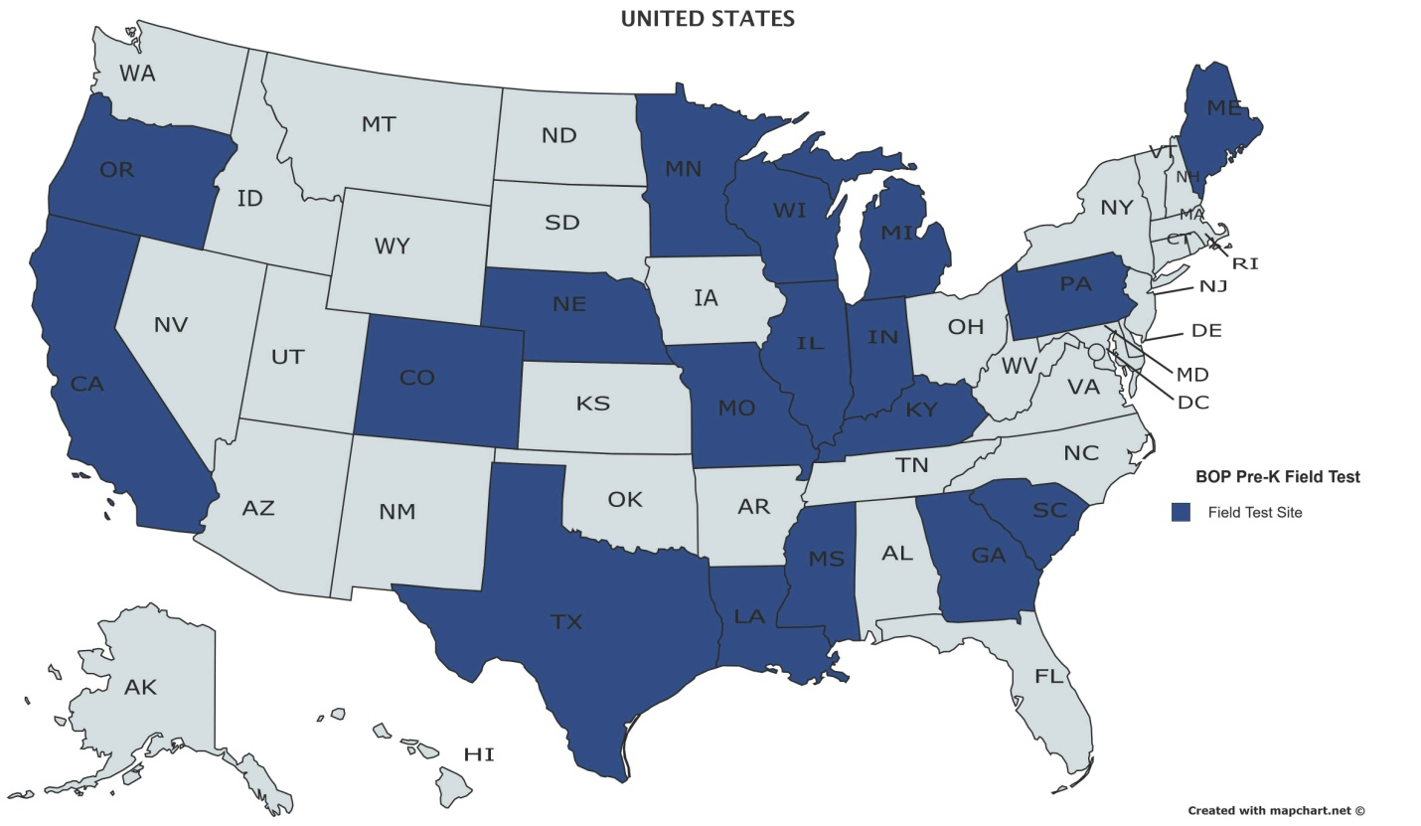

The following is a list of the materials distributed to the field test sites:
- Quick Start (print)
- For the Teacher of Students with Visual Impairments booklet (print)
- Teacher's Manual, Volumes 1–6 (print)
- Reference Volume (print)
- Reading Roundup Booklet (print)

Student Kit with
- Preschool Teacher Booklet (print)
- Parent Booklet (print)
- Set of Print Children’s Books (print)
- Student Set of Braille Children’s Books (braille)
- Student Workbooks and Tactile Storybooks (braille)
- Worksheets (braille)
- Parent Letters (print)
- Monitoring Charts and Reading Roundup Consumables (print)
- Manipulatives Pack (tactile cards: weather cards, emotion cards, plant cycle cards, obstacle cards, animal cards; green APH Scorecard; orange 3D-printed fish model; 1.5-inch natural wood cube; APH Digital Recording Device)

Word files for the Parent Letters, Monitoring Charts, and Reading Roundup Consumables and recordings of songs used in the lesson that are less likely to be familiar to teachers were also made available at this website: www.aph.org/buildingonpatterns/prek. Teachers were asked to customize the Parent Letters to themselves, their student, and their student’s family.

Questionnaires for the field test were developed to be administered via an online survey to obtain the following information:
- Additional demographic information about the teacher and the student(s) they are working with
- Each teacher’s initial reaction to the introductory and reference materials of BOP Pre-K
- Each teacher’s reaction to teaching each lesson (questionnaire to be completed at the end of each lesson) and their assessment of their student’s response to their instruction based on the lesson

Teachers were instructed to provide copies of the data collection forms documenting students’ progress to APH. Teachers were also asked to provide optional photo/video documentation of the student's participation in the lessons. A model release form was provided for teachers who were willing to do this in order to get the family’s permission.

Additional questionnaires will be developed to obtain teachers’ overall reaction to the program and support materials, including the Reference Volume and assessment plan at the mid-point (in December, regardless of how far along the teacher and student are in the program) and end of using the program.

A list of potential expert reviewers was compiled with input from Ralph Bartley, Executive Director of Research; Kate Herndon, Director of Educational Product Research; Diane Wormsley, APH Executive in Residence (at the time); Holbrook; and Ferrell. The project leader sent requests to six candidates to do a complete review of the program and one to a candidate who specializes in tactile graphics. Five of the six complete reviewers and the tactile graphics reviewer agreed to do the expert review. Materials were shipped and questionnaires were sent to Field Evaluators and Expert Reviewers in August.

Some of the BOP group gave a presentation on the changes based on the pilot filed test and the work being done on the project, titled “Prekindergarten Building on Patterns: Lessons Learned,” at the 2015 GITWL Conference in Albuquerque, NM, in November. Attendees at this presentation were enthusiastic about the new level of the curriculum.

Due to quality issues of the materials produced for field testing and expert review, the first set of materials was not shipped to field evaluators and expert reviewers until October 2016. This set contained most of the materials, but only the tactile storybooks and workbook for Lessons 1–9. The rest of the sets of these books were shipped as soon as they became available to all the expert reviewers and to the field evaluators who were progressing in their use of and feedback about the lessons. The set for Lessons 11–16 was available at the end of November, the set for Lessons 18–24 was available in mid-January, and the last set for Lessons 26–31 was available near the end of February.

Holbrook and the project leader agreed that it would be helpful to have one of the expert reviewers, Dr. Frances Mary D’Andrea, focus her evaluation on the assessment materials. A specialized questionnaire was developed and sent to her. Completed questionnaires from all the expert reviewers were received in early to mid-February 2017. S. Lee compiled the criticisms and suggestions from the general expert reviewers and the tactile graphics expert review. She also compiled the field evaluators’ criticisms and suggestions from the responses to the first nine lesson questionnaires and the first Bi-Annual Questionnaire.

In late February, Holbrook and the project leader reviewed some of the compiled feedback; this informed work on the additional questionnaires needed for the field test, including the Second Bi-Annual Questionnaire to be filled out at the end of the field test. They also discussed possible content for a workshop and poster session related to BOP Pre-K at the 2018 Getting in Touch With Literacy Conference. Holbrook composed proposals for these presentations, and the BOP group gave their feedback and approval during a conference call.

Field evaluators were asked to complete all questionnaires by May 22. The last response included in the field test data was received June 8.

Some evaluators and their students withdrew from the field test for various reasons, including student relocation, student’s lack of readiness for the curriculum, and insufficient time for lessons because of the teacher’s caseload. One teacher had a student with behavioral issues that made participation difficult, so she passed on the materials to a colleague who was working with a qualified student. Two of the teachers did not officially drop out but stopped responding and filling out questionnaires; the data for these teachers and their students is not reflected in the final field test report. Another teacher’s student moved away, but her feedback on all the lessons was collected. Of the 36 teachers selected for the field test, 31 were still participating at the end of the evaluation period.

Of the 46 students selected for the field test, 36 were still participating at the end of the evaluation period. This is a summary of the characteristics of those students:

Child’s Age (as of September, 2016)
- 3 years old: 2
- 3.5 years old: 1
- 4 years old: 31
- 5 years old: 2

Tactual learner
- Yes: 35
- No: 1 (This child was accepted because he has the same TSVI as another child and the teacher’s reasons for including him were persuasive: “My second student just recently started in our district. He appears to be a strong auditory learner with no functional vision. He will begin learning prebraille skills and I think he too can benefit from trying out this new product.” “Student is a strong auditory and tactual. I think he would be a great candidate for BOP.”)

Additional disabilities diagnosed
- Yes: 12
- No: 24

English spoken at home
- Yes: 33
- No: 3

Service delivery setting
- Center-based: 10
- Center-based and Itinerant: 1
- Inclusive: 2
- Inclusive and Itinerant: 5
- Inclusive and Residential: 1
- Itinerant: 14
- Residential: 3

The field test sites chosen were geographically diverse in the United States, as shown in the map below. One field test site was also chosen in British Columbia, Canada. (The teacher at the field test site in Michigan dropped out of the field test due to student issues.)

Approximately two-thirds of the field test sites completed Lessons 1–5. After that, the number of lessons completed went down with only a half to a third completing through Lesson 14. Only two teachers with students were able to complete through Lesson 24. Feedback on all the lessons was only received from the teacher from whom only teacher feedback was collected.

In the Second Bi-Annual Questionnaire at the end of the field test, teachers were asked, “If you have a student in prekindergarten in the future, would you use BOP Pre-K?” All of the 26 teachers who responded to the question chose “Yes” as their answer.

At the BOP Writing Group Meeting, June 26–30, Holbrook presented a slideshow with feedback from the field test and expert review of BOP Pre-K. The group discussed this information and made revisions to some materials based on that input. This included changing some of the tactile cards, changing the wording for activities in a few of the lessons, condensing the lesson sequences to two pages, making some additions to the TSVI Booklet, making a change to one of the parent letters, and adding reminders that the letters to the parents can be personalized. It was decided that some of the comments in the feedback could be addressed by adding resources to the BOP Pre-K Web site (which will have this new URL when broadly released): www.aph.org/building-on-patterns/pre-k/. After discussion, the group decided some concerns did not need to be addressed; most of these concerns were only expressed by one evaluator.

In response to feedback that some students would benefit from braille labels in the print children’s books, Emily Grimany helped to prepare braille-ready files that teachers could use to emboss the text of the books onto adhesive labels to place in the books. These will be provided on the BOP Pre-K Web site when ready. Grimany also produced the rest of the transcriptions of the children’s books (including image descriptions) for braille-reading teachers.

S. Lee, Holbrook, and the project leader continued to analyze the field test and expert review data and work on a comprehensive report of the data. Hiring an outside researcher to assist with this work was discussed.

Spicknall and Swenson reviewed and enhanced the content of the Parent Booklet and Preschool Teacher Booklet. Swenson and S. Lee assisted in the post-field test updates to the Reference Volume.

The components that were not formally laid out before the field test were sent to InGrid Design for layout: Volume 6, Lessons 26–32; the Reading Roundup lessons booklet; the Reference Volume; and the booklets for the parents, preschool classroom teachers, and TSVIs. Edits to Volumes 1–5 of the teacher’s manual were made based on the feedback from the field, writing group decisions, and changes for consistency. A scope and sequence was added to each volume of the teacher’s manual. S. Lee and Leasha Twyman assisted in the reviews of the laid out documents.

The publisher informed APH that the book chosen to accompany Lesson 3 will be going out of print. Joon Lee assisted with obtaining permission to use the text of this book to reprint the book. A replacement book for Lesson 30 (confirmed in June 2016 as out-of-print by the publisher) was written by the writer hired to write books for BOP Kindergarten. Jones and other graphic design personnel obtained photos and created illustrations for both books. Three quotes were obtained, and an outside printer was chosen to produce these books as well as the other two books determined in 2015 to not be available from the publisher.

A vendor was chosen to create the mold for the fish model and provide the models for the Student Kits.

Work began to produce the tooling for the tactile graphics for production runs. The five sets of tactile cards in the Manipulatives Pack will be vacuum-formed using 0.010-inch vinyl. At the time of this report, a decision had not been finalized on the material to be used for the other tactile graphics.

A plan to release the BOP Pre-K materials to the Production floor in stages, rather than all at one time, was discussed. A list of materials was developed and reviewed with Production and Purchasing personnel. The majority of the production specifications were written. Work to procure the purchased items for the production run of the Student Kit began.

Work during FY 2018
In October 2017, a meeting with Production and Purchasing personnel to provide an overview of the items included in the product and quantities to produce for the first production run for the product was held. Current page counts and estimates, where needed, for the items in the product were provided following the meeting to help Production with planning.

The teacher’s manual and other print components were transcribed into braille by Emily
Grimany and proofread by proofreaders at the Clovernook Center for the Blind & Visually Impaired and S. Lee. This included braille versions of the Preschool Teacher Booklet and Parent Booklet, which will only be provided as free downloadable braille-ready files. The print files were marked for edits found during this process, as well as for other updates. InGrid Design made the edits to all volumes of the Teacher’s Manual, Reference Volume, Reading Roundup lessons booklet, and booklets for the parents, preschool classroom teachers, and TSVIs. InGrid Design also created covers for the braille versions of the Reference Volume, Reading Roundup lessons booklet, and the booklet for the TSVI.

Some of the BOP group gave a workshop and poster session related to BOP Pre-K at the December Getting In Touch With Literacy Conference in New Orleans, LA.

After more testing and evaluation, a 0.005-inch thick vinyl that is white, and feels more like paper than other material available for thermoformed tactile graphics, was selected as the material to be used for the majority of the tactile graphics in the product. Frank Hayden worked with Production personnel to develop a process to produce consistently good results for the BOP Pre-K tactile graphics using this material.

The project leader worked with Poppe to finalize the files for producing the Roland® masters for the tactile graphics to be thermoformed. This included changes to the margins for the graphics as requested by Production personnel.

The writers for the lessons determined that two of the worksheets should still be produced on 0.010-inch thick vinyl because of the way they are used in the lessons. Patterns for vacuum-forming these two worksheets, as well as the five sets of tactile cards in the Manipulatives Pack, were created by Katherine Corcoran.

It was determined that it should be possible for the four print children’s books to go with the lessons that are not available from publishers to be printed at APH. Jones and Laura Greenwell worked with Production to create files for these books that would produce consistently good results when printed in-house.

The needed copies of each of the other 23 print books and one print-braille book were purchased and checked when received. Some copies were rejected, and replacement copies were obtained from the vendors. The fish models were also purchased.

As discussed during FY 2017, the BOP Pre-K materials were released to the Production floor in stages. The first specifications meeting, for the Student Set of Braille Children’s Books, was held in May. The second, for the worksheets and part of the Braille Teacher Kit, was held in June. Starting in mid-June, weekly meetings were held with Educational Product Research and Production personnel to monitor the status of and discuss plans and issues related to the production of the product.

The third specifications meeting, for the Print Teacher Kit, was held in July. Also in July, the four children’s books to be printed in-house were turned over via e-mail in a “virtual” specifications meeting. The fourth meeting, for the remainder of the items in the Braille Teacher Kit and Student Kit except for the Student Workbooks and Tactile Storybooks, was held in early August. The Student Workbooks and Tactile Storybooks and the Braille Teacher’s Manual were turned over in late August. At the time of this report, Production anticipated having enough materials in stock to release the product in mid-September.

Braille-ready files of the Braille Teacher’s Manual, the Parent Booklet, and the Preschool Teacher Booklet were made available on the APH Downloadable Product Manuals webpage.

The project leader worked with Jones and Ricky Irvine on a video introducing the components of the BOP Pre-K kits to be linked on a BOP Pre-K Web site. Swenson and Mary Filicetti worked on other videos for the website. BOP Pre-K pages were added to the BOP component of the Braille Literacy Web site. The pages include “Features & Samples,” “Teaching Components,” “Ordering Information,” and “Teacher Resources,” similar to the pages for the other levels of BOP. However, the “Teacher Resources” include the following additional materials for Pre-K:
- Frequently Asked Questions (FAQ) list for BOP Pre-K developed by the BOP writers during the June 2018 BOP Writing Group Meeting
- links to the video introducing BOP Pre-K, a video introducing a braillewriter, and videos showing Filicetti working with a preschooler on reading and writing braille
- electronic versions of the Parent Letters so teachers can tailor the letters for the child’s parent or guardian
- electronic versions of the Monitoring Charts and Reading Roundup Consumables
- recordings of songs in BOP Pre-K that are less likely to be familiar to teachers
- braille-ready files that teachers can emboss to make braille labels for the text of the print children’s books

Work planned for FY 2019
Production of the materials will continue. Additional materials to supplement the curriculum will be developed and placed on the BOP Pre-K Web site.

Fun with Braille [Modernization]
(New)

Purpose
To modernize an existing APH publication to reflect the changes from English Braille American Edition to UEB

Project Staff
Dawn Wilkinson, Early Childhood Project Leader
Robin Wingell, Author/Consultant

Background
This one volume booklet was originally released in 2006. This book provides practice for elementary students who are learning braille with 35 fun activities that emphasize various contractions and their usage. Due to the occurrences of activities that taught contractions such as “ally,” “ble,” and “ation,” along with basic changes involving the “to sign” and snuggle words, changes need to be made in the content to reflect UEB code.

Work during FY 2018
The project leader and consultant began evaluating the current book in its entirety to identify necessary content changes. Some activities needed total rewrites because those contractions no longer existed or the activity taught a rule such as putting signs together which is no longer the case with UEB.

Work planned for FY 2019
Revisions to the original book will be completed. Files will be turned over to graphic design and braille. Once tooling is complete, a specification meeting will be held and the revised product will become available for sale.

I-M-ABLE (Individualized Meaning-Centered Approach to Braille Literacy Education) Kit
(Continued)

Purpose
To provide an alternative model for braille literacy instruction to students with visual and additional disabilities

Project Staff
Diane P. Wormsley, Author/Project Consultant
Monica Vaught-Compton, Project Leader
Susan Spicknall, Project Leader
Adam Clark, Manufacturing Specialist
Frank Hayden, Director of Technical & Manufacturing Research
Carrie McCollough, Braille Transcriber
Matthew Poppe, Graphic Designer

Background
The Individualized Meaning-Centered Approach to Braille Literacy Education (I-M-ABLE) project was initiated in early 2014, to address the needs of students learning to read and write braille with additional disabilities. Diane P. Wormsley, Ph.D., developer and author of the I-M-ABLE program, agreed to collaborate with APH to design a kit of instructional aids and materials to accompany the practice guide. The project focuses on providing an ever-growing population of students an appropriate pathway to successful literacy. These students are often not well served by traditional instructional strategies or materials. An individualized approach, which focuses on a student's particular interests to provide relevance and motivation for learning, offers a positive alternative to existing programs.

During 2015, numerous meetings were held to establish a working partnership between the American Foundation for the Blind® (AFB) and APH, to select and design components of the kit, to plan training videos/materials, and to develop a schedule and procedures for the field evaluation. An extensive survey was written with specific criteria for recruitment of field testers. Teachers and students were identified using predetermined profiles for the purpose of obtaining solid data. A teleconference was held with the teachers to explain the schedule and procedure for field evaluation.

An I-M-ABLE training workshop was organized and presented to an audience of six TVIs. Video clips were made of the training corresponding to various components of the I-M-ABLE approach. The rationale behind the approach, background on the differences between braille and print, and the importance of teaching proficient tactile skills were included in the workshop. These clips were edited, and a private link to them was created for access in field testing.

The field test kit consisted of the following:
- A final non-copyedited version of the publication I-M-ABLE
- A Califone® CardMaster™ Card Reader and a set of cards with recording capability. The cards are large enough for a clear recording of a word or a short sentence in braille.
- Chunk Stacker, a phonics teaching game, consisting of two sets of tiles that fit into small trays. The blue tiles are onsets (beginnings of words), and the pink tiles are rimes (word families). Clear braille adhesive labels will be applied to each set for accessibility.
- Four vacuum-formed trays (used for a variety of activities). Each tray will hold four cards.
- Reward Stickers (currently sold by APH)*
- A private link to the training videos, which were developed during 2015

Field testing began in October 2015 and extended throughout the remainder of that year and into 2016. Teleconference meetings were held with field testers on a 2-week basis initially, and then monthly as field testers began implementing the approach with their students. An electronic mailing list was created for field testers to use to communicate with each other and with the project leader and consultant.

During January through March 2016, field testing of the I-M-ABLE kit continued. Monthly communication with the field evaluators was held by means of the electronic mailing list in January and February, but by a teleconference call in March since this was the last month of the field testing. The field testers completed a survey to evaluate their experience implementing the kit and answered questions about the importance of the various components of the kit.

Thirteen field evaluators participated in the field test. The evaluators each used the kit with one student. These 13 evaluators were from 12 different states: Arizona, Indiana, Kentucky, Louisiana, New York, North Dakota, Oregon, Pennsylvania, South Carolina, Tennessee, Utah, and Washington.

Students ranged in age from 8 to 12 years, with most concentrated at the ages of 8 and 11. Students had a variety of etiologies: cataracts, CHARGE, cerebral palsy, glaucoma, opacification of corneas, no light perception, loss of oxygen due to choking on grapes, ONH, Nystagmus, SOD, Peters syndrome, prematurity, intellectual disability, autism, ADHD, learning disorder, Microphthalmia, WAGR Syndrome, and aniridia.

The field test survey was posted online via SurveyMonkey®. Overall, teachers had very positive evaluations of the kit. The one component that did not rate as well was the APH Feel n’ Peel Reward Stickers that were included with the kit. Because of the reviewers’ comments, the Reward Stickers were eliminated from the kit. The Reward Stickers can be purchased separately from the kit (from APH), as one or two of the field evaluators recommended be done. All other components of the kit were evaluated favorably. All 13 teachers indicated that they would use the APH I-M-ABLE Kit in the future either with the student with whom they evaluated in field test, or with other students. All 13 evaluators also indicated that they would recommend this product for use by other teachers; some evaluators indicated that they had already done so.

Evaluators recommended that some sort of document accompany the kit that would detail how the various kit components can be used to implement the I-M-ABLE approach. Therefore, Dr. Wormsley developed an instruction booklet to package with the kit; it is titled “Instructions for Teachers on the Use of the APH I-M-ABLE Kit and Components.”

In 2016, AFB Press published I-M-ABLE: Individualized Meaning-Centered Approach to Braille Literacy Education. At that point, APH intended to purchase books (both print and from AFB Press to form part of the APH I-M-ABLE Kit. To meet accessibility requirements, customers would be able to purchase either a kit with the I-M-ABLE print book or a kit with instructions on how to download the I-M-ABLE electronic book from AFB. Anticipated kit components to be included in both of these kits were as follows: I-M-ABLE book, instruction booklet written by Wormsley, Califone® CardMaster™ Card Reader with set of blank magnetic cards, Chunk Stacker game with braille labels for the game tiles, and four vacuum-formed trays. The instruction booklet includes a private website link to the training videos as well as an appendix with the handouts to accompany the videos.

In FY 2017, the manufacturing specialist worked to complete product specifications. In January 2017, the manufacturing specialist discovered that the Chunk Stacker game was recently discontinued by the manufacturer and replaced by a similar game called Chunks. The project leader and author reviewed Chunks and found that it was a suitable replacement for Chunk Stacker in the I-M-ABLE kit. However, the Chunks game tiles contained different rimes and onsets than Chunk Stacker. Thus, re-tooling of the braille labels for the rimes and onsets in the game was necessary. Further, text revisions to the instruction booklet were made; this included revisions to the braille-ready file with another proofreading by the Braille Department.

Revisions to the kit due to the Chunks game replacement were complete by May 2017. It was at this time that the manufacturing specialist learned that the Califone® CardMaster™ Card Reader was being discontinued by the manufacturer. Project staff searched extensively for a replacement for the CardMaster™, but one was not found. Therefore, the CardMaster™ was eliminated from the kit. Project staff convened to identify another product to include in the kit. After reviewing the original list of products considered for inclusion in the kit, project staff decided to include the APH Word PlayHouse (Catalog #1-03562-00), uses for which Wormsley describes in the book I-M-ABLE. Word PlayHouse provides opportunities for individualized instruction for braille literacy. With the inclusion of Word PlayHouse, project staff decided that the inclusion of the Chunks game was redundant as Word PlayHouse meets a similar instructional component; therefore, it was eliminated from the kit.

Work during FY 2018
A product specifications meeting was held in October 2017. The product was slated for release in early 2018. However, delays were significant on the production floor with regards to assembly of the Word PlayHouse product for inclusion in the I-M-ABLE Kit.

The APH and AFB partnership, announced in February 2018 and commenced in July 2018, affected product specifications for the APH I-M-BLE Kit. Customers who purchase the kit with an electronic version of the I-M-ABLE book will now receive a USB flash drive with an EPUB® of the book (prior to the APH/AFB partnership, customers were given download instructions for how to obtain an electronic version of the book from the AFB Web site). This change led to several revisions to product documentation, including the print/braille instruction booklet and product specifications. These changes delayed the product release. As of September 2018, no further revisions are anticipated to this product. The product will become available for sale prior to the end of FY 2018.

Low Cost Brailler/Embosser
(Continued)

Purpose
To provide a low-cost embosser with the target audience being teachers of the visually impaired, school-age children, and adults who have need of an embosser to produce braille for small embossing jobs (i.e., worksheets in classrooms, student work, or documents in the workplace)

Project Staff
Martin Monson, Project Leader
Dorinda Rife, Vice President, Educational Products and Research
Frank Hayden, Director of Technical & Manufacturing Research
Kate Herndon, Director of Educational Product Research
Larry Skutchan, Director of Technology Product Research

Background
The idea for this product followed the established protocol. Two idea submissions were submitted to APH about embossers. One idea focused on developing a low-cost personal embosser, while the other focused on a portable embosser. During review of the ideas by the Product Evaluation Team and the Product Advisory and Review Committee, the two ideas were combined and assigned a grant number.

Product description
This product is still in the ideation stage.

Work during FY 2018
Several meetings concerning the possibility of APH producing an embosser were held. The discussions focused on which route to take in developing an embosser: personal, portable, or both. Requests for proposals were developed for both types of embossers. No decision was made on which route APH should take to develop an embosser.

Work planned for FY 2019
Internal discussion about which route APH wants to take to develop this idea will continue. Proposal will be reviewed. Once a decision is made, a request for proposals will be published.

Quick Pick Braille Contractions [Modernization]
(Continued)

Purpose
To provide practice materials for elementary students who are learning braille

Project Staff
Dawn Wilkinson, Early Childhood Project Leader
Frank Hayden, Director of Technical & Manufacturing Research
Jeremiah Rose, Research Assistant

Background
A survey was conducted in 2001, in order to determine a need for study materials, in uncontracted and contracted braille. Research verified that drill and practice in identification of contractions increases reading speed and comprehension. The Quick Pick Braille Contractions set was developed in the early 2000s. The kit contains two packets of cards and includes all contractions in literary braille. Each card displays a symbol/group of symbols in contracted form in the upper left-hand corner. Four possible uncontracted equivalents are listed across the card below. A hole under each spelled-out version of the contraction allows the student to choose his/her answer. The reader selects an answer by inserting a stylus into the hole beneath his/her choice. If he/she is correct, the card can be slid from the packet; if incorrect, the card cannot be removed. This format for practice materials had already been used successfully with five previous Quick Picks: Addition, Subtraction, Multiplication, Division, and Counting. Production of this product began in September 2005.

In 2015, Quick Pick Braille Contractions was identified for modernization in order to update the product to incorporate Unified English Braille (UEB). The updated kit will also include a flat stylus to prevent crushing of the braille on the cards.
New catalog numbers were assigned for this new UEB version of Quick Pick. The words on the cards were rearranged for better spacing and alignment. The label for the outer cover for each set of cards was brailled. The project was assigned to Dawn Wilkinson, Early Childhood Project Leader, in April 2016. The project leader and research assistant continued to make adjustments to the product and meet with Technical Research staff.

Graphic Design completed all print files containing the new catalog number for the modernized product. Production continued to work on a solution for the alignment issues on the braille cards.

Work during FY 2018
Alignment issues continued to be addressed. Another project was placed ahead of this one until these issues could be resolved.

Work planned for FY 2019
Final tooling and specifications will be completed. The UEB Quick Pick Braille Contractions kit will become available for sale.

Handwriting

For FY 2018, there are no projects in this category to report.

Study Skills / Organizational Skills

For FY 2018, there are no projects in this category to report.

Tactile Graphics

Feel 'n Peel Stickers: Additional Packages
(New)

Purpose
To determine the need for additional packages of Feel 'n Peel Stickers in combination with those newly approved for development (e.g., negative number stickers) and those recently suggested by the field (e.g., grade stickers)

Project Staff
Karen J. Poppe, Tactile Literacy Project Leader

Background
For nearly two decades, various types of Feel 'n Peel Stickers packages (a series originated by the project leader in 1999) have been produced by APH. Available kits offer point symbol stickers, reward statement stickers, alphabet stickers, color name stickers, smiley/frowny face stickers, and assorted adhesive-backed textures. After years of availability, APH’s sticker packages have remained popular and sales have been steady. APH frequently receives requests for additional Feel 'n Peel Sticker packages. For example, a request for negative numbers stickers was submitted by Anita Pineda, Certified Teacher of the Visually Impaired/Certified Orientation and Mobility Specialist, in Texas. Another package that was suggested frequently is grade stickers; the latest such request was submitted by Karen Klein, Teacher of the Visually Impaired/Clinician, in Missouri.

Work during FY 2018
In February 2018, the project leader constructed a SurveyMonkey® online survey to garner feedback from teachers in the field regarding their current use of the existing Feel 'n Peel Sticker packages, their expected use of sticker packages currently under development, and identification of other types of needed stickers. The link to this survey (www.surveymonkey.com/r/RSH9WKK) was announced in the March issue of APH News.

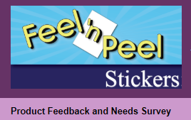

As of July 2018, 106 teachers had completed the online survey. The large number of submitted surveys alone indicated the continued popularity of and need for Feel 'n Peel Stickers.

As shown in Figure 1, the majority (80%) of survey respondents (N=105) represented teachers of the visually impaired and blind who used Feel ꞌn Peel Stickers in itinerant/mainstream instructional settings. The remaining percentage of survey respondents taught in residential schools (8%), resource centers (2%), rehabilitation centers (1%), and other venues—for example, in early childhood education centers and private schools, and through home-based services (8%).
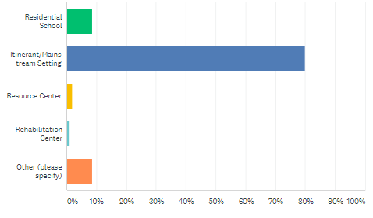
Figure 1. Distribution of Survey Respondents by Instructional Setting

Figure 2 illustrates that the representation of survey respondents (N=106) across all categories of teaching experience was fairly balanced: 0-5 years (21%), 6-10 years (25%), 11-15 years (23%), 16-20 years (10%), and 21 or more years (22%).

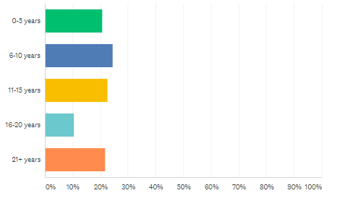
Figure 2. Distribution of Survey Respondents by Years of Teaching Experience

The student populations typically served by the survey respondents (N=106) ranged from infants/preschoolers (69%) to students in high school (87%); 75% taught kindergarten students, and 84% taught elementary and middle school students. Slightly more than 10% of the survey respondents worked with adult blind consumers; one survey respondent was an adult blind consumer. (Refer to Figure 3.) Specific other student populations served transition students and medically fragile students in their homes.
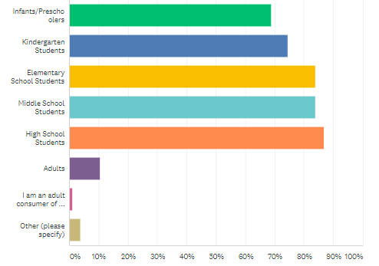

Figure 3. Distribution of Survey Respondents by Student Populations Served

Figure 4 shows that the survey respondents (N=106) had used many of the available Feel ‘n Peel Sticker packages with their students/clients. The Alphabet Letters (lowercase style) stickers had been used by the largest percentage (93%) of the survey respondents, followed by Smiley/Frowny Face stickers (86%) and Point Symbol stickers (77%). The Nemeth and Unified English Braille (UEB) Basic Math Symbol stickers were used by the fewest survey respondents; only 38% of the survey respondents had used the Nemeth version, and 30% of the survey respondents had used the UEB version. Note that Basic Math Symbol stickers were recently introduced by APH and their availability may not have been as familiar to the survey respondents.
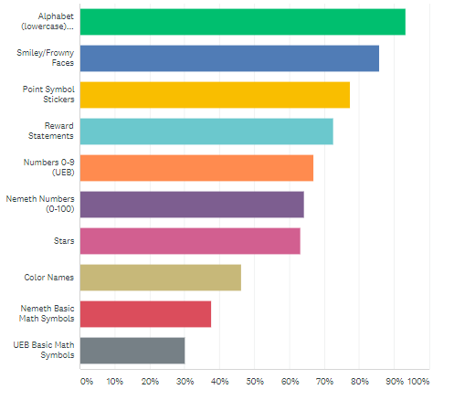
Figure 4. Available Feel ꞌn Peel Stickers Used by Survey Respondents

Table 1 reveals that survey respondents used the available Feel ‘n Peel Sticker packages to varying degrees. Of the 103 survey respondents familiar with the Alphabet Letter stickers, nearly half used them frequently and 35% used them occasionally. Of the 102 survey respondents familiar with the Smiley/Frowny Face stickers, 38% used them frequently and 33% used them occasionally. The Point Symbol stickers were also popular; survey respondents familiar with these stickers (N=102) used them either frequently (32%) or occasionally (45%). Of the 100 survey respondents familiar with the Reward Statement stickers, 34% used them frequently and 35% used them occasionally. Fewer than 40% of the survey respondents (N=93) familiar with the Color Names stickers used them frequently (9%) or occasionally (25%). Likewise, fewer than 40% of the survey respondents (N=82) familiar with the UEB Basic Math Symbols stickers used them frequently (10%) or occasionally (27%).

Table 1
Frequency of Use by Sticker Package
Available Sticker Package | Number of Evaluators | Frequently | Occasion-  ally | Rarely | Never
Alphabet (lowercase) | N = 103 | 49.51% | 34.95% | 9.71% | 5.83%
Point Symbols | N = 102 | 32.35% | 45.10% | 7.84% | 14.71%
Reward Statements | N = 100 | 34.00% | 35.00% | 14.00% | 17.00%
Smiley/Frowny Faces | N = 102 | 38.24% | 33.33% | 18.63% | 9.80%
Numbers 0-9 (UEB) | N = 87 | 41.38% | 20.69% | 8.05% | 29.89%
Numbers 0-100 (Nemeth) | N = 91 | 37.36% | 29.67% | 8.79% | 24.18%
UEB Basic Math Symbols | N = 82 | 9.76% | 26.83% | 10.98% | 52.44%
Nemeth Basic Math Symbols | N = 83 | 18.07% | 30.12% | 12.05% | 39.76%
Stars | N = 95 | 25.26% | 37.89% | 21.05% | 15.79%
Color Names | N = 93 | 8.60% | 24.73% | 30.11% | 36.56%

The survey respondents indicated their expected use of sticker packages currently being developed at APH. Table 2 shows that nearly 75% of the survey respondents (N=103) indicated that it was “very likely” that they would use the Braille/Print Capital Letters A-Z (see separate annual report). More than half (64%) of the survey respondents (N=100) indicated that it was “very likely” that they would use the UEB Braille/Print Numbers 0-100 (see separate annual report). However, a more conservative 43% of the survey respondents (N=102) indicated a “very likely” use of the Negative Numbers sticker package.

Table 2
Anticipated Use of Planned Sticker Packages
Planned Sticker Package | Number of Evaluators | Very Likely | Possibly | Unlikely
Braille/Print Capital Letters A-Z | N = 103 | 73.79% | 24.27% | 1.94%
Negative Numbers (-1 thru -20) | N = 102 | 43.14% | 37.25% | 19.61%
UEB Braille/Print Numbers 0-100 | N = 100 | 64.00% | 22.00% | 14.00%

With regard to the need for Grade Stickers, nearly half (46%) of the survey respondents (N=106) indicated that APH should pursue the development of such a package of Feel ꞌn Peel Stickers, 23% indicated “no,” and 31% were “uncertain.” The survey respondents’ descriptions of the ideal package of Grade Stickers differed and sometimes contradicted each other. Examples of preferred features included the following:
- “I think 5-10 (sheets) of each grade would be sufficient. And the sheet should all be one color similar to the packaging of the reward statements.”
- “A’s and B’s would be great! Bright red or blue.”
- “Any quantity is ok, just include more plain grades without the + or – since a lot of teachers I know leave those off. Variety of colors with good contrast would make them fun.”
- “I believe the same color should be [used] for the same grade.”
- “More A’s, B’s, and C’s and less D’s and F’s.”
- “Colors can be a variety, but produce more of the higher grades, less of F and D.”
- “Equal amounts of each letter grade as each student is different. I think this is a great idea for Gen Ed teachers to provide feedback instantly to the student. Colors don’t really matter.”
- “20 of each letter grade, color no preference.”
- “Clear, 20 of each.”
- “Same color for all grades.”
- “Colored stickers are fun, and if the student has residual vision they love them.”

Despite the plethora of already existing Feel ꞌn Peel Sticker packages, as well as those in the production pipeline, the survey respondents identified additional types of stickers for APH to consider producing. Proposed sticker packages included some of the following:
- “Names of zoo and farm animals.”
- “Some basic shapes such as circle, square, triangle, rectangle, heart, oval, etc.”
- “I’d love to [see] more different types of point symbols.”
- Ordinal numbers/terms—1st, 2nd, 3rd; first, next, then
- “Arrows with lines (choice of broken or continuous) to use for pointing to diagram locations; can be cut to length.”
- Labels for functional skills and tasks (first, next, last, finished, left, right, put on, take out, sort, and so forth).
- Subject-based stickers: Reading, English, Math, Spelling, Social Studies, and so forth.
- “On, off, high, medium, low”
- Months of the year; days of the week.
- “Scratch and sniff!”
- “Morning calendar items: types of weather, shapes, feelings, …”
- “Fun emojis for rewards and for students to use to express their feelings.”
- “Possibly add stickers for the holidays.”
- “Procedure stickers for school To Do lists.”
- Sight words
- “More generic shape and design stickers, such as: butterflies, flowers, animals, sports balls, etc.”
- Labels for household and classroom items (e.g., cereal box, soap, apple juice)
- “Higher mathematics operations symbols and some scientific symbols. Mathematics lower level operations symbols and fractions.”
- “Perhaps concepts words: top/bottom; left/right; same/different; first/second/third; next; big/small;…”

Work planned for FY 2019
The development of Feel ꞌn Peel Stickers: Negative Numbers, in both UEB and Nemeth versions, will be undertaken after the completion and introduction of the UEB Braille/Print Numbers 0-100 (see separate report). The prioritization of the Grade Stickers is pending. According to a new matrix-scoring process used by an in-house review committee to evaluate all APH product ideas and endeavors, the Negative Number stickers garnered a weighted score of 66 out of a possible 93, and the Grade Stickers garnered a weighted score of 57 out of a possible 93.

Feel 'n Peel Stickers: Braille/Print Capital Letters A-Z
(Completed)

Purpose
To provide a new package of Feel 'n Peel Stickers featuring braille/print capital letters
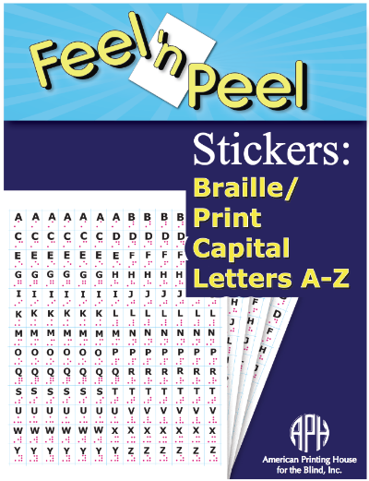

Project Staff
Karen J. Poppe, Tactile Literacy Project Leader
Rachel Bishop, Research Assistant
Adam Clark, Manufacturing Specialist
Anthony Jones, Director of Creative Services/Graphic Designer
Background
For nearly two decades, various types of Feel 'n Peel Sticker packages (a series originated by the project leader in 1999) have been produced by APH. Available kits offer point symbol stickers, reward statement stickers, alphabet stickers, color name stickers, smiley/frowny face stickers, and assorted adhesive-backed textures. After years of availability, the sales of APH’s sticker packages have remained popular and steady. The Feel 'n Peel Stickers: Alphabet Letters (1-08849-00), a package featuring lowercase letters A-Z, consistently appears among APH’s “Top 25” selling products; 1,445 packages were sold in FY 2015, and 1,795 packages were sold in FY 2016 indicating a growing demand for letter stickers.

APH frequently receives requests for additional Feel 'n Peel Sticker packages. A request for capital letter stickers was formally submitted by Stephanie Bissonette, Supervisor of Children’s Services, Vermont Association for the Blind and Visually Impaired. One suggested use for the letter stickers was for the construction and labeling of embossed Punnett squares for biology classes.

In November 2016, the development and production of Feel ‘n Peel Stickers: Braille/Print Capital Letters A-Z was presented to the Product Evaluation Team and in December 2016, to the Product Advisory and Review Committee. Formal field testing was deemed unnecessary since the production methods, materials (e.g., clear .005-in. vinyl sheets), and expected customer uses mirrored those of earlier Feel ꞌn Peel Sticker packages.

On January 10, 2017, the project leader conducted a Product Development Committee meeting. She shared a digital file that illustrated the expected print layout, braille letter position, and spacing of die-cut lines. This sticker setup, arranged in a 13 x 13 matrix, would generate the exact number of stickers as the counterpart sticker package of lowercase alphabet letters. Production staff expressed some uncertainty regarding the best route for printing the sticker sheets in light of the recent omission of in-house screen-printing capabilities. Alternative paths for printing the stickers were explored, including offset printing in-house or via the Roland® UV printer; the latter option proved to be slow and not cost-effective. Eventually, an outside vendor was identified for printing the sticker sheets; samples were received and approved. The project team anticipated that 1,000 units of this new sticker package would sell within the first year.

A new catalog number (1-08870-00) was assigned to the Feel ‘n Peel Stickers: Braille/Print Capital Letters A-Z. The project leader prepared the content for the Suggested Uses insert and provided it to the graphic designer for layout and design. Braille translation of the Suggested Uses insert was initiated during the last quarter of the FY 2017.

Work during FY 2018
During the first quarter of FY 2018, remaining tooling tasks were completed in-house and by the outside vendor to accommodate mass production of the Feel ꞌn Peel Stickers: Braille/Print Capital Letters A-Z. Specifically, the following were designed:
- Digital file for the sticker sheet (rendered by the manufacturing specialist)
- Photo-etched magnesium embossing plates (prepared by the outside vendor)
- Cutting dies to face-cut the stickers

In December 2017, the final product specifications were presented to Production staff. In April 2018, the project leader and manufacturing specialist monitored the quality of parts received from the vendor and subsequent in-house packaging during the pilot and production runs. On May 3, 2018, the Feel ꞌn Peel Stickers: Braille/Print Capital Letters A-Z (Catalog No. 1-08870-00) was announced as a new APH product with a selling price of $19.00 and available with Quota funds. The final sticker package included the following:
- 4 sticker sheets
- Print Suggested Uses insert
- Braille Suggested Uses insert
- Print Parts List
- Braille Parts List
The project leader prepared related brochure content. The manufacturing specialist made slight refinements to the print artwork to make the font size consistent across all letter stickers for subsequent production runs.

Work planned for FY 2019
Active work on this package of stickers is officially completed. The development of additional packages of Feel 'n Peel Stickers recently requested by the field will be pursued. Planned and underway packages include UEB Braille/Print Numbers 0-100 (see separate report), Negative Numbers (see separate report), and Grade Stickers (see separate report).

Feel 'n Peel Stickers: UEB Braille/Print Numbers 0-100
(New)

Purpose
To provide a new package of Feel 'n Peel Stickers that provides a Unified English Braille (UEB) version of braille/print numbers 0-100 as a counterpart to APH’s existing collection of number stickers in Nemeth braille format
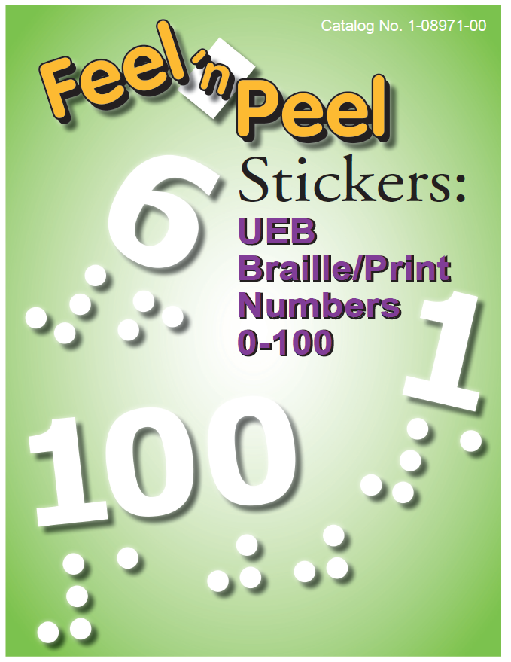

Project Staff
Karen J. Poppe, Tactile Literacy Project Leader
Emily Grimany, Research Assistant
Adam Clark, Manufacturing Specialist
Laura Greenwell, Graphic Designer
Background
For nearly two decades, various types of Feel 'n Peel Sticker packages (a series originated by the project leader in 1999) have been produced by APH. Available kits offer point symbol stickers, reward statement stickers, alphabet stickers, color name stickers, smiley/frowny face stickers, and assorted adhesive-backed textures. After years of availability, the sales of APH’s sticker packages have remained popular and steady. The Feel 'n Peel Stickers: Nemeth Braille/Print Numbers 0-100 consistently appears among APH’s top 30 selling products; 1,335 packages were sold in FY 2016 and 1,180 were sold in FY 2017. The provision of a UEB version of this sticker package supports APH’s continued mission to provide product materials in both Nemeth and UEB to accommodate both options for the customer.

In March 2017, the project leader prepared and submitted a Product Modernization Form suggesting the provision of number stickers 0-100 in UEB format—that is, each number positioned in the upper portion of the braille cell. The form specified the primary target populations as students with visual impairments and blindness in preschool, kindergarten, and early elementary grades; older students and adults; and teachers and parents working with this population.

In April 2017, the development and production of Feel ‘n Peel Stickers: UEB Braille/Print Numbers 0-100 was presented to the Product Evaluation Team and in May 2017, to the Product Advisory and Review Committee. Approval to proceed with development of the product was garnered. Formal field testing was deemed unnecessary because the production methods, materials, and expected customer uses mirrored those of the existing Feel ꞌn Peel Stickers: Nemeth Braille/Print Numbers 0-100.

Work during FY 2018
A new catalog number (1-08971-00) was assigned to the Feel ‘n Peel Stickers: UEB Braille/Print Numbers 0-100. The project leader prepared the content for the Suggested Uses insert and provided it to the graphic designer for layout and design. Suggested uses included the following:
- Adapting science or math measurement devices (e.g., measuring cups, rulers and yardsticks, number lines, thermometers, and clock faces)
- Creating hundreds charts; addition/subtraction/multiplication/division tables; number books/cards
- Creating tactile graphs and diagrams in the areas of science and math
- Adapting games with numbers (e.g., counting/patterning math games)

In October 2017, the graphic layout of the print Suggested Uses insert and the corresponding braille translation of the document were both completed and approved for production.

Work planned for FY 2019
Remaining tooling tasks will be completed in-house and by the outside vendor to accommodate mass production of the Feel ꞌn Peel Stickers: UEB Braille/Print Numbers. Specifically, the following will be designed:
- Digital file of the sticker sheet (rendered by the manufacturing specialist)
- Photo-etched magnesium-embossing plates (prepared by the outside vendor)
- Cutting dies to face-cut the stickers
The stickers will be printed and embossed on .005-in. clear adhesive-backed rigid vinyl.

The project will then enter Gate 5: Specifications and move to production status, according to the New Product Development cycle. The final product specifications will be presented to Production staff. The project leader and the manufacturing specialist will monitor the quality of parts received from the vendor and subsequent in-house packaging during the pilot and production runs. The final sticker package will include the following:
- 4 sticker sheets of UEB braille/print numbers 0-9 (169 stickers total per sheet)
- 4 sticker sheets of UEB braille/print numbers 10-100 (91 stickers total per sheet)
- Print Suggested Uses insert
- Braille Suggested Uses insert
- Print Parts List
- Braille Parts List

The introduction and development of additional packages of Feel 'n Peel Stickers recently requested by the field will continue as well. Recently-introduced packages include Braille/Print Capital Letters A-Z (see separate report), as well as newly-approved packages Negative Numbers and Grade Stickers (see separate related report “Additional Sticker Packages”).

Finger Walks
(Continued)

Purpose
To compile a book of thermoformed labyrinth designs, along with a description of how to use them, for recreational and therapeutic use and for tactile and spatial concept development

Project Staff
Fred Otto, Tactile Literacy Project Leader
Frank Hayden, Director of Technical and Manufacturing Research
Andrew Moulton, Manufacturing Specialist
Rod Dixon, Manufacturing Specialist
Katherine Corcoran, Model Maker
Lara Kirwan, Research Assistant

Background
The project idea was submitted by Maia Scott, an arts instructor who is blind, with the title Walking in the Dark. Ms. Scott has extensive experience using both walking labyrinths and finger labyrinths with learners of all ages, and she proposed to work with APH to produce a collection of classic and modern labyrinth designs in a portable, tactile format.

Ms. Scott’s product submission cited several benefits of working with labyrinths, including enhancing spatial awareness; enhancing concentration, calm, and focus; the fun of making rubbings and exploring patterns; quiet play for children; and fine motor development. Research and personal experience of the project leader confirmed that finger labyrinth diagrams are used in schools and other settings as a way to calm and focus students who are overstimulated or acting out.
The project is regarded at APH as enhancing the area of tactile skill development, but also having potential benefits for O&M, social interaction, and sensory efficiency.

The submission was reviewed and discussed by project leaders and other staff, and then approved by the Product Advisory and Review Committee. Preliminary work on layouts and choosing appropriate materials began.

The project leader produced designs of 12 labyrinths, and Technical Research made two sets of tactile samples using the Roland® UV printer. The project leader and Ms. Scott agreed that this process could serve as an effective basis for the product. The tactual qualities of some of the designs may be enhanced by using collage or other techniques to add height or texture.

A product development meeting was held to discuss various options for materials, components, and processes. It was agreed that the final collection of labyrinth pages should be reasonably priced, durable, and cleanable between uses. The best way to satisfy these goals is to make vacuum-formed sheets with matching print and raised outlines.

The tactile labyrinths will be offered in a binder along with a booklet giving brief historical notes and suggestions for use.

Work during FY 2018
Project staff settled on 16 as the number of images to include in the product. To this end, they decided to send out 18 images in the field test, with the plan to omit the two images that testers ranked lowest.

The project leader worked with the Model Shop and Technical and Manufacturing Research to design and produce a limited number of tactile samples for field testing. Ms. Scott and project staff collaborated on a draft of the written guidebook, and a survey form was created. Field testing is being conducted over the summer of 2018 at a variety of programs with a wide range of student/participant ages. The evaluation is ongoing at the time of this writing.

Work planned for FY 2019
After compiling and reviewing the field test responses, staff will make final decisions about the product’s components and the guidebook content. Graphic designers will format the guidebook and make it attractive, as appropriate for a product with artistic and aesthetic appeal. Staff will also look for affordable binding/packaging options that offer more appealing presentation than a standard binder does.

Staff will work to complete tooling for the four vacuum-form patterns needed to produce 16 tactile images. Work on production specifications will begin at the same time. These activities are expected to conclude late in the fiscal year, with actual production occurring in FY 2020.

Flip-Over Concept Books: MAKE A FACE
(Continued)

Purpose
To provide young children with an interactive tactile book series that encourages the development and understanding of basic concepts and tactile skills related to shape, texture, spatial concepts, etc. The Flip-Over Concept Books: MAKE A FACE will focus on changing facial expressions via the flip-over panel format.

Project Staff
Karen J. Poppe, Tactile Literacy Project Leader
Matthew Poppe, Graphic Designer
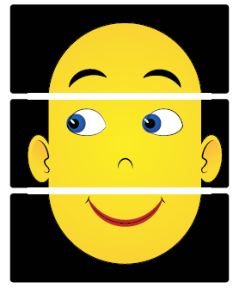

Background
In April 2006, the project leader submitted a formal proposal to develop a series of interactive tactile/print books to encourage young children's development and understanding of basic concepts related to shape, texture, spatial concepts, counting, etc. Flip-Over Concept Books incorporate an interactive feature whereby the child independently flips pages or adjacent print/tactile panels that can be matched or sequenced. The panels turn so that, for instance, the child can find all of the panels that have a rough texture, continue a line path, complete a sequence, build an image, etc. Over a decade later, APH has introduced three unique books as part of the Flip-Over Concept Books series, including LINE PATHS, PARTS OF A WHOLE, and TEXTURES; two additional books—FRACTIONS and TELLING TIME—are currently under development (see separate annual reports). Even after years of availability, the first three books continue to sell in large numbers: LINE PATHS—430 (FY14); 317 (FY15); 311 (FY16); PARTS OF A WHOLE—407 (FY14); 387 (FY15); 263 (FY16); TEXTURES—810 (FY14); 787 (FY15); 567 (FY16).

During the field test of the first two Flip-Over Concept Books, field evaluators requested additional books, including ones with recreational themes. Over half (62%) of the field evaluators requested funny faces that could be built with a stack of facial features.
Unlike previous and more recent Flip-Over Concept Books, MAKE A FACE will not require correct pairing or sequencing of panels; instead, it will encourage open-ended, independent use by the student as she learns to discriminate subtle differences between shapes that represent different eyebrow, eye, and mouth panels. The faces morph with a simple flip of a panel (top, middle, or bottom) to generate a new face combination to be explored by the student. In the process, shifting facial features will lead to discussion and exploration of different line types, textures, and tactile shapes. Exploration of the tactile faces will allow young fingers to trace the upward or downward curve of a mouth, the downward or upward slant of the eyes/eyebrows, and so forth. Related facial expressions (e.g., happy, sad, surprised, puzzled) can be reviewed as well. MAKE A FACE will accommodate relaxed and recreational tactile learning experiences for young students without the stress of sorting panels in a particular order/sequence.

In January 2017, the project leader submitted a formal product submission form that recommended the development of Flip-Over Concept Books: MAKE A FACE, which will function similarly to previous Flip-Over Concept Books. Specifically, it will feature freely rotating panels that are threaded onto a ProClick® binding, allowing the removal and repositioning of panels, if desired. The panels will be printed and vacuum-formed on .010-in. white vinyl. Separate braille and large print versions of the Reader’s Guide will be included with the flip-over book to outline recommended and extended uses. The student will orient the flip-over book vertically with the binding on the left as panels are flipped right to left or left to right. The back panel will consist of a durable polyblend cover. Raised separators or notches might be formed within the back cover so that panels can be locked into a definite location to minimize scissoring of adjacent panels during tactile exploration. The anticipated overall size of the MAKE A FACE will be larger than previous books in the series.

Prior to review and approval by the Product Evaluation Team (PET) and the Product Advisory and Review Committee (PARC), the product idea was reviewed by additional APH staff. The Early Childhood Project Leader indicated, “The Flip-Over Concept book would provide a fun first step in learning about facial expressions which is often difficult for kids with congenital blindness, but moreover present an amazing tactile graphics learning activity. What a great addition to the existing Flip-Over series.” In May 2017, the book concept was considered and approved for development by PET and PARC.

Throughout the third quarter of FY 2017, the project leader and graphic designer experimented with preliminary designs of the facial panels. The panels are separated into three groupings: eyebrow position, eye direction/shape (with constant ear and nose shapes), and mouth shape. The goal is to provide a minimum of 10 unique panels for each facial feature to accommodate 1,000 possible combinations of facial expressions.

In August 1017, the project leader brainstormed the possibility of developing iOS® apps to complement existing or planned Flip-Over Concept Books. A formal Product Modernization Form was prepared and submitted for consideration by the PET and PARC committees. The project leader suggested three books within the series for app-development: MAKE A FACE, LINE PATHS, and PARTS OF A WHOLE. It was expected that similar visual artwork developed for the tactile books would be utilized for the creation of the corresponding apps. In September 2017, the PET committee approved the modernization proposal and forwarded it to the PARC committee.

Work during FY 2018
Continued focus and priority on the production tooling development and completion for two other Flip-Over Concept Books currently in the pipeline —that is, FRACTIONS and TELLING TIME—freed the project leader’s time to further investigate app designs for existing and planned flip-over books. She prepared brief electronic-slide simulations to demonstrate the expected look and functionality of the proposed apps to the PET and PARC committees. Theoretically, regardless of concept presented, students could “flip” or change panels using swiping gestures on an iPad® or other iOS® device.

In November 2017, the PARC committee approved the development of an app for MAKE A FACE, later renamed Flip-Over FACES App (see separate annual report). At that time, development of the physical tactile/print book, MAKE A FACE, was postponed; attention immediately shifted to the development of the corresponding app. However, many of the facial-feature artwork previously rendered for the physical book conveniently segued to the app’s design, thus expediting the latter toward the field-test stage.

Work planned for FY 2019
According to a new matrix-scoring process used by an in-house review committee to evaluate all APH product ideas and endeavors, Flip-Over Concept Books: MAKE A FACE garnered a weighted score of 55 out of a possible 93. In an effort to minimize the number of active projects on a given project leader’s work plate, as well as time demands on other staff resources, MAKE A FACE officially reverted to on-hold status as of July 2018. Reintroduction of this project to active status hinges on the completion of projects closer to availability and the reassessment of the project leader’s priorities. If the project re-enters the active project pipeline in FY 2019, the project leader will utilize gathered field test data for the Flip-Over FACES App to directly impact the eventual design for the tactile/print flip-over book, MAKE A FACE.

PermaBrailleTM [Modernization]
(Continued)

Purpose
To identify a suitable vinyl material for the purpose of extending routine and possible uses of APH’s PermaBraillleTM (with, for example, braillewriter, slate stylus, spur-wheel and other cold-forming techniques) to table-top thermoforming and in-house large-scale vacuum-forming tasks

Project Staff
Karen J. Poppe, Tactile Literacy Project Leader
Frank Hayden, Director of Technical & Manufacturing Research
APH Production and Purchasing Staff

Background
In January 2014, the modernization of PermaBrailleTM, a product currently marketed and sold by APH in a variety of package styles, was precipitated by an unexpected, significant increase in the cost and related lead time associated with the incorporated vinyl. In response, the project leader proposed replacing it with another known and tested vinyl type that fulfills the same function and purpose as the current style of PermaBrailleTM, but also extends its use for table-top thermoforming. She also encouraged the utilization of the vinyl for other in-house production tasks to increase volume usage and consequently decrease cost. The considered vinyl was determined to be lead-free and child-safe via required safety-data documentation.

Multiple sheets of the new vinyl were cut to 11.5 x 11-in. size and sent to an outside producer of thermoformed tactile graphics as a preliminary test. Reported outcomes were very positive, prompting the project leader to conduct a more formal field test at sites currently generating thermoformed graphics for students with visual impairments and blindness across the country.

A field test announcement was posted in the April 2014 issue of the APH News. Appropriate field test sites were also recommended by APH staff who regularly communicate and utilize the services of vendors engaged in large-scale production of thermoformed graphics (e.g., prison braille programs). Nine field test sites were selected from a narrow pool of possibilities. Shrink-wrapped packages of 50 sheets of generically titled “Vinyl for Thermoforming” were mailed to participating evaluators on April 28, 2014. Evaluators were instructed to utilize existing tactile masters that they had recently prepared (e.g., maps, graphs) and created with a variety of methods (e.g., collage, ViewPlus® Tiger embosser, foil). The return of completed evaluations and formed samples was requested by May 23, 2014.

One hundred percent of the field test evaluators returned their evaluation forms and tactile samples by the specified due date. One field evaluation site yielded separate reviews from multiple braillists and transcribers; consequently, helpful feedback was garnered from 21 individuals representing the intended target population. Field test sites were predominantly prison braille programs in the states of Indiana, Kentucky, Ohio, South Carolina, South Dakota, Texas, and Washington. The majority (81%) reported using thermoform machines “frequently” (daily/weekly); the remaining percentage (19%) produced thermoformed graphics “occasionally.” Typical annual quantities of produced graphics ranged from a total of 200 to 50,000 units. Collage was the most popular tactile method utilized for creating thermoform masters; 86% of the evaluators reported using this method. Smaller percentages reported using the Tiger Embosser (24%), a hybrid of collage and Tiger Embosser graphics (33%), and other methods such as foil (10%).

Feedback regarding the primary characteristics of the vinyl was very positive, with its size, texture, and durability garnering near-perfect scores as reported in the chart below.

Product Feature | Number of Eval-uators | Average Rating | % for each rating  5= Excellent to 1 = Poor
Product Feature | Number of Eval-uators | Average Rating | 5 | 4 | 3 | 2 | 1
Color (White) | N = 21 | 4.52 | 67% | 19% | 14%
Size (11.5 x 11) | N = 21 | 4.90 | 90% | 10%
Texture | N = 21 | 4.95 | 95% | 5%
Thickness | N = 21 | 4.67 | 75% | 14% | 10%
Durability | N = 21 | 4.90 | 90% | 10%

Scrap rate due to unwanted wrinkling, tearing, bubbling, or other problems was very minimal. Most rejected parts arose during initial setup of heat settings and cycle times. Once the thermoform machine was ideally calibrated, positive and consistent results were typically experienced.

Evaluators used a rating scale of 5 = “noticeably better” to 1 = “noticeably worse” when comparing the field-tested vinyl to the type(s) typically used for thermoforming. More than half of the evaluators (52%) provided a rating of 5, 24% gave a rating of 4, 19% provided a rating of 3 or 3.5, and 5% gave a rating of 2.

Descriptions such as “definitely better than our current product,” “had better suction and made a better copy,” “it doesn’t bubble or wrinkle like the current product we use,” and “lines and edges of textures are more pronounced” clarified the majority’s preference for the new vinyl material, translating into an overall rating of 4.26. When asked to rate the likelihood of using the new vinyl in lieu of material(s) routinely used, 52% responded “definitely” (rating of 5); 24% provided a rating of 4, and another 24% provided a rating of 3. Conversion to the use of another type of vinyl would be, of course, contingent upon a competitive price for the sheets.

Positive feedback from evaluators was complemented by returned samples of thermoformed graphics produced with the field-tested vinyl. Below are examples of the types of graphics constructed using a variety of production masters (e.g., collage, Tiger Embosser, heavy-gauge aluminum foil, and hybrid formats) and the same graphics thermoformed using the vinyl material.

In-house reviews by braille readers confirmed the likability of the vinyl for specific reasons:
      - pleasant to the touch
      - not clingy
      - feels more like paper
      - doesn’t tear easily
      - easy to read for longer periods of time

Similar reactions from a braille-reading perspective were echoed in field evaluator statements:
- “hands slide/glide across paper in a smooth motion”
- “feels nice and crisp”
- “nice sharp braille”
- “great texture and closer to embossed paper”

In late May 2014, the project leader convened the Product Development Committee to review the field test results and returned tactile samples, discuss plans for substitution of the current PermaBrailleTM material, explore wider application for APH in-house production purposes, and estimate needed quantities—both for bulk ordering and consistent packaging of available PermaBrailleTM products. Unanimous support to utilize the new vinyl for both textbook and educational product production was supported by multiple in-house departments (Research, Purchasing, Accessible Tests, and Production).

Quota approval for the bulk packages of PermaBrailleTM was requested and received from the Educational Products Advisory Committee at the 146th Annual Meeting in October. Throughout the fiscal year, in-house meetings were intermittently conducted with staff from Production, Purchasing, and Research departments to discuss the feasibility and related costs of procuring and sheeting the field-tested material. Providing the vinyl sheets in bulk (500 sheets) proved infeasible due to the anticipated high-end price to the customer. Peripheral efforts were made to reintroduce Brailon® in large quantities from APH. On June 22, 2015, an “Airplane” was released for Brailon® (1-04630-00) in 500-sheet packages (in 11.5 x 11 size, 19-hole-punched style) for $55.95 (available with Quota funds).

During FY 2015, momentum on the provision of the new PermaBrailleTM product was nearly halted due to related purchasing costs and procurement issues, paired with the availability of the new Brailon® product from APH. However, the field-tested vinyl continued to be considered as a possible option for future APH products (e.g., Building on Patterns) that required specific readability features that are liked by braille readers.

Throughout both FY 2016 and FY 2017, extensive in-house testing of the .0067-in. vinyl material for larger production runs experienced difficulties. Specifically, webbing/wrinkling of the vinyl was common when employing normal production procedures. However, alternate methods of forming the material (e.g., reversing heating and vacuum cycles on the tabletop vacuum-form machine) were tested with more successful, promising outcomes and little-to-no scrap. Production staff suggested the acquisition of a thinner-gauge, .005-in. vinyl (a nonstandard thickness for the vendor) with the intention of achieving finer-detailed tactile graphics.

Work during FY 2018
Testing and re-testing of the alternate, slightly thinner vinyl for in-house production purposes composed most of the work during FY 2018. Once Production and Purchasing staff felt confident that all “systems were go” on acquiring the .005-in. version for in-house production, as well as for the modernization of PermaBrailleTM, final catalog numbers were assigned for the 500-sheet, 11.5 x 11-in. bulk-size packages (19-hole-punched and un-punched versions), as well as the 50-sheet, 8.5 x 11-in. package. Subsequently, the project leader prepared an updated Product Insert and ushered it through braille translation. The custom-cut sizes, produced to APH’s specifications, made the finished product Quota-eligible.

Introduction of the three unique PermaBrailleTM packages was expected to occur in June 2018. In late April, a formal Gate 5: Specifications meeting was conducted. In anticipation of its debut, the project leader was asked to prepare a write-up to alert customers that this new vinyl would be used in future APH products (e.g., tests and textbooks with tactile graphics). The project leader’s question-and-answer style report titled, “Coming Soon: Different Color…Different Texture…Different Experience,” was featured in the April 2018 issue of APH News.

In early summer, the first sizeable batch of the purchased .005-in. vinyl formed similarly to the previously tested sheets was run. However, a second procurement of the same material, at the same exact thickness, experienced some setbacks during the vacuum-forming process—that is, poorly formed graphics near the outer margins of sheet. The unexpected change was the result of a tension change within the material that occurred during the extrusion process. As of August 2018, APH was working with the vendor to negotiate stress tests for the desired vinyl.

Work planned for FY 2019
APH staff from various departments will continue to problem-solve any remaining issues with the vendor-acquired vinyl for re-introduction of the planned PermaBrailleTM packages. The project leader will assist in monitoring the quality of the material, participate in post-production marketing tasks, and demonstrate possible uses of the product at future tactile graphic conferences/workshops.

Room with a View: Map-Reading Concepts and Skills
Formerly Room with a View: A Tactile Model of Indoor Settings
(Continued)

Purpose
To provide an interactive “room” with an assortment of realistic models that can be used to represent the interior layout of a single room (e.g., bedroom, kitchen, school classroom) or larger venue (e.g., grocery store, library, etc.). Through the use of this tactile room, cognitive mapping skills and spatial understanding can be encouraged and practiced. The product will encourage the transition from three-dimensional models to abstract, two-dimensional layouts as typically encountered in Picture Maker and static raised-line maps.

Project Staff
Karen J. Poppe, Tactile Literacy Project Leader
Rachel Bishop, Research Assistant
Patrick White, Pattern/Model Maker
Andrew Moulton, Manufacturing Specialist
Laura Greenwell, Graphic Designer
Matthew Poppe, Graphic Designer
Anthony Jones, Director of Creative Services

Background
As conceptualized by the project leader, the product will be an “indoor” equivalent to APH’s Tactile Town. Tactile Town primarily focuses on outdoor settings (e.g., street layouts, multi-block arrangements); in contrast, Room with a View: Map-Reading Skills and Concepts will address indoor surroundings and layouts. The concept of perspective will also be emphasized via tactile observation of the room from various angles (e.g., front view, top view, side view). Lesson plans will encourage the student to “re-draw” the room independently using a variety of tactile materials (e.g., DRAFTSMAN, flat VELCRO® brand compatible or magnetic shapes).

The product addresses the following needs and requests from the field:
- Provide additional interactive tactile materials to assist students’ understanding of the world around them.
- Allow exposure to tactile graphic displays within a purposeful context (e.g., understanding a room layout and how the view of a room can change depending on one’s perspective and physical position in a room).
- Promote the transition from three-dimensional layouts to abstract and/or permanent raised-line graphics.
- Design materials that engage a young child/student in open-ended creative activities (e.g., building and designing room layouts).
- Address specific requests from the field as garnered from Tactile Town field evaluators and attendees of Tactile Town product training sessions such as the following:
- “Expand this fantastic tool to include parts of inside of buildings to orient students to a library, grocery store, and school building.”
- “I would love to have a doll-sized house and store that is designed for teaching O&M to illustrate floors and how rooms and hallways exist in all these structures.”
- The need for this product was echoed at NFB’s 2013 Tactile Graphics Conference in Baltimore, MD, by an audience member during the project leader’s presentation on the development of early tactile skills and concepts.

Successfully navigating an indoor setting can be assisted by the modeling of a room’s layout via the use of models. Creating a tactile map allows a student with visual impairment/blindness to “establish a better understanding of the ‘big picture’ of the classroom layout and/or school environment.” iris.peabody.vanderbilt.edu/module/v01-clearview/cresource/q2/p06/

“Touch plays a role in our understanding of spatial awareness in the same way that we rely on our sense of sight. Feeling a three-dimensional model to comprehend a layout of a room triggers the same part of the brain that would have been activated if the room was seen.”—Dr. Thomas Wolbers, Centre for Cognitive and Neural Systems www.ed.ac.uk/news/all-news/spatial-260511

The former field evaluation of Tactile Town, with 114 students with visual impairments and blindness, will greatly impact and guide the design and presentation of Room with a View. Field test results indicated that a three-dimensional realistic model was beneficial to the target populations because of the following features:
- allows the construction of concrete, understandable representations
- interactive, versatile, and engaging
- accommodates many layouts
- both colorful and tactile
- quick to put together and take apart
- addresses many concepts (e.g., directionality, spatial and positional terms, walking routes, interpretation of tactile layouts/maps)
- realistic detail of manipulative/models
- pretend-play opportunities

Anticipated target populations for Room with a View will likely mirror those for Tactile Town, specifically preschoolers and students in Grades K-3 with visual impairments/blindness, as well as low vision and tactile readers in Grades 4-8. However, the product could potentially be used by older students and adults who want to make a mockup of a layout of a room in a more realistic manner. The format of the product will appeal to sighted peers and family members as well.

In May 2013, the project leader prepared a formal Product Submission Form describing the unique purpose and need for Room with a View. In August 2013, the concept was considered and approved for development by both the Product Evaluation Team and Product Advisory and Review Committee.

Significant work on Room with a View was curtailed during FY 2014 and FY 2015 by the project leader’s involvement in higher priority projects that were in later stages of development, field testing, and/or production. However, the project leader gave periodic thought to anticipated components and tools for Room with a View including the following:
- A pivoting “room” for attaching room features and positioning and re-positioning 3D models (e.g., tables, chairs, windows, doorways, steps, people, and so forth)
- An assortment of models that are APH-designed and/or purchased from outside vendors
- Tactile graphic layouts that serve as examples of room layouts
- Guidebook with lesson plans
- CD with accessible files and recording forms
- Carrying/sorting box for provided materials

The project leader initially focused on finding a feasible production method for designing the walls of the room. Specifically, the project leader needed walls that could be adjusted to various sizes and configurations, but were also durable and colorful with tactually discernible windows and door(s). She built a representative model using 3 mm thick foam with interlocking, jigsaw-puzzle-like sides. When locked together, the walls stand upright and can be positioned on a VELTEX® brand surface via hook material. It is anticipated that the outer sides of the foam wall will be silkscreened with a visual pattern (e.g., brick wall) to provide realism and visual interest/contrast. In theory, sets of walls in different lengths and designs (e.g., with or without doors/windows, etc.) can be provided to accommodate a variety of room scenarios.

The project leader also investigated commercially available miniature furniture and possible in-house 3-D printing or liquid resin options for generating APH original parts. Plans also included the incorporation of APH existing manipulatives (e.g., people models from Tactile Town).

Noticeable strides were made on the development of the Room with a View prototype throughout FY 2016. Innovative approaches to the design and construction of 3-D manipulatives and related tactile materials were executed, especially the following:
- An in-house 3-D printer was used to generate a variety of common room features (e.g., bed, desk, couch, bookshelf, stairs) as well as a person figure in two different styles. The project team made style tweaks to multiple iterations of the 3-D designs to ensure tactile clarity, durability, and realistic representation. Patrick White created the original STL files, and Andrew Moulton printed them via the 3-D printer.
- The wall styles of two different lengths were die cut out of 3 mm blue EVA foam. The wall styles varied by window and door location and quantity of each.
- Three roof sizes were designed and formed out of yellow polyblend and die cut with a remaining “pie crust” to rest on the upper surface of the vertically positioned foam walls.
- Common 2-D room layouts were designed via CorelDRAW® using the “footprints” of the 3D pieces; one-to-one size and shape consistency was maintained between the two styles. The room layouts captured a variety of settings (e.g., a kitchen, living room, bedroom, classroom, office, bookstore/library, and a grocery store). The two-dimensional room layouts were eventually output via the Roland® UV printer, negating the need for vacuum-form setups. The tactile height, generated via multiple ink passes on the printer, was sufficient for field testing purposes.

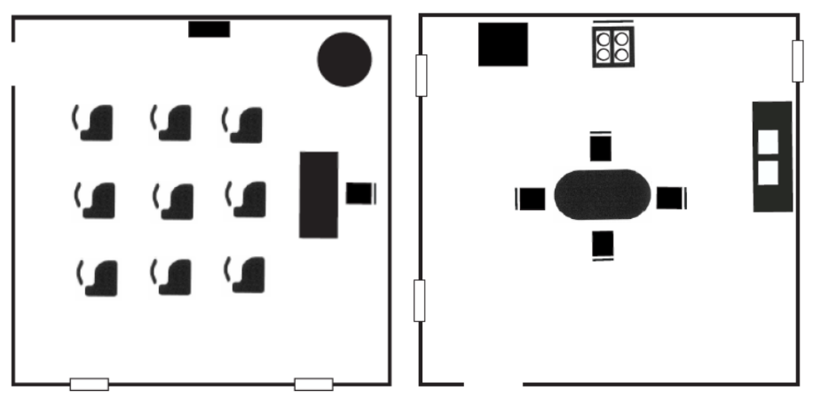

- A Room with a View template was designed to allow instructors to customize their own room layouts. The template includes 2D “footprint” images of the walls and room features included in the kit. Two versions of this template are now available for free download on APH’s Tactile Graphic Image Library—one with an 8.5 x 11-in. canvas and the other with an 11.5 x 11-in. canvas. An accompanying tutorial was scripted, directed, and narrated by the project leader and Matthew Poppe. It is posted online (youtu.be/1NFa9Dirr-w) for field test evaluators to assess its usefulness and application during the field test phase.

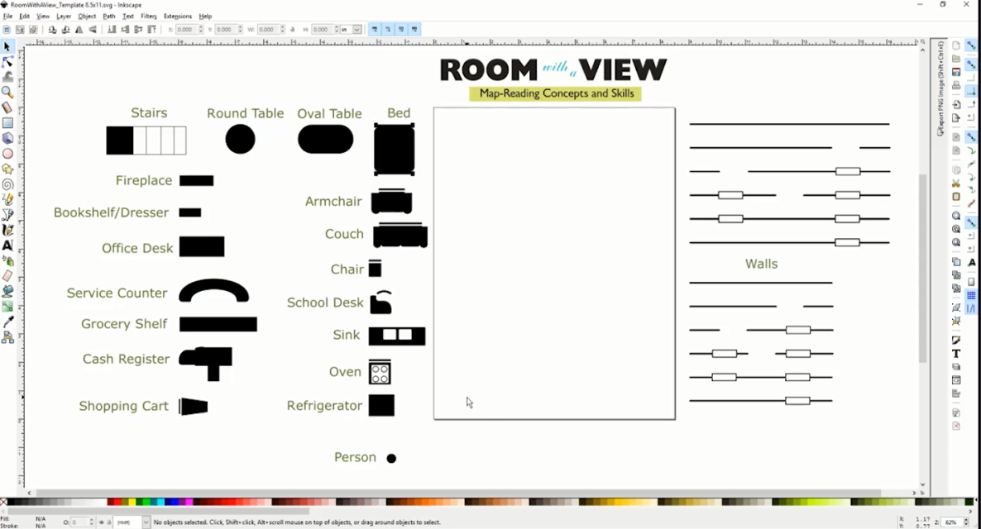

The artwork for the product logo, guidebook covers, felt board inserts, and outer carrying box were prepared by Laura Greenwell. By the end of July 2016, the entire structural design of the product itself was determined. The project leader and research assistant focused the last quarter of the fiscal year on writing and editing the guidebook content, which would be used in field testing.

A field-test announcement was posted in the October 2016 APH News. More than 65 teachers of the visually impaired and orientation and mobility specialists expressed interest in participating in the evaluation of Room with a View. From this sample, 10 field-evaluation sites were selected based upon geographic location, number of available students, and type of instructional setting; preference was given to those who had not recently field tested an APH product. Some selected sites allowed multiple teachers to share and evaluate the prototype.

Potential evaluators gave reasons for wishing to field test Room with a View with their students with visual impairments and blindness; reasons hinted at the product’s usefulness even before the formal field test. Their shared explanations included the following:
- “My interest in this product is that I struggle with how to give students a 3D representation of rooms and interiors of buildings so they can build their mental maps and concept development. This product seems like it would be a great addition to my tools.”
- “I believe this product could benefit a lot of my students in the realm of initial room orientation and familiarization, spatial concepts, positional concepts, cognitive mapping, and room construction.”
- “We have students that struggle with map reading on a 2D level, so having items that are more 3D to use with those students might help with their understanding of how the classrooms and school are laid out.”
- “Most of my students are functional-academic and have some issues with processing and memory. There can be some spatial relation difficulties. I think having an organized system of presenting some of these concepts would be helpful.”
- “We have been saying for years that we need something like this to try with adults who come here who do not have the opportunity to develop spatial understanding and cognitive mapping skills when they were younger.”

Prototypes of the Room with a View were mailed to selected field evaluators on November 28, 2016. Evaluators were asked to return their completed evaluation forms and student-outcome forms by March 10, 2017. The deadline was extended a week or two if additional time was requested by an evaluator. By the end of the month, 100% of the evaluators had returned their forms.
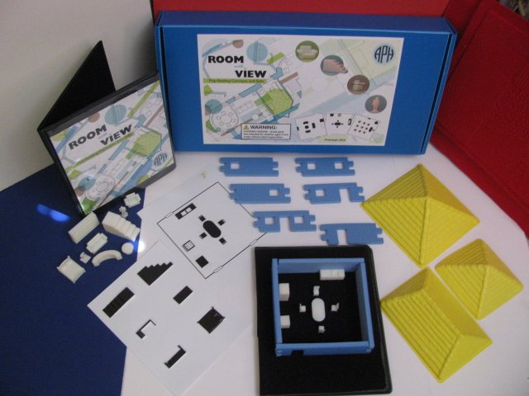

In April 2017, the project leader compiled a final field-test report. Field-test evaluation forms were completed by 11 teachers of the visually impaired and blind and/or certified orientation and mobility specialists (COMS). The field evaluators represented the states of California, Colorado (2), Florida, Iowa, Michigan, Mississippi, Ohio, Rhode Island, Vermont, and Washington. The largest percentage (73%) of sites represented itinerant settings. Table 1 and Figure 1 show the distribution of field-test sites according to type of educational setting and geographical location.

Table 1
Type of Educational Setting
Type of Educational Setting (N=11) | State Location of Field Test Sites | Percentage
Itinerant | CA, CO (2), FL, IA, MI, RI, VT, | 73%
Residential | OH, MS | 18%
Itinerant/Resource | WA | 9%
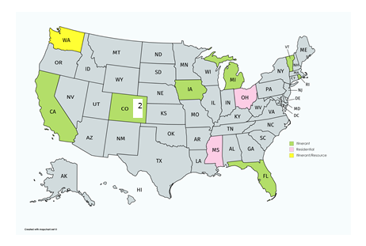
Figure 1. Geographical Distribution and Educational Setting of Field Test Sites.
Participating field evaluators represented teachers of the visually impaired and/or COMS with varied teaching experience; 27% had less than one year of teaching experience, 45% had 6-10 years of teaching experience, 18% had 11-15 years of teaching experience, and the remaining 9% had 21 or more years of teaching experience. All of the field evaluators noted difficulties that students with visual impairments and blindness tend to experience related to map-reading concepts and skills. Some of these challenges included the following:
- “Grasping the large picture of the whole room.”
- “Orienting a map to the real world and keeping it oriented as they move in space.”
- “Understanding a bird’s eye view. Putting themselves into a map mentally. Comparing real world to a map.”
- “Generalizing the map to reality; building on concepts of different rooms within a building—the doorway/window concepts; 3D to 2D.”
- “They have the most difficulty understanding the relationship between things (objects in the rooms, the rooms to each other, buildings to each other, etc.).”

Prior to field testing Room with a View, the field evaluators had used other materials and tools, commercially available or from APH, to teach map-reading skills and concepts to their students. Commonplace tools included Tactile Town, Picture Maker: Wheatley Tactile Diagramming Kit, TREKS, O&M Tactile Graphics, Quick-Draw Paper, DRAFTSMAN, homemade maps, Wikki Stix®, and foam cutouts/textured paper.

The field evaluators used Room with a View with a total of 48 students who represented noticeably more males (63%) than females (37%). The sample population represented cultural diversity: 56% White, 15% Hispanic, 6% Black, 6% Asian, 2% Native Hawaiian/Pacific Islander, 9% two or more races, and 6% “other” (see Figure 2). The majority (65%) of the students had other disabilities, such as cerebral palsy, Down syndrome, attention deficit disorder, dyslexia, autism, and learning disabilities.

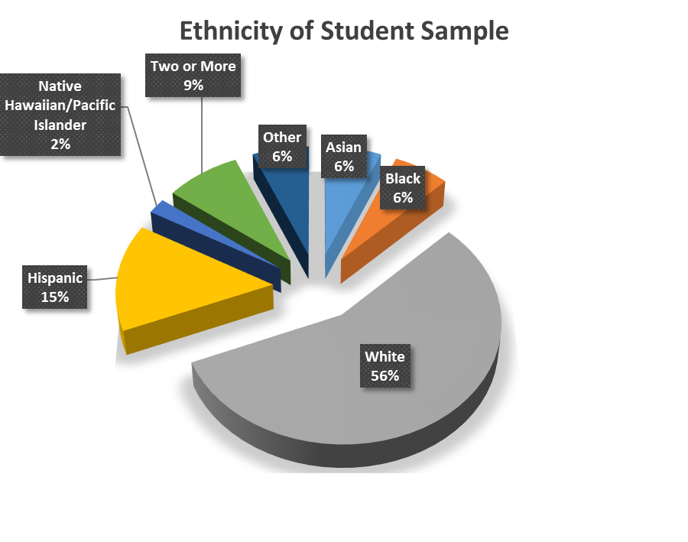
Figure 2. Students’ Ethnicity

Students ranged in age from 4 to 16 years. The majority of the students were either 7 to 9 years old (38%) or 13 to 16 years old (31%); 12% were 4 to 6 years old, and 19% were 10 to 12 years old. (See Figure 3.)

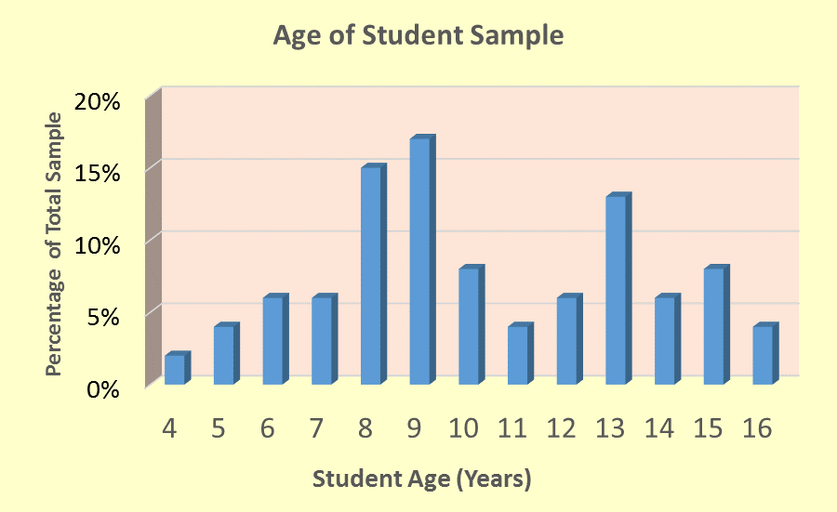
Figure 3. Students’ Age Range

With regard to grade level representations, nearly equal percentages of students were in Grades K to 3 (44%) or Grades 4 to 8 (42%); only 15% were in high school. (See Figure 4.)

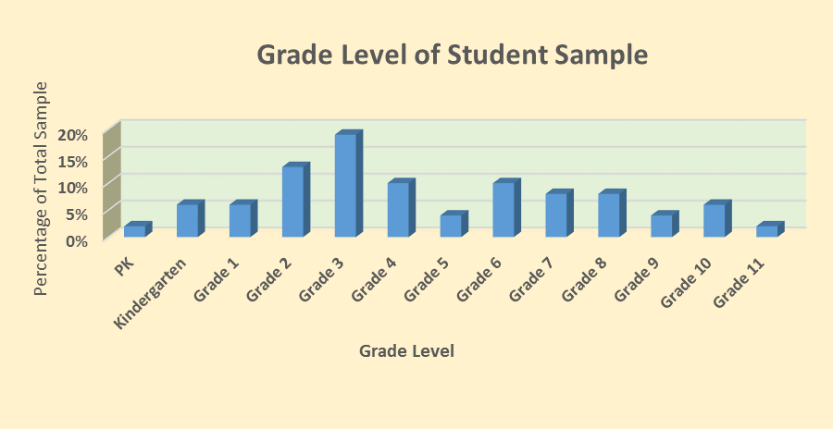
Figure 4. Students’ Grade Level
Braille readers comprised the largest percentage (34%) of the student sample; 25% were large print readers, 18% were dual readers (e.g., auditory/braille, large print/braille), 15% read print with magnification, 6% were auditory readers, and 2% were prereaders. (See Figure 5.)

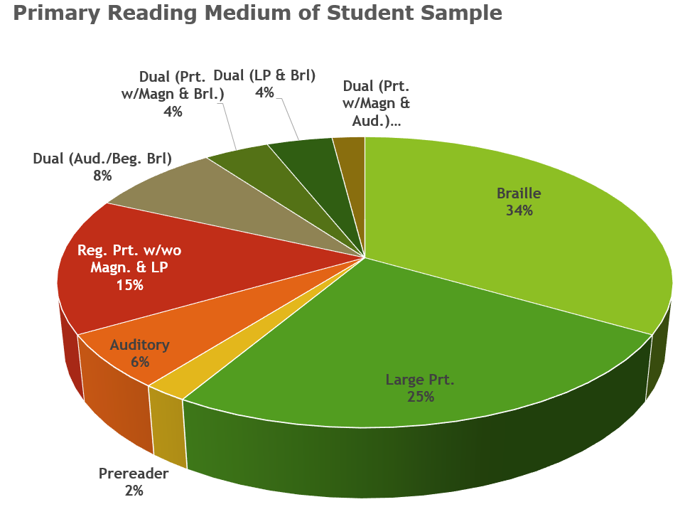

Figure 5. Students' Primary Reading Medium
The field-evaluation form allowed teachers to rate the overall design features of Room with a View. Table 2 indicates the average rating for each feature.

Table 2
Overall Design Features of Room with a View
Rating Scale: 5 = Excellent to 1 = Poor (or Unneeded)
Product Feature | Number of Evaluators | Average Rating | 5 | 4 | 3 | 2 | 1
Overall presentation | N = 11 | 4.36 | 45% | 45% | 9%
Tactile/print 2D room layouts | N = 11 | 4.64 | 64% | 36%
3D models | N = 11 | 3.82 | 9% | 73% | 9% | 9%
RWAV felt board | N = 11 | 4.91 | 91% | 9%
Interlocking foam walls | N = 11 | 4.09 | 18% | 73% | 9%
Roofs (three sizes) | N = 10 | 3.90 | 50% | 30% |  |  | 20%
Instruction booklet | N = 11 | 4.64 | 64% | 36%
RWAV template and related tutorial | N = 8 | 4.63 | 63% | 37%
Packaging/storage style | N = 11 | 3.82 | 9% | 64% | 27%

Field evaluators provided very positive ratings for the 3D models with regard to their overall design (refer to Table 3) and with regard to each model’s specific structural design (refer to Table 4).

Table 3
Overall Design of 3D Models
Rating Scale: 5 = Excellent to 1 = Poor
Product Feature | Number of Evaluators | Average Rating | 5 | 4 | 3 | 2 | 1
Overall size/scale of 3D models | N = 11 | 4.64 | 64% | 36%
Color/contrast with black RWAV felt board | N = 11 | 4.72 | 73% | 27%
Assortment/types of 3D models | N = 11 | 4.45 | 45% | 55%
Durability of 3D models | N = 11 | 3.91 | 27% | 55% | 9% |  | 9%
Storage style | N = 11 | 3.91 | 18% | 55% | 27%

Table 4
Specific Design of 3D Models
Rating Scale: 5 = Excellent to 1 = Poor
Product Feature | Number of Evaluators | Average Rating | 5 | 4.5 | 4 | 3 | 2 | 1
Grocery/bookshelf | N = 11 | 4.82 | 82% |  | 18%
Small bookshelf | N = 11 | 4.55 | 55% |  | 45%
Chest of drawers | N = 11 | 4.73 | 73% |  | 27%
Office desk | N = 11 | 4.45 | 45% |  | 55%
Staircase | N = 11 | 4.77 | 73% | 9% | 18%
Refrigerator | N = 11 | 4.73 | 73% |  | 27%
Oblong table | N = 11 | 4.73 | 73% |  | 27%
Armchair | N = 10 | 4.80 | 80% |  | 20%
Couch/large sofa | N = 11 | 4.82 | 82% |  | 18%
Checkout counter | N = 10 | 4.80 | 80% |  | 20%
Human figurine (2 styles) | N = 11 | 4.55 | 55% |  | 45%
Grocery cart | N = 10 | 4.40 | 50% |  | 40% | 10%
Small chair | N = 11 | 4.36 | 45% |  | 45% | 9%
Round table | N = 10 | 4.60 | 70% |  | 20% | 10%
Kitchen sink | N = 11 | 4.64 | 73% |  | 18% | 9%
Service counter | N = 9 | 4.89 | 89% |  | 11%
Oven/stove | N = 11 | 4.64 | 73% |  | 18% | 9%
Bed | N = 11 | 4.64 | 64% |  | 36%
Classroom desk | N = 10 | 4.20 | 50% |  | 30% | 10% | 10%
TV screen | N = 11 | 4.45 | 64% |  | 27% |  | 9%
Computer monitor | N = 11 | 4.64 | 64% |  | 36%
Fireplace | N = 11 | 4.27 | 64% |  | 18% |  | 18%

Likewise, the 2D room layouts garnered strong evaluator ratings across multiple design features (refer to Table 5). These tactile/print layouts facilitated students’ transition from 3D room displays to less concrete representations showing top-view perspectives of various room scenarios (e.g., grocery, classroom, bedroom, etc.).
Table 5
Design Features of 2D Room Layouts
Rating Scale: 5 = Excellent to 1 = Poor
Product Feature | Number of Evaluators | Average Rating | 5 | 4 | 3 | 2 | 1
Visual presentation/quality | N = 11 | 4.82 | 82% | 18%
Tactile presentation/quality | N = 11 | 4.64 | 73% | 18% | 9%
Assortment of 2D room layouts (13 total) | N = 11 | 4.64 | 64% | 36%
Inclusion of 2D layouts showing top-view and side-view perspectives of desk, stairs, and bed | N = 11 | 4.27 | 64% | 18% | 9% |  | 9%
Usefulness of tactile lines to indicate back of chairs and sofas and denote directionality | N = 10 | 4.60 | 70% | 20% | 10%
Print/braille page number to indicate orientation of layout | N = 11 | 4.91 | 91% | 9%
One-to-one correspondence with 3D models | N = 11 | 4.73 | 73% | 27%
Durability of 2D room layouts | N = 10 | 4.80 | 80% | 20%
Storage style (inside clear folder) | N = 11 | 4.55 | 64% | 27% | 9%

The linkable foam walls received promising ratings for the most part; the “ease of linking walls together” received the lowest rating of 3.91 (refer to Table 6). This feature will be improved in the final product via implementation of an interference fit during the die-cut process; this will ensure a snugger fit when walls are linked together.

Table 6
Design Features of Linkable Foam Walls
Rating Scale: 5 = Excellent to 1 = Poor
Product Feature | Number of Evaluators | Average Rating | 5 | 4 | 3 | 2 | 1
Color (blue) | N = 11 | 4.64 | 64% | 36%
Texture (rough and smooth opposite sides) | N = 10 | 4.80 | 80% | 20%
Ease of linking together | N = 11 | 3.91 | 27% | 36% | 36%
Quantity (10 walls in two different lengths) | N = 11 | 4.64 | 64% | 36%
Door and window configurations and options | N = 11 | 4.55 | 55% | 45%
Length/height of walls in combination with 3D models | N = 11 | 4.82 | 82% | 18%

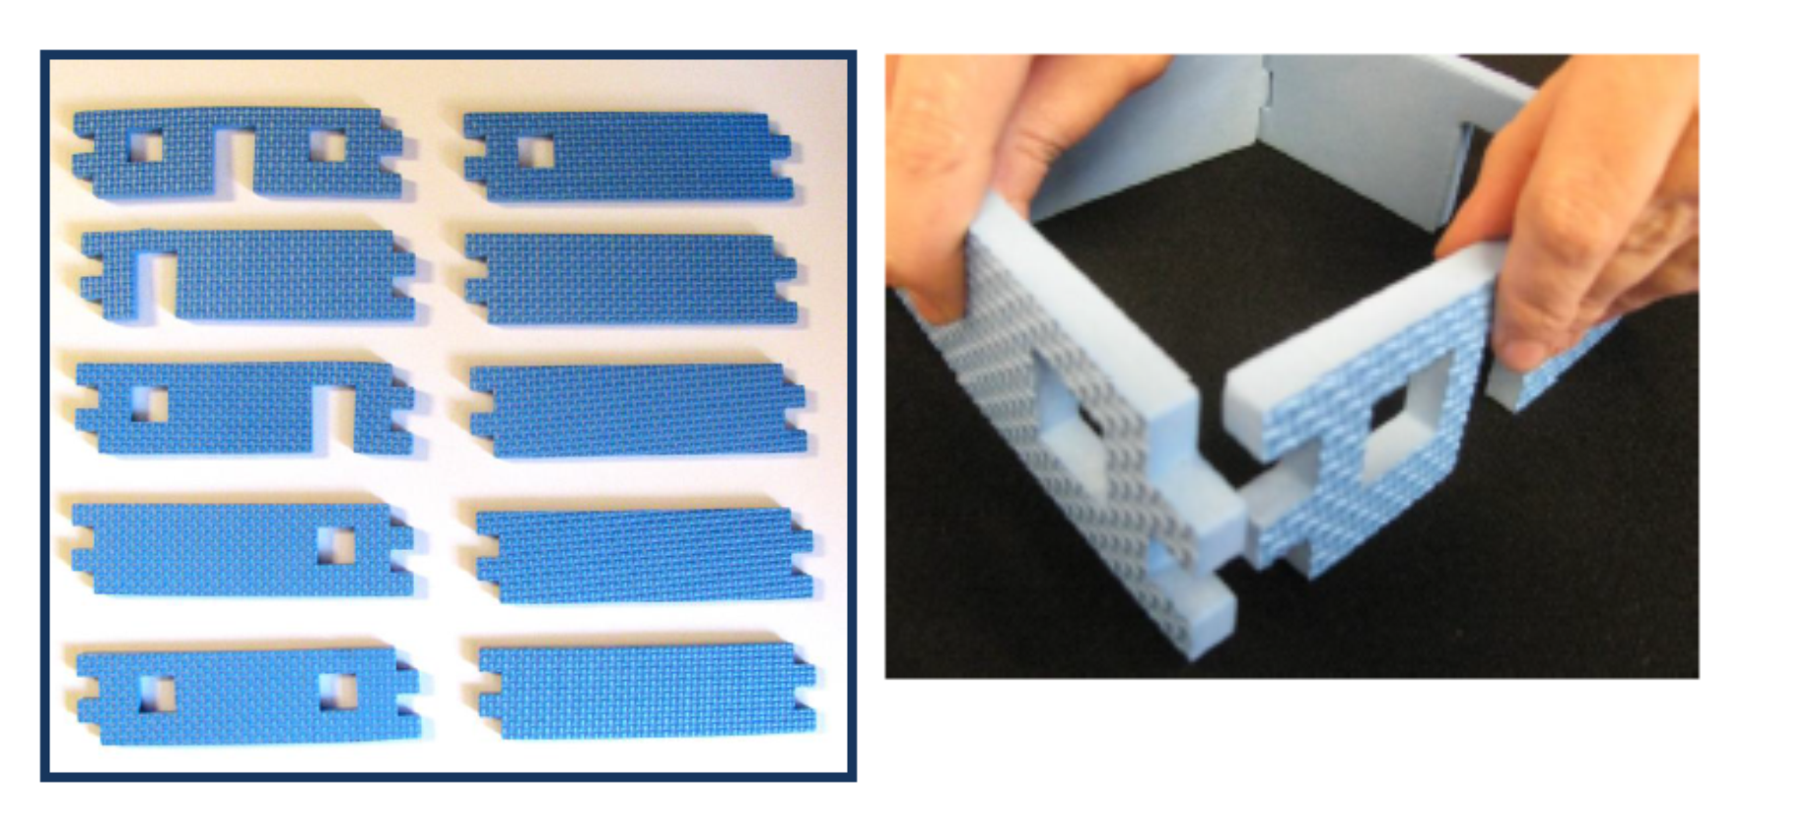
Although the inclusion of a roof to demonstrate top-view perspectives of a room was very helpful, the roofs in three different sizes were not frequently used. The number of roofs also contributed to difficulty closing the outer box lid. Therefore, the number of roofs within the final kit will be trimmed from three to just one. Table 7 provides evaluator ratings for the roof styles.

Table 7
Design Features of Roof Styles
Rating Scale: 5 = Excellent to 1 = Poor
Product Feature | Number of Evaluators | Average Rating | 5 | 4 | 3 | 2 | 1
Assortment of sizes | N = 11 | 4.36 | 73% | 9% | 9% |  | 9%
Color (yellow) | N = 11 | 4.73 | 82% | 9% | 9%
Texture | N = 10 | 4.90 | 90% | 10%
Ease of propping on top of constructed foam walls | N = 10 | 4.90 | 90% | 10%
Storage style | N = 9 | 4.33 | 44% | 44% | 11%

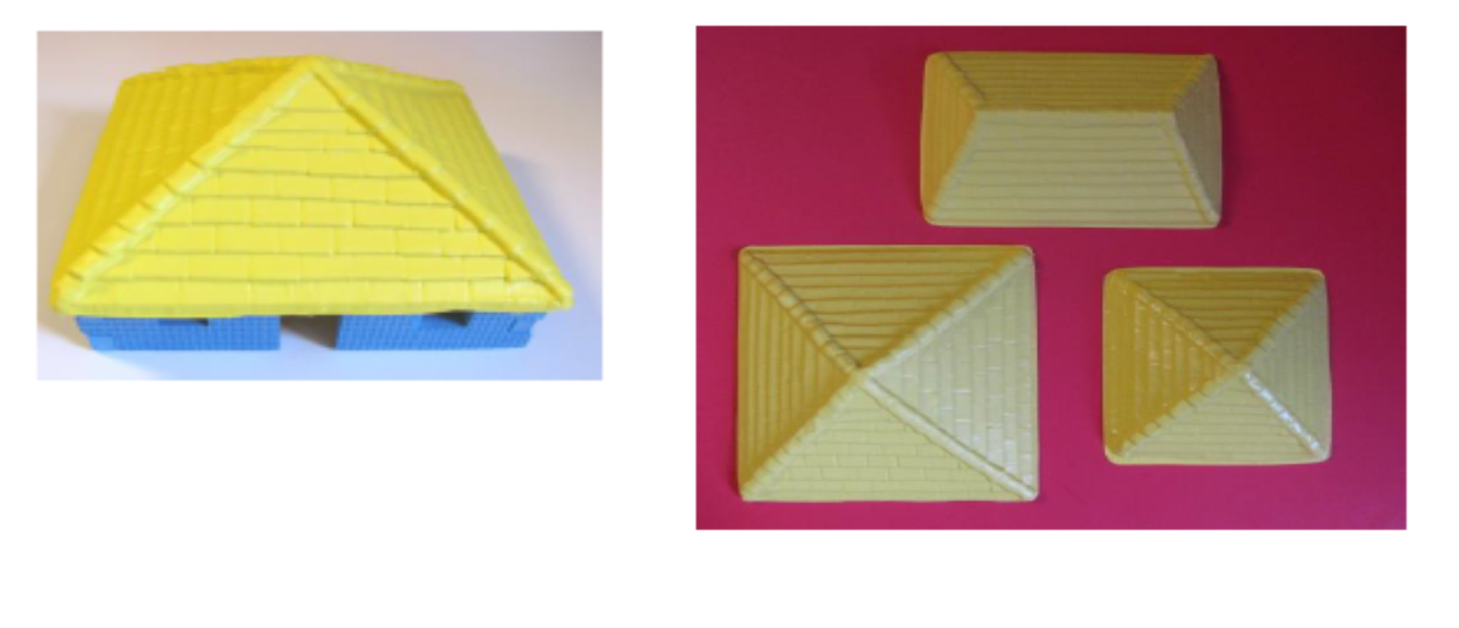
Other unique features of Room with a View received high ratings, including the felt board (4.91) and the template and tutorial (4.63). One evaluator commented that the felt board “worked well with all the pieces in the kit. Having two sides allows the 2D map to be alongside the building space of the 3D map.” With regard to the tutorial, 82% of the field evaluators indicated that this component was helpful in learning how to use the template and that the template itself was a useful component. One evaluator indicated, “This was a very well done tutorial that really seemed to address most issues there could be with the program.” Another teacher noted that the template “is the most flexible piece of the unit and for my older students would be more helpful because they wanted actual room creation capabilities.”

One hundred percent of the field evaluators thought the accompanying Instruction Booklet sufficiently described the purpose and the use of Room with a View; they unanimously liked the layout and design of the booklet as well. Ninety-one percent of the field evaluators described the included “Checklist of Concepts” as a helpful resource. Table 8 shows the degree of usefulness for each chapter section as assessed by the field evaluators.

Table 8
Usefulness of Chapter Sections
N = 11
Chapter Section | Very Helpful | Somewhat Helpful | Not Helpful
List of Materials | 100%
Initial Orientation/Setup | 91% |  | 9%
Focusing on Details | 82% | 18%
Spatial Skills and Concepts Using the 2D Layout | 91% |  | 9%
Spatial Skills and Concepts Using the 3D Layout | 91% | 9%
Change of Perspective | 82% | 18%
Creative Approaches | 82% | 18%
Real Room Experiences | 82% | 18%

Room with a View was favorably received by the students themselves. Evaluators indicated that 100% of the students enjoyed using the prototype. Comments ranged from a short, enthusiastic “Very much!” to lengthier explanations for its positive reception: “They wanted to go through all the pieces and make their own maps,” and “They like making models and seeing how the 2D and 3D representations matched each other. They liked making their own room configurations and describing them to me.” According to 73% of the evaluators, Room with a View increased their students’ interest in reading and constructing maps.

The majority (91%) of the evaluators indicated that Room with a View offered specific advantages over other map-reading products, homemade or commercially available, including
- “The ability to teach perspectives in a tangible way;”
- “More variety of tactile items;”
- “Quick and easy to use;”
- “Very convenient to use and a nice to have accurate furniture pieces;”
- “I never had 2D and 3D maps that matched before and this was very beneficial;”
- “Stronger and better 3D pieces, 2D models, an instructional manual, online tutorial, and nice casing to store it all;”
- “The objects and walls were more interesting than just textures to students.”

Table 9 reveals the field evaluators’ assessment of how effectively Room with a View promoted the development of tactile map-reading skills and concepts.

Table 9
Effectiveness of Room with a View
The purpose of Room with a View is to promote tactile map-reading skills and concepts. Did Room with a View meet this learning objective?
Rating Scale: 7 = Strongly Agree to 1 = Strongly Disagree
N = 10
7  Strongly Agree | 6 | 5 | 4 |  | 3 |  | 2 | 1  Strongly  Disagree
70% | 10% | 20%

Table 10 indicates the evaluator ratings for the product’s usefulness for promoting specific skills and concepts.

Table 10
Skills/Concepts Promoted with Use of Room with a View
Rating Scale: 7 = Extremely well to 1 = Not at all
Skill/Concept | Number of Evaluators | Average Rating | 7 | 6 | 5 | 4 | 3 | 2 |  | 1
Understanding perspective | N = 11 | 6.64 | 73% | 18% | 9%
Understanding spatial skills | N = 11 | 6.36 | 45% | 45% | 9%
Understanding cardinal directions | N = 11 | 6.00 | 55% | 27% |  |  | 18%
Symbolic understanding | N = 11 | 6.50 | 64% | 18%  9% (5.5) | 9%
Transition from 3D to 2D representations | N = 11 | 6.45 | 64% | 27% |  | 9%
Increased interest in constructing tactile maps | N = 11 | 6.09 | 55% | 36% |  |  |  |  | 9%
Interest in pretend play activities | N = 11 | 6.64 | 73% | 18% | 9%

Data collected via 48 Student Outcome Forms also illuminated strides made by individual students. The students’ prior experience with reading tactile maps varied: 25% had no previous experience, 46% had limited experience, 25% had frequent experience, and 4% had extensive experience. The most-witnessed improvements among the student sample related to three skill/concept areas: understanding perspective (73%), symbolic understanding (65%), and increased interest in constructing maps (58%). The degree of interest that the students exhibited during the use of Room with a View ranged from “very interested” (65%) to “somewhat interested” (31%) to “uninterested” (4%). The likelihood of wanting to use the product again in the future was “very likely” for 73% of the students. Specific aspects of the product enjoyed by the students included the following:
- “Loved the pretend play aspect.”
- “Excited that there were actual objects for the things he typically encounters day to day.”
- “Being able to set up and create their classroom.”
- “Really interested in the page of top-view and side-view of objects.”
- “Really liked the Spatial Skills and Concepts questions asked.”
- “Excited to explore the different options for furniture.”
- “Enjoyed building to match the 2D maps and creating a familiar classroom from memory.”
- “Enjoyed creating her own room and talking about how she has similar rooms at home with the same pieces of furniture.”
- “Enjoyed the use of the walls with cutouts representing windows and doors; he felt it made a much better representation than the tactile maps we had used previously.”

One hundred percent of the field evaluators recommended that APH produce Room with a View. Supportive comments regarding its strengths included the following:
- “This is a great product to add to our O&M toolkit.”
- “Absolutely. It is a fantastic conceptual product and idea!”
- “It allows students to create actual environments using actual objects to represent what they find in the real world. This allows them to work on object orientation and relationships between objects that can’t be done in the same way with any other kit I have found.”
- “Engaging for students, flexible uses, ability to customize with 3D template and 3D printing; saves me time in creating materials.”
- “Everything! I really liked this…I think this will be a great addition to APH’s catalog.”
- “Obviously, it is quick to construct a room and the furniture is very true to form and function. I think you thought of everything, with lesson ideas that come with it, the 2D sheets, and the lifelike furniture.”
- “Provides a nice tactile opportunity for students to experience an interior environment, and the various features within it.”

As Table 11 reveals, the most appropriate target populations for Room with a View, as assessed by the 11 field evaluators, are tactile and low vision kindergarteners and students in early elementary grades. A full 91% of the evaluators also noted that tactile readers in Grades 6-8 are an appropriate audience. Use of the product with older students and adults is possible as well. Tactile readers in Grades 3-5 appeared to be the ideal target population for the product.

Table 11
Appropriate Target Populations
Target Population | Percentage of evaluators  (N =11) indicating appropriateness of product for target population
Preschoolers who are blind | 55%
Preschoolers with low vision | 64%
Low vision students in Grades K-2 | 91%
Tactile readers in Grades K-2 | 91%
Low vision students in Grades 3-5 | 91%
Tactile readers in Grades 3-5 | 100%
Low vision students in Grades 6-8 | 64%
Tactile readers in Grades 6-8 | 91%
High School students with low vision/blindness | 64%
Students with additional physical disabilities | 36%
Students with deafblindness | 64%
Sighted peers | 55%
Adults who are visually impaired/blind | 36%
Low vison adults | 9%
Sighted adults | 18%

Formal field-test feedback was complemented by supportive and enthusiastic comments from conference attendees at the 2017 International AER Orientation & Mobility Conference during the project leader’s presentation titled, “SENSE-able Ways to Build Tactile Literacy Skills.”

In June 2017, the project leader regrouped the Product Development Committee members to transition the product to the “tooling stage” and review needed updates based upon feedback and suggestions from field evaluators. The following notable improvements and provisions were anticipated:
- Enhancements to the structure of some 3D pieces. For example, the grocery cart will have a deeper cavity for the basket area, and the school desk will consist of separate tables and chairs (instead of the “old-fashioned” one-piece style).
- Inclusion of new 3D models for a bathroom setting (e.g., toilet, bathtub, and small sink) and end tables
- Provision of 3D models in a variety of colors (in lieu of all white)
- Minimization of number and types of roofs, as well as incorporation of a chimney
- Addition of a “ceiling” to provide tactile/visual separation between room and roof
- Incorporation of an interference fit to hold the linkable foam walls more securely together
- Exaggerated tactile difference between the two human-figurine styles. Figurines will differ in base style, color, arm position, and shirt texture. Note: These models will be included in SPORTS COURTS as well (refer to separate annual report).

Work during FY 2018
FY 2018 began with Quota approval acquisition from the Educational Products Advisory Committee at the 149th APH Annual Meeting of Ex Officio Trustees. In December, the project leader gave a formal presentation at the 13th Getting In Touch with Literacy Conference in New Orleans, LA. The presentation, titled “Room with a View: The Inside Scoop of Using 3D and 2D Maps to Build Spatial Skills,” gave the audience a behind-the-scenes tour of the product’s development and planned revisions based on field-test results. A similar presentation was given during a concurrent session at APH’s Annual Meeting. The following video was shown to demonstrate recent 3D-printing capabilities for creating and producing prototypes such as Room with a View: https://youtu.be/CsYetDWRkv8

Progress on the project was moderate and intermittent throughout the year. Some notable strides included the following:
- The project leader convened two working meetings in February and April to maintain project momentum.
- The model maker updated the vacuum-form master for the single-roof style to include a chimney and deeper divisions between the roof shingles.
- The model maker designed new end tables, created 3D files to generate new models for the bathroom (toilet, sink, tub), and updated the classroom desks (with separate desk and chair). In some cases, field-test models were refined to provide a larger base surface for hook-material application.
- The project leader and graphic designer decided upon minor refinements to the prototype artwork for the felt board inserts, cover art for the Instruction Booklet, and artwork for the carrying box.
- The project leader clustered the planned 3D room pieces into newly assigned color classifications—white, red, and yellow—for eventual injection molding. This expansion of color options addressed field evaluators’ recommendations.
- The catalog number was assigned to the kit.

In mid-June, the project leader conducted a newly implemented Gate 4: Modifications meeting attended by staff representing various APH departments. A detailed list of expected components for the final kit was shared and discussed. Suggestions from the group related to ideal production/assembly/collation were incorporated into the Gate 4 form and approved by all required members. Recommendations were specific and related mostly to tooling setup (e.g., grouping both lengths of EVA walls on the same cutting die) and procurement of materials from vendors (e.g., assigning individual part numbers to each related bag of 3D models).

According to a new matrix-scoring process used by an in-house review committee to evaluate all APH product ideas and endeavors, Room with a View garnered a weighted score of 66 out of a possible 93. In an effort to minimize the number of active projects on a given project leader’s work plate (as well as time demands on other staff resources), the project reverted to on-hold status as of July 2018. Reintroduction of this project to active status hinges on the completion of projects closer to availability and on the reassessment of the project leader’s priorities. However, because of its positive impact on the field, Room with a View is expected to reenter the active project pipeline in FY 2019 and to remain a priority for the project team.

Work planned for FY 2019
Project staff will continue to focus exclusively on the tasks to prepare Room with a View for mass production. The final stretch of the product continuum will be involved due to the number and complexity of the included components. However, the success of the various components during the field test will ensure a smoother transition during the final tooling stage. Product specifications will be completed, and the product will enter Gate 5 in the New Product Development cycle introduced in FY 2018. Actual production and introduction of the kit is not anticipated until FY 2020.

Tactile Graphics Research
(Ongoing)

Purpose
To study and develop techniques for making useful tactile graphics, to work toward standards in tactile graphic presentations, and to evaluate product submissions and ideas from the field related to tactile graphics

Project Staff
Karen J. Poppe, Tactile Literacy Project Leader
Fred Otto, Tactile Literacy Project Leader
Kelly Kennedy Mimms, Research Assistant

Background
APH has a variety of means for producing tactile graphics, including embossed paper, puff ink, capsule paper, thermography, vacuum-form, and Roland® UV printer thermoform masters. One goal of this research project is to learn which media are appropriate for which uses. Another goal is to identify and expand the available methods/tools useful for the production of tactile displays, whether by APH or by the individual teacher, transcriber, or student.

In addition, tactile graphic products are frequently submitted by teachers or other professionals who would like to collaborate with APH to produce their materials. Project staff provide written reviews of these submissions. Yet another aspect of this research is to monitor developments in practice, technology, and philosophy as they evolve.

Work during FY 2018
Throughout the year, project staff conducted a variety of tactile graphic workshops and training sessions (both in-house and at national conferences), initiated contacts and gathered input from the field, and proposed new product ideas. Examples of these activities are listed below:
- Reviewed available products or product ideas submitted from the field, such as the following:
    - Tactile Braille Correction Pen
    - Tactile “I Spy” Books
    - Full Stop
    - Grade Stickers
- Submitted product submission forms and/or removed the following products from the PARCing (Product Advisory and Review Committee) Lot. Examples include the following:
- Hand Paths
- Flip-Over FACES (see separate annual report)
- Conducted occasional tactile graphic workshops for visiting focus groups, in-house staff and teachers, test developers and administrators, sighted parents and children, and so forth (see “Presentations & Workshops” section for a complete listing)
- Experimented with new tactile graphic materials/processes
- Located or approved replacement options for materials used in existing tactile products (e.g., Quick-Draw Paper)
- Continued to update the online Tactile Skills Matrix (refer to separate report)
- Participated in occasional phone meetings of the Diagram Center’s 3D Printing Tactile Standards group
- Furnished requested tactile products and materials to other APH staff who were conducting workshops/presentations across the country or internationally
- Provided assistance to APH Development Staff during grant-writing activities specific to funding opportunities for new tactile graphic products
- Posted several online product surveys to garner feedback about existing APH tactile products (e.g., Feel ꞌn Peel Stickers, Match-It-Up Frames, etc.). One of the online surveys requested input regarding the use of four older APH tactile graphic products—Tactile Graphics Kit, Tactile Graphics Starter Kit, and two Crafty Graphics kits. Respondents to this online survey (N=37) represented a variety of professionals in the field, including teachers of the visually impaired, braille transcribers/braillists, and orientation and mobility specialists. Nearly half (48%) of the respondents who assessed the Tactile Graphics Kit (N=29) indicated that they used the kit frequently; 28% occasionally used it, 17% rarely used it, and 7% never used it. Thirty-one survey respondents reported their use of the Tactile Graphics Starter Kit: 10% frequently used it, 35% occasionally used it, 23% rarely used it, and 32% never used it. Twenty-seven survey respondents reported their use of the Crafty Graphics Stencil Embossing Kit: 13% frequently used it, 23% occasionally used it, 33% rarely used it, and 30% never used it. Thirty survey respondents reported their use of the Graphic Graphics II Kit: 13% frequently used it, 23% occasionally used it, 33% rarely used it, and 30% never used it. Some of the more popular components among these four kits are included in the Tactile Graphics Kit:
- The rubber pad was assessed as very useful by 75% of the 32 respondents for this item.
- The wooden eraser was assessed as very useful by 60% of the 33 respondents for this item.
- The Tactile Line Drawing Tool Set was assessed as very useful by 66% of the 32 respondents for this item.

Work planned for FY 2019
Project staff will continue to monitor advances in technology and practice as they relate to tactile design and teaching, conduct workshops and conference presentations, and work in-house to promote consistently good tactile design.

Tactile Skills Online Matrix
(Ongoing)

Purpose
To provide an online document or “matrix” that cross-references important tactile skills with available APH products

Project Staff
Karen J. Poppe, Tactile Literacy Project Leader
Rachel Bishop, Research Assistant
Ricky Irvine, Website and Video Designer
Scott Blome, Director of Communications Department
Laura Greenwell, Graphic Designer

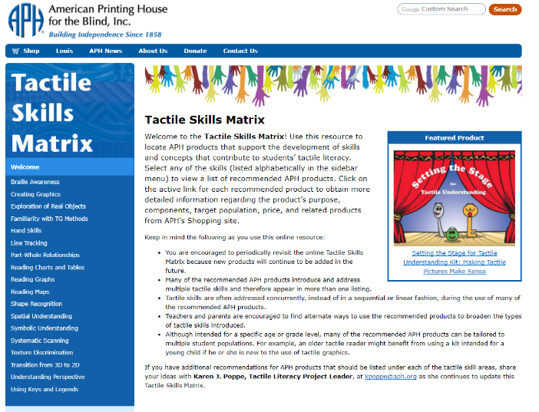
Background
APH frequently receives comments that teachers do not really know about our products or how they can be used in conjunction with others. Just as importantly, APH does not have well-established ways to reach parents to inform them about the need for tactile skills development and what that means for their child or how they can begin to nurture tactile skills development early on. The continuum of tactile skills—such as body and spatial awareness, shape recognition, scanning/tracking ability, perspective understanding, and so on—are known to contribute to successful tactile interpretation. The basic progression needed for tactile learning—from experiences with real objects to models to raised-line images—is well-documented and modeled in a variety of APH products (e.g., Setting the Stage for Tactile Understanding). However, students who are tactile learners are likely to be getting piecemeal instruction and are, therefore, poorly equipped to handle the increasing variety of graphically presented material in textbooks and high-stakes tests.

In October 2010, a sample of a possible Tactile Skills Online Matrix was developed and then presented by the project leader at a Product Input Session during APH’s Annual Meeting. The chart detailed a general progression of identified tactile skills/concepts to support the tactile continuum from exploration from real objects to models to raised-line graphics. The tactile skills/concepts were pictorially cross-referenced with APH products. The project leader explained that the matrix would navigate the user (e.g., parents, teachers, paraprofessionals, etc.) to full product descriptions, a discussion of a specific product’s rationale and use, or video demonstrations. Theoretically, it would continue to be a live, online document that could be updated with video or written submissions from teachers and parents. The need for this online pictorial and interactive roadmap of tactile skills and related products was echoed by the audience of Ex Officio Trustees and other special guests attending this Annual Meeting session.

In late October 2010, the project leader prepared a Product Submission Form explaining the idea of using a prominent link on APH’s Web site that will guide the target audience (teachers, parents, administrators, and paraprofessionals) to a user-friendly, interactive, and accessible chart of tactile skills that promotes a foundation for tactile graphic reading ability and literacy. The product idea was supported by both the Product Evaluation Team and the Product Advisory and Review Committee in January 2011.

The project leader met with staff from the Communications Department who are directly involved in designing and managing APH’s Web site. Early advice was given to the project leader regarding possible visual layouts, as well as considerations for additional features.

The first tactile skill addressed for inclusion in the matrix was Line Tracking. In April 2011, the project leader reviewed the APH Product Catalog for products that intentionally taught this skill and identified products that may have exercises/worksheets to foster this same ability. Input from other project leaders, especially those who have worked at APH for many years and are well-versed in APH products, was requested. The following list of products (or parts of products) was compiled:
- Flip-Over Concept Books: LINE PATHS
- On the Way to Literacy Books: The Longest Noodle and Bumpy Rolls Away
- Moving Ahead Series: Turtle and Rabbit and Goin’ on a Bear Hunt
- Rolling Into Place
- Web Chase
- Patterns Pre-Braille: First Line Book and Second Line Book
- SQUID: Tactile Activities Magazine – for example, “Stormy Weather” [SQUID Issue 3] and “Mouse Trap” [SQUID Issue 5]
- “Moving On Pages” included in Teaching Touch

The same routine was followed to construct exhaustive lists of products that address the various tactile skills included within the matrix. Thought was also given to alternate approaches to filtering the information onto APH’s Web site in smaller, intermittent amounts—for example, per skill/concept area. Some minimal adjustments to the existing handout chart were made with references to new products and distributed at in-house workshops focusing on tactile graphic instruction and materials.

In 2015, the project leader approached the construction of the Tactile Skills Online Matrix by submitting skill-specific installments for publication in multiple issues of APH’s APH News throughout the year. The first five installments were published in the February, March, April, and August issues:
- Tactile Line Tracking and Discrimination
- Texture Discrimination
- Exploration and Functional Use of Real Objects
- Basic Shape Recognition

Due to extensive work on other products in prototype development and pre-production stages throughout FY 2016, the project leader did not have the time to devote to multiple installments of the Tactile Skills Online Matrix. However, one additional installment was published in the October 2015 APH News. This installment mirrored the format of the previous installments and focused on products that supported the development of spatial skills.

The project leader continued to reference the developing matrix at tactile graphic related workshops and shared hardcopy versions as well. Other project leaders indicated that they used this matrix as a guide during the planning and development of other ongoing tactile literacy products.

In response to frequent demand from in-house staff and the field for the Tactile Skills Online Matrix, the project leader abandoned the routine, periodic introduction of new skill installments and instead focused on the construction and completion of the entire matrix for immediate posting on APH’s Web site. By mid-October, the project leader had prepared final content for the full construction of the Tactile Skills Online Matrix, having cross-referenced 18 distinct tactile skills/concepts with available and appropriate APH products. The tactile skills/concepts featured in the matrix are the following:
- Braille Awareness
- Creating Graphics
- Exploration of Real Objects
- Familiarity with Tactile Graphic Methods
- Hand Skills
- Line Tracking
- Part-to-Whole Relationships
- Reading Charts and Tables
- Reading Graphs
- Reading Maps
- Shape Recognition
- Spatial Understanding
- Symbolic Understanding
- Systematic Scanning
- Texture Discrimination
- Transition from 3D to 2D
- Understanding Perspective
- Using Keys and Legends

The graphic designer prepared a decorative border of colorful, overlapping hands to provide an attractive visual design for the online matrix. The tentative look of the Tactile Skills Online Matrix was shared with an Ex Officio Trustee who often championed and supported the creation of this online resource; she indicated that the proposed design for the Tactile Matrix was “colorful and engaging. The list of skill areas are excellent choices. This will be an extremely useful resource for vision teachers and paraprofessionals as they work with our emergent braille readers.”

The website designer readied the content for online accessibility, maintaining the hyperlinks that navigate the user to additional information on APH’s shopping site. The project leader provided content for a Welcome page that described the intended use of the Tactile Skills Online Matrix.

The user merely navigates through the list of skills on the left side of the page and then clicks on the desired skill/concept. This reveals a list of available APH products, such as the ones in this example for symbolic understanding: www.aph.org/tactile-skills/symbolic-understanding/

The posting of the Tactile Skills Matrix (as it is concisely referred to) was officially announced in the May 2017 APH News. It is also featured in the “What’s Hot” section of APH’s home page (see below).
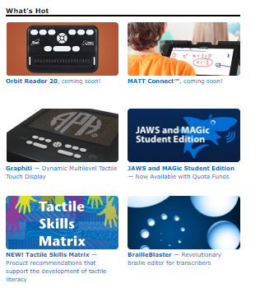

In May 2017, the project leader prepared content for a brochure for the Tactile Skills Online Matrix that could be shared at upcoming conferences/workshops to spread the word about its availability. Kerry Isham, Field Services Representative, also created a Quick Tip video to demonstrate the use of this online resource: www.youtube.com/watch?v=HZPMie4L4ig&feature=youtu.be

Work during FY 2018
Although the Tactile Skills Online Matrix is currently available in its entirety on APH’s Web site, the project leader continued to monitor the introduction of new products throughout the fiscal year and incorporate them into the various tactile skills/concept listings. Newly released APH tactile products added to the online matrix included the following:
- A Touch (see separate report)
- Best for a Nest (UEB version) (see separate report)
- Color-by-Texture CIRCUS Coloring Pages (see separate report)
- Feel ꞌn Peel Stickers: Braille/Print Capital Letters A-Z (see separate report)
- Holy Moly (see separate report)
- Reach and Match® Learning Kit (see separate report)
- Tactile Algebra Tiles (see separate report)
- Tactile Book Builder (see separate report)
- Tactile World Globe (see separate report)

Work planned for FY 2019
The project status will remain ongoing, with periodic updates throughout the coming years. The project leader will monitor feedback from the field regarding the usefulness of the Tactile Skills Online Matrix and make improvements as needed. Planned reconstruction of the APH Web site may impact the location and look of the matrix.

TactileDoodle
Formerly Sketch-A-Doodle
(Continued)

Purpose
To offer an affordable, no-frills drawing surface for producing immediate tactile displays created using the same drawing film offered with the DRAFTSMAN Tactile Drawing Board

Project Staff
Karen J. Poppe, Tactile Literacy Project Leader
Rachel Bishop, Research Assistant
Tom Poppe, Model/Pattern Maker (Retired)
Patrick White, Model/Pattern Maker
Andrew Moulton, Manufacturing Specialist
Rod Dixon, Manufacturing Specialist
Laura Greenwell, Graphic Designer
Anthony Jones, Director of Creative Services
InGrid Design, Photographer

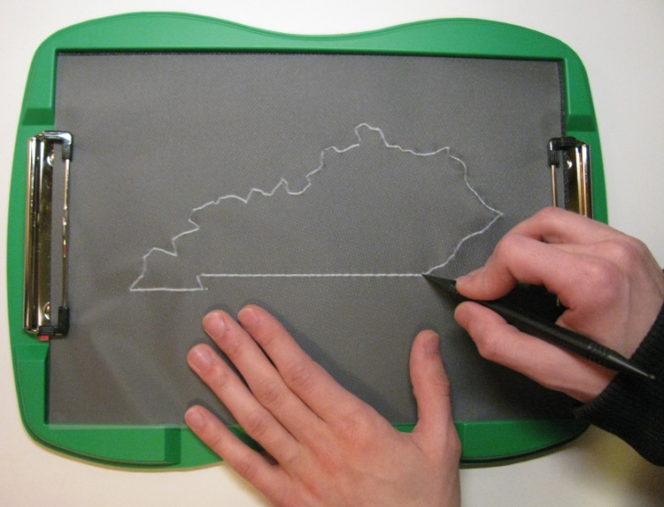

Background
The idea for the Sketch-A-Doodle occurred to the project leader during the development of Color-by-Textures Marking Mats. After noticing that the black, underside foam surface of the Color-by-Textures’ nonskid tray provided an ideal drawing pad when combined with the drawing film included with the DRAFTSMAN Tactile Drawing Board (Catalog No. 1-08857-00), the project leader submitted a formal product submission and recommended the development of a significantly less costly drawing board for creating tactile displays. The current cost of the DRAFTSMAN Tactile Drawing Board exceeds $190.00. Although not intended as a substitute for the DRAFTSMAN Tactile Drawing Board, the TactileDoodle (originally titled “Ready-to-Draw Tray” and referred to as the “Sketch-A-Doodle during the field test stage) will provide an affordable alternative for students to draw their own graphics independently, or for those working with students with visual impairments and blindness.

The product submission form was shared with an expert reviewer who stressed that the “DRAFTSMAN is a wonderful tool for creating quick tactile graphics. However, at a cost of $180, it is hard to justify buying one for each tactile learner. I suspect classrooms share this tool as opposed to having one for each student. There is a definite need for a quick and easy tactile graphic tool…I believe TVIs and families would embrace a more economical solution.”

On January 11, 2016, the product idea was considered and approved by the Product Evaluation Team who assessed its product development difficulty as “low” and production difficulty as “low.” The estimated yearly volume for the first 3 years is 1,000 units. On February 8, 2016, the Product Advisory and Review Committee reviewed and approved the development of the product. The product transitioned immediately to the active timeline and was assigned the grant #621.

Prototype design and construction of the Sketch-A-Doodle (the tentative product name used during the field test stage) was swift. Within months after transitioning to the active timeline, the project staff accomplished the following tasks:
- Conducted a Product Development Committee (PDC) meeting to review the expected product design and anticipated production processes
- Identified ideal materials (e.g., 3 mm green rigid foam) for building the drawing board’s outer frame
- Built a vacuum-form pattern to generate the outer frame of the drawing board
- Attached low-profile clips to hold the drawing film onto the board
- Selected a black open-cell sponge rubber to affix within the frame
- Designed a single-tip, short, “chunky” stylus that is easier for smaller hands to grasp
- Authored a brief Instruction Booklet
- Constructed multiple prototypes for field test purposes

A field test announcement was posted in the April 2016 APH News. Approximately 25 teachers expressed interest in participating in the evaluation of the Sketch-A-Doodle. From this sample, 13 field evaluation sites were selected based upon geographic location, number of available students, and type of instructional setting; preference was given to those who had not recently field tested an APH product. Some selected sites allowed multiple teachers to share and evaluate the prototype.

Potential evaluators gave reasons for wishing to field test the Sketch-A-Doodle with their students with visual impairments and blindness; reasons hinted at the product’s usefulness even before formal field testing. Their explanations included the following:
- “A lot of times I need to make something ‘on the fly’ and don’t have time to sit down at a computer to create an embossed tactile graphic.”
- “I am always looking for improvements with tactile drawings for my students and for the students to be able to [draw] their own in the sciences and mathematics.”
- “I can see the Sketch-A-Doodle as a quick way to make on-the-spot maps and also to build environmental and math concepts.”
- “I would like to field test this item to see how it compares to the DRAFTSMAN. Many of my students enjoy using the DRAFTSMAN and I would like to see how it may be different, and if it would be a useful alternative in the art room. I would especially like to see if it is easier to use than the DRAFTSMAN with my younger students and students who have difficulty with their muscle strength.”

Prototypes of the Sketch-A-Doodle and related materials (e.g., styluses, drawing film, and Instruction Booklet) were mailed on April 20, 2016. Evaluators were asked to return their completed evaluation forms and student outcome forms by the June 15, 2016.

Field-test evaluation forms were completed by 14 teachers of the visually impaired and blind. One selected evaluator did not complete and return her evaluation form. The field evaluators represented the states of Arkansas, California, Colorado (2), Maine, Michigan, Minnesota (2), North Dakota, New Jersey (2), Pennsylvania, and Washington (2). The largest percentage (71%) of sites represented itinerant settings. Table 1 and Figure 1 show the distribution of field test sites according to type of educational setting and geographical location.

Table 1
Type of Educational Setting
Type of Educational Setting  (N = 14) | State Location of Field Test Sites | Percentage
Residential | AR, CO (2) | 21%
Itinerant | CA, ME, MI, MN (2), ND, NJ (2), PA, WA | 71%
Home school | WA | 7%

Figure 1. Geographical Distribution and Educational Setting of Field Test Sites

Participating field evaluators varied in their teaching experience. The largest percentage (36%) reported 6-10 years teaching experience, 29% reported 11-15 years teaching experience, and 7% reported 16-20 years teaching experience. The percentage of teachers with less than 5 years of teaching experience mirrored the percentage of teachers with more than 21 years of teaching experience—14% within each category.

Most evaluators indicated a prior need to create tactile graphic displays for their students either “frequently” (43%) or “occasionally” (43%); 14% “rarely” or “never” created graphics for reasons such as the following: “Most of my students have braillists working with them on a daily basis. They are the ones making tactile graphics on a consistent basis.”

The majority of evaluators (71%) had previously used APH’s existing DRAFTSMAN Tactile Drawing Board. Repeated complaints revolved around students’ struggles to properly place the drawing film on the board, noting that it was especially “difficult for students with low muscle tone” or younger students. The evaluators were also very familiar with other means of creating tactile displays. Popular materials used were foam stickers, glue, graphic tape, tracing wheels, APH’s Quick-Draw Paper and Picture Maker, as well as specific commercial products—Wikki Stix®, Pictures in a Flash, and Sensational BlackBoard. Many of these tools and materials were also used independently by students.

As shown in Figure 2, field evaluators used the Sketch-A-Doodle with a total of 37 students who represented slightly more males (54%) than females (46%).
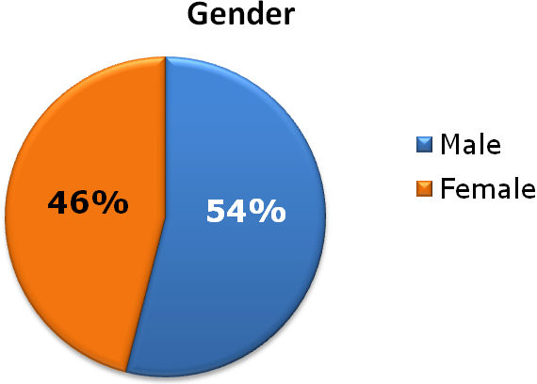
Figure 2. Students’ Gender

As apparent in Figure 3, the sample population represented cultural diversity: 51% White, 8% Asian, 11% Hispanic, 11% American Indian, 5% Black, 8% Two or more races, and 5% Other. Over a quarter (27%) of the students had other disabilities such as cognitive impairment, deafblindness, adjustment disorder, and autism.
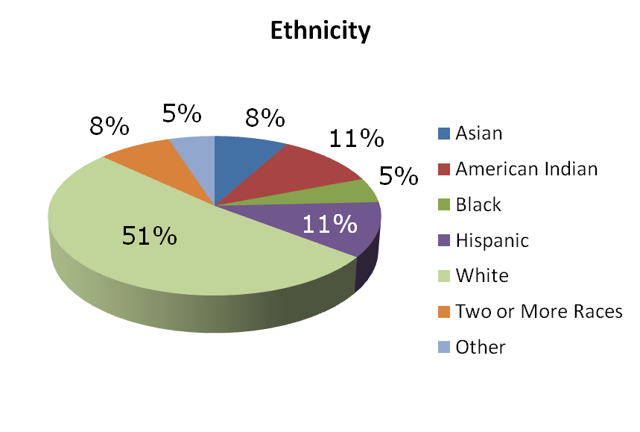
Figure 3. Students’ Ethnicity

Students ranged in age from 5-80 years old. Equal percentages were either 7-9 years old (13%), 16-18 years old (13%), or 39-80 years old (13%). Likewise, identical percentages were either 10-12 years old (22%) or 13-15 years old (22%). The remaining 16% of students were 5-6 years old. (Refer to Figure 4.)
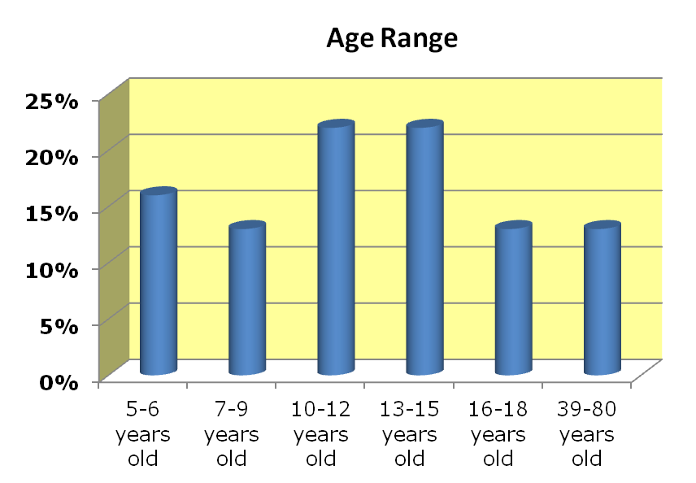
Figure 4. Students’ Age Range

The distribution of students by grade level spanned from kindergarten to college graduate. Nearly equal percentages of the student sample were in Grades K-3 or Grades 4-8—30% and 35%, respectively. Nearly one-fifth (19%) were high school students. The grade level for one student was unreported. (Refer to Figure 5.)
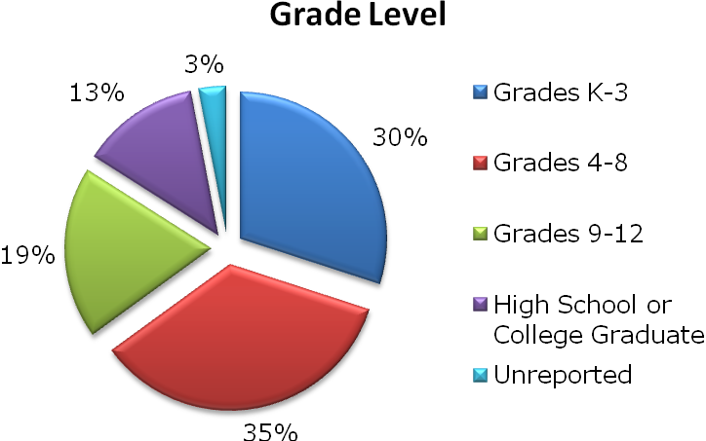
Figure 5. Students’ Grade Level

As evident in Figure 6, over half (51%) of the students were braille readers. Each remaining classification of primary reading medium was represented by 8% or less of the student sample that included large print readers, auditory readers, beginning braille readers, and dual readers. The preferred reading method for one student was unreported.
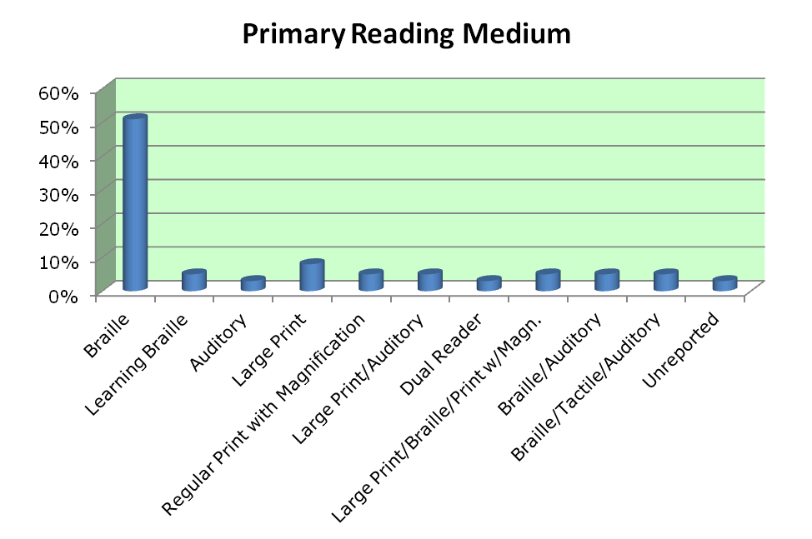
Figure 6. Students’ Primary Reading Medium

The field evaluation form allowed teachers to rate each feature of the Sketch-A-Doodle. Table 2 provides the average rating for each product feature.

Table 2
Overall Design of Sketch-A-Doodle
Product Feature | Number of Evaluators | Average Rating | 5 | 4 | 3 | 2 | 1
Overall look/appearance of product | N = 14 | 4.78 | 79% | 21%
Overall size | N = 14 | 4.57 | 71% | 21% |  | 7%
Color of frame (green) | N = 14 | 4.43 | 57% | 29% | 14%
Color of rubber mat (black) | N = 14 | 5.00 | 100%
Ease of loading drawing film under clips | N = 14 | 3.71 | 43% | 21% | 7% | 21% | 7%
Durability of mat/board | N = 14 | 4.86 | 86% | 14%
Portability/weight | N = 14 | 4.93 | 93% | 7%
Stability provided by rubber feet during drawing tasks | N = 14 | 5.00 | 100%
Quality of tactile lines produced | N = 13 | 3.77 | 30% | 23% | 38% | 8% | 0%
Versatility for various tactile drawing tasks | N = 14 | 4.43 | 57% | 36% |  | 7%

Specific evaluators’ comments related to the features of the Sketch-A-Doodle supported its overall strong ratings; comments included the following:
- “I love the sleek design of the Sketch-A-Doodle.”
- “Lightweight”
- “Very portable”
- “Good size for little hands.”
- “The Sketch-A-Doodle feels very sturdy.”

However, contradictions were encountered in evaluators’ individual assessments of the prototype. For example, some evaluators liked the clips and some did not, some liked the quality of tactile lines generated and some did not, and some liked the color of the frame and some did not. The variance in responses highlighted features for possible improvement for the finished product; features receiving a rating below 4.00 were later addressed.

One hundred percent of field evaluators thought the accompanying Instruction Booklet sufficiently described the purpose and use of the Sketch-A-Doodle. It offered extended uses for creating tactile images (e.g., grids) using the drawing board in combination with off-the-shelf items, such as needlepoint canvas.
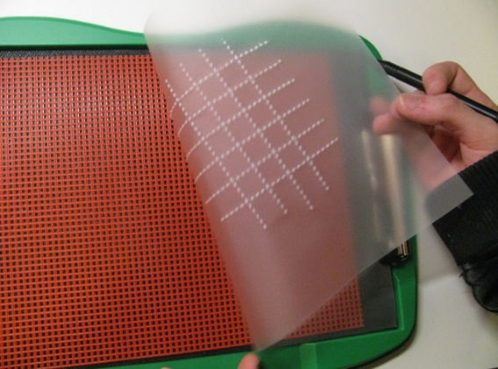

Two types of drawing styluses accompanied the Sketch-A-Doodle—the two-ended stylus included with the DRAFTSMAN, and a noticeably shorter, single-tip stylus. Table 3 shows how frequently each stylus or ballpoint pen was used.

Table 3
Use of Stylus and Drawing Tools in Combination with Sketch-A-Doodle
Stylus/Drawing Tool | Number of Evaluators | Frequently | Occasionally | Never
Two-ended black stylus | N = 14 | 79% | 21%
Short single-tip stylus | N = 14 | 43% | 43% |  | 14%
Ballpoint pen | N = 14 | 21% | 21% |  | 57%

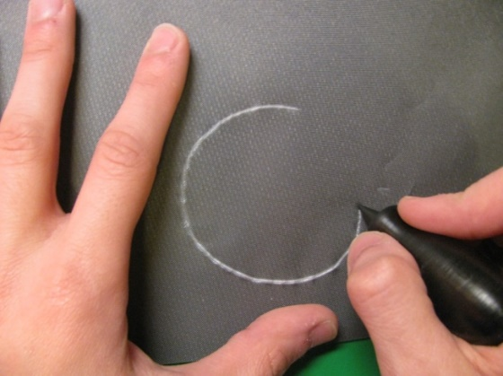

Each stylus type was preferred for different reasons and varied from user to user:
- “Smaller stylus easier to hold and apply pressure.”
- “The short, single-tipped stylus was easier for my student who is a braille user. She is not accustomed to routinely holding/using a pen-style apparatus.”
- “The two-ended black stylus was the most helpful due to ease of the grip and the sharp lines produced.”
- “The advantage with different stylus types was you could make different sized lines.”
- “I liked the big ball end for making landmarks and larger filled in shapes.”
- “Short, single-tipped stylus could be used to make braille dots.”
- “The short stylus has been great with smaller hands, students with CP and other hand-altering issues and students who cannot hold pencils/long stylus/pens and brushes as well.”

Some evaluators/students used other drawing tools such as tracing wheels and a wooden braille eraser.

The Sketch-A-Doodle was favorably received by the students themselves. Evaluators indicated that 100% of the students enjoyed using the drawing board. Supportive comments included the following:
- “Students compared [it] to DRAFTSMAN and found Sketch-A-Doodle easier for circles and curves.”
- “She enjoyed the simplicity of the clips to hold the paper in place.”
- “Students really enjoyed the design. One said, ‘Oh, It’s a clipboard!’”
- “One of my students said it was much easier to draw with; others said the same.”
- “Able to share images faster.”
- “This is so neat to draw and to feel it!”
- “It can be carried around and I can use it if I need to use it while in route as my map.”

Positive statements about the Sketch-A-Doodle’s ease of use were contradicted by expressed frustrations from some teachers and students regarding the clip style. Although the task of loading the film onto the board was easy and intuitive for some students, it posed challenges for others. Some evaluators and students described the clips as “too strong” or “didn’t always hold the film in place.” Younger students and those with fine motor difficulties needed assistance with the clips.

A small percentage (36%) of the field evaluators indicated that the Sketch-A-Doodle was used in the company of sighted peers and family members. Specific comments highlighted sighted peers’ reactions to the board and related tactile drawings:
- “Everyone who tried it enjoyed its different feel and look. Most everyone commented on the black background and great contrast with the film.
- “The kindergarten student’s peers were working on a coloring page when this was introduced. They were all excited that my student was able to do the same task as them.”
- “My students’ sighted classmates were intrigued by the raised lines.”

Sixty-five percent of the evaluators indicated that Sketch-A-Doodle offered specific advantages over other drawing boards or tools for creating tactile graphics: “it’s lighter,” “more streamlined,” “it was ready to go,” “quick, easy, understandable, fun, etc.,” “space and easier to use for a variety of shapes,” and “it’s more convenient for quick tactual displays.” One evaluator also noted a particular advantage over the DRAFTSMAN Tactile Drawing Board: “DRAFTSMAN has harder rubber surface, therefore harder for students/anyone with weak muscles or strength issues of any kind. Sketch-A-Doodle was easier.” More than half (54%) of the evaluators indicated being more impressed and pleased by the Sketch-A-Doodle compared to their original expectations prior to field testing; 23% indicated that its usefulness matched their original expectations, and another 23% indicated being less impressed by its usefulness. An explanation for the latter assessment was disappointment that it did not work in combination with regular paper as well as plastic film.

Using a rating scale of 7 = Strongly Agree to 1 = Strongly Disagree, the evaluators gave a combined score of 6.50 when asked to indicate how well Sketch-A-Doodle met its original goal and objective of providing a tool for quickly creating tactile displays for and by students with visual impairments. (Refer to Table 4.)

Table 4
Overall Assessment of Sketch-A-Doodle
Sketch-A-Doodle provided a tool for quickly creating tactile displays for and by students with visual impairments.
N = 14 evaluators
7  Strongly Agree | 6 |  | 5 | 4 | 3 | 2 | 1  Strongly Disagree
71% | 14% |  | 7% | 7%
Average Rating
6.50

Evaluators noted a variety of skills and concepts supported by the use of the Sketch-A-Doodle including the following:
- “The Sketch-A-Doodle was helpful for computer math testing.”
- “Spatial awareness”
- “Clocks, handwriting, games, columns/rows, creativity, and tracing”
- “Map making and reading”
- “Braille letters, writing games, drawing shapes”
- “Identifying circles and squares as well as determining amount of pressure to use”
- “Concepts of parallel and perpendicular, square, compass directions, directional corners, and street patterns/layouts”
- “Confirmed information for the student. Made the activity participatory. Concepts = endless!”

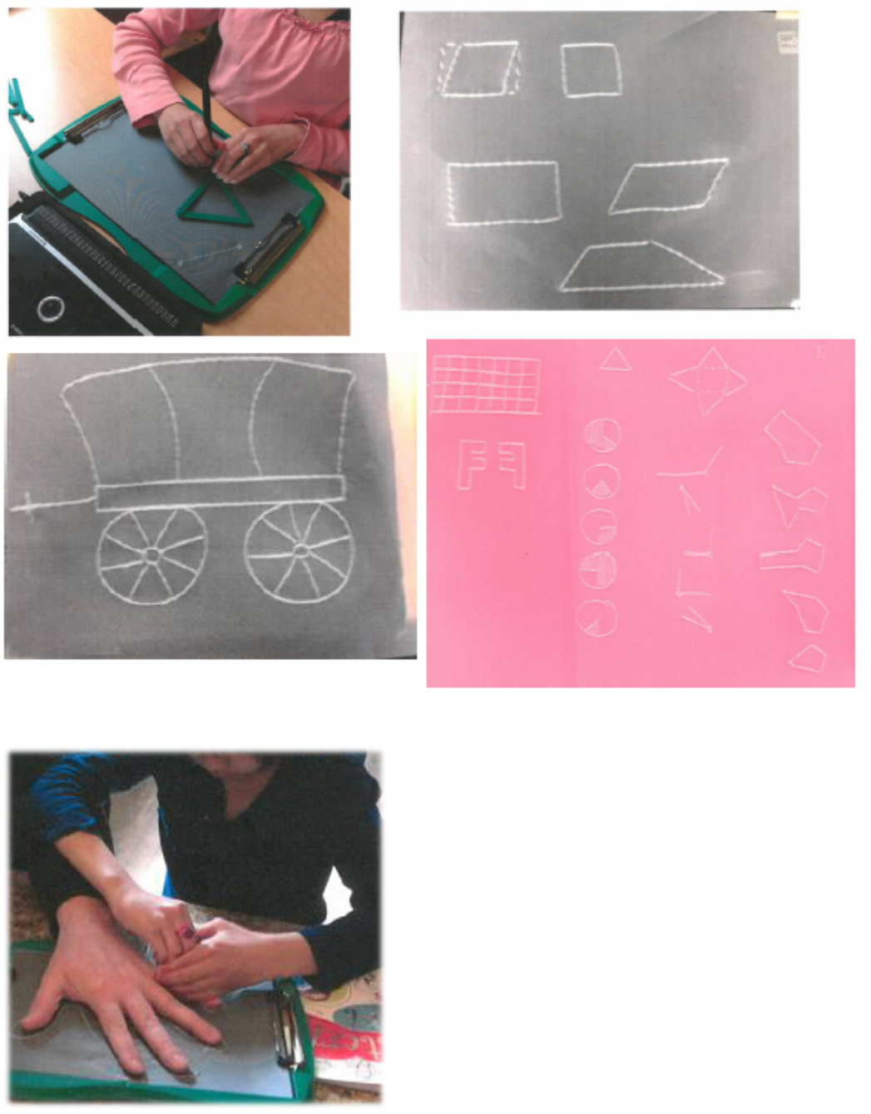

As Table 5 reveals, the most appropriate target populations for the Sketch-A-Doodle as assessed by the 14 field evaluators were preschoolers with blindness, tactile readers in Grades K-8, high school students with low vision and blindness, and adults with blindness.

Table 5
Appropriate Target Populations
Target Population | Percentage of evaluators  (N =14) indicating appropriateness of product for target population
Preschoolers who are blind | 86%
Preschoolers with low vision | 57%
Low vision students in Grades K-3 | 64%
Tactile readers in Grades K-3 | 79%
Low vision students in Grades 4-8 | 57%
Tactile readers in Grades 4-8 | 86%
High school students with low vision and blindness | 93%
Students with additional physical disabilities | 50%
Students with deafblindness | 64%
Sighted peers | 57%
Adults with blindness | 86%
Low vision adults | 7%
Sighted adults | 7%
Other (indicate): | - “Instructors, teachers, employers, etc. Anyone who wants to convey something in a tactile form rather than describing it.”  - “Limitless”

Although not unanimous, the majority (79%) of field evaluators recommended APH produce and make available the Sketch-A-Doodle, 14% were uncertain, and only one teacher indicated “No” because she still preferred the DRAFTSMAN. More than half (67%) of the evaluators indicated a preference for the Sketch-A-Doodle over the DRAFTSMAN, 22% preferred the DRAFTSMAN, and 11% didn’t notice an appreciable difference between the two drawing boards. If the cost of the Sketch-A-Doodle were $80-$100 lower than than the cost of the DRAFTSMAN, 50% of the evaluators would purchase only the Sketch-A-Doodle, 29% would purchase both drawing boards, and 7% would purchase only the DRAFTSMAN; 14% of the evaluators were unfamiliar with the DRAFTSMAN and were therefore unable to make a choice between the two drawing boards.

All of the evalutors thought the final kit should include a Sketch-A-Doodle board, a 25-sheet package of drawing film, the two-ended black stylus, and a print Instruction Booklet; fewer evaluators recommended inclusion of the short single-tip stylus and the a braille Instruction Booklet—79% and 93%, respectively. Several evaluators recommended a different product name (e.g., Sketchman, Tactile Sketch, Tactile Doodle Board, and Make-A-Tactile Board).

On August 16, 2016, the project leader regrouped the PDC to review field test results and determine the final structure of the product. A new product name—TactileDoodle—was selected that was free from copyright infringement. Planned components included the following:
Quantity | Expected Components
1 | TactileDoodle board
1 | 25-sheet package of drawing film
1 | Short single-tip stylus
1 | Instruction Booklet (large print)
1 | Instruction Booklet (braille)
1 | Print Parts List
1 | Braille Parts List

The project leader and Rachel White authored and edited final content for the accompanying Instruction Booklet. Professional layout and design of the booklet was implemented by Laura Greenwell. Photos of additional uses of the drawing board were incorporated into the design.

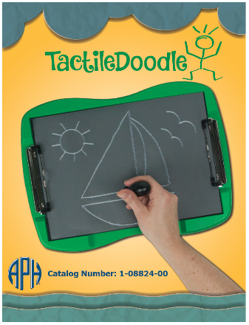

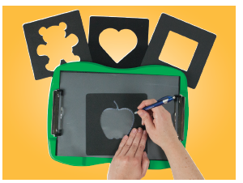

Turnaround time for braille translation of the Instruction Booklet was swift; the braille-ready file was completed by the end of FY 2016.

In October 2016, Quota approval for the TactileDoodle and related single-tip stylus was requested and received from the Educational Products Advisory Committee during Annual Meeting. The project staff undertook remaining tooling tasks to prepare the product for mass production. Prior to his retirement in mid-October, Tom Poppe finalized the majority of the production tooling needed to produce the TactileDoodle. Patrick White then assumed responsibility for the remainder of the tooling; he incorporated embossed typography of the product name into the fiberglass master and added pins to form the equivalent braille text into the frame. Locating fixtures were built as well. By the end of February 2017, the majority of the production tooling was completed.

Work during FY 2018
At the beginning of the fiscal year, about 50% of the product specifications document was completed. The manufacturing specialist prepared and tweaked the computer file needed to router-cut the bottom portion of the board. Some challenges to generating smoothly cut radius corners for the board were experienced early on, but all tooling difficulties were resolved. The manufacturing specialist completed and presented the product specifications document at the Gate 5: Specifications meeting on June 13, 2018. Production quantities were determined. All required signatures were collected on the gate form, indicating approval to proceed with planned production methods and processes for the final product design. The project leader prepared a chart that juxtaposed the differences and similarities of the TactileDoodle and the DRAFTSMAN Tactile Drawing Board for later reference by customer service staff, marketing staff, and field representatives.

Notable characteristics and functions shared by the Tactile Doodle and DRAFTSMAN are the following:
- Both can be used in combination with Tactile Drawing Film (APH Catalog No. 1-08858-00).
- Both offer an open-ended platform for designing instant, spur-of-the-moment graphics (maps, science diagrams, artwork, etc.).
- Both generate similar tactile lines.
- Both can be used with ordinary ballpoint pens.
- Both are ideal for the novice user, as well as the experienced tactile artist.

Differences between the two drawing boards can be summarized as follows:
- The DRAFTSMAN has a plastic frame with grooves/gutters to accommodate an add-on tactile ruler (included with the kit), whereas the TactileDoodle has a streamlined/modern appearance with a curved frame and a recessed resting area for the artist’s hand.
- Graphics drawn on the DRAFTSMAN’s tan-colored pad appear white, whereas those drawn on the TactileDoodle appear white against the board’s black foam pad. The result is a chalkboard appearance to ensure visual contrast.
- The DRAFTSMAN has built-in hinged “wings” that secure the drawing film securely to the drawing surface; the TactileDoodle utilizes commonplace clipboard-style clamps (as used on APH’s ReadWrite Stands) to secure the drawing film to the drawing surface.
- The DRAFTSMAN is accompanied by a two-ended drawing tool; the TacitleDoodle offers a shorter, single-tip drawing stylus that is more user-friendly for younger students.
- The TactileDoodle is expected to be noticeably less costly than the DRAFTSMAN because of its more economically produced, no-frills structural design. It is not intended to replace the DRAFTSMAN Tactile Drawing Board; rather, it will serve as a more affordable alternative for projects with a similar goal/purpose.

Work planned for FY 2019
The project staff will oversee the first pilot and full production runs of the TactileDoodle to ensure quality of manufactured components, including the short, one-ended Delrin® stylus received from an outside vendor. Actual production of the final product is expected to occur during the second quarter of FY 2019. The project leader will assist with postproduction activities and demonstrate the product at tactile graphics-related workshops.

Textured Graphic Art Tape
(Continued)

Purpose
To provide an extended collection of graphic art tape in a variety of textures for a myriad of tactile graphic applications by teachers and braille transcribers, as well as by students with visual impairments and blindness

Project Staff
Karen J. Poppe, Tactile Literacy Project Leader
Rachel Bishop, Research Assistant
Rod Dixon, Manufacturing Specialist
Katherine Corcoran, Model/Pattern Maker
Matthew Poppe, Graphic Designer
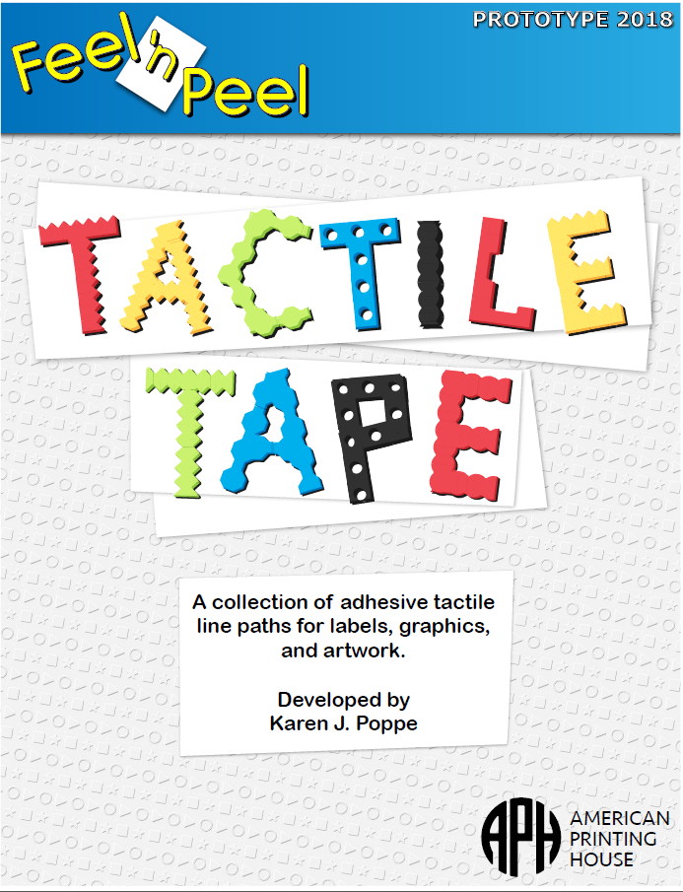

Background
In January 2017, Cindy Queen, teacher of the visually impaired from Kentucky, submitted a formal product submission form that described the need for textured art tape that “could be used for numerous purposes: graphs, charts, art work, underlining (highlighting), graphic organizers, and tactile graphics of all types.” A more diverse assortment of textured tape would complement APH’s existing Graphic Art Tape Kit (1-08878-00), which currently offers three widths of black, crepe-textured rolls of commercially available graphic art tape.

In March 2017, the project leader reviewed the product idea and submitted a formal review of the concept based on several criteria, including the need for the product, originality, appropriate target populations, similarity to existing or planned APH products, and importance when compared to other ongoing projects. The project leader indicated that the product idea was supported in the field and was one that purchasing and manufacturing staff explored in recent years. This most recent request was the impetus for giving the product possibility more careful consideration. The project leader recommended that APH pursue the development of the product, especially since the demand for the existing Graphic Art Tape Kit has continued to grow in recent years, with 1,452 packages sold in FY 2015 and 1,606 packages sold in FY 2016.

To expedite the product through the development stage, the project leader recommended utilizing established textures and production tooling available in existing APH products to generate a tactually robust kit of graphic art tape. She suggested providing adhesive-backed, die-cut strips that are at least 8.5-in. long and 0.25 in. wide in a variety of textures (e.g., soft, bumpy, rough); each texture would be available in different colors. Other types of commercially available textured tape (e.g., glitter tape) could be included with the kit without jeopardizing Quota eligibility. Each type of textured strip could be offered under a different part number to allow repurchasing of specific types of tape based on customer preference.
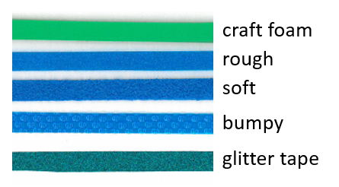

In April 2017, the development and production of Textured Graphic Art Tape was presented to the Product Evaluation Team; and in May 2017, it was presented to the Product Advisory and Review Committee. Both committees supported active development of this product. The project was assigned grant #688.

Minimal work on this newly approved product occurred during FY 2017. However, the project leader accomplished the following:
- The project leader located and ordered glitter tape with adhesive backing from an outside vendor.
- The first Product Development Committee meeting was conducted in late August to review the purpose and expected design of the product with in-house staff from various departments.

Work during FY 2018
Significant strides in the design and construction of the prototype of the tactile tape collection were made throughout FY 2018, assuring a strong possibility for field test launch in September. However, the product was removed from the active product timeline in July in accordance with the New Product Development process. Prior to this date, notable tasks accomplished included the following:
- The project leader ordered and received commercially available tapes from vendors, assuring NET 30 terms.
- The manufacturing specialist created die-cut drawings for the planned tactile border strips.
- The manufacturing specialist generated Roland® UV-printed samples of planned raised-shape strips (circle, star, square, and triangle).
- The project leader prepared a detailed chart of the types of tape strips/tape that would be included in the prototype kit including the following:
Textured Strips with adhesive backing offered in a variety of colors  Soft  Rough  Bumpy  Craft Foam | 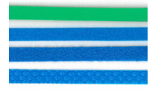
Tactile Border Strips with adhesive backing cut out of craft foam and offered in a variety of colors  Scalloped  Diamond  Hole-Punched  Zipper  Castle Wall  Saw-Toothed | 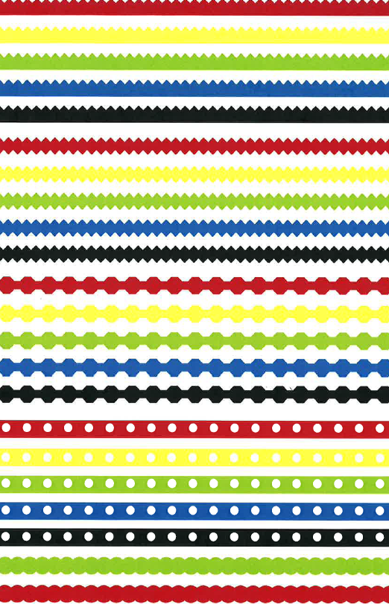
Tactile Line Strips (formed on .005-in. transparent vinyl) with adhesive backing and offered in variety of colors  Dotted  Dashed  Railroad  Arrow | 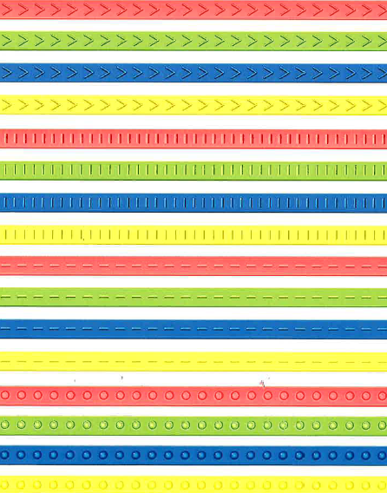
Embossed Tactile Shape Strips (formed on .010-in. white vinyl)  Circles  Stars  Squares  Triangles  Note: These strips can be used to trim away a single raised shape to serve as a point symbol on a tactile map/display. | 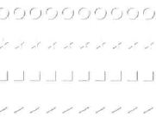
Sparkle/Glitter Tape in a variety of colors (commercially acquired)
Graphic Art Tape in a variety of colors (commercially acquired)

Work planned for FY 2019
According to a new matrix-scoring process used by an in-house review committee to evaluate all APH product ideas and endeavors, Textured Graphic Art Tape garnered a weighted score of 51 out of a possible 93. In an effort to minimize the number of the project leader’s projects, as well as time demands on other staff resources, the project reverted to an on-hold status as of July 2018. Reintroduction of this project to active status hinges on the completion of projects closer to availability and reassessment of the project leader’s priorities. If the project reenters the active project pipeline in FY 2019, the project leader will continue prototype development for eventual field-test purposes.

TG TV
(Continued)

Purpose
To create a series of instructional videos that give real-time, specific examples of the thinking that goes into the adaptation of print images into tactile graphics

Project Staff
Fred Otto, Tactile Literacy Project Leader

Background
The previously existing videos related to tactile graphics, from APH and elsewhere, speak either in general terms about philosophy or in specific terms about working with production tools. What was evidently lacking was a discussion of how to adapt a print graphic after deciding what is to be shown—that is, how to convert it into a readable design for a tactile graphic. A video format with actual examples seemed to be an effective way to illustrate good reasoning and good practices.

The project leader experimented with screen-capture programs, which record the onscreen editing of images along with voice-over narration. This is a low-cost, direct technique to use as the foundation of the videos. The same software is used to add music, sound effects, and on-screen text and highlights for a more appealing presentation. The popular screen-capture program Camtasia® was downloaded for trial use and then purchased.

Two videos were produced; one served as an introduction to the series, and the other conveyed content about editing and design decisions. The latter video was screened for APH staff and again for two representatives of the BANA Tactile Graphics Committee to obtain feedback and recommendations.

After lengthy troubleshooting by the Communications Department to resolve the requirements for accessible closed captioning, the first three videos were released for free viewing or download on the APH YouTube™ channel and the APH Web site (https://www.aph.org/tgtv/). Since then, two more episodes have been posted.

Work during FY 2018
No significant work was done on this project during the year.

Work planned for FY 2019
If time and other project priorities permit, one or more new installments of the series will be produced and posted online.

INDEPENDENT LIVING SKILLS

For FY 2018, there are no projects in this category to report.

ORIENTATION AND MOBILITY

Crossings With No Traffic Control: Teaching Concepts and Skills to Deal With Them
(Formerly Concepts and Skills for Crossings with No Traffic Control)
(Continued)

Purpose
To create audio, video, and written materials to help persons with visual impairments learn that it is not necessarily safe to begin a crossing at an uncontrolled intersection when no vehicle is heard

Project Staff
Terrie (Mary T.) Terlau, Adult Life Project Leader
Dona Sauerburger, Consultant
Laura Zierer, Project Leader
Michael McDonald, Programmer
William Freeman, Quality Assurance Analyst
Joseph Hodge, Quality Assurance Analyst
Kelly Kennedy Mimms, Research Assistant
Rod Dixon, Manufacturing Specialist
Matthew Poppe, Graphic Design

Background
Dona Sauerburger, certified orientation and mobility specialist (COMS), has conducted numerous regional and national workshops for other COMS on the topic of teaching students to recognize situations of uncertainty for crossing independently at intersections with no traffic light or stop sign controls. Sauerburger's approach stipulates that if a greater amount of time is required to cross a street than the time during which a student can hear or see the approach of an oncoming vehicle, it is uncertain that the student can cross the street independently and safely. Although Sauerburger's approach has gained acceptance in the O&M field, persons who are no longer O&M students (i.e., adults with visual impairments who completed O&M instruction in the past) have not been taught this life-saving strategy. Sauerburger's Product Idea Submission Form proposes the creation of auditory/visual videos and instructional materials to teach these individuals how to determine such situations of uncertainty and how to develop alternate, safe strategies for managing them.

Preliminary Research
Terlau monitored the reception of Sauerburger's approach in the O&M community on e-mail lists and at numerous regional O&M conferences. Terlau found that Sauerburger's approach to analyzing the level of certainty that an uncontrolled intersection can be crossed safely has gained wide acceptance. Terlau examined Sauerburger's materials on vehicles striking pedestrians with visual impairments and found her conclusion to be sound: Many of these pedestrians were injured or killed because they believed what had been taught since the inception of O&M instruction—"It is safe to cross an uncontrolled intersection when it is quiet, when you can hear no traffic."
Initial Product Development
During FY 2011, the product was accepted for development by APH. Initial discussions about the scope of work between the project leader and Sauerburger were conducted.

During FY 2012, additional discussions were conducted between Sauerburger and the project leader regarding next steps. Sauerburger agreed to submit several videos of intersections she would like to use in the product so that APH staff could determine whether she would need the assistance of a professional videographer or whether her videos were of sufficient quality to be used in the product. Discussion with Larry Skutchan indicated that software could be developed to present video clips and that a software stopwatch necessary for some aspects of the product's functionality could be produced or located.

During FY 2013, additional planning telephone meetings were conducted between Sauerburger and Terlau. Sauerburger submitted draft scripts for the video. It was decided that a professional videographer would record intersections in Louisville, KY, for use in the project under Sauerburger's direction.

Terlau and other attendees at an initial Product Structure Meeting expressed strong concern that students might misunderstand instructions about determining situations of uncertainty and might use information in the video to support dangerous, risk-taking behavior. Terlau and Sauerburger determined that the product should be developed as a teaching tool to be used by orientation and mobility instructors with their students and not as a self-study product for students themselves. Student activities planned originally will be included, but will be packaged as exercises that instructors can use with their students. Additional information on concepts and theory will be provided in the book and video to support instruction in these skills.

During FY 2015, Sauerburger redrafted existing exercises and sections of video text to conform to the new product focus. The draft script for the videos and book has been completed.

Terlau and Sauerburger continued to refine draft text, software requirements, and scripts to be recorded for use in the software. Sauerburger worked with Terlau for one week in Louisville firming up program functions and obtaining traffic videos for use in the product. Terlau and the videographer from InGrid Design conducted four additional traffic video sessions.

Three meetings were held with Larry Skutchan and programmers to discuss feasibility of software requirements. All software requirements were deemed feasible.

Sauerburger completed 10 videos in Maryland for use in the software. Sauerburger created audio and visual clips and created auditory and visual traffic scenarios for use in the software. Terlau prepared a list of product specifications to be submitted for bid.

In FY 2016, with specifications written by Terlau and approved by Larry Skutchan, the RFP was released. Proposal responses to the RFP were received from three companies. Terlau answered questions posed by these respondents and submitted documents requesting clarification or more detail to them. All companies responded to the request for additional information.

Based on an evaluation of initial and updated proposals, Intellectyx Inc. was accepted as the software development company for this product. A contract was provided by Intellectyx. It is anticipated that contract negotiations will be completed and a contract signed before the end of FY 2016.

Terlau refined onscreen and narrated materials for the software and developed clear “if-then” rules for pairing appropriate feedback files with all possible student responses. Material to be recorded was submitted to the studio. It is anticipated that recordings and separation of recorded material into specified small feedback files will be completed before the end of FY 2016.

Upon Terlau’s retirement in September 2016, Zierer took responsibility for overseeing the development and testing of the software. Intellectyx met with Terlau and Zierer in August 2016 to kick-off the project and introduce the team. All finalized text files and logic spreadsheets were handed over to the development team at the completion of this meeting.

Narration files were completed by chapter and delivered to Zierer throughout FY 2017. Zierer, Rose, and Twyman divided chapter content into separate files, which were then passed on to the developers for use in the software.

A new project page was created within a project-management tool shared between APH and Intellectyx. Issues were reported, tracked, and resolved within this system. Progress updates were delivered to Zierer and Freeman through weekly conference calls with the lead developer and project manager. Functionality and accessibility testing were completed in-house for each build delivered from the developers.

Field testing was conducted throughout March, April, and May 2017. Field evaluators were sent a flash drive containing the software and the hardware chosen for the kit (two sets of identical headphones and a Y-splitter).

Nine evaluators participated in the field test. The evaluators were from Illinois, 4 (44%); Texas, 1 (11%); Maryland, 1 (11%); Washington, 1 (11%); and the New Brunswick province of Canada, 2 (22%). Evaluators were all O&M Specialists working with school-age children and adults. Participants were selected based on diversity of setting and geography. Testers were queried about the functionality of the software, delivery and organization of the content, and the hardware components supplied with the software. Sequential restrictions were removed, allowing users to move freely about the program. New headphones are being considered for the final product based on field test feedback.

Suggestions were made for improvement:
- “You need to be able to press the buttons to move onto the next one before the reader reads the whole answer every time.”
- “Ex. 5.2 needs a way to advance past instructions/headphones test when you are restarting the exercise.”
- “Need pause option everywhere.”
- “I want to be able to use the hot keys before the reader finishes talking, especially when she is repeating stuff.”
- “The constant review of which keys to press for this exercise becomes tedious and time wasting.”
- “Have control on the speed of the narrator; be able to rewind or forward the narrator.”
- “Instructors need to have at the beginning of each chapter an estimated time of completion. If you want them to use this curriculum, they need to know how much time to schedule with students.”

Zierer also gathered feedback at two sessions of the 2017 AER International O&M Conference where the software demo was presented. Among these, it was suggested that the font be increased throughout the program and a prompt be added to address keypress delay before replaying the scenario.

New features were added into the software to address these concerns.
- Skip Repeat feature was added to allow instructor to decide if student needs to repeat a task that is answered incorrectly.
- Skip Forward feature was added to skip over narration in exercise directions.
- Font will be increased in the final version.
- Prompt will be added in four exercises, which require multiple keypresses.

The estimated time for completion of modules will not be added. This decision is based on the fact that this will vary on student performance.

Work during FY 2018
The contract developers completed high-priority feature additions and released the source code to APH. McDonald implemented additional features and minor text edits. An installer and updater were also added to the software, allowing the software to be updated after it is installed as long as the user is connected to the Internet. Zierer, Hodge, and Freeman tested the software extensively once these changes were made.

Specifications were finalized by Dixon, and a specifications meeting was held in December 2017. It was discovered that the earbuds selected for the product were no longer available for purchase; therefore, new earbuds were selected for inclusion in the product.

Crossings With No Traffic Control was released in June 2018. A new brochure was created for the product. Sauerburger announced its release in multiple outlets.

Work planned for FY 2019
A promotional video will be created to showcase the software’s capability. Sauerburger and Zierer will present the software at APH’s 150th Annual Meeting in October and at the Southeastern Orientation and Mobility Conference in December 2018.

O&M Trivia
(Continued)

Purpose
To provide orientation and mobility trivia questions that can be accessed through voice assistant devices in order to reinforce O&M skills, provide an indoor activity during inclement weather, and promote small group activities

Project Staff
Laura Zierer, Project Leader
Julie Hapeman, Consultant
Mary Wejrowski, Consultant
Corey Knapp, Developer
Leasha Twyman, Research Assistant
Heather Kennedy-MacKenzie, Technology Program Manager
Mark Renfrow, Educational Product Research Program Manager
Frank Hayden, Director of Technical & Manufacturing Research
Ryan Gosling, Developer (IUS)
Joseph Olin, Developer (IUS)
Ben Pister, Developer (IUS)
Michael Roark, Developer (IUS)
Eric Schulze, Developer (IUS)

Background
Orientation and mobility skills are imperative for individuals who are blind or visually impaired in order to travel safely and efficiently, allowing greater independence. Teachers and COMS use informal versions of trivia games based on O&M terminology frequently with their students to reinforce these concepts.

A Product Idea Submission Form was completed by Julie Hapeman and Mary Wejrowski in January 2017 (originally submitted under the name Don’t Get Creamed). These O&M professionals designed trivia questions to be used in conjunction with a commercially-available game in their classrooms. The submission was to offer this content along with the game board for O&M instructors to use when reviewing concepts with students. This proposed O&M trivia game comes at a time when APH is exploring the development of audio-based games for voice assistant devices. The project leader recommended this content be available through these means.

The product submission was reviewed by two project leaders and approved for development on May 24, 2017. Hapeman and Wejrowski agreed to be consultants for this project. Content development began in July 2017. Trivia questions will be categorized into three levels: Beginner, Intermediate, and Advanced. Question content will be based on different O&M concepts such as compass directions, body/positional awareness, cane techniques, and shapes. The first 125 questions were submitted for review.

Trivia questions were developed from three different O&M resources: Foundations of Orientation and Mobility, Orientation and Mobility Techniques: A Guide for the Practitioner, and Teaching Age-Appropriate Purposeful Skills: An Orientation & Mobility Curriculum for Students With Visual Impairments. Zierer and Twyman reviewed, referenced, and edited the content submitted by Hapeman and Wejrowski.

Work during FY 2018
It was originally decided that the development of this game would be handled solely by Technology Product Research once content was finalized; however, APH was afforded a great opportunity to work with computer science students enrolled at Indiana University Southeast (IUS) seeking real-world projects as a capstone requirement. APH has worked with this program in the past and was asked to submit projects for consideration. Kennedy-MacKenzie submitted two separate projects: (1) develop a trivia framework for a Google™ action and (2) develop a trivia framework for an Amazon® skill.

Two teams of three students chose to work on these projects, fulfilling APH’s need for code development. It was decided that Knapp would mentor the students throughout the process. A new project page was created within the project-management tool utilized by APH. Zierer, Knapp, MacKenzie, and Renfrow met with the two teams in September during a project launch meeting at APH. Timelines were discussed and a plan of action determined. APH staff presented the Math Flash™ action developed for the Google Assistant™ during this meeting and shared the code as a reference for the students. Development teams spent the first month learning the details of writing code for voice assistant devices. Once this groundwork was laid, a sample of trivia questions was given to the teams and work began to develop prototypes. Students submitted monthly reports on their progress. Meetings occurred throughout app development to display progress, discuss challenges, and create solutions.

In October 2017, Zierer submitted a post to multiple Facebook® groups’ pages, seeking field testers to review the questions included in this product. Additionally, Zierer posed the opportunity to members of an O&M electronic mailing list. Twenty-five testers were selected from interested professionals based on location and setting type. Fourteen of these 25 filled out the field test survey to completion. These sites are geographically distributed as follows: California, 2 (14%); Florida, 2 (14%); Maine, 1 (7%); Maryland, 1 (7%); Massachusetts, 2 (14%); Montana, 1 (7%); New York, 2 (14%); Ohio, 1 (7%); Texas, 1 (7%); and Virginia, 1 (7%). Regional distribution of sites is displayed on the following map.

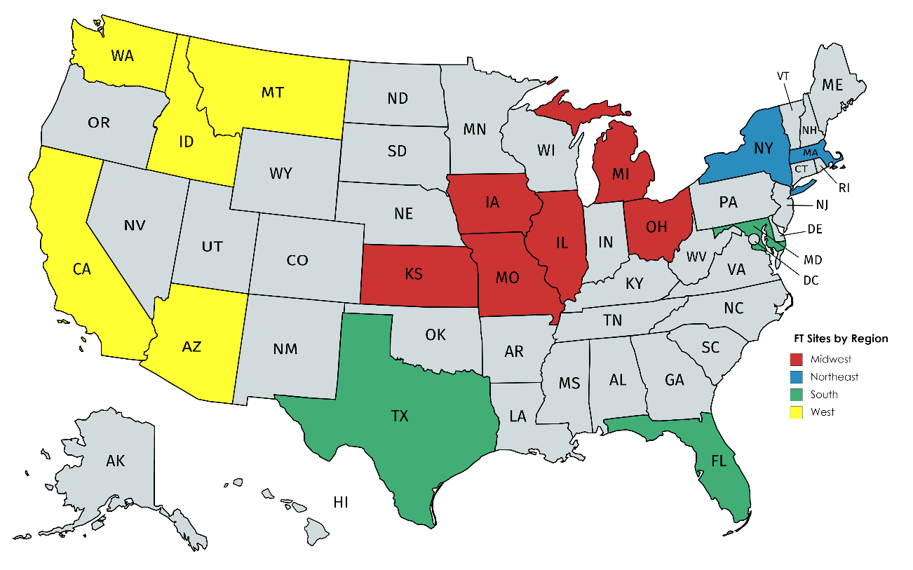

Field testers were asked to read through the questions and response choices in order to judge content based on accuracy, clarity, and thoroughness. Testers were also asked to listen to sound files used as stimuli in a number of trivia questions to ensure ease of identification and distinguishability. The field review concluded in December 2017. Changes made due to field tester comments include grammatical errors identified and corrected, improved clarity of questions relating to cardinal directions, and submit replacement sound file due to difficulty of identification. Suggested changes not incorporated in final product include increase quantity of questions relating to body awareness and more complex cane techniques. Zierer did not address these changes due to the original scope of the product. Questions can be added later to the trivia game if a product modernization is submitted and accepted.

Testers were asked to identify populations who could benefit from this product. The table below displays the feedback regarding end user recommendations.

Population Identified | Percentage of Field Testers
Preschool | 33%
Kindergarten | 42%
Elementary school | 92%
Middle school | 75%
High school | 67%
Adults | 33%

Content went through a final round of proofreading by Twyman and was delivered to the developers. Approved sound files were also made available to the developers. IUS students continued to work on this project throughout the semester.

As a capstone requirement, teams presented group projects at the 14th Annual IU Southeast Student Conference in April 2018. The development team who created the Amazon® skill was awarded The Social Sciences Award for Community or Civic Engagement for their work on O&M Trivia. Even though only one project could receive this award, both teams were given recognition from the dean for their work with a local nonprofit organization.

An official project handoff meeting occurred in May 2018 between APH staff and IUS student teams. Over the next month, Knapp and Zierer discussed changes to improve the product and achieve consistency between the two platforms. As of the writing of this report, Knapp is finalizing code for submission; release is anticipated in early FY 2019.

Hill, E. W., & Ponder, P. (1976). Orientation and mobility techniques: A guide for the practitioner. New York, NY: American Foundation for the Blind.
Pogrund, R., Healy, G., Jones, K., Levack, N., Marttin-Curry, S., Martinez, C., . . . Vrba, A. (2000). Teaching age-appropriate purposeful skills: An orientation & mobility curriculum for students with visual impairments (2nd ed.). Austin, TX: Texas School for the Blind and Visually Impaired.
Wiener, W. R., Welsch, R. L., & Blasch, B. B. (2010). Foundations of orientation and mobility (3rd ed., Vols. 1-2). New York, NY: American Foundation for the Blind.

RECREATION AND LEISURE

Flip-Over FACES App
(New)

Purpose
To provide an app that allows students with low vision to interactively explore and create facial expressions in a casual and recreational context. The app will simulate the panel-flipping format encountered in existing and planned Flip-Over Concept Books via accessible swiping gestures on an iPad® or other iOS® device.
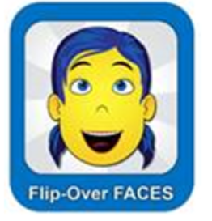
Project Staff
Karen J. Poppe, Tactile Literacy Project Leader
Lawrence Lovelace, iOS® Developer
Rezylle Milallos, Android™ Developer
Matthew Poppe, Graphic Designer
Anthony Jones, Director of Creative Services
Heather Kennedy-MacKenzie, Project Advisor
Joseph Hodge, Software Quality Assurance
Leasha Twyman, Research Assistant

Background
In August 2017, the project leader brainstormed the possibility of developing iOS® apps to complement existing or planned Flip-Over Concept Books. A formal Product Modernization Form was prepared and submitted for consideration by the Product Evaluation Team (PET) and Product Advisory and Review Committee (PARC). The project leader suggested three books within the series for app development including MAKE A FACE (see separate annual report), LINE PATHS, and PARTS OF A WHOLE. It was expected that the visual artwork developed for the tactile books would be utilized for the creation of the corresponding apps. In September 2017, the PET committee approved the modernization proposal and forwarded it to PARC for further consideration. The project leader prepared electronic-slide simulations to demonstrate the expected look and functionality of the proposed apps. Theoretically, regardless of concept presented, students could “flip” to change panels using swiping gestures on an iPad® or other iOS® device.

On September 15, 2017, a project kickoff meeting was conducted and attended by APH staff representing various departments. The meeting served to invite additional ideas from expected project team members. The group decided to begin app development for MAKE A FACE instead of LINE PATHS or PARTS OF A WHOLE for the following reasons:
- Targeted a more inviting, interesting, and universal concept
- Promised a wider-audience potential—low vision students, students with Cortical Visual Impairment (CVI), students with multiple disabilities, children with autism, and sighted peers
- Provided an open-ended, low-stress experience—that is, no right or wrong selections/pairings of facial features
- Served as a test flight for the eventual end design of the physical print/tactile book
- Expected popularity/demand
The team members also developed a tentative, but realistic timeline for the app’s development for eventual field test purposes.

Work during FY 2018
In November 2017, the PARC committee approved the development of the MAKE A FACE app, later renamed Flip-Over FACES. The committee also recommended that the app be provided for both iOS® and Android™ platforms. Its potential use with other APH products, such as the MATT ConnectTM and the GraphitiTM, was also mentioned. Development of the physical tactile/print book MAKE A FACE was postponed; attention immediately shifted to the development of the corresponding app.

Initially, the project leader and the graphic designer created a variety of facial features for the app. Their goal was to provide at least 10 unique options for each of the three facial sections: eyebrow position/shape, eye direction, and mouth expression. Added facial embellishments, such as hairstyles and eyeglasses, were designed as well. A visually simplistic presentation was maintained; however, options such as whimsical hairstyles and eyeglass styles were offered to add interest and variety. The color for the basic face (yellow) was employed to ensure maximum visual contrast against either a white or a black background. Some of the possible facial-feature combinations are shown below.

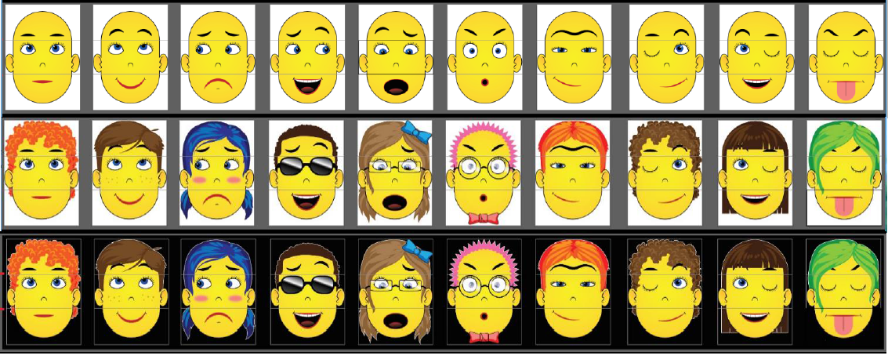
After the file renderings of the facial features were completed, the programmer initiated the construction of the iOS® version of the app (for iOS® 10.1 or later). Although an Android™ version of the app was planned and concurrently underway, it was determined that only the iOS® version would be formally field tested. The app’s construction incorporated the following functions and features:
- One-finger-swipe gesture to change eyebrows, eyes, and mouth panels
- Two-finger-swipe gesture to change the eyeglass style and hairstyles
- Single-tap gesture to activate the audio description of displayed eyebrows, eyes, or mouth
- Double-tap gesture to activate the audio description of displayed hairstyle or eyeglasses
- A playback button to activate an audio description of the entire face shown on the screen
- A toggle button for switching between the two background options—white or black
- Anticipated “Favorites” folder to archive the student’s favorite face design(s) for later retrieval
- Voice-over navigation
- Portrait-mode orientation only
- Voice-over commands
- A landing/home page with four visual icons that link to related content and options

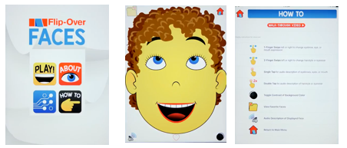

A walk-through video of the app’s basic functionality was prepared and included within the HOW TO menu. The video was uploaded as a YouTube™ video: www.youtube.com/watch?v=K1RrxCRU-OM

A field-test announcement was posted in the March 2018 APH News. The following requirements for testing the app were stated:
- Access to iPhone®, iPad®, iPad mini®, or iPod touch® with iOS® 10.1 or later
- Ability to directly test the app with students, 5 years of age or older, with low vision or CVI (with or without other disabilities) and complete an online product survey

A total of 50 teachers of the visually impaired and orientation and mobility specialists expressed interest in participating in the evaluation of the Flip-Over FACES app. Potential evaluators gave reasons for wishing to field test the Flip-Over FACES app with their students with visual impairments and blindness; their reasons hinted at the product’s usefulness, even before the formal field test began. Specific explanations included the following:
- “I have a number of children with low vision and ASD who would benefit from additional supports in the area of facial expressions. It sounds like a very interesting app as teaching facial expressions is often an area that we forgot to teach. Plus, I’m always looking for new apps to use with my students.”
- “In Texas the Expanded Core Curriculum for students with visual impairments is now a legal requirement. This app will assist in teaching social interaction skills to students who may otherwise not see the fine detail of faces to understand facial expressions.”
- “I notice that most students engage with electronic devices. These devices can be very motivational. Those at Phase 2 on the CVI Range might well use this app.”
- “I think this would be a fun way to teach and develop awareness and understanding of nonverbal facial expressions and social skills.”
- “I have students who enjoy looking at themselves in mirrors and making faces. I believe it would be beneficial for them to be exposed to other faces and different facial expressions to see how they engage.”
- “I’m always looking for ways to improve functional vision for my students with cortical visual impairment. One of the major conversations I have with families as they’re concerned for their children not to be able to read other students’ faces and derive appropriate meaning from conversations.”
- “I would like to tease out whether my students could understand the pictures and translate the features to specific feelings.”
- “I would like to see if these students can discriminate the details of facial expressions on the iPad.”

A total of 35 field evaluation sites were selected, based upon geographic location, number of available students, and type of instructional setting. The field-test stage was initiated in May 2018.

The field evaluators were given the following instructions for thoroughly testing the app with their students with visual impairment:
- Confirm that iOS® 10.1 or later is installed on your device.
- Install the TestFlight® app in advance from the Apple® App Store®.
- Open your invitation email from the device you plan to test with.
- Tap on the “Start Testing” or “View in TestFlight®” link.
- Download the field test version of Flip-Over FACES for iOS®. (The testing period began on Tuesday, May 1, 2018).
- Begin testing the app for instruction and everyday use with your student(s)/child.
- Keep detailed notes of observations regarding individual features and the product as a whole.
- Update the Flip-Over FACES app, if notified.
- Complete an online evaluation form for yourself and for each student by June 8, 2018.

The majority (74%, 26 of 35) of the selected field test evaluators completed and returned required field test forms by the due date. A few evaluators dropped out due to limited time with the student(s) or because of end-of-school-year commitments. Figure 1 shows the distribution of field test sites according to geographical location. Survey respondents represented the following states: California, Colorado (3), Illinois, Kentucky (2), Maine (2), Michigan (2), New York, New Hampshire, New Jersey, North Carolina (2), Ohio (2), Pennsylvania, Texas (2), Washington (3), and Wisconsin; one evaluator taught in New South Wales, Australia.

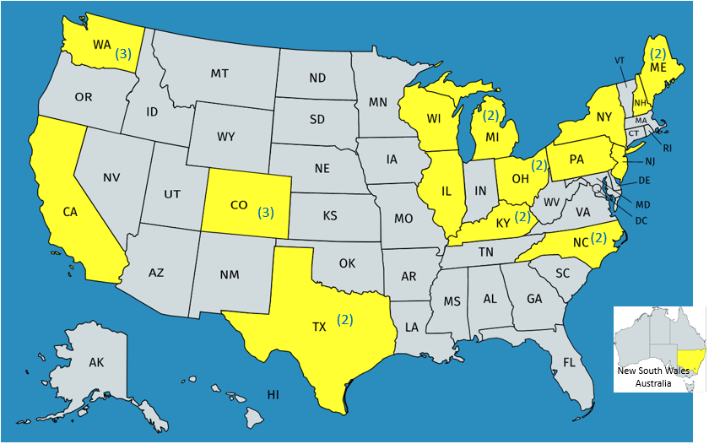
Figure 1. Distribution of Field Evaluators by Geographical Location

Table 1 shows the classification of field test sites according to type of instructional setting. Some evaluators taught in multiple types of instructional settings.

Table 1
Type of Educational Setting
Type of Educational Setting (N=26) | Location  of Field Test Sites | Percentage
Residential School for the Blind | WI | 4%
Public School with Inclusive Setting | Australia, CA, CO(3), IL, KY, ME(2), NH, MI(2), NC, NY, OH, TX | 62%
Public School with Individualized Instruction | Australia, CA, CO(3), KY(2), IL, OH(2), WA(3), ME, MI(2), NC(2), NY, NH, TX(2) | 85%
Center-based Program | CO, MI(2) | 12%
Private School for Special Needs | PA, NJ | 8%
Individual Home Setting | MI, NC, TX | 12%

Participating field evaluators (N=26) represented teachers of the visually impaired with varied teaching experience: 23% had less than 5 years of teaching experience, 23% had 6-10 years of teaching experience, 15% had 11-15 years of teaching experience, 12% had 16-20 years of teaching experience, and 27% had 21 or more years of teaching experience. Their reported level of expertise with assistive technology varied; the majority (65%) described themselves as average or average/power users, 31% described themselves as power users, and the remaining 4% indicated that they were limited users. Most of the evaluators were able to use the Flip-Over FACES app with multiple students; nearly 70% of the evaluators used the app with three or more students. All of the field evaluators installed the app on an iPad® with iOS® 10.1 or later; three field evaluators (12%) installed the app on an iPhone®; and one evaluator installed the app on an iPad mini®. Exactly half of the field evaluators reported previous use of techniques, tools, or materials for facial expression instruction prior to field testing the Flip-Over FACES app.

The field evaluators used the Flip-Over FACES app with 84 students, with noticeably more males (64%) than females (36%). The sample population represented cultural diversity: 72% White, 9% Hispanic, 5% Black, 4% Asian, 6% two or more races, and 4% “other.” (See Figure 2.) Over half (54%) of the student sample were reported as having CVI. Two students who lacked a visual impairment were reported as having autism. As Table 2 reveals, additional disabilities were common among the student sample.

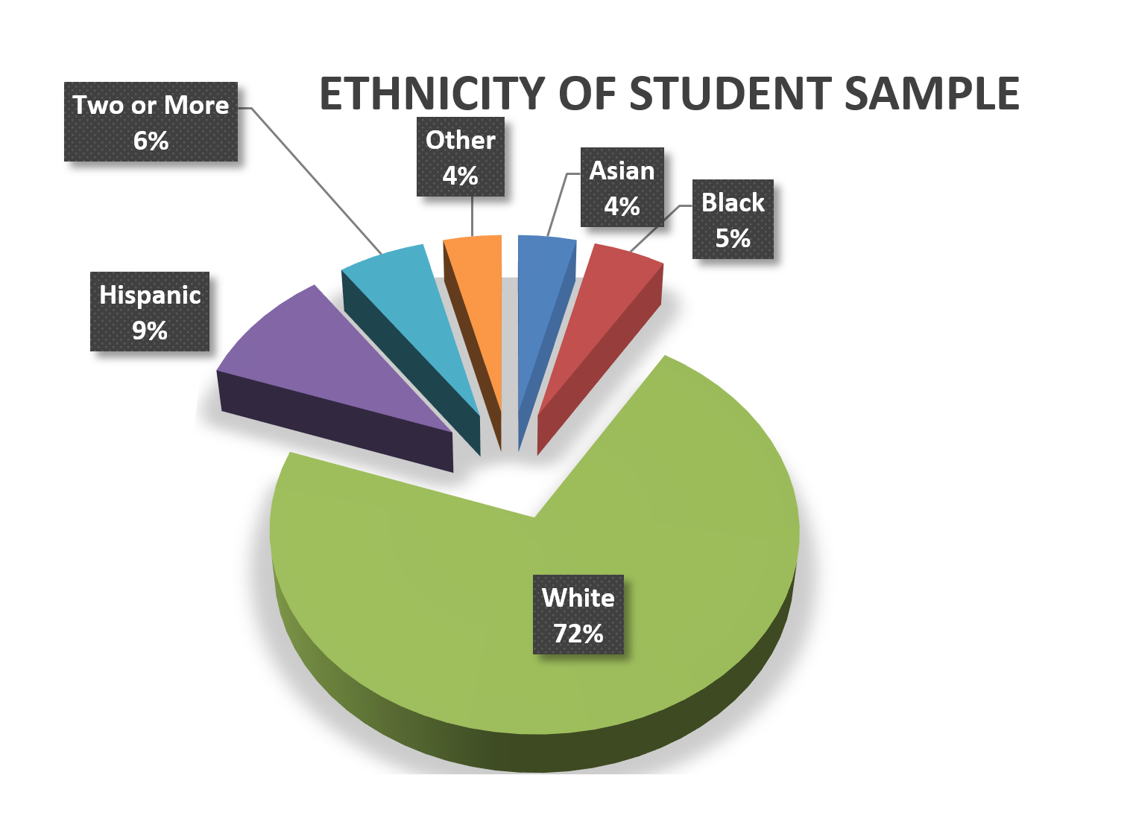
Figure 2. Students’ Ethnicity (N=84)

Table 2
Additional Disabilities
Disability | Number of Students  (N=84) | Percentage of Total Student Sample
Autism | 14 | 17%
Cognitive Impairment | 51 | 61%
Speech/Language Delays | 51 | 61%
Deafblind | 1 | 1%
Cerebral Palsy | 25 | 30%

The student sample ranged in age from 3 to 20 years. A quarter of the students were 3 to 5 years old, 29% were 6 to 8 years old, 31% were 9 to 13 years, and 15% were 14 to 20 years old. (See Figure 3.)

With regard to grade level representations, 36% were in preschool, kindergarten, or an early child special education class; 17% were in Grades 1 to 2; 19% were in Grades 3 to 5; 10% were in Grades 6 to 8; 11% were in Grades 9-12; and 7% were ungraded. (See Figure 4.)

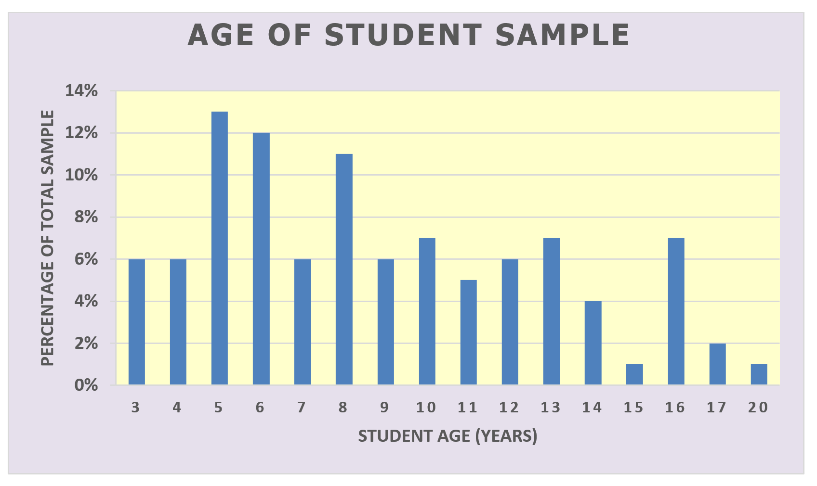
Figure 3. Age of Student Sample (N=84)

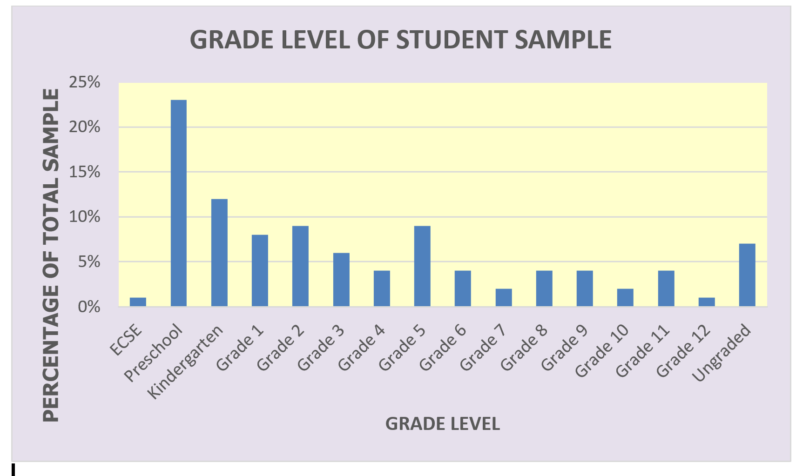
Figure 4: Grade Level of Student Sample (N=84)

As Table 3 reveals, the preferred reading medium varied from student to student, likely as a result of the variety of reported eye conditions and disabilities for the entire student sample; many students were dual readers with preferences for two or more reading modes.

Table 3
Primary Reading Medium
PRIMARY READING MEDIUM | N=84 | Percentage
Regular print | 1 | 1%
Regular print with magnification | 6 | 7%
Large Print (18 pt. or larger) | 16 | 19%
Auditory | 13 | 15%
Symbols/Pictures (print or tactile) | 7 | 8%
Prereader | 3 | 4%
Nonreader | 1 | 1%
DUAL READERS
Auditory/Symbols | 11 | 13%
Auditory/Braille | 2 | 2%
Regular Print with Magnification/Symbols | 2 | 2%
Large Print/Auditory | 3 | 4%
Large Print/Pre-Braille | 1 | 1%
Large Print/Electronic | 2 | 2%
Large Print/Symbols | 1 | 1%
Large Print/Reg. Print with or without Magnification | 3 | 4%
Large Print/Braille/Auditory | 1 | 1%
Auditory/Electronic/Symbols | 3 | 4%
Regular Print with Magnification/Auditory | 1 | 1%
Large Print/Auditory/Symbols | 1 | 1%
Regular Print with Magnification/Electronic | 1 | 1%
Regular Print with Magnification/Auditory/Symbols | 2 | 2%
Auditory/Symbols/Prereader | 1 | 1%
Auditory/Prereader | 1 | 1%
Regular Print with Magnification/Braille/Auditory | 1 | 1%

As Table 4 reveals, the most appropriate target populations for the Flip-Over FACES app, as assessed by the 26 field evaluators, were low vision preschoolers, kindergarteners, and students with CVI. Other ideal populations noted by some evaluators were students in grades 5-12 with cognitive impairments, high-functioning CVI students, and students with hearing loss.

Table 4
Appropriate Target Populations
Target Population | Percentage of evaluators (N=26) indicating appropriateness of app for target population
Preschoolers with low vision | 96%
Kindergarteners with low vision | 92%
Students with low vision in Grades 1-3 | 69%
Students with low vision in Grades 4-8 | 27%
Students with low vision in Grades 9-12 | 8%
Students with CVI | 88%
Students on the autism spectrum | 62%
Students with multiple disabilities | 69%
Sighted peers | 38%

Data collected via 84 Student Outcome Forms also illuminated strides, as well as challenges, experienced by individual students during their use of the Flip-Over FACES app. Students’ prior experiences with the iOS® devices they used during the field test of the app spanned from very experienced (18%) and experienced (37%) to limited/minimal experience (39%) and no experience (6%). The number of instructional sessions during which each student used the Flip-Over FACES app also varied; more than half (56%) used it at least 2-5 times, 11% used it 6-10 times, and 32% used it during only one instructional session. Only one student used the app 10 or more times.

The students’ degree of interest in playing with the Flip-Over FACES app vacillated noticeably. Whereas 40% of the students were “very interested” and engaged in the app and desired to play it repeatedly, a comparable 36% were reported as “somewhat interested” and engaged throughout the initial use but did not express a desire to play with the app again. The remaining 24% of the students were described as “disinterested” and had very limited use of the app. For the latter group, disinterest was sometimes attributed to present cognitive, developmental, or physical challenges and delays; for example, evaluators mentioned that the student “didn’t have the fine motor dexterity in his hands to interact with the iPad appropriately,” or the student was “very distractible and impulsive with a short attention span.”

Students showed progress in various skills and concepts. The types of strides made varied from student to student (refer to Table 5).

Table 5
Student Progress in Skill/Concept
Skill/Concept | Percentage of students (N=84) reported as making progress
Increased awareness/understanding of facial expressions | 43%
Understanding cause/effect of swiping gesture/movement to change facial features | 63%
Independent play/interaction with app | 42%
Imitation of displayed facial features | 33%
Using expressive language to describe displayed faces | 29%
Understanding of basic spatial skills (above/below, left/right, up/down, etc.) | 26%
Independent choice-making based on personal preference of facial features/elements | 40%
Visual attentiveness/focus on task | 60%
Social interaction with peers in shared use of app | 4%

Evaluators noted other positive gains for some students in the areas “increased gaze and tracking,” “finger-swiping gestures,” “color identification,” and “stopping play to listen to auditory output.”

Although a wide range of subtle facial expressions can be generated with the Flip-Over FACES app, some of the exaggerated expressions were successfully recognized by the students to varying degrees: happy/cheerful (67%), sad/unhappy (50%), tired/sleepy (25%), skeptical/puzzled (12%), afraid/frightened (20%), surprised/startled (36%), and disgusted (15%). Students particularly enjoyed faces with bright hairstyles, eyeglass options, and silly mouth expressions (e.g., tongue sticking out). The robotic audio-descriptions were among their least favorite elements.

Overall, the students were more successful using one-finger swipes or taps to change or activate the facial features (eyebrows, eyes, mouth) than using two-finger swipes or taps to change or activate the eyeglass and hairstyle options and related audio descriptions. (Refer to Table 6.)

Table 6
Tasks Performed Independently by Student Sample
Task Performed | Percentage of students (N=84) who were able to perform task independently
Change eyebrow direction (one-finger swipe) | 46%
Change eye direction (one-finger swipe) | 52%
Change mouth direction (one-finger swipe) | 58%
Change hairstyle (two-finger swipe) | 31%
Change eyeglass option (two-finger swipe) | 32%
Tap on speaker icon (to activate full description of face with one-finger tap) | 43%

Nearly one-third of the field evaluators (31%) indicated that the app would be useful for theirs student(s) as it is currently designed. Thirty-eighty percent indicated that the app would be useful for their student(s) if minor updates were made, 23% indicated that the app would be useful with their student(s) if significant updates were made, and the remaining 8% (2 evaluators) indicated that the app would not be useful with their students regardless of updates or modifications made.

Successful features and noted advantages of the Flip-Over FACES app were echoed by multiple evaluators and included the following:
- Variety of faces that can be generated
- Facilitates open dialogue about facial expressions/emotions
- Bright colors/low clutter
- Colors of facial features (e.g., “great colors for CVI” students)
- Easy to use, simplicity (e.g., “not test-like”)
- Eyeglass options
- Cartoon-like facial images
- Variety of hairstyles
- Ability to change background color
- Favorite Face folder/icon
- Visual icons
- Landing page
- HOW TO instructions
- “Fun for kids”
- “So many options to include with instruction”

Some evaluators described their creative extensions for the app, such as having the student imitate the displayed face on the screen, using the app in combination with a mirror, and using augmentative/alternative communication devices to find the icons that describe the facial expressions.

Susan Sullivan, APH’s CVI Project Leader, was encouraged by the field test results and indicated that the Flip-Over FACES app would be an ideal tool for providing concentrated exposure to facial features, assessing visual attention, and encouraging a student to “listen first, then describe” the salient features of a face. The flexibility of the app for use with multiple students was also viewed as a positive feature.

In July 2018, the project leader regrouped the project team to transition the product to the tooling stage and review needed updates based upon feedback and suggestions from field evaluators. The project leader also received guidance from the Director of Research, as well as the CVI Project Leader regarding the most essential updates prior to release of the product. The following notable improvements and provisions were anticipated:
- Modify two-finger swiping and tapping gestures that posed difficulty for students when changing between hairstyles and eyeglass options, as well as activating related audio descriptions.
- Explore switch-adapted augmentations for students with multiple disabilities.
- Allow the ability to lock selected panels to allow a student to swipe only one (or two) regions of the face.
- Deactivate voice by default, that is, require voice to be activated by user.
- Re-position some of the visual icons (e.g., speaker icon) to a more predictable location.
- Shift some visual icons (e.g., contrast icon) to a menu accessed via the landing page to prevent students from inadvertently changing the background color.
- Minimize or eliminate the darkening of face panels when student touches the panel too long.
- Eliminate reflection elements within the eyeglass styles.
- Make lips fuller and more distinctive when mouth is closed.
- Ensure that the audio descriptions can be muted.
- Add eye patch option (as recommended by APH’s CVI Project Leader).
- Suggest creative uses or extensions mentioned by the field evaluators within the HOW TO menu.
- Stress that the app can be useful to older students with cognitive delays; avoid referring to appropriate chronological age.
- Proceed with development of an Android™ version of the app.

Work planned for FY 2019
According to a new matrix-scoring process used by an in-house review committee to evaluate all APH product ideas and endeavors, the Flip-Over FACES app garnered a weighted score of 51 out of a possible 93. In an effort to minimize the number of active projects assigned to a project leader and time demands on other staff resources, the Flip-Over FACES app officially reverted to on-hold status as of July 2018. An official reintroduction of this project to active status hinges on the completion of projects closer to availability and the reassessment of the project leader’s priorities. If the project re-enters the active project pipeline in FY 2019, the project leader will utilize field test data for the Flip-Over FACES App to make needed revisions to the app and launch it as a final product.

SELF-DETERMINATION

V-file
Formerly Personal Vision Portfolio
(Continued)

Purpose
To provide students, teachers, counselors, and parents of visually impaired students a tool to collect, organize, and document pertinent information and materials that will aid in transition from kindergarten through adult life

Project Staff
Jeanette Wicker, Core Curriculum Project Leader
Karen Ross, Project Consultant
Edith Ethridge, Project Consultant
Frank Hayden, Director of Technical & Manufacturing Research
Bryan Rogers, Manufacturing Specialist

Background
Edith Ethridge developed the Personal Vision Portfolio during her tenure as low vision specialist at Kentucky School for the Blind. She used this portfolio with students across Kentucky through the Outreach Program at the school. This portfolio becomes a working file of activities, documents, and resources used by the student and teacher. It is an aid to students through a variety of transitions: from teacher to teacher, middle to high school, from high school to college, and work/adult life. Ethridge retired from her position on July 1, 2006. The popularity and continued demand for the sharing of her work by groups and organizations around the U.S. led to a product submission. In January 2006, the product idea was approved by the Product Evaluation Team and the Product Advisory and Review Committee. Ethridge agreed to serve as a consultant. The initial work of writing and revising the portfolio began.

Work was delayed due to illness of the consultant. She continued to write, revise, and update the text for the teacher’s manual as well as the various forms to be used in the portfolio. The Technical Research Department developed models of the parts of the eye that could be used with a story board as well as patterns for a tactile graphic of the eye. The consultant completed the recording forms for TVIs, parents, and students to use with the portfolio.

In FY 2013, Ethridge continued to write, revise, and update the text for the teacher’s manual as well as the various forms to be used in the portfolio. She was able to use portions of the prototype with students at Kentucky School for the Blind during the school’s Low Vision Clinic. During this process, she identified areas of needed revision.

In FY 2014, work was again delayed due to illness of the consultant and that of her husband. The project leader and the consultant met throughout the year as the consultant’s health permitted. Ethridge continued to write, revise, and update the text for the teacher’s materials.

In FY 2015, Cathy Johnson, retired Outreach Director from Kentucky School for the Blind, agreed to assist in the development and completion of the project. Johnson, Ethridge, and the project leader met regularly throughout the year for writing sessions. The group was able to finalize the first two sections of the teacher’s manual. The project leader and the writing team continued to meet through FY 2016.

In FY 2017, Ethridge’s family obligations forced her to resign from the project. Karen Ross signed a contract to become the new consultant for the v-file. Ethridge, Ross, and Wicker met in July 2017 to transition the project materials and plan for the completion of the prototype.

Work during FY 2018
The writing team continued to meet on a regular basis to complete the remaining sections of the teacher manual and plan for field evaluation.

Work planned for FY 2019
The final sections will be completed and turned over to graphic design for layout. The kit will be field tested with teachers of the visually impaired.

SENSORY EFFICIENCY SKILLS

DeafBlind Pocket Communicator
(Completed)

Purpose
To provide a portable, low tech communication tool for use between a consumer who is DeafBlind and another communicator. The speaker talks by guiding the receiver’s fingers over the text to spell out words and sentences.

Project Staff
Susan Sullivan, CVI Project Leader
Amy Parker, Project Leader
Leasha Twyman, Research Assistant
Laura Zierer, Research Assistant
Frank Hayden, Director of Technical & Manufacturing Research
Andrew Moulton, Manager, Technical & Manufacturing Research
Anthony D. Jones, Art Production/Design Manager

Product Description
The DeafBlind Pocket Communicator (DBPC) is a slim, double-sided, pocket-sized, and no-tech device that displays the braille alphabet embossed beneath the corresponding raised print letters, numbers, and symbols. Intended to be used as a communication card, the speaker "talks" by moving the receiver’s fingers over the letters. It is a conversation tool for the DeafBlind and those who cannot fingerspell, communicating limited braille messages. This device is also suitable for teaching early braille skills.

Background
The project leader received a product submission for creating a product that had been previously made in the United Kingdom, and distributed in the United States through MaxiAids until 2005. The product was called Brailtalk. The product was a pocket-sized (6 inches long, 3 inches across, and ¼ inches high), hinged case that opened to display braille symbols embossed beneath the corresponding raised, high contrast, print letters, numbers zero through nine, “&” sign, and “$” sign. It was used as a communication tool, where the sighted person talked by guiding the fingers of the receiver over the letters communicating questions and answers.

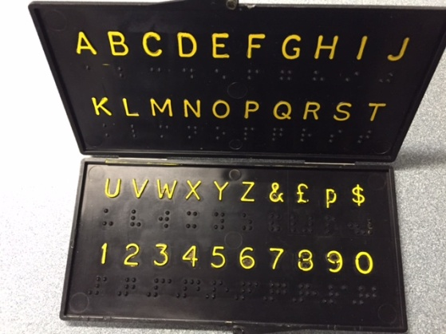

Product submission was made in August 2015, and the product was reviewed in September 2015. It was approved through a PET meeting in October 2015, and PARC in December 2015.

Attempts to verify whether or not the Brailtalk still existed were made via an Internet search; e-mail contact with former distributors both in the UK and United States; a letter to the company who originally made the product; and a search of worldwide databases of patent, trademark, or registered design rights. The product is not traceable, and there is no evidence of it being available for purchase.

Relevance
For many DeafBlind people, having a simple, low-tech tool is beneficial especially when traveling in the community or interacting with members of the public. When a person is DeafBlind, conditions such as bad weather, noisy streets, glare, or poor lighting can make communicating even more challenging. Not everyone is comfortable with using high tech devices and many people aren’t fluent in sign language. For this reason, the DeafBlind Pocket Communicator was created to support efficient communication for both children and adults in a variety of community or educational settings.

Nothing is more important than communication. For individuals who are DeafBlind, having combined vision and hearing loss can create a profound sense of isolation. It is not surprising that having access to reliable tools for communication and connection is a top priority for both children and adults. 3-D printing allows for rapid prototyping to develop and share files with the community who represents a low-incidence market for product sales.

This product will be fully accessible to the population who will use it. The DBPC materials will be available in print, BRF, text file, and HTML to meet APH requirements for accessibility.

Research
The project leader contacted two agencies working with the DeafBlind population: Michelle Cline at Phillip Rock Center in Chicago, IL; Diane Haynes, State Coordinator at the Kentucky DeafBlind Project in Lexington, KY; as well as the product’s submitter Jackie Souhrada, supervisor, Adaptive Skills in Austin, TX, asking about relevance of the product and guidance in what they thought the product should look like and include. All believed that the product was appropriate for those who lost sight or hearing quickly and would need a way to communicate in the community. “If vision and hearing are lost together, quickly, but the person could read the English alphabet, it is a lifesaver for emergency receptive language!” A card that explains how to use the communicator was suggested to be included with the product: English on one side, Spanish on the other. The product would need both raised print letters with high contrast and braille in order to be accessible to both populations. Desire for a downloadable 3-D file available to print the DeafBlind Pocket Communicator in emergency situations was voiced.

Prototypes were made that were similar to the original Brailtalk design. They were pocket-sized (6 inches long, 3 inches across, and 1/4 inches high), with a hinged case that opened to display braille symbols embossed beneath the corresponding raised, high contrast, print letters, numbers zero through nine, “$” sign, “cent” sign, question mark, and yes/no option.

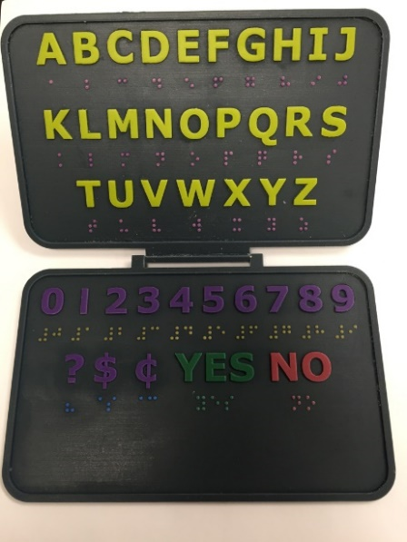

The first review period took place March through April 2017. Expert reviewers reported that the hinge connecting the two surfaces was very fragile. Fifty-seven percent arrived broken, and another broke after only a couple of uses. Additional suggestions included the addition of “@” and period symbols.

The APH team held a Product Development Committee (PDC) meeting to discuss changes to the 3-D file addressing expert reviewer requests. The updated prototype would be printed as a two sided piece, eliminating the need for a hinge, adding “@” and period symbols. A notch in the product’s top right corner would be added to aid in orientation for the hands as well as provide an ideal location to attach a break-away lanyard to allow wearing the communicator increasing freedom for the user’s hands.

The second set of prototypes was sent to expert reviewers in May 2017 with surveys completed by July 2017. Eighty-eight percent shared they found the DBPC to be “just right” in size, with 12% believing it was too big. Eighty-eight percent believed the product had the appropriate contrast in presenting yellow letters, numbers, and symbols. Sixty-three percent reviewed the quality of braille as high, 25% had no opinion, and 12% reported poor quality of braille.

Seventy-five percent of the reviewers found the visual clarity of the font to be high, with 25% having no opinion. Sixty-three percent reported high quality of tactile quality of font, 25% had no opinion, and 12% believed the tactile clarity of font to be poor. One hundred percent believed the new prototype to be very durable and easy to clean.
Sixty-five percent voiced the need for communication cards to accompany the product as an introduction to communication partners or to provide a specific request.
The project leaders acknowledge the helpfulness of this suggestion, but agree that each consumer would need a unique communication card, and agree that a product insert would be packaged with the DBPC guiding to research, resources, and even a template for consumers to create their own communication cards.

One hundred percent of the expert reviewers shared the prototype with colleagues for feedback, reaching over 35 additional professors, resource teachers, interveners, DeafBlind specialists, rehabilitation staff, orientation & mobility instructors, and students. Most consumers used the DBPC to purchase items, take a taxi, or communicate during an O&M lesson. Fifty-seven percent of reviewers reported the usefulness of the product for people who are DeafBlind to be excellent, 29% good, and 14% fair.

When asked if they had access to a 3-D printer for printing their own DBPC, 33% reported yes, 33% reported no, and 33% reported maybe. Reply to being asked if they would prefer to purchase the product from APH or print their own on their 3-D printer, 100% replied that they would prefer to purchase from APH. Project leaders agree that the 3-D file will be available on the APH Tactile Graphic Image Library for quick availability in emergency situations when a consumer needs the product immediately.

Changes were made to the original design after two rounds of expert reviews took place. Survey results were collected in July. A PDC meeting took place in July. Changes were made to the 3-D file per expert review requests. Project leaders created an online resource for the product, placed the 3-D file in the APH Tactile Graphic Image Library, and moved the project toward production.

Work during FY 2018
Product was available for sale on October 26, 2017.

Work planned for FY 2019
A Spanish version of the product will become available only on the APH Tactile Graphic Image Library.

Let’s Join In [Modernization]
(Continued)

Purpose
To provide educators of children with multiple sensory impairments a new perspective for inclusion in the educational setting. Dr. Jan van Dijk is working to expand his Child Guided Strategies into the standard education curriculum.

Project Staff
Susan Sullivan, CVI Project Leader
Jan van Dijk, Consultant

Product Description
Assessment guiding intervention will be demonstrated through video case studies of 10-12 students over time. Based on the outcome of the initial assessment, recommendations will be formulated. Discussion will demonstrate how these recommendations can be included in the standard classroom practice. The session and the discussion will be filmed, as well as follow up filming after 6 months to capture how interventions worked.

Background
APH published Child-guided Strategies: The van Dijk Approach to Assessment – For Understanding Children and Youth with Sensory Impairments and Multiple Disabilities, written by Catherine Nelson, Jan van Dijk, Teresa Oster, and Andrea McDonnell, in 2009. Since then, Dr. van Dijk has lectured internationally using the work as the basis of his work. Professionals from the field of visual impairment and blindness have struggled to integrate his work with children learning in inclusive educational settings. Let’s Join In is being developed in collaboration with Dr. Jerry Petroff, Professor at New Jersey College of Education, as well as staff from the Maryland DeafBlind Project and Alabama Institute for Deaf and Blind. Filming and editing is ongoing.

Relevance
There is evidence that for about 1% of the children with multiple sensory impairments, even an adapted form of the standard curriculum is inadequate. Collaboration with the regular classroom teacher, professionals, administration, as well as parents is needed so that the team is working together to utilize the child’s strengths and formulate goals that are important to the child.

Reference: Nelson, C., Van Dijk, J., Oster, T., & McDonnell, A. (2009). Child-guided strategies: The Van Dijk approach to assessment – For understanding children and youth with sensory impairments and multiple disabilities. Louisville, KY: American Printing House for the Blind.

Dr. van Dijk and Dr. Petroff filmed video clips of the children. They are working on an outline to show how others can implement the van Dijk child-guided assessment, how this approach is rooted in other foundational values and practices of effective approaches to assessment (literature review), and how this assessment approach can yield intervention that is critical to teaching the general education curriculum.

Work during FY 2018
Work slowed as Dr. van Dijk became ill. He passed in January 2018. Dr. Petroff is continuing to organize video clips and written material, which will be placed into an eLearning format for access via the Internet.

Work planned for FY 2019
Work is scheduled for completion and release.

Light Box Ledges
(Continued)

Purpose
To create an adaptive surface that helps bulkier objects stay on the light box when tilted on an angle

Project Staff
Tristan Pierce, Project Leader
Patrick White, Model Maker
Advisory Team: Susan Sullivan, Dawn Wilkinson, Suzette Wright

Project Description
This covers four catalog items: Large Light Box Ledge, Mini-Lite Box Ledge, Dycem® for Large Light Box Ledge, and Dycem® for Mini-Lite Box Ledge. The Ledges are adaptive work surfaces (clear plastic) that fit to the existing APH Light Box and APH Mini-Lite Box to prevent materials from sliding off the lighted surface when the light box is in an upright or semi-upright position. One sheet of custom-sized Dycem® will accompany each ledge. The two sizes of Dycem® are also available as catalog numbers.
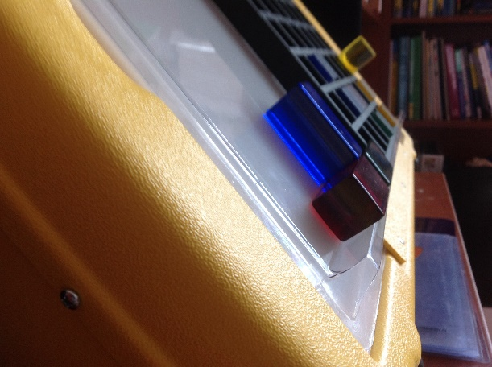
Background
The project leader and the advisory team determined the following criteria for the design of the ledges: They must be easy to attach and remove from the Mini-Lite and Light Box, they must be producible with existing APH processes, and they must accept existing Light Box and Mini-Lite Box materials.

Relevance
The American Printing House for the Blind (APH) made the decision to produce the Light Box Ledge based on a standardized process of product selection. Suzette Wright submitted a Product Modernization Form on December 1, 2015. Wright is an APH project leader who helped create the Light Box Materials. A Product Submission review, a Product Evaluation Team review, and a Product Advisory and Review Committee review were not required because it is a modernization (addition) to an existing product. However, an internal team composed of project leaders for early childhood, early childhood literacy, cerebral/cortical visual impairment (CVI), and multiple disabilities met with the Director of Technical & Manufacturing Research and a model maker to discuss and review possible designs for the ledge. After the team discussed initial design needs, the Multiple Disabilities Project Leader continued to shepherd the product.

The Light Box Ledge is fully accessible to the population using it. The molded lower edge allows learners to rest educational aids on the Light Box when using it in a tilted position. This is especially beneficial to learners who are unable to grasp and hold objects tightly. The clear material does not produce any visual complexity for the learner, which is beneficial for all young learners and especially those with low vision, delayed visual maturation, CVI, and intellectual and developmental disabilities.

The Light Box Ledge follows APH guidelines for determining relevance of a product. As APH continues to create educational aids for Light Box use by children with visual and multiple disabilities, it is the understood, accepted, and responsible action for APH to provide such a tool. The Bright Shapes Knob Puzzles, which APH recently released, reaches a broader population when paired with the ledge as does the longtime existing items in the Light Box Materials (e.g., plexiglass shapes, pegs, cubes), and a future product series that focuses on animal face recognition designed specifically for Light Box use.

There is evidence of an examination of the need for this product. In the past, APH suggested that teachers try clear contact paper using the sticky side up, but this is not a long-lasting solution. Teachers indicate that they use an iPad® for children with severe motor challenges, in part because it supplies a visual display that responds to a slight touch, rather than present objects on the Light Box that slide off if a learner does not have good motor control. The expression, “If the eyes don’t move, the hands become the eyes,” is proven by neurologists who point to images that show regions of the brain normally dedicated to processing visual information, instead using tactual processing in individuals without sight (Pascual-Leone & Torres, 1993). However, what does the brain process if both eyes and hands do not work? According to Gibson (1988), young learners use their “sensing” and “action” systems to learn about what is in their worlds. Learners who cannot use their hands to explore objects develop knowledge of their worlds based primarily on auditory information. Auditory input alone does not make much sense (Smith, 2012). Many learners with visual and multiple impairments require the touch of tangible objects for cognitive learning and recognition. The Light Box Ledge can help learners touch and explore objects to help learn the meaning of those objects. They need objects supported on a light box.

There is evidence APH sought opinions of knowledgeable individuals to determine the need for this product. Historically, as stated above, teachers and APH have long discussed the need that has evolved from using sticky contact paper to the evolution of the iPad®. In addition, recent field-testing with the Bright Shapes Knob Puzzles renewed the need and interest in solving this problem.

This product addresses an identified need for a person who meets the definition of “visually impaired.” Touch is the most essential remedial strategy for children with blindness. Unfortunately, the technique used most frequently is passive touch. This means a learning partner places the learner’s hand on an object or puts an object in the learner’s hand and moves the learner’s hand over the object. This is still passive touch because the brain activities needed for ideation, motor planning, and muscular execution of movement occurs in the teacher’s brain, not the learner’s brain. Passive touch provides poor quality information (Smith, 2012). The Light Box Ledge provides support for the object on the Light Box to enable a learner with motor challenges to explore objects more slowly and allow time for cognitive processing.

Research
APH gathered data using an appropriate method. Product evaluators submitted one teacher evaluation and one evaluation on each student with whom they used the ledge via SurveyMonkey®, an online survey development cloud-based software.

There is evidence that APH considered research data as part of decision-making in product completion. APH asked product evaluators if using Dycem® improved their students’ learning experience. Seven teachers responded, and six (86%) of them said yes. APH asked them to consider their students’ ability when they used Dycem® in conjunction with the ledge and if APH should include a full sheet of translucent white Dycem® with each sized ledge. Overwhelmingly, the 11 (100%) evaluators responded yes. Unsure of the cost of Dycem®, APH asked teachers to consider the increased cost of the product; a slight majority (55%) still want APH to include it with the ledge. Most evaluators (82%) said they would purchase Dycem® as a replacement part/separate product. The responses of the evaluators provided affirmation to APH’s desire to solidify talks with Dycem® to purchase custom-sized sheets of Dycem® Reels for the two sizes of ledges. The leadership at Dycem® understands the importance of APH’s mission to provide educational materials for a low-incidence population and thus have offered to create custom dies and provide materials to APH at a very reasonable low cost. Evaluators’ comments on Dycem® included the following.
- The materials remained in place so the student was not distracted, and the lesson ran smoother.
- The face puzzle stuck to the material and had to be pulled off. Using it greatly improved the length and quality of interaction.
- The Dycem seemed to help with the pictures but only for short use. Once the Dycem lost its tacky feel the pictures fell off in the two square frame.
- It allowed objects and cards to be put anywhere on the Light Box not just the bottom.
- It provided extra grip.
- The Dycem allowed for easy manipulation of the pegs because it kept the pegs in a spot that the student could try to reach for, and then if the student accidentally missed the peg (and it was going to fall), the ledge would typically prevent it from falling.
Two evaluators had no comments on the prototype ledge. One evaluator said the ledge was too big for one of her smaller learners to reach over it. Three evaluators said it was too small—wishing the ledge was a little longer. Five evaluators submitted positive comments.
- I had one of my smaller students actually have a hard time reaching over the edge of the ledge. It got in his way with the motor control he has.
- The ledge is a great start, but needs a few modifications to make it work with all of the APH materials. A slightly larger ledge and larger lips on the sides would be helpful.
- My only criticism is the ledge was just a little too small, 1/2 an inch wider would be better.
- I have both [sizes of] light boxes. I would like to purchase both as a set. However, if I only had one size, I would like the option of purchasing one size. I think that perhaps if the ledge was a little larger it could hold the sorting cups with the clear Dycem. The sorting cups would not stay on without being held.
- I found the ledge very helpful and it reduced the frustration in using the Light Box and associated materials with my students. I liked that the ledge was movable so that I could accommodate the left/right side field preferences of my students. I would love the Light Box to be on a stand so that students can extend their legs underneath to facilitate a play posture.
- When I received the product, I was doubtful that it would have the impact it had with my students. I was amazed at how well it fit, how sturdy it was, and how well items stayed on the light boxes! One of my students consistently pulled the mini ledge off the Light Box but the ledge did not break or crack. The Dycem also worked very well, especially with the face puzzle.
- Great adaptation for the Light Box!
- I LOVED the ledge! It worked best with Dycem. I cannot believe I never thought to use Dycem myself! It really helped when I used both. The overlays worked fine with the ledge but when I wanted to have my students manipulate more items, the Dycem helped the objects stay still and the ledge helped keep them on the Light Box when they fell.
- Loved the two sizes.
The development of the Light Box Ledge followed APH Research Guidelines.
- Input from the field – Field evaluators who tested various APH products in the past requested help to hold items on the Light Box when used in a tilted position.
- Safety report /Technical review – The clear plastic that is the sole material used in making the ledge and is a material used in many APH products and has safety data sheets on file at APH. The accompanying Dycem® sheet, manufactured in the United Kingdom, is a non-toxic latex-free product. Dycem® submitted to APH the technical data sheet for Dycem® Non-Slip Reel Products.
- Representative product prototype – The team discussed various materials and designs and decided to create two versions of a ledge, one an angled piece of metal that slid into the bottom lip of the light box, and one clear plastic sheet that covers the plate of the light box with a thermoformed ledge on the bottom. The team decided to pursue the clear plastic version because of cost, readily available materials, safety (metal ledge is potentially dangerous if used inappropriately), and requires no hand finishing, which the corners of the metal ledge did. APH produced and sent to evaluators prototypes that were identical to the final product. The only difference was the model maker cut the prototypes out by hand as opposed to using a die-cutting plate.
- Outside evaluators – APH selected field test sites by location, educational setting, student/client size, and evaluator qualifications.
- Evaluation tool and collection – The product development team created the field test packets and sent them to the field test sites. Data collection was through an online tool designed in SurveyMonkey®.
- Sufficient time – Product evaluation lasted 5 weeks.
- Reporting – Throughout the development process, the project leader reported monthly at the department’s New Products Meeting. The project leader presented the field test results to the Product Development Committee and the group met to determine future steps.
- Modifications – The team read the field test report and recommended to have four catalog numbers: Mini-Lite Box Ledge with Dycem®, Large Light Box Ledge with Dycem®, Dycem® for Mini-Lite Box, and Dycem® for Large Light Box.
- Quota approval – The project leader applies for Quota Approval at Annual Meeting (October 2018).
- Specifications – An APH manufacturing specialist wrote the specifications.
- Marketing – APH graphic designers produce product brochure and include new products in the next print catalog. Marketing posts on the APH shopping website, through social media, and at conferences.

The research method used collected sufficient information. Of the 11 product evaluators, eight (73%) used the large ledge and eight (73%) used the small ledge. Five (45%) of the 11 evaluators used both ledges. Eight teachers responded to the question on how well the large ledge fits in the Light Box. The majority (75%) responded that the ledge “fits very well.” The remaining respondents (25%) said it “fits okay.” Eight teachers responded on how well the small ledge fits on the Mini-Lite Box. Again, the majority (87.5%) responded, “fits very well”; one teacher (12.5%) said, “fits okay.”

After the teachers completed the required trials with their students, APH asked them if the extended bottom ledge on the prototype is sufficient to hold the APH items that their students used on a 45-degree tilt, which is the largest bracket on the back of the Light Box. The eight responses for the large ledge showed five (62.5%) evaluators responded yes and seven (87.5%) of the eight evaluators using the Mini-Lite Box responded yes. These quantitative figures reflect a more positive result than the qualitative outcomes from the evaluators’ general comments. Upon the completion of the product evaluation, the majority (91%) said they would recommend that their school district/agency purchase the Light Box Ledge. When asked if they would prefer to purchase the two sizes of the Light Box Ledge as a set or sold separately, 10 of 11 teachers answered the question. The majority (80%) preferred that APH sell the two sizes separately.

In addition to the ¾-inch bottom ledge, there is a very small profile trim on the remaining three sides. APH asked the evaluators if the raised trim on the sides prevented their students from sliding objects off the sides of the box. Evaluators gave responses for 13 of 14 students. Of those 13, seven (54%) said yes and six (46%) said no. APH asked for recommendations on how high the side trims should be; only two teachers responded, saying that they should be the same size as the ledge. It would be difficult to remove overlays from the ledge if all four sides were as high as the bottom ledge. One teacher commented that, “It was the bottom ledge that prevents items from falling.”

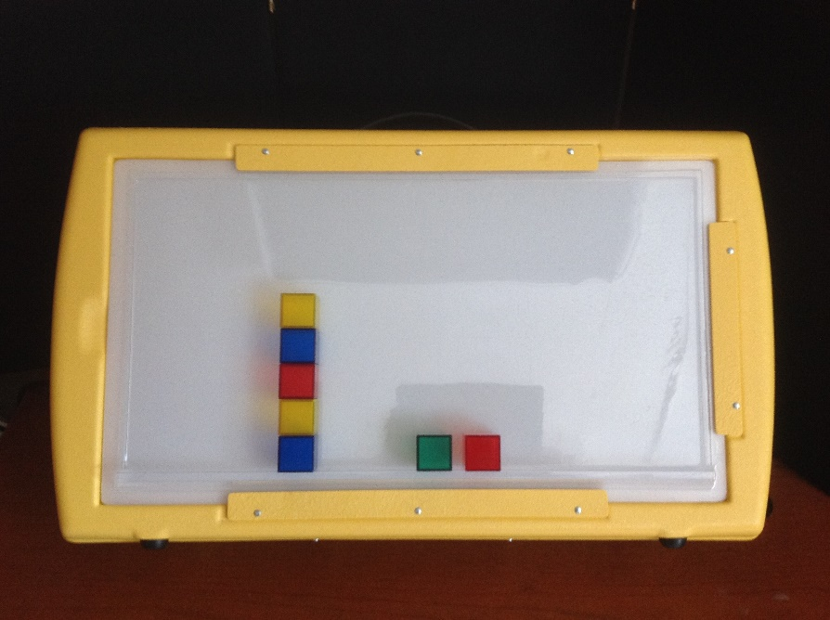
Teachers named specific products that their students used successfully with the ledge and with which the ledge proved extremely beneficial. Items included cups, pegs with pegboard, pictures, face puzzle, swirly mats, knob puzzles, pictures for matching, beads on grid, tracing paper, overlays, black mat with shape, and colored lid shapes.

Teachers provided comments on specific items/products that continued to fall off the Light Box while using the ledge.
- The ledge has made a difference but the Dycem really helps and additional Dycem for the back part of ledge helped.
- Knob Puzzles—items stayed on longer and student was able to interact longer than without the ledge, but due to her hypotonia the puzzles tended to get knocked off.
- Thicker shapes, such as the plexi-glass pictures/objects that have slicker backs.
- Translucent colored blocks, they are just a little too big for the ledge.

APH gathered data from a geographically diverse U.S. population. Eleven product evaluators from six states and one Canadian province participated in the product evaluation. Field test sites were in Colorado, Illinois, Maine, New York, South Dakota, Wisconsin, and the province of Alberta. The locations included public schools, residential schools, and educational service agencies.

APH gathered data from appropriately qualified individuals. Nine (82%) evaluators are teachers of students with visual impairments. One TVI holds dual certification as a certified orientation and mobility specialist and another one serves as an assistive technology coordinator. The two remaining evaluators are an outreach vision consultant and a team leader of early intervention.

APH gathered data from an adequate number of sources. Evaluators used the prototype ledges with 43 students, ranging from a 1:1 to 6:1 student-teacher ratio. They used these experiences for general comments. Teachers selected 14 students, 1:1 to 3:1 student-teacher ratio—on whom to submit trial data.

The students’ visual diagnoses included nystagmus (2), CVI (8), retinopathy of prematurity (2), and one entry each for aphakia, bilateral cataracts, coloboma hypoplasia, myopic astigmatism, ocular albinism, and optic nerve hypoplasia. Teachers listed four students as having multiple visual impairment diagnoses.

The 14 students have a variety of additional disabilities that may affect the motor skills of their arms, hands, and fingers. These include cerebral palsy (4), (Down syndrome (3), epilepsy/seizures (3), hypotonic (1), intellectual and developmental disabilities (4), other health impaired (3), and orthopedic impairment (2). Two teachers listed autism and speech impairment.

APH gathered data on student/consumer outcomes. The field test instructions directed teachers to use several APH items on the Light Box positioned at a 45-degree slant without any accommodation. They then chose one of those items that consistently fell off the Light Box. To measure outcomes, the teacher conducted five trials using the selected item on at least a 45-degree slant without the prototype ledge. They rated each trial as unable to succeed (item fell off 4-5 times), somewhat successful (item fell off 2-3 times), or successful (item fell all 0-1 times). Teachers then followed the same procedure using the same item with the prototype ledge.

As Chart 1 shows, a greater number of students (47.63%) were unable to succeed, followed by 36.32% of students who were somewhat successful, and only 16.13% of students achieved success when using a Light Box at a 45-degree slant without the ledge.
Chart 1: Average of Five Trials Without Ledge
Trial # | Unable to succeed | Somewhat successful | Successful
1 | 64.29% | 14.29% | 21.43%
2 | 50% | 42.60% | 7.14%
3 | 28.57% | 64.29% | 7.14%
4 | 57.14% | 14.29% | 28.57%
5 | 38.16% | 46.15% | 16.38%
Average | 47.63% | 36.32% | 16.13%

Figure 1 is a graphic representation showing the average of each of the five trials performed by the 14 students when they did not use the ledge. The five trials show an up-down pattern that possibly represents students improved by repeating the same action in Trials 2 and 3, fatigue taking over for Trial 4, but then rebounding for Trial 5. The product evaluators did not provide any insight to the up-down pattern, such as rest periods in between trials.
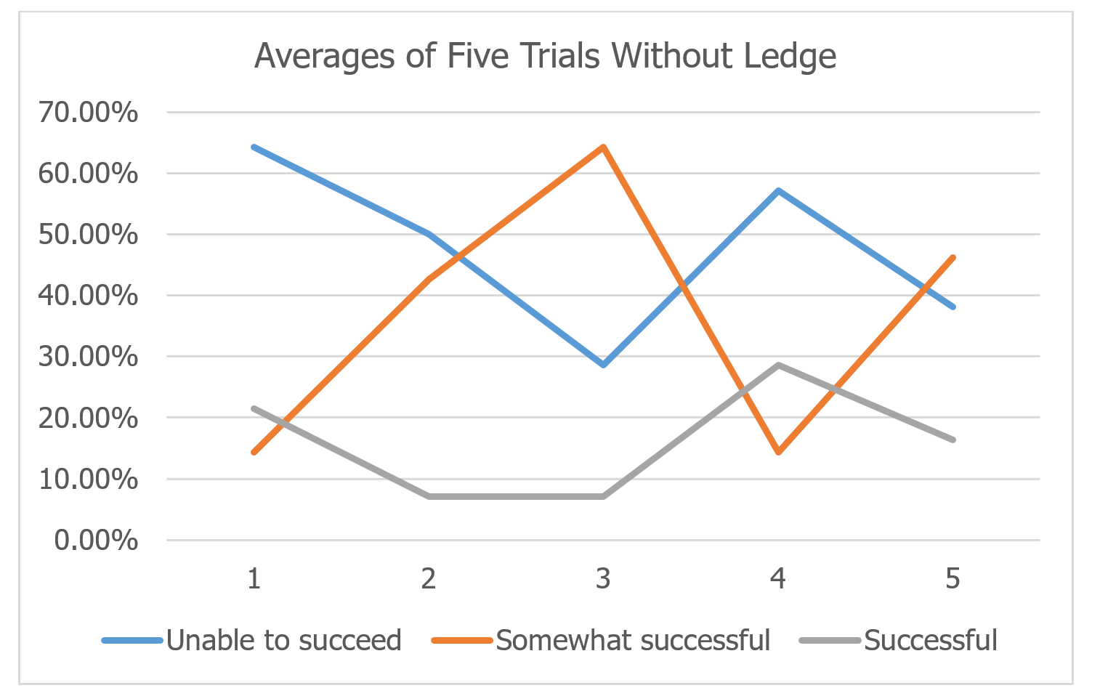
Figure 1. Averages of Five Trials Without Ledge

Chart 2 shows the greater percentage of students (62.46%) were successful during the five trials when using the ledge, while 25.91% of students showed some success, and 11.43% were unable to succeed.
Chart 2: Average of Five Trials With Ledge
Trial # | Unable to succeed | Somewhat successful | Successful
1 | 14.29% | 28.57% | 51.14%
2 | 7.14% | 36.71% | 57.14%
3 | 14.29% | 21.43% | 64.29%
4 | 7.14% | 21.43% | 71.43%
5 | 14.29% | 21.43% | 68.29%
Average | 11.43% | 25.91% | 62.46%

Figure 2 is a graphic representation showing the average of each of the five trials performed by the 14 students when they used the ledge. The unable-to-succeed category presents a down-up-down-up pattern; the somewhat-successful category went up, down, and then remained constant; and the successful category showed a steady improvement with each trial except the last trial, which again may show fatigue, which is a common occurrence in children with multiple disabilities.
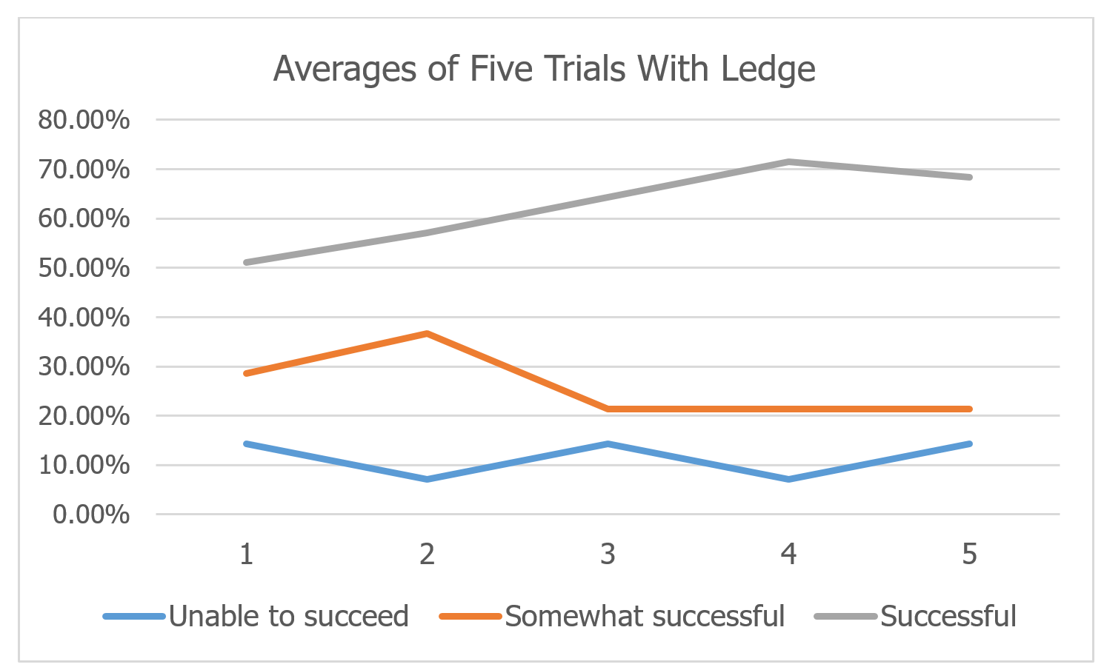
Figure 2. Averages of Five Trials With Ledge

Overall, both numbers and graphics show that students who have motor challenges affecting arms, hands, and fingers are more successful when they use a ledge on a slanted light box. Figure 3 presents the success comparison between using a ledge and not using a ledge. Without using a ledge, the bar graph demonstrates three descending stairs. Standing on the top stair are the greater number of students (47.63%) who were unable to succeed, taking one step down are the fewer number of students (36.32%) who were somewhat successful, and taking the last step down to the bottom stair shows the least number of students (16.13%) who were successful without a ledge. Walk across the base/floor (0.00%) of the bar graph to another set of stairs; this set of stairs represents using the ledge on the Light Box. One small step up to the first stair shows the least number of students (11.43%), those who are not successful using a ledge. Step up to the second stair reserved for a greater number of students (25.91%) who were somewhat successful, and finally take a huge step up to the third stair reserved for the greatest number of students (62.46%) who were successful when using a ledge.
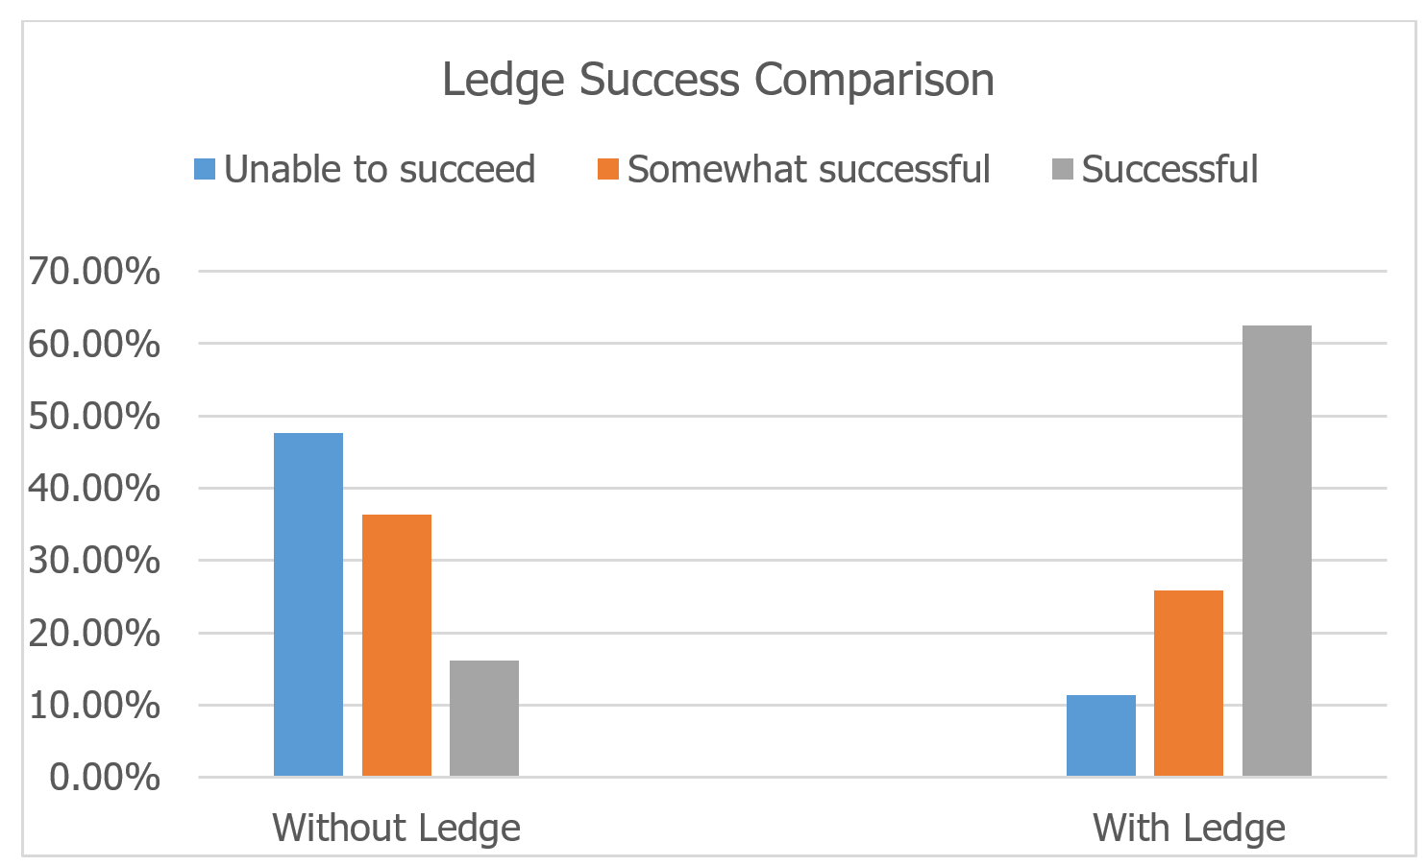
Figure 3. Ledge Success Comparison

APH gave prototype evaluators an opportunity to provide general comments. Grouped and listed below are the comments.
- The Dycem is very helpful to making sure the materials remain in place. I would recommend that it is included in the kit.
- This student was able to interact with ALL of the items we tried using the ledge with--much more success than without the ledge. She was much more engaged in the activities and interacted longer while using the ledge. This is a great product!
- The ledge provided more security during the lesson. Less apt to see slippage.
- The ledge has been very effective with all products tried, and with other, non-APH products such as an iPad® with OtterBox® case.
- We also tried sorting with shapes. The edge helped keep the shapes on the Light Box but once the student tried to touch the shapes with his inconsistent motor movements (push off) the shapes fell off.
- Both the large and small ledges were very effective for this student.
- I think the ledge is a great product. It just did not work with the bell. I believe that is because of the handle on the bell makes it top heavy and likely to fall off when presented at 45 degrees. What if the ledge had an additional barrier that went up 1 centimeter to help secure things on the ledge?
- The ledge was very helpful in positioning the student to the light box and not have items on the Light Box fall off. Was able to do a lot more in all areas of the Light Box.
- Overall, I loved it. I will use it all the time!
- As mentioned earlier, I like the concept of the ledge but I feel some of the items we use with students are a bit bigger than the ledge can accommodate. I would like the ledge to be about 1/2 an inch wider.
- Loved the ledge.
- The ledge and Dycem help so much!
References
Gibson, E. J. (1988). Exploratory behavior in the development of proceeding, acting, and the acquiring of knowledge. Annual Review of Psychology, 39, 1-41.
Pascual-Leone, A., & Torres, F. (1993). Plasticity of the sensorimotor cortex representation of the reading finger in braille readers. Brain, 116 (1), 39-52.
Smith, M. (2012). SAM: Symbols and meaning. Louisville, KY: American Printing House for the Blind.

SLK: Sensory Learning Kit (Revision)
(Continued)

Purpose
To update this successful product using feedback from the field and to add a video component to match its sister product, SAM: Symbols and Meaning

Project Staff
Tristan Pierce, Multiple Disabilities Project Leader
Millie Smith, Consultant/Author
Stacey Chambers, Teacher of Students with Visual Impairments
Monica Vaught-Compton, Project Assistant
Kelly Kennedy Mimms, Research Assistant
Emily Grimany, Research Assistant
Frank Hayden, Director of Technical & Manufacturing Research

Production Description
The Sensory Learning Kit (SLK) is the first of three sequential products that APH offers as an intervention continuum—Sensory Learning Kit, SAM: Symbols and Meaning, and Tactile Connections: Symbols for Communication. The SLK contains two books, three switches, one power control unit, and a variety of manipulatives.

Background
The SLK has been on the market since 2005. During that time, APH has co-hosted numerous training events across the country. Based on input from the field, we have learned additional information, resources, and educational aids that teachers and parents would like to have in the kit. Through field testing SAM, the second product of the continuum, we learned how valuable videos are to the user. We decided to incorporate videos into the revision of the SLK.

In FY 2013, Millie Smith continued to write the guidebook. Smith and the project leader convened in Frisco, TX, in February, April, and May to take photos and direct the filming of five students in three active learning classrooms as they progressed through the Attention, Exploration, and Function zones of the new SLK. In 2014, filming took place at the New Mexico School for the Blind and Visually Impaired. The project remained on hold for the rest of the year because other projects had timeline precedence.

In FY 2015, filming took place in Coppell, TX, in February, March, April, and May to establish a baseline on four students and to then follow them as they progressed through the SLK levels. The project leader and Smith reviewed the videos from Frisco, TX; New Mexico School for the Blind and Visually Impaired; and Coppell, TX, to decide what is usable for the project.

Work during FY 2018
APH completed two SLK videos and posted them on YouTube™. Millie Smith and the project leader continued to work on the guidebook and lesson plans for case studies presented in the book. Millie Smith, consultant; Stacey Chambers and Angela Campbell, Frisco ISD; Tessa McCarthy and Douglas Kostewicz, University of Pittsburgh; and Tristan Pierce, APH project leader, wrote and submitted an article for publication on two of the case studies featured in the guidebook.

Work planned for FY 2019
Work will continue on the videos along with editing the product documentation and selection of tangible items for the kit.

Cortical Visual Impairment

Color Raceway
(Continued)

Purpose
To provide a recreational game developed for players with low vision, including those diagnosed with cerebral/cortical visual impairment (CVI), who demonstrate color vision and emerging matching skills. It will target the key characteristics of movement, complexity, and color by engaging players to use their vision while participating in a fun, social activity.

Project Staff
Susan Sullivan, CVI Project Leader
Leasha Twyman, Research Assistant
Frank Hayden, Director of Technical & Manufacturing Research
Andrew Moulton, Manager of Technical & Manufacturing Research
Adam Clark, Manufacturing Specialist
Anthony D. Jones, Art Production/Design Manager
Laura Greenwell, Graphic Designer
Katherine Corcoran, Model/Pattern Maker
Beth Ramella, Consultant

Product Description
Color Speedway is designed to utilize the CVI characteristics of color, movement, and low-to-high complexity, to encourage players to use their vision in a functional and fun way. Up to four players compete by “racing” their cars around the speedway. Players take turns activating the spinner that is color coded with reflective green, yellow, and red. Each player will match the chosen spinner color to the appropriate color card from his set of playing cards, and move his race car: two spaces for “go fast” green, one space for “go slow” yellow, or zero spaces for “stop” red.

Background
From 2009–2011, a group of professionals from the Western Pennsylvania School for Blind Children (WPSBC) participated in a 2-year CVI Mentor training program. As an outcome of their training, professionals developed CVI recreational games and activities. The games are being developed by APH one at a time. Match Sticks was the first game completed and released in 2014. Color Speedway is the next game in development. Beth Ramella, Outreach Director/CVI Project Leader at WPSBC, is the consultant for these products.

Relevance
Recreation and leisure as well as social interaction skills are considered part of the Expanded Core Curriculum for children with visual impairments. Often children who are visually impaired do not experience the same opportunities for recreation and leisure that children with no vision loss have in the early years (Pogrund, 2002).

For turn taking and social interaction to develop, the child must first recognize and understand that there is a surrounding world with people who provide interest (Lueck & Dutton, 2015). Children with CVI need specific, individualized environmental adaptations in order for them to participate. The Color Speedway is being developed to provide ways to make adaptations for each child who plays the game.

It is often difficult for young children who are blind or visually impaired to interact appropriately with their peers. They may not be able to maintain visual attention to toys that their friends are interested in (Fazzi, 2002). Using toy cars for game pieces will promote socialization and inclusion with peers, and siblings.

This product will be fully accessible to the population who will use it. The Color Speedway materials will be available in print, BRF, text file, and HTML to meet APH requirements for accessibility.

References
Fazzi, D. L. (2002). Social focus: Developing social skills and promoting positive interactions. In Pogrund, R. L. & Fazzi, D. L. (Eds.), Early focus: Working with young children who are blind or visually impaired and their families (p. 199). New York, NY: AFB Press.
Lueck, A. H., & Dutton, G. N. (Eds.) (2015). Vision and the brain: Understanding cerebral visual impairment in children. New York, NY: AFB Press.
Pogrund, R. L. (2002). Independence focus: Promoting independence in daily living and recreational skills. In Pogrund, R. L. & Fazzi, D. L. (Eds.), Early focus: Working with young children who are blind or visually impaired and their families (p. 242). New York, NY: AFB Press.

Research
The evaluation period took place January–March 2017. Eight educational sites were selected for the field evaluation. Sites were located in the following states: Connecticut, Florida, Illinois (two sites), Kentucky, Pennsylvania, South Dakota, and Texas. Two of the sites were residential schools, four were public school settings, and two were early intervention home sites. Twenty-nine percent were located in rural areas, and 71% were in suburban settings.

Forty students participated in the field test. Five were braille readers without the diagnosis of CVI. Thirty-nine were diagnosed with CVI. Numerous peers and siblings played the game as well.

Teachers self-reported their experience working with children diagnosed with CVI. Fourteen percent reported little experience, 29% reported moderate experience, and 57% reported lots of experience.

Field testers were asked which characteristics of CVI the Color Raceway addresses. They answered color, movement, visual motor/reaching, distance viewing, and levels of complexity.

The aspects of the game that the students with CVI were most interested in were the spinner, the cars, moving the car around the track, and holding/looking at the color cards for their reflective quality. The students most loved winning, selecting their car, spinning the spinner, and the cars themselves.

Field testers agreed 100% that the game is appropriate for children with visual impairment or blindness other than CVI. “Yes! Nice adaptations for a child with low vision or blindness,” one said in referencing the braille color words on the spinner and the cards, the raised line spaces for the cars, and the braille numbers.

Field testers reported positive comments about the design of the board. “I like that you can add or take away the pieces from the green infield.” Seventy-one percent thought the game board was very durable; 29% said it was durable.

Field testers reported challenges of the game board: “Make board foldable for transportation,” and “Need a case with a handle or some other way of making transportation easier.”

The project leader met with the manufacturing specialists and production to discuss final design changes needed according to field tester comments. The game board will not be able to fold because of the material it is made with, but the team has decided to ship the game in a box with a handle that can be used for transporting.

Field testing was completed. The Product Development Committee meeting was held to discuss any challenges associated with production. Mattel® Hot Wheels® denied the project leader’s request to include their cars in the game kit. The project leader worked with the manufacturing specialist to choose a non-name die cast set of cars for inclusion. The guidebook with photos was completed and sent to graphic design.

Work during FY 2018
Suggested changes were made to the product. The project leader searched for cars to include in the kit that would be appropriate for learners with CVI, but determined that teachers and parents should choose cars appropriate to the visual needs of the child.

Work planned for FY 2019
The specification meeting will be held, and Color Raceway will be on its way to production.

Cortical Visual Impairment (CVI) Projects and Needs
(Ongoing)

Purpose
To assess needs and manage product development to better serve individuals with CVI

Project Staff
Susan Sullivan, CVI Project Leader
Leasha Twyman, Research Assistant

Background
In July 2014, APH hired a full-time CVI Project Leader.

APH’s CVI Web site was completely revamped in 2015 through updates of medical information, current APH products appropriate for the population, parent information, assessments, strategies for expanded core curriculum, orientation & mobility, teaming, literacy, and play, as well as resource links to research articles, books, websites, webinars, tablet apps, social media support groups, and project sharing sites.

Work during FY 2018
In addition to working on product development and updating the CVI Web site, the CVI Project Leader responded to customer service calls and e-mails to support professionals working with children diagnosed with CVI through product recommendations.

The project leader presented a CVI APH Product Showcase to future teachers for the visually impaired visiting APH from University of Kentucky, and to the 149th Annual Meeting of the American Printing House for the Blind (October). Other presentations included the following: CVI: What works and what’s new, presented at Early
Learning Sensory Support for Visually Impaired, Raleigh, NC (August); Cerebral Visual Impairment: Global and professional perspectives, facilitated at AER International Pre-Conference, Reno, NV (July); CVI: How a learning media assessment will help, presented at Charting the Cs, 10th Annual Cross Categorical Conference, Alexandria, MN (April); Cerebral/Cortical Visual Impairment: Diagnosis and environmental
Considerations, presented at Charting the Cs, 10th Annual Cross Categorical Conference, Alexandria, MN (April); Cerebral Visual Impairment (CVI): Working together toward habilitation/rehabilitation, presented at Craig Hospital National Brain Injury Summit, Vail, CO (January); CVI: How a learning media assessment will help, Presented at Getting in Touch with Literacy, New Orleans, LA, (December); CVI Website, presented at the 149th Annual Meeting of Ex Officio Trustees of the American Printing House for the Blind, Louisville, KY, (October); Create farm animals using “Animal Recipes”, presented at the 149th Annual Meeting of Ex Officio Trustees of the American Printing House for the Blind, Louisville, KY.

Work planned for FY 2019
The CVI Project Leader will continue to work on products recommended by surveys and submissions from the field, and update existing APH products to meet current APH and educational standards.

CVI Book Builder [Modernization]
(Completed)

Purpose
To provide materials for assembling individualized first books for young children diagnosed with cortical visual impairment (CVI)

Project Staff
Susan Sullivan, CVI Project Leader
Laura Zierer, Research Assistant
Frank Hayden, Director of Technical & Manufacturing Research
Andrew Moulton, Manager of Technical & Manufacturing Research
Anthony D. Jones, Art Production/Design Manager

Product Description
The CVI Book Builder provides materials that will allow parents and teachers to build first books appropriate for their reader, by using photos taken of the child’s favorite objects. The kit provides a variety of black pages and black binders to use as low complexity backgrounds against which to present objects, pictures, and letters.
These first books will help to build a bridge between an actual object that the child has experience with and a photo of that exact object, teaching that photos (symbols) have meaning.

Background
The Emergent Literacy Project Leader created Tactile Book Builder for use with children who are blind or have low vision. Field test results from that project showed a desire from the field for more black pages and black binders to be used with children diagnosed with CVI.

The CVI Project Leader submitted this product as a modernization of Tactile Book Builder. It moved through the Product Evaluation Team and then through the Product Advisory and Review Committee.

The CVI Project Leader worked with the original Tactile Book Builder prototype to determine which pages should be included in the CVI Book Builder kit. The manufacturing specialist ordered black binders to pair with the black pages for guidebook photos.

Relevance
According to recommendations received at the 2014 Meeting of the Minds, the 2014 APH Annual Meeting, and the 2014 APH News CVI Survey, literacy materials for the child with CVI are highly desired. Parents, early interventionists, TVIs, and university faculty are asking for products to use with children in all stages of CVI.

Barclay (2015) noted that understanding the typical development of early literacy is important when assessing whether students with CVI possess the foundational skills necessary for progress in reading. A child must understand that a picture/photograph or letter/word has meaning in order for them to comprehend content in books. Making simple first books will help to build a connection between an actual object that the child has experience with and a photo of that exact object, teaching that photos (symbols) have meaning.

This product will be fully accessible to the population who will use it. The CVI Book Builder materials will be available in print, BRF, text file, and HTML to meet APH requirements for accessibility.

Reference:
Barclay, L. A. (2015). Assessments linked to interventions: Literacy and math. In Lueck, A. H., & Dutton, G. N. (Eds.), Vision and the brain: understanding cerebral visual impairment in children (p. 419). New York, NY: AFB Press.

Work during FY 2018
Product was released in August 2018. No further work is required on this product.

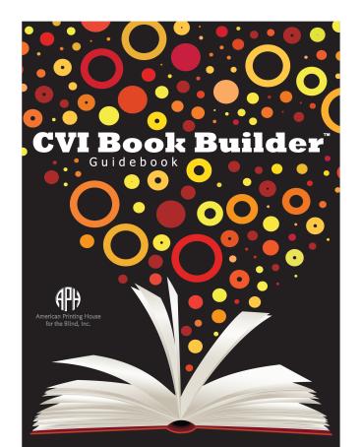

CVI Companion Guide to Developmental Guidelines for Infants with Visual Impairments [Modernization]
(Continued)

Purpose
To provide an expanded narrative on cerebral visual impairment. The companion guide will include additional columns to the Developmental Charts that address issues specific for children who have CVI. A CVI checklist form will be designed so that teachers can follow the developmental progress of their children with CVI as they move through the developmental clusters.

Project Staff
Susan Sullivan, CVI Project Leader
Amanda Lueck, Consultant
Deborah Chen, Consultant
Elizabeth Hartmann, Consultant
Leasha Twyman, Research Assistant
Frank Hayden, Director of Technical & Manufacturing Research
Andrew Moulton, Manager of Technical & Manufacturing Research
Anthony D. Jones, Art Production/Design Manager
Laura Greenwell, Graphic Designer

Product Description
This product will be a spiral book of approximately 150 pages in the same design as the Developmental Guidelines for Infants with Visual Impairments. An app will be designed to allow users to record student information on the data collection sheets.

Background
Product was submitted as a modernization in August 2017. It was reviewed and accepted as an active development product. Authors of the original Developmental Guidelines, Amanda Lueck, Deborah Chen, and Elizabeth Hartmann, agreed to work as consultants on the CVI Companion Guide.

Relevance
CVI is the highest cause of visual impairment in the U.S. An observation guide that addresses a variety of early developmental areas, not just functional vision, will be helpful to teachers and families since CVI affects all developmental domains.

A review of the research reveals that CVI can affect function in a variety of ways. The Companion Guide will explain behavioral manifestations that caregivers and interventionists can refer to as they spend time with each child. Interventions and accommodations can be embedded into daily routines to promote the use of vision for children with CVI for different domains of development.

Work during FY 2018
Authors have completed fine motor, communication, and CVI manifestations chapters.

Work planned for FY 2019
Authors will complete writing the guide, and work will begin on app development for the reporting forms.

CVI Web site
(Ongoing)

Purpose
To provide a current resource for research articles, books, websites, blogs, strategies, and support for parents, teachers, university faculty, and students as we strive to learn more about cerebral/cortical visual impairment (CVI)

Project Staff
Susan Sullivan, CVI Project Leader
Michael McDonald, Programmer
Leasha Twyman, Research Assistant

Background
CVI Synergy, a group of nine professionals, representing both educational and medical fields, met at APH in May 2002. The group agreed to act as advisors via an electronic mailing list to help APH develop a new website dedicated to CVI. Unable to attend the meeting, Dr. Jim Jan served via telephone and e-mail as the medical advisor.

In 2003, the Multiple Disabilities Project Leader developed an outline for the CVI website and began writing text and requesting submissions from the field. The APH Librarian obtained permissions on articles recommended by CVI Synergy to be placed on the website. Photographs of children using homemade and APH products were taken.

Dr. Jan organized CVI Synergy West in Vancouver, British Columbia, Canada. This second group, also representing educational and medical fields, addressed the issue of definitions associated with CVI. This meeting resulted in the education-based definition and the medical-based definition for CVI that APH used on the initial website.

In 2015 the APH CVI Web site was completely revamped through updates of medical information, current APH products appropriate for this population, parent information, assessments, expanded core curriculum, orientation and mobility, teaming, literacy, and play, as well as resource links to research articles, books, websites, webinars, tablet apps, social media support groups, and project idea sites.

Work during FY 2018
Site pages have been expanded. Video clips have been added to products as they become available.

Work planned for FY 2019
The CVI Web site will be monitored for content, format, and accessibility as technology is updated, and more resources about CVI become available.

Increasing Complexity Pegset
(Completed)

Purpose
To provide a product that promotes pairing vision with fine motor skills. The overlays will allow early interventionists and teachers for children with visual impairments (TVIs) to individualize the level of complexity needed for each student.

Project Staff
Susan Sullivan, CVI Project Leader
Laura Zierer, Research Assistant
Frank Hayden, Director of Technical & Manufacturing Research
Andrew Moulton, Manager of Technical & Manufacturing Research
Rod Dixon, Manufacturing Specialist
Anthony D. Jones, Art Production/Design Manager
Laura Greenwell, Graphic Design

Product Description
The Increasing Complexity Pegboard was created for children with visual impairments, including those diagnosed with cerebral/cortical visual impairment (CVI). Paired with diagnostic teaching strategies, the pegboard set helps to determine and support the
child’s color, lighting, movement, and complexity needs. Children diagnosed with CVI frequently have difficulty in understanding objects presented in a complex array. The Increasing Complexity Pegboard provides materials for parents and teachers to create background templates specifically for their learner. The product provides a black pegboard with 25 holes, a variety of black templates with openings for peg placement,
colorful reflective stickers to add increasing degrees of complexity, and hook and loop coins for optional re-use of stickers.

The pegboard can be paired with the APH All-In-One Board, allowing the pegboard to slant at different angles to accommodate student's physical needs.

Background
The project leader submitted the product idea, which moved through the Product Evaluation Team and was approved by Product Advisory and Review Committee in August 2015.

Relevance
Results from the 2014 CVI Survey posted in the APH News showed that 85% of the 46 respondents would find a pegboard with increasing complexity overlays to be useful when working/playing with a student diagnosed with CVI.

Respondents emphasized the value of pegs and pegboard as a tactile and multi-sensory experience. Comments included the following: "Something with a variety of textures and possibly with other sensory feedback for those with DHH issues"; "make sure the pegs are made easy to grasp for those students with fine motor challenges or offer two different types of pegs"; "easy to grip pegs; textured pegs could help the student have a multisensory experience"; and "differing sized pegs for those with OT/fine motor skills (i.e., fat pegs, long pegs, pegs with ridges, etc.)." "I would like it to be easily used by children with physical impairments as many of my students have difficulty using their hands," one respondent commented. Additional important features requested were appropriate colored pegs, light factor, black background, high contrast, and simple to complex pegboard patterns.

The project leader took all comments into consideration when the prototypes were made. The pegs were made 3 inches long with textured ridges to fit into small hands, but still have the bright colors observable. The overlays build complexity from one hole on a black background to a full 25-hole pegboard. Colored stickers will provide an additional way to add more complexity and visual interest.
This product will be fully accessible to the population who will use it. The Increasing Complexity Pegboard materials will be available in print, BRF, text file, and HTML to meet APH requirements for accessibility.

Research
The evaluation period took place February through April 2016. Twelve educational sites were selected for the field evaluation. Sites were located in the following states: Illinois (two sites), Kentucky, Michigan (three sites), New Mexico (two sites), North Carolina, Pennsylvania, Utah, and Washington. Four of the sites were residential schools, and seven were public school settings.

Twenty-seven students participated in the field test. Breakdown of demographics follows:
- Gender: 15 female students, 12 male students
- Chronological age ranged from 4 to 10 years
- Primary reading medium was listed as: Two large print, six regular print, and 19 not yet determined
- Five students were reported to have severe CVI, 13 moderate CVI, and nine mild CVI
- Additional eye conditions: Hyperopia, strabismus, optic atrophy, nystagmus, esotropia, optic nerve hypoplasia, myopia, amlyopia, retinopathy of prematurity, oculocutaneous albinism
- Additional disabilities: Down Syndrome, hypothyroidism, hydrocephaly, cerebral palsy, agenesis of the corpus callosum, seizure disorder, cytomegalovirus, Dandy Walker syndrome, Deaf-Blind, and developmental delays

Field testers were asked if they were able to incorporate the Increasing Complexity Pegboard into IFSP/IEP goals for their students. Specific examples given were: Use colors to touch/pull the different or same colored pegs, color identification, create patterns with colored pegs, to pair look and reach, visual scanning, fixation, remove/replace pegs with high complexity background, shift gaze, grasp pegs, and drop pegs into a container. Many field testers noted that the pegboard was helpful in their student’s play-based functional vision assessment.

Field testers reported the advantages of using the pegboard with their students as follows: tactual interest, easy to grasp, simplicity of design, drawn to bright colors on black background, ability to create the templates according to child’s level of engagement, assessment possibilities, ability to pair with APH All-In-One Board to provide a slant, and place on wheelchair tray.

Field testers reported the disadvantages of using the pegboard with their students as follows: Difficult for student to put the pegs in due to motor ability, make black screens but paint holes yellow, paint base to pop color, need a way to organize the pegs, different colored overlays, pre-made complexity overlays, and need to incorporate light.

The project leader met with the manufacturing specialist to discuss final design changes needed according to field tester comments. Changes included the following:
- Drill the holes all the way through the pegboard. This allows the board to be set on the Light Box. Different colored Light Box overlays can be placed behind the board to provide lighted color cues for peg placement and matching.
- Include a fine motor milestones list to help teachers understand the progression of fine motor skills needed to facilitate play with the pegboard
- Include photos of the pegboard on the All-In-One-Board so that they can see the ability to provide a slant
- Include photos of examples of increasing complexity of the templates from very simple to very complex

Work during FY 2018
The product became available for sale in November 2017. No further work will be needed on this product.

Mini-Lite Box Overlays
(Completed)

Purpose
To provide overlays designed to fit the APH Mini-Lite Box. Materials will be created to individualize levels of visual complexity by layering one overlay at a time, accommodating for each child’s needs. Overlays can be used for shape and color identification, initiating and maintaining visual attention, as well as providing additional complexity behind the APH Spinners, APH Swirly Mats, APH Light Box puzzles, APH Pegs and Pegboard, or APH Threading Beads.

Project Staff
Susan Sullivan, CVI Project Leader
Laura Zierer, Research Assistant
Frank Hayden, Director of Technical & Manufacturing Research
Andrew Moulton, Manager of Technical & Manufacturing Research
Adam Clark, Manufacturing Specialist
Anthony D. Jones, Art Production/Design Manager
Laura Greenwell, Graphic Design

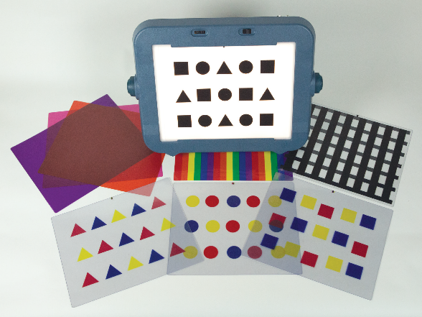

Product Description
The product is a set of overlays, sized to fit the Mini-Lite Box. The set will include patterned overlays including red circles, squares, triangles; blue circles, squares, triangles; yellow circles, squares, triangles; black multi-shapes, black horizontal lines, black vertical lines, rainbow stripes, solid orange, solid pink, solid purple. The overlays may be presented one at a time or layered to provide learning opportunities for color identification, shape matching, counting, visual skills, and for assessing the level of complexity with which a student is able to be successful.

Background
The project leader submitted the product idea, which moved through the Product Evaluation Team and was approved by Product Advisory and Review Committee in August 2015.

Relevance
Early interventionists and teachers for children with visual impairments have requested overlays made to fit the Mini-Lite Box through the APH News CVI Survey conducted in October 2014 and through discussion at an APH presentation at Kentucky AER 2015.

Requests included a variety of levels of complexity, smaller set of visual patterns that fit on the Mini-Lite Box, more solid colored backgrounds (pink, orange), more artwork for the Light Box, and stories that could be presented on the Light Box.
The project leader took all comments into consideration when the prototypes were made. Overlays were designed to build complexity based on student ability. By breaking down the detail of the design, more concepts can be assessed.

This product will be fully accessible to the population who will use it. The Mini-Lite Box Overlays materials will be available in print, BRF, text file, and HTML to meet APH requirements for accessibility.

Research
The evaluation period took place April through June 2016. Eleven educational sites were selected for the field evaluation. Sites were located in the following states: Colorado, Illinois (two sites), Kentucky, Massachusetts (two sites), New Mexico, Oregon, Pennsylvania, Texas, and Utah. Six of the sites were residential schools, and five were public school settings.

Thirteen students participated in the field test. Breakdown of demographics follows:
- Gender: 5 female students, 8 male students
- Chronological age ranged from 1 to 17 years
- Primary reading medium was listed as: 1 large print, 3 regular print, 2 auditory, and 7 not yet determined
- Eye conditions: CVI, hyperopia, astigmatism, optic atrophy, nystagmus, esotropia, optic nerve hypoplasia, myopia, amlyopia, von Hippel-Lindau Syndrome, Pseudopapilledema, hemifield loss, aniridia, exotropia
- Additional disabilities: Fetal Alcohol Syndrome, schizencephaly, leukodystrophy, Chromosome 3P Deletion, plagiocephaly, WAGR Syndrome, Wieacker-Wolff Syndrome, hydrocephaly, cerebral palsy, seizure disorder, and developmental delays

Field testers were asked if they were able to incorporate the Mini-Lite Box Overlays into IFSP/IEP goals for their students. Eleven out of 13 responded yes. Specific examples given were sequencing, maintaining visual attention and focus, and horizontal lines used as a reading guide.

When asked if the Mini-Lite Box Overlays had an impact on the student’s use of the Mini-Lite Box, 13 out of 13 responded yes. Successful interventions included the following: The orange overlay was the student’s preferred color so it drew attention to whatever she put on the Mini-Lite Box for the child to work with, shape identification, and labeling.

Field testers were asked to share impressions of individual overlays
Color | Liked | Neutral | Disliked
Pink | 62.5% | 37.5% | 0%
Purple | 62.5% | 37.5% | 0%
Orange | 75% | 25% | 0%
Rainbow | 75% | 12.5% | 12.5%
Horizontal stripes | 87.5% | 0% | 12.5%
Vertical stripes | 75% | 0% | 25%
Blue shapes | 87.5% | 12.5% | 0%
Red shapes | 100% | 0% | 0%
Yellow shapes | 100% | 0% | 0%

Suggestions for changes or additional light box overlays for future development were as follows: more complexity, grid outlines for object placement, solid color yellow or patterns of yellow, textured overlays, different size shapes on the overlays, story overlays, colors as highly saturated as possible, and make colors more intense.

The project leader met with the manufacturing specialist and graphics production supervisor to discuss final design changes needed according to field tester comments. Changes included the following:
- Make the vertical lines thinner, the same size as the horizontal lines
- Include information for the grid overlay available from another product
- Fix registration issues on the Roland® Flatbed to adjust printing placement of red squares.

Changes were incorporated into the product.

In FY 2017, the product guidebook and braille and HTML translations were completed. Specifications were written by the manufacturing specialist and presented to APH team in June 2017.

Work during 2018
The product was released in August 2018. No further work is needed on this product.

Visual Organization Toolbox
(Continued)

Purpose
To provide a toolbox of materials on hand to allow specialists a variety of supports, determine what is useful, and then be able to order that specific tool

Project Staff
Susan Sullivan, CVI Project Leader
Leasha Twyman, Research Assistant
Frank Hayden, Director of Technical & Manufacturing Research
Andrew Moulton, Manager of Technical & Manufacturing Research
Adam Clark, Manufacturing Specialist
Anthony D. Jones, Art Production/Design Manager
Laura Greenwell, Graphic Designer

Product Description
This product will be a collection of APH products and future products that will be used to determine which types of assists are helpful for specific learners with low vision and/or neurological visual impairment.

Background
Product was submitted in October 2016, passed through the Product Evaluation Team in January 2017, and the Product Advisory and Review Committee in February 2017.

Relevance
Learners with brain based visual impairments including Cerebral/Cortical Visual Impairment (CVI), Traumatic Brain Injury (TBI) and Acquired Brain Injury (ABI) often have difficulty accessing complex visual tasks. They need tools to help them simplify complexity by organizing visual input.

The aging adult population who are developing visual impairments as well as those with ocular visual impairments or print disabilities may also benefit from the Toolbox. Teachers and rehabilitation counselors are challenged with trying many tools to find what will provide access for their learners. Having a toolbox of materials on hand will allow specialists to try a variety of supports, determine what is useful, and then be able to order that specific tool.

This product will be fully accessible to the population who will use it. The Visual Organization Toolbox materials will be available in print, BRF, text file, and HTML to meet APH requirements for accessibility.

Research
Learning media assessment for learners with visual impairment are essential to determine the primary mode of sensory input for each learner. When vision is determined to be the primary mode for learning, challenges occur as the student tries to access print materials. Visual functions that may be affected include visual acuity, contrast sensitivity, color vision, visual field, light sensitivity, motility, and complexity of array.

Simple accommodations provided by the teacher can make a big difference in easing the challenge by altering the physical environment. “Teachers who understand their students’ visual impairments and the functional implications of their visual impairments can use this information to ensure their instruction supports authentic and efficient access to visual representation” (Lueck, Chen, Kekelis, & Hartmann, 2008).

The Visual Organization Toolbox will offer a variety of tools that the teacher can try with the learner to determine which help to access the visual environment and print materials.

Lueck, A. H., Chen, D., Kekelis, L., & Hartmann, E. (2008). Developmental guidelines for infants with visual impairments: A guidebook for early intervention (2nd ed.). Louisville, KY: American Printing House for the Blind.

Work during FY 2018
Informal surveys of teachers, professors, and consumers concerning which products will be needed in the Toolbox has begun. However, because of the project leader’s priorities, active development has not started.

Work planned for FY 2019
The project leader will send out a formal survey to determine the products needed to be included in this product to make it a success. The materials will be assembled for a group of expert reviewers who are knowledgeable in completing learning media assessments and functional vision assessments for the target population. The input provided will determine the actual components of the Toolbox, which will be assembled in 2019.

Low Vision

Barraga Visual Efficiency Program
(Continued)

Purpose
To update and bring the intervention models of APH’s Program to Develop Efficiency in Visual Functioning, originally created by Dr. Natalie Barraga, in line with current research

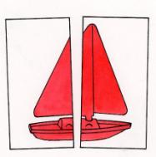

Project Staff
Tristan Pierce, Multiple Disabilities Project Leader
Millie Smith, Lead Author
Monica Vaught-Compton, Project Assistant
Kelly Kennedy Mimms, Research Assistant
Leasha Twyman, Research Assistant
Bryan Rogers, Manufacturing Specialist
Model Maker, Andrew Dakin
Ingrid Design Design and Layout

Product Description
The Barraga Visual Efficiency Program (BVEP) includes a book divided into three unit books: guidebook, evaluation, and design for instruction. The program includes four objects (hats, spoons, mini books, and toy sailboats) each in four colors (red, yellow, blue, and green) and three sizes. An additional book is the assessment tool teachers use to present pictures of the four objects to the young student. The program will be an aid to teachers and other professionals who work with young learners who have low vision.

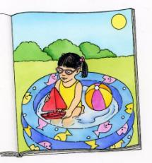

Background
APH first published Dr. Barraga's Program to Develop Efficiency in Visual Functioning (PDEVF) in 1978. This low vision program was a cornerstone product for APH for many years. All scholarship needs to be up-to-date and intervention models brought in line with current research. This was the case with the PDEVF. In addition, it became more difficult for APH to obtain the many commercially available items in the kit. APH and Dr. Barraga agreed that it was time to revise the program. Dr. Ralph Bartley, Director of Research, met with Dr. Barraga and upon her request, APH asked Millie Smith to be the lead consultant and author for the revision. As a graduate student, Smith studied under Dr. Barraga and worked with Dr. Barraga on the original product. APH created an advisory panel that convened at the Texas School for the Blind and Visually Impaired (TSBVI) in 2009 to establish an outline for the project. Dr. Barraga attended the 2-day meeting.

BVEP provides information and materials to evaluate needs and to design instruction to maximize the use of available vision. The program addresses the needs of students with low vision who have ocular impairments and who have achieved cognitive developmental skills at or beyond the 3-year-old level.

Visual efficiency is the extent to which one uses available vision effectively (Corn & Erin, 2010). Smith (2015), lead consultant and author of BVEP, states the following:

Visual efficiency is also an area of instruction included in the Expanded Core Curriculum (ECC). The ECC defines nine crucial areas of instruction that are unique to visual impairment. One of these is Sensory Efficiency. The area of Sensory Efficiency addresses needs related to the use of all sensory systems: visual, tactile, auditory, gustatory, olfactory, proprioceptive, and vestibular. The BVEP addresses one of these areas—the use of vision. (p. 2)

Relevance
There is evidence that APH made the decision to revise this product based on a standardized process of product modernization. The Program to Develop Efficiency in Visual Functioning (PDEVF) was a longtime selling and very successful APH product created by Dr. Barraga. To reflect current APH and educational standards, APH Executive Director of Research, Ralph Bartley, Ph.D., presented to Dr. Barraga the possibility of revising the product. She was happy to learn that her life's work may reach another generation of children with low vision. The project leader, Tristan Pierce, organized a 2-day meeting and work session with Dr. Barraga and an advisory panel in Austin, TX, to review the existing product and to outline the potential new one. Upon return from Austin, Pierce submitted a Product Modernization Form on August 17, 2009. Pierce submitted the product under the name Program to Develop Efficiency in Visual Functioning, the same name as the original Barraga product. Eventually, APH and the advisory panel decided to name the new product in honor of Dr. Barraga, the Barraga Visual Efficiency Program (BVEP). The significant focus of the new BVEP is the same as the old PDEVF—development of visual skills in young children.

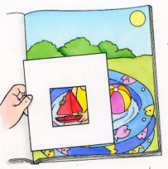
BVEP is fully accessible to the population using it. APH produces the kit documentation in enlarged type (14 point) with an HTML file for individuals who use screen readers and a braille-ready file (BRF) for personal download available on the Internet. Teachers complete the accessible assessment forms online. The kit items are in three primary colors (red, yellow, and blue) and one secondary color (green), which are high-contrast colors and typically known by very young learners.

BVEP follows APH guidelines for determining relevance of a product. The Advisory Panel agreed with Dr. Barraga that the panel should conduct a meta-analysis on low vision studies. Charged with this task were Smith and Pierce. They looked to a just completed meta-analysis—conducted on the request of APH—on the educational applications of low vision research; conducted by Kay Alicyn Ferrell, Ph.D.; Cherylann Dozier, Ph.D.; and Martin Monson, Ed.D. at the National Center on Severe and Sensory Disabilities (NCSSD) in Colorado. APH also hired Jon Howe, University of Arizona doctoral student, to conduct a literature review based on a list of key words created by the group in Austin. Howe's report and the statistical results of eight articles he used were not helpful for APH's purposes because he addressed one specific visual impairment and one visual behavior. However, some articles in the 36 pages of Howe's larger literature review, his narrative analysis, were significant. Smith and Pierce reported results of the meta-analysis and the literature review to the Advisory Panel and recommended that in addition to looking at research on learning visual skills, we also look to research on learning in general. Smith was particularly interested in research that shows performance improves because of practice and that providing opportunities to practice skills using highly effective strategies is the basis of good teaching in any skill area. Smith and Pierce proposed to the Advisory Panel that the new product include three components: 1) a teacher's guide to give TVIs information and materials that they need to provide learners opportunities to practice targeted visual skills and experiences that are highly motivating and meaningful, 2) a visual efficiency assessment procedure, and 3) a set of intervention activities/lessons.

There is evidence of an examination of the need to revise this product. The need to revise the original product has evolved with documentation for many years: Barraga demonstrated that school-age children with low vision could learn to use their vision more efficiently within a program that taught visual perceptual skills.
Barraga, N., & Morris, J. (1978). Source book on low vision: Program to develop efficiency in visual functioning. Louisville, KY: American Printing House for the Blind.

Hall and Bailey conceptualized a model for training vision functioning that incorporated three methodologies: 1) visual skills training, 2) visual environment management, and 3) visual dependent task training.
Hall, A., & Bailey, I. L. (1989). A model for training vision functioning. Journal of Visual Impairment & Blindness, 83, 390-396.

Ferrell and Muir suggest that the environment be designed so that the use of vision is practical, and instruction in the use of vision be incorporated into daily tasks rather than as an individual lesson or component of a program.
Ferrell, K. A., & Muir, D. W. (1996). A call to end vision stimulation training. Journal of Visual Impairment & Blindness, 90, 364-366.

APH also identified the need for this product revision in two domains: manufacturing and educational. APH purchased many items in the PDEVF from the commercial market. Over the years, manufacturers discontinued some items and or items became economically prohibitive to purchase in small quantities for the kit. To provide the best service and avoid backorders, APH decided to manufacture most of the items in house: Reliance on the commercial market is not always practical for maintaining educational value and ensuring availability for the lifetime of a product. Educationally, APH published the original PDEVF in 1970 (based on Dr. Barraga's dissertation from 1963) with occasional updates through 1998. It was time to update it. Policymakers, educators, and parents expect increased accountability in how public funds are spent in education and if there are measurable student outcomes. As stated previously, APH asked NCSSD to examine the educational research literature on low vision stimulation, development, and devices for evidence to support teaching procedures commonly practiced by teachers of students with visual impairments. The online and manual search resulted in 2,011 articles or other pieces of literature from 1964–2008. Only 46 articles met the specified criteria; and in final analysis, just 31 studies were included because of effect size. The initial 2,011 articles show a plethora of research continues and articles are written about visual impairment to educate readers and to validate the continued need for low vision assessment procedures and intervention activities/lessons. NCSSD's meta-analysis and Howe's literature review show that there are few published studies that meet all criteria to ensure a sufficient quantitative result. Visual efficiency evaluations are one of the most important sources of information that a teacher of persons with visual impairment can use to guide the decision-making needed to plan instruction and select intervention approaches for persons with low vision (Lueck, 2004). Going back to Howe's literature review, many of the articles pointed to evidence of positive effects for training of ocular visual skills and visual perceptual skills. Reputable journals from a variety of fields including neuroscience, cognitive psychology, ophthalmology, aging, rehabilitation, and education published these articles.

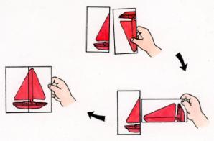

There is evidence that APH sought opinions of knowledgeable individuals to determine the need for the revision of this product. Dr. Barraga requested that Smith, be the lead consultant. Smith taught many years in Texas public schools and at TSBVI. Smith, honored by her peers, is the recipient of numerous awards. Smith has authored books for APH, American Foundation for the Blind® (AFB), and TSBVI. With Dr. Barraga's help, Smith and Pierce created a list of potential vision professionals to participate as an advisory panel. Dr. Barraga accepted the selection of the BVEP Advisory Panel in May 2009, and several members met with Dr. Barraga in Austin that August.

BVEP Advisory Panel
William Daugherty
Jane Erin, Ph.D., contributing writer
Amanda Lueck, Ph.D.
Deborah Orel-Bixler, Ph.D., O.D., contributing writer
Rona Pogrund, Ph.D., contributing writer
Christine Roman-Lantzy, Ph.D., contributing writer
L. Penny Rosenblum, Ph.D., contributing writer
Irene Topor, Ph.D., contributing writer

Anne Corn, Ph.D., joined the Austin group one afternoon to share ideas. Kay A. Ferrell, Ph.D., wrote an appendix for the program, and the AFB Press granted permission to reprint a second original work by Ferrell. APH Low Vision Project Leader, Elaine Kitchel, served as an in-house, low vision advisor. The willingness of such a prestigious group of professionals from the vision field to volunteer time to review and provide feedback validates the need for the revision of this product.

BVEP addresses an identified need for a person who meets the definition of “visually impaired,” specifically, a young individual with low vision. The kit items are available in four, high-contrast colors that young children typically know: red, yellow, blue, and green. The items, picture drawings, and graphic symbols (letters, numbers, and words) are available in small, medium, and large with a size sequence—recommended by Kitchel—that follows a progression in which each is 60% the size of the previous (proportional differentiation between sizes) (Lueck et al., 2003). The evaluation tools help teachers to identify regularly occurring activities that have a low, medium, or high need for instruction. They identify the media/object affected by poor visual efficiency, and then they help plan and organize interventions (e.g., accommodations, skills, or strategies) to address the previously identified needs for instruction. Through the Barraga evaluation tools, teachers pair related developmental sequences (e.g., simple/complex, part/whole, outer edges/internal detail, etc.) with interventions. Most importantly, teachers use the Perceptual Skills Evaluation to determine the perceptual deficits related to poor visual efficiency performance for media items previously identified through the Barraga tools. The three media categories in which the program evaluates specific perceptual skills are objects, pictures, and graphic symbols (letters, numbers, and words). Through instruction, teachers use a collaborative visual skills lesson plan for instruction of visual efficiency skills in regularly occurring activities and they use a direct instruction visual skill lesson plan for vision specific activities.

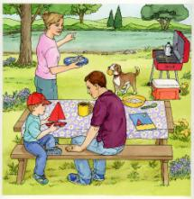
Research
APH gathered data on BVEP using an appropriate method. APH sent the BVEP guidebook, evaluation book, and design for instruction book to the evaluators, who read them over the December 2014 school break. In early January 2015, APH shipped the prototype kits to field test sites. Evaluators field tested BVEP (3 books; hats, spoons, toy sailboats, and miniature books—in four colors and three sizes; the same items as picture card drawings along with letters, numbers, and words; five designs each of sample placemats and array placemats; and two white, visual closure cloths of different sizes and fabric) in their classrooms through mid-March 2015.

The student demographic form and the product evaluation form were Google Drive™ forms, which the evaluators completed online. The evaluation form incorporated rating scales, multiple choices, open-ended questions, and comment sections. The rating scales were unbiased (1 = low to 5 = high); participants had an equal number of negative choices as they did positive choices. Some questions included measurable outcome responses (e.g., “Prior to using…” and “After using…”). Though not required, one teacher recorded the number of successful trials versus unsuccessful trials on her student's Perceptual Skills Evaluation Procedure.

Evaluators submitted evaluation tools (described in previous section) on their students by completing them electronically and sending the Word documents to APH via e-mail; or they printed out the files, completed them by hand, and returned them to APH with their kits. This field test/project report presents the evaluator comments verbatim.

There is evidence that APH considered research data as part of decision-making in product completion. In response to field testing results, in May 2015, Smith and the project leader decided to combine the multiple guides (e.g., Intervention Guide, Developmental Sequences and Perceptual Skills Guide, etc.) into one guide; provide additional hat bills, boat sails, and spoons to be used exclusively for the internal detail activities; reduce the number of objects and pictures used for each activity; combine the three books into one book with three units titled, Guidebook, Evaluation, and Design for Instruction; and to create a flip book to present the pictures to students—eliminating all the cards.

APH completed the following APH Research Guidelines during the development of BVEP:
- Input from the field—APH used an advisory panel from the field whose members reviewed the manuscript and provided professional feedback.
- Safety Report/Technical Review—All kit items are manufactured by APH except the visual closure cloth, which has a safety data sheet (SDS) on file at APH.
- Representative product prototype—APH printed and spiral-bound the documentation; manufactured the kit objects, picture cards, and placemats; and purchased visual closure cloths.
- Outside evaluators—APH used an advisory panel of respected and published professionals from the vision field to create and review the product. APH field tested the prototype at sites selected by geographic location, student/client sample, and evaluator qualifications.
- Evaluation tool and collection—Field evaluators used an electronic evaluation and hard copy instructions accompanied the prototype. Evaluators returned the guidebooks with mark-ups.
- Sufficient time—Evaluators had 3.5 months to use and evaluate the product.
- Reporting—The project leader submitted product development updates in writing for the APH Annual Research Report and presented orally and in writing at monthly New Products Meetings. She compiled field test data into a final BVEP Field Test Report.
- Product modifications—Changes to the product were determined and made based upon evaluator input, discussions with the lead author, and the Product Development Committee.
- Quota Approval—The project leader submitted the BVEP Quota Approval Form, and the Educational Products Advisory Committee granted approval in the Spring of 2017.
- APH held a specification meeting, and the manufacturing specialist turned over materials for production.
- APH marketing personnel will create a marketing plan.

APH gathered data from a geographically diverse U.S. population. The seven evaluators teach in California, Kansas, North Carolina, and Ohio. An eighth evaluator from Missouri failed to submit the evaluation forms or the Barraga tools. Six evaluation sites were in public schools, and one was in a private school.

APH gathered data from appropriately qualified individuals. The seven evaluators are teachers of students with visual impairments, and four hold an additional certification as orientation and mobility specialists. The three evaluators who submitted the most information with useful details on the evaluation form and the tools are the three with 15 to 23 years of experience working as a TVI. Before using BVEP, five (71.4%) evaluators used another program to evaluate vision efficiency with students. Four used Barraga's earlier programs, and one used TAPS, Oregon Project.

APH gathered data from an adequate number of sources. Eleven students participated in the BVEP field testing. Their chronological ages ranged from 5 years old to 14 years old. Their cognitive ages ranged from 3 years old to 13 years old. The students' eye conditions included <20 degree vision field, achromatopsia (with field loss), bilateral cystoid macular edema, CVI (from a traumatic brain injury), esotropia, exotropia (intermittent), myopia (high), night blindness (congenital, stationary), nystagmus, ocular albinism, optic nerve abnormalities, optic nerve atrophy, optic nerve neuropathy, retinitis pigmentosa, retinopathy of prematurity, and rod cone dystrophy.

The BVEP guidebook identifies the type of student who is an ideal candidate to use the product. Evaluators selected the identifier that best represented their student(s). Two evaluators selected multiple identifiers.
- Five (45.5%) students' visual skills and behaviors are still developing.
- Five (45.5%) students have developed visual skills but need to apply them in new context.
- Two (18.2%) students are recovering from neurological insult.
- One (9.1%) student has experienced recent vision loss and is learning to use his/her visual capabilities.
- No student has no visual skill or no rudimentary visual skill.
- No student has experienced sensory deprivation.

APH targeted and solicited academic students for field testing; however, the Student Evaluation Forms indicate that some students did have additional handicapping or health conditions. The evaluators listed cardiofaciocutaneous syndrome, undiagnosed attention [deficits] and autism, developmental delays, speech/language/articulation, and brain tumor accompanied with diabetes

As requested, the evaluators identified the students' functional vision assessment/evaluation that they used in tandem with BVEP. Some responded with the year of the FVA/E while others wrote descriptive answers.
- SJ was diagnosed just two years ago just as she moved into our school system, her functional vision was good in most areas, biggest area of concern for her parents was her inability to read and comprehend at grade level, (fourth at that time) and her frequent headaches. SJ routinely sees her eye doctor to prevent further damage from cystoid macular edema, most recent eye report is 2/17/15, noted acuity distance 20/70, night vision loss, peripheral vision loss OU partial superior temporal, inferior temporal, superior nasal, and inferior nasal, extraocular movement full, teacher reports that SJ participates fully in class, grades at that time were average, has a prescribed magnifier that she rarely uses, and that SJ tells her that her eyes get tired and words start dancing off the page after a while. No problems maneuvering around the classroom or the school, TVI eval-color vision intact, 8/8 colors identified, matched; she is able to fixate, shift gaze, track and scan. SJ's visual condition is unstable, with buildup of fluid monitored, she takes daily meds for pain and edema.
- AH functions well considering the field loss and extreme photophobia that he experiences, he wears his prescribed glasses and has maintained them well for the past year. Prior to this, in his elementary years, he constantly broke them. AH is colorblind, distance impaired and photophobic, despite this, he maneuvers well, O&M eval stated he does not need the use of direct instruction or the use of a cane at this time. He has good visual skills, fixation, shift of gaze, tracking and scanning. His reading ability is most affected by his visual condition, due to lack of progress in print reading efficiency and large print, team decided that braille instruction was needed. He is disinterested in braille instruction also and not progressing.
- AA has a field loss, is sensitive to lighting changes, and figure-ground material.
- 2013
- 2011
- Last FVA/triennial was 2014
- Visual Reflex-None, Eye Preference-Left, Convergence-Difficult, Visual Field-20 degrees, Visual Acuity Near: R-20/100 L-20/50 Both 20/100, Visual Acuity Distance: R-20/100 L-20/50 Both 20/100
- FVA, February, 2014
- Medical report from ophthalmologist, Functional Vision Assessment that included function acuities, observations in indoor and outdoor environments, interviews of parents, student and teacher, visual fields, ocular motor skills, and learning media assessment
- Medical report from ophthalmologist, Functional Vision Assessment that included function acuities, observations in indoor and outdoor environments, interviews of parents, student and teacher, visual fields, ocular motor skills, and learning media assessment
- Medical report from ophthalmologist, Functional Vision Assessment including functional acuities, visual field, ocular motor skills, observations in various environments, and observation of sensory channels for learning media assessment.

Three (27.3%) of the students' teams (i.e., family, teachers, specialists) incorporated BVEP into the student's IEP. Evaluators wrote the following comments on seven of the eight students who did not incorporate BVEP into an IEP. Incorporation of BVEP into an IEP was not required for the field testing.
- SJ had already been evaluated and IEP done prior to participating in this study, visual efficiency and technology goals were already in place, SJ uses a typoscope and reading guides to help eliminate eyestrain, extraneous information and to keep from losing her place. She still does not like to use her magnifier. She is learning to use shortcut keys in technology.
- Preestablished, braille instruction, technology goals, and organization skills
- Made some accommodations
- Just Christine Roman materials, acuity/field measures, etc.
- IEP included a vision specific goal and no new needs were found following BVEP.
- IEP was in December. Will add all new information gained in next IEP.
- IEP is com in [sic] up and information from BVEP will be incorporated.

APH gathered data on student outcomes. Evaluators stated that nine (81.8%) students demonstrated some visual examining behaviors prior to using BVEP. After using BVEP, evaluators stated that 11 (100%) students demonstrated visual examining behaviors. One evaluator documented successful and unsuccessful trials on the Perceptual Skills Evaluation Procedure. Three evaluators submitted comments:
- I didn't realize that AA wasn't looking at all her choices and she could match color, but didn't realize when I was referring to match mine and it was by size.
- identifies isolated print letters, numbers
- Student has a degenerative eye condition but acuities remain stable. She is primarily a visual learner with continuing needs for learning to use low vision devices and computer/assistive technologies.

Evaluators responded that six (54.5%) students demonstrated visually guided movements of the body prior to using BVEP. After using BVEP, evaluators responded that nine (81.8%) students demonstrated visually guided movements of the body. Two teachers submitted comments:
- We continue to use the accommodations for morning routine but we also remember to have her wait while she looks at all of her choices before selecting.
- She uses her sight for travel; she exhibits proper head and body alignment, as well as adequate cane technique. She utilizes her cane for travel in unfamiliar environments, although her usage is generally to alert other persons to her low vision rather than any great need on her part to judge safe pathways and drop-offs. She continues to use the cane in order to maintain her skill with the device.

The research method used on BVEP collected sufficient information. APH collected information on the students through the Student Evaluation Form and information on the teacher evaluators and the prototype through the Product Evaluation Form. APH requested that the evaluators complete and submit the following tools on their student(s): Activity Inventory, Developmental Sequences and Perceptual Skills Guide, Perceptual Skills Performance Record, and Intervention Guide. Some teachers completed and submitted more tools than others. A teacher may have submitted information on two students in the Product Evaluation Form, but only submitted the Barraga tools on one student.

Barraga Tools
Activity Inventory
Evaluators submitted Activity Inventories on nine students as displayed in Table 1. Reading and math list as the most common regularly occurring activities that are in need of instruction during the students' school day. The regularly occurring activity that appears most often and identified as the most in "high need" of instruction is reading. These activities are tagged, "priority activities."

Table 1. Activity Inventory of most frequently listed regularly occurring activities identified as needing instruction
Number of Students Regularly Occurring Activity
6 Reading (Low need of instruction=2, M=0, H=4)
5 Math, (L=2, M=2, H=1)
4 Writing
4 Physical Education
4 Lunch
4 Language Arts
3 Social Studies
3 Science
3 Recess
3 Arrival

Intervention Guide
Evaluators submitted Intervention Guides on seven students. Teachers listed 17 activities on the students' Intervention Guides. Reading, language arts, and group activity/time appear as priority activities on three students' Intervention Guides. These three activities sometimes overlap, such as "print comprehension" during language arts. Other priority activities listed at least once are recess, writing, arrival time, physical education, math, lunch, putting toys away, independent seatwork, library, feeding the dog, brushing teeth, indoor soccer, centers, and circle time. Table 2 displays an Intervention Guide with three priority activities for three students; a different evaluator submitted each priority activity.

Table 2. Intervention Guides of three students

Priority  activities | Media/Object  affected by poor  visual efficiency | Intervention  Accommodation (A)  Skill (S)  Strategy (St)
Reading | Multiple lines of print on page  Glare | A: Line marker to keep place or typoscope to isolate each word  St: Finger point to each word  A: Pink acetate overlay to reduce glare on page
Group Activity | Directions and parts of task are presented visually at a distance | St: Student previews or reviews the presentation up close to see details  A: Teacher verbalizes each step using descriptive language  S: Student uses a monocular to view the presentation  A: Teacher checks for understanding before student begins task
Putting toys away | Locating dropped objects  Finding correct bins to put toys away | S: Scan from left to right to locate objects  S: systematic search pattern to locate small items on floor  S: Scan bins on shelf from left to right  S: Identify label on desired bin  A: Provide 20 pt san serif font on bin labels

Evaluators submitted Developmental Sequences and Perceptual Skills Guides on six students. Table 3 shows two priority activities of two students submitted by two evaluators.

Table 3. Developmental Sequences and Perceptual Skills Guides on two students

Priority  activities | Media/Object affected by  poor visual  efficiency | Related developmental sequences | Related  perceptual  skill deficit
Putting toys away | Locating dropped objects  Finding correct bins to put toys away | Tracking-Scanning  Tracking-Scanning | Visual memory
Physical Education | Distance activities | Large, small, and high contrast | Figure ground

Evaluators submitted Perceptual Skills Performance Records (PSPR) on nine students. The PSPR has three parts: objects, pictures, and graphic symbols (letters, numbers, and words) which presents the skills sequentially. "Skill 2.10: Match item in scene to single item" is the most difficult skill of the picture cards. For example, for a student to identify the three-color book lying on an angle on the picnic table with a floral tablecloth, the student will need to use skills 2.1-2.9 (e.g., match color, shape, size, internal detail, orientation, etc.) Three evaluators completed the PSPR slightly different from the given instructions, but the three showed good documentation in a way that the data could merge with the remaining responses. As stated earlier, one evaluator documented the number of successful and unsuccessful trials for each skill, another evaluator documented the success of each object or picture within each skill, and one incorporated an intermediate level (o=had some problems) between skill success (+) and unable to do skill (–). Table 4 displays the merged data showing the number and percentage of students who were successful (+), had some problems (o), or were unable to do the skill (–). Not every student listed attempted each skill across every domain. For example, if a student was unsuccessful at matching constancy with three-color items, then the evaluator decided not to evaluate the student on constancy with internal detail. Percentages are based on the number of students who attempted each skill.

Table 4. Average percentages of success for students using the Perceptual Skills Performance Record
Objects | Perceptual  skill | 1 Color | 3+  Colors | Internal  detail
1.1 Skill: Match color | Identification | +8 (99%)  –1 (1%) | +7 (78%)  –2 (22%)
1.2 Skill: Match shape | Identification | +9 (100%) | +8 (99%)  –1 (1%)
1.3 Skill: Match  size | Identification | +8 (99%)  –1 (1%) | +8 (99%)  –1 (1%)
1.4 Skill: Match internal detail | Identification | +7 (78%)  o1 (11%)  –1 (11%) | +7 (89%)  –1 (11%) | +4 (100%)
1.5 Skill: Match whole  and partially obscured objects | Visual closure | +9 (100%) | +8 (100%) | +8 (100%)
1.6 Skill: Match objects  on patterned background | Figure-ground | +9 (100%) | +8 (99%)  –1 (1%) | +8 (100%)
1.7 Skill: Name missing object | Visual memory | +7 (78%)  o1 (11%)  –1 (11%) | +7 (78%)  – –2 (22%) | +7 (87.5%)  –1 (12.5%)
1.8 Skill: Match orientation | Constancy | +9 (100%) | +8 (89%)  –1 (11%) | +8 (100%)
1.9 Skill: Match object to embedded object | Part-whole | +9 (100%) | +8 (89%)  –1 (11%) | +8 (100%)

Pictures | Perceptual  skill | 1  Color | 3 or more  Colors | Internal detail | Outline
2.1 Skill: Match object to picture | Identification  (3D to 2D) | +9(100%) | +9 (100%) |  | +8 (100%)
2.2 Skill: Match color | Identification  (2D to 2D) | +8 (89%)  –1 (11%) | +8 (89%)  –1 (11%) |  | +8 (89%)  –1 (11%)
2.3 Skill: Match shape | Identification | +9 (100%) | +9 (100%) |  | +8 (100%)
2.4 Skill: Match size | Identification | +8 (89%)  –1 (11%) | +8 (89%)  o1 (11%) |  | +7 (87.5%)  o1 (12.5%)
2.5 Skill: Match internal detail | Identification | +9 (100%) | +8 (89%)  o1 (11%) | +5 (83%)  o1 (64%) | +8 (89%)  o1 (11%)
2.6 Skill: Match fully drawn picture to partially drawn picture | Visual closure | +8 (89%)  o1 (11%) | +7 (78%)  o1 (11%)  –1 (11%) | +8 (89%)  o1 (11%) | +8 (89%)  o1 (11%)
2.7 Skill: Match pictures on patterned background | Figure-ground | +8 (89%)  o1 (11%) | ++8 (89%)  o1 (11%) | +8 (89%)  o1 (11%) | +8 (89%)  o1 (11%)
2.8 Skill: Name missing picture | Visual memory | +7 (78%)  o1 (22%) | +6 (67%)  o1 (11%)  –2 (22%) | +5 (56%)  o1 (11%)  – – –3 (33%) | +7 (78%)  o1 (11%)  –1 (11%)
2.9 Skill: Match orientation | Constancy | +7 (87.5%)  o1 (12.5%) | +7 (87.5%)  o1 (12.5%) | +7 (87.5%)  o1 (12.5%) | +7 (87.5%)  o1 (12.5%)
2.10 Skill: Match item in scene to single item | Part-whole | +7 (87.5%)  o1 (12.5%) | +7 (87.5%)  o1 (12.5%) | +7 (87.5%)  o1 (12.5%) | +7 (87.5%)  o1 (12.5%)

Graphic  Symbols | Perceptual  Skill | Single  letters and  numbers | Words and  numbers  sequences
3.1 Skill: Match  shape symbol | Identification | +7 (87.5%)  o1 (12.5%) | +7 (87.5%)  o1 (12.5%)
3.2 Skill: Match size | Identification | +7 (87.5%)  o1 (12.5%) | +7 (87.5%)  o1 (12.5%)
3.3 Skill: Match manuscript symbols | Identification | +6 (75%)  –2 (25%) | +6 (75%)  –2 (25%)
3.4 Skill: Match cursive symbols | Identification | +5 (62.5%)  –3 (37.5%) | +5 (62.5%)  –3 (37.5%)
3.5 Skill: Match symbols on patterned background | Figure-ground | +7 (87.5%)  –1 (12.5%) | +7 (87.5%)  –1 (12.5%)
3.6 Skill: Name missing symbol | Visual memory | +7 (87.5%)  –1 (12.5%) | +7 (87.5%)  –1 (12.5%)
3.7 Skill: Match orientation | Constancy | +7 (87.5%)  –1 (12.5%) | +7 (87.5%)  –1 (12.5%)
3.8 Skill: Match symbol to embedded symbol | Part-whole | +6 (75%)  –2 (25%) | +6 (75%)  –2 (25%)
Graphic  Symbols | Perceptual  Skill | Single  letters and  numbers | Words and  numbers  sequences
3.1 Skill: Match  shape symbol | Identification | +7 (87.5%)  o1 (12.5%) | +7 (87.5%)  o1 (12.5%)
3.2 Skill: Match size | Identification | +7 (87.5%)  o1 (12.5%) | +7 (87.5%)  o1 (12.5%)
3.3 Skill: Match manuscript symbols | Identification | +6 (75%)  –2 (25%) | +6 (75%)  –2 (25%)
3.4 Skill: Match cursive symbols | Identification | +5 (62.5%)  –3 (37.5%) | +5 (62.5%)  –3 (37.5%)
3.5 Skill: Match symbols on patterned background | Figure-ground | +7 (87.5%)  –1 (12.5%) | +7 (87.5%)  –1 (12.5%)
3.6 Skill: Name missing symbol | Visual memory | +7 (87.5%)  –1 (12.5%) | +7 (87.5%)  –1 (12.5%)
3.7 Skill: Match orientation | Constancy | +7 (87.5%)  –1 (12.5%) | +7 (87.5%)  –1 (12.5%)
3.8 Skill: Match symbol to embedded symbol | Part-whole | +6 (75%)  –2 (25%) | +6 (75%)  –2 (25%)

Guidebook

All (100%) evaluators responded that the guidebook establishes the goal and rationale for the program.

Comments:
- The appendices are great. A wealth of information.
- Guidebooks were excellent.
- This was something new that I haven't worked on with my students. It gave me great information.

All (100%) respondents said the guidebook clearly defines unfamiliar terms and it explains the two categories of visual skills for which BVEP provides methods for instruction. One evaluator commented, "I think it will be very helpful to new teachers."

All (100%) respondents said the guidebook clearly defines visual perception and the six areas that are often included in tests of visual perceptual skills. One evaluator provided the following comment:

I think this is an area that is overlooked in higher education now (the programs for educating future teachers). Intervention Specialists are not learning how to teach strategies to students with deficits in visual perceptual skills. Often times, the TVI is asked to help with these skills. If you can add some strategies in just to give the TVI something to help the IS's that would fill a void in everyone's education.

Teachers rated the educational value (1=no value, 5=great value) of the four appendices.

Appendix A: Continuum of Visual Development
- some value… 14.3%
- good value… 14.3%
- great value… 71.4%

Appendix B: Differential Criteria for Assessment and Instruction of Needs Resulting From Cortical Visual Impairment
- good value… 71.4%
- great value… 28.6%

Appendix C: Traumatic Brain Injury and Children: Incidents, Causes, and Intervention
- good value… 57.1%
- great value… 42.9%

Appendix D: Best Practices in Educating Students With Low Vision
- good value… 57.1%
- great value… 42.9%

Comments about appendices:
- Wonderful information--have--you considered having these as separate documents available for purchase outside of the kit.
- Loved Appendix A--helped guide me to where students need to go. I have more students with CVI. I would love to see how this could help them as well.

When asked if they are interested in an appendix on Vision Therapy, five (71.4%) answered yes.

Evaluation Book

The evaluators reported that the evaluation book helped them identify the vision needs of eight (72.7%) students.

Comments:
- Not this student, I think she may have too well developed visual skills for this evaluation, she had no issues with the colors, embedded detail or print cards portion of evaluation, she was able to identify all detail and color, size and constancy questions.
- Not this student, color blindness prevented some of the eval, he was able to do all other parts, but became bored with tests, saying they were too easy and he just started saying off the wall answers, eval was stopped
- AA had to be directed to my selected item most of the time. She wouldn't scan to notice them all.

Six (85.7%) of the evaluators said the evaluation book helped them determine appropriate instructional methods. The one evaluator who said "no," wrote, "I think it will for younger students that [sic] I will assess in the future."

Again, six (85.7%) of the evaluators said that the evaluation book helped them determine students' activities that occur regularly.

Comments:
- It was difficult to gather data from everyone in the short time period for the trial but I think this is a good piece for looking at the child in everyday situations.
- I like having the template. It helps ensure that no part of the student's day is overlooked in planning for instruction and/or modifications.
- Really liked that part of the evaluation tools, it helps to stop and think about all aspects of the student's day and what does go on routinely.
- The evaluation book really helped break it down and helped me to see how the student's schedule words [sic].

The evaluators were asked to rate on a scale of 1 to 5 (1=difficult, 5=easy), the ease of use of the Barraga Visual Efficiency Evaluation (BVEE) tools:

Activity Inventory
- difficult… 0%
- somewhat difficult… 14.3%
- moderate… 0%
- somewhat easy… 14.3%
- easy… 57.1%

Intervention Guide
- difficult… 0%
- somewhat difficult… 14.3%
- moderate… 0%
- somewhat easy… 28.6%
- easy… 42.9%

Developmental Sequences and Perceptual Skills Guide
- difficult… 0%
- somewhat difficult… 14.3%
- moderate… 0%
- somewhat easy… 28.6%
- easy… 42.9%

The evaluators were then asked to rate on a scale of 1 to 5 (1=not beneficial, 5=extremely beneficial), the beneficial value of the BVEE tools.

Activity Inventory
- not beneficial… 0%
- somewhat beneficial… 14.3%
- beneficial… 0%
- very beneficial… 57.1%
- extremely beneficial… 28.6%

Intervention Guide
- not beneficial… 0%
- somewhat beneficial… 14.3%
- beneficial… 14.3%
- very beneficial… 28.6%
- extremely beneficial… 42.9%

Developmental Sequences and Perceptual Skills Guide
- not beneficial… 0%
- somewhat beneficial… 14.3%
- beneficial… 14.3%
- very beneficial… 57.1%
- extremely beneficial… 14.3%

Teachers rated on a scale of 1 to 5 (1=poor, 5=excellent) the three parts of the Perceptual Skills Evaluation Procedure: objects, pictures, and graphic symbols.

Part 1: Objects
- poor… 0%
- fair… 28.6%
- good… 14.3%
- very good… 42.9%
- excellent… 14.3%

Part 2: Pictures
- poor… 0%
- fair… 0%
- good… 14.3%
- very good… 14.3%
- excellent… 71.4%

Part 3: Graphic
- poor… 0%
- fair… 0%
- good… 14.3%
- very good… 14.3%
- excellent… 71.4%

Evaluators were asked if there is a skill (e.g., 2.8 Skill: Name missing picture) that they felt should be added to the Perceptual Skills Evaluation Procedure. All (100%) said there were no skills that need to be added to the evaluation. One evaluator commented, "These were very good and I think they will be very good for beginning teachers as well."

Design for Instruction Book

Six (85.7%) evaluators said Table 1.1: Sample Accommodations, Modifications, and Supports provided insight to help them prepare independent education plans more efficiently in the future.

Comments:
- I think it is helpful to have a resource like the BVEP that I can check to be sure I have considered all the needs of my students. Often times, TVI's have a very busy caseload and some things can be forgotten when you are rushing from school to school, meeting to meeting.
- Not enough time

Three (42.9%) evaluators used the Intervention Guide with a classroom teacher who did not have experience working with students with visual impairment.

Comments:
- I finished assessing one student and ran out of time. However, this section is well written and clear.
- I think all of these forms will be helpful for future plans and keeping things organized.
- My classroom teachers and I collaborate very well so this was not needed. I think it is helpful when you do have a teacher who is not following the IEP. It is something concrete to show the steps that have been taken to educate the staff about the student's unique needs.
- It helped guide me in my selection.

The Design for Instruction book includes templates for direct instruction lesson plans (vision specific activities) and collaborative visual skills lesson plans (transition skills from vision specific activities to regularly occurring activities). The evaluators reported that seven (63.6%) of the students used direct instruction lesson plans and collaborative visual skills lesson plans.

Comments:
- SJ is using vision skills in her regularly occurring activities that were implemented prior to taking this evaluation
- I felt the morning routine was very important to get the day started off right. Plus, I felt getting her independent with these skills could carry over in the classroom during additional activities.
- functional handwriting... name, phone #, etc.
- Teacher mentioned that she is seeing the student use some strategies in her classroom.
- Still needs prompting from classroom teacher but is able to demonstrate skills.
- Teacher and I are working on same goals in classroom as part of routine, with me on increasing difficulty of task.

BVEP provides a team training plan for those teams who may need it. Two of the students' teams used the team training plan and stated that the team training plan was helpful.

Six (85.7%) evaluators felt that the Design for Instruction tools (e.g., Collaborative Visual Skills Lesson Plan, Direct Instruction Lesson Plan, Team Training Plan) provide for the implementation of the intervention methods described in the Intervention Guide.

Comments:
- The teacher and I collaborated about the benefits of each item on the guide.
- I think these tools will be helpful to parents, therapists, and teachers who are new to the field.

Kit Items

Stickers
All (100%) evaluators said that the four sticker designs (i.e., stars, peace signs, smiley faces, and crescent moons) are sufficient to conduct an evaluation.

Comments:
- My student loved the different designs.
- I think the designs are sufficient, but sticking and removing the stickers was extremely frustrating during the evaluation. It was too time consuming and my students were either bored waiting for me or lost focus on the activity. I think the stickers should not be used. Instead the products should have inner detail on them.
- They provide good fine detail to help me observe visual behaviors.

The prototypes included yellow stickers and blue stickers. All (100%) evaluators said that the two colors are sufficient to conduct an evaluation. Six (85.7%) said the quantity of each design is sufficient to conduct an evaluation.

Fabrics
The prototype kits contain two types of fabric, which are used to evaluate visual closure. The majority (57.1%) preferred the white micro fabric over the white blackout fabric. Evaluators were also given fabric in two sizes. While 42.9% preferred the small size and 28.6% preferred the large size, 28.6% would like APH to include both sizes of fabric.

Placemats
The prototype kit included placemats in five designs, each in two sizes: The sample placemat measures 9 x 11 inches, and the array placemat measures 19.5 x 11 inches. The designs include white, marble, floral, blue plaid, and black plaid. APH's Low Vision Project Leader recommended the designs. The back of each placemat indicates the top of the placemat and where the card should be positioned on the front.

Six evaluators (85.7%) said the sample placemats and the array placemats are appropriately sized. One evaluator would like the array placemat to be a "little bit longer."

The prototype kit did not include a blackline (without color) floral design placemat. Instructions to the evaluators said to use the white placemat with the blackline floral picture cards. Four (57.1%) evaluators felt that accommodation was sufficient and APH did not need to include blackline floral placemats. Three (42.9%) evaluators would like APH to include blackline floral placemats in the final product. One evaluator wrote, "The easier and standardized this kit is to implement, the better/more valid the results."

Objects
Spoons
The spoons were designed with a 60% proportional differentiation (distinguishing small to medium to large). Four (57.1 %) evaluators responded that the proportional differentiation of the spoons is adequate, and three (42.9%) responded that it is not adequate. The three submitted comments.
- I had trouble figuring out sizing with short notice.
- I had a very hard time distinguishing size of all the objects, this may just be my own problem, but I would imagine some other people could have the same difficulty. I think they should be marked with the size.
- Too small

Five (71.4%) said the design of the spoons allows them to create one-color, two-color, and three-color spoons easily. Of the two evaluators who differed with the majority, one said she was worried she would break the spoons if she pulled the sections apart and the other one said the hook and loop material came off the spoons when she pulled the sections apart. The spoons are made of vinyl. APH chose the material because of its durability; the pieces will not break if pulled apart. If someone tried to break a spoon in half purposefully, it might bend.

Four (57.1%) evaluators said the quantity of spoons, supplied in the prototype, was not sufficient to conduct an evaluation. Two evaluators submitted comments; both preferred multiple sizes in each color.

Toy Sailboats
APH designed the toy sailboats with a 60% proportional differentiation. Six (85.7 %) evaluators responded that the proportional differentiation of these sailboats is adequate. One evaluator said she had difficulty with the task and requested that each size be marked.

Five (71.4%) said the design of the toy sailboats allows them to create one-color, two-color, and three-color toy sailboats easily.

Comments:
- I felt if the quality of the materials were better, they would be easier to put together and not fall apart during assessment.
- Although again, since I had a problem figuring out the sizes, [sic] could not get the items ready quickly. This was very frustrating for me and the student.
- Once again, it was hard to put them together as I was testing. My student was already ready to move on. I needed to be fast.
- These are good for boys, it makes them want to look at it.

All (100%) evaluators said the quantity of toy sailboats as supplied in the prototype was sufficient to conduct an evaluation. Evaluators did not submit comments for this question.

Hats
APH designed the hats with a 60% proportional differentiation. Four (57.1%) evaluators said there was not enough proportional differentiation of the hats. Each submitted a comment.
- I would recommend a larger proportional differentiation. It was difficult to tell.
- See comments from above.
- It was hard to tell.
- Seemed too close in size.

Six (85.7%) evaluators said the design of the hats allows them to create one-color, two-color, and three-color hats easily. One teacher felt it was too difficult to change the hat brim/bill to a different color.

Five (71.4%) evaluators said the quantity of hats supplied in the prototype was sufficient to conduct an evaluation. One teacher wrote, "It would be best to have enough to do each sample item without switching the products around or adding detail. The student is quick to answer and it took me several minutes to prepare the next array."

Miniature Books
APH designed the miniature books with a 60% proportional differentiation. All (100%) evaluators said the proportional differentiation of the books is adequate and that the quantity of books supplied in the prototype was sufficient to conduct an evaluation. The miniature books were supplied in one-color and three-color formats; therefore, the evaluators did not need to make the color changes themselves.

In summary, the 60% proportional differentiation was successful for the spoons, toy sailboats, and miniature books; it was not successful for the hats. The quantity of toy sailboats and hats provided in the prototype is sufficient to conduct an evaluation; however, more spoons are required. APH did not ask this for the miniature books because APH provided the preprinted books in multiple colors and internal detail; therefore, evaluators did not switch out parts. No evaluator made a general comment that she needed more miniature books.

Picture Cards
All (100%) evaluators said the proportional differentiation of the picture cards and the graphic symbols (letters and numbers) cards is adequate. Five (71.4%) evaluators said the pictures are good representative drawings of the objects.

Comments:
- The book was not a good representation. One student did not know it was a book. If there is a way to show the spine and pages, it might look more like a book.
- perfect

All (100%) evaluators responded that the graphic difference of the four type fonts (Century Gothic, KG Penmanship, Times Roman, and D'Nealian Cursive) is adequate.

When asked if additional cards, not provided in the prototype, are needed to conduct an evaluation, 100% of the evaluators answered no.

The cards with multiple colors and internal detail had skill numbers printed on the backside to help evaluators identify which cards to use with each assessment activity. Some cards had multiple numbers on the back. Evaluators selected which scenario would serve them and their students better in the final product.

- 28.6% ‒ Keep the cards as presented in the prototype—multiple numbers on the back of some cards.
- 71.4% ‒ Have multiple copies of the same card, each with its own skill number.

Packaging

Keeping the objects and, especially the cards, organized is a huge task. The correct type of packaging and storage can help make a teacher's job easier and allow an evaluation to proceed more smoothly. Evaluators selected from the following options to help APH determine the best way for teachers to store the kit items. Unfortunately, there is no majority response to this question.

- One (14.3%) evaluator recommends that APH provides the cards in plastic bags by object drawing. For example, all hat drawings (regardless of color, size, internal detail) would be in one bag. This option would have cards similar to the prototype (multiple skill numbers on the back of some cards).
- One (14.3%) evaluator recommends that APH provides the cards for each skill in small plastic bags with each bag marked with the Skill number. This option requires having multiple copies of the same card, each with its own skill number.
- One (14.3%) evaluator recommends that APH provides the cards as if they were a deck of playing cards (in a box) by object drawing. For example, all hat drawings (regardless of color, size, internal detail) would be one deck of cards and in its own box. This option would have cards similar to the prototype (multiple skill numbers on the back of some cards).
- One (14.3%) evaluator recommends that APH provides the cards (in a box) by Skill number. For example, all cards used in "2.2 Skill: Match color" would be in one deck of cards and in its own box. This option would require having multiple copies of the same card, each with its own skill number.
- Three (42.9%) evaluators recommend that APH provides the cards in plastic window sleeves in a binder. For example, label a window sleeve 2.5, which stands for "2.5 Skill: Match internal detail." Inside that sleeve are all the cards used during that skill assessment. This option would require having multiple copies of the same card, each with its own skill number.

APH solicited alternative packaging and storage ideas from the evaluators, but no one submitted an idea. Four evaluators submitted general comments about the cards.
- They were a bit overwhelming, storing by object drawing might help.
- I would like to see all the same sizes grouped alike.
- I tried to divide cards into sets and place in zip lock bags, but like the option I chose in #56.
- I definitely think you need multiple cards. I had piles going for each item number and I still was searching for cards. I think it would be easier to keep the cards in plastic bags (easier than sliding in/out of sleeves) but the bags need to be kept organized. Perhaps pouches that can be help in a binder would work. It also needs to be portable because I had a hard time fitting everything into bags while I carried around all my other materials.

Evaluators provided general comments about the BVEP.
- Overall, very good, I think my kids were a bit too old to use it with, bored with it, too well developed visual skills already, since I've had them for awhile and had worked on these skills beforehand, with younger ones, which I would do it with had I had more time, I think it would have helped lots.
- This test requires a teacher to be more organized and have everything ready. I feel that the more I would give this test, the easier it would be to manipulate the objects and cards. I also found that I need a bigger work space and time to work with the students for a little bit longer. I feel that this test could give me some valuable information in regards to how the student uses their [sic] vision. I feel that the more I could give this test, the better I would become at it.
- Organization is the key to making this product user-friendly. The books are excellent. Organization of the materials was cumbersome and labor intensive. I would recommend it arrive with as little 'assembly required' as possible and in order, to match the assessment protocol. I would use it then...but I would not order or use this product if it arrived the way it did. All the parts and pieces were too overwhelming and disorganized. I would continue to use the older Barraga screening, with is just 2-D black line, and not as comprehensive as this updated version.
- The test could provide a vast amount of visual information, but with my population of VI students I could not use this because all have additional disabilities and did not fit the profile.
- Overall, it's OK . . . I like the original Barraga better because of its portability.
- I have always valued Barraga products. I think this program is a comprehensive tool for Teachers of Students with Visual Impairments that can be used as a guide for assessment and instruction of visual efficiency skills, which is one component of the expanded core curriculum.

Four (57.1%) evaluators said they would recommend that their school or agency purchase the BVEP. Three (42.9%) said they are undecided about recommending the product. APH requested clarification on undecided responses. Two of the evaluators said that it depends on how the final product is packaged and organized. The third evaluator suggested eliminating redundancy, which would reduce the amount of time needed to conduct an evaluation.

As the project continued, APH made final changes to the books, and the project leader submitted them for HTML and braille transcription (still in process at this writing). The model maker completed all the molds for the objects. The reduced number of hats in the kit allowed APH to have tri-color hats ready-made so teachers will not have to assemble them. APH tested (out-of-house) silk-screened colors for the tri-color spoons by having blue and red applied to yellow plastic. The colors are a nice match with the fabric and plastic in the kit. APH will continue to thermoform and die-cut the spoons in house. This also allows APH to provide ready-made tri-color spoons so teachers do not have to assemble them. The project leader finished the product videos. The Barraga team programmer constructed the Barraga website, which contains the electronic assessment forms, accessible formats of the books, the “Message From Dr. Barraga” video, the “Millie Smith Interviews Dr. Barraga” video, and outline drawings of the kit objects for children to color for expansion or take-home activities. The project leader approved the canvas carryall case for the kit.

Work during FY 2018
The manufacturing specialist held the specifications meeting to ready the product for production. The Barraga website is complete but on hold because APH is assessing all its websites for privacy and accessibility. Work on the HTML stopped for lack of resources and then reactivated in August. APH updated copyright dates because of delays.

Work planned for FY 2019
APH will manufacture the kit and make it available for sale.
References
Corn, A. L., & Erin, J. N. (Eds.). (2010). Foundations of low vision: Clinical and functional perspectives (2nd ed.). New York: AFB Press.
Ferrell, K. A., Dozier, C., & Monson, M. (2011). A meta-analysis of educational applications of low vision research. Greeley, CO: University of Northern Colorado. Available at http:///www.unco.edu/ncssd/research/LowVisionMeta-Analysis.shtml
Howe, J. (2010). Eccentric viewing training and its effect on reading rate for individuals with absolute central scotomas. Unpublished draft, University of Arizona, Tucson, Arizona.
Lueck, A. H. (2004). Overview of intervention methods. In A. H. Lueck (Ed.), Functional vision: A practitioner's guide to evaluation and intervention (pp. 257-275). New York: AFB Press.
Lueck, A. H., Bailey, I. L., Greer, R. B., Tuan, K. M., Bailey, V. M., & Dornbusch, H. G. (2003). Exploring print-size requirements and reading for students with low vision. Journal of Visual Impairment & Blindness, 97, 335-354.
Smith, M. (2015). Barraga visual efficiency program: Guidebook (prototype). Louisville, KY: American Printing House for the Blind.

Decision Making Guide
(Completed)

Purpose
The purpose/need for this project is twofold:
- Conduct basic research to determine visual accommodation needs, requirements, and strategies of students with low vision when reading passages of continuous text
- To provide teachers and practitioners with a decision tree product, based on the results of data analysis from the basic research that would assist them with the selection of print/font size for their students

Project Staff
Elaine Kitchel, Low Vision Project Leader
Martin Monson, Project Leader
Amanda Hall Lueck, Ph.D., Project Consultant
Ian Bailey, O.D., Consulting Research Optometrist
Jane Erin, Ph.D., Consulting Low Vision Education Expert
Rajiv Pannikar, Ph.D., Consulting Low Vision Education Expert
Anthony D. Jones, Art Production/Design Manager
Frank Hayden, Director of Technical & Manufacturing Research
Andrew Moulton, Manufacturing Specialist
Kelly Kennedy Mimms, Research Assistant

Background
This project was the third in a sequence of studies on how magnification, accommodation, and the visual reserve affect reading efficiency in students with low vision who already know how to read.

Production of reading passages was completed. The team developed comprehension questions for the selected passages and conducted field testing on the passages. Data were collected, analyzed, and published.

The data analysis was incorporated into a report and published in the Journal of Blindness & Visual Impairment in 2006. A decision tree to help teachers and interventionists select appropriately sized print for students who are print users has now been developed. A model of the decision tree and a user’s guide were developed and reviewed by APH and outside experts.

Preliminary Research
A first step for any project leader is to search for any existing products that might eliminate the need for development of this project. For this reason, Internet searches of the following Boolean terms were conducted: print size, visual impairment and learning media, vision and print size, and vision and learning media.

In addition, APH Library Services helped search the patent office database to see if any products had the same basic contents as the proposed one. It was determined that no such product existed.

The following articles and books were read by the project leader during the development of the product as content development revealed that specific kinds of information were needed.

Anderson, R. C., & Pearson, P. D. (1984). A schema-theoretic view of basic processes in reading comprehension. In P. D. Pearson (Ed.), Handbook of reading research (pp. 255-291). New York, NY: Longman.
Bailey, I. L., Lueck, A. H., Greer, R., Tuan, K. M., & Dornbusch, H. (2003). Understanding the relationships between print size and reading in low vision. Journal of Visual Impairment & Blindness, 97, 325-334.
Block, C. C., & Pressley, M. (2001). Comprehension instruction: Research-based best practices. New York: The Guilford Press.
Bosler, D. (2012). Mastering type: The essential guide to typography for print and web. Palm Coast, FL: Howe Books.
Holbrook, C., & Koenig, A. (2000) Foundations of education: Instructional strategies for teaching children and youths with visual impairments. New York, NY: AFB Press.
Legge, G. E. (2007). Psychophysics of reading in normal and low vision. Mahwah, NJ: Lawrence Erlbaum Associates.
Lueck, A. H., Bailey, I. L., Greer, R., Tuan, K. M., Bailey, V., & Dornbusch, H. (2003). Exploring print-size requirements and reading for students with low vision. Journal of Visual Impairment & Blindness, 97, 335-354.
Moore, D. M., & Dwyer, F. M. (1994). Visual literacy: A spectrum of visual learning. Englewood Cliffs, NJ: Educational Technology Publications.

Relevance
APH made the decision to produce this product based on a standardized process of product selection. Dr. Amanda Hall-Lueck submitted the project idea in October 2007. The project leader presented the product submission to the Product Evaluation Team (PET) in January 2008. PET voted to move the project forward. The Product Advisory and Review Committee approved the project, and it was assigned grant #419.

This product will be fully accessible to the population who will use it. It is for teachers and practitioners who work with students who have visual impairments. Since many of those teachers and practitioners are themselves visually impaired, the materials will be presented in braille and/or braille-ready format file, and HTML as accessibility options.

This product follows APH guidelines for determining relevance of a product. The consultants conducted research with more than 30 children with visual impairments in the San Francisco/Bay Area. As expected, they found that when students find the smallest print that they can read, they read at maximum efficiency when that print is enlarged by 60%. Their findings were published in the Journal of Visual Impairment & Blindness. This ability to read at maximum efficiency promotes and enhances reading as an activity and improves students’ overall feelings about reading. This makes reading overall a more desirable activity.

There is evidence of an examination of the need for this product. The research showed that students in the study were not reading at their maximum efficiency. Teachers did not know how to select print size because no mathematical formula had yet been devised and tested. However, the development of Decision Making: A Guide to Print Size Selection, offers a selection system based on the student’s vision and his/her “visual reserve.” This simple mathematical process is easy to understand and apply. It provides the teacher/practitioner with a foolproof way to determine print size for each and every student with a visual impairment.

APH sought opinions of knowledgeable individuals to determine the need for this product. An in-house panel reviewed the materials and decided to show them to two experts for their opinions. Both experts, Dr. Jane Erin and Dr. Rajiv Panikkar found the method helpful and stated a need for the materials. But they stated the materials were in need of a little simplification, which was later achieved. The materials were then reviewed by five working teachers of students with visual impairments. Three of the five supported the development and publication of the materials.

This product addresses an identified need for a person who meets the definition of “visually impaired” as evidenced by the fact that until this product came to light, no method existed for the determination of print size for students and adults with visual impairments. The need was further affirmed by the experts who reviewed the materials.

The expert review was begun. Edits of the text and decision tree began. The project leader used the decision tree and found it very difficult. Not only was it difficult to see, but translation of the concepts into numeric values and modification of those values was confusing. APH in-house experts believed educators would not use it. The overly technical text was of little assistance.

Seven experts completed reviews of the product and generated these opinions and conclusions:
- The text that accompanies the decision tree is much too technical and would require too much homework for the educators who might want to use it. Educators might abandon the use of the product; therefore the text should be more user-friendly.
- The text and directions for use of the decision tree are far too complex and should be simplified.
- The decision tree itself is too complex and intimidating. Efforts should be taken to see if it could be simplified.
- The decision tree, and perhaps the text, should be available electronically.
- The decision tree should be downloadable.

APH staff concluded that a rewrite of the text and decision tree into a more user-friendly language and format should take place. The originators agreed to develop a simpler version that they completed and submitted to APH. The resultant version was simple enough that only two calculations are needed to reach the necessary conclusions. These can easily be done in one’s head or on paper and do not warrant the development of an electronic product at this time.

Layout of the guidebook was completed. Changes to the cards were determined. There were many discussions about the sizes of the samples on the cards because some were as small as 1.6 millimeter. The cards content and size was determined, and layout took place in October 2015. Many fine-tuned changes had to be made to accommodate the super-tiny print on the cards. Only one printer could be found to print the cards at the 1.6 mm print size. Braille translation of the text and cards began in August 2016.

Work during FY 2018
After the review of the guidebook, grade-level passages, and sentence and word charts revealed several errors in 2017, several revisions were made with input from Drs. Lueck and Bailey, product consultants. Final copies were then sent to InGrid Design for file preparation. InGrid Design completed preparing the files. The product was released for sale in July 2018.

Work planned for FY 2019
No further work is planned for this project.

Explorer Bright Ray: LEDs for Persons with Low Vision
(Completed)

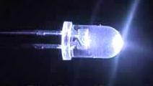

Purpose
Students and teachers have long requested a good head-borne light that students could wear to keep their hands free and their desks clear of clutter and hazards. The Explorer Bright Ray light is designed to be worn on the head. It is an extra-bright LED lamp that has three brightness levels, three directional settings, and is easy to use. The lamp is designed to provide light to
- Students who do not have enough desk space for a task lamp.
- Students who cannot get access to an electrical outlet.
- Students for whom task lamps and cords present a hazard.
- Students who must hold their text very close to their faces.
- Students who need light to supplement task lamp emissions.
The Explorer Bright Ray light comes with an informational book about light, head-borne lights, lighted magnifiers, and LED lights specifically.

Project Staff
Elaine Kitchel, Project Leader
Martin Monson, Project Leader
Frank Hayden, Director of Technical & Manufacturing Research
Anthony D. Jones, Art Production/Design Manager
Yoshi Miyake, Freelance Graphic Artist
Adam Clark, Manufacturing Specialist

Background
Even though students, teachers, and parents have requested head-borne, bright light for several years, until recently nothing was on the market that was bright enough, adjustable, affordable, and offered the right emissions for people who had low vision. In the first decade of the 21st century, many head-borne lights became available as the possible uses of light emitting diodes (LEDs) were realized. Many almost met the needs of persons with low vision, but nothing was quite bright enough or flexible enough.

The problem with LEDs is that they do not project the light very far compared to other sources of light. Much improvement has taken place recently to equip LEDs with reflectors and other technology that will project the light several feet. Fortunately, APH can take advantage of this new development to provide students with the head-borne light that they need. This item is now called the Explorer Bright Ray light.

Project Research
The project leader has researched the lighting weblogs, websites, and literature for several years to monitor the development of the well-projected LEDs. When they became available, the project leader accessed the following sources:

Klipstein, D. L., Jr. (2008). LED types by color, brightness, and chemistry. Available from http://donklipstein.com/ledc.html
Klipstein, D. L., Jr. (2009). LEDs 101. Available from http://donklipstein.com/ledd.html
Klipstein, D. L., Jr. (2009). The most efficient LEDs and where to get them! Available from http://donklipstein.com/led.html
Li, R. (2010, April 12). LED flashlight mysteries, What is a LED emitter? Retrieved August 23, 2011, from http://ezinearticles.com/?LED-Flashlight-Mysteries,-What-is-a-LED-Emitter?&id=4094084
Murray, M. (2010). Revolutionary 100mm LED downlight. Durham, NC.

Utility Research
The project leader purchased two samples and tested them for color temperature, brightness, durability, flexibility, utility, emission projection, and luminosity. She then proposed the Explorer Bright Ray light as a product to the Product Advisory and Review Committee (PARC), and it was accepted. Additional research is now underway to provide information for a booklet called LEDs. This booklet will be part of the Explorer Bright Ray light kit.

Relevance
APH made the decision to produce this product based on a standardized process of product selection. The product was proposed by the project leader and presented as a submission. In-house and out-of-house experts were asked to review the submission and give an opinion as to whether the product idea should move forward toward production. The product idea was then presented to the Product Evaluation Team and PARC, where it was subjected to questions and had to meet certain qualifying standards for APH product development.

This product is fully accessible to the population who will use it. Materials are available in large print, braille, and HTML files so all teachers/practitioners who need accessible materials will have them.

This product follows APH guidelines for determining relevance of a product. It was affirmed by field tester teachers that their students with visual impairments often benefitted from head borne lighting. This fact was also affirmed by the students themselves, who tested the product in at least 12 different environments.

There is evidence of an examination of the need for this product. There is currently no head borne lighting product that has been tested for and with students with visual impairments. This product was tested by in-house experts, students with visual impairments, and their teachers. All groups affirmed that there was an identifiable need for head borne light for both students and teachers who have visual impairments.

This product addresses an identified need for a person who meets the definition of “visually impaired” as evidenced by the responses by both teacher and student field testers. Both groups indicated that they needed such a product.

Research continued until the booklet LEDs was in rough draft state. The booklet text was completed and edits began in earnest. Text was edited, and procurement of photos and graphics began. Some items required drawing from scratch. Arrangements were made to engage an artist to draw them. Clean text files were developed for the translation/transcription process.

In FY 2015, the Explorer Bright Ray device and booklet were field tested. Data showed the field testers had no complaint about the device, except that it tended to slide down and rest on children’s noses. It was decided to include a hat for the user to wear under the device to prevent the slippage. Testers also wanted a pouch to protect and carry the Explorer Bright Ray in. This change was made. The booklet was finished and readied to be translated into braille.

Work during FY 2018
The specifications meeting was held in January 2017. This product was made available for sale in July 2017. No work was done on this project in FY 2018.

Light Box and Reading Stand Mounting System
(Continued)

Purpose
To provide a way that individuals with visual impairments who spend a portion of their awake hours in a wheelchair (upright or reclining) or a bed can use a light box and or reading stand. This product may become void if APH is able to design the LED Mini-Lite Box to accommodate existing mounting systems.

Project Staff
Tristan Pierce, Multiple Disabilities Project Leader
Nick Hadfield, Consultant
James Robinson, Manufacturing Specialist
Frank Hayden, Director of Technical & Manufacturing Research
APH Advisors: Susan Sullivan and Suzette Wright

Background
APH received a request from a teacher of students with visual impairments who stated that, “Nearly 70% of our visually impaired students have multiple impairments and I work with a significant amount of students who are wheelchair-bound or non-ambulatory. This requires a variety of products that are very hard to maneuver around feeding tubes, tracheotomy/oxygen tubes, wheelchairs, etc…….but there is no real safe or effective way [to mount iPads, light boxes, and reading stands] to do this.” This request coincided with APH’s plans to redesign the Mini-Lite Box. After many discussions, the product development team for the new light box accepted this challenge as well, hoping to design a small light box that can mount on a couple of well-designed stands on the commercial market, thus relieving APH from entering into the specialized business of adapted mounting systems.

The project leader reviewed online many manufacturers and distributors of assistive technology mounting systems and then talked to various manufacturers of these mounting systems on the phone and while attending conferences. APH decided to concentrate on our history and knowledge of designing light boxes and to refer with two manufacturers of mounting stands to meet this need. With this information and upon the recommendation of the educator who submitted the request to use the light box with wheelchairs and beds, APH selected two manufacturers and ordered mechanical parts, such as a universal device socket and VESA plate. If the new design works for the new light box, APH may decide to incorporate the same design on the plate of a reading stand.

Work during FY 2018
The team continued to test the component parts with the prototype of the revised Mini-Lite Box. The team review a ½ scale 3-D printed model of the case, noting small changes. The manufacturing specialist completed circuitry design, and the team chose lighting from the design prototype. The drawings and bid packages went out in June to create a production sample.

Work planned for FY 2019
Project staff will review and test the production sample, decide on any revisions, and enter into agreement for production.

MATT Connect
(Continued)

Purpose
APH was interested to develop a tablet-based magnifier for near and distance viewing. Its purpose would be to allow low vision students in a classroom setting to access information electronically (shared desktop/whiteboard) and would also function as a typical electronic magnifier. The device would have the added functionality to access information at a distance through the use of a separate camera connected by Wi-Fi. As the device is also a tablet, students could use any number of mainstream or specialized apps.

Project Staff
Laura Zierer, Project Leader
Leasha Twyman, Research Assistant
Laura Greenwell, Graphic Designer

Background
The MATT Connect is a partnership project with HumanWare™. As APH was interested in developing a tablet-based magnifier, Martin Monson, the project leader, submitted a product submission idea form. It was approved by both the Product Evaluation Team (PET) and the Product Advisory and Review Committee (PARC).

Product Description
The MATT Connect is a tablet-based magnifier. It uses a dual-boot operating system: Prodigi™ and Android™. Prodigi™ is the low vision access software. It allows the user to view documents live or capture information via Android™ apps from an instructor’s whiteboard or via the included Wi-Fi camera. Once the image is captured, the Prodigi™ Optical Character Recognition (OCR) software allows users to manipulate it to meet their viewing needs. The text can be enlarged, text and background colors can be changed, and text can be read aloud. The product is shipped with a collapsible stand that protects the tablet and functions as a way to carry the device. It also comes with a high-megapixel Wi-Fi camera, camera mounting stick, glare-reduction shields for the tablet, all necessary cables, and a carrying case similar to a laptop bag to transport everything. The APH MATT Connect is unique in that it comes bundled with the Wi-Fi camera and the APH Toolbox. The APH Toolbox is accessible through the Prodigi™ menu and contains a list of special and mainstream apps designated by the expert reviewers to be beneficial to students participating in typical K–12 classrooms.

This project began with APH developing and publishing a Request for Proposals (RFP) for a tablet magnifier. The RFP was released in March 2017. APH staff received the proposals and as a group came together to select the best one. HumanWare™ was chosen as the company to best fulfill the RFP requirements. HumanWare™ was able to furnish APH with prototype units, which were used in the expert review process.

Expert reviewers were solicited via an advertisement on various social media group pages related to the education of students with a visual impairment. Reviewers were chosen based on their willingness to review the product, experience with assistive technology specific to the visually impaired, and geographic location. The intent was to select at least one reviewer from four different regions of the United States. These sites are geographically distributed as follows: Nevada, 1 (17%); North Carolina, 1 (17%); North Dakota, 1 (17%); Texas, 1 (17%); Vermont, 1 (17%); and Washington, 1 (17%). Regional distribution of sites is displayed on the following map.

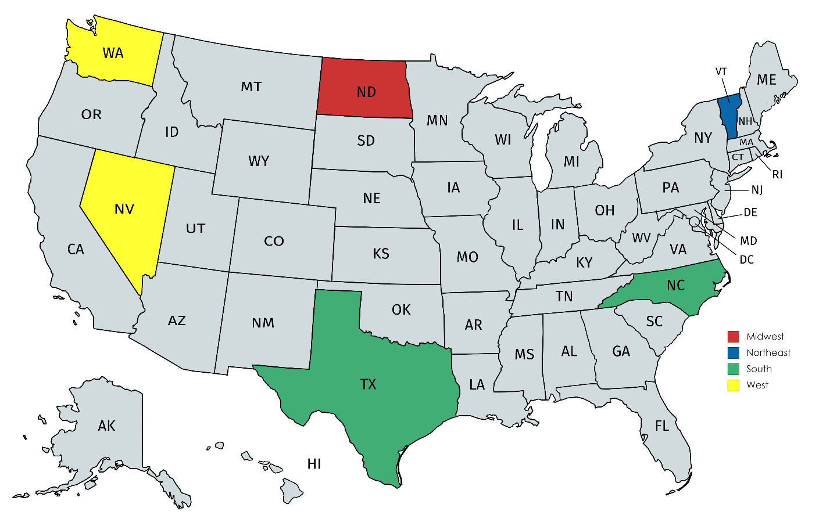

Input was gathered from the reviewers in May 2017 and used to shape the final appearance and app composition of the APH Toolbox. A pilot run of 10 MATT Connects was sent to APH in July 2017 with the complete order delivered later in the fiscal year. The product was then offered for sale. Monson left APH in August 2017; at this time, Zierer was named the new project leader for the MATT Connect.

Work during FY 2018
Zierer supported the Customer Service Department with training and warranty inquiries. Product return and restocking procedures were developed, and necessary replacement parts were identified.

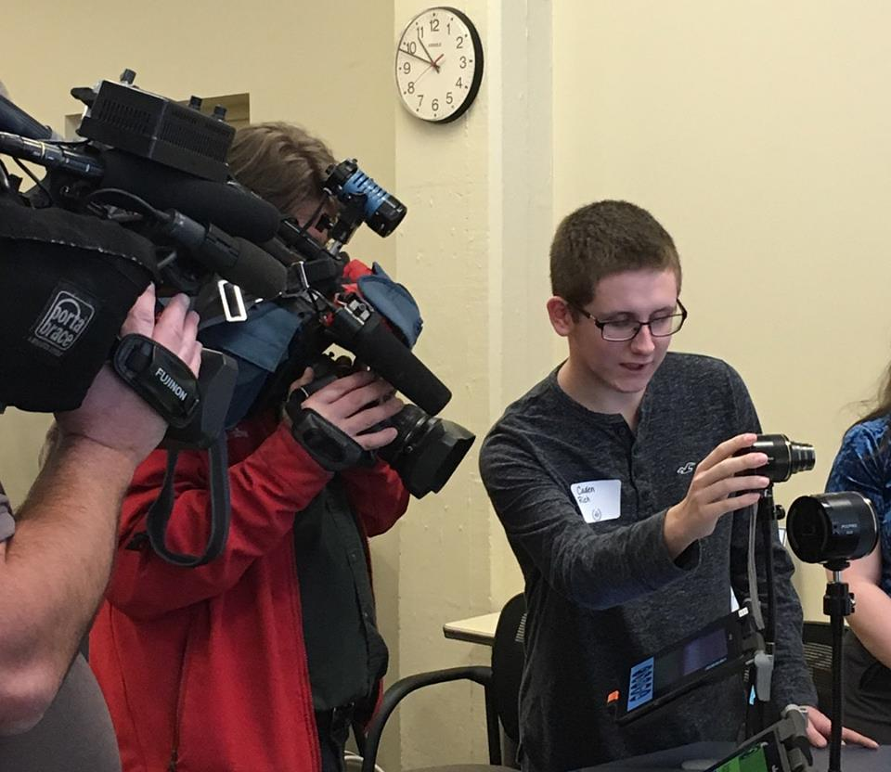
APH celebrated 160 years of business in January 2018. The celebrations included an open house, for which an invitation was extended to the entire community. During this event, multiple products were chosen to be on display for demonstrations, including the MATT Connect. Zierer invited a family friend who is a high school student in Bullitt County Public Schools to assist in the demonstration of the MATT Connect. This student uses the MATT Connect for distance viewing in his classes so that he is not required to sit in the front of the classroom in order to access material. Local news stations and government officials attended this event.

The writing tool feature addition sparked a rewrite of the user guide for this product, which was handled by Zierer and Greenwell in March 2018. At this time, HumanWare™ and APH began discussing modifications to address issues identified by teachers. Professionals expressed concern surrounding the use of the MATT Connect by young children. Two frequently mentioned issues were (1) the tablet can be easily removed from the magnifier stand, and (2) the interface is too complex for students just learning to use assistive technology. The addition of two simpler user interfaces was proposed, as well as a modification to the tablet stand’s clip—users will be able to insert a screw to lock the tablet in place when desired.

In April 2018, Zierer distributed a survey to six assistive technology experts. Five of these professionals submitted a completed survey, geographically distributed as follows: Arizona, 1 (20%); Georgia, 1 (20%); Kentucky, 2 (40%); and Massachusetts, 1 (20%). Detailed descriptions of the proposed modifications along with screen shots and images were included in the survey. Reviewers were asked if they would like to implement none, one, or both software modifications implements; all five respondents agree to implement both of the changes. The reviewers were also asked if they thought the hardware modification would help prevent damage to the tablet; three reviewers strongly agreed, one agreed, and one responded “unsure.” It was decided upon to move forward with the hardware modification; HumanWare™ also began development of the software modifications in a beta version.

In June 2018, the beta version was demonstrated by HumanWare™ and made available to Zierer for testing purposes. A focus group of APH employees was held to garner feedback on the changes. Zierer also took the device to the Kentucky School for the Blind during the Elementary Summer Program to observe students using the device. Three sites offered to assist in testing the new software version during the summer. These sites are geographically distributed as follows: Kansas, 1 (33%); Texas, 1 (33%); and Washington, 1 (33%). As of the writing of this report, there has been support shown to move forward with the update, which will be pushed to all MATT Connects. The hardware modification will be incorporated in the next production run of units.

Zierer will edit the user documentation to include the modifications. New production files of the User Guide and Quick Start Guide will be supplied to HumanWare™ for inclusion in kits.

Work planned for FY 2019
Zierer will continue to offer training and support for this device.

See Like Me: Low Vision Simulators
(Completed)

Purpose
APH has been asked many times to provide vision practitioners with a low vision simulation product of some kind to show parents, education professionals, paraprofessionals, and peers of students with visual impairments what it may be like to work with low vision of one of eight more common types. We believed that existing products were not adequate because while they attempt to simulate particular visual pathologies, they show neither the color changes that often accompany the problem, nor the differences that occur between the two eyes.

Project Staff
Elaine Kitchel, Project Leader
Martin Monson, Project Leader
Frank Hayden, Director of Technical & Manufacturing Research
Anthony D. Jones, Art Production/Design Manager
Katherine Corcoran, Model Maker
Rachel Bishop, Research Assistant
Leasha Twyman, Research Assistant

Background
For several years, APH has been asked by the field of practitioners in visual impairments to provide a set of low vision simulation devices that would more adequately demonstrate the vision of someone with one of the eight primary eye conditions. Until recently, the technology that could show both color differences and differences in the vision in two separate eyes was not economically feasible. As soon as that technology became affordable, APH responded to the need and has developed eight different filters that show simulation of disease or disorder and also differences between the eyes.

Utility
A field test will be conducted to make sure the product is usable, safe, useful, durable, and helpful. Both students and their teachers will be asked to respond to questions about the product. The results of the field test will be analyzed to determine if changes to the product or its accompanying documentation are appropriate.

Relevance
APH made the decision to produce this product based on a standardized process of product selection. The product was proposed by various teachers and practitioners over the past 8 years. In-house and outside experts were asked to review the submission and give an opinion as to whether the product idea should be accepted as a product. The product idea was then evaluated to see if existing production methods could meet the need in a cost effective way. The answer was affirmative, so the idea went to the Product Evaluation Team and Product Advisory and Review Committee where it was subjected to questions and had to meet certain qualifying standards for APH product development.

This product is fully accessible to the population who will use it. It is designed specifically for people who have typical vision but who would benefit from the experience of a simulation of low vision. Documentation materials will be available in large print, braille, and HTML. Therefore all teachers and practitioners or parents who need accessible materials will have them.

This product follows APH guidelines for the determination of the relevance of a product because it has been requested by teachers of students with visual impairments and other vision practitioners. It will be field tested by potential users with typical vision and general education teachers.

There is evidence of an examination of the need for this product. There is currently no affordable low vision simulation kit that has the features of this one. This product will be tested by in-house experts, teachers, vision professionals, and people with typical vision. Changes suggested by these responders will be considered and where appropriate, implemented.

This product addresses an identified need for a person who meets the definition of “visually impaired.” The product meets the identified need as a way of explanation and experience of people with typical vision to reach an understanding of what the student with a visual impairment deals with every day. Many people, such as parents, peers, general education teachers, and others can assist the student with a visual impairment far better once they experience the simulation of vision loss.

Work during FY 2018
The Model Shop produced several pilot kits for field testers to use in 2017. The kits included: a handled, waxed, cardboard carrying box, a key of the simulators adhered to the inside top of the box, a user-guide that gives a brief explanation of each of the etiologies, the simulators, and a piece of egg-crate foam to hold the simulators in place. The simulators were used by 13 evaluators in an in-service type of environment with multiple participants. The results of the field test follow and include direct quotes from the evaluators on the various components of the kit.
Kit Component:
- Simulator, overall rating (out of 5 possible points), and specific feedback from the evaluator:
- Hemianopsia 3.42
  - I felt like this simulator blocked too much vision to be considered a simulation of hemianopsia. First the darker area covered more than half of the visual field, also the “clear” portion of vision on the lens was impossible to see anything through. It was basically totally blinding.
  - I would reduce the field a bit more since the simulator allows individuals with full field to kind of peek around the blockage in the visual field on the lenses.
  - Blocked vision to both sides—inability to see both left and right when on. Stroke patient would be able to see in one visual field.
  - I found that while I really liked the surround style of the simulator set, different from the old-style simulator, and significantly more comfortable, what were supposed to be clear areas of the PVC inserts were not adequately clear enough to simulate areas of clear vision.
- Myopia 4.69
  - This was by far the most popular and had the most dramatic reaction from individuals. I would like to have a full set of just Myopia with different acuities 20/70-20/600 to show teachers more accurately what their VI student can and cannot see.
  - This was the one simulator that I felt did a very good job of simulating the visual impairment.
- Macular Degeneration 4.00
  - The central scotoma was too large and the other smaller and more disperse black portions blocked too much vision to simulate AMD though there may be different degrees of vision loss depending on the severity of the condition(s)
  - See hemianopsia above. [clear non-affected parts of lens]
- Retinitis Pigmentosa 4.15
  - I used this one a lot, it really allows the user to understand what a severely reduced field looks like.
  - The simulator only represented one pattern of vision voids. The student for whom it was being tested did not have the pattern represented, but rather the opposite, outer field compared to inner.
  - See hemianopsia above. [clear non-affected parts of lens]
  - However, the participant indicated that the student had the reverse of the simulator vision with central vision absent and the peripheral vision retained.
- Diabetic Retinopathy 4.00
  - See hemianopsia above. [clear non-affected parts of lens]
- Cataracts 4.00
  - See hemianopsia above. [clear non-affected parts of lens]
- Retinal Detachment 3.69
  - See hemianopsia above. [clear non-affected parts of lens]
- Glaucoma 4.00
  - See hemianopsia above. [clear non-affected parts of lens]
  - Again the degree may vary depending on severity
- Carrying Case 2.92 out of 5
- If you carry the box with the handle all the simulators become loose in the box and are not in place when you open the box.
- Thicker foam or deeper lens holders or both—Lenses are not held in place at all and fall around inside the kit.
- Very light, I travel to community and it’s great, could improve it by having an elastic band to hold the goggles in the slots, when you carry it they all fall to the bottom
- Smaller storage box would be easier to transport
- The box didn’t always stay closed and the simulators often became dislodged from their slots.
- Box could be more stable and protective.
- Sturdy
- Smaller box would be easier for transportation.
- Making the simulators stay in place while carrying
- When you carry to box by the handle the glasses fall out from resting position in the foam.
- The simulators fall out of their spots when it is carried by the handle.
- As soon as I picked up the box the simulators would fall out of their slots. Someway to snap them in would be helpful. A smaller box would also be better.
- When you pick up the box the lenses fall out of the slots they are in. You need to carry the box flat in order for the lenses to stay in place.
- Matching Key: 4.08 out of 5
- Good and I think this is the correct labeling for Glaucoma and cataracts.
- This was helpful.
- Very easy to match.
- No changes recommended.
- Simulator glasses could be marked in some way so that users who may not have the box in front of them could know which condition they were “trialing.”
- Works okay.
- Good
- Labeling the simulators
- Could be larger—Tag could be attached to glasses themselves.
- Fine—could be on the arm of the simulators too.
- The key was good, but tags on the simulators themselves would be helpful.
- Brochure: 4.15 out of 5
- The key and the brochure did not match for Glaucoma and cataracts (was flipped in brochure) but otherwise good.
- I printed, laminated and bound these into a book. I also used laminated pages to display the simulators on a table with the description below the lenses.
- Basic information is good for teens to adults.
- Good information
- Beautiful – large print – color
- This is okay but if you have the simulators on a brochure describing the condition was not really needed.
- Good
- Very good
- Compared to other kits:
- If improvements are made to the AMD and Hemianopsia filters I think this kit would be much better. I like that the glasses are wrap around and cover the peripheral field as well. The other kits we have had are actual goggles with an elastic strap with screw in lenses which block the peripheral field. The glasses in this kit are much more comfortable for the wearer and are easier to use. Also you have the simulation OU whereas our other kids only had a lens with one eye to simulate the eye condition.
- Other simulators are clumsy to put together and change, have elastic bands and plastic lenses and people shy away from them. I like that these function as easily as sunglasses and the user is not as self-conscious about the way they look to others.
- We have an old (really old) DAAS kit that we have used, but it’s hard to use because you have to keep changing out the disks in the goggle form (I think they are made from welding glasses). We have tried cardboard ones, but they are flimsy and don’t hold up. These are a good compromise between the two.
- I liked the idea of safety glasses (this kit) vs. goggles (other kits that I've used).
- The simulator inserts mimicking the various conditions were very informative and gave the users an excellent experience. However, they seemed a little “temporary”— I'm not confident that they would hold up under even moderate use.
- See above... What I found is these were good for more “generalizations” of vision conditions but if I was to use these for my individual students I could not really customize them in a way that provided for the variation between vision in both eyes. What I got from participants was “is this how so and so sees?” I would prefer more flexibility for customization.
- The glasses are much more comfortable to wear than goggles.
- These give a more accurate insight on the eye conditions.
- Previously I have used a lab goggle style that seems to be easier for older individuals to put up to their eyes for quick demo. If using for student activities at PT school your glasses are more comfortable to wear for lab activities and change full field of vision (which makes it more “real”)
- The ease of putting on, the key. The actual simulations are all superior.
- I can’t pick one because they are not consistently better or worse. As I have described above, the viewing area, comfort, and the surround, is significantly better. But the quality of the PVC insert is a significant issue.
- Slightly easier to put on for demonstrations.
- Rate the design: 4.36 out of 5
- Very simple yet effective design, uses a product people are already familiar with.
- A few of the largest students had trouble getting them on, too narrow on their heads, but most had no trouble.
- Design is very good.
- Sometimes the overlays slipped away from the glasses themselves, and the glasses did not always fit snugly around the person's face, even though the stems were adjustable. They felt much less durable than simulators that have been previously available.
- The simulator inserts mimicking the various conditions were very informative and gave the users an excellent experience. However, they seemed a little “temporary”— I'm not confident that they would hold up under even moderate use.
- I guess what comes to mind is these are somewhat flimsy and I am wondering if these would hold up over time with a lot of use. I live in a state that has a lending library, a set of these could get a lot of use and I could see them wearing quickly.
- Some of the glasses didn’t cover lower and side fields.
- The eye condition sheet that goes in the glasses may get torn or damaged.
- Light weight, easy to don.
- I wonder if it would be possible to put the simulations directly on the glasses, as opposed to using a PVC insert, though I understand that this would increase costs. Or explore other [overlay] materials.
- Would you like to see more eye conditions?
- No.
- More Myopia acuities represented 20/70-20/600 and one with 2 different acuities in each eye such as L 20/40 R 20/200. A variety of different field losses
- Not that I can think of, perhaps double vision but I am not sure how it could be done.
- I would like to see general vision acuity added to the set to give users an idea based on the eye report. I have seen kits with 20/200 or 20/400 goggles.
- Field loss, or visual processing disorders
- 20/200, 20/400, monocular vision, optic nerve atrophy
- The myopia only shows one acuity. In the kit that I made I had three, one for under 20/100 20/200 and 20/400. The kids all vary and one size myopia might not be a good representation.
- Cortical visual impairment, color blind
- Optic Atrophy because it is very common for our VI students. A basic blindfold to describe the students with no vision.
- Different degrees of severity, could be built into same glasses, left side vs right side.
- Different acuities
- I thought your selection was good.
- Albinism possibly
- All 13 respondents did not want any included conditions removed.
- Please list positive outcomes of participants.
- I had a father [whose] 40 y/o daughter has severe PDR. He said it helped him understand what she was dealing with.
- Many people used the Myopia simulator and had a better understanding of what their child or student could see. Many teachers responded that they understand the large print and magnification requirements of their students now that they have used the simulator.
- The students reported that they had never really thought about the variety of types of vision loss until they put on the goggles.
- Participants noted it was difficult to observe objects in their visual fields once they tried moving around with the glasses on. They also seemed to empathize more with the student’s visual condition.
- The participants in our training reported that the simulators gave them a good first-hand experience of the vision condition.
- My leadership team was VERY impressed and are already talking about ways to utilize the kit with board of directors, volunteers and visitors to the agency.
- As I have found in other times when I have used simulators an experience where you actually are visually limited speaks volumes over just talking about the limitations. These are enormously helpful in promoting understanding and empathy not sympathy.
- People were amazed by the glasses and appreciated having an understanding of how their child/student uses his or her vision.
- The in-service was fantastic! The participants described the simulators as an eye opening experience and they realized they needed to be more patient.
- Help them realize how much a person[’s] vision can be impacted by certain eye conditions.
- The teachers were very strongly influenced by experiencing a bit of their students’ visual experiences.
- None noted.
- They liked exchanging them and completing the tasks under different simulations. When compared to the older simulators that were present they liked the ease of using these (See Like Me).
- Did the participants list or did you notice any negative outcomes?
- None
- No negative comments.
- None
- No negative outcomes, remarks, or reactions.
- Fit and comfort of the simulators
- Only concern is about how long the simulators would last with frequent use.
- There were a few people who didn’t like having reduced vision and were somewhat negative there...I put them under some specific tasks and it was frustrating.
- Many people were not able to keep the high myopia glasses on. Some people felt some of the simulators were the extreme version of the diagnoses.
- The glasses were not labeled when given out.
- Older individuals felt the frame arms were tight—think they did not know that they were able to be pull apart further without damaging them. PT students ?? Hemianopsia glasses as vision impaired in both visual fields
- None noted.
- Any other feedback?
- No additional feedback
- None
- Would love to see these in production soon, I can really use them with family, institutional caregivers, donors, and lots of other types of groups who need experiential learning on vision loss.
- Can you make the brochure condensed and able to be copied in order to give it to participants?
- Improving the carrying case would help significantly, in addition to making the overlays fit better with the glasses themselves.
- Could be helpful to have a “lesson plan” included to help the facilitator complete the experience.
- Has anyone from APH seen the kits that George Zimmerman puts together? He is a OM/Consultant from Pennsylvania. I am wondering why you couldn't work a deal with George to distribute his kits?
- Great job!
- A blindfold included
- The carrying case more compact
- Simulators labeled

Based on the feedback from the field testers, the following components of the kit were changed:
- The non-occluded portions of the lenses were cleared up.
- The diabetic retinopathy and cataract lenses were changed so that they allowed in more light and, as a result, occluded less.
- The macular degeneration lens was changed to have more of a central field loss in the left eye.
- The carrying case was changed significantly. It is now purchased through an outside vendor and is made of hard plastic and includes a handle and a secure closure. A much smaller case will be used so that the lenses inside of it will not move.
- While the key will be adhered to the inside top of the simulator carrying case, the guidebook will be available for online download only.
- Due to the close proximity of the lenses to each other in the smaller carrying case, each lens will be put into its own small cloth bag to prevent scratching of the lenses.

Information from the above field test results was used to modify the product before it went to Production. The following changes were made:
- A hard plastic box with a handle and snap closure was found from one of APH’s current vendors. The glasses fit snugly inside, and there is no room for movement.
- The lenses for diabetic retinopathy, glaucoma, and cataracts were all lightened to allow more light to pass through the lens but to remain opaque enough to show the significant visual impairment.
- The non-occluded portions of the hemianopsia lens and the retinal detachment were cleared up to more accurately reflect those types of vision loss.
- The decision was made not to include the brochure in the kit, as the new case will not allow an 8.5 x 11-inch paper to be placed inside without being folded. The brochure will be available on the APH Web site as a free download.

This product became available for sale in August 2018.

Work planned for FY 2019
No further work is planned on this project.

TADPOLE Overlay Electronic Version [Modernization]
(Completed)

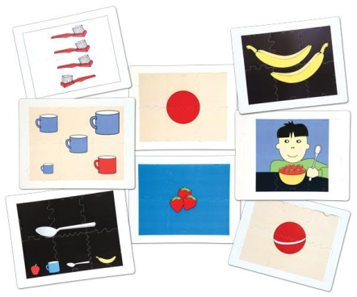
Purpose
In late FY 2015, APH was notified by one of its printers that the price on TADPOLE overlays was about to double. This increase was not due to an increase in the paper that the images were printed on, but on the printing process itself. The project leader considered what other media were available for presentation of the TADPOLE images. She sought information about a tablet app as a possibility. By using an app, the images could be presented with sound and instruction, so it was decided to do it that way.

Project Staff
Elaine Kitchel, Low Vision Project Leader
Martin Monson, Project Leader
Frank Hayden, Director of Technical & Manufacturing Research
John Hedges, Programmer
Heather Kennedy-MacKenzie, Project Leader/Technology Liaison
Steve Mullins, Studio
Anthony D. Jones, Art Production/Design Manager

Background
The search to substitute something for Light Box overlays due to increases in costs of screen printing led to the development of an e-pub application that could present the TADPOLE images on tablets or computers with music, instruction, and responses.

Utility
Usefulness of the images was established with the TADPOLE product. However, the use of the image on a notepad instead of the Lite Box is a different medium. Other products have established utility on notepads, and we are extrapolating from that knowledge that the TADPOLE images will be useful as well. But it has yet to be proved.

Relevance
APH made the decision to produce this product based on a standardized process of product selection. The product was proposed by the project leader and presented as a submission. In-house and out-of-house experts were asked to review the submission and give an opinion as to whether the product idea should move forward toward production. The product idea was then presented to the Product Evaluation Team and Product Advisory and Review Committee where it was subjected to questions and had to meet certain qualifying standards for APH product development.

This product is fully accessible to the population who will use it. Materials are available in large print, braille, and HTML files so all students, teachers, and practitioners who need accessible materials will have them.

This product follows APH guidelines for determining relevance of a product. It was affirmed by field tester teachers that their students with visual impairments often benefitted from the TADPOLE overlays. This fact was also affirmed by the students themselves who used the product in its original form.

There is evidence of an examination of the need for this product. There is currently no cost-effective method to produce the overlays that has been tested for and with students with visual impairments. This product was tested by in-house experts, students with visual impairments, and their teachers. All groups affirmed that there was an identifiable need for the overlays in some accessible form for both students and teachers who have visual impairments.

This product addresses an identified need for a person who meets the definition of “visually impaired.” The need has been established because users are asking for it, and the responses by in-house experts and other testers of the materials indicate the beta product will fill that need.

In FY 2015, the overlay images were ordered to present concepts from simple to complex. They were arranged also to indicate and teach such concepts as off-on, inside-outside, part-whole, and so forth. A script was written, edited, and finalized. It was then sent to Steve Mullins to be recorded as WAV files. Meanwhile, John Hedges began the programming part of the effort. Anthony Jones prepared some SRG files to provide the layers that are needed for the graphics.

Work during FY 2018
The program was made available to the public as a free download in November 2016.

Work planned for FY 2019
No work is expected as this product is complete and available for customer use.

Topaz Filters [Modernization]
(Continued)

Purpose
To expand the line of UltraLens offerings to include topaz-tinted filters

Project Staff
Carolyn Zierer, Project Leader
Leasha Twyman, Research Assistant

Background
The expansion of the UltraLens offerings to include topaz allows APH to offer customers an option that addresses the amount of blue light they are exposed to through computer screens, overhead lights, and so forth. However, its primary use is in conjunction with personal devices, such as tablets or smartphones given the large amount of blue light these devices emit and their close proximity to the eye when used by low vision users.

Product Description
The product will be offered in the same frame sizes and styles as the UltraLens but will be a topaz shaded filter.

In FY 2017, the modernization of the UltraLens to include topaz filters followed the process established at APH. To determine if there was a need for the topaz filters, a survey was created via SurveyMonkey®, and the survey notice was listed in the APH News. According to the results of the completed survey, APH consumers thought APH should offer both a yellow and a topaz UltraLens. The majority of respondents (14/15) said they would buy both colors, try each with their students/clients, and give their students the one that seemed to meet their needs best. Several of the comments supporting the addition of a topaz UltraLens follow. These comments are representative of the type of comment received. While one of the respondents indicated APH should offer only the topaz lens, all of the supplied comments indicate a choice is preferred.
- Any additional lens options would be a benefit and all sizes would be so helpful. The lighting in most schools and the increase in technological demands causes the need for tinted lenses for so many students.
- It would be nice to have a choice of the topaz lens to help other students. Since other companies are difficult to find child size options in.
- I had a kiddo that would not wear sunglasses although he was light sensitive. But he would wear these glasses
- Yellow doesn't work for everyone!

While the number of respondents to the survey was small, and the annual sales of the yellow UltraLens are not great, it seems there is a group of people who would find a topaz UltraLens beneficial to the students/clients with whom they work. The product was approved by both the Product Evaluation Team and the Product Advisory and Review Committee.
After approval by the product committees, several samples were ordered from two companies, Eschenbach and Noir. The samples sent from both companies were off-the-shelf products. All of the samples were for outdoor use and as such occluded too much light for the intended use. As Eschenbach produces a line of lenses titled “night drivers” that have a very small amount of tint in them, it was decided to work with that company to produce the topaz lenses. However, after continuing to try to develop this line of lenses with Eschenbach throughout most of the year, it was decided to develop the lenses with Noir instead. This decision was due to the fact that Eschenbach couldn’t economically provide the lenses in the frame sizes APH needed and in the small quantity that past sales have indicated is required. Noir does produce lenses in the sizes that APH requires. Noir is the current vendor for the yellow UltraLens and can meet our low-volume purchasing requirements.

Work during FY 2018
During FY 2018, project staff worked with the second identified producer of colored filtered lenses, Noir. Noir currently produces the yellow UltraLens that APH sells. As such, the frame sizes should be available and in the small quantities that APH requires. The work of FY 2018 focused on working with Noir to determine their ability to produce the topaz lens in the desired range of light occlusion.

During this fiscal year, the project lead was changed to Mark Renfrow and then to Carolyn Zierer in order to facilitate the final details of the project.

Work planned for FY 2019
The manufacturing specialist will finalize the product specifications and will convene a Gate#5 specifications meeting. The timeline for release will be projected.

SOCIAL INTERACTION SKILLS

For FY 2018, there are no active Social Interaction Skills products to report.

TESTS AND ASSESSMENTS

BRIGANCE CIBS II
(New)

Purpose
To provide a curriculum-based and grade placement assessment for teachers to use with students with visual impairments. This instrument is widely used with special education populations in grades K-9 to accurately determine a student’s present level of performance.

Project Staff
Carolyn D. Zierer, Project Leader
Kay Alicyn Ferrell, Consultant
Leasha Twyman, Research Assistant
Rod Dixon, Manufacturing Specialist
InGrid Design, Graphic Design

Background
The BRIGANCE CIBS II has been requested through feedback gathered in surveys on assessment needs, focus group sessions at the APH Annual Meeting, and direct contact through e-mails, phone calls, and conversations with TVIs at conferences. It is acclaimed to be the “go to” instrument in determining the present level of performance and assists professionals in developing an educational plan for students.

Work during FY 2018
An extensive review of the assessment was completed. The project leader met with the consultant, Dr. Kay Alicyn Ferrell, in October 2017 to review needed adaptations for the braille edition. Adaptations for the student materials were noted for large print and braille. A supplemental administration guide for the braille adaptation was created to accompany the publisher materials listing for each adapted item, its modifications, and/or suggestions for an alternate assessment. Product development meetings were held in late November 2017 to hand over the files to InGrid Design for the large print and to the APH Transcription Department for translation into UEB with Nemeth (contracted and uncontracted).

Due to the workload in transcription, the braille translation did not begin until late spring 2018. The size and the needed formatting of the large print has been very slow to be completed by InGrid Design.

Work planned for FY 2019
The project leader will continue with the development of both braille and large print sections of the BRIGANCE CIBS II throughout the year with hopes of nearing a completed prototype by early spring 2019.

Functional Skills Assessment
(Continued)

Purpose
To provide assessment tools for daily living/functional skills for students in primary grades, middle school, secondary school, and transition classes

Project Staff
Terrie (Mary T.) Terlau, Adult Life Project Leader
Diane Bender, Project Author/Consultant
Laura Zierer, Project Assistant
Laura Greenwell, Graphic Designer
Monica Vaught-Compton, Project Assistant
Emily Grimany, Research Assistant
Kelly Kennedy Mimms, Research Assistant
Michael McDonald, Programmer
Andrew Moulton, Manufacturing Specialist

Background
As the expanded core curriculum becomes increasingly important in the education of students who are blind or visually impaired, a systematic method to assess a student’s progress in learning functional skills becomes essential. Dianne Bender’s assessment system for functional skills has been developed during her extensive teaching career in a residential school for the blind setting. Her system is comprehensive and provides scoring procedures so that students' progress can be tracked from year to year.

Preliminary Research
Terlau has collected skills assessment protocols used by schools for the blind and rehabilitation centers. She has also monitored e-mail lists in which assessments of functional skills have been discussed. Examination of these resources supports the conclusion that many schools for the blind, university training programs, and rehabilitation agencies have developed their own strategies for assessing different aspects of self-care and daily living tasks. However, a systematic assessment process that incorporates a criterion-based scoring system and utilizes core curriculum skills in all levels of its functional assessment has not been made widely available. The need for such a comprehensive system has been expressed by numerous educators of persons who are blind or visually impaired. Bender’s system is being used as the basis for the Functional Skills Assessment project because of its comprehensive coverage of functional skill areas; scorable testing protocols; and concise, clear testing directions.

Initial Product Development
Telephone conferences with Bender resulted in the finalization of four areas to be included in the Functional Assessment: Food Management, Clothing Management, Self Management, and Home Management. Based on this plan, Bender submitted revised materials for all four levels of each module. Item editing and revision and creation of additional items by Bender and the project leader have continued.

During FY 2009, the project leader reviewed all items at all levels in all modules of the system. She prepared suggested item changes throughout all modules and levels of the assessment to support more standardization across assessors and to equalize weights given to similar items across module levels. She spoke with Bender about these issues, provided general descriptions of and rationale for item changes, and prepared specific item change suggestions in spreadsheet format. Spreadsheets with specific item content changes were sent to Bender for consideration and review.

During FY 2010, in monthly teleconferences, Bender and the project leader reviewed changes to support test-retest and inter-rater reliability, redesigned the scoring system to enhance psychometric properties of the test, determined final rewrites of items in the Clothing Management and Food Management modules, wrote scoring scenarios and item explanations for these modules, and developed plans for content of the Home Management and Personal Management modules.

During FY 2011, Bender and the project leader continued to refine the test scoring system, rewrote scoring scenarios for previously completed modules to conform to new test scoring procedures, and wrote items and scoring scenarios for the Self Management Module. Because of extensive reworking of previously completed modules in order to improve standardization strategies and potential for high inter-scorer reliability, new item development was confined to the Self Management Module, with work on the Home Management Module postponed to FY 2012.

During FY 2012, item content, item explanations, scoring criteria, and scoring scenarios were completed for the Home Management Module. The Self Management Module was revised to include self-care, social skills, and consumer skills.

During FY 2013, the Scoring Booklet for the Home Management Module was developed and revised to include not only information needed to score each item, but also information that teachers would want to know about techniques and skills that the student used as the testing task was performed. Excessive detail was omitted from the Scoring Booklet, and language for all test items in the Assessment Manual was changed to conform to this Scoring Booklet style. Terlau prepared Scoring Booklet draft item layouts for the remaining three modules.

During FY 2014, Scoring Booklets for Home Management Assessment and Clothing Management Assessment were edited and redrafted to request more material from examiners about how various tasks were performed. Scoring Booklet layout was finalized. Terlau prepared drafts of Food Management Assessment and Self Management Assessment to conform to improved layout and data collection procedures.

During FY 2015, Terlau completed the first chapter of the assessment manuals. All manuals and scoring books were edited and made ready for field testing. Field test evaluation forms were prepared, and field test sites in K-12 and adult settings were identified. Field test materials were sent to 19 testers: 11 testers and one expert reviewer for use with K-12 students; and three testers and four expert reviewers for use with adults. Useable field test materials were returned by 12 testers (63% of the total group): six testers and one expert reviewer for use with K-12 students; and two testers and three expert reviewers for use with adults.

Table 1 displays the regional distribution of the 19 initial testers and the 12 who returned useable material as a whole and according to whether they tested K-12 students or Adults.

Table 1
Regional Distribution of Field Test Sample

 | Initial Tester Sample |  |  |  |  | Testers Returning Useable Materials
 | Northeast | Midwest | South | West | Total | Northeast | Midwest | South | West | Total
K-12 | 2 | 5 | 3 | 2 | 12 | 0 | 4 | 3 | 0 | 7
Adult | 3 | 0 | 3 | 1 | 7 | 2 | 0 | 2 | 1 | 5
Total | 5 | 5 | 6 | 3 | 19 | 2 | 4 | 5 | 1 | 12

Table 1 shows that the initial 19 testers were fairly equally distributed across the Northeast, Midwest, and South, but were somewhat under-represented in the West. However, the 12 testers who returned useable materials were not equally distributed across regions, with the Northeast and West being very under-represented. Functional Skills Assessment results are analyzed separately for use with K-12 students and for use with adults. The seven testers who returned useful materials for K-12 students and the five testers who returned materials for adults, considered separately, display very poor regional variation. Because factors that vary across geographic region were not expected to impact evaluations of Functional Skills Assessment, the limited geographical distribution of testers did not reduce the value and utility of field test results.

Three expert reviewers and two testers working with adults strongly suggest that the developmental focus of this assessment is not useful for adults who have been visually impaired and for adults who lose vision in adulthood. Because this product was constructed primarily for use with K-12 and transition students, the finding that this assessment was not appropriate for use with adult students was not surprising. Responses from the five testers regarding adult functional skills assessment needs offer directions for future product development for this population.

Overall, the six field testers who used parts of the assessment with their K-12 students and the expert reviewer found this assessment to be a valuable tool for tracking student progress. Testers agreed that test items were age/level appropriate, that administration directions were clear, and that the scoring criteria and scoring scenarios were helpful. Two testers commented that assessing a task (e.g., doing laundry) helped the student take more responsibility for doing the task at home.

Results suggest that scoring books should be simplified. Scoring Books should retain the summary description of the task, the table for recording which aspects of the task the student performed correctly, the scoring criteria, and the line for the item score and date. However, testers did not fill in approximately half of the scoring book fields for descriptions of how the student performed the task, and several testers commented that several of these fields were not necessary. Based on this feedback, a thorough review of qualitative fields in the scoring book was undertaken. Approximately 50% of the qualitative questions were omitted.

During FY 2016, it was decided that the field test results supported the need for a redesign of scoring books. Abandoning the item layout on two facing pages, the new scoring book design provided summary information on the first page and scoring tables for three administrations of the test item on the next three pages. Items adapted for students with multiple disabilities were included in their own scoring pages pack. In addition, pages were provided for administrations of an item beyond the three administrations in the scoring book, and other scoring pages were designed so that examiners could create and score their own test items. Further examination of expert review and field test results obtained from professionals working with adults with vision loss support the inapplicability of this developmentally focused assessment for adults.

In a meeting with the graphic designer and manufacturing specialist, the project leader clarified the product structure so that layout and specifications could be completed appropriately.

Layout and content were finalized in FY 2017. Clean electronic files and printouts of the final layout of the four assessment manuals were provided to Braille Translation, with formatted braille files of the manuals to be made available as free downloads from the APH Web site. McDonald began work on the development of Web forms to supply scorebooks digitally. These forms will allow the user to store information for multiple students without the need for hardcopy scorebooks.

Work during FY 2018
Braille files were completed and approved in April 2018. Also in that month, a specifications meeting was held. The printed books are expected to be made available in FY 2019. The majority of the work completed in FY 2018 focused on the Web forms for the scoring of the assessment. McDonald and Zierer met to discuss table layout and functionality of the website. Grimany has spent a significant amount of time proofing the content and checking the functionality of these forms. Issues were tracked using the project-management tool utilized by APH.

Work planned for FY 2019
The print books will be produced and made available for sale. Web forms will be completed and released. Accessible files of assessment manuals and student assignments will be made available on the APH Web site.

KeyMath™-3 Large Print and Braille Adaptation
(Continued)

Purpose
In keeping with a long-time collaborative tradition between AGS/Pearson Assessment and APH, a braille/tactile adaptation will be developed. This instrument has been widely used to assess math skills of students who are visually impaired.

Project Staff
Carolyn D. Zierer, Project Leader
Laura Zierer, Project Assistant
Leasha Twyman, Research Assistant
Adam Clark, Manufacturing Specialist
Andrew Moulton, Manufacturing Design
InGrid Design, Graphic Design

Background
Continuing a long tradition of working with AGS Publishing to develop the original KeyMath™ and KeyMath™-Revised in braille/tactile formats, APH requested permissions from the new publisher, Pearson Assessment, to develop adapted versions of KeyMath™-3. APH requested the approved pre-production copy ahead of the print publication date in order to expedite production of the braille and large print editions. The project leader reviewed all test materials. Progress on the project stalled while waiting for copyright approval, during which time, the project was placed back on the PARCing (Product Advisory and Review Committee) Lot.

Application for copyright permissions was resubmitted, as better communications with the publisher were established during the last quarter of FY 2011. The project was removed from the PARCing Lot and brought into active development again. Debra Sewell was selected as a project consultant, and a project assistant was assigned.

During FY 2012, editing for braille translation resumed. The project leader and the consultant held a 2-day work meeting at APH in July 2012. The majority of the editing took place at that time. Several teleconferences were held in August and September to continue the work.

During FY 2013, a working meeting was scheduled during Annual Meeting in October for Sewell and the project leader to complete the remaining sections. Sewell and the project leader participated in an input session on KeyMath™-3 at Annual Meeting.

During FY 2014, work on this project was delayed.

During FY 2015, work resumed on this project with the project leader conducting a complete review for large print and braille adaptations. The adaptations were shared with three expert reviewers (Susan Osterhaus, Derrick Smith, and Sean Tikkun); each contributed feedback. A Product Development Committee meeting was held in February 2015 to introduce the components and layout of the large print and braille products. The project leader initiated contact with Pearson to inform them of our intentions to resume work on the project. The electronic PDF files were obtained from the publisher, and work resumed on the adaptation process for the large print. InGrid Design is working with APH to recreate the images and layout of the large print student book and teacher administration pages. Elaine Kitchel, APH Low Vision Project Leader, was consulted regarding the adaptations needed for students with eye conditions that may affect their ability to complete the large print assessment. Keeping in mind examiners who may need materials in an accessible format, the teacher pages will be produced in large print. A BRF will be supplied for teachers who are braille readers upon request. Laura Zierer, research assistant, created image descriptions for each of the images to be included with the administration directions. A meeting was held with the APH translation department to outline the details for braille translation and graphic illustration.

In FY 2016, work continued on the adaptation of the large print and braille forms of the assessment. InGrid Design continues to create the adaptation of the images for the large print, which has been an intense undertaking due to the changes needed to colors, spacing, and deletion of excessive details. Formatting the material in large print to be accessible for both teachers and students with visual impairments creates unique challenges while maintaining an assessment that is easily administered. Work resumed in translation on the braille adaptation and graphics in April after having been on hold due to other production commitments. An adjusted timeline was established.

In FY 2017, work continued on both the large print and braille adaptations. After careful consideration, and in the interest of time constraints with limited resources in braille translation, staff decided that only the student materials would be produced in braille. The administration manual and test record forms for the braille would be presented to the examiner in large print. The adapted versions were sent to three expert reviewers: Kathryn Botsford, Sara Larkin, and Derrick Smith. After evaluating the feedback on the adapted materials, modifications on both the large print and the braille editions were completed.

Work during FY 2018
The expert review of KeyMath-3 was conducted by a geographically diverse group of experts (Botsford, Larkin, and Smith). They evaluated the prototype based upon their experience in the field of teaching mathematics to students with visual impairments. Expert reviewers suggested subtle changes to the tactile graphics and color contrasts. Upon review of these suggestions, changes were made to add texture to some tactile graphic shapes, some colors were altered to provide more contrast, and some tactile graphics were altered to reduce clutter and potential distraction. Minor errors were identified and corrected. Additionally, braille formatting and translation issues were addressed, specifically regarding the UEB and Nemeth. Some comments offered were the following:
- Overall, the presentation was quite nice. While it was essentially "enlarged," it was very "clean."
- For the most part, the color contrasts were good.
All agreed that the construction of the materials provided ease in administration, offered clear and concise information for the administrator, and the presentation was student-friendly and would be usable by the visually impaired student population.
A final specifications meeting was convened on May 22, 2018, after completion of the suggested modifications from the expert reviewers in September 2017. The specifications meeting was delayed due to a backlog in rendering part numbers and the manufacturing specialist’s workload. Production will follow making the product available to our customers with a projected release date of early 2019.
Work planned for FY 2019
A launch meeting will be held prior to the release of the large print and braille kits to evaluate the development process and finalize brochures for the product.

NewT: New Tools for Use with FV/LMA
(Completed)

Purpose
FV/LMA, a set of protocols for conduction of functional vision and learning media assessments, requires a set of tools for practitioners to use. The protocols within FV/LMA often require such tools as colored markers, print samples of varied sizes, photos, pictures, cartoons, rulers, and so forth to be used with them. In the past, practitioners have been responsible for the development of their own sets of tools. However, there is value in standardization and accessibility. When tools are standardized, other practitioners, optometrists, teachers and all people of a student’s vision care/educational team understand how the results of the functional vision and learning media assessments were gathered and analyzed. They all understand what the results mean. With the development of NewT, practitioners across the country will be able to interpret results from their colleagues’ reports when a child moves to a different state, for example. The NewT product will be accessible to all persons with blindness or low vision.

Project Staff
Elaine Kitchel, Project Leader
Martin Monson, Project Leader
LaRhea Sanford, Ed.D. Consultant
Rebecca Burnett, Ed.D. Consultant
Laurianne Matheson, Consultant
Bryan Rogers, Manufacturing Specialist
Katherine Corcoran, Model Maker
Anthony D. Jones, Art Production/Design Manager
Yoshi Miyake, Freelance Graphic Artist
InGrid Design, Graphic Design Firm
Denise Snow Wilson, Technology Product Specialist
Kelly Kennedy Mimms, Research Assistant

Background
FV/LMA became available in 2008. Dr. LaRhea Sanford, one of the originators of FV/LMA held several workshops through the National Instructional Partnership. After each of her presentations, practitioners, teachers, and early interventionists called APH to request sets of tools such as the kind NewT would provide. They want to procure the tools to complement their FV/LMA products. During the development of FV/LMA, Sanford and Burnett developed their own set of tools and made a list of those items. The project leader and other staff worked out ways to make all the tools and materials accessible for practitioners who have blindness or low vision. The project leader and consultant met in June of 2009 to determine the scope of the product, and to brainstorm about which items would go into the array of tools in NewT. The project leader then met with the manufacturing specialist assigned to the product and talked over the projected specifications.

Research
Burnett, R., & Sanford, L. (2008). FV/LMA: Functional vision and learning media assessment for students who are pre-academic or academic and visually impaired in grades K-12. Louisville, KY: American Printing House for the Blind.
Koenig, A. J., & Farrenkopf, C. (1995). Assessment of braille literacy skills. Houston, TX: Region IV Education Services Center.
Koenig, A. J., & Holbrook, M.C. (1995). Learning media assessment. Austin, TX: Texas School for the Blind and Visually Impaired.
Roman-Lantzy, C. (2007). Cortical visual impairment: An approach to assessment and intervention. New York, NY: AFB Press.
Sewell, D. (1997). Assessment kit of informal tools for academic students with visual impairments, part 1 – assessment tools for teacher use. Austin, TX: Texas School for the Blind and Visually Impaired.

Note: These are the first five of many sources. For a complete list of sources, please contact the project leader.

Relevance
APH made the decision to produce this product based on a standardized process of product selection. Drs. Sanford and Burnett brought the request to develop a kit of tools to accompany FV/LMA. They submitted a formal product idea submission through the Low Vision Project Leader in 2009. Among requests for the tool kit to accompany FV/LMA from the field, requests from the developers of FV/LMA, and requests from attendees at National Instructional Partnership need was established. The product idea was presented to the Product Evaluation Team and Product Advisory and Review Committee and accepted as a product.

This product is fully accessible to the population who will use it. Materials are available in large print, braille, and HTML files so all teachers and practitioners who need accessible materials will have them.

This product follows APH guidelines for determining relevance of a product. The NewT materials support the FV/LMA while the FV/LMA supports the practitioner and the optometrist as they do their parts of the functional vision and learning media assessments. The project leader solicited information from those who attended the FV/LMA workshops to make sure the NewT contained what they needed. In field testing, practitioners were again able to suggest what might be of use to them in the kit. Most of those suggestions were fulfilled.

There is evidence of an examination of the need for this product. The research showed that professionals wanted this kit of materials to use in conjunction with the FV/LMA product. An in-house panel reviewed the materials and forwarded them to field testers who also affirmed the need for the product in their practices. Additionally, APH receives phone calls each month from practitioners who want to know when the product will be released for sale.

This product addresses an identified need for a person who meets the definition of “visually impaired” as evidenced by the fact that the FV/LMA is an assessment for use with school-aged students who are visually impaired and on an academic track. It calls for a whole list of tools to use with it. APH has standardized that set of tools and made it available as a way to ensure the validity of the outcome of the FV/LMA when it is used to assess a student. The need was further affirmed by the experts who reviewed the materials.

In FY 2012, the project leader enlisted feedback from many of those who had attended the FV/LMA workshops to determine specific guidelines and grade levels for the NewT materials to meet. She and Dr. Sanford discussed this as well. The manufacturing specialist then identified which items in the tool array would be made within APH walls, and which ones would need to be procured outside APH. The project leader then examined several items procured outside APH to determine if they would be suitable for use in the NewT array. The project leader worked with the consultants who had specific requests about what they wanted in Nigel Newt’s Portfolios. Work continued on the products to be made within APH.

In FY 2013 and FY 2014, the consultants have developed a short informational booklet for use by the consumer. The project leader wrote and pursued layout options of grade-specific materials for use by teachers and practitioners who have low vision. These are the materials in Nigel Newt’s Portfolios. The project leader developed, formatted, and finalized Nigel Newt’s Portfolios. Field testing took place and data were analyzed.

In FY 2015, revisions were made based upon field test data. A search for an appropriate carrying case took place, and two additional cloth carrying bags were requested by the field testers. The project leader completed edits on student portfolios. The field testers requested a booklet that showed all the items in the kit and pictures and descriptions of how these are used. This booklet was developed and finalized. Braille translation was completed.

Work during FY 2018
The product was made available for sale in September 2018.

Work planned for FY 2019
No further work is planned on this project.

Test and Assessment Needs
(Ongoing)

Purpose
To determine the needs of the field with regard to testing and assessing students who are blind or visually impaired

Project Staff
Carolyn D. Zierer, Project Leader
Leasha Twyman, Research Assistant

Background
Meeting the needs of TVIs and others who are called upon to assess students who are visually impaired is the focus of this home project. The project leader worked with the staff of Accessible Tests and Communications in FY 2007 to develop the first Accessible Tests Web site. Comments received on how the field has come to view the Accessible Tests Web site included "the best information source out there."

Commercially-available products for development of daily living skills, job skills assessment, and career interest inventories were reviewed by project staff because of their particular importance for instructors who transition students who are visually impaired.

During FY 2010, the project leader spent a lot of time with customers answering questions about the newly released Woodcock-Johnson® III Tests of Achievement- Braille Adaptation.

The project leader was asked to concentrate on the TEST READY® project as a priority. As a result, the project leader returned to the Research Department where projects were re-evaluated and new projects planned for FY 2011. One new project was brought forward in FY 2010 (Boehm-3).

In FY 2011, the project leader reviewed several new commercially-available assessments. Due to the division of responsibilities, Debbie Willis, Director of the Accessible Tests Department and staff took over the project to update Test Access: Guidelines for Computer-Administered Testing. Barbara Henderson, project leader at the time OOO, agreed to assist Willis with finding resources and reviewing drafts. A package of articles and references were shared with Willis and staff in early FY 2011. The project leader also assisted Willis by reviewing chapters in a best practices document that Willis was reviewing for a test publisher. In August 2011, the project leader was invited to serve on a Common Core Curriculum advisory panel as Senior Advisor regarding accommodations for students who are visually impaired.

During FY 2012, the project leader served on the GED® Fairness Review Committee and attended three meetings to develop the new GED® test, which will be released in 2014. She also worked with Measured Progress™, ETS®, and SBAC to develop computerized testing guidelines for students who are visually impaired.

During FY 2013, the project leader considered the development of a new survey to determine the kind of guidance school systems need to ensure that their students with visual impairments make a successful transition to the Common Core Standards.

During FY 2014, a new project leader was placed in this position. Work began on projects that had been delayed.

During FY 2015, the project leader continued to seek input and explore commercially available assessments requested by professionals in the field of visual impairment. A survey was created using SurveyMonkey® online software to seek input from professionals in the field of visual impairment regarding assessments used in their districts for all students for kindergarten readiness, specific learning disabilities, and gifted education. The survey asked for input on which, if any, of these assessments were needed for the students who are blind and visually impaired. The Developmental Indicators for the Assessment of Learning™, Fourth Edition (DIAL™-4) was most often listed for Kindergarten readiness, Woodcock-Johnson® IV (WJ IV™) is most widely used for identifying specific learning disabilities, and Wechsler Intelligence Scale for Children®-Fifth Edition (WISC®-V) was listed for identifying students for acceptance into gifted and talented programs. When asked for input on what they most needed, the (WJ IV™) and WISC®-V were most often listed.

An informational meeting with Houghton Mifflin Harcourt™-Riverside™ Publishing (HMH®-Riverside™) was conducted to share information about how to create materials in an accessible format for students who are blind and visually impaired. Overviews of best practice and guidelines were presented for creating accessible print content as well as points to consider when creating assessments for students who are braille readers.

The project leader continued to seek input from the field in regard to most needed assessments. The priority of developing partnerships with publishers and evaluating various commercially available products continued to be a primary focus as we strive to provide assessments for TVIs and psychologists who serve the needs of students. HMH®-Riverside™ accepted APH’s offer to assist in reviewing items in the development phase for accessibility prior to piloting. APH was excited to embark on this venture to participate in the development phase and eliminating the task of retrofitting an assessment after its release.

Input from the field was APH’s first priority in order to become aware of the specific needs in the area of assessment. The project leader reviewed assessments that have been updated or revised by publishers and sought input from TVIs, school psychologists, and others on their priority needs in the field.

The project leader continued efforts to establish and maintain relationships with publishers, making it a high priority to seek representatives to discuss products available and our needs in the adaptation process while attending conferences throughout the year. The project leader encouraged publishers to invite APH to become a partner in the development process for new and revised assessments prior to piloting them with students.

Work during FY 2018
The project leader continued to work with production to prepare needed assessments for customers. The project leader surveyed end users for needs in the area of diagnostic assessments. Work continued to foster and establish new relationships with publishers in order to increase the awareness of working in tandem on development of assessments. The project leader targeted specific conferences to foster and maintain relationships with publishers.

Work planned for FY 2019
Throughout this year, the project leader will continue efforts to maintain relationships with publishers and seek feedback from experts in the field on the needs to continue the mission of providing skills needed for students with visual impairments to become successful and independent. This task will be accomplished through attending conferences, monitoring electronic mailing lists, conducting surveys, and informal conversations.

Wide Range Achievement Test (WRAT5)
(New)
Purpose
To provide an easily administered reading and math inventory for teachers to use in their classrooms to determine the instructional level of a student

Project Staff Carolyn D. Zierer, Project Leader Leasha Twyman, Research Assistant Rod Dixon, Manufacturing Specialist Laura Greenwell, Graphic Design
Background This assessment is relevant to the needs of our student population. The Wide Range Achievement Test (WRAT5) is an assessment that quickly assesses the grade level of a student’s reading and mathematics skills. This assessment will be adapted for students who are visually impaired and will meet the needs of teachers who often request a reading inventory. The final product will be available in large print and braille in both contracted and uncontracted UEB. The math portions will be presented in both UEB and Nemeth for students preferring one code to the other. Discussions were initiated at conferences regarding the need for this type of assessment, and opinions were sought regarding preferences for an assessment of this type. Formerly, the John’s Reading Inventory had been provided to teachers; however, multiple attempts to acquire permission from the publisher were not successful. In the search, the project leader made the acquaintance of Dr. Gary Robertson, one of the authors of the WRAT5 through Dr. Ann Boehm. The author expressed a great interest in providing this assessment in an accessible format for students with visual impairments and introduced the project leader to the project lead at Pearson Clinical. Pearson Clinical was extremely cooperative and through our positive working relationship with them, APH was granted permission and was provided, prior to release of the publisher print edition, the use of the publisher electronic files, thus expediting the adaptation process. The WRAT5 will not only provide a starting point for instruction for reading instruction but also math instruction.
Since the adaptation required no edits, the decision was made to expert review the prototype. Teachers of the visually impaired were sought from diverse geographical areas. The reviewers were encouraged to use the instrument with students, but were not asked to collect quantitative data. It was requested they provide APH any feedback that may prompt a discussion on possible modifications.
Work during FY 2018 Permissions were granted to APH from Pearson Clinical to adapt the WRAT5 student materials. Work promptly began on the adaptation of the WRAT5 to be accessible in large print and in braille. The decision was made that since this instrument would be widely used to quickly assess students on their present level of performance that the braille materials would be provided in contracted and uncontracted UEB with the math portions being provided in both UEB and Nemeth contracted and uncontracted. All materials prepared for a prototype are to be shared with a select number of expert reviewers. The targeted group of reviewers are to be selected based upon geographical location and years of experience as a currently practicing TVI. These criteria are important since this group would be the primary users of the assessment. A Gate 3 Prototype Evaluation meeting was held on June 5, 2018, to approve the prototype for expert review. All agreed to allow the prototype to advance to the expert review stage. A projected timeline was established for a prototype to be available for distribution in fall 2018.
Work planned for FY 2019 Results of the expert review will be analyzed. Approved modifications will be made to the prototype. A new prototype will be presented at a Gate #4 meeting seeking approval to proceed to the production phase. Prior to release of the product, a launch meeting will be held to discuss the development process as well as finalize product brochures.

Woodcock-Johnson® IV – Tactile and Large Print Adaptation
(Completed)

Purpose
To adapt this widely used psycho-educational assessment instrument for braille and tactile format

Project Staff
Carolyn D. Zierer, Project Leader
Cathy Senft-Graves, Project Consultant
Lynne E. Jaffe, Project Consultant
Jane Erin, Project Consultant
Sara Lee, Research Assistant
Laura Zierer, Research Assistant
Rod Dixon, Manufacturing Specialist
Anthony D. Jones, Art Production/Design Manager
InGrid Design, Graphic Design

Background
Tests of achievement are commonly used to assess academic strengths and weaknesses in children and adults. More than any other single title, practitioners in the field of visual impairment have expressed their desire to have APH provide an adaptation of the Woodcock-Johnson® IV (WJ IV™) for braille and large print readers. Many schools are moving beyond the Woodcock-Johnson® III and are now asking that the WJ IV™ be used since it is a more comprehensive battery of assessments.

The WJ IV™ assessment is comprised of three batteries of assessments (WJ IV™ Tests of Achievement, the WJ IV™ Tests of Cognitive Abilities, and the WJ IV™ Tests of Oral Language). The three batteries of tests can be administered together or separately. There are additional assessments that have been added to the WJ IV™ such as phonological processing and verbal awareness. With the additional batteries, the WJ IV™ is a more comprehensive assessment that provides the teacher an even better picture of student strengths and areas of need.

During FY 2014, copyright permissions were sought from Houghton Mifflin Harcourt™-Riverside™ Publishing (HMH®-Riverside™) in June 2014. Planning discussions began with the publisher in July 2014. Lynne Jaffe, Ph.D., and Jane Erin, Ph.D., were chosen to be the project consultants to complete the adaptation of the assessments for the WJ IV™.

During FY 2015, work continued on the large print and the adaptation for the tactile version. Electronic files were provided for the WJ IV™, and work began on the large print edition. InGrid Design is creating the images for the large print in an accessible format for large print readers. This process was very labor intensive and time consuming, thus delaying the project. Many meetings were held to discuss layout issues. Much progress was made, and some of the components approved.

A preliminary Product Development Committee meeting was held in May 2015 to discuss the development of the braille edition. The braille adaptation was delayed due to unforeseen issues experienced by the consultant. Work did commence, and much progress accomplished. Several conference calls were held with HMH®-Riverside™ to discuss the progress of obtaining needed materials to complete the adaptation for a braille reader. Dr. Woodcock retains some of the data needed in order to make item substitutions when needed to make an item accessible. A conference call was conducted including Dr. Woodcock, HMH®-Riverside™, Jaffe, and representatives from APH. In the discussion with Dr. Woodcock, he was assured of our awareness of security as well as the availability of the instrument to only those persons who have received the necessary training to administer the assessment. With Dr. Woodcock’s approval, the consultants were able to obtain the needed files and work began on the braille edition. Each item was reviewed and necessary changes made to the Examiner’s Manual.

In FY 2016, Jaffe continued work on the development of the braille adaptation of the three batteries, completing the examiner manuals for each battery as well as an administration guide. Test records and student materials were adapted for those tests, which are able to be adapted. All teacher materials were made accessible in large print for test administrators.

Negotiations with the Dailey Data Group (DDG), developer of the WJ IV™ scoring report software for HMH®-Riverside™, were finalized. DDG was in the development phase of creating the scoring software for the braille adaptation. The APH Technology Product Research department and the project leader reviewed each of the versions of the software for accuracy and functionality.

The student test books were transcribed and proofread in the APH translation Department. Cathy Senft-Graves conducted a quality assurance review of the braille. Most tests were completed, but work was paused until BANA published new guidelines on the treatment of mathematics being translated in UEB with Nemeth.

The large print WJ IV™ was field tested. The initial prototypes were sent to eight sites in California, Texas, Arizona, Indiana, Illinois, Kentucky, Ohio, and Alabama. Due to a variety of circumstances, not all sites were able to complete their commitment to field test. One of the primary reasons was a result of the site not having access to the required publisher materials in order to complete field testing. Several sites had ordered their materials from the publisher but had not yet received them. Preliminary feedback received from the sites able to complete their evaluation of the large print prototype was extremely positive.

During FY 2017, the evaluations and recommendations of the large print field test evaluators were carefully reviewed and all suggested modifications were addressed.

The field test was conducted by eight field evaluators representing six state sites: Alabama, Arizona, Illinois, Indiana, Ohio, and Texas. Their experience ranged from 0 years to 21+ years. The prototype was used with 15 students, 10 males and five females, representing three ethnic backgrounds. The students ranged from ages 5 to 19 years in grades 2-12. Twenty percent of the students were enrolled in primary grades, 40% were enrolled in middle school, and 41% were enrolled in high school. Eighty percent of students had additional disabilities such as SLD, CVI and deaf/blindness. Of the 15 students, 53% of the students’ primary reading medium was listed as only large print, 7% of the students used magnified print, and 40% of the students used a combination of large print and braille. Students participating in the field test were primarily selected based on the recommendation of their TVI. Accommodations were only permitted during the administration of the test contingent upon these being documented on the student’s current educational plan.

Summary: In the adapted large print WJ IV™, 90% of the tests within the three batteries were administered to students. Evaluations of the tests were very favorable in regard to utility. Field test results reflect that 94.5% of the evaluators agreed (51.33%) or strongly agreed (43.2%). The student books provided in large print were functionally and adequately presented for students with low vision. Only 5.4% disagreed the material was not presented in an adequate manner. The issues presented by the evaluators were primarily focused on the construction of the books. It was suggested the spiral binding be larger to make it easier for the students to turn the pages independently. This was resolved by increasing the size of the spiral binding. Secondly, for tests that needed to be produced on wider paper, it was stated that the fold allowing the set to be inserted in a folder was a problem for students. This issue was resolved by not folding and inserting these tests in a folder. Instead, these tests were spiral bound individually and presented under separate covers on the wider paper without folding. Thirdly, a concern was listed regarding the number of items per page and a suggestion was made to reduce the number of items per page in order to increase the size of the image and the number of lines provided for the student to respond. This issue was resolved by decreasing the number of images per page and increasing the number of provided lines per item for student responses. One concern was not addressed. It specifically pointed out that in the Tests of Oral Language Test 6, Following Oral Directions was not accessible for students with CVI. This was discussed with experienced professionals in the area of CVI. It was said that due to the complexity of the picture, a student with CVI would have difficulty with this test. Susan Sullivan suggested that the test administrator allow the students to use windows to frame certain parts of the full-page picture, thus allowing them to better view the scene.
Suggested changes were carefully considered and modifications made accordingly. The WJ IV™ large print was released for sale on April 4, 2017.
Work during FY 2018 The goal was met for the WJ IV™ braille adaptation to have the completed adaptation of the student materials, authoring of the manuals, and preparation of the prototype for field test produced. Field test evaluators were sought through the APH News. The 10 evaluators were geographically diverse, spanning from Hawaii to New York. At this writing, all field test data has been compiled, analyzed, and modifications completed for the braille adaptation.

Participating in the WJ IV™ Braille field test, 57% of students were male and 43% were female. Ethnicity was divided among the following groups: 57% white, 19% Hispanic, 14% Black, 5% two or more ethnicities, and 5% “other.” Student ages were distributed into three categories: 5-9 years (19%), 10-14 years (43%), and 15-19 (38%). Grade levels ranged from 1st grade to high school level, with 19% in grades 1-3, 24% in grades 4-6, 14% in grades 7-8, and 43% in high school.

Regarding whether or not students had additional disabilities, 86% of students reported “yes” while 14% reported “no.” The primary mediums were split between contracted braille (67%), uncontracted braille (14%), and dual print/braille (19%). The survey included students from a wide variety of states and regions, with 23% from the Midwest, 23% from the Northeast, 23% from the South, and 32% from the West.

One field test participant suggested that floppy binders come with labels for each binder. This was taken into consideration, and it was decided that labels would be included for each of the binders for test administrators to apply.

Another field tester suggested that the test covers should explicitly say “Contracted” and “Uncontracted” instead of “C” and “U” to differentiate between the two types of tests. For clarity and ease, this change was made. Additionally, minimal errors in teacher’s manuals were corrected.

Suggested changes were carefully considered and modifications made accordingly. It was decided in order to expedite the release of the WJ IV™ braille, there would be incremental lot releases of the product due to demands in production. The WJ IV™ braille was released for customers on July 13, 2018.

TECHNOLOGY PRODUCT RESEARCH

Larry Skutchan, Director

3-D Printed 8-Dot Slate Files
(New/Completed)

Purpose
To provide downloadable files for 3-D printing of an 8-dot slate

Project Staff
Larry Skutchan, Director of Technology Product Research
Anita Slaughter, Production Project Manager
Gage Mertz, Coop Engineer
Nicholas Battjes, Coop Engineer
Andrew Moulton, Technical Manufacturing Manager

Background
Specialized tools for braille are difficult to produce because creating molds from which parts are manufactured is expensive, and the total number of users is very small. Creating tools from files that can be produced on a 3-D printer is one way to solve this problem.

While most braille is composed of 6 dots per cell, there are cases where an 8-dot cell is useful. These cases include technical material, foreign languages, and adding the ability to mark places without effecting the braille character.

APH also thinks distributing tools this way can be useful for a wide variety of situations, including replacement parts for APH products. Several parts are already available on the APH Tactile Graphic Image Library site.

Work during FY 2018
- Staff used 3-D software to create STL files of an 8-dot slate. The files, one for the top and one for the bottom of the slate, connect with a hinge.
- Staff added a dividing line between lines 3 and 4 and marker dots at every five cells between lines 1 and 2 and 3 and 4.
- Staff uploaded the files to Thingiverse for feedback from potential users.

Work planned for FY 2019
- Staff will continue to gather feedback and improve the design as dictated. Suggested changes include creating a version without pin paper holds, adding better instructions about material and printing methods, and adding markers.
- Staff will add instructions to provide new users more information about how to achieve the best result when printing or contracting with a company to print the files.
- Staff will also add these files to the 3-D section of the APH Tactile Graphic Image Library.

40-Cell Braille Display with a QWERTY Keyboard
(Continued)

Purpose
To develop a 40-cell braille display with QWERTY keyboard and local file reading and simple editing capabilities.

Project Staff
Keith Creasy, Project Leader
Larry Skutchan, Director, Technology Product Research
Ken Perry, Consultant
Jeanette Wicker, Consultant

Background
In 2016, APH began the process of developing a 40-cell braille display with a QWERTY keyboard with simple reading and editing capability. Along with other goals, APH wants the device to be as inexpensive as possible and to work as a keyboard and a braille display when connected to most mobile devices and personal computers.

During FY 2017 the project was mostly stalled, due to updates in the technical specifications made in response to feedback from customers and a mandate for APH to “innovate” and not just “follow.” Additional funds were secured for making improvements and enhancements.

In FY 2017, project staff completed the following:
- Developed specifications for improvements and enhancements to the original design
- Updated the budget and timeline for the project based on the new specifications
- Secured approval for additional funds for development
- Worked on the final contract (ongoing)

Work during FY 2018
Project staff completed the following:
- Produced and distributed a new RFP based on additional information and requirements
- Received and evaluated new bids from three vendors

Work planned for FY 2019
- Finalize contract and timeline
- Begin development

BrailleBlaster
(Continued)

Purpose
To develop an application program to make the production of braille quicker, easier, and less expensive by taking advantage of the rich semantic markup found in National Instructional Materials Accessibility Standard (NIMAS) and EPUB® digital publications

Project Staff
Keith Creasy, Project Leader
Rezylle Milallos, Programmer
Michael Whapples, Programmer
Corey Knapp, Programmer
Leon Blakey, Programmer
Mike Gray, Programmer
Rebecca Luttmer, Programmer
William Tribbey, Programmer
Leyvis Valdez, Programmer
William Freeman, Quality Assurance Analyst
Jonathan Carson, Transcriber consultant
Denise Snow Wilson, Technical Communications Specialist
Jane Thompson, Product Owner
Julia Myers, Director, REAL Plan

Background
Currently the production of braille textbooks is a very labor-intensive process involving many hours of manual editing by professional and volunteer transcribers. The result is braille textbooks that are very expensive to produce and often take several months to complete. APH has committed—as part of The REAL Plan—to create tools and strategies to reduce the amount of labor required and thus the time and cost associated with producing braille textbooks.

APH began work on this new software tool in early 2012 and adopted the BrailleBlaster open-source project as our future braille production software system. Using BrailleBlaster, we are seeking to take full advantage of the rich markup found in NIMAS and EPUB® 3 files to translate into braille accurately and to quickly do much of the formatting work before a transcriber even begins to work with a textbook.

We found that while BrailleBlaster was an excellent concept, there was a great deal of work to be done in order for it to become a tool capable of meeting APH’s need to produce quality braille textbooks quickly. In particular, the very precise and detailed requirements of Braille Authority of North America (BANA), and Braille Formats 2011, were not well addressed.

In FY 2017, staff worked on the following tasks:
- Continued to improve BrailleBlaster’s ability to format braille automatically
- Continued to improve the editing capabilities of BrailleBlaster
- Added and improved support for Unified English Braille (UEB) and Nemeth math
- Fixed defects, and made improvements based on user feedback and requests
- Introduced a new, simpler document model and better modularization to make BrailleBlaster more stable and easier to develop
- Added new features for editing math and technical material
- Added more support for translation and formatting of math, in both UEB and Nemeth
- Added importer and exporter framework
- Began work on supporting additional document types
- Added support for uncontracted Spanish
- Held several significant training and feedback events

Work during FY 2018
Project staff completed the following:
- Improved the editing capabilities of BrailleBlaster
- Improved BrailleBlaster’s ability to format braille automatically
- Added features and fixed issues based on user requests and feedback
- Added better support for various embossers in both text and graphics modes
- Added features for working with tactile graphics in BrailleBlaster
- Added support for documents such as Word®, EPUB®, and text
- Added many features for producing STEM content

Work planned for FY 2019
- Continue to improve editing and formatting features based on user needs and requests
- Continue to develop support for additional embossers for both braille and graphics
- Develop a feature to convert direct braille input into MathML (or another common markup) for automatic rendering of any braille code
- Continue to provide training materials and opportunities for both professional transcribers and casual users
- Begin development of proofreading tools that complement BrailleBlaster in a production environment

Canute
(New)

Purpose
Providing an affordable multi-line refreshable braille display is the goal of the partnership between Bristol Braille, England, and APH in June 2018. This device is similar to the commercially available e-reader.

Project Staff
Carolyn D. Zierer, Project Leader
Cathy Senft-Graves, Project Consultant
Ken Perry, Technical Research Consultant
Leasha Twyman, Research Assistant
Frank Hayden, Director of Manufacturing and Technical Research

Background
APH representatives (Craig Meador, Dorinda Rife, Gary Mudd, and Larry Skutchan) met with Bristol Braille Technology, Bristol, England, to discuss a potential partnership for distributing the Canute 360, a braille e-reader. The project was initiated by Bristol Braille Technology in 2008 with a timeline of a projected 2017 release. This timeline has been delayed because of manufacturer and technical issues. The goal was to develop an affordable multi-line braille display that would be an e-reader for the braille reader.

Work during FY 2018
One prototype was received from Bristol Braille Technology in June 2018. Several members of the Technology Products Research team reviewed the capabilities of the prototype. Brainstorming sessions were held with others at APH, including several braille readers. Discussions were held to evaluate the pros and cons of the device as well as develop a list of items that APH considered important in order to provide the end user with a quality product at an affordable price. Further exploration of the feasibility of APH entering into a partnership with Bristol Braille will be explored. Other adult and student braille readers outside APH will be sought at various conferences and other settings to complete a survey after review of the prototype.

Work planned for FY 2019
APH will receive from Bristol Braille Technology two additional prototypes with improved features. These prototypes will be used to continue the review and gather feedback from various age groups and locations. Once APH determines the feasibility of continuing this project, work will resume on improvements deemed essential by APH. A teacher guide will be written to direct teachers in familiarizing themselves with the device and using with students in the classroom.

Graphiti™
(Continued)

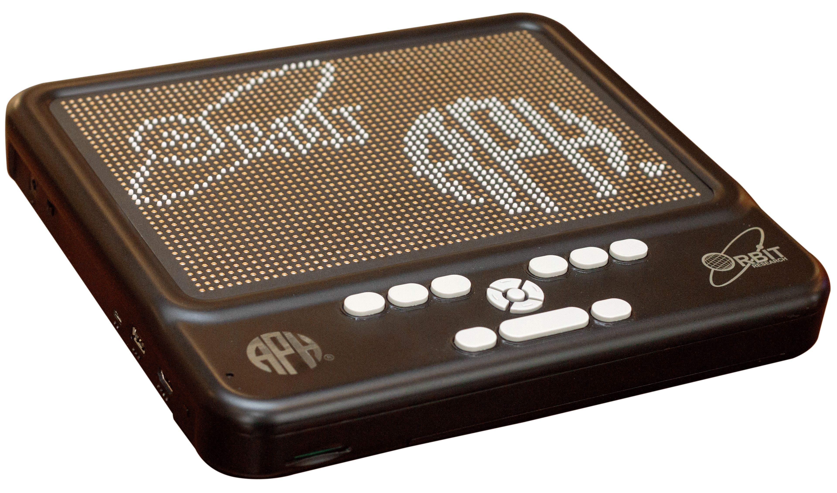

Purpose
To develop an affordable refreshable tactile graphic display that will work as a standalone unit and with a PC or other devices to display graphics on demand

Project Staff
Ken Perry, Project Leader
Jeanette Wicker, Core Curriculum Project Leader
Larry Skutchan, Director of Technology Product Research
Heather Kennedy-MacKenzie, Technology Program Manager
Venkatesh Chari, Consultant
Robert Conaghan, Technology Project Specialist
William Freeman, Software Quality Assurance Analyst
Frank Hayden, Director of Technical and Manufacturing Research
Joseph Hodge, Software Quality Assurance Analyst
Ricky Irvine, Website and Video Designer
Stephanie Lancaster, Graphic Designer
Andrew Moulton, Manager of Technical and Manufacturing Research
Cecilia Peredo, Director of Grants
Matthew Poppe, Tactile Graphics Designer
Denise Snow Wilson, Technical Communications Specialist

Background
The need for a refreshable tactile graphic display has been known for a long time, but has recently become critical as trends in the distribution of educational and testing materials are changing. While there are products that provide a proven solution, the inherently expensive nature of the piezoelectric actuator technology utilized leads to un-affordably high costs and consequently low adoption rates.

Past attempts to develop technically and commercially viable alternatives to piezoelectric actuator technologies have met with very limited success. While new technologies utilizing exotic materials and experimental fabrication methods hold promise, the investments involved remain prohibitively high and, as a result, the timeline to realize a mass-producible product is a long one.

In FY 2016, a product submission by Larry Skutchan was approved by the Product Evaluation Team and the Product Advisory and Review Committee

APH worked with Orbit Research to develop a contract for the development of the Refreshable Tactile Graphic Display through the winter of 2016. Orbit Research has extensive experience in the development and manufacture of products for the blind and has developed and demonstrated the essential technologies required for this product. A contract was signed by Orbit and APH in March 2016.

APH developed hardware and software specifications for the display. Orbit Research began work to develop and manufacture a low-cost refreshable tactile graphic display by utilizing conventional technologies, Commercially available Off-The-Shelf (COTS) materials and components, and proven mass-production methods.

The first prototype of Graphiti™ was presented to APH in April 2016. The first prototype was an array of 6 x 4 pins. The primary goal of Proto 1 was to develop and evaluate the motor design, the Force Limiter (springs), and the performance, reliability, and durability of the system design.

The second prototype, delivered in July 2016, was an array of 30 x 20 pins. It utilized the finalized design of the elements of Proto 1. The display connected to a PC and displayed graphics from an image library through software loaded on the PC. APH announced the development and exhibited the Graphiti™ prototype at AER International in July 2016.

The Director of Grants, Cecilia Peredo, procured a grant for $200,000 from the William Wood Foundation to provide the prototypes for expert review and field evaluation by teachers and students.

In FY 2017, Orbit Research delivered five Graphiti™ Proto 3 units in the spring. These units were a 30 x 20 array of pins but featured a “touch” interface that allowed the end user to “draw” on the display. APH began the first phase of evaluation with an expert reviewer in December 2016 using the first Proto 3. APH expanded the evaluation in the spring of 2017 to include three additional experts in the field of assistive technology and/or tactile graphics who provided input; this input was used to refine software and hardware for the full size units. APH and Orbit Research began the development of support for the interface of the Orion TI-84 Talking Graphing Calculator with the Graphiti™.

Orbit Research began delivering Graphiti™ Proto 4 units in June 2017. These are full size units of the Graphiti ™ with a 60 x 40 array of pins and feature the touch interface. APH began the expert review of these full size units.

Staff from APH presented or exhibited the Graphiti™ at several conferences including CSUN, California; Island Conference, Indiana; Sight City, Germany; Gateways, Kentucky; National Federation of the Blind (NFB), Florida; and American Council for the Blind (ACB), Nevada. A Proto Unit 3 was displayed at the Kennedy Center in Washington, D.C.

Work during FY 2018
APH expanded the expert review and began field testing full-size displays of the Graphiti™ with a 60 x 40 array of pins and featuring the touch interface with teachers and students. The sites included national testing companies, professors in teacher preparation programs, software developers, experts in the field of tactile graphics, and teachers of the visually impaired (TVI) working with students. APH also began receiving units from Orbit Research with HDMI. This advancement allowed users to connect the Graphiti™ to any device with HDMI output. APH and Orbit Research finalized the Graphiti™ form factor.

Staff at APH developed a Student Training Guide for TVIs that included a manual, a set of 78 digital tactile graphics, and six hard-copy tactile graphics. Staff from APH presented or exhibited the Graphiti™ at several conferences including California State University, Northridge Center on Disabilities (CSUN), California; Island Conference, Indiana; Sight City, Germany; Gateways, Kentucky; National Federation of the Blind (NFB), Florida; American Council for the Blind (ACB), Missouri; Getting in Touch with Literacy, Louisiana; Idea Festival, Kentucky; California Transcribers and Educators for the Blind and Visually Impaired (CTEBVI), California; and AER International, Nevada.

Work planned FY 2019
APH will expand field testing to 34 sites, continue developing and finalize the software, continue to display and provide workshops and training on the Graphiti™, and prepare for production based on the feedback from expert reviewers and teachers in the field.

Math Flash [Modernization]
(Completed)

Purpose
To provide Math Flash in a fun and compelling environment for voice-assistant devices

Project Staff
Laura Zierer, Project Leader
Corey Knapp, Developer
William Freeman, Quality Assurance Analyst
Joseph Hodge, Quality Assurance Analyst
Frank Hayden, Director of Technical & Manufacturing Research
Heather Kennedy-MacKenzie, Technology Program Manager

Background
Math Flash is a talking software program that currently runs under Windows®. Professionally narrated digitized speech presents math problems in a flash card format and responds with fun positive and negative feedback. The program lets the teacher specify the kinds of math problems to use and the ranges of the numbers. It allows the use of the four basic arithmetic functions in any combination.

Math Flash received Quota approval from the Educational Products Advisory Committee and became available from APH in the spring of 2000. It has been a tremendous success and captures the attention of children and adults alike, both sighted and visually impaired.

This modernization of Math Flash will develop an Amazon® skill and a Google™ action that will be accessed through the Google Assistant™ and Amazon Alexa®.

Staff began exploring the use of voice assistant devices in FY 2017. It was decided to develop an extension of a current product to demonstrate the usefulness of these delivery methods. Math Flash was selected based on its popularity, simplicity, and developer access to human-narrated audio files. The initial goal for voice-assistant exploration was to identify how APH could utilize new technologies and how professionals in the field would benefit from this work.

During FY 2017, Knapp continued development of the Math Flash action for Google™. Freeman and Hodge reviewed the functionality of the action and identified bugs. Once finalized, Knapp submitted the code to Google™ developers for approval. Math Flash was approved by Google™ in September 2017, and fully deployed shortly after.

Work during FY 2018
Zierer, Knapp, and other APH staff members presented this action during a session at the 149th Annual Meeting in October 2017. This product was highly praised by attendees, and it was decided to move forward with coding for an Amazon® skill of Math Flash. Knapp began development for this platform with the goal of release within FY 2018. Freeman and Hodge reviewed the functionality of the skill and identified bugs. Once finalized, Knapp submitted the code to Amazon® developers for approval. Math Flash was approved and released by Amazon® in July 2018.

Math Flash Online [Modernization]
(Continued)

Purpose
To develop an accessible software program that provides math drill and practice in a flash card format. This is a modernization of an existing product.

Project Staff
John Hedges, Project Leader/Programmer
Robert Conaghan, Technology Product Specialist
Denise Snow Wilson, Technical Communications Specialist
Joseph Hodge, Quality Assurance Analyst
Background
Math Flash is a talking software program that currently runs under Windows®. Professionally narrated digitized speech present math problems in a flash card format and respond with fun positive and negative feedback. The program lets the teacher specify the kinds of math problems to use and the ranges of the numbers. It allows the use of the four basic arithmetic functions in any combination, as well as the use of positive and negative numbers. The teacher can also allow division with or without remainders. Math Flash generates the problems randomly, or the teacher can use specific problems and save the preferences to disk.

The program offers three main modes of presentation. Drill mode allows the student to practice problems and offers feedback after each answer is entered. Test mode presents the problems, but does not give feedback on the results until all problems have been completed. Auto mode presents problems, pauses for a group of students to shout out an answer, and then gives the correct answer and moves on to the next problem.

Math Flash received Quota approval from the Educational Products Advisory Committee and became available from APH in the spring of 2000. It has been a tremendous success and captures the attention of children and adults alike, both sighted and visually impaired.

The modernization of Math Flash will develop an online version with similar features that operates in a browser on multiple platforms.

Work during FY 2018
Staff added the features to the initial online version and conducted field testing.

Work planned for FY 2019
Staff plan to continue to conduct field testing. Staff also plan to make enhancements to the product based on the feedback obtained through filed testing and make it available.

Monitoring Technological Developments and Educational Applications
(Continued)

Purpose
To identify and develop technological solutions that support educational needs; to monitor technological developments and educational applications of technology; to provide support to the other project leaders in the Education Research Department; to provide support to the Production area for various braille and Digital Talking Book production issues; to disseminate information on current uses of assistive technology

Project Staff
Larry Skutchan, Director of Technology Product Research
Heather MacKenzie, Program Manager, Technology Product Research
Rob Meredith, Programmer
John Hedges, Programmer
Keith Creasy, Programmer
Mike McDonald, Programmer
Rezylle Millalos, Programmer
Ken Perry, Programmer
Mark Klarer, Programmer
Corey Knapp, Programmer
Lawrence Lovelace, Programmer
Leon Blakey, Programmer
Rebecca Luttmer, Programmer
Michael Gray, Programmer
William Tribbey, Programmer
Lavis Valdas, Programmer
Haden Pike, Programmer
Joe Wegner, Programmer
John Karr, Programmer
Robert Conaghan, Technology Product Specialist
Denise Snow Wilson, Technical Communications Specialist
William Freeman, Quality Assurance Analyst
Joseph Hodges, Quality Assurance Analyst
Jeremiah Rose, Digital Maps Coordinator
Lemuel Mason, Technical Assistant
Mark Rohret, Technical Assistant
Michael Whapples, Consultant
Rene Meza, Consultant

Background
The rapid advances in use and development of software, hardware, accessibility, and educational theories require significant attention. The Technology Product Research (TPR) Department monitors and participates in numerous activities to keep abreast of developing trends and current implementations and encourages trends, policies, and standards that use technology to promote APH's mission. These ongoing endeavors help keep APH personnel knowledgeable and influential in the areas of regular and assistive technology.

TPR staff stays informed through participation in numerous electronic mailing lists that focus on programming and accessibility issues. The group actively uses and beta tests pre-releases of operating system code, key applications, accessibility APIs, screen enlargement, and speech or braille output accessibility aids. The group attends conferences, presents products and activities, and demonstrates APH products related to technology.

The TPR Department creates software for both internal research and use as direct products, applies expertise to help make APH effective and accessible in its production of braille and large print and its application of new and emerging technologies to these processes, and disseminates information to APH and directly to users. The group promotes accessibility within APH by establishing techniques that make the entire company accessible.

TPR staff regularly works with other project leaders to suggest and implement technologies for projects that have technological components in specific areas of interest. Such projects include a Web-based early trade book learning and management system for braille readers (see report for Early Braille Trade Books), an orientation and mobility instructor tool to help disseminate useful information to a client's parents, an interactive EPUB® for CVI, and a Web-based manual for wheelchair users that includes both video description and accessible captioning.

Work during FY 2018
- Staff began creating skills for voice assistants (such as Amazon Echo® and Google Home™ smart speakers.) Staff continued to enhance several Web-based applications including some that define techniques for accessible closed captioning.
- Staff continued work with the hardware and firmware for the Braille Buzz project.
- TPR continued to participate in beta testing, monitor electronic mailing lists, attend conferences, collaborate with other developers, and disseminate information.
- Staff provided advice and expertise at Product Advisory and Review Committee meetings, evaluated products submitted to APH for possible production or sale, helped ensure the accessibility of the APH website and online ordering systems, and participated in modernizing APH's recording studios.
- Staff regularly provided advice and technical assistance to APH's Business Contract Department and meets with staff from Customer Relations and Field Services to familiarize them with new products as they near their introduction date. Staff regularly consulted and assisted with technical or information requests via phone and e-mail.
- Staff worked with the Computer Training Services on issues such as telephone systems and accessibility.
- Staff continued investigation into 3-D haptic feedback controllers as a method of providing tactile graphics or mapping information and actively monitored the development of 3-D printing devices.
- Staff created a 3-D printable slate.
- Staff provided support and markup services to other project leaders so that all product documentation is accessible in electronic format.
- Staff worked with project leaders to find methods to display rich media with accessible subtitles.
- Staff implemented and continues to refine a request tracking system and project management system for both software and hardware projects.
- Staff continued with the BrailleBlaster project and made major advancements to that project (see brailleblaster.org).
- Staff performed the executive functions of the Transforming Braille Group with the project to identify and execute a disruptive technology to reduce dramatically the cost of refreshable braille displays (see Orbit Reader 20).
- Staff began working with hands-on educational STEM content to find ways to make mainstream components accessible.
- Staff continued consulting with project leaders on numerous software projects.
- Staff created a feasible indoor orientation and way finding solution.

Work planned for FY 2019
The TPR Department will increase its involvement in the following:
- Digital document access
- Web app and streaming technology
- Rich media content distribution and accessibility
- Universal design concepts and alternative user interfaces
- Critical accessibility assurance of system components and emerging systems
- Information dissemination and advisement to government, manufacturers, and consumers about accessibility issues
- Develop high-quality, educationally-sound software and hardware solutions for students and adults who are blind and visually impaired
- Advance the accessibility of Web applications
- Continue to pursue ways of applying technology to the production of tactile graphics, help educate other project leaders, and look for ways to use technological solutions to further APH's mission
- Pursue funding for special projects and experiment with emerging technologies
- Continue to expand the APH network site license
- Continue to make high-interest demonstrations, trainings, and presentations
- Continue to advance the BrailleBlaster project
- Continue development of the Transforming Braille Display (now Orbit Reader 20)
- Continue working toward partnering with commercial companies to make hands-on educational STEM learning materials accessible
- Continue development on Graphiti™ tactile graphics display and research developments in ways to deliver interactive tactile graphics, including as part of electronic braille textbooks

Nearby Explorer
(Continued)

Purpose
To improve orientation and mobility for blind users by providing contextual location based queues about configuration and proximity on common devices

Project Staff
Rob Meredith, Project Leader
Keith Creasy, Indoor Project Leader
Mark Klarer, Programmer
Joe Wegner, Programmer
John Karr, Programmer
Laurence Lovelace, Programmer
Ken Perry, Programmer
Jeremiah Rose, Digital Maps Coordinator
Robert Conaghan, Technology Product Specialist
Denise Snow Wilson, Technical Communications Specialist
William Freeman, Quality Assurance Analyst
Joseph Hodge, Quality Assurance Analyst
Tim Allen, Consultant
Michael Borsuk, Programmer

Background
The Nearby Explorer app began as a tool for the Braille Plus 18 Android™ braille smart phone/tablet and was offered to Android™ smartphone and tablet users through the Google Play™ Store in 2013.

Providing unique feedback via speech synthesis and braille along with the ability to point the device to find objects in the environment, this GPS tool gives blind users an interface that provides the information necessary to navigate successfully through both familiar and new areas with confidence.

The original goals of the project were the following:
- Provide location based information in outdoor spaces
- Share points of interest with other users
- Provide information about indoor spaces

The first two goals were successfully completed early in the project. While the third goal continues to evolve, solid progress was made during this fiscal year.

In 2014, a blind pedestrian submitted a product suggestion through the APH Web interface to bring a similar tool to the iOS® platform.

In 2015, APH released a free, world-wide version of the app for the Android™ platform that does not use proprietary map data. Although it has not been translated into additional languages and requires a network connection for use, it has over 4,300 downloads.

In 2016, APH released a version of the app for the iOS® platform.

In FY 2017, APH continued to receive constructive feedback from users. Many features were added to the iOS® version, including an onboard map update, support for contacts, and an initial implementation of indoor support. Four updates were issued for the iOS® version, while one update was issued for the Android™ version.

Indoor Lead, Keith Creasy, began work on a plan to implement the results of research conducted by consultant Tim Allen and other staff toward a solution that brings the feedback currently provided for outdoor spaces to GPS-denied areas such as indoors.
The plan combines locating beacons at exact positions and using multiple beacons to triangulate an accurate position and then to use the position with regular point-of-interest objects.

Android™ Lead, Ken Perry, completed support for the Fused API in the full version of the app, and began porting the source code for the free version to modern development tools.

OSM Specialist, Mark Klarer, implemented a plan to use OpenStreetMap.org map data in the iOS® version. Data from OpenStreetMap® are converted to a special format for efficient access by Nearby Explorer, and stored locally on the device. Five U.S. states from OpenStreetMap® are available for use in the app at the time of this writing.

Technology Specialist, Robert Conaghan, continued to maintain the transit databases used by the program. Over 100 metropolitan areas are now supported by the Transit feature.

Work during FY 2018
APH continued to receive constructive feedback from users. Many features were added to the iOS® version, including a sophisticated OpenStreetMap® updater, OpenStreetMap® support for all 50 states, and an enhanced map view with live updates as one moves.

The Android™ version was updated to look and perform more like the iOS® version, including the addition of Indoor Explorer support, convenience buttons for common functions, and OpenStreetMap® support.

Technology Specialist, Robert Conaghan, continued to maintain the transit databases used by the program. Over 100 metropolitan areas are now supported by the Transit feature.

Indoor Lead, Keith Creasy, continued work on a plan to implement the results of research conducted by consultant Tim Allen and other staff toward a solution that brings the feedback currently provided for outdoor spaces to GPS-denied areas such as indoor spaces. The plan combines locating beacons at exact positions and using multiple beacons to triangulate an accurate position, and then to use the position with regular point-of-interest objects.

To date, the following sites have been quipped and mapped to support the indoor features of Nearby Explorer. Links take you to the OpenLevelUp building maps.

Kentucky:
- 21C Museum Hotel
700 W. Main St., Louisville 40202
- Actors Theatre of Louisville
316 W. Main St., Louisville 40202
- American Printing House for the Blind
1839 Frankfort Ave., Louisville 40206
- Crescent Hill Branch, Louisville Free Public Library
2762 Frankfort Ave., Louisville 40206
- Frazier History Museum
829 W. Main St., Louisville 40202
- Hyatt Regency Louisville
311 S. 4th St., Louisville 40202
- Center for the Arts
501 W. Main St., Louisville 40202
- Louisville Science Center
727 W. Main St., Louisville 40202
- LouieLab and C/NET Smart Apartment
745 W. Main St., Louisville 40202
- Louisville International Airport (SDF)
600 Terminal Dr., Louisville 40209
- McDowell Center
8412 Westport Rd., Louisville 40242
- Muhammad Ali Center
144 N. 6th St., Louisville 40202
- Visually Impaired Preschool Services (VIPS)
1906 Goldsmith Lane, Louisville 40218

Oregon:
- Portland State University Millar Library 1F
1875 SW Park Ave., Portland 97201

Texas:
- Region IV Education Service Center
7145 Tidwell Rd., Houston 77092

Work planned for FY 2019
While Nearby Explorer is a mature and stable app, many of its existing building blocks are in jeopardy. Costs for both onboard and online map data are increasing substantially at the time of this writing, and revenue from the app cannot possibly cover the new costs. While OpenStreetMap® is free for all to use, much of its data are lacking compared to data from commercial services. APH will work to negotiate agreements with existing data providers, or find new lower cost providers, which can continue to provide data needed for the apps functionality. APH will also attempt to engage individuals to help with adding data to OpenStreetMap®, making this new data free for all to use.

Staff will work to complete the following:
- Improve both Android™ and iOS® versions as strategically necessary
- Refine indoor capabilities
- Provide documentation for venues detailing how to mark indoor spaces for use with the app
- Add more regions to OpenStreetMap® data
- Work to improve OpenStreetMap®
- Localize the app for many common foreign languages

Orbit Reader 20™
Formerly Transforming Braille Display
(Continued)

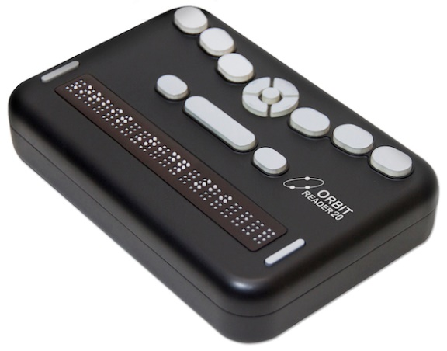

Purpose
To develop a low cost refreshable braille display

Project Staff
Ken Perry, Project Leader
Jeanette Wicker, Core Curriculum Project Leader
Larry Skutchan, CEO, TBG LCC and Director of Technology Product Research at APH
Heather Kennedy-MacKenzie, Technology Program Manager
Venkatesh Chari, Consultant
Stuart Baskett, Quality Control Clerk
Robert Conaghan, Technology Project Specialist
William Freeman, Software Quality Assurance Analyst
Frank Hayden, Director of Technical & Manufacturing Research
Joseph Hodge, Software Quality Assurance Analyst
Ricky Irvine, Website and Video Designer
Stephanie Lancaster, Graphic Designer
Andrew Moulton, Manager of Technical & Manufacturing Research
Bryan Rogers, Manufacturing Specialist
Rachel Bishop, Research Assistant
Denise Snow Wilson, Technical Communications Specialist

Special Recognition
Kevin Cary, President, Transforming Braille Group (TBG) LLC
Luiza Aguiar, Perkins School for the Blind
Neil Jarvis, Blind Foundation, New Zealand
Clara Van Gerven, National Federation of the Blind

Managing Members of the TBG LLC
Association Valentin Haüy (AVH) in France
American Printing House for the Blind (APH) in the USA
Blind Foundation (formerly RNZFB) in New Zealand
National Federation of the Blind (NFB) in the USA
Norwegian Association of the Blind and Partially Sighted (NABP) in Norway
Perkins School for the Blind in the USA
Royal National Institute of Blind People (RNIB) in the United Kingdom
Sight Savers in India
Vision Australia in Australia

Advisory Board for the TBG LLC
CNIB (Canada)
CBM
Celia Library in Finland
The International Council on English Braille (ICEB)
National Library Service of the Library of Congress (NLS) in the USA
Sense International
Spanish National Organization of the Blind (ONCE) in Spain
World Braille Council (WBC)

Background
The Transforming Braille Group (TBG), an international collaboration of blindness organizations, works to increase literacy among blind people by dramatically lowering the cost to participate in the information revolution.

The prohibitive cost of refreshable braille displays limits many braille readers to a hard copy reading experience only. Refreshable displays are generally attainable only in the most prosperous countries, often supplied by government programs for education and employment. The market for a new device produced with a substantially less expensive technology consists almost entirely of readers who do not have access to the current displays. The TBG project is not meant to compete with the sophisticated multi-feature products now available, rather it is intended to bridge the gap between the abundance of accessible text files and the blind readers worldwide who have no tactile means of accessing them.

The objective of the TBG is to identify and implement a breakthrough solution that will radically reduce the cost of refreshable braille technology so that it both comes within the reach of blind people in developing countries and also allows braille libraries everywhere to give readers the choice of inexpensive electronic text files in addition to expensive hard copy braille.

The high cost of refreshable braille has remained constant for over 30 years. Recognizing this fact, in 2012, TBG resolved to disrupt the market by developing a technique to produce comparable refreshable braille at one-fifth the cost of units currently on the market.

By the middle of 2012, TBG had ranked all the existing projects and determined the top two choices. The group analyzed 63 projects for feasibility, likelihood, and maturation rate. This was a snapshot of activity at the time, and projects continue to develop. Some of the technologies hold significance, but maturation is too far away. Some cannot be mass-produced, others are too expensive, and others are great ideas, but not feasible.

On August 6, 2014, Orbit Research LLC and the Transforming Braille Group LLC announced an agreement to produce a low cost refreshable braille display. Orbit, an international engineering company based in Wilmington, Delaware, specializes in high quality, low cost products for blind and partially sighted people, is undertaking the research, development, and manufacture of this unique product.

Orbit Research provided multiple designs for review by members of the group. Most of the initial designs focused on form factor and key layout. There were eight different key layouts. Members met four times to evaluate the form factor and provided feedback about size and layout.

Representatives from APH, Perkins (Luiza Aguiar), NFB (Clara Van Gerven), and RNIB (Neil Jarvis) began bi-weekly phone conferences in August 2015 and continued through March 2016. Members of the group developed five different surveys to be used during field evaluation. APH, Perkins, NFB, and RNIB conducted the field evaluation of the Transforming Braille Display.

The five surveys included:
- Short Survey – to be used at conferences and presentations (Both USA and International)
- International Survey
- Adult Users (USA)
- Experts in the Field of Education and/or the Field of Blindness and/or Accessible Technology (USA)
- Teachers with Students (USA)

Also, during the meetings group members were advised of revisions and updates to the hardware and software, issues and concerns with the units, and members shared their progress with field evaluations.

An electronic mailing list was developed for all participants in the field evaluation so that questions and concerns could be addressed quickly during the evaluation period.

In October 2015, the APH News posted a call for field evaluators. Contact information for Perkins and NFB was included in the announcement and noted the different target audience of the three agencies. APH received 48 responses and chose 16 sites including three expert reviewers and 14 teachers at 13 sites. Field evaluators were chosen based on geographic distribution, age of students, the type of agency, and the expertise of the evaluator.

The Transforming Braille Group received a total of 103 evaluations.
- Short Survey – 40 responses
- International Survey – 17 responses
- Adult User (USA) – 17
- Experts in the Field of Education and/or the Field of Blindness and/or Accessible Technology (USA) – 15
- Teachers with Students (USA) – 14

The Transforming Braille Device was evaluated in the following locations:
- Australia - Melbourne, Victoria, Sydney, and New South Wales
- Canada – Alberta, British Columbia, New Brunswick, Nova Scotia, Ontario, Vancouver, and Quebec
- New Zealand – Auckland and Wellington
- United States – Washington D.C. and 20 states including Alabama, California, Colorado, Florida, Georgia, Illinois, Kentucky, Louisiana, Maryland, New York, Massachusetts, Michigan, Minnesota, Missouri, Montana, South Carolina, Virginia, West Virginia, and Washington

Field Evaluators
The field evaluators had a wide range of expertise.
Field Evaluators
 | Adult Braille User | Technology Instructor | Teacher of the Visually Impaired | Student/  Graduate Student | Professor
Short Evaluation | 31 |  | 9
International | 15 |  | 1 | 1
Adult User | 17
Expert | 4 | 3 | 5 | 1 | 2
Teacher with Students |  |  | 14
Total | 67 | 3 | 29 | 2 | 2

Neither the Short Survey nor the International Survey asked for Years of Experience.

Years of Experience were reported by Adult Users (reading braille), the Teachers with Students, and Experts in the Field of Education and/or the Field of Blindness and/or Accessible Technology.

Years of Experience
 | 0-5 yrs | 6-10 yrs | 11-15 yrs | 16-20 yrs | 21+ yrs
Adult User | 0 | 1 | 1 | 3 | 21
Expert | 1 | 1 | 3 | 0 | 10
Teacher with Students | 4 | 4 | 1 | 2 | 3
Total | 5 | 6 | 5 | 5 | 34

Neither the Short Survey nor the International Survey requested the ethnicity of the reviewer. Additionally, some reviewers declined to list their ethnicity.

Ethnicity
 | Hispanic | Amer. Indian | Black or African American | Asian | White | Two or more races
Adult User | 1 | 0 | 0 | 1 | 12 | 2
Expert | 0 | 0 | 0 | 1 | 14 | 0
Teacher with Students | 2 | 0 | 1 | 0 | 10 | 1
Total | 3 | 0 | 1 | 2 | 36 | 2

Neither the Short Survey nor the International Survey asked whether the evaluator had used a refreshable braille display prior to the use of the Orbit Reader 20.

Have you used a Refreshable Braille Display before? | Yes | No
Adult User | 16 | 1
Expert | 13 | 2
Teacher with Students | 13 | 1
Total | 42 | 4

Students
Nineteen students used the Orbit Reader 20 and ranged in ages from 5-18. One student was 5, one student was 7, one student was 9, one student was 10, three students were 12, three students were 13, three students were 14, two students were 16, one student was 17, and two students were 18 years old. One student’s age was not reported.

Students were enrolled in classes from Pre–K through 12th grade. One student was enrolled in Pre-K, one student was enrolled in second grade, two students were enrolled in third grade, one student was enrolled in fourth grade, three students were enrolled in sixth grade, three students were enrolled in seventh grade, two students were enrolled in eighth grade, one student was enrolled in ninth grade, one student was enrolled in 10th grade, two students were enrolled in 11th grade, and two students were enrolled in 12th grade.

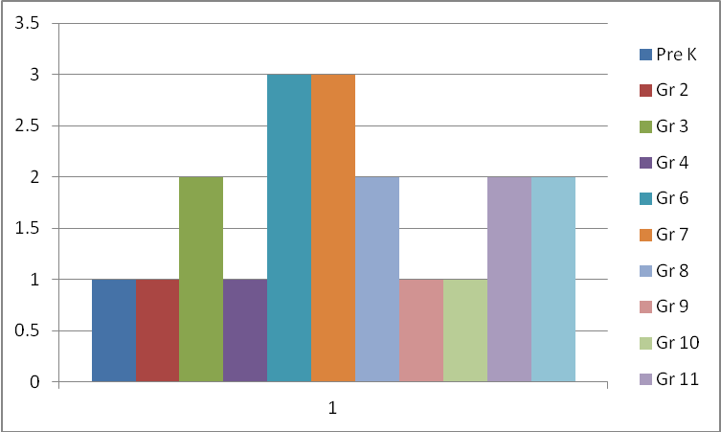

Six students were males, and 13 students were female. Fourteen students had no other disabilities/conditions that might impact braille reading skills, and five had additional disabilities/conditions that might impact their braille reading skills.

Thirteen students had a reading medium of braille, four students use a combination of print and braille, and two students use electronic braille.

Five students were enrolled in a residential setting, 12 students were enrolled in a mainstream classroom, one student received services in a resource room, and one student was enrolled in a special day class.

Ten students were reported as white, three were reported as Black or African American, two were reported as Hispanic, two were reported as Asian, one was reported as one or more race, and the race of one student was not reported.

Six students were reported to have beginning level braille skills, three were reported to have intermediate level braille skills, and 10 were reported to have advanced level braille skills. All students used braille on a regular (weekly) basis. Sixteen of the students had used a braille display before the field test, and three had never used a braille display.

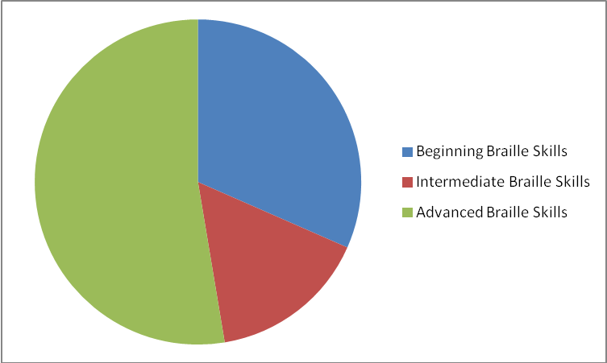

Seven of the students reported difficulties using the Transforming Braille Display, and 12 reported that they had no problem using the device. Of those reporting problems, five reported problems pairing the TBD with another device, one reported that the unit froze occasionally, one reported noise of the pins as an issue, and one student had difficulty finding and opening a document.

After instruction, 18 of the students were able to read independently using the TBD. The teacher of the Pre-K student noted, “She is not ready to be independent with any braille display. Her hands are not big enough or her fingers are not strong enough or coordinated enough to advance or go back without taking her hands off the pegs. She was not far from being independent with this display.”

Evaluations
Evaluators were asked to evaluate the mechanical design as well as the software and applications. The short survey only asked eight questions, and thus their responses are reflected in only a few of the questions.

It should be noted that all units were hand built and have some inherent differences. One unit was returned to Orbit for repair as the battery/charging circuitry had to be replaced.

The cells are spaced properly for easy reading.
 | Strongly Agree | Agree | Disagree | Strongly Disagree
Adult User | 10 | 7 | 0 | 0
Expert Reviewer | 10 | 5 | 0 | 0
Teacher with Students | 10 | 4 | 0 | 0
International | 12 | 5 | 0 | 0
Total/Percent | 42/67% | 21/33% | 0/0% | 0/0%

The dot height and spacing are suitable for easy reading.
 | Strongly Agree | Agree | Disagree | Strongly Disagree
Adult User | 12 | 5 | 0 | 0
Expert Reviewer | 10 | 3 | 0 | 2
Teacher with Students | 9 | 5 | 0 | 0
International | 10 | 7 | 0 | 0
Total/Percent | 41/65% | 20/32% | 0/0% | 2/3%

The refresh rate (the speed at which the pins change) is suitable
for efficient reading.
 | Strongly Agree | Agree | Disagree | Strongly Disagree
Adult User | 6 | 8 | 3 | 0
Expert Reviewer | 3 | 7 | 2 | 3
Teacher with Students | 4 | 8 | 2 | 0
International | 1 | 14 | 2 | 1
Short Survey | 9 | 21 | 8 | 2
Total/Percent | 23/22% | 57/55% | 17/17% | 6/6%

The position of the controls, keys (position and feel),
and braille display is suitable for comfortable reading.
 | Strongly Agree | Agree | Disagree | Strongly Disagree
Adult User | 5 | 8 | 4 | 0
Expert Reviewer | 5 | 6 | 3 | 1
Teacher with Students | 5 | 7 | 2 | 0
International | 4 | 9 | 4 | 0
Short Survey | 10 | 21 | 8 | 1
Total/Percent | 29/28% | 51/50% | 21/20% | 2/2%

The operation of the device was easy to understand.
 | Strongly Agree | Agree | Disagree | Strongly Disagree
Adult User | 6 | 9 | 2 | 0
Expert Reviewer | 5 | 9 | 1 | 0
Teacher with Students | 5 | 8 | 1 | 0
International | 9 | 8 | 0 | 0
Total/Percent | 25/40% | 34/54% | 4/6% | 0/0%

It was easy to recharge the device.
 | Strongly Agree | Agree | Disagree | Strongly Disagree | Did Not Attempt
Adult User | 9 | 5 | 2 | 0 | 1
Expert Reviewer | 9 | 5 | 0 | 0 | 1
Teacher with Students | 9 | 4 | 1 | 0 | 0
International | 7 | 4 | 0 | 0 | 8
Total/Percent | 34/54% | 18/29% | 3/5% | 0/0% | 8/12%

It was easy to determine the battery level.
 | Strongly Agree | Agree | Disagree | Strongly Disagree | Did Not Attempt
Adult User | 5 | 6 | 3 | 0 | 3
Expert Reviewer | 7 | 7 | 0 | 0 | 1
Teacher with Students | 9 | 3 | 1 | 0 | 1
International | 6 | 4 | 3 | 0 | 4
Total/Percent | 27/43% | 20/32% | 7/11% | 0/0% | 9/14%

How would you rate the battery life?
 | Very Good | Good | Adequate | Needs Improvement | N/A
Adult User | 8 | 4 | 0 | 3 | 2
Expert Reviewer | 8 | 3 | 1 | 0 | 3
Teacher with Students | 6 | 3 | 1 | 2 | 2
International | 5 | 4 | 3 | 0 | 5
Total/Percent | 27/43% | 14/22% | 5/8% | 5/8% | 12/19%

It was easy to find titles on the SD card.
 | Strongly Agree | Agree | Disagree | Strongly Disagree
Adult User | 8 | 9 | 0 | 0
Expert Reviewer | 9 | 5 | 1 | 0
Teacher with Students | 7 | 7 | 0 | 0
International | 9 | 6 | 1 | 0
Short Survey | 12 | 24 | 0 | 4
Total/Percent | 45/44% | 51/50% | 2/2% | 4/4%

It was easy to open a title saved on the SD card.
 | Strongly Agree | Agree | Disagree | Strongly Disagree
Adult User | 10 | 7 | 0 | 0
Expert Reviewer | 9 | 6 | 0 | 0
Teacher with Students | 10 | 3 | 1 | 0
International | 8 | 8 | 0 | 0
Total/Percent | 37/59% | 24/39% | 1/2% | 0/0%

It was easy to transfer a file from a computer.
 | Strongly Agree | Agree | Disagree | Strongly Disagree | Did Not Attempt
Adult User | 1 | 5 | 1 | 0 | 10
Expert Reviewer | 3 | 2 | 0 | 1 | 9
Teacher with Students | 6 | 3 | 2 | 0 | 3
International | 3 | 4 | 1 | 0 | 8
Total/Percent | 13/21% | 14/23% | 4/6% | 1/2% | 30/48%

It was easy to connect the TBD to a smart phone or tablet.
 | Strongly Agree | Agree | Disagree | Strongly Disagree | Did Not Attempt
Adult User | 2 | 7 | 2 | 3 | 4
Expert Reviewer | 2 | 4 | 1 | 1 | 5
Teacher with Students | 4 | 5 | 2 | 2 | 1
International | 3 | 5 | 4 | 0 | 4
Total/Percent | 11/18% | 21/35% | 9/15% | 5/8% | 14/23%

What do you consider the most important benefits of the TBD? (This was an open ended question. Responses from all five surveys have been combined.)
- Price – 36
- Portability – 17
- Good braille – 13
- Increased access to braille – 13
- Easy to use – 13
- Pairs with other devices – 12
- Size – 11
- Capable of holding many files – 6
- Battery – 2

Please list the major areas of difficulty or areas of needed improvement for the TBD. (This was an open ended question. Responses from all five surveys have been combined.)
- Bluetooth® connection/pairing devices – 14
- Noisy – 11
- Clunky keys/sticky keys – 10
- Keyboard layout and spacing between keys/too tight – 8
- Need note-taking ability – 6
- Need cursor routing keys – 6
- Refresh rate – 5
- Battery life – 4
- SD card slot not properly oriented – 3
- Needs a case – 3
- Needs “Find” command – 3

Expert reviewers and Teachers with Students were asked an additional question.

The TBD is appropriate for: (Check all that apply.)
 | Expert Reviewers | Teachers with Students
Elementary student who are braille readers | 73.33% | 100%
Braille students who are reading below grade level | 66.67% | 85.71%
Braille students who have a mild cognitive disability | 60% | 64.29%
Middle School students who are braille readers | 66.67% | 100%
High School students who are braille readers | 66.67% | 92.86%
Adult braille readers | 73.33% | 85.71%
School libraries that provide braille materials for patrons | 80% | 92.86%
Home settings – Parents and young students | 60% | 85.71%
Other – please list | 40%  Rehab agencies  Professionals  Patrons of NLS and Bookshare  TVIs | 21%  Newly blind  TVIs  DSS offices

Overall, how would you rate the TBD?
 | Good | Adequate | Needs Improvement
Adult User | 9 | 5 | 2
Expert Reviewer | 6 | 4 | 5
Teacher with Students | 7 | 5 | 2
International | 12 | 2 | 2
Total/Percent | 34/56% | 16/26% | 11/18%

Final Recommendations

Would you purchase or recommend the TBD for purchase by a braille reader?
 | Yes | Maybe | No
Adult User | 9 | 6 | 1
Expert Reviewer | 7 | 4 | 4
Teacher with Students | 11 | 3 | 0
International | 11 | 4 | 1
Short Survey | 21 | 17 | 2
Total/Percent | 59/58% | 34/34% | 8/8%

Evaluator Comments
Evaluators were asked to include any general comments.
- “The future is NOW. I love this device and just hope the cost delivers on the promise.”
- “The TBD has the potential to become a very useful device, which would be helpful to Braille readers of all ages in many settings.”
- “Looking forward to when the TBD becomes available.”
- “I personally think this is going to be a great addition for the braille students. My student loved it. It was easy for her to use and easy for her to move around.”
- “I really like it! Please let me know when it is available for purchase.”
- “Excellent, and this is just the Beta version.”
- “I can’t wait to get one for myself. I expect that it will be the primary way I read braille.”

Changes/upgrades made based on field evaluations and comments during field evaluation
- During the field test, hardware was upgraded several times. Many of these were to improve reliability. It was determined early on, for example, that the hand fabricated pins were not precise enough.
- The Power button was extended to make it easier to identify.
- The SD card orientation was slated to be changed.
- Experimented with key sound dampening and travel adjustments
- Replaced fixed pins with spring pins

Software also saw multiple iterations during field evaluation. Some of the software improvements included:
- Better screen reader support
- Enhancement of Bluetooth® communication
- Software update utility improvements
- Documentation
- Gross file movement commands added
- Enhanced refresh rate

Changes planned before release for sale
Hardware changes planned:
- Change the SD card orientation
- Change the input button mechanism type to scissor
- Change the navigation key mechanism type to dome
- Change both single pan buttons to dual rockers for more functionality
- Revise keyboard layout and spacing
- Add indent around braille pins for comfort and ease of reading
- Final positioning of tactile power button
- Add tactile indicators for USB and SD card slot
- Add entire device sound dampening
- Add rings to case enclosure to accommodate user supplied strap

Software and feature upgrades planned include:
- Basic note-taking capabilities
- Better file management commands
- Larger buffers
- Navigation compatible with traditional braille displays
- Better standby handling
- Several changes to the menus and menu user interface
- Language changing support for the user interface
- Refine Bluetooth® communication
- Improve power management
- Software enhancements to improve refresh rate
- Add “Find” command
- “Blinking” braille cell to indicate the device is “booting up”

During the field testing of the Transforming Braille Display, APH approved the development of the unit as an APH product. The Product Evaluation Team and the Product Advisory and Review Committee approved the Transforming Braille Display in January 2016. The Educational Products Advisory Committee gave Quota Approval in May 2016.

The Transforming Braille Display was announced at CSUN in March 2016, and the name was changed from the Transforming Braille Display to the Orbit Reader 20.

In FY 2017, APH staff continued the ongoing revision of the user manual, revised and updated the website, and shepherded the product through production and release for sale. APH sold a limited number of units at consumer conferences. APH continued field testing the Orbit Reader with users in the field and monitored the shipments of units for quality control, provided workshops and training sessions on the Orbit Reader 20, and continued to update the software. Working with Orbit Research, staff developed the Spanish language files to allow the Orbit Reader 20 to be used in Spanish speaking countries.

Work during FY 2018
Orbit Research and APH staff continued to update software. APH staff revised the user manual to reflect any needed changes, provided workshops and training session on the Orbit Reader 20, completed a series of four videos, and monitored the shipments of Orbit Reader 20. In February 2018, APH released the Orbit Reader for sale. On June 12, 2018, the Orbit Reader 20 was awarded the 2018 FCC Chairman's Awards for Advancement in Accessibility.

Talking Typer Web Application
(Continued)

Purpose
To provide a platform-independent Web application of Talking Typer, APH’s accessible, interactive keyboard training software

Project Staff
Robert Conaghan, Project Leader
Heather Kennedy-MacKenzie, Program Manager, Technology Product Research
Larry Skutchan, Director, Technology Product Research
Rene Meza, Consultant/Programmer
Lawrence Lovelace, Consultant
Michael McDonald, Programmer
Leon Blakey, Programmer
Denise Snow Wilson, Technical Communications Specialist
William Freeman, Quality Assurance Analyst
Joseph Hodge, Quality Assurance Analyst

Background
Talking Typer Web is a standards compliant Web application for modern browsers building on APH’s four previous Talking Typer programs: Talking Typer for Apple® II, PC Typer, Talking Typer for Windows® (v. 1.14 released FY 2013), and Talking Typer iOS® (in development). Talking Typer for Windows® is a tremendously successful program that includes features that allow users to create and modify drills and dictation exercises. It also includes features for recording, storing, and examining student records. Feedback from the field and Educational Products Advisory Committee indicated the demand for an updated online version of this program.

In FY 2015, staff completed the following:
- Researched and reviewed current online typing tutorials for accessibility and function
- Created functional specifications
- Contracted and began work with software development company, Prosoft, LLC
- Implemented letter, word, and phrase drills and the ability to add custom drills
- Began work on universal sign-in to be used for Talking Typer and future APH web applications

In FY 2016, staff completed the following:
- Added library of default letter, word, and phrase drills
- Implemented admin, teacher, and student dashboards for managing content and progress
- Implemented keyboard explorer feature to explore keyboard with speech feedback
- Finished universal sign-in as a Web service to allow for student management and lesson creation and sharing from any modern browser
- Solicited feedback through field testing 4th quarter of FY 2016

In FY 2017, staff completed the following:
- Rebuilt development environment for better maintainability and to implement unit and regression testing
- Created application backend for managing users and lessons
- Refocused lessons to reflect Web standards, removed code that targeted non-conformant platforms
- Released core functionality for beta testing 4th quarter FY 2017

Work during FY 2018
Staff completed the following:
- Moved rendering of the lessons module from client to server to improve performance
- Implemented new authentication method
- Upgraded API to Rails 5
- Upgraded dependencies to transition code to APH container environment
- Integrated all work into TPR's new CI/CD environment
- Updated design and logos to reflect new APH branding
- Beta tested and released minimum viable product

Work planned for FY 2019
Staff will complete the following:
- Field test and release user account features
- Create new default lesson content that is contemporary and engaging

Talking Word Puzzles [Modernization]
(Continued)

Purpose
To produce a Web-based educational game that uses hidden word or crossword-type puzzles with universal design concepts

Project Staff
Joe Wegner, Programmer
Haden Pike, Programmer
Rebecca Lutmer, Programmer
Joseph Hodges, Quality Assurance Analyst
Robert Conaghan, Consultant
Denise Snow Wilson, Technical Communications Specialist

Background
The need for an educational type of game like hidden word and crossword puzzles has been long expressed by customers and experts in the field. APH's Product Advisory and Review Committee supported the idea for such a project in May 1998, and the programming group began work on the program in FY 2000 and released Talking Word Puzzles shortly thereafter.

Since the release of the program, requests for additional platforms have been most prominent.

Staff began work on an HTML5- and JavaScript-based version of the app that is platform independent and uses the most modern Web accessibility guidelines and principles.

Features include an intuitive and standards based approach to working with screen readers and other assistive technology to provide text-to-speech, refreshable braille, and large print navigation system through the puzzle grid. The interface includes appropriate, responsive speech, and highlighting feedback as the student uses the shift key along with the arrow keys to mark a word in the grid and distinguishable characteristics as the student moves across words already marked.

Specifications also call for a creation process that allows the teacher to enter either a list of words or a list of words and clues to those words in the case of a crossword puzzle. This data gets committed to persistent storage and all puzzles get dynamically generated from this information.

In FY 2017, programmers are writing code to implement the specifications using Web standards, such as ARIA, so the app works with every assistive technology.

Completed areas of functionality include:
- Grid Navigation through the puzzle
- Appropriate feedback as focus moves to a square in the grid that contains a number, letter, blank space, or black space
- Hot keys to move from the clue to the appropriate place in the grid
- Loading puzzles in XWC format

Work during FY 2018
Programmers are writing code to implement the specifications using Web standards, such as ARIA, so the app works with most assistive technology.

Completed areas of functionality include:
- Grid navigation through the puzzle
- Audio feedback as focus moves to a square in the grid that contains a number, letter, blank space, or black space.
- Hot keys to move from the clue to the appropriate place in the grid
- Loading puzzles in Crosstalk for Windows® Compiled Script (XWC) format
- Show the number of letters in the answer at the end of the clue
- Audio feedback for a variety of screen readers
- Make a “bump” sound as the user “bumps into the wall” when they enter the last letter of an answer
- Require users to agree to APH privacy policy the first time they open the app
- Check for puzzle changes—if the puzzle changed, the user-saved progress will be invalid and discarded.
- Field test for computer/desktops

Work planned for FY 2019
Release of desktop version is planned for early FY 2019. Staff will continue coding, field testing, and refining the app based on field test results, and release.
Tasks remaining to complete include the following:
- Mobile views
- Release puzzle generation
- Support additional file formats
- Online publishing
- Exportable embeddable Web component
- Checking if completed puzzle is correct

UEB Math Tutorial
(Ongoing)

Purpose
To provide a device-independent method for learning the Unified English Braille (UEB) Braille Code used for mathematics that is both visually appealing and operates with refreshable braille displays for learners who are blind

Project Staff
Michael McDonald, Project Leader
Wendy Buckley, Consultant
Sandy Smith, Consultant
William Freeman, Quality Assurance Analyst
Joseph Hodge, Quality Assurance Analyst

Background
APH has developed a Web-based UEB Math Code Tutorial to assist blind students and adult learners in transitioning to the new UEB code. The tutorial is a valuable tool for students and adults as they learn to read and write braille mathematics independently or with minimal assistance from a teacher assistant or rehabilitation instructor. The UEB Math Tutorial follows the model of the successful Nemeth Code Tutorial developed by APH in 2015.

The project is funded by a grant from the William M. Wood Foundation, Bank of America, N.A., Trustee. The grant funds the content creation by Wendy Buckley and Sandy Smith, as well as the design and development of the website.

The UEB Math Tutorial consists of four sessions, which introduce the rules governing the use of UEB Math Symbols and interactive activities to practice reading, writing, and proofreading UEB math. For an optimal experience, blind learners can use the UEB Math Tutorial in conjunction with a refreshable electronic braille display—a readily available assistive-technology device that can be used to tactually read text displayed on a computer monitor. The explanatory session and three sessions on reading, writing, and proofreading are described below:

Explanatory Section
- Instructs users regarding the rules governing the use of UEB Math Symbols
- Defines UEB Math Symbols
- Provides appropriate examples to clarify UEB Math rules

Interactive Sections
Learning to Read UEB Math Symbols
- Displays UEB math expressions on a refreshable braille display for the learner to read aloud
- Allows users to compare their responses with an automated spoken expression using a simple key command

Learning to Write UEB Math Symbols
- Provides an automated spoken UEB math expression without tactually displaying it on the refreshable electronic display
- Directs the learner to write the expression in braille using the keys on the refreshable braille display
- Praises the learner when the correct response is given, and offers a humorous admonishment with encouragement for incorrect responses
- Allows learner to use edit commands to correct the error and reassess

Learning to Proofread UEB Math Symbols
- Asks learners to find the error in incorrectly written expressions on the braille display by listening to the automated correct expression
- Allows learner to use edit commands to correct the error and judge again

To expand on the tutorial and lessons, the site will contain practice lessons. The practice lessons will allow users to solve braille mathematics problems. The problems will be divided by grade level and will display problems in UEB Math. The two types of practice lessons will be direct answer and multiple choice. This will give users the chance to use the braille knowledge they have gained to practical use solving problems.

The UEB Math Tutorial is aligned with the Common Core State Standards for Mathematics by grade level and is ideal for the following:
- Middle and high school students learning UEB Math for the first time
- Middle and high school students transitioning from the former English Braille American Edition (EBAE) code to the new UEB Math code
- Secondary school students—especially those going into STEM fields (science, technology, engineering, and math)
- Preparing students to transition to post-secondary programs
- Adults who have lost their sight later in life who want to learn braille
- Teachers of the visually impaired (TVIs)

We anticipate approximately 10,000 people will access the program online to learn and practice their UEB math skills. The UEB Math Tutorial is available free: https://www.uebmath.aphtech.org

Work during FY 2018
The tutorial section of the website has been completed. The tutorial is now available for use, and all lessons and exercises are complete.

Work planned for FY 2019
The tutorial will be expanded to incorporate practice exercises giving users the chance to solve mathematical problems using braille. The problems will be broken up by grade level and contain direct-answer and multiple-choice type problems.

TECHNICAL & MANUFACTURING RESEARCH

Frank Hayden, Director

Technical & Manufacturing Research Activities
(Continued)

Purpose
Technical & Manufacturing Research (TMR) functions as a “bridge” between the concepts of the project leader’s product and the concrete reality on the production floor. This area is a concentration of specialized skill sets within the Educational Research Department. The purpose of this area is to remain as faithful as possible to the project leader’s intent and function of the product while making it as inexpensive and as easily produced on the manufacturing plant floor as possible. This area is involved in all aspects of the product including design work, materials selection, tooling development, vendor selection, and process development. While both areas are involved in process and tooling development, the model makers’ primary focus is the physical development of tooling. TMR is heavily involved in tooling, materials, and process development and research with an emphasis on the documentation of product specifications and manufacturing processes. After developing and documenting product specifications, TMR works with production workers, floor supervisors, upper levels of APH management, and outside vendors to shepherd the project leader’s product throughout its entire pilot and first production runs.
Some of the contributions that TMR makes to product development on a regular basis include the following:
- Development of conceptual drawings and the construction of prototypes for field testing purposes
- CAD (computer aided drafting) layout and design of injection molds, cutting dies, and some product artwork
- Development of 3D CAD files for rapid prototyping of products for hands-on evaluation of a concept when appropriate
- Creation of an in-house 3D printing station for rapid prototyping of products, reducing the need for outside rendering of 3D CAD files
- Development of CAD files and fixtures for in-house machining of parts on a CNC (computer numerically controlled) router
- Development and fabrication of in-house tooling (vacuum-form molds, assembly fixtures, special assembly tools, etc.)
- Researching new materials and vendors
- Researching and implementing new processes
- Development and documentation of product packaging, particularly any special packaging or packaging needs
- Documentation of all aspects of a product for both in-house production use and outside vendor manufacture
- Entry of the initial bill of materials into the APH materials resource planning program (SYSPRO)
- Distribution of product specifications to all APH production and production support areas as well as to any outside vendors that may be involved
- Monitoring the progress of a product under development
- Shepherding the project through its entire production process both on the APH production floor and with any outside vendors that may be involved

This development, documentation, and preparation of the product for actual manufacture, along with the monitoring of the manufacturing process by this area, help to ensure the greatest probability of success for a new product.
Division staff
Frank Hayden, Director of Technical & Manufacturing Research
Adam Clark, Manufacturing Specialist
Katherine Corcoran, Model/Pattern Maker
Andrew Dakin, Model/Pattern Maker
Rod Dixon, Manufacturing Specialist
Nancy Etter, Administrative Assistant
Andrew Moulton, Manager of Technical & Manufacturing Research
James Robinson, Manufacturing Specialist
Bryan Rogers, Manufacturing Specialist
Patrick White, Model/Pattern Marker
Work during FY 2018
A Touch
(Completed)

This product was added to the new products schedule in late September 2017. This item is a pass-through product. That is, the product is made by an outside vendor and APH stocks and sells the product. This product is made for APH by LDQR in France. TMR worked to establish the product in SYSPRO, request a catalogue number, and establish a cost and warehouse for the product. This product was made available for sale March 13, 2018.

(PMF) ABC’s of Braille
(Abandoned)

This project was abandoned per the November 2017 Product Advisory and Review Committee meeting.

Adapted Biology Lab Manual
(Continued)

Name changed from General Biology Lab Activity Manual. Added per the February 6, 2017 Product Advisory and Review Committee meeting. Content for this product is currently under development. TMR will develop product specifications once more information has been received.

Adapted Science Materials Kit
(Continued)
Members of TMR, the Model Shop, Production, and Engineering met in August 2017 to review the process of producing the foam floats and gluing the scales to them for the 50ml and 100ml scales. At this meeting, it was agreed that hot glue was not the best method to attach the scales to the floats, as it sometimes melted the vinyl scales. RTV Silicone was agreed upon as a substitute later that month. Production also requested changes to the drill fixture for the floats to increase safety. Production on this kit began in early 2018. Work on the final component of the kit, the 50ml and 100ml scales, began in May. There were issues with cutting the foam floats, as the edges of the Foamular material had a tendency to melt because of friction from the modified punch. The Model Shop created a new bit for drilling the plugs, but there were still issues with the floats slightly warping and not looking uniform. The Model Shop also created a prototype vacuum-form pattern that would create plastic floats that could be easily die-cut, but the project leader preferred the Foamular. Currently, the plan is for APH to ship the Foamular sheets it has in stock to the outside vendor who initially worked on this part; then, the vendor will cut the floats, and ship them back to have the scales attached at APH. This will allow completion of the initial production run, while TMR and Engineering work out either a different process for cutting the floats, or identify an alternate material, for future runs.

Animal Recipes
(Continued)
Prototypes were completed in April 2018 and sent out for fields testing. Field test results were reported in June 2018. Changes are being applied to the product tooling and the product design finalized. TMR will continue to monitor the progress of this project.

AnimalWatch VI Suite
(Completed)

This project was originally a physical product with an app. After field testing, staff decided APH would compete the app and make it available for free. The app was completed and became available for free download on November 28, 2017.

AnyMath Kit Nemeth
AnyMath Kit UEB
(Continued)

Formerly Math Graphing Kit and Graphic Aid for Mathematics. This product has many very small parts in the kit. The parts are so small that traditional die cutting methods are insufficient. Due to the small area of the parts, they are deformed by the pressures caused by traditional die cutting. Laser cutting of the parts was investigated, but this cannot be done due to the materials the parts are made of. They are not suitable for laser cutting. Waterjet cutting was also investigated. This process will work and produced very good parts in testing. However, most waterjet cutting shops will not cut smaller parts. They prefer larger parts because smaller parts can be lost in the water flow of the cutting and are hard to keep track of. Another method that was investigated was a specialized die cutting rule. The rule is a special die cutting rule blade made in Japan that has a much more acute cutting angle to the bevel of the blade. This was decided to ultimately be too expensive of an upfront cost for the tooling and was abandoned. The waterjet vendor who ran test parts continued to work with TMR to come up with a solution and tested the cutting of the parts on a new piece of equipment at the vendor that cuts the pieces using a sharp gimbal mounted blade. This proved to be the best method yet as it produced extremely high-quality parts without the large upfront tooling cost. However, the vendor ultimately decided the scope of producing these parts was beyond their capabilities and put TMR in touch with another vendor that they thought would be able to cut the parts. TMR exchanged correspondence with the new vendor but ultimately was unable to get the vendor to commit to running the parts for either samples or a full production run. Due to the difficulty in obtaining a vendor to cut these small pieces, the design has been altered so that the pieces are large and can potentially have a higher success rate of being die cut. An experimental cutting die is being designed by TMR and will be used to see which width is acceptable. TMR will continue to work on this project and to monitor the progress of this project.

APH Insights Calendar 2019
APH Insights Calendar, Custom 2019
(Completed)

TMR facilitated the production of the calendar by monitoring the artwork selection, production layouts, and SYSPRO product structure for the 2019 APH Insights Calendar and Custom Calendar. This product was made available for sale July 3, 2018.

APH Insights Calendar 2020
APH Insights Calendar, Custom 2020
(Continued)

Technical Research is currently monitoring the progress of the 2020 calendars. Artwork has been selected. A meeting is planned in the fall of 2018 to set the remainder of the schedule for calendar artwork, tooling, and production.

(PMF) Astro Adventure Balls
(Continued)

Name changed from Revolution Sports Ball. After initial prototypes of the Astro Adventure Ball were unable to replicate the length of sound of the original balls that inspired this kit, TMR ordered various sized bearings and plastic balls to try in August 2017. After these failed to perform any better, members of Educational Research and TMR visited First Build to consult with their engineers about possible solutions. First Build recommended vendors to approach for creating the tooling for injection molding as well as sonically welding the balls. They also agreed to test the material of the original, which in October they reported was High Impact Styrene (HIPS). TMR got initial injection molding quotes for the ball in October. In December, a quote was received for creating the fixture (horn) needed to sonically weld the ball. That same vendor also suggested incorporating a step joint to the design of the ball to facilitate the welding process. TMR met with the project leader in January 2018 to discuss these quotes, and advised that the only way to see if design would work was to create the tooling and produce the ball as it would be made in an actual production run. TMR warned, however, that there was a possibility the design may fail, in which case the tooling would be useless. Research agreed with this approach and TMR worked on incorporating the suggested changes to the joint of the ball, which were completed in March. Additional injection mold vendors were approached in May with the redesigned CAD files. As of June 2017, TMR is in the process of getting price quotes from one more injection mold vendor. When all quotes are in, TMR will meet with the project leader to review the final quoted costs (estimated to be between $10,000 and $12,000), before ordering the necessary tooling for new prototypes.

Azer’s Interactive Periodic Table Study Set Nemeth
Azer’s Interactive Periodic Table Study Set UEB
(Modernization)

The Model Shop began working in October 2017 on updating the existing Azer’s vacuum-form patterns to make them UEB compliant. Educational Research, Graphic Design, and TMR worked together through December and January to update the print tooling for the Periodic Tiles. Sample tiles made in January were found to have some issues with the print not running all the way to the edge of the tile. After a new die was ordered and a few different test runs completed, the Model Shop and TMR recommended that the print bled out 1/8” to ensure total coverage. The print files were updated in April, and work on specifications continued through May. TMR is preparing to hold a specification meeting shortly.

(PMF) BANA Braille Formats, 2016
(Completed)
Specification were turned over December 2017. Production was completed and the product made available for sale April 5, 2018. There were no issues encountered in the production of this product.

(PMF) BANA Music Braille Code, 2015
(Completed)
Specifications were turned over April 2017. Production was completed and the product made available for sale December 4, 2017. There were no issues encountered in the production of this product.

Barraga Visual Efficiency Program
Barraga Book and Perceptual Skills Evaluation
(Continued)

Formerly Develop Efficiency in Visual Functioning, 2nd Edition. A meeting was held to go over the revisions to the product based on field test evaluations. Field test results noted the large number of parts to the product and the complexity of the product. Based on the recommendations from field testing, it was decided to reduce the number of parts by reducing the number of different sizes of the parts. This necessitated modifying the sizes of the remaining parts of the product to achieve easier discrimination between the two different sizes. The project leader and model maker worked together to determine the optimum sizes for the remaining parts. A specification meeting was held on May 21, 2018. At the meeting, production asked for five new dies to replace the hand cutting steps before die cutting the final parts. The dies were ordered immediately and received on June 13, 2018. This product is currently being scheduled for production by the APH planning and production departments. TMR will continue to work with the project leader and monitor the progress of this project.

(PMF) Best for a Nest UEB Update
(Modernization)

This a UEB update to The Best for a Nest Kit that required new tooling for the print/braille book as well as the Braille User Guide. The manipulatives remain unchanged. The updated tooling was completed in April 2017; updated specifications were finalized in June 2017. A specification meeting was held in July 2017. The product was made available for sale May 3, 2018.

BrailleBlaster
(Completed)
This product is a free download program written by the Technology Products Research department. TMR worked to enter the product in SYSPRO and to inform all APH support departments of the product. This product was made available for free download December 12, 2017. www.brailleblaster.org

Braille Buzz
(Continued)
TMR 3D printed and hand-made circuit boards for prototype units. These units were assembled and sent out for field testing. Field test results proposed some minor programming changes. These changes were made, but the physical design of the unit remained the same. Bid packages along with 3D printed prototype cases were sent out in March 2017. The case for this product was designed using the haptic device in the Model Shop. Unfortunately, late in the bidding process, it was discovered the output files of the haptic did not import into most outside vendor mold-making programs. Modifications were made to the way the drawings were developed, and the files were saved in a different format. This was completed in early July 2017 with copies of the new files going out to all interested bidders. Final price quotes were received and a final vendor selected in March 2018. Production of the units is underway with the units shipping from overseas to APH in mid-August 2018. Both the pilot and production runs of packaging the kit is scheduled for October 2018. TMR will continue to work with the project leader and monitor the progress of this product.

(PMF) Braille Contraction Cards
(Modernization)
(PMF) Expanded Dolch Cards
(Completed)

From August through September 2017, TMR worked with Production and Braille Translation to resolve issues with braille placement and die-cutting the cards. Part of the issue with the braille plates was establishing the proper setting on the PEDs (Plate Embossing Devices) used to make the plates. TMR worked with production, and this issue was resolved in September 2017. A proof set of printed, embossed, and die-cut cards was approved in late October 2017. The kit was made available for sale on February 15, 2018.

Braille DateBook 2018 Calendar
Braille DateBook 2018 Calendar Tabs
(Completed)

This product was placed on the active time schedule in late 2016. Tooling for the plates was completed in April 2017. This product was completed and available for sale October 27, 2017.

Braille DateBook 2019 Calendar
Braille DateBook 2019 Calendar Tabs
(Continued)

Tooling for the plates was completed in May 2018. The kit is on the Production floor as of June 2018 and is anticipated for sale in September 2018. TMR will continue to monitor the progress of this project.

Braille Reading Readiness Workbook
(Continued)

Added per the May 24, 2017, Product Advisory and Review Committee meeting. TMR will develop product specifications once more information has been received about this product.

(PMF) BRIGANCE Diagnostic Comprehensive Inventory of Basic Skills II
(New)

A Product Development Committee meeting was held in November 2017, and files turned over to Translation in December. TMR will continue to work with the project leader on this kit.

Build-a-Cell
(Continued)

This product is an extension of the DNA Twist and related products line. Design work to develop the concept of the product began in January and was completed in May 2016. Tooling for prototypes began in May 2016. The prototypes were completed in early April 2017 and sent out for field testing later that month. Field test evaluation concluded in August 2017. Field test results recommended numerous changes to the tooling for the product. Tooling revisions are currently underway, and product specifications are currently being composed. TMR will continue to monitor the progress of this product as it goes through production.

Building on Patterns (BOP) Pre-K
(Revision)

A production goal date for the entire kit was set for August 15, 2018. A decision was made to turn the specifications over for this product in stages as they become ready so that production could get a head start on as much of the project as possible. The first of these partial specification meetings was held on March 6, 2018. One of the seven catalogue items was turned over in full, the Student Set of Braille Children’s Books, and the Student Kit was partially turned over. The second partial specification meeting was held on June 19, 2018. One of the six remaining catalogue items was turned over in full, the Worksheets, and the Braille Teacher Kit was partially turned over. As of June 19, 2018, there are three catalogue items that haven’t been turned over at all, two that have been partially turned over, and two that have been turned over in full. Work has begun on the APH Production floor for this product. TMR will continue to monitor the progress of this project through development.

Building on Patterns (BOP) Kindergarten
(Revision)

This product is a revision of the existing BOP Kindergarten product. It is in its early stages of development and conceptualization. TMR will continue to work with the project leader and monitor the progress of this project.

Color-By-Texture CIRCUS Coloring Pages
(Completed)

This product was not field tested as it is a continuation of the series of CBT products. Content of the product was finalized early in 2017 with tooling and specifications completed in May and June 2017 respectively. This kit was made available for sale on November 13, 2017.

Color Raceyway
(Continued)

The toy cars are in need of another vendor as the original cars have been discontinued. Specifications are expected to be complete by the end of July 2018, pending the success of find a new vendor. Following completion of specifications, a meeting will be held with Production and other departments to turn over product specifications and tooling and to begin the production stage of this product. TMR will continue to monitor the progress of this project through development.

Color Star®
(Completed)

Name changed from Color Test II. This product is an update of the existing Color Test II product. It was added to the new products schedule in late August 2017. TMR worked with the project leader and the vendor to establish product specifications and incoming testing procedures for the product. These were turned over to Production in advance of the shipment of units. The units arrived and passed all incoming testing. This product became available for sale April 2, 2018.

Count Me In: Motor Development in a Box
(Continued)
TMR worked with the project leader to develop the circuitry needed for the running guide bar and the physical bar itself. Work on the guide bar was completed with more work needed for the stands for the bar. Work halted on this product due to multiple projects with the project leader and a shortage of Model Shop time to work on the product. Work is anticipated to resume in FY 2019. TMR will continue to work with the project leader and monitor the progress of this project.

Crossing With No Traffic Control: Teaching Concepts and Skills to Deal With Them
(Completed)

Formerly Concepts and Skills for Crossing with No Traffic Control. The project leader met with TMR in July 2017 to discuss field test results, which indicated a need for a new set of headphones to include with the kit. Various types of head and earphones were gathered and sent out for testing. By September, a new model of earphone was tested. While Educational Research and Technology Research worked on finalizing the software, TMR worked on tentative specifications, which were completed in October 2017. A specification meeting was held on December 11, 2017. Initial proof versions of the flash drive arrived in late March 2018, but were rejected due to not running properly. The vendor identified the problem, and a new proof was received and approved in April. Packaging of the pilot run was completed in May. The kit was made available for sale on June 19, 2018.

(PMF) CVI Companion to the Developmental for Infants with Visual Impairments
(New)

Project was added per the November 2017 Products and Advisory Review Committee meeting. TMR will develop product specifications once more information has been received.

CVI Book Builder
(Continued)

A product specifications meeting for this product was held in November 2017. The pilot run was completed in early June 2018. The full production run is scheduled for completion by October 2018. TMR will continue to work on this product and monitor its progress through the development process.

Deafblind Pocket Communicator
(Completed)

Formerly Braille Talk and Deafblind Tactile Communicator. This project was added December 2015. This product is a 3D printable part that can be made on a wide variety of 3D printers in the field. In addition, the part will be available from APH and will be printed on demand using the TMR department’s 3D printer. Prototypes were sent out for field testing in February 2017. These prototypes featured a hinge that was simple enough in design that tabletop 3D printers in the field could reproduce the design. Field test evaluations were completed May 2017. The hinged design proved to be susceptible to breakage. Design changes were made to eliminate the hinge, to make the part smaller, and to make it a single piece with content on the front and back. This updated design was sent out for expert review; results came back in June 2017. Content for print and braille inserts was finalized by the project leader in July 2017. A final cost and selling price for the product was established in October 2017. The product was made available for sale October 26, 2017, through a “soft launch” since this is a very specialized product. TMR continues to produce small quantity production runs of this kit as stock quantities diminish.

Decision Making Guide
(Continued)

Product specifications were turned over in October 2017. The pilot run was packaged in May 2018. The pilot and production runs for this product were completed in July 2017. This product was made available for sale on July 11, 2018.

Detachable Light Box Ledges
(Continued)

Combination of two projects APH Light Box Ledge and APH Mini-Lite Box Ledge. This is an adaptive ledge/work surface that can be fitted to the existing APH Light Box and APH Mini-Lite Box to prevent materials from sliding off the lighted surface when the light box is in an upright or semi-upright position. TMR completed the prototypes needed for field testing in April 2018. Field test results were received and evaluated in June 2018. Field testers recommended minimal revisions to the products. Work is underway to complete production tooling for both products. The vendor for the Dycem® has been contacted and sizes of the mats, pricing, and minimum order quantities have been established. In July 2018, work was started on the product specifications. TMR will continue to work with the project leader and monitor the progress of this project.

Earth Science Tactile Graphics
(Continued)

A specification meeting for this product was held on September 20, 2017. In April 2018, Production reported difficulties getting the print to register to the vacuum-form properly during the pilot run. The Model Shop and TMR worked to resolve this issue, which resulted in a slight redesign of the print artwork. The pilot run of this kit was completed in May 2018. Quality assurance procedures were developed by Research and added to the specifications in June 2018. The production run of this product is anticipated in August 2018. TMR will continue to monitor the progress of this product.

Emergent Numeracy for Preschool Students 3-5
(Continued)

Five Speckled Frogs – Field test results were discussed in June 2018. Currently, changes are being implemented and new cutting dies for Production are being designed. Work is beginning on product specifications. TMR will continue to monitor the progress of this project through production.
My Very First Book of Shapes – This product was added to the new products schedule on April 26, 2018. The Graphic Design team and Model Makers are working together to create the physical and visual artwork. The cutting die for the pages has arrived in-house. TMR will continue to monitor the progress of this product through development.

EZ Track Calendar 2018
(Completed)

This product became available for sale August 22, 2017, after the FY 2017 report was submitted.

EZ Track Calendar 2019
(New)

Specifications and tooling for this product were completed in April 2018. This product has been turned over to Production. TMR will continue to monitor the progress of this project.

Feel ‘N Peel Stickers: Braille/Print Capital Letters A-Z
(Completed)

Specifications were turned over inDecember 2017. The product was made available for sale May 3, 2018. There were no issues with the production of the product, but an adjustment was made to the font sizes for some letters to facilitate production on future orders.

(PMF) Feel ‘n Peel: Carousel of Texture II
(Modernization)

Name changed from Carousel of Texture II. A Product Development Committee meeting was held for this product in January 2018. In March, TMR worked with the Model Shop to create the necessary vacuum-form patterns and dies for the texture sheets. These were approved in April. A Gate 4 meeting was held in May, and a box for the kit was finalized soon after. The Instruction Booklet was turned over to braille translation in June. Specifications are currently 75% complete. When final page counts are known and specifications complete, a specification meeting will be scheduled. TMR will continue to work with the project leader and monitor the progress of this product.

(PMF) Feel ‘N Peel Stickers: Negative Numbers
(Modernization)

This is a continuation of the Feel ‘N Peel series of products. Prototypes for field testing are not required. TMR will develop product specifications once more information has been received.

(PMF) Feel ‘N Peel Stickers UEB Numbers 0-100
(Modernization)

Name changed from Feel ‘N Peel Stickers II Numbers. This is a continuation of the Feel 'N Peel series of products. Prototypes for field testing were not required. Specifications and tooling are being developed. TMR will continue to monitor the progress of this project.

Feel the Beat: Teaching Music
(Continued)

TMR will develop product specifications once more information has been received.

Finger Walks
(Continued)

Name changed from Walking in the Dark. In March 2018, the project leader provided the artwork needed to create field testing kits. TMR worked with the Model Shop to make the necessary parts for field testing, all of which were assembled and delivered to the project leader in May 2018. These were sent out for field testing in June 2018. Four of the images were vacuum-formed for field testing, while the rest were made as print copies only. Following the field test evaluation, specifications for the kit will be written, and TMR will work with the Model Shop to create the four remaining vacuum-form patterns and finalize the print tooling.

Five Frame and Ten Frame
(Continued)

This was added per the August 2015 Product Advisory and Review Committee meeting. Early in 2016, the vacuum-form patterns for two versions of trays were completed. Approximately 60 pieces of each tray were vacuum-formed and printed for use in field testing. Field testing concluded in January 2017. Revisions of both the five compartment tray and the 10 compartment tray were required. The revisions to tooling were completed in September 2017. Product specifications were turned over to Production in April 2018. Production is scheduled to be completed in September 2018. TMR will continue to work with the project leader and monitor the progress of this project.

Flip-Over Concept Book: Fractions, UEB
Flip-Over Concept Book: Fractions Nemeth
(Continued)
Formerly Flying Through Fractions. Field test evaluation was completed in March. Revisions and final product content were completed in April 2016. TMR met with the project leaders to discuss breaking this kit into two catalog items, one for UEB and one for Nemeth. A decision was made to go through with splitting the kit. Tooling has been completed for both the UEB and Nemeth versions of this kit. Over 10 vacuum-form patterns were made to make all the parts for both the UEB and Nemeth versions of this product. The vacuum-form tooling has been completed. Cutting dies have been designed, ordered, and received. Product specifications for both the Nemeth and UEB versions are complete, and a specifications meeting is anticipated for early July 2018. TMR will continue to monitor the progress of this project.
Flip-Over Concept Book: Make-A-Face
(Continued)

Added per the May 24, 2017 Product Advisory and Review Committee meeting. TMR will develop product specifications once more information has been received.

Flip-Over Concept Book: Telling Time – Nemeth
Flip-Over Concept Book: Telling Time - UEB
(Continued)

Name changed from Analog Clock Flash Cards. Roland® masters have been designed to make production tooling for the various vacuum-formed components of this kit. The Model Shop is working on pouring molds off those masters. Cutting dies have been designed and will soon be ordered. Production specifications are underway. TMR will continue to monitor the progress of the product as it moves through the development process.

Flip-Over Concept Books App
(New)

This product is not a physical product but a downloadable app. The app is currently in the conceptualization stages. TMR will work to obtain a catalogue number for the app and to establish the app in SYSPRO in order for it to be made available for download. TMR will continue to work with the project leader and monitor the progress of this product.

Four Corners
(Completed)

This item will be a pass-through early literacy tactile book from LDQR in France. All forms have been completed to establish this as a pass-through product including obtaining a catalogue number. TMR worked with all Production support areas to have the order for these books placed. The product airplane was sent in August 2018.

Functional Skills Assessment (set of 8 catalogue items)
(Continued)
As the project leader developed content for this series of products, it was found the assessment manuals were so large that they would require being many multiple volumes. The decision was made to break the assessment manuals apart based on the module of skill they covered (clothing, home, food, and self) rather than trying to put all modules in one book. Thus, the product will be split into 12 catalogue items. Content for the products has been written, and the products are currently in the process of having print layout files and tooling created. These products will be available as print media and as on-demand produced braille books. In addition, the braille books will be offered as free downloads. Product specifications were turned over in April 2018, and the pilot and production run are scheduled for completion by the end of July 2018. TMR will continue to assist the project leader and to monitor the progress of this project.

Going to the Playground Overlays
Going to the Playground App
(Continued)

Name changed from O&M for iPad®. Prototypes for field testing were finalized in January 2018, and field test results were evaluated in March 2018. A set of five overlays was designed by Graphic Design; these were turned over to TMR to create Roland® masters for the Model Shop to create production vacuum-form tooling. The design is laid out and the master patterns produced. Model Shop anticipates completing all tooling for production by the end of July 2018. Then work can begin on creating the product specifications for this kit. TMR will continue to work with the project leader to monitor the progress of this product.

Graph Bender
(Continued)

Name changed from Math Homework Kit. Field test results were evaluated in February 2018. These are based on prototypes made by the vendor in September 2017 using a special Japanese cutting rule to make the parts. The pieces in the product are very small, which makes traditional die cutting difficult. TMR explored both waterjet cutting and CNC gimbal cutting of the parts with little success. The waterjet cutting worked, but the parts were too small and got lost in the overflow of the water used for cutting. The CNC cut parts looked good, but the vendor did not want to make the parts. Attempts to locate other CNC gimbal cutting vendors have been unsuccessful. Currently, work has begun on potential redesigns of the parts to allow them to be made using traditional die cutting. An experimental die was designed and is currently being made. Upon receipt, TMR will make parts for review by the project leader to see if they are acceptable. Once a design and tooling is agreed upon, work can begin on writing product specifications. TMR will continue to work with the project leader and monitor the progress of this project.

Graphiti™
(Continued)

The vendor has furnished four handmade prototypes of this item. The first prototypes were full size but had a fourth of the total pins in place. Several non-working prototypes are being 3D printed for display and concept conveyance. One of the 3D printed non-working prototypes is being displayed in the entry of the Kennedy Center for the Arts in Washington, DC. Work on this product, including design revisions is ongoing with the Technology Product Research department. TMR will work to develop incoming inspection procedures for this item and to establish this product in SYSPRO as a pass-through item once the designs are finalized. TMR will continue to work with the project leader and to monitor the progress of this product.

Health Education for Students With Visual Impairments: A Guidebook for Teachers
Health Education Tactile Graphics
(Continued)

Formerly Health Education for Students With Visual Impairments Teachers Manual. This product is an instructional book with an optional set of tactile graphics. TMR worked with the project leader to finalize graphic designs. All vacuum-form patterns are completed for the graphics as is the print art. All artwork and vacuum-form patterns have been tested, and all artwork aligns with the tactile features. The composition of the book is nearing completion. TMR is working to find an acceptable set of divider tabs to use in this book. Preliminary work on specifications has begun. TMR will continue to work with the project leader and monitor the progress of this project.

Holy Moly: First Touch Books
(Completed)
Specifications and tooling for this product were completed in May 2017 and June 2017 respectively. This product begins with fabrication of components on the APH production floor with final assembly by an outside vendor. TMR worked to document all APH made components and the steps for the vendor's final assembly operations. An actual sample was fabricated to give to the vendor to use as a guide for assembly in addition to detailed, page-by-page instructions for assembly. Final proofs from the vendor were approved in July 2018. This product was made available for sale February 20, 2018.

Hop-A-Dot Mat
Braille/Print Alphabet Spinner
Braille/Print Numeric Spinner
(Continued)

The Spinners will be a separate product (but will be included in the Hop-a-Dot Mat kit). Specifications are underway. Tooling is nearly complete. Specifications are anticipated to be turned over in July 2018. TMR will continue to assist on the project and monitor the progress of the product through the development process.

(PMF) Hundreds Board – Nemeth
Hundreds Board – UEB
(Modernization)

These products are modernizations of the original Hundreds Board kit. It was decided to offer a version of this product in Nemeth code and in UEB code. The Model Shop worked to create new vacuum-form molds for the new braille markings in the products. Content of the product and tooling were finalized in March 2018. Specifications were turned over in April 2018. The product is currently in queue on the production floor. TMR will continue to monitor the progress of this project.

I-M-ABLE Practice Guide Kit
I-M-ABLE Practice Guide Kit, Electronic Book Version
(Continued)

Specifications were turned over for this product in October 2017. This kit contains the original APH Word PlayHouse product. The Word PlayHouse tiles are time consuming to make. Production is trying to work in the production of 500 sets of these tiles to be used in this product. For the electronic version of the product, the original plan was for customers to download the electronic file of the I-M-ABLE book from American Foundation for the Blind® (AFB) website. A procedure was in place for this process, and product instructions complete. However, the APH and AFB partnership in July 2018 altered the procedure for how an APH customer might go about obtaining an AFB book. Thus, the electronic book download was replaced with a flash drive containing an EPUB® of the I-M-ABLE book. TMR will continue to monitor the progress of this project through development.

(PMF) Illinois Braille UEB Update
(Modernization)

Due to the demands of testing season, braille translation of Book 1 was stalled from November 2017 and did not resume until March 2018. TMR completed preliminary specifications in December 2017. Later, page numbers could be added in when translation was complete. At Educational Research’s request, TMR approached an outside vendor about translating Book 2 in February 2018. Initial translation was completed March. In May, the Illinois Braille Committee recommended revisions to Book 2, which, due to their complexity, they recommended be done by members of Educational Research to avoid any communication issues and expedite the process. The Illinois Braille Committee gave final proof approval of the braille version of Book 1 in late May 2018. Small revisions were requested for the Large Type version of Book 1 at the same time. A specifications meeting was held for both versions of Book 1 on July 2, 2018. TMR will continue to work with production and monitor the progress of these two products.

Increasing Complexity CVI Pegboard
(Completed)

The product was released for sale on November 1, 2017. Shortly after release, it was discovered that many of the die-cut templates did not fit properly in the recessed portion of the pegboard. Subsequent research determined this was a result of the polyblend sheets the templates were die-cut coming in from the vendor at the maximum of their tolerance range (+/- 0.125”). Dies were ordered to trim the existing templates of the kits then currently in stock to the smaller dimension in order to fit properly in the pegboard. These dies were then shipped to the polyblend supplier, to ensure future shipments were properly sized. The kit went back on sale December 2017.

JAWS®—ZOOMTEXT®—MAGic® SUITE
(New)

This item is not a physical product but a suite of three programs that can be purchased and downloaded. The download is good for a 1-year digital subscription. TMR worked to request a catalogue number and establish this product in SYSPRO. This product was made available for sale on January 25, 2018.

(PMF) Joy Player Cartridge
(New)

This is a specially designed flash cartridge meant to be used with the Joy Player. An initial design was created, and 3D printed models were produced and sent out for field testing in December 2017. The field test results were received and evaluated in March 2018. TMR met with the project leader to discuss a few minor design changes in May 2018. Work is being done to implement these changes to the design of the cartridge case. TMR is working with Purchasing to source the USB drive that will be installed into the cartridges. This might require some slight redesign of the interior features of the cartridge to fit the USB drive. TMR will continue to work with the project leader and monitor the progress of this project.

Key Math 3 (set of 4 catalogue items)
(Continued)

Field test evaluations for this product were completed in September 2017 with revisions to the product being finalized in October 2017. Tooling for the product was completed in May 2018. The specifications were turned over the same month. TMR will continue to monitor the progress of this project through development.

Keitzer Check-Writing Guide (set of 2 catalogue items)
(New/Completed)

This product was placed on the new products schedule in March 2018. Specifications for this product were completed in March 2018. This product became available for sale April 5, 2018.

(PMF) Landform and Map Study
(Abandoned)

This product was abandoned per the August 2, 2017 Product Advisory and Review Committee meeting.

Laptime and Lullabies
(Continued)
Laptime and Lullabies Handbook
(Completed)

Formerly Focus On Fingers: Preparing Little Hands to Enjoy Tactile Learning and Literacy. Work on prototype development began in November 2015. The two versions of artwork had test copies run for review, and a selection was made for the final artwork. Dies were ordered for the butterfly parts. Materials were gathered for both books with the Where’s Fuzzy? book prototypes being completed by the Model Shop in early January 2016. The Butterflies book prototypes were fabricated next. Both sets of prototypes were sent out for field testing in March with field test results being evaluated in December 2017. Following field test results, the product was revised based on the recommendations from the field. A specification meeting was held on October 4, 2017. This product contains both tactile books as well as a series of booklets that comprise the handbook. After the specifications meeting, production requested numerous modifications to the tactile books for the production floor. Due to the complexity of these revisions, it was decided to break out the handbook materials as a separate kit. TMR worked to create separate specifications for only the handbook materials. On May 11, 2018, TMR turned over the Handbook specifications. The Laptime and Lullabies Handbook was released for sale July 27, 2018. The requested revisions to the tactile books are currently underway. This includes the complete redesign of at least two cutting dies. This will not only require redesign of the tooling for these books but also rewriting the product specifications and all parts entries in SYSPRO. TMR will continue to work with the project leader and monitor the progress of this project.

Large Magnetic Dry Erase Board
(Completed)

The pilot run for this product was completed in September 2017 with the production run shortly behind that. The product was made available for sale October 12, 2017.

(PMF) LED Mini-Lite Box and Universal Mounting System
(Modernization)

In early 2017, TMR learned that fluorescent lighting tubes are being gradually phased out. Specialty tubes, like those used in the mini light box are the first being phased out from production. A supply of tubes was secured to allow production to continue on the current design of mini light box until early to mid-2019. By March 2017, work was started to research parts and designs for an LED-based mini light box. To date, a light panel has been chosen, batteries for the unit have been chosen, and the circuitry design is complete. Work was completed on the case design. The size of the lighting area on the current mini-light box will be maintained in order to allow the use of all current mini-light box materials already developed and sold. The mini-light box itself will be somewhat smaller and lighter than the current design. The case was also designed to accommodate mounting plates for at least two commercially available stands in order to more easily use the LED mini-light box with wheelchair users or for use other than on a standard table. The bid package was finalized and sent out to perspective vendors on June 22, 2018. Bids should be received and a vendor selected in August or early September 2018. TMR will continue to work on this project and monitor its progress with the ultimate goal of having the new LED design available as the current fluorescent tube design is sold out.

Let’s Join In (Child Guided Strategies: The Van Dijk Approach to Assessment)
(Continued)

Added per the August 8, 2016, Product Advisory and Review Committee meeting. This product was put on hold for a time due to the death of Dr. van Dijk. Dr. van Dijk's brother continues his work and will complete this item. It is unknown at this time when content on this item will be completed. TMR will develop product specifications once more information is received.

Let’s Start Coding
(New)

TMR will develop product specifications once more information is received.

Lighted Cane
(Continued)

Added per the May 24, 2017, Product Advisory and Review Committee meeting. Three different prototypes of lighted canes have been fabricated by TMR. These were evaluated in-house as well as reviewed by outside personnel. Further research on this item is required. TMR plans to visit a cane manufacturer and injection molder in Canada in the coming months to obtain further information on canes and cane design. Once a design is selected, it will go through the regular product development process. TMR will develop product specifications once a design is finalized.

Lighting Guide Kit (Modernization)
(New/Revision)

This is an update to the old Lighting Guide Kit. The old kit used a fluorescent tube. The new kit will be based on a light that uses an LED light bulb. TMR met with the project leader in February 2018 to discuss the updates to the kits. A catalogue number and part numbers needed for the kit were requested. Product specifications are well underway. The project leader is finalizing content for the manual; once that is complete, a specification meeting will follow. TMR will continue to work with the project leader and monitor the progress of this project.

Math Drill Cards
(Modernization)

Initial files for translating the UEB update of the cards were turned over to Translation in November 2017. The project leader met with TMRin March 2018 to discuss reformatting the layout of the braille and die-cut for the cards in order to fit the equations onto a single line of braille. A revised braille template was created by TMR, which was turned over to Translation in May 2018. A new die is expected to be ordered shortly. When braille translation is complete, and page counts are known, the specifications will be finalized and turned over to Production.

Math Flash – Google Home™
(Completed)

This product is not a physical product. It is a free downloadable app. TMR worked to establish this product in SYSPRO including requesting a catalogue number. This product was made available for free download on Decemeber 12, 2017.

Math Flash – Amazon Alexa® Skills
(Completed)

This product is not a physical product. It is a free app that can be accessed via Amazon Alexa®. TMR worked to establish this product in SYSPRO including requesting a catalogue number. This product was made available for free download on July 23, 2018.
MathBuilders Units 2, 3, and 4
(Continued)
The project leader and consultant continue work on the product’s curriculum. At this time, limited work can be done on the tooling and specifications for this product. TMR will continue to work with the project leader and monitor the progress of this project.

MATT Connect
(Completed)

Formerly Table Magnifier. This product was entered in to the new products database near the end of June 2017. This is a pass-through item. That is, the product is made by an outside vendor. APH stocks and sells the product. TMR worked to establish the product in SYSPRO. A catalogue number was requested and all areas made aware of the product’s existence. Specifications were completed in June 2017. The product was made available for sale August 11, 2017.

Mini Light Box Overlays
(Continued)

Specifications were turned over June 2017. After the pilot run, it was discovered that there were issues with the ink. The ink caused the die-cut sheets to stick together, leaving residue. Further research into the problem revealed there had been an ink change. The new ink was what had caused the sheets to stick together after they were packaged as a product and sat on a shelf for a while. Tests were conducted using the original ink specified for the product. These tests were successful with none of the sheets sticking together after being packaged for several weeks. Production is going back to the original ink for this product and for other full-sheet sized products. The pilot run will be scrapped and completely re-run. TMR will continue to monitor the progress of this project.

Nearby Explorer Online for iOS® Devices
(Completed)

Name changed from (PMF) Nearby Explorer Web. This product is not a physical product but rather a free downloadable app developed by the APH TPR department. It is an electronically distributed product and will not require the APH production floor. TMR worked to establish the product in SYSPRO including requesting a catalogue number for this item. This product was made available for free download on November 21, 2017.

Nemeth Code Reference Sheet
(Continued)

Work is resuming on this product with product specifications anticipated in the coming year. TMR will continue to work with the project leader and monitor the progress of this project.

NewT: New Tools for Functional Vision Assessment
(Completed)
Field test evaluations for this series of products were completed in April 2015. Work began to create a product structure in the APH computer system and to request part numbers for the product. Work was started on product specifications in November 2015. Multiple meetings were held to review first drafts of the product specifications in order to finalize them. At several meetings, the product content was augmented and had to be accounted for in the product specifications and in the APH computer system. In late June 2016, the specifications were deemed final. A specification meeting was held on August 18, 2016. A desired pilot production date was set for November 2016. Production was in the process of producing the pilot run, but ran into issues because the laminators were removed between the release of the specifications and producing the product on the floor. The parts were laminated outside APH and then returned to APH for further processing. Also, an in-house produced tactile measuring cord was dropped due to safety concerns from production. This part was researched and replaced with a purchased tactile measuring tape. Production was completed, and the final product was released and available for sale on September 15, 2017.

Novel Effect
(New/Abandoned)

Project added per the November 1, 2017 Product Advisory and Review Committee (PARC) meeting. Project was abandoned per the March 15, 2018, PARC meeting.

O&M Trivia
(Continued)

Formerly Don’t Get Creamed. Added per the May 24, 2017, Product and Advisory Review Committee meeting. Prototypes were sent out electronically for field testing in October 2017. Evaluations were completed in December 2017. Programming revisions to the product based on field test results are underway. TMR will develop product specifications once more information has been received.

On the Way to Literacy Storybooks, Revised
(Continued)

TMR developed specifications on the new in-house production of digitized printing files for the On the Way to Literacy series. The re-design of the tooling for Geraldine’s Blanket was completed in September 2016. After Geraldine’s Blanket was completed, work began on revisions to The Caterpillar Book. This book was totally revised. Artwork for the book is now more colorful, and there are moving caterpillars in the book that can be articulated by the parent or the child. The book is richer in textures and more interactive than the original version. TMR has worked for quite some time to try to design the book in a way that would be acceptable to the APH production floor. Some elements of the book were able to be designed to work on the APH production floor, but a good portion of the book could not be redesigned to be suitable for the APH production floor. The decision was made that this book will be a combination of APH made materials that are sent to an outside vendor for assembly as a final book. TMR worked to extensively document the assembly procedures for the book to the vendor. Many meetings were held with the vendor, APH Purchasing, and TMR to obtain quotes for the vendor work being done on this book. Currently, TMR has supplied materials to the vendor to make sample wrapped covers of the book. APH no longer laminates materials because they discarded the three in-house laminators. At a minimum, the vendor will print and laminate the cover wrap. Samples and quotes are being requested to determine if the vendor should make the entire cover or just the cover sheet with APH making the book cover. Once all details for the book are finalized along with the vendor selection, TMR will furnish the vendor with detailed assembly instructions as well as a handmade sample book to use as a guide for final assembly of the books. The next book in line for redesign is The Jellybean Jungle. There has been a 1-day, all-day design session held on the original The Jellybean Jungle. This is in the early stages of design at this time. TMR will continue to work with the project leader and monitor the progress of this project throughout the remaining titles in the series.

Orbit Reader 20
Orbit Reader Bulk Pack
(Completed)

This product was placed on the new products schedule in September 2016. Final revisions to the programming content were completed in October 2016. TMR worked to write product specifications including incoming testing procedures for the units. The units and their ancillary items are purchased from an outside vendor. APH performs an incoming inspection of the items and then packages the product for sale. A specification meeting was held on December 6, 2016. “Soft releases” of the product were attempted during the year in 2016, but intermittent problems with pins raising and lowering were encountered. The Technology Product Research (TPR) department worked with the vendor to correct these issues. Once several hundred of these items were in stock, the product was formally released for sale on February 2, 2018. TPR and TMR continue to monitor the sales and customer feedback on this product. Ongoing improvements in performance are being made to the product.

Paint-By-Numbers Safari™: Tropical Rainforest
(Completed)

Formerly Tactile, Braille, and Fun Facts Paint-by-Number Kit. This is a pass-through item. That is, an outside vendor produces the product and APH stocks and sells the product. Revisions from field testing and final product content were completed in February 2017. Specifications for the product were completed and turned over to Production support departments in March 2017 with tooling being completed in April 2017. The books arrived from the vendor without incident and were received into APH stock. This product became available for sale August 22, 2017.

Paint-By-Numbers Safari: Under the Sea
(New)
This product is a pass-through item. That is, an outside vendor produces the product and APH stocks and sells the product. This product was added to the new products schedule in late April 2018. TMR has worked to establish this product in SYSPRO including requesting a catalogue number. TMR held a meeting July 17, 2018, to inform departments of this product. The product has been ordered and is on its way to APH.
Periodic Table of Elements Reference Chart UEB
Periodic Table of Elements Reference Chart Nemeth
(Modernization)

Technical and Manufacturing Research will continue to work with the project leader and monitor the progress of these products.

PermaBraille™
PermaBraille™ 19-Hole
PermaBraille™ 8.5 x 11
(Continued)

Several years ago, investigation of this material with the Maryland vendor found very high minimum quantities needed for purchase. An order for 66,000 sheets was the effective minimum order quantity. This product was also found to be nearly twice as expensive as the current American Renotherm product. Due to these two factors, this product was not used at that time. It was requested that further testing be conducted on this material in early 2017. APH production tested the material but found it to web (wrinkle) extensively. Following production testing, TMR conducted tests as well in early April. The webbing was very common when run using the normal production procedures. However, it was found that by adjusting regular production procedures slightly the material could run with no webbing whatsoever. TMR conducted an on-floor demonstration of the process June 21, 2017, at the request of the company president. The only other flaw in using the material was that the new material is slightly thicker than the standard material used. This results in a slight loss of the finer details on tactile graphics. Production requested the material be sampled in a thinner gauge to match the gauge of the current material being used. This thinner gauge material is a non-standard material for this manufacturer. The sample material came in and was tested. All testing showed the material ran flawlessly. The new material was ordered in large quantity in June 2018. This material had problems with wrinkling on a large scale. TMR again adjusted the production process, and the material ran very well. Discussions with the vendor isolated a quality in the material (Machine direction Stress – basically tension within the material) that was different between the sample APH ran with no problems and the full shipment that gave problems with wrinkling. APH will use up the current material using the adjusted production process. New material will be ordered to conform to the needed MDS standards so customers would not need to make any adjustments to their thermoforming process. This re-order is currently in-process. TMR will continue to work with all areas to facilitate the procurement of the best material for use by our customers.

Place Value Setter
(Continued)

Specifications were turned over August 2017. The pilot run of this product began in May 2018. It was discovered during the pilot run that there was a content error in the approved printout of the yellow sheets as well as the braille. The pilot run was stopped, and the incorrect materials were isolated. The vendors were notified and given corrected files. The plastic is in-process of reprint and the braille labels are in-process of being re-embossed. Work will resume on the pilot run when the new materials are received. TMR will continue to monitor the progress of this project through development.

Possibilities: Recreation Experiences of People Who Are Deaf-Blind
(Continued)
This product is an electronic version that will not be made as a physical product on the APH production floor. TMR will assist on this project to obtain a catalogue number and move the product through development to its availability for sale.

Practice2Master Fractions
(Completed)

This product was added to the new products schedule in March 2018. This product is a program that is available as a free download. It is not a physical product. TMR worked to establish this product in SYSPRO and to make all APH production support departments aware of the product’s development. This product was made available for free download on May 29, 2018.

Publisher Collaboration—Pearson
(Continued)

Expert review kits shipped out in May 2018. When results from the review are received, TMR will write specifications for this product.

Quick Pick Braille Contractions, UEB update
(Continued)

This product was going into production when APH discontinued use of the clamshell braille presses and went exclusively to the Heidelberg shuttle presses. This, combined with adjustments made to the plate embossing machinery, have required re-working the registration of braille to the embossing plates. Tests were concluded in June that verified the new registration requirements. TMR is currently working to document those registration requirements. Once this is complete, work can resume on this product. TMR will continue to monitor the progress of this product through production.

Reach & Match®
(Completed)

This product is a pass-through item. That is, the product is made by an outside vendor and then stocked and sold by APH. TMR worked with the vendor to ensure compliance with child safety standards. TMR also worked to establish the product in SYSPRO including requesting a catalogue number for the item and establishing costs and warehouses in SYSPRO. This product was made available for sale October 4, 2017.
Rigby UEB Update
(Revision)

The first three kits (Platinum Editions) were made available for sale September 12, 2017. Braille tooling for the next three kits (Nonfiction Editions) was created and approved in FY 2017. Part numbers for these kits were received in September 2017, and product specifications were completed in May 2018. A specification meeting for the Nonfiction Edition series was held on July 3, 2018. TMR will continue to work with the project leader and monitor the progress of this project through production.

Room with a View
(Continued)

Field test results were received and evaluated in FY 2017. This prompted some redesign of the components to be included in the final production of the kit. The Model Shop updated some of the 3D parts, which were proofed using the 3D printer and accepted by the project leader. A new roof design was also created using 3D printed master for the project leader to review. The design was approved. Now work is underway to create production tooling for the roof. Cutting dies have been designed but not ordered. Quotes will be requested and a vendor selected for the injection molding of the 3D parts. Product specifications have been started. TMR will continue to monitor the progress of this project.

SALS (Submersible Audio Light Sensor)
(Continued)

This product was originally designed to be an electronic probe sealed in glass with a dedicated hardware unit to read and announce the probes readings when submersed in various solutions. After some experimentation and design, it was decided to retain the glass enclosed probe but to replace the dedicated unit with an app. The app would be much more versatile than the dedicated hardware unit and could be adapted by altering the app programming and not requiring extensive circuit alterations. Work was completed on researching and verifying this approach. Currently, the product will consist of the probe with a module attached to one end. The module will transmit the probe readings via Bluetooth® to a phone with an app to give the user the readings from the probe. This design is currently being refined and finalized. TMR will continue to work with the project leader and monitor the progress of this project.

See Like Me: Low Vision Simulators
(Continued)

Name changed from Simulation Filters for Print Materials. Final content for the product was developed in June 2017. Tooling was completed and specifications were turned over December 2017. The Myopia glasses were received but found to have several quality issues. The defective glasses were returned. A new vendor was researched and will be used for future orders. During the product packaging for the pilot run, it was found the box for the kit was just barely big enough for the product. In order to facilitate packaging the product and to give a little room for packing variance, a slightly larger box was chosen for the product. All future runs of the product will use this larger box. TMR will continue to monitor the progress of this project.

Sensory Learning Kit (SLK)
(Continued)
DC Supplement Adapter (for SLK)
(Continued)

This product is on hold due to lack of available time by the project leader. It is anticipated work will resume on this near the end of FY 2019. TMR will continue to work with the project leader and monitor the progress of this project.

Six Little Dots Card Game (LDRQ)
(Continued)

This is a pass-through product. That is, an outside vendor will produce this product and APH will stock and sell it. LDQR in France will make this product. TMR will work to establish this product in SYSPRO and obtain a catalogue number for this item. TMR will work with all areas to facilitate the receipt, stocking, and sale of this product. TMR will continue to monitor the progress of this product.

Snap Circuits Jr.® Access Kit
Snap Circuits Jr.® Access Pack
(Continued)

Following field testing, revisions were made to the product during the month of February 2017. Content of the product was finalized the following month. Tooling was completed in July 2017. A specification meeting was held August 15, 2017. In December, it was discovered during production of a proof that the Braille Guide was too large to spiral bind in one volume. The Guide was split into two, self-covered volumes. The kit was made available for sale on March 13, 2018.

SPORTS COURTS
(Continued)

Work is still in progress of digitizing the handmade art from field testing using the large format scanner and using those scans to create templates for creating and updating the vacuum-form patterns. This is a joint venture between TMR, the Model Shop, and Graphic Design. Product specifications are underway. TMR will continue to monitor this project.

Strike-A-Pose
(Continued)

Added per the May 24, 2017, Product Advisory and Review Committee meeting. TMR will develop product specifications once more information has been received.

Student Math Kit
(Continued)

TMR has no new information on this product. Product specifications will be developed once more information has been received.

Tactile Algebra Tiles
(Completed)

Specifications for this product were completed in May 2017. This product was made available for sale on February 6, 2018.

Tactile Book Builder
(Completed)

Product specifications were turned over near the end of FY 2017. The pilot run was completed in April 2018. This product was released for sale on July 11, 2018. There were no major problems encountered in the production of this product.

Tactile Book Builder Texture and Item Add-On Pack
(Continued)

Added per the February 6, 2017, Product Advisory and Review Committee meeting. TMR is working in conjunction with the project leader to find materials for prototypes for field testing. A majority of the materials have been located. Prototypes will be assembled and sent out once all materials are located, ordered, and received. TMR Research will develop product specifications once more information is received.

Tactile Caliper Set
(New)

This product will be a set of Vernier calipers; 1 metric and 1 SAE, packaged together with instructions for both in print and in braille. Work is currently underway to develop product packaging and to transcribe the instructions into braille. TMR will continue to work with the project leader on this product, assist in any way possible, and monitor the progress of the product’s development.

Tactile World Globe (Revision)
(Completed)

Name changed from Tactile Globe. The specification meeting was held in September 2017. The product was made available for sale May 14, 2018. There were no major issues with production.

TactileDoodle
(Continued)

Name changed from Sketch-A-Doodle. TMR and the Model Shop began collaborating on a router file and fixture in December 2017. There were difficulties transitioning the routing file from the software in TMR to the router in Production. It took several months of work off and on, but the routing file and fixture were finalized in April 2018. TMR worked with Production in May to determine the appropriate-sized rivets to attach the clipboard clips to the board. A specification meeting was held on June 13, 2018. TMR will continue to monitor this project and will be available to assist Production as it moves through the floor.

Tactual Profile
(Hold)

Project returned to PARCing Lot per the March 15, 2018, Products Advisory and Review Committee meeting.

Talking Scientific Balance
(Continued)

Formerly Talking Balance. This project was added per the June 2016 Product Advisory and Review Committee meeting. This product was originally envisioned as a dedicated audio reading device that would be attached to an electronic scale to read the weights of materials in chemistry classes and others. Upon researching the product, it was determined the product would work better and potentially be able to be used with a wider variety of scales if the data from the scale was transmitted via Bluetooth® to a phone with an app. Work has begun on creating the app and on building a potential interface with Bluetooth®. TMR will continue to work with the project leader and to monitor the progress of this project.

Textured Graphic Art Tape
(Continued)

The project leader provided TMR with a list of the components of this kit in December 2017. A meeting was held in February 2018 to discuss what was needed for field testing. In April, the project leader said the plan was to have field test kits ready to send out in July. The tooling to produce the field test kits was completed in June. The Model Shop and TMR worked together to get the field test kits together.

TG TV
(Continued)

This is a series of short videos for use on the Internet. This project does not involve production floor fabrication of materials. The series of videos is ongoing. TMR will continue to monitor this project and assist in any way needed. This product has minimal impact on the department’s workload.

Topaz Filters
(Continued)

This product was added to the new products schedule in late August 2016. TMR obtained samples of various filters from a vendor and submitted them to the project leader. The samples were approved by the project leader. TMR met with the project leader to discuss the components and makeup of the kit. Specifications are underway with a specification meeting anticipated before the end of FY 2018. TMR will continue to monitor this project and to assist in any way possible.

Transition Program Components
(Abandoned)

This project was abandoned per the March 15, 2018 Product Advisory and Review Committee meeting.

UEB Math Tutorial
(Continued)

This is an electronic software product. It will not be a physical product made on the APH Production floor. When software is finalized, TMR will work to complete the pass through form and to establish this product in SYSPRO (catalogue number, cost, warehouses, etc.) in order to facilitate this product becoming available for sale.

V-File Vision Portfolio
(Continued)

A new consultant has been selected for this project. The original consultant, project leader, and new consultant had a meeting on December 27, 2016, to discuss the turnover. Some time ago, TMR created prototype pieces to use as models for the eye (polyblend pieces backed with hook material to use on a loop board). It is anticipated these manipulatives will be used in the prototypes once the curriculum is complete. TMR will continue to monitor the progress of this project.

Visual Organization Toolbox
(Continued)

Currently, the project leader is brainstorming with TMR as well as other project leaders as to the materials to include in this kit. TMR will assist in the development of prototypes for field testing once the product is more clearly defined.

What is IT?
(Continued)

The project leader provided TMR with a tentative Braille Order Form in January 2018. The project leader and TMR met in April 2018, along with Graphic Design, to discuss the status of revisions to the print tooling, as well as what is still needed to be done for the braille tooling. A completed Braille Order Form was turned over to Translation in June 2018. Updates to specifications are currently a third of the way complete. When braille tooling is complete, then specifications will be finalized and turned over to Production.

Wide Range Achievement Test (WRATS)
(Continued)

This product was added to the new products schedule in March 2017. A Product Development Committee meeting was held in November 2017, and files were turned over to Braille Translation in December. A Gate 3 meeting was held in May 2018. Mini-specifications for production of the field test kits were discussed at that time, and Production requested that the braille and print tooling be revised so that it would be setup identically to how it would be made in an actual production run. TMR plans to meet with Translation in August to have the necessary changes made. Mini-specifications will be revised and turned over to Production, with the hopes that field test kits will be ready in September 2018. TMR will continue to monitor the progress of this product.

Wilson Reading System UEB
(New)

This product is a revision to UEB braille code of the existing product. This product was added to the new products’schedule in April 2018. A Gate 2 meeting was held for this product in late April 2018. The Model Shop began work to revise the vacuum-form pattern of the tiles in May. Files were turned over to Translation for updating later that month. TMR will continue to assist with these products and develop specifications as time allows.

Woodcock-Johnson® IV Tests of Achievement, Braille
(Continued)

A specification meeting was held for this product on October 31, 2017. A proof of the duplicated flash drive arrived and was approved in March 2018. That same month, a translation error was discovered on some of the test pages, which was promptly corrected. This product was made available for sale on July 13, 2018.

Other Technical and Manufacturing Research Projects
Plant Safety
The Technical and Manufacturing Research area is the lead area for safety programs in the basement floor in the front of the plant. The areas covered by TMR include the Technology Group, TMR, Model Shop, electronics shop, basement restrooms, vacuum-forming area, Roland® and 3D printing area, and dark room/film developing area. TMR continues to conduct monthly safety meetings and monthly safety inspections of all departments in this section of the plant. All paperwork and recordkeeping are maintained and turned in monthly in a timely fashion. No safety incidents have been reported in any department in the area. TMR has the longest running record of consistent record keeping in the safety program. Not one meeting has been missed nor has one report not been filed on time in the 16-year history of the safety program. TMR is the only area that has this uninterrupted record of holding meetings, making inspections, and filing the proper paperwork in the entire safety program.

Product Updates/Redesigns and Special Projects
TMR worked on redesigns and updates for several products this year including the following: 2019 APH Insights Art, EZ Track, and Braille Datebook Calendars, various UEB updating products, and others.

BilCare material
(Special Project – Continued)

For a number of years, the Educational Research Department has wanted to use a material called BilCare as a replacement for the current Renotherm material. The top two reasons are the following: 1) the BilCare material looks more like paper. It is white, and the Renotherm material is tan. 2) The main reason is the feel of the material as the user reads the braille. Most users report the “finger drag” or the feel of the BilCare material more closely matches that of paper and is more pleasant to read for an extended time. TMR worked to obtain samples of the vendor’s standard 0.067” thick material. While this material ran well, APH Production requested the material come in the standard Renotherm thickness of 0.005”. TMR worked a second time to procure the 0.005” thick samples. This material arrived and was tested. It performed near flawlessly on the APH tabletop thermoforming machines. A large shipment of the material was ordered. When it arrived, there were difficulties encountered with “webbing” (a wrinkling of the material when thermoformed). Samples of the test material previously sent were placed on the machines and thermoformed. Again, the original sample material performed near flawlessly. It was determined the new material had a slightly higher level of stress in the material than the original material that would, upon heating, cause the material to web/wrinkle. The material is in specifications for the normal production of the vendor. However, APH needs a slightly more-narrow tolerance in the inherent stress level of the material. In the interim, TMR developed a method of applying vacuum before heat on the machines that greatly reduced the webbing of the current material in production. This method was demonstrated to Production along with an easy modification to the machinery to apply vacuum then heat (normally, heat is applied first). This modification is easily reversible with no permanent changes to the machines unless it is desired to be retained. The current plan is to use all of the first shipment of materials only for in-house APH production. Once the new tolerance for the material stress level is established, more material will be ordered for both use in APH Production and as a bulk-packaged material for our customers’ use. At this time, discussions are ongoing with this vendor and there is not a definitive timeline for the procurement of the second, more-narrowly defined, material stress level shipment.

Colored Pegs Set and Threaded Beads Set
(Special Project – Completed)
TMR worked extensively with the APH Purchasing Department, project leaders, and an outside vendor to design and develop replacement parts for the colored peg sets and the threaded beads sets for the light box materials products. These parts have been made using an extrusion process for a long time. This process produced items with variations in colors and quality. The delivery of these parts was not reliable with the vendor usually missing their delivery dates by several months or more. Molds were designed and fabricated. This project was completed in May 2018. The first shipment of threaded beads arrived in late May with the first set of colored peg sets to arrive in the coming weeks. This project is estimated to save over $12,597 per year based on a usage of 300 sets each of the two types of beads/pegs. Most importantly, Purchasing and Production should be able to create more reliable schedules for the production of the products using these sets due to a more reliable delivery time anticipated from the vendor. See table that follows.
ITEM | CURRENT COST PER SET | NEW PARTS COST PER SET | COST SAVINGS PER SET | APX COST SAVINGS @ 300 ANNUAL QUANTITY
61-156-084 THREADING BEADS SET | $48.30 | $35.00 | $13.30 | $3,990.00
61-157-001 COLORED PEGS SET | $109.18 | $80.49 | $28.69 | $8,607.00
TOTAL |  |  | $41.99 | $12,597.00

Dolly Parton Imagination Library Series (DPIL)/Braille Tales
(Special Project - Continued)

The DPIL Series of books are printed books that are sent on a periodic basis to young children to foster an interest in reading. APH partnered with DPIL to select titles in FY 2018 to adapt and make accessible to children who are blind or have low vision. In 2017, the name of the series was changed to “Braille Tales.” APH maintains a registration database for children eligible for the program. While TMR has taken a reduced role in this project, it still helped to facilitate the procurement of the books and the materials to modify them. These books are being done outside of the regular APH manufacturing resource planning program (known as SYSPRO). TMR has worked with the Planning Department over the past year to keep them informed as to what amounts of materials would be required to make a certain book and its timing for production. These books are timed to be released approximately every other month. Up to this point, all titles have been produced in the timeframe anticipated. This is an ongoing project.

LED Version Mini Light Box
(Product Maintenance - Continued)

The current fluorescent tube mini-lite box (mlb) will be retired in the next 12 to 16 months. Fluorescent tube production is declining worldwide, and the tubes will no longer be available in the next 1 to 2 years. TMR has worked to develop a newly designed mlb based on an LED light panel. The new design will be lighter, have a longer battery life, have more evenly diffused light, and attach to at least two aftermarket stands to facilitate use of the mlb in a wheelchair or in a bed. Circuitry has been fully designed and tested. The case has been designed using 3D CAD software. Batteries and the light source have been selected and tested. More than 50 pages of schematics, mechanical drawings, and specifications in electronic format were mailed to interested vendors for bid solicitation on June 22, 2018. We hope to select a vendor by mid-August 2018 and begin tooling for production of the product. Every attempt is being made to have the new LED mlb in stock prior to or as close as possible to when stock of the existing fluorescent design has been exhausted.
Rapid Prototype Modeling (RPM)
(Special Project - Continued)

TMR secured a third 3D printer in October 2016. This was accomplished largely through a grant secured by the APH Development Department that funded over 50% of the project. Rapid prototype modeling continues to play an expanding role in prototype and product development as well as field testing and vendor bidding packages. New in FY 2017, the 3D printer was used to directly make production parts for the deafblind communicator. This is the first time in the company’s history that a plastic product was made without expensive injection molding tooling or vacuum-form tooling. In FY 2017, the 3D printer was used to manufacture the APH deaf/blind communicator as well as fabricate all of the prototype cases and buttons for the Braille Buzz project. Following field testing, the 3D CAD files were modified/updated to reflect changes recommended in field testing. These same files were sent out as part of the bid package for vendors to quote on making the tooling and producing the units in the spring of 2017. The bid was awarded in April, and the Braille Buzz units are anticipated to be at APH’s dock in mid to late September 2018. This product would not have been able to be field tested effectively without the benefit of 3D printing.

PRESENTATIONS & WORKSHOPS

Hoffmann, R. (2017, October). Update on the Submersible Audible Light Sensor (SALS) app. Talk presented during the STEM Consortium at the 149th Annual Meeting of Ex Officio Trustees of the American Printing House for the Blind, Louisville, KY.
Hoffmann, R. (2018, April). Teaching health education to students with visual impairments. Presentation to students enrolled in the Teacher Preparation Program in Visual Impairments at the University of Kentucky, Kentucky School for the Blind, Louisville, KY.
Hoffmann, R. (2018, September). The SALS app: Making chemistry accessible with iOS devices. Talk presented at the 9th Annual IsLAND Conference on Disability, Princeton University, Princeton, NJ.
Holbrook, C., & Senft-Graves, C. (2017, October). Using BOP Prekindergarten and Kindergarten to prepare students to enter school in a standards-based environment. Product information session presented at the 149th Annual Meeting of Ex Officio Trustees of the American Printing House for the Blind, Louisville, KY.
Blaylock, L., Croft, J. E., Dilworth, K., Filicetti, M., Holbrook, C., Peek, R., Senft-Graves, C., Swenson, A., & Wingell, R. (2017, December). Using Building on Patterns Prekindergarten and Kindergarten to prepare braille-reading children to enter school in a standards-based environment. Concurrent session at the 2017 Getting in Touch with Literacy Conference, New Orleans, LA.
Blaylock, L., Croft, J. E., Dilworth, K., Filicetti, M., Holbrook, C., Peek, R., Senft-Graves, C., Swenson, A., & Wingell, R. (2017, December). The role and responsibility of teachers of students with visual impairments in curriculum development: BOP model. Poster session at the 2017 Getting in Touch with Literacy Conference, New Orleans, LA.
Lieberman, L., Haibach-Beach, P., & Pierce, T. (2018, July). Physical education and afterschool sports: A state-run model program. Presentation at AER International Conference, Reno, NV.
Otto, F. (2017, December). Paths to hand skills and body awareness. Presented at the Getting In Touch With Literacy biennial conference, New Orleans, LA.
Perry, K., & Wicker, J. (2017, December). Graphiti. Presented at Getting in Touch with Literacy Conference, New Orleans, LA.
Perry, K., & Wicker, J. (2017, December). Orbit Reader 20. Presented at Getting in Touch with Literacy Conference, New Orleans, LA.
Perry, K., & Wicker, J. (2017, October). Graphiti. Presented at STEM Professional Experts and Consultants Discussion Group at the 149th Annual Meeting of Ex Officio Trustees of the American Printing House for the Blind, Louisville, KY.
Perry, K., & Wicker, J. (2018, April). Touching the future: Graphiti. Presented at California Transcribers and Educators for the Blind and Visually Impaired Conference (CTEBVI), San Francisco, CA.
Perry, K., & Wicker, J. (2018, February). Graphiti. Presentation at Kentucky Braille Challenge, Louisville, KY.
Perry, K., & Wicker, J. (2018, February). Touching the future: Graphiti. Presentation at IdeaFestival, Bowling Green, KY.
Perry, K., & Wicker, J. (2018, July). The Graphiti – a tactile graphic display. Presented at the Gateways, Louisville, KY.
Perry, K., & Wicker, J. (2018, July). Touching the future in tactile graphics. Presented at the AER International Conference, Reno, NV.
Perry, K., & Wicker, J. (2018, March). Graphiti & Orbit Reader 20. Presented to Vanderbilt University Personnel Prep In-Service Training, American Printing House for the Blind, Louisville, KY.
Perry, K., Scott, K., Skutchan, L., Wicker, J., & Zierer, C. (2017, October). Online testing and tactile graphics. Panel at the 149th Annual Meeting of Ex Officio Trustees of the American Printing House for the Blind, Louisville, KY.
Perry, K., Scott, K., Skutchan, L., Wicker, J., & Zierer, C. (2017, October). Online testing and tactile graphics. Concurrent Roundtable Discussion at the 149th Annual Meeting of Ex Officio Trustees of the American Printing House for the Blind, Louisville, KY.
Perry, K., Venkatesh, C., & Wicker, J. (2017, October). Getting up close with the long-awaited Orbit Reader 20. Presented at the 149th Annual Meeting of Ex Officio Trustees of the American Printing House for the Blind, Louisville, KY.
Perry, K., Venkatesh, C., & Wicker, J. (2017, October). Touching the future: Graphiti. Presented at the 149th Annual Meeting of Ex Officio Trustees of the American Printing House for the Blind, Louisville, KY.
Perry, K., Venkatesh, C., & Wicker, J. (2018, March). Advancing STEM with the Graphiti: a tactile graphic display. Presented at the Annual International Technology and Persons with Disabilities Conference (CSUN), San Diego, CA.
Pierce, T. (2017, November). Reach & Match: Learning literacy through play. Poster at OCALICON, Columbus, OH
Pierce, T. (2017, November). Single subject study: Research-based instructional strategies for sensorimotor learners. Poster at OCALICON, Columbus, OH
Pierce, T. (2018, July). Literacy, cognitive, and motor skill outcomes using inclusive environments and tools. Presentation at AER International Conference, Reno, NV.
Pierce, T. (2018, June). Product showcase: Products for students with multiple disabilities/Adapted PE products & websites. Presented to The Ohio State University In-Service Training, American Printing House for the Blind, Louisville, KY.
Pierce, T. (2018, March). Inclusive learning through exercises and games. Presentation at the CTEBVI Conference, Los Angeles, CA.
Poppe, K. J. (2018, December). Room with a View: The inside scoop of using 3D and 2D maps to build spatial skills. Presented at the 13th Biennial Getting in Touch With Literacy Conference, New Orleans, LA.
Poppe, K. J. (2018, January). Tactile Town: Product demonstration. Presented at APH Founder’s Day Event, American Printing House for the Blind, Louisville, KY.
Poppe, K. J. (2018, April). MATCH-IT-UP Frames: Large set and small set. Presented to the U.S. Department of Education Panel, American Printing House for the Blind, Louisville, KY.
Poppe, K. J. (2017, July). New tactile graphic products. Presented at In-House International AER Product Training, American Printing House for the Blind, Louisville, KY.
Poppe, K. J. (2018, July). Tactile graphic products. Presented to Ohio State University Students, American Printing House for the Blind, Louisville, KY.
Poppe, K. J. (2018, August). New tactile graphic literacy products. Presented at New Ex Officio Trustee Training, American Printing House for the Blind, Louisville, KY.
Poppe, K., & Moulton, A. (2017, October). Defying gravity: The rise of 3D-printed models in the education of students with visual impairments and blindness. Presented at the 149th Annual Meeting of the American Printing House for the Blind, American Printing House for the Blind, Louisville, KY.
Poppe, K., Moulton, A., White, R., White, P., & Poppe, M. (2017, October). Breaking down walls: The inside scoop on Room with a View. Presented at the 149th Annual Meeting of the American Printing House for the Blind, Louisville, KY.
Poppe, K. J., & Wright, S. (2018, March). The whole kit and caboodle: Tactile literacy tools. Presented at the Kentucky Chapter of the Association for Education and Rehabilitation of the Blind and Visually Impaired, Lexington, KY.
Poppe, K. J., & Wilkinson, D. (2018, December). Touch the past, present, and future of tactile product design. Presented at the 13th Biennial Getting in Touch With Literacy Conference, New Orleans, LA.
Sullivan, S. (2017, December). CVI: How a learning media assessment will help. Presented at Getting in Touch with Literacy, New Orleans, LA.
Sullivan, S. (2017, October). Acquired vision loss due to brain injury in adults. Presented at the Neurological Visual Impairment Division Learning Program, 149th Annual Meeting of Ex Officio Trustees of the American Printing House for the Blind, Louisville, KY.
Sullivan, S. (2017, October). Create farm animals using “Animal Recipes”. Presented at the 149th Annual Meeting of Ex Officio Trustees of the American Printing House for the Blind, Louisville, KY.
Sullivan, S. (2017, October). CVI website. Presented at the 149th Annual Meeting of Ex Officio Trustees of the American Printing House for the Blind, Louisville, KY.
Sullivan, S. (2018, April). Cerebral/Cortical Visual Impairment: Diagnosis and environmental considerations. Presented at Charting the Cs, 10th Annual Cross Categorical Conference, Alexandria, MN.
Sullivan, S. (2018, April). CVI: How a learning media assessment will help. Presented at Charting the Cs, 10th Annual Cross Categorical Conference, Alexandria, MN.
Sullivan, S. (2018, August). CVI: What works and what’s new. Presented at Early Learning Sensory Support for visually impaired, Raleigh, NC.
Sullivan, S. (2018, January). Cerebral Visual Impairment (CVI): Working together toward habilitation/rehabilitation. Presented at Craig Hospital National Brain Injury Summit, Vail, CO.
Sullivan, S. (2018, July). Cerebral Visual Impairment: Global and professional perspectives. Facilitated at AER International Pre-Conference, Reno, NV.
Wright, S. (2018, August). Emergent literacy products. Presented at Ex-Officio Training, American Printing House for the Blind, Louisville, KY.
Wright, S., & Poppe, K. (2018, March). Tactile literacy: The whole kit and caboodle. Presented at the 2018 Kentucky Chapter AER Annual Professional Conference, Lexington, KY.
Wicker, J., & Wilkinson, D. (2017, October). Early numeracy for children with visual impairments. Concurrent Roundtable Discussion at the 149th Annual Meeting of Ex Officio Trustees of the American Printing House for the Blind, Louisville, KY.
Wilkinson, D. (2017, November). Early childhood products. Presented to University of Kentucky, In-Service Training, American Printing House for the Blind, Louisville, KY.
Wilkinson, D. (2018, July). Products that connect families with early intervention services. Early Intervention Summer Minicamp, Bloomington, IL.
Wilkinson, D. (2018, June). Early childhood products. Presented to Ohio State University, In-Service Training, American Printing House for the Blind, Louisville, KY.
Wilkinson, D. (2018, March). Early childhood products. Presented to Vanderbilt University, In-Service Training, American Printing House for the Blind, Louisville, KY.
Wilkinson, D., & Brauner, D. (2017, December). Fun for the littlest learners: Braille, technology, and play. Concurrent session at the biannual Getting In Touch With Literacy Conference, New Orleans, LA.
Wilkinson, D., & Clarke, K. (2018, July). Laptime and Lullabies. AER International Conference, Reno, NV.
Wilkinson, D., & Poppe, K. (2017, December). Touch the past, present, and future of product tactile design. Preconference session at the biannual Getting in Touch with Literacy Conference, New Orleans, LA.
Wilkinson, D., & Sullivan, S. (2017, October). Create farm animals using Animal Recipes. Concurrent session at the 149th Annual Meeting of Ex Officio Trustees of the American Printing House for the Blind, Louisville, KY.
Wilkinson, D., & Sullivan, S. (2017, October). Early Intervention and Infant Services. Concurrent session at the 149th Annual Meeting of Ex Officio Trustees of the American Printing House for the Blind, Louisville, KY.
Zierer, C. (2017, October). Updates on adventures in assessments. Presented at the 149th Annual Meeting of Ex Officio Trustees of the American Printing House for the Blind, Louisville, KY.
Zierer, C. (2018, April). Introduction to Woodcock Johnson IV Braille Edition. Presented at the American Printing House for the Blind, Louisville, KY.
Zierer, C. (2018, January). Diagnostic assessments for students with visual impairments. Presented to Nevada Early Intervention Services, Las Vegas, NV.
Zierer, C. (2018, July). Diagnostic assessments for students with visual impairments: What’s in your toolbox? Presented at International AER Conference, Reno, NV.
Zierer, L. (2017, November). Using simulation software to teach students how to deal with uncontrolled crossings. Presented at the Arizona AER Fall Conference 2017, Sedona, AZ.
Zierer, L. (2017, October). Using simulation software to teach students how to deal with uncontrolled crossings. Presented at 149th Annual Meeting of Ex Officio Trustees of the American Printing House for the Blind, Louisville, KY.
Zierer, L. (2018, January). MATT Connect demonstration. APH Founder’s Day Product Showcase, American Printing House for the Blind, Louisville, KY.
Zierer, L. (2018, July). MATT Connect and voice-assistant devices. Presented at JCPS professional development event for vision teachers, American Printing House for the Blind, Louisville, KY.
Zierer, L. (2018, March). Echolocation and FlashSonar. Presented to the U.S. Department of Education Panel, American Printing House for the Blind, Louisville, KY.
Zierer, L., Creasy, K., & Freeman, W. (2018, March). APH technology for school, work, and life. Presented at 2018 Kentucky Chapter AER Annual Professional Conference, Lexington, KY.
Zierer, L., Otto, F., Knapp, C., Maddox, T., Ferrara, P., & Zhou, L. (2017, October). Voice assistant technology in the classroom and beyond. Presented at 149th Annual Meeting of Ex Officio Trustees of the American Printing House for the Blind, Louisville, KY.

PRODUCT MATERIALS

Braille Authority of North America. (2017). Music braille code, 2015. Louisville, KY: Braille Authority of North America.
Braille Authority of North America. (2018). Braille formats: Principles of print-to-braille transcription, 2016. Louisville, KY: Braille Authority of North America.
Hoffmann, R. (2017). AnimalWatch VI Suite. Louisville, KY: American Printing House for the Blind.
Hoffmann, R. (2018). Adapted Science Materials Kit. Louisville, KY: American Printing House for the Blind.
Hoffmann, R. (2018). Earth Science Tactile Graphics. Louisville, KY: American Printing House for the Blind.
Parker, A., & Sullivan, S. (2018). DeafBlind Pocket Communicator. Louisville, KY: American Printing House for the Blind.
Pierce, T., & Lopez, J. (2018). Paint by Number Safari: Under the Sea: Fun facts. Tucson, AZ: PlayAbility Toys, Louisville, KY: American Printing House for the Blind.
Poppe, K, J. (2018). PermaBraille Sheets: Product insert. Louisville, KY: American Printing House for the Blind.
Poppe, K. J. (2017). Color-by-Texture: CIRCUS Coloring Pages: Product insert. Louisville, KY: American Printing House for the Blind.
Poppe, K. J. (2017). Feel ꞌn Peel Stickers: Braille/Print Alphabet Letters A-Z: Product insert. Louisville, KY: American Printing House for the Blind.
Poppe, K. J. (2017). Flip-Over Concept Books: TELLING TIME: Instruction booklet (Nemeth version). Louisville, KY: American Printing House for the Blind.
Poppe, K. J. (2017). Flip-Over Concept Books: TELLING TIME: Instruction booklet (UEB version). Louisville, KY: American Printing House for the Blind.
Poppe, K. J. (2017). Hop-A-Dot Mat: Activity booklet. Louisville, KY: American Printing House for the Blind.
Poppe, K. J. (2017). TactileDoodle: Instruction booklet. Louisville, KY: American Printing House for the Blind.
Poppe, K. J. (2018). Carousel of Textures II: Product insert. Louisville, KY: American Printing House for the Blind.
Poppe, K. J. (2018). Feel ꞌn Peel Stickers: UEB Braille/Print Numbers 0-100: Product insert. Louisville, KY: American Printing House for the Blind.
Senft-Graves, C., Croft, J. E., Dilworth, K., Wingell, R., Blaylock, L., Buhler, K., . . . Dibble, F. (2018). Building on patterns (2nd ed.): Prekindergarten: Braille teacher kit. Louisville, KY: American Printing House for the Blind.
Senft-Graves, C., Croft, J. E., Dilworth, K., Wingell, R., Blaylock, L., Buhler, K., . . . Dibble, F. (2018). Building on patterns (2nd ed.): Prekindergarten: Print teacher kit. Louisville, KY: American Printing House for the Blind.
Senft-Graves, C., Croft, J. E., Dilworth, K., Wingell, R., Blaylock, L., Buhler, K., . . . Dibble, F. (2018). Building on patterns (2nd ed.): Prekindergarten: Student kit. Louisville, KY: American Printing House for the Blind.
Sullivan, S. (2018). Color Raceway. Louisville, KY: American Printing House for the Blind.
Zhou, L., & Poppe, K. J. (2017). Flip-Over Concept Books: FRACTIONS: Instruction booklet (NEMETH version). Louisville, KY: American Printing House for the Blind.
Zhou, L., & Poppe, K. J. (2017). Flip-Over Concept Books: FRACTIONS: Instruction booklet (UEB version). Louisville, KY: American Printing House for the Blind.

PUBLICATIONS

Poppe, K. J. (2018). Tactile skills matrix. Available from: http://www.aph.org/tactile-skills/
Wright, S. (2017). Holy moly. American Printing House for the Blind: Louisville, KY.
Wright, S. (2017). Tactile Book Builder: Guide to designing tactile books. American Printing House for the Blind: Louisville, KY

FISCAL YEAR 2018 PRODUCT STATUS CHARTS

PRODUCT NAME | GRANT # | CATALOG #
A Touch | 491 | 6-77956-00
AnimalWatch VI Suite | 550 | D-30026-AP
BANA Braille Formats, 2016, Braille Ed | 692 | 5-09652-00
BANA Braille Formats, 2016, Print Ed | 692 | 7-09652-00
BANA Music Braille Code 2015, Braille Ed | 660 | 5-09651-01
BANA Music Braille Code 2015, Print Ed | 660 | 7-09651-01
Braille Contraction Cards, Updated (UEB) | 637 | 1-03561-01
Braille Datebook Calendar 2018 | 577 | 1-07899-18
Braille Datebook Calendar Tabs 2018 | 577 | 1-07898-18
BrailleBlaster | 90-922-0919 | D-30029-00
Color By Texture: Circus Coloring Pages | 521 | 1-03333-00
Color Star® | 701 | 1-03952-00
Crossings With No Traffic Control | 483 | 1-08988-00
Crossword | 607 | D-19912-OL
CVI Book Builder | 585 | 1-08825-00
Deaf Blind Pocket Communicator | 615 | 1-16999-00
Decision Making Guide | 419 | 7-96156-00
Dolch Word Cards, Updated (UEB) | 637 | 1-03560-01
Earth Science | 524 | 1-03131-00
Feel ‘n Peel Capital Letters A-Z | 664 | 1-08870-00
Four Corners | 491 | 6-77957-00
Four Line 8 Dot Slate | 617 | D-19920-ED
Holy Moly | 441 | 6-77910-00
Increasing Complexity CVI Pegboard | 601 | 1-08160-00
INSIGHTS Calendar 2019 | 576 | 5-18971-19
INSIGHTS Custom Calendar 2019 | 576 | 5-18972-19
JAWS®—ZOOMTEXT®—MAGic® SUITE, 1-Year Digital Subscription | 612 | D-11001-ED
Keitzer Check Writing Guide | 94 | 1-03528-00
Keitzer Check Writing Guide For Veterans | 94 | 1-03528-VET
Laptime & Lullabies Handbook | 465 | 6-77702-00
Large Magnetic Dry Erase Board | 538 | 1-03557-00
Math Flash – Google Home™ | 341 | D-30028-AP
Math Flash (AS) | 619 | D-19910-AS
Nearby Explorer Online For iOS® Devices |  | D-30027-AP
Orbit Reader 20™ | 631 | 1-07419-00
Patterned Mini-Lite Box Overlays I | 602 | 1-08659-00
Practice2Master Fractions | 671 | D-30030-AP
Reach & Match® | 661 | 1-08816-00
See Like Me | 625 | 1-08053-00
Six Dot Card Game | 491 | 1-03568-00
Snap Circuits Jr® Access Kit | 615 | 1-03041-00
Snap Circuits Jr® Access Pack | 615 | 1-03042-00
Tactile Algebra Tiles | 549 | 1-0841-00
Tactile Book Builder Guidebook, Print | 442 | 7-08826-00
Tactile Book Builder Kit | 442 | 1-08826-00
Tactile World Globe | 517 | 1-01551-01
The Best for a Nest UEB Version | 630 | 5-12301-01
UEB Math Tutorial | 614 | D-30032-ED
WJ IV™ Print Test Records (Set Of 5) | 528 | 4-66004-00
WJ IV™ Test Of Achievement, Braille | 528 | 6-66001-00

Complete Projects
(Chart I)
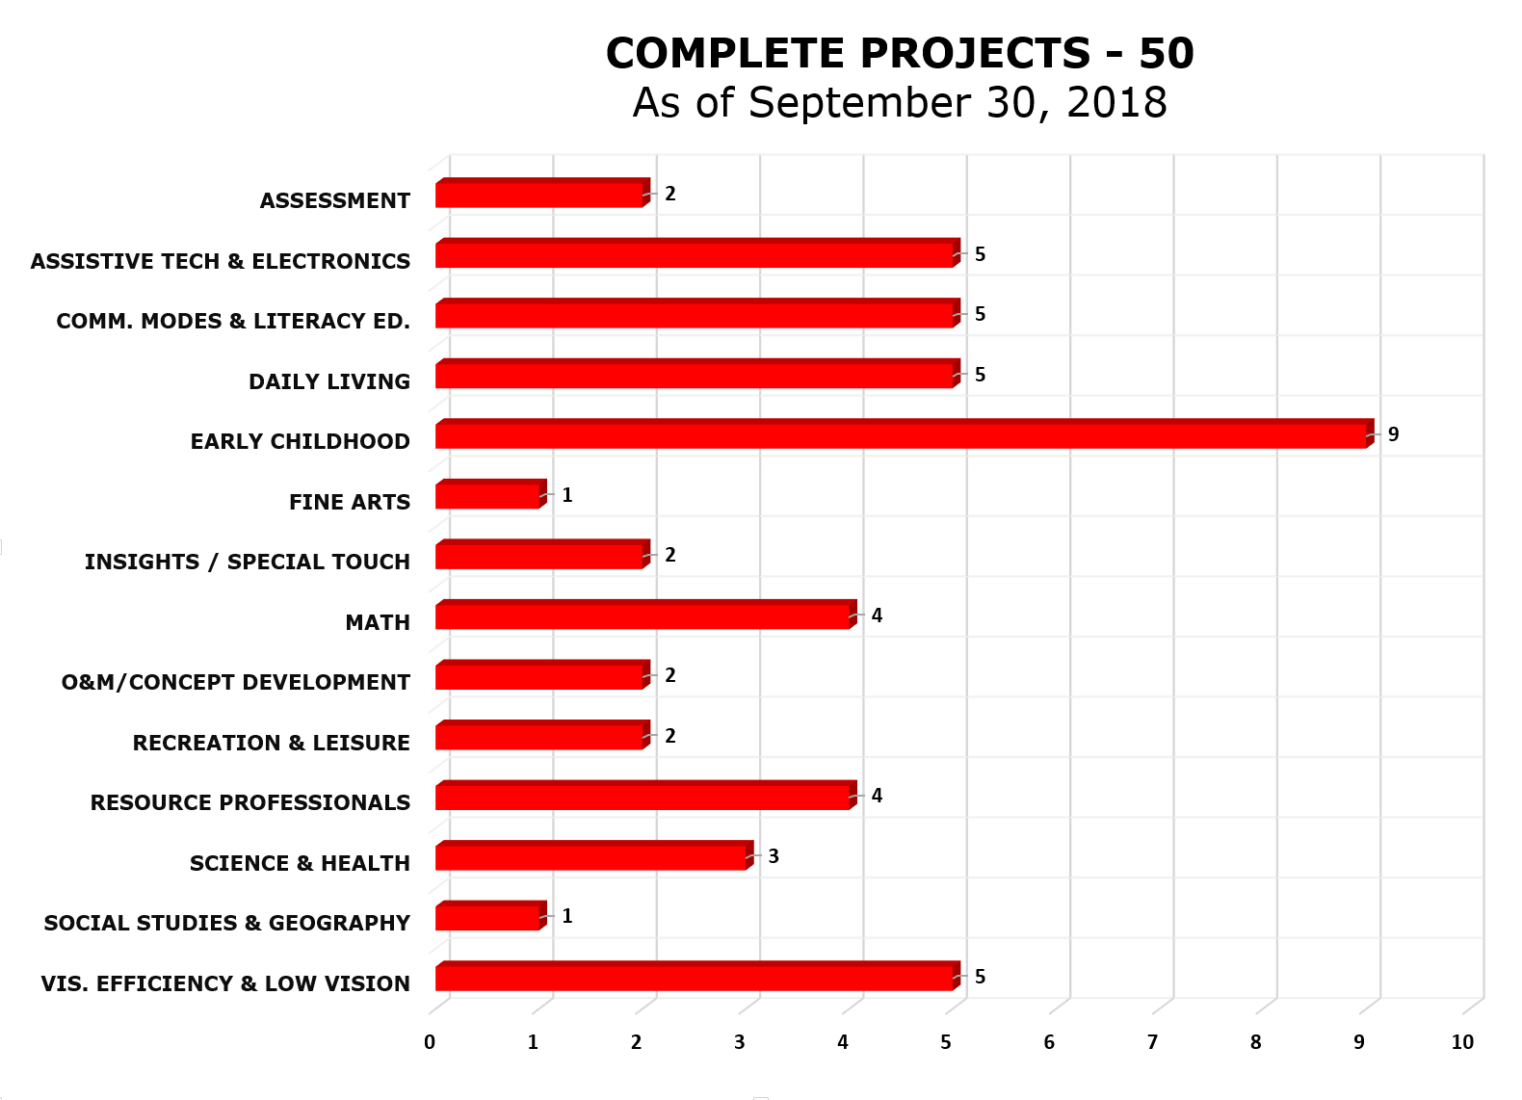

Active Projects
(Chart II)
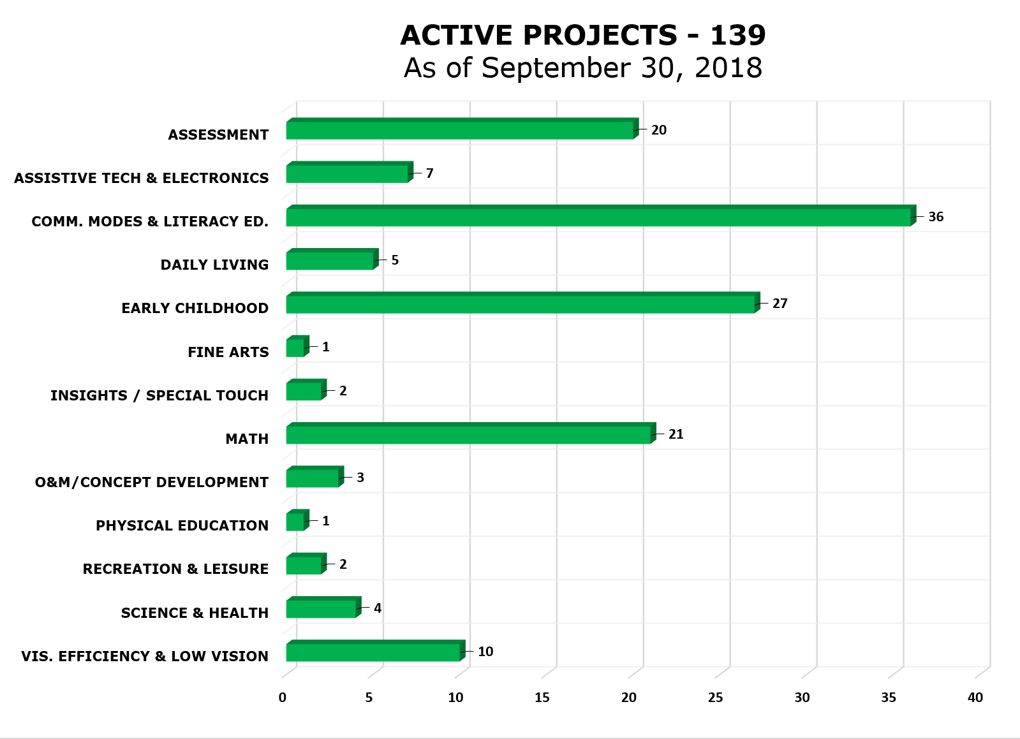

Pipeline Projects
(Chart III)
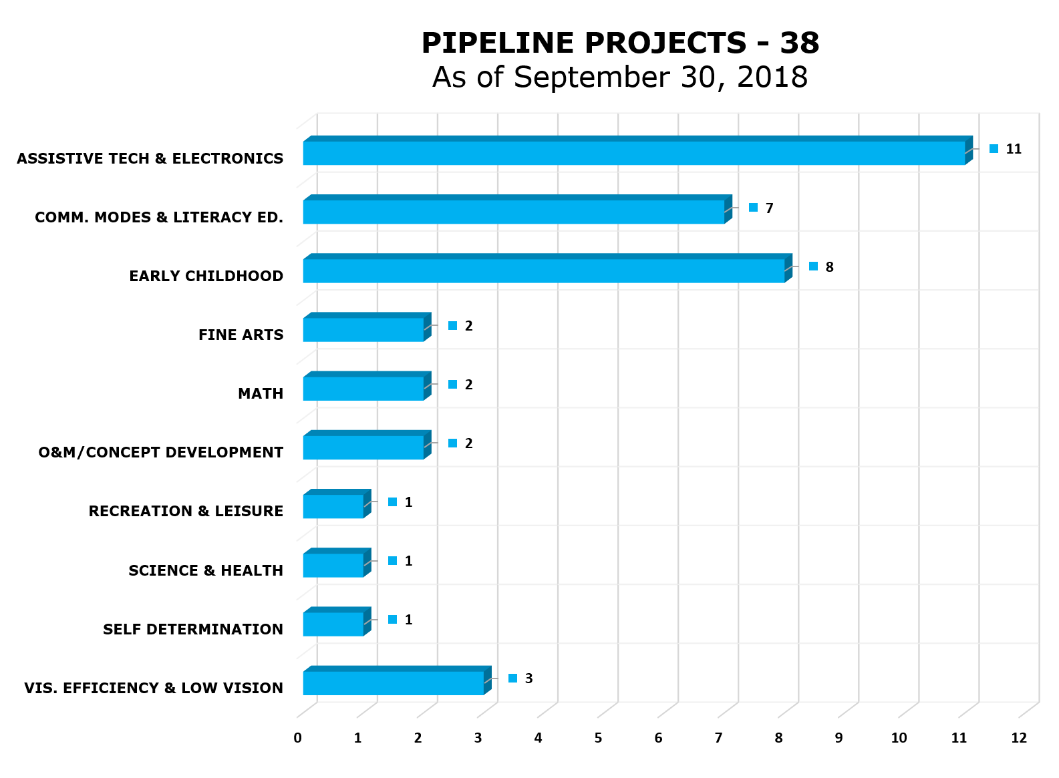

PARCing Lot Projects
(Chart IV)
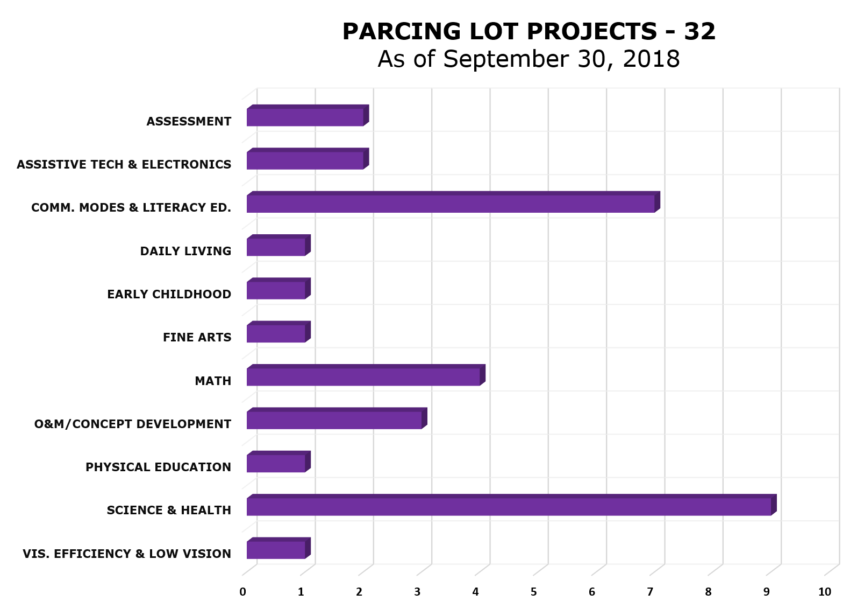

Compilation of Projects
(Chart V)
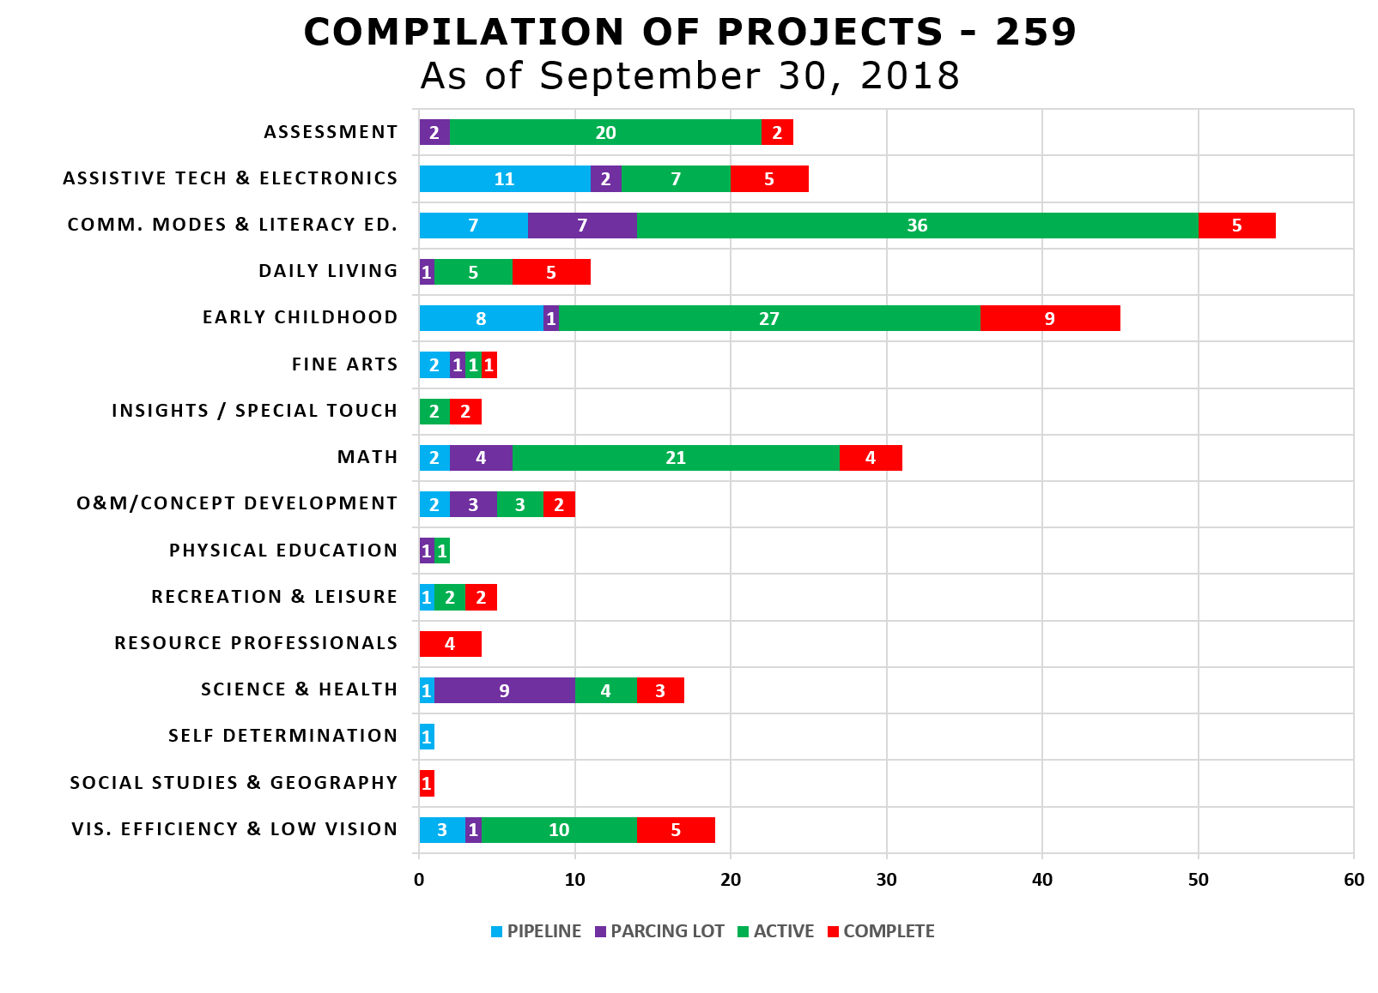
Status of Product Development
(Chart VI)
STATUS OF PRODUCT DEVELOPMENT
as of September 30, 2018
 | CATEGORY | Pipeline |  | PARCing Lot | Active | Complete | Grand Total
 | VIS. EFFICIENCY & LOW VISION | 3 |  | 1 | 10 | 5 | 19
 | SOCIAL STUDIES & GEOGRAPHY |  |  |  |  | 1 | 1
 | SELF DETERMINATION | 1 |  |  |  |  | 1
 | SCIENCE & HEALTH | 1 |  | 9 | 4 | 3 | 17
 | RESOURCE PROFESSIONALS |  |  |  |  | 4 | 4
 | RECREATION & LEISURE | 1 |  |  | 2 | 2 | 5
 | PHYSICAL EDUCATION |  |  | 1 | 1 |  | 2
 | O&M/CONCEPT DEVELOPMENT | 2 |  | 3 | 3 | 2 | 10
 | MATH | 2 |  | 4 | 21 | 4 | 31
 | INSIGHTS / SPECIAL TOUCH |  |  |  | 2 | 2 | 4
 | FINE ARTS | 2 |  | 1 | 1 | 1 | 5
 | EARLY CHILDHOOD | 8 |  | 1 | 27 | 9 | 45
 | DAILY LIVING |  |  | 1 | 5 | 5 | 11
 | COMM. MODES & LITERACY ED. | 7 |  | 7 | 36 | 5 | 55
 | ASSISTIVE TECH & ELECTRONICS | 11 |  | 2 | 7 | 5 | 25
 | ASSESSMENT |  |  | 2 | 20 | 2 | 24
 | GRAND TOTAL | 38 |  | 32 | 139 | 50 | 259
 | PRODUCT FAMILIES REPRESENTED | 38 |  | 23 | 69 | 38 | 168
In FY 2018, 69 product ideas were submitted.

Proper Trademark Notice and Attribution

ACT® is a registered trademark of ACT, Inc.
Adobe® and Illustrator® are registered trademarks of Adobe Systems, Inc.
Amazon®, Amazon Echo®, and Amazon Alexa® are registered trademarks of Amazon Technologies, Inc.
American Foundation for the Blind® is a registered trademarks of American Foundation for the Blind, Inc.
American Institutes for Research® and AIR® are registered trademarks of American Institutes for Research in the Behavioral Sciences.
Android™, Google™, Google Apps™, Google Assistant™, Google Chrome™, Google Docs™, Google Drive™, Google Hangouts™, Google Home™, Google Play™, and YouTube™ are trademarks of Google Inc.
App Store®, Apple®, iPad®, iPad mini®, iPhone®, iPod touch®, and TestFlight® are registered trademarks or service marks of Apple Inc., registered in the U.S. and other countries.
Assessment of Learning™, Developmental Reading Assessment®, DIAL™, enVisionmath®, KeyMath™, Wechsler Intelligence Scale for Children®, and WISC® are trademarks in the U.S. and/or other countries of Pearson Education, Inc., or its affiliate(s).
Bluetooth® is a registered trademark of Bluetooth SIG, Inc.
Brailon® is a registered trademark of American Thermoform Company.
Califone® and CardMaster™ are registered trademarks of Califone International Inc.
Camtasia® is a registered trademark of TechSmith Corporation.
CASAS® is a registered trademark of CASAS - Comprehensive Adult Student Assessment Systems.
College Board® is a registered trademark of the College Board.
Color Star® is a registered trademark of CareTec International GmbH.
CorelDRAW® is a registered trademark of Corel Corporation.
Delrin® is a registered trademark of DuPont or its acetal resins.
Delta Education® is a registered trademark of Delta Education, LLC.
Discovery Communications™ is a registered trademark of Discovery Communications, Inc.
Dropbox™ is a trademark of Dropbox, Inc.
Dycem® is a registered trademark of Dycem Limited Company.
Dynamic Learning Maps™ and DLM® are trademarks of The University of Kansas state educational institution.
Elenco®, Snap Circuits®, and Snap Circuits Jr.® are registered trademarks of Elenco Electronics, Inc.
EPUB® is a registered trademark of International Digital Publishing Forum.
ETS® is a registered trademark of Educational Testing Service.
Excel®, Microsoft®, and Windows® are registered trademarks of Microsoft Corporation in the United States and/or other countries.
Facebook® is a registered trademark of Facebook, Inc.
GED® is a registered trademark of the American Council on Education.
Hot Wheels® and Mattel® are registered trademarks of Mattel, Inc.
HumanWare™ and Prodigi™ are trademarks of HumanWare Inc.
Hungry Fingers™ is a trademark of Hungry Fingers.
IGEN® is a trademark of Xerox Corporation.
Imagination Playground™ is a trademark of Rockwell Investments, LLC.
iOS® is a registered trademark of Cisco in the U.S. and other countries and is used under license by Apple Inc.
JAWS® and MAGic® are registered trademarks of Freedom Scientific, Inc.
Lexile® is a registered trademark of MetaMatrics, Inc.
Math Window® is a registered trademark of Wolf, Roger P.
Measured Progress™ is a trademark of Measure Progress, Inc.
Measurement Incorporated® is a registered trademark of Measurement Incorporated.
OpenStreetMap® is a registered trademark of OpenStreetMap Foundation.
OtterBox® is a registered trademark of Otter Products, LLC, registered in the U.S. and other countries.
Paint-by-Number Safari™ and PlayAbility Toys™ is a trademark of Josephine Baldacchino Lopez.
Perkins Brailler® is a registered trademark of Perkins School for the Blind.
PermaBraille™ is a trademark of the American Printing House for the Blind, Inc.
Popsicle® is a registered trademark of Unilever Group
ProClick® is a registered trademark of ACCO Brands.
Questar Assessment, Inc.™ is a trademark of Questar Assessment, Inc.
Reach & Match® is a registered trademark of Reach & Match Pty. Ltd.
Riverside™ is a trademark of Riverside Publishing.
Roland® is a registered trademark of Roland DGA Corporation.
Sticky Dots™ is a trademark of Therm O Web, Inc.
SurveyMonkey® is a registered trademark of SurveyMonkey.com, LLC.
Tangle® is a registered trademark of Tangle Inc.
TEST READY® is a registered trademark of Curriculum Associates, Inc.
Trello™ is a Trademark of Trello, Inc.
Tri-Pour® is a registered trademark of Sherwood Medical Company.
Twister® is a registered trademark of Hasbro, Inc.
Twitter® is a registered trademark of Twitter, Inc.
VELCRO®, VELTEX® and VELCOIN® are registered trademarks of Velcro Industries B.V.
ViewPlus® is a registered trademark of ViewPlus.
VisioBook® is a registered trademark of Baum Retec AG.
Vivelle® is a registered trademark of Wintech International.
VoiceOver® is a registered trademark of Voicebrook, Inc.
WiDA™ is a trademark of Wisconsin Center for Education Research.
Wikki Stix® is a registered trademark of Omnicor, Inc.
Woodcock-Johnson®, WJ IV™, Houghton Mifflin Harcourt™, and HMH® are trademarks or registered trademarks of Houghton Mifflin Harcourt Publishing Company.
WordPress® is a registered trademark of WordPress Foundation.
Ziploc® is a registered trademark of S.C. Johnson & Son, Inc.
ZoomText® is a registered trademark of Algorithmic Implementations, Inc.



Copyright © 2018
American Printing House for the Blind, Inc.
1839 Frankfort Avenue
Louisville, KY 40206
Toll-free 1-800-223-1839
E-mail: info@aph.org
Web: www.aph.org
Shop: shop.aph.org

