Kainundrum Lite Accessibility Addendum
Compatible with iOS and Android tablets.
Watch along video guide (YouTube Link)

Making Coding Accessible for All
KaiBot offers an engaging way for students who are blind or low vision to learn coding, even without prior computing experience. Through the integration of Kainundrum Lite and Braille Coding Cards, KaiBot fosters a collaborative and inclusive learning space. This hands-on, social play approach empowers students to develop confidence, critical thinking, and coding abilities.

Tactile & Auditory Coding for Every Learner
Students engage with real-world coding challenges using:
Braille Coding Cards – Physically program movements, stories, and puzzles.
Reader Mode – Auditory support for reading coding cards and tile directions and numbers.
Social Learning – Encourages teamwork and problem-solving.

Empowering Future Coders
KaiBot teaches foundational coding concepts, inspiring students to explore careers in computer science. With no prior coding knowledge required, educators can easily lead lessons using:
- A comprehensive curriculum library (Web Link)
- Step-by-step guidance & engaging activities
- KaiBot + Kainundrum Lite + Braille Coding Cards = An Inclusive, Interactive Coding Adventure!

Relevant links
Video Guide (YouTube Link)
Kainundrum Music Video (Web Link)
KaiBot User Guide (Web Link)
Kainundrum lite User Guide (Web Link)
Kainundrum introduction video (Web Link)

KaiBot Accessibility Addendum Index
Making Coding Accessible for All
Tactile & Auditory Coding for Every Learner
Empowering Future Coders
Relevant links
Introduction
What you’ll need
Accessibility options overview
Screen-free mode - No Application
Voice Reader Mode.
Accessibility Features (with the App)
Multilingual Screen Reader support
On-Screen Navigation Assistance
Coding Card Feedback
Tile Positioning Guidance
KaiBot Reader Mode
Getting Started
Setting up KaiBot
Turn on device Accessibility mode
Set up the App
Layout the tiles
Navigating Kainundrum lite in Accessibility Mode
Controls
Key Features for Accessibility Users
Coding Card Mode
KaiBot Reader Mode
How to Activate:
Having problems with VoiceOver or Talkback?
Enabling In-built Accessibility Mode
Enabling Accessibility Mode for iOS
Changing Language / Pronunciation for iOS
Enabling Accessibility Mode for Android
Changing Language / Pronunciation for Android

Introduction
Accessibility in education is not just a feature—it’s a fundamental right. In classrooms around the world, students of all abilities deserve equal opportunities to learn, explore, and succeed. At Kai’s Education, we are deeply committed to creating tools and experiences that empower every student, regardless of their needs.
KaiBot, along with the Kainundrum Lite app, has been thoughtfully designed to foster an inclusive learning environment. It opens the doors to coding and problem-solving, ensuring that everyone has a chance to engage with technology in meaningful ways.
Recognizing the challenges many educators face in integrating accessibility into their classrooms, we’ve built accessibility features directly into our products. From multilingual Voiceover support to Braille-compatible coding cards and tactile navigation tools, KaiBot is designed to make coding tangible and interactive for all learners.
Beyond teaching coding, our mission is to inspire confidence, creativity, and collaboration, equipping students with essential 21st-century skills. By integrating tools like KaiBot into classrooms, we not only teach STEM, but also cultivate a sense of belonging, demonstrating that technology is accessible to all.
Kai’s Education is proud to work alongside educators, parents, and students to build a brighter, more inclusive future, one accessible innovation at a time.

What you’ll need
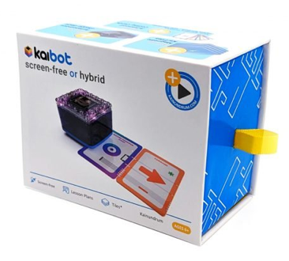
KaiBot robot
Product Link
Advanced Braille Coding Cards
Product Link
Tablet iPad or Android tablet

Kainundrum Lite app
Available on the App Store and Google Play
App Store
Google Play

Wikki Stix (to hold coding the cards together while coding)
Amazon

Accessibility options overview

Screen-free mode - No Application
KaiBot can operate completely independently using only the Braille Coding Cards—no tablet or app required. This mode provides a screen-free unplugged experience, great for teaching the fundamentals of coding before moving to a device. However, there is no voice feedback for the user. It is recommended to use it with the Kainundrum Lite app for the best accessibility.

Voice Reader Mode.
For speech feedback, you’ll need to have voice to text accessibility settings on your device enabled.

Accessibility Features (with the App)
When paired with the Kainundrum Lite app, KaiBot offers enhanced accessibility support, including:

Multilingual Screen Reader Support
Available in English, Spanish, French, and Italian.

On-Screen Navigation Assistance
Instructions read aloud via VoiceOver (iOS), TalkBack (Android), or built-in system voice.

Coding Card Feedback
Announces the function of each Braille Coding Card scanned by KaiBot.

Tile Positioning Guidance
Auditory feedback confirms KaiBot’s current tile number and direction on magnetic KaiTiles.

KaiBot Reader Mode

How to activate:
- Kainundrum Lite application must be open to use Reader Mode
- Pair KaiBot with the app
- While the KaiBot’s power switch is held to the right, Reader Mode will be active.

What it does:
- When you scan a card or tile while Reader Mode is active, the app will read out information without changing the program
- It will read out the card name
- It will read out the tile number and the KaiBot’s facing direction on the tile.

Getting Started

Setting up KaiBot
- Turn on KaiBot and ensure it’s fully charged.
- Check that your KaiBot is using the latest firmware version.

Turn on device Accessibility mode
- Ensure your devices' accessibility settings for VoiceOver / TalkBack back are on. Navigate down in the document to learn how to do this on iOS and Android.

Set up the App
- Download & install the Kainundrum Lite app from the App Store and Google Play Store. Chromebook users, you’ll need to install the app from the App store.

Layout the tiles
Layout your tiles and ensure all numbers are orientated the same direction. If you are unable to tell, use Reader Mode.
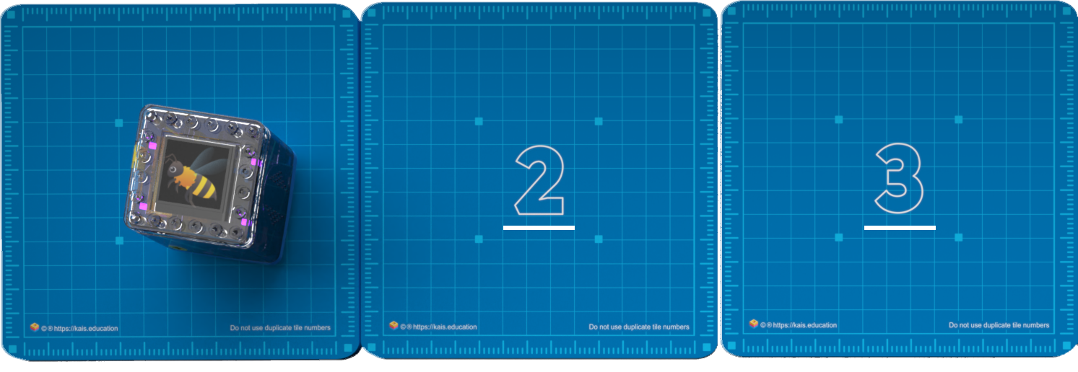
Requires Kainundrum Lite version 2.7 and KaiBot firmware 9.3
Navigate to the “Coding Card Mode” 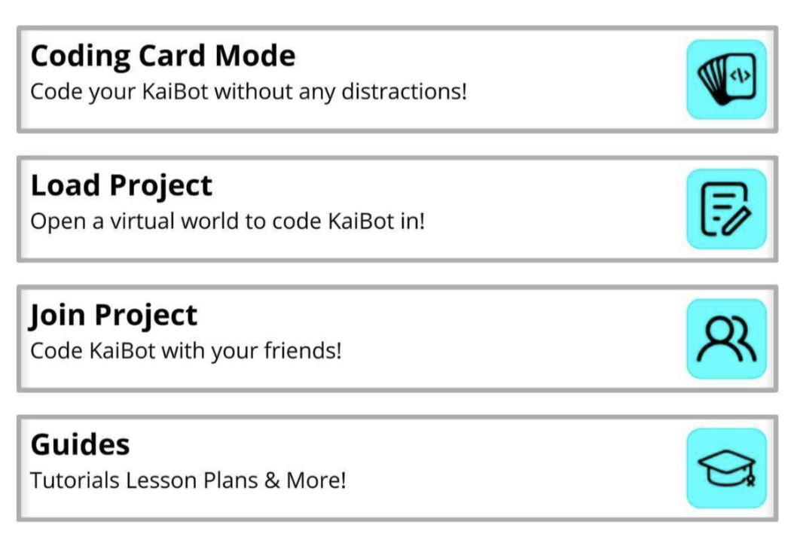

Navigating Kainundrum lite in Accessibility Mode

Controls
- Swipe left and right to navigate between selection items
- Double-tap to activate the selected item
- To adjust selection sliders, Double-tap the slider and then use up & down swipes to change the value.
- Triple-tap with 3 fingers to toggle accessibility mode on / off.

Key Features for Accessibility Users

Coding Card Mode
Kainundrum Lite’s coding card mode simplifies coding by presenting coding cards in a structured, tabular format similar to text-based coding. This hands-on mode helps students learn foundational and advanced coding concepts without using the Kainundrum 3D environment.
Students program KaiBot directly with the coding cards, on the tiles and receive auditory feedback, making it accessible for learners who are blind or low vision. By bridging the abstract concepts of text-based coding with the tangible experience of coding cards, this mode offers an inclusive and intuitive way to master coding skills.
No specific tile layout is required and students have the freedom to create themselves any tile layout to see if they can “touch each tile with KaiBot” or “Code KaiBot to the finish/last tile”
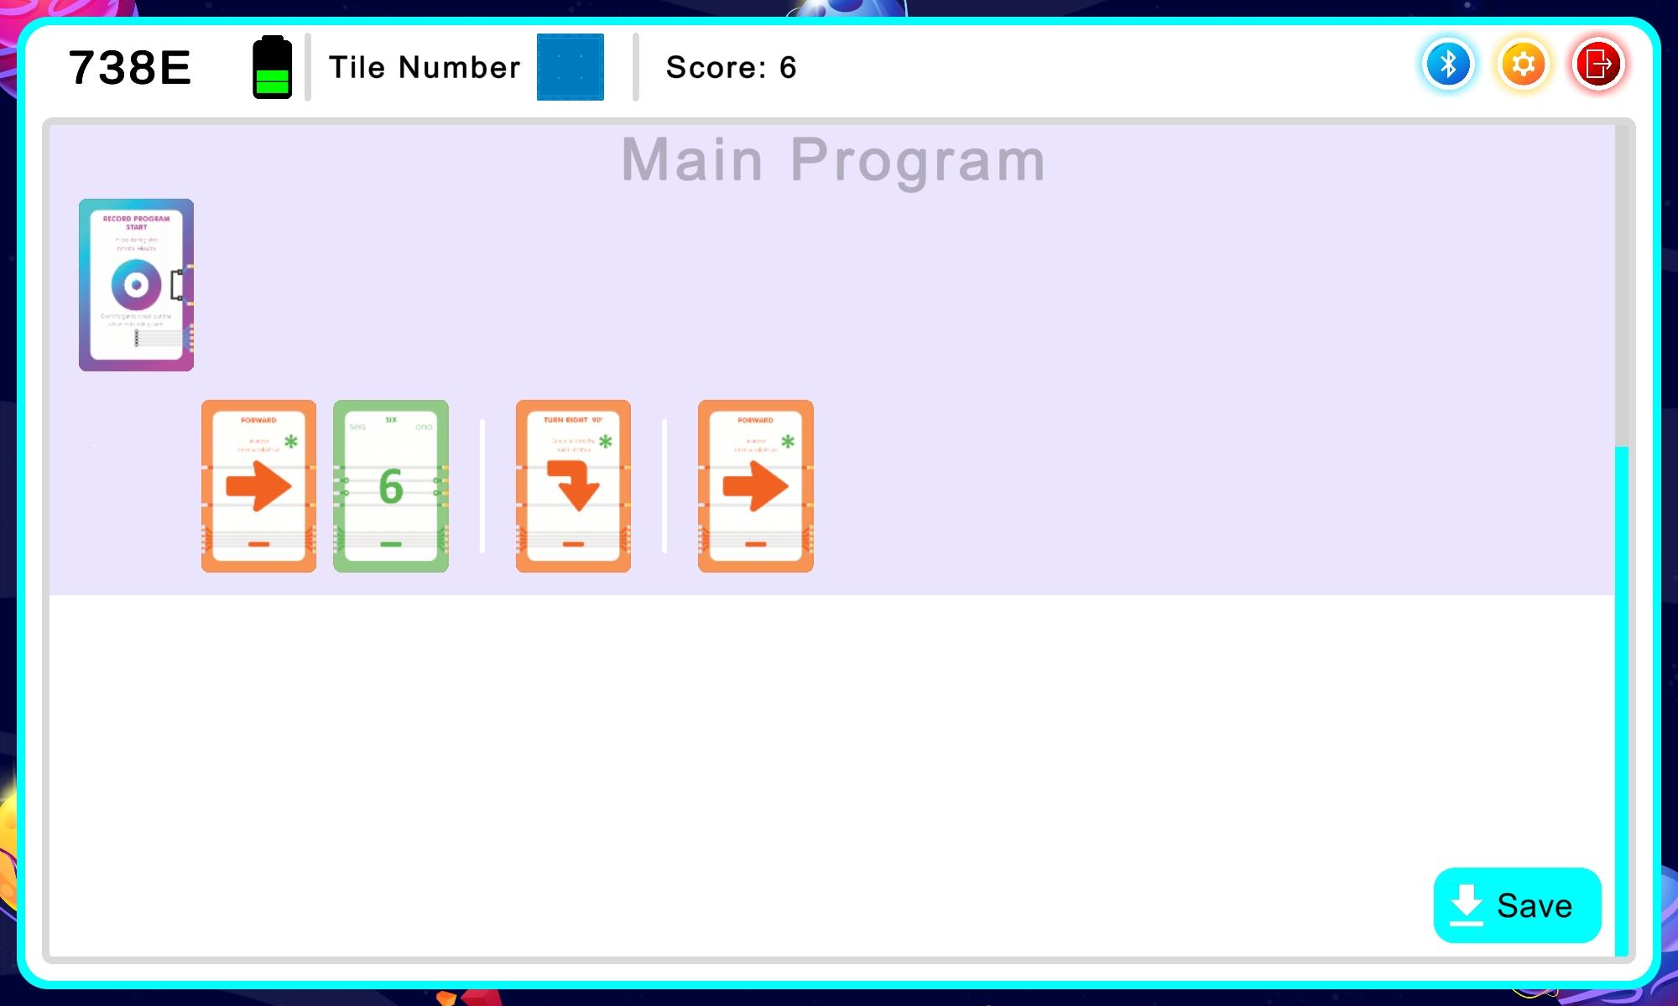

KaiBot Reader Mode
Auditory Feedback Only – KaiBot reads out coding card functions and tile numbers without changing the program.

Perfect For:
Students who are blind or low vision and may need audio confirmation before coding.
Braille learners – Helps teach basic braille through audio reinforcement.
Collaborative play – Lets peers or teachers verify cards together.

How to Activate:
- Kainundrum Lite application must be open to use Reader Mode.
- Pair KaiBot with the app.
- While the KaiBot’s power switch is held to the right, Reader Mode will be active.
- When you scan a card or tile while Reader Mode is active, the app will read out information without changing the program.
- Releasing the power switch will turn off Reader Mode.

Avoid sliding the switch too far to the left—you don’t want to power off KaiBot accidentally!
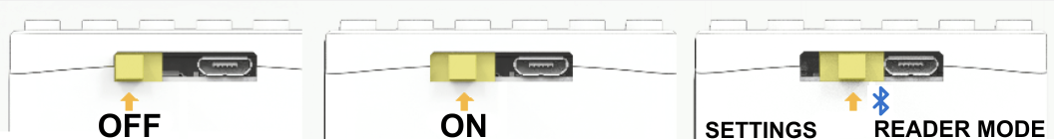
Switch far left = OFF Switch center = ON Switch pushed to right = Reader mode
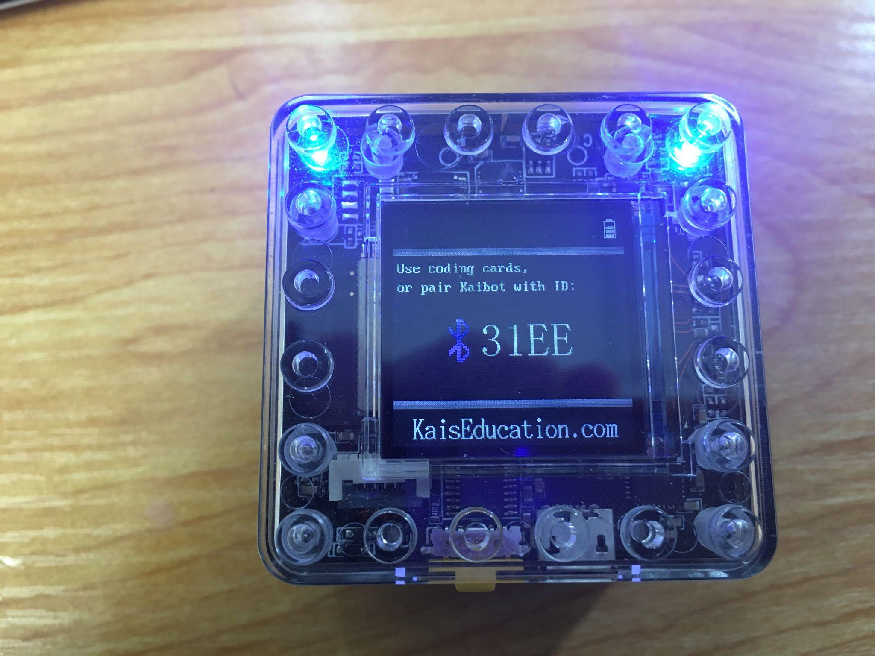
Switch the robot on, wait for it to finish booting. You’ll hear 3 long sounds and that’s when KaiBot is ready to use.
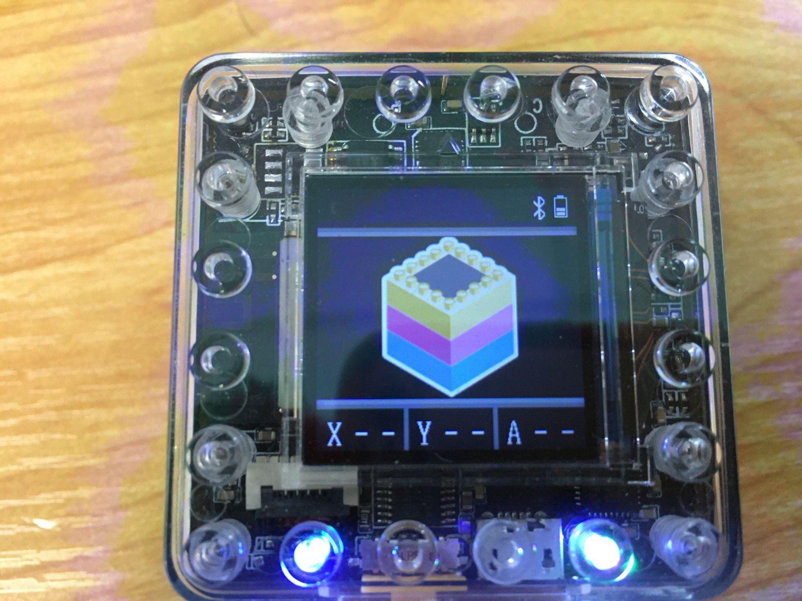
Once the robot is on, Pair robot with Kainundrum Lite app and connect to Bluetooth
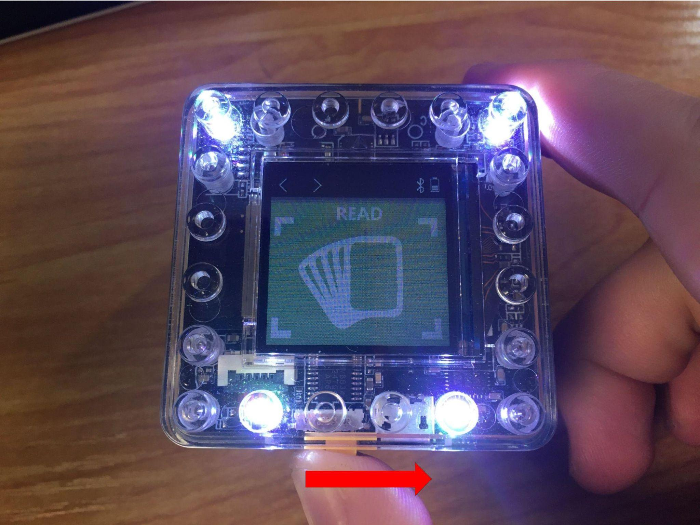
Long press and keeping hold the power button to the right side, to enter and stay in read mode.
Note: Reader mode will exit if you release the switch.
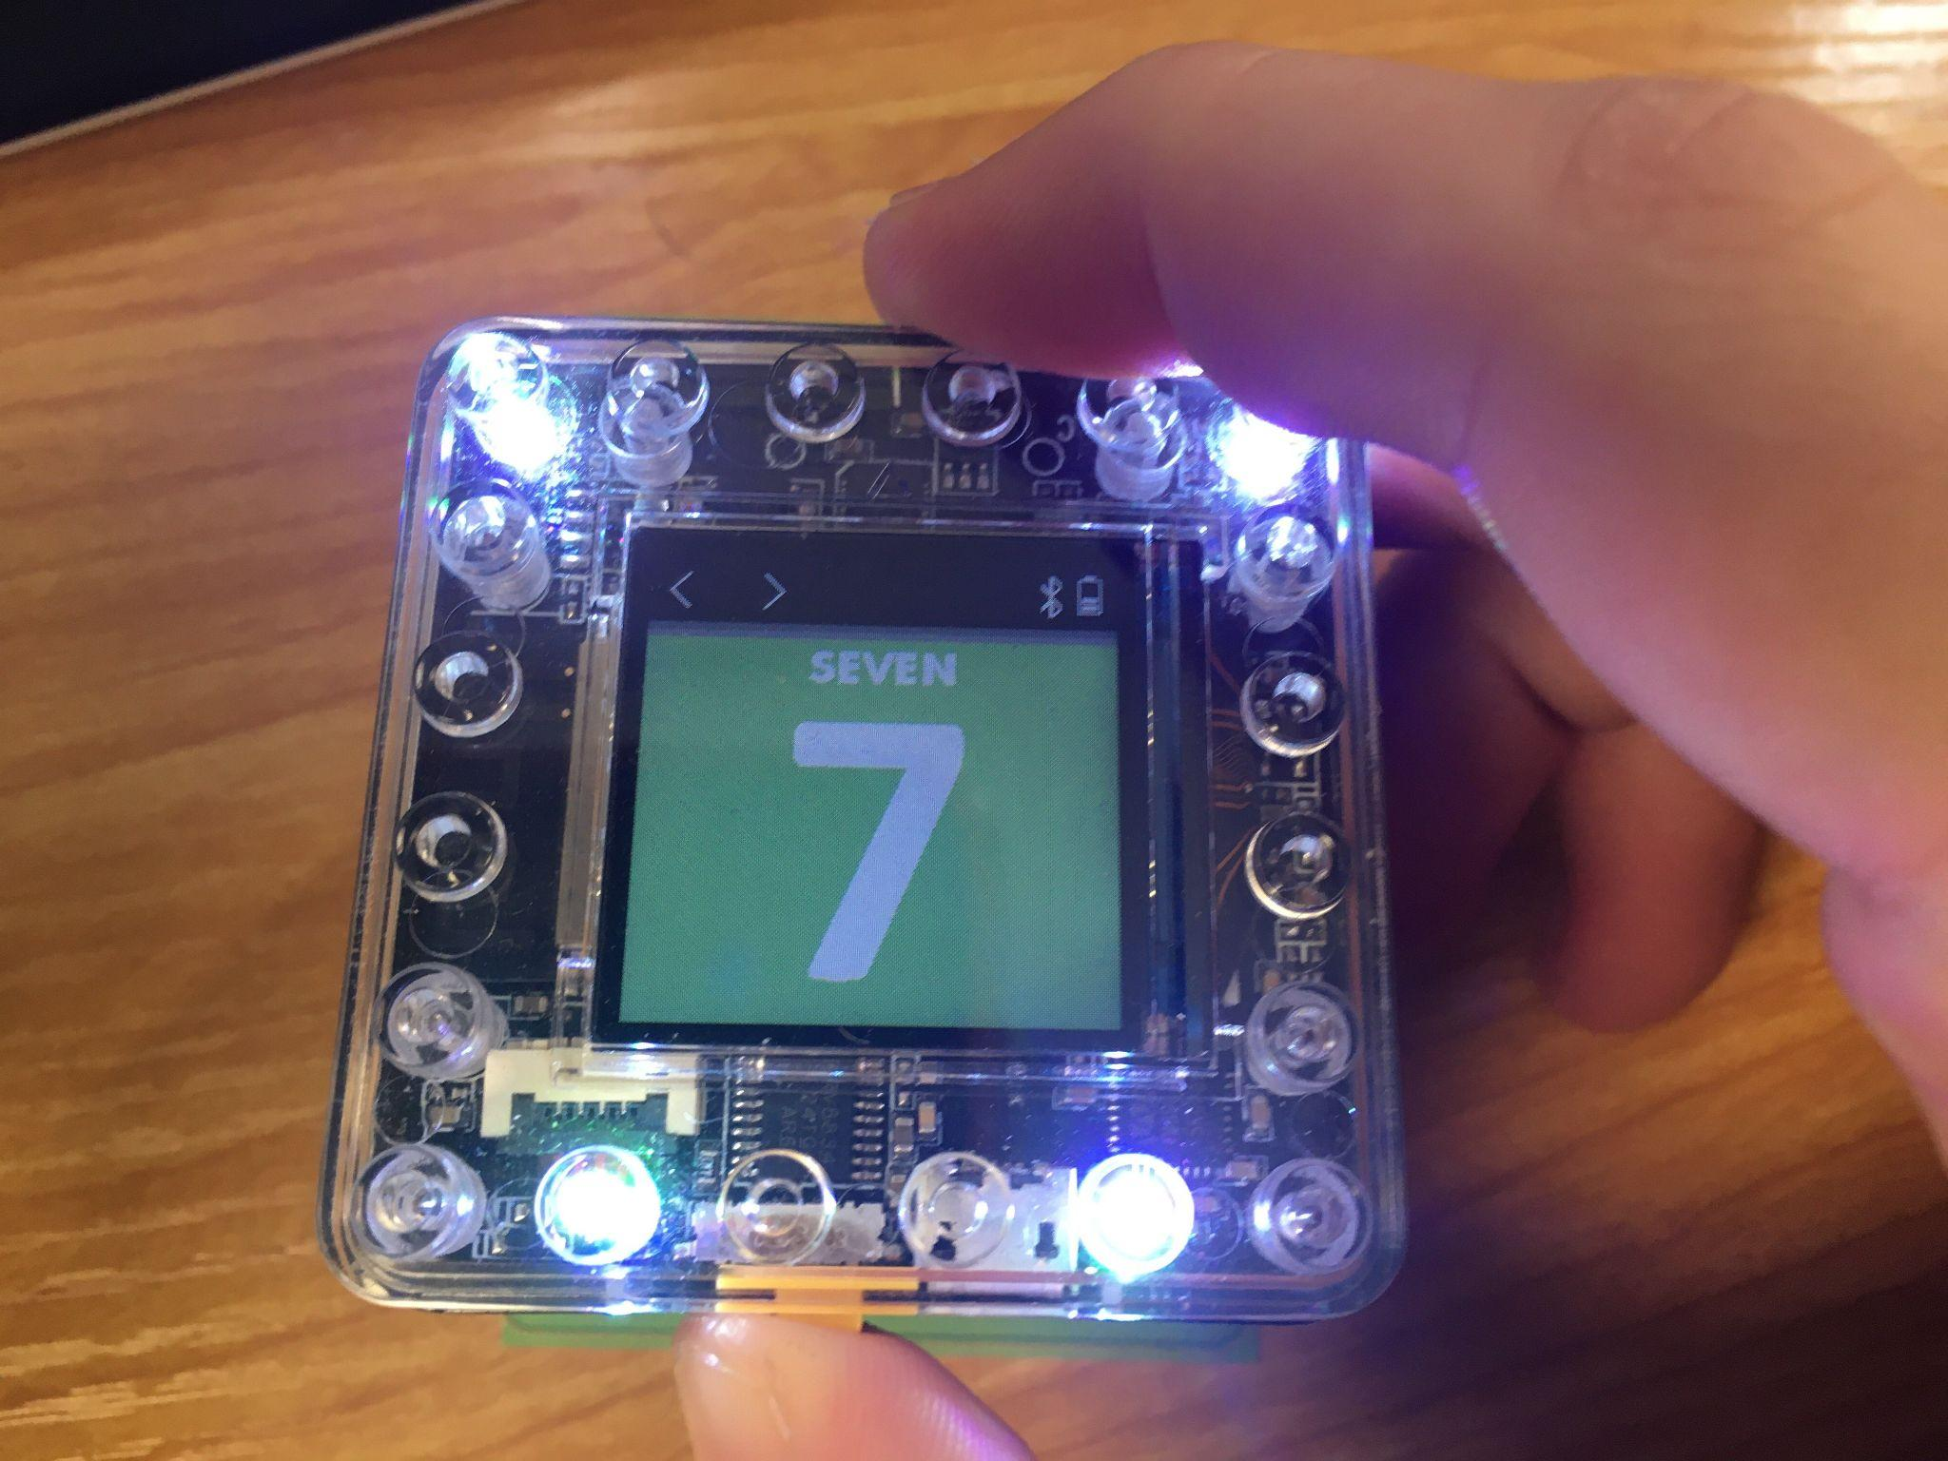
Place the bottom of robot over a card or tile, while paired with Kainundrum Lite and accessibility mode is activated. The tablet will read out what card or Tile it is placed on.
Note: Whilst in reader mode, no program is recorded by KaiBot.

Having problems with VoiceOver or Talkback?
If you are having issues with VoiceOver or TalkBack being slow, unresponsive or otherwise inadequate, you can use Kainundrum Lite’s In-built Accessibility Mode.

Enabling In-built Accessibility Mode
This system will act similarly to VoiceOver or Talkback. It will read out on-screen elements, and allows the user to navigate with touch gestures. It will also read out what cards and tiles KaiBot scans.

Before using the In-built Accessibility Mode, you will need to disable VoiceOver or TalkBack.
It is recommended that you enable a shortcut for toggling VoiceOver/TalkBack to make transitioning easier.

From the main menu, tap the orange gear button to get to the settings window.
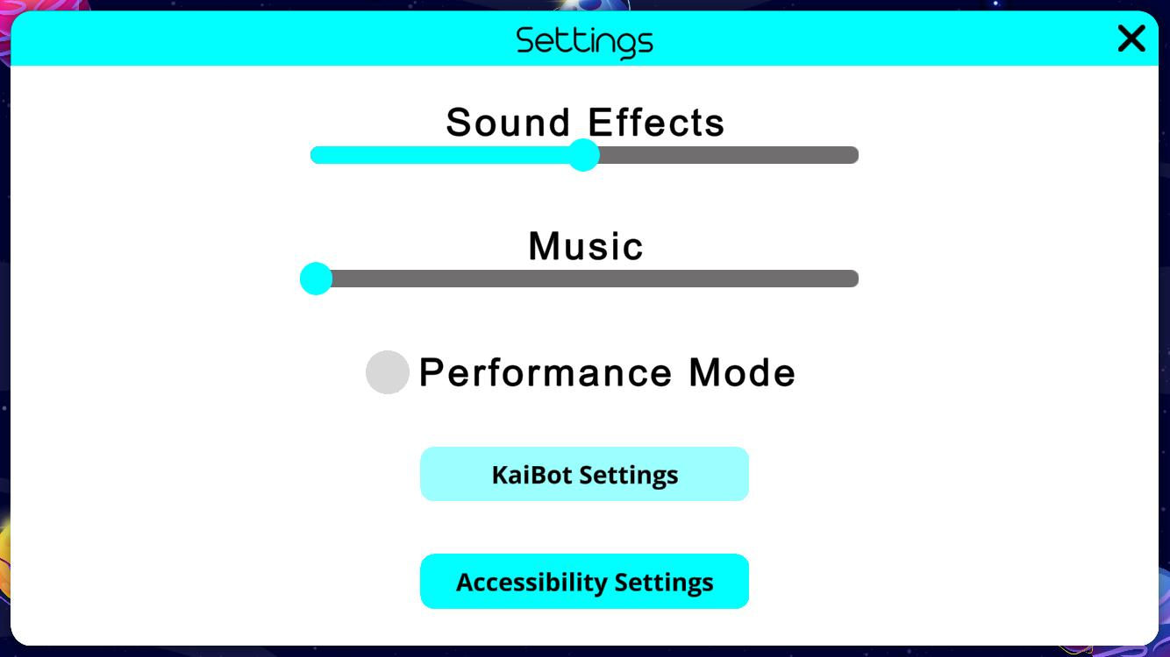
When the settings window is open, tap the “Accessibility Settings” button.
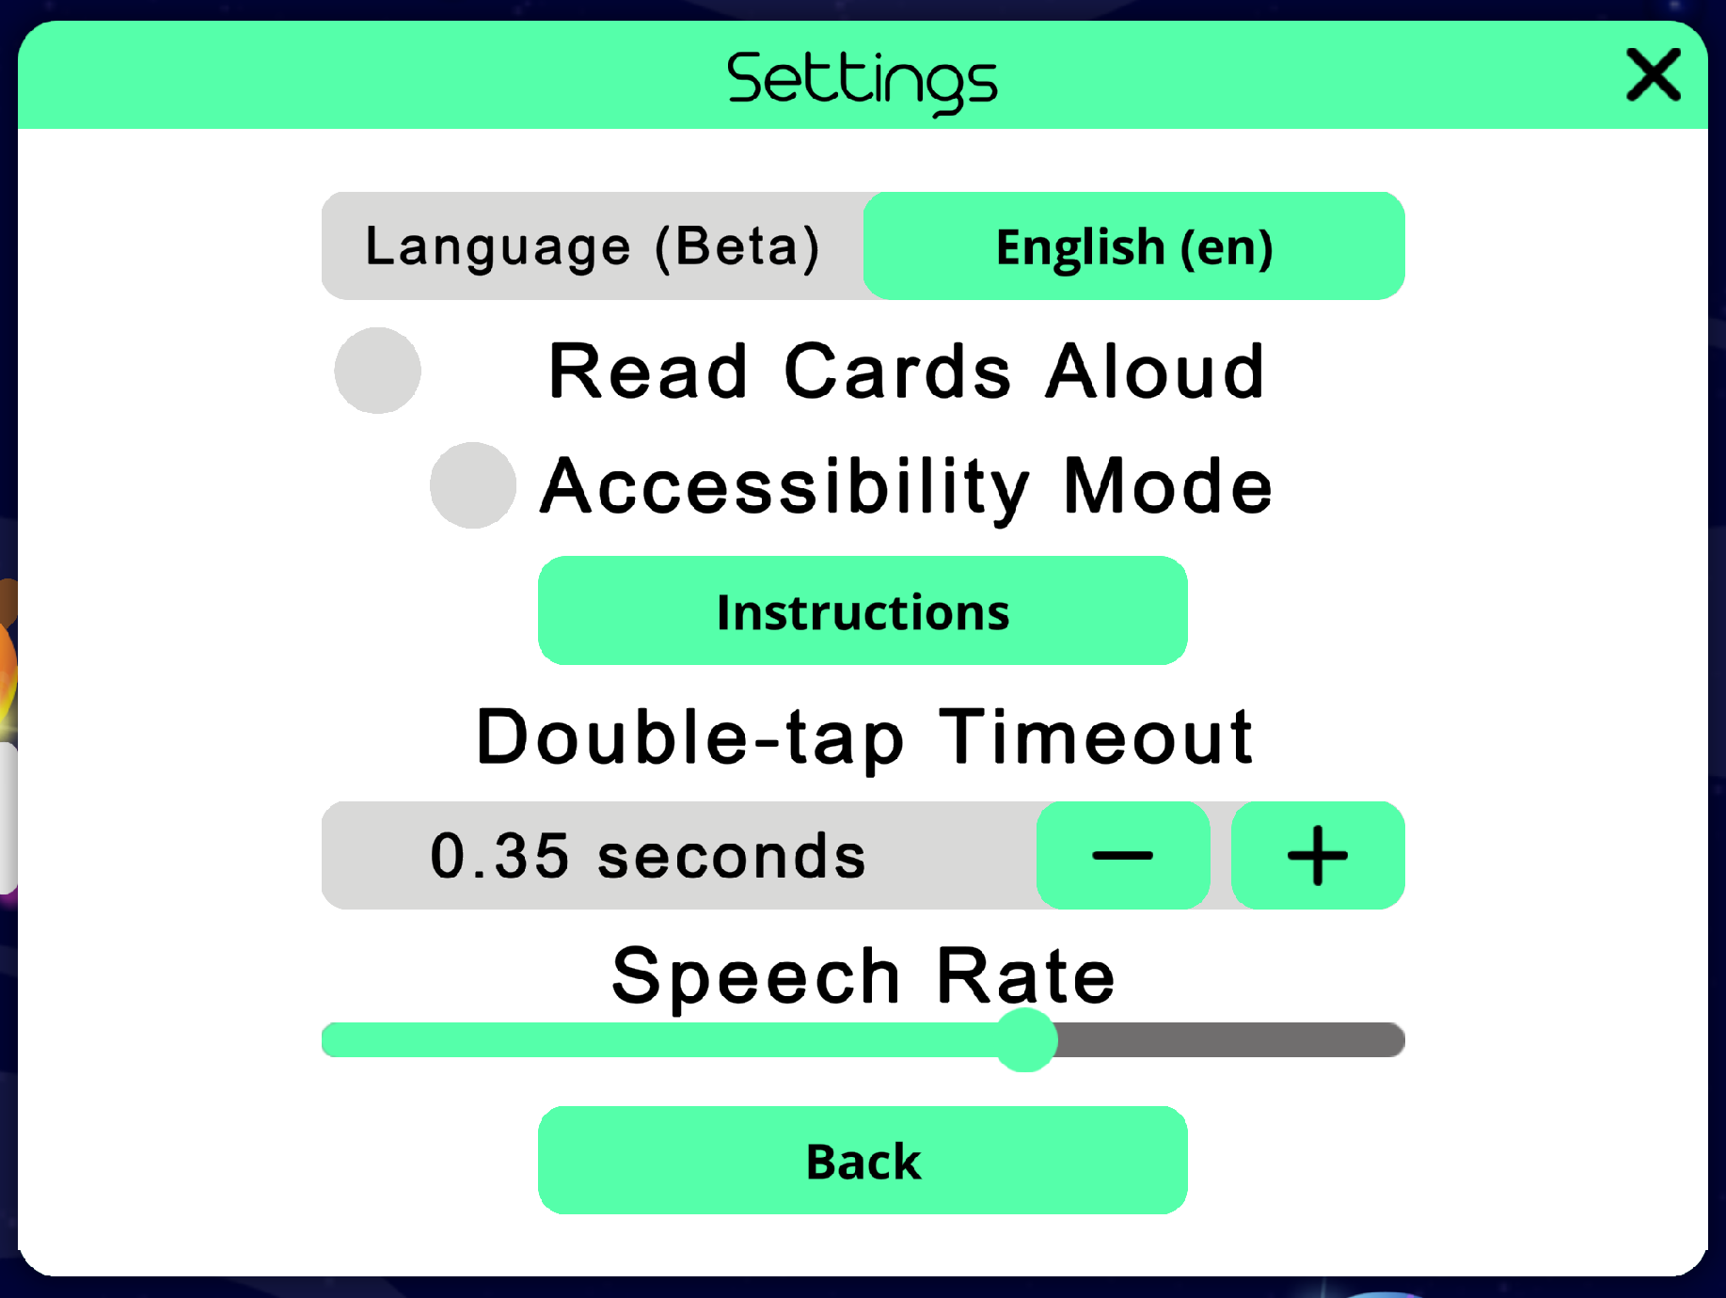
Once in accessibility settings, tap the Accessibility mode toggle to enable accessibility.
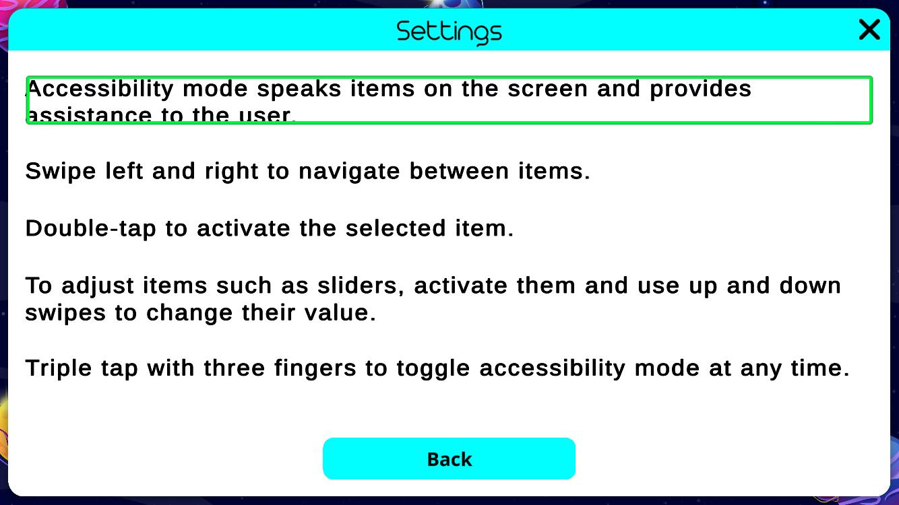
To navigate to the instructions, swipe right once. When the “instructions” button is selected, double-tap on the screen to show the instructions.
This will tell you how to navigate and use accessibility mode.
You can also triple-tap on the screen with three fingers to toggle accessibility at any time.

Enabling Accessibility Mode for iOS
Accessibility mode reads out on-screen elements, and allows the user to navigate with touch gestures. It reads out what cards and tiles KaiBot scans.
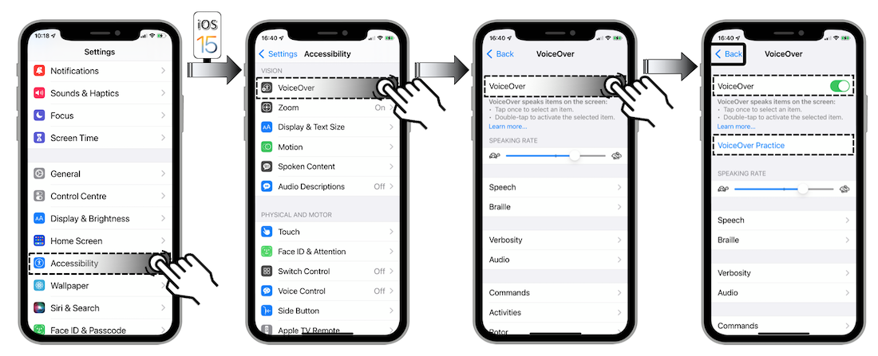
- Turn on VoiceOver
  - Navigate to Accessibility in the iOS Settings
  - Tap the VoiceOver toggle to enable/disable the screen reader.
  - You can tap VoiceOver Practice to learn the gestures to control the screen reader.
- Open Kainundrum Lite app

Changing Language / Pronunciation for iOS
For when you want the voice to sound out in a different accent.
Text to speech Language/Pronunciation
The pronunciation of the speech in the app is linked to the selected language of the device.
This can be changed with the following steps:
- Go to General > Language & Region
- Add your preferred language
Dragging the desired language to the top. This will change the language for your entire device.
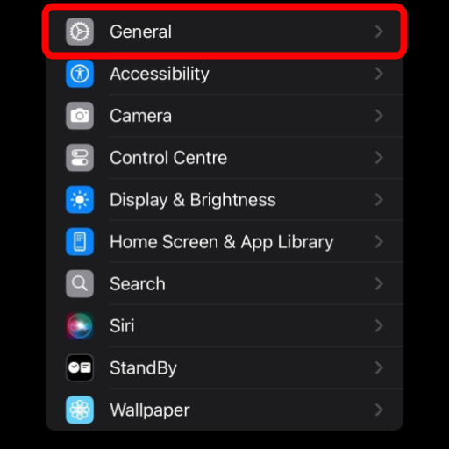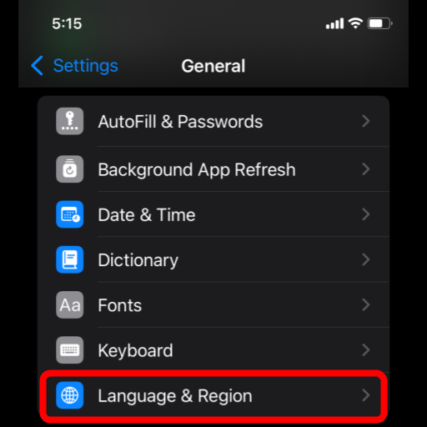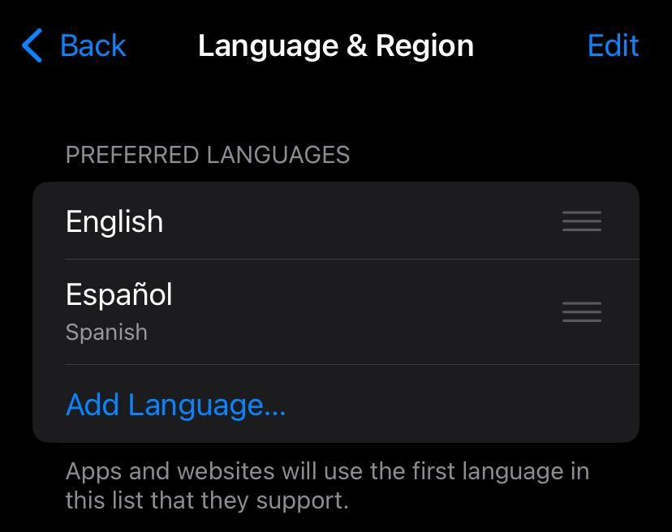

Enabling Accessibility Mode for Android
Accessibility mode reads out on-screen elements, and allows the user to navigate with touch gestures. It reads out what cards and tiles KaiBot scans.
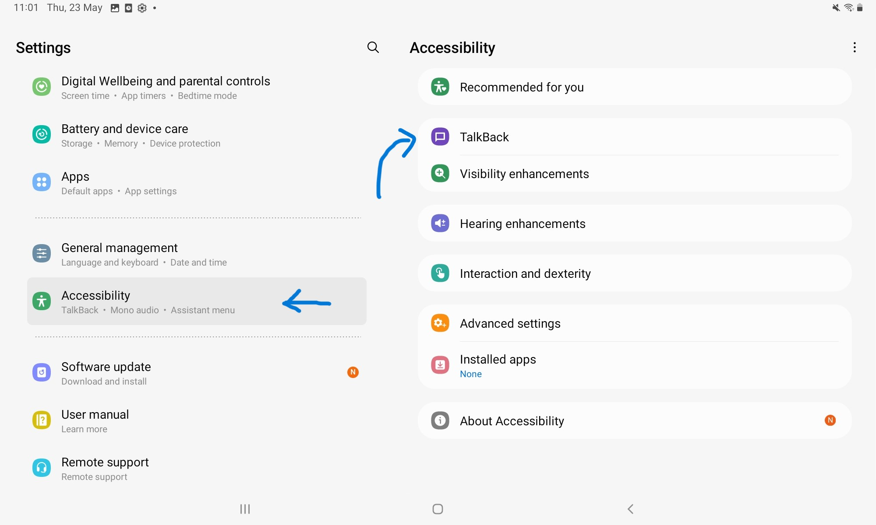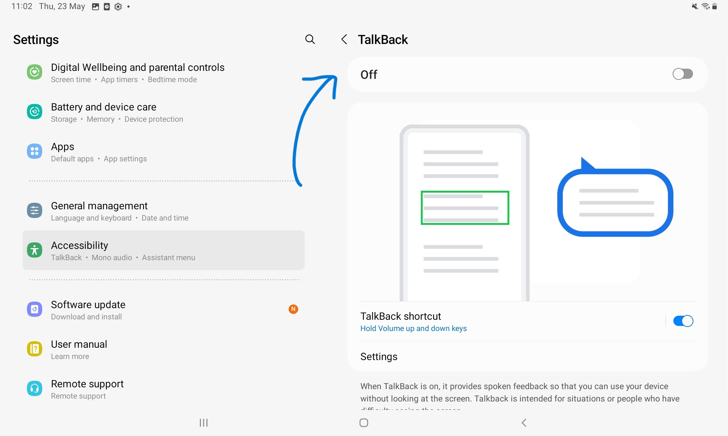
- Enable TalkBack
  - Navigate to Accessibility in the Android settings
  - Tap TalkBack to open the setting for the screen reader
  - Tap the toggle switch to enable/disable TalkBack
- Open the Kainundrum Lite app
Note: TalkBack will prevent the user from moving the KaiBot’s third person camera while in a project. While in projects it is recommended to use the Built-in Accessibility Mode instead.
It is highly recommended to enable the TalkBack shortcut found below the TalkBack toggle.

Changing Language / Pronunciation for Android
Text to speech Language/Pronunciation: The pronunciation of the speech in the app is linked to the selected language of the device.
The method for doing this may vary from device to device.
- Navigated to General Management > Text-to-speech.
- Tap the gear icon next to Preferred engine.
- Install the voice data of the language you would like to use.
- Tap language and select the language you want the text-to-speech to use.
Note: It may be necessary to restart Kainundrum Lite for changes to take effect.
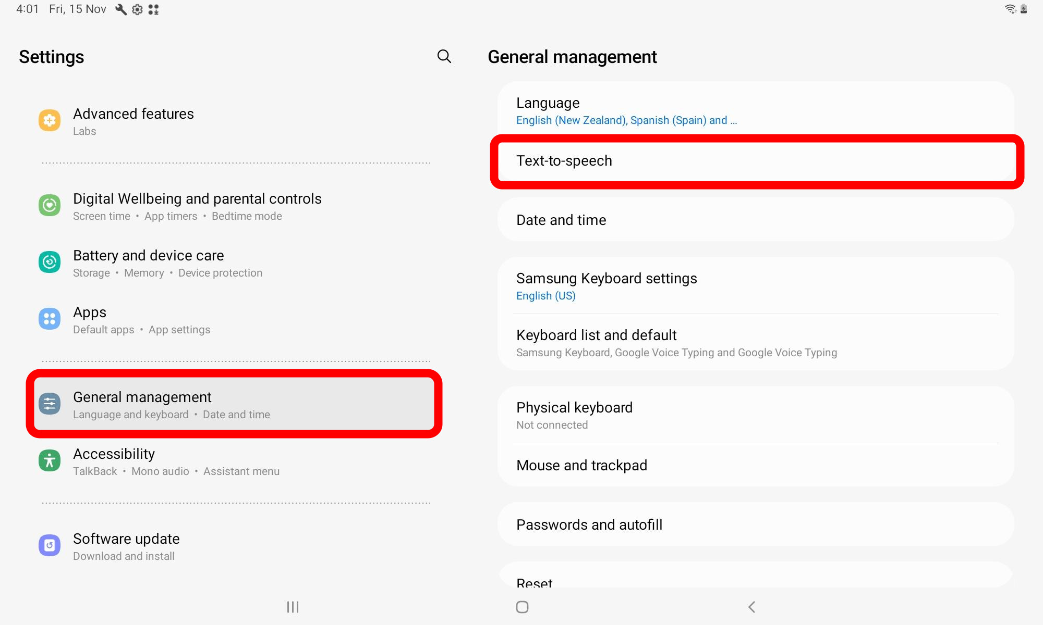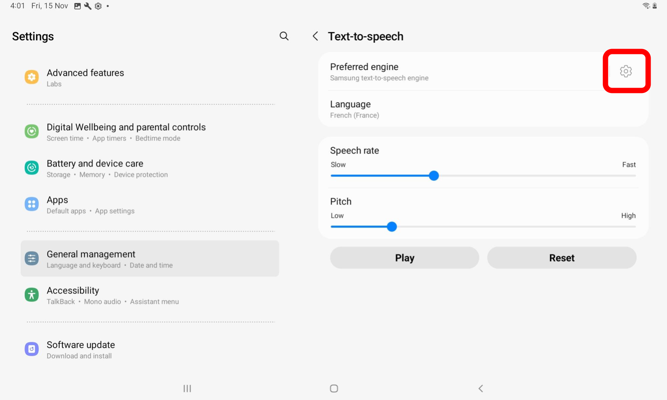
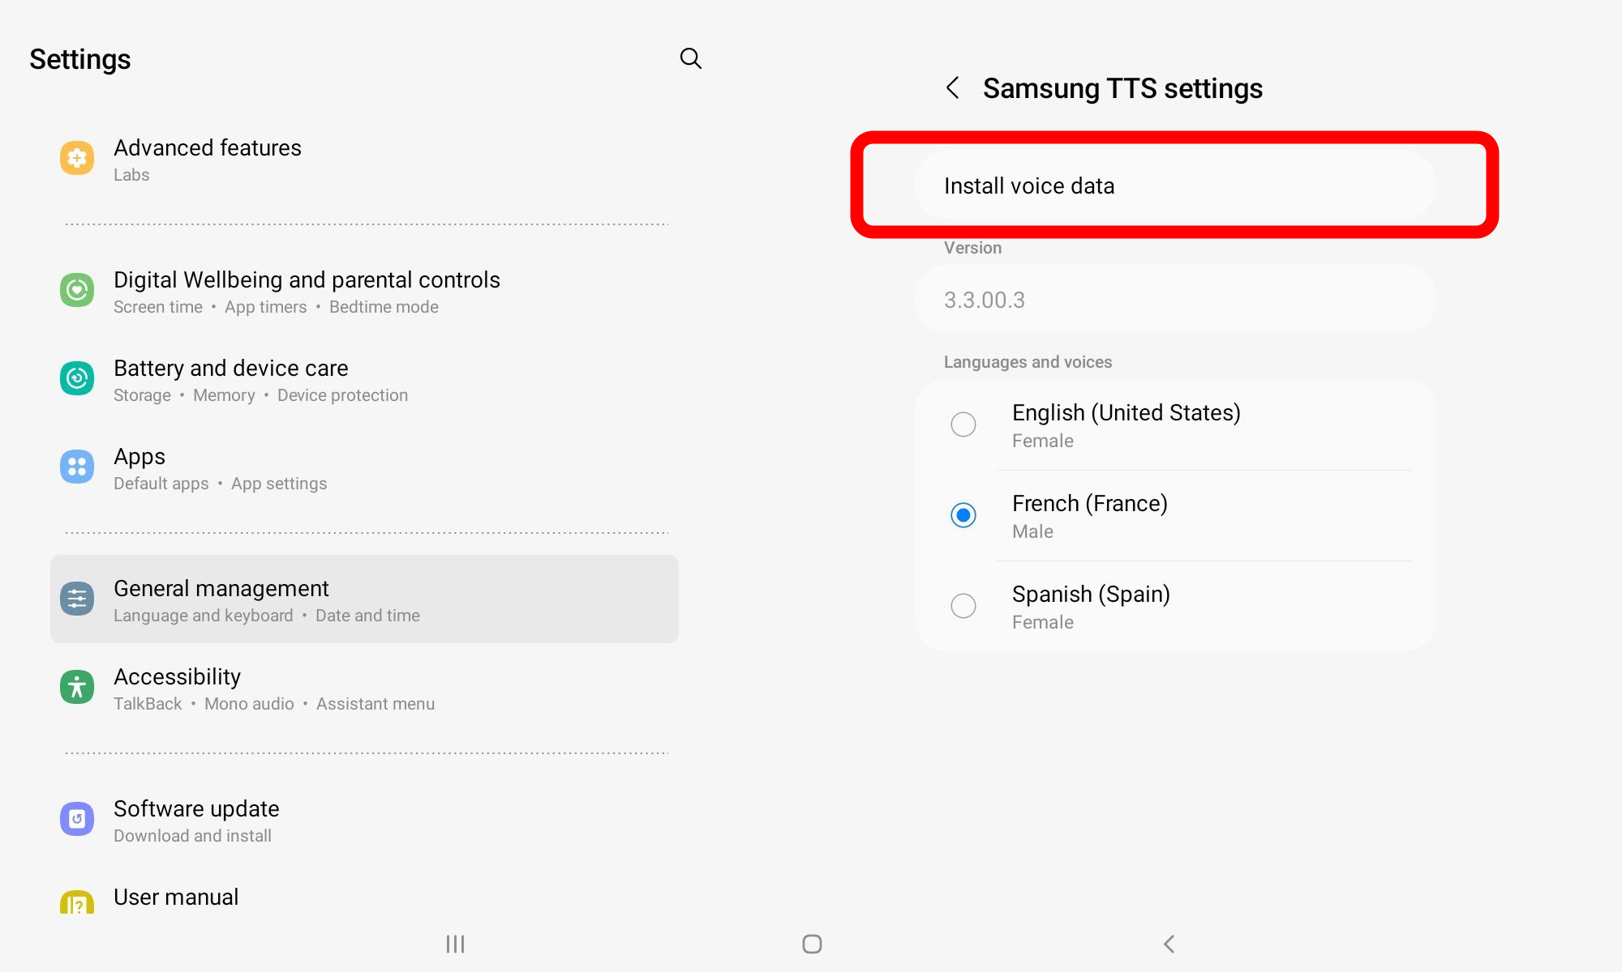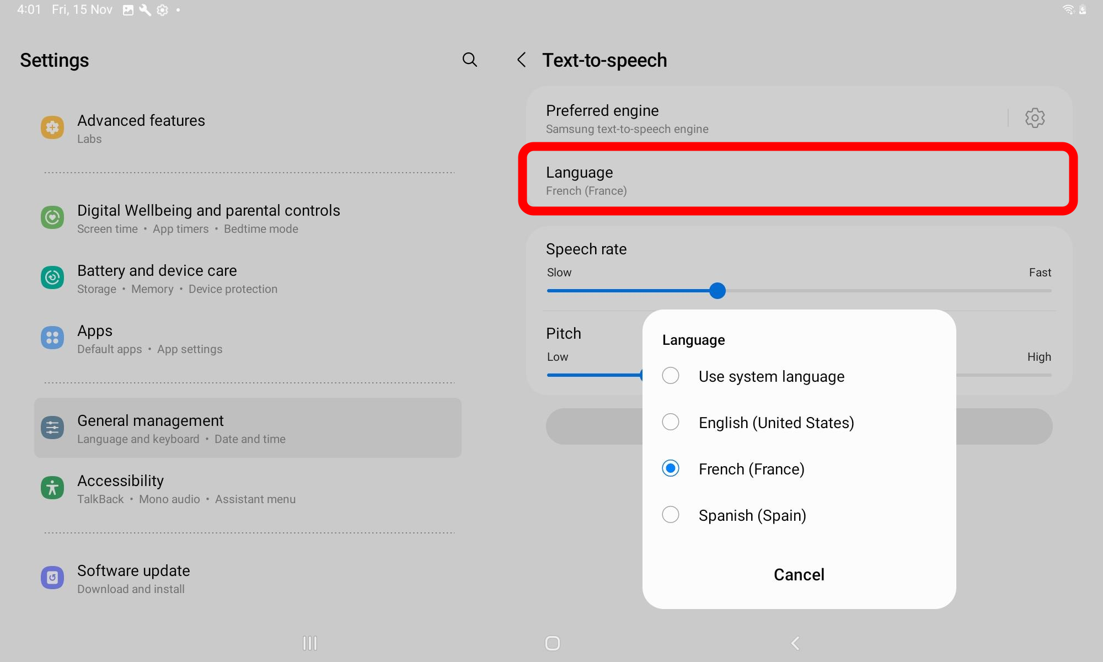

Trademark Attributes
Android, Chrome, Chromebook, Google Books, and Google Play are trademarks or registered trademarks of Google LLC. App Store, Apple, iBooks, iMessage, iPad, iPhone, and Mac are trademarks of Apple Inc., registered in the U.S. and other countries and regions.

